**Activating Animus: The Uniquely Social Roots of Trump Support**

**Appendix A: Full Models for Figures 1-6:**

**Figure A1: Democratic Group Animosity and Trump Support Measures**

**Figure A1a. Trump Approval 2017**

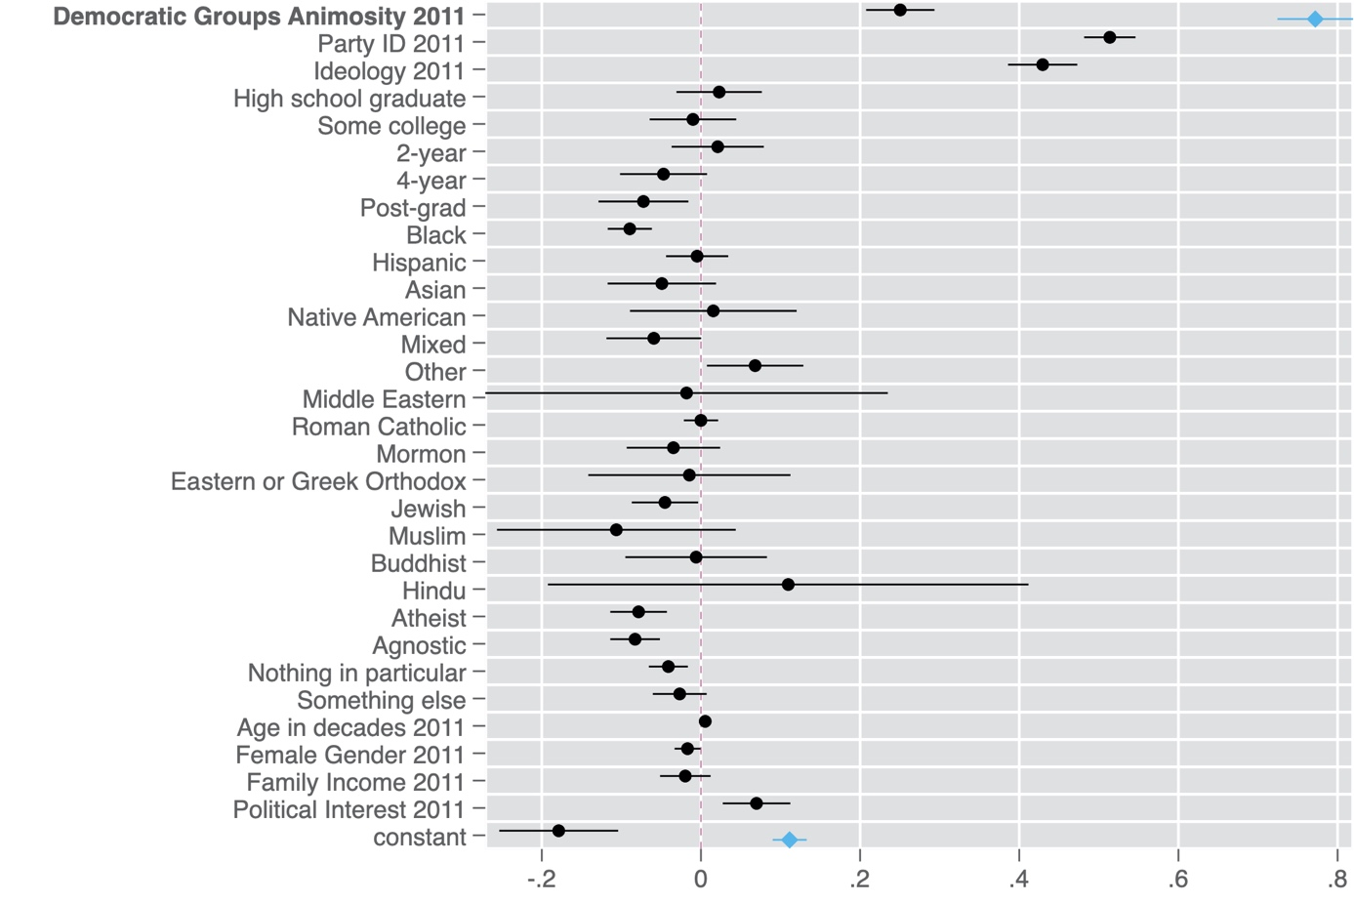

Note: Points are OLS regression coefficients. 95 percent confidence intervals shown by horizontal lines. Blue diamonds are estimates from the bivariate model, while black dots are estimates from the full model. All variables coded to range from 0 to 1. The dependent variable is Trump Approval in 2017. Bivariate model: N=5,961, R-squared = 0.13. Full model: N=5,770. R-squared=0.54.

**Figure A1b. Trump Favorability 2017**

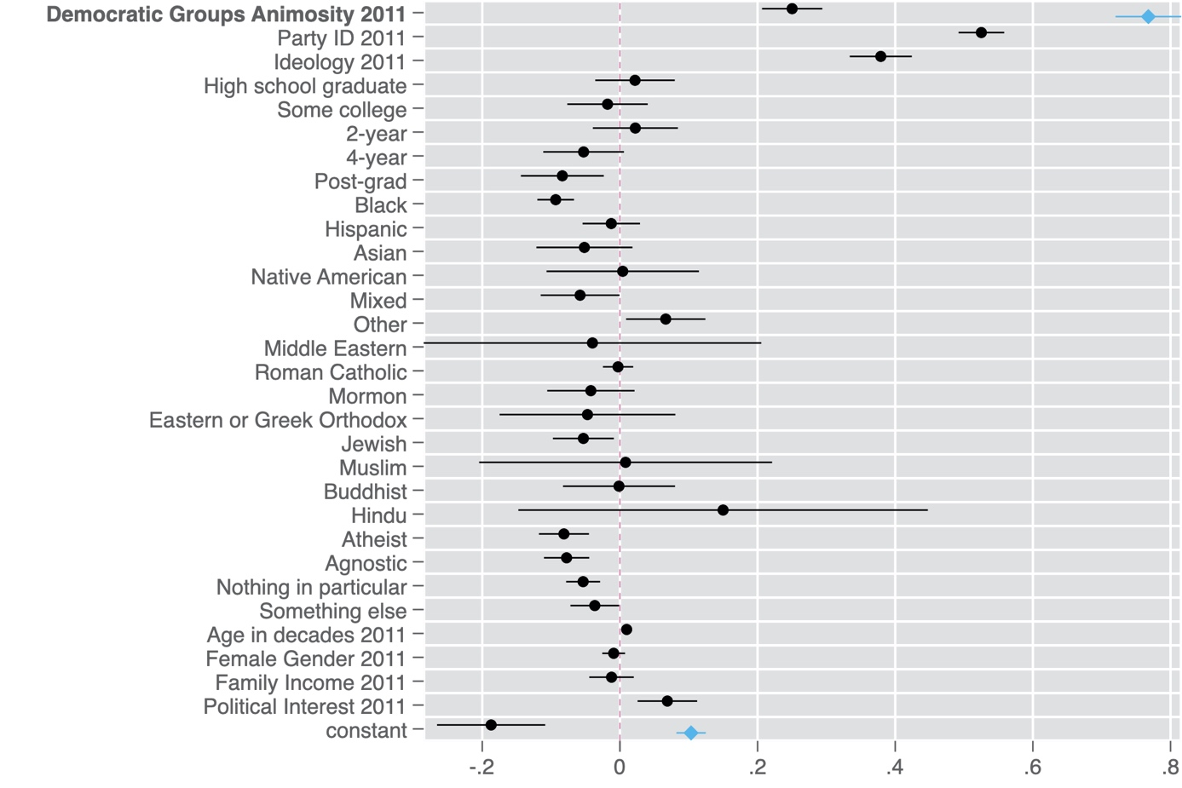

Note: Points are OLS regression coefficients. 95 percent confidence intervals shown by horizontal lines. Blue diamonds are estimates from the bivariate model, while black dots are estimates from the full model. All variables coded to range from 0 to 1. The dependent variable is Trump Favorability in 2017. Bivariate model: N=5,866, R-squared = 0.13. Full model: N=5,680. R-squared=0.52.

**Figure A1c. Trump Approval 2018**

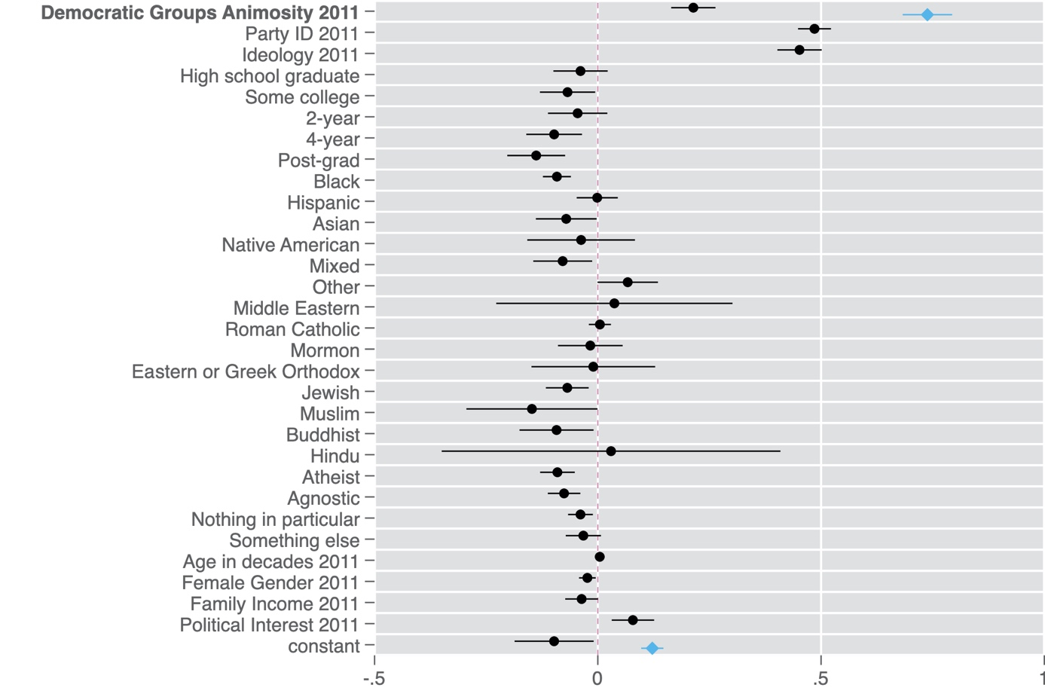

Note: Points are OLS regression coefficients. 95 percent confidence intervals shown by horizontal lines. Blue diamonds are estimates from the bivariate model, while black dots are estimates from the full model. All variables coded to range from 0 to 1. The dependent variable is Trump Approval in 2018. Bivariate model: N=4,528, R-squared = 0.12. Full model: N=4,378. R-squared=0.53.

**Figure A1d. Trump Favorability 2018**

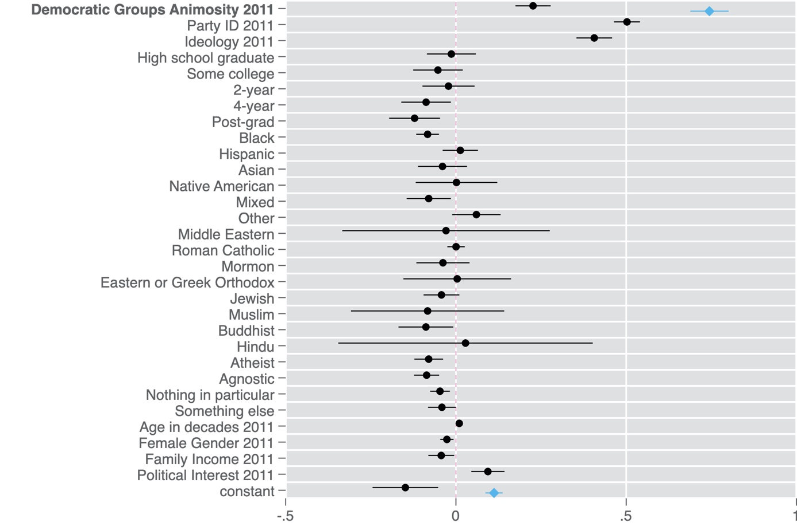

Note: Points are OLS regression coefficients. 95 percent confidence intervals shown by horizontal lines. Blue diamonds are estimates from the bivariate model, while black dots are estimates from the full model. All variables coded to range from 0 to 1. The dependent variable is Trump Favorability in 2018. Bivariate model: N=4,526, R-squared = 0.12. Full model: N=4,378. R-squared=0.51.

**Figure A2. Democratic Group Animosity and Republican Party/Elite Support**

**Figure A2a. Paul Ryan Favorability 2018**

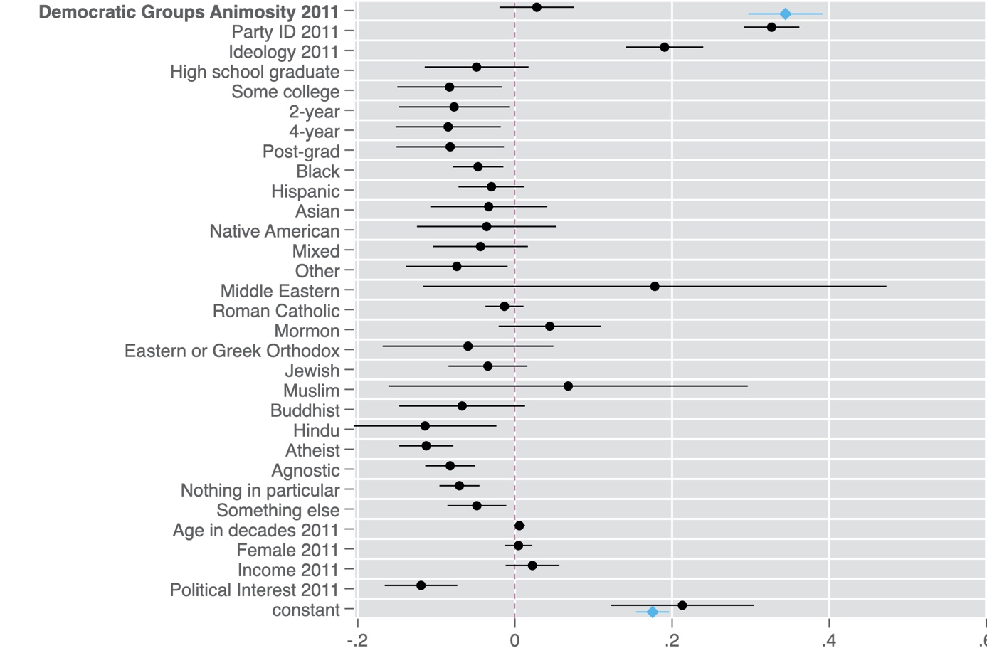

Note: Points are OLS regression coefficients. 95 percent confidence intervals shown by horizontal lines. Blue diamonds are estimates from the bivariate model, while black dots are estimates from the full model. All variables coded to range from 0 to 1. The dependent variable is Paul Ryan Favorability in 2018. Bivariate model: N=4,307, R-squared = 0.05. Full model: N=4,167. R-squared=0.30.

**Figure A2b. Mitch McConnell Favorability 2018**

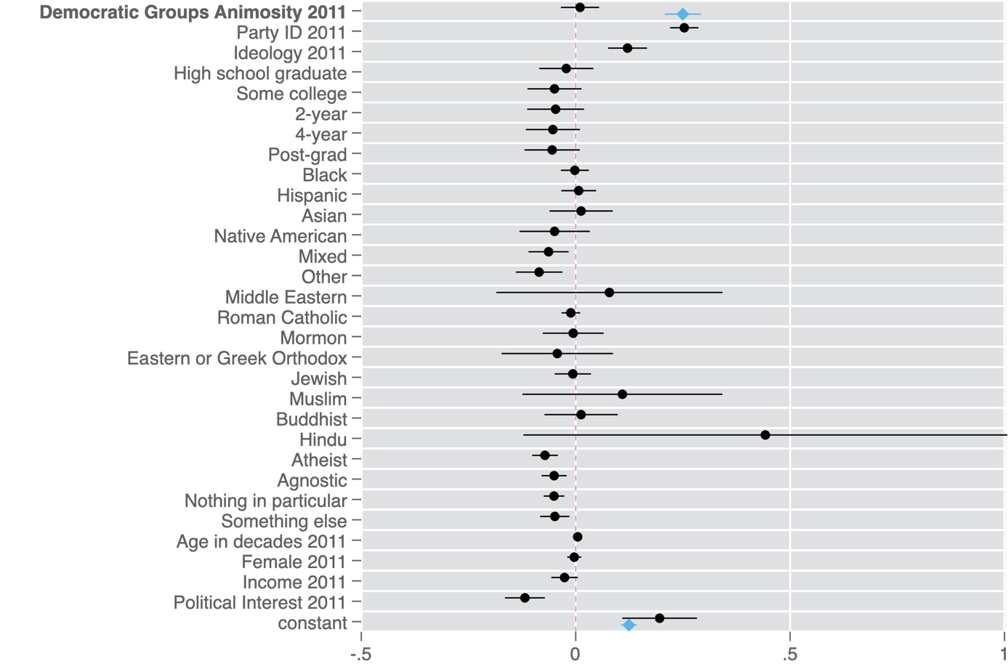

Note: Points are OLS regression coefficients. 95 percent confidence intervals shown by horizontal lines. Blue diamonds are estimates from the bivariate model, while black dots are estimates from the full model. All variables coded to range from 0 to 1. The dependent variable is Mitch McConnell Favorability in 2018. Bivariate model: N=3,970, R-squared = 0.04. Full model: N=3,845. R-squared=0.22.

**Figure A2c. Republican Party Favorability 2017**

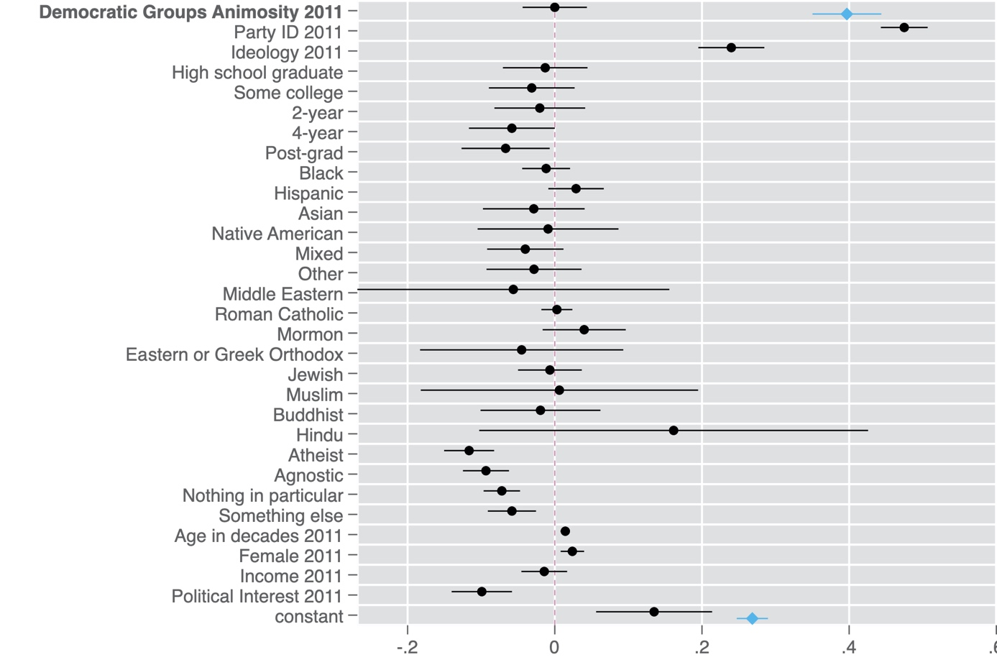

Note: Points are OLS regression coefficients. 95 percent confidence intervals shown by horizontal lines. Blue diamonds are estimates from the bivariate model, while black dots are estimates from the full model. All variables coded to range from 0 to 1. The dependent variable is Republican Party Feeling Thermometer in 2017. Bivariate model: N=5,531, R-squared = 0.05. Full model: N=5,359. R-squared=0.41.

**Figure A2d. Bernie Sanders Favorability 2018**

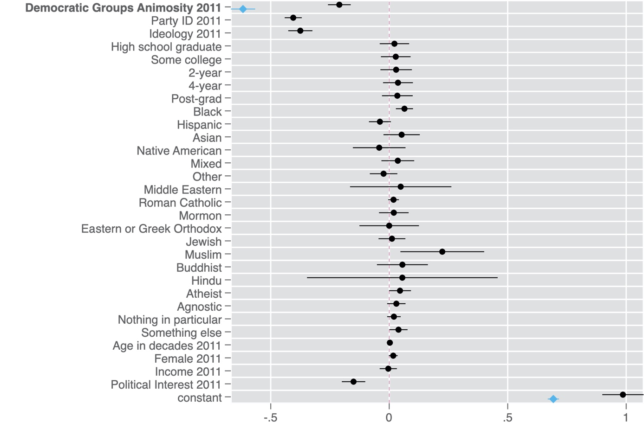

Note: Points are OLS regression coefficients. 95 percent confidence intervals shown by horizontal lines. Blue diamonds are estimates from the bivariate model, while black dots are estimates from the full model. All variables coded to range from 0 to 1. The dependent variable is Bernie Sanders Favorability in 2018. Bivariate model: N=4,421, R-squared = 0.11. Full model: N=4,277. R-squared=0.45.

**Figure A3. Trump Support and Animus toward Democratic Groups by Party**

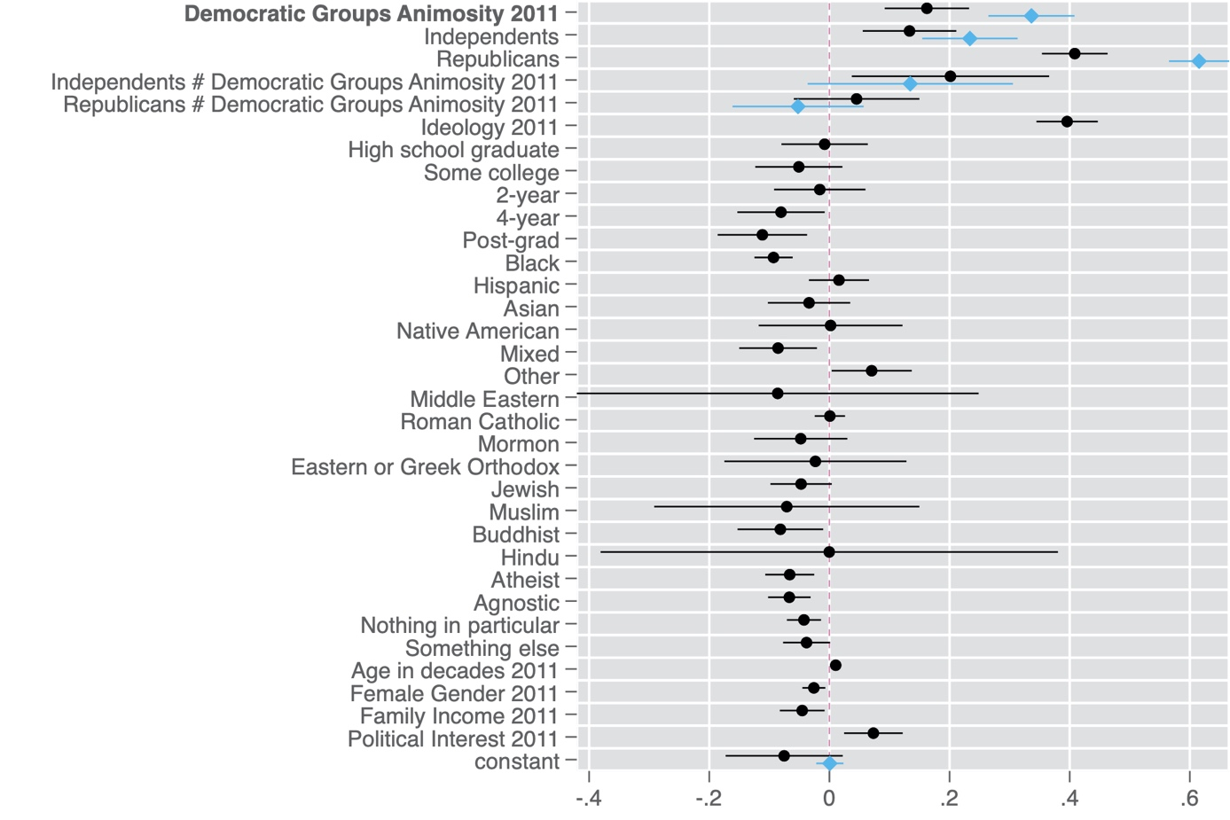

Note: Points are OLS regression coefficients. 95 percent confidence intervals shown by horizontal lines. Blue diamonds are estimates from the interaction model without controls, while black dots are estimates from the full model. All variables coded to range from 0 to 1. The dependent variable is Trump Favorability in 2018. Simple model: N=4,473, R-squared = 0.47. Full model: N=4,378. R-squared=0.53.

**Figure A4. Republican Group Animosity and Democratic Party and Elite Support**

**Figure A4a. Hillary Clinton Favorability 2018**

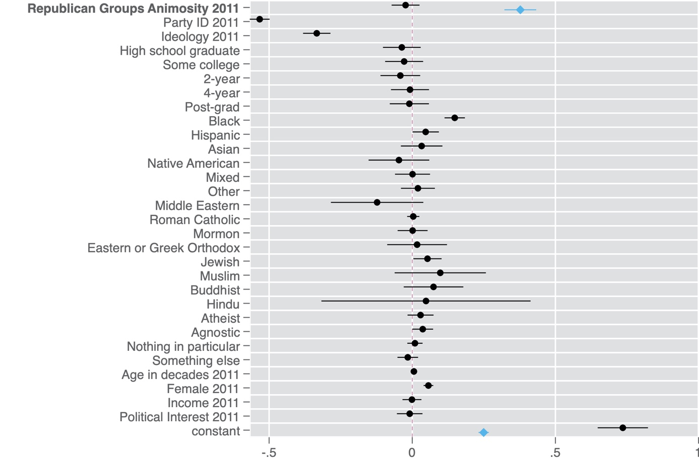

Note: Points are OLS regression coefficients. 95 percent confidence intervals shown by horizontal lines. Blue diamonds are estimates from the bivariate model, while black dots are estimates from the full model. All variables coded to range from 0 to 1. The dependent variable is Hillary Clinton Favorability in 2018. Bivariate model: N=4,519, R-squared = 0.04. Full model: N=4,371. R-squared=0.52.

**Figure A4b. Bernie Sanders Favorability 2018**

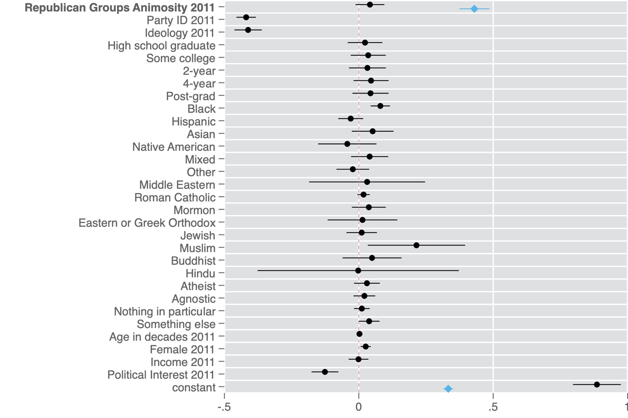

Note: Points are OLS regression coefficients. 95 percent confidence intervals shown by horizontal lines. Blue diamonds are estimates from the bivariate model, while black dots are estimates from the full model. All variables coded to range from 0 to 1. The dependent variable is Bernie Sanders Favorability in 2018. Bivariate model: N=4,409, R-squared = 0.05. Full model: N=4,264. R-squared=0.44.

**Figure A4c. Nancy Pelosi Favorability 2018**

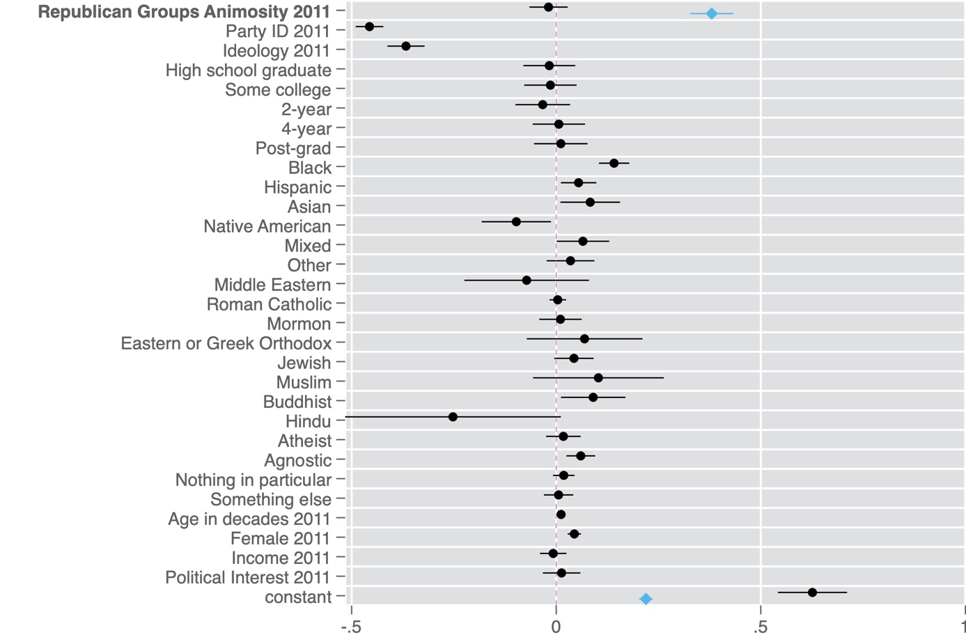

Note: Points are OLS regression coefficients. 95 percent confidence intervals shown by horizontal lines. Blue diamonds are estimates from the bivariate model, while black dots are estimates from the full model. All variables coded to range from 0 to 1. The dependent variable is Nancy Pelosi Favorability in 2018. Bivariate model: N=4,316, R-squared = 0.04. Full model: N=4,175. R-squared=0.52.

**Figure A4d. Chuck Schumer Favorability 2018**

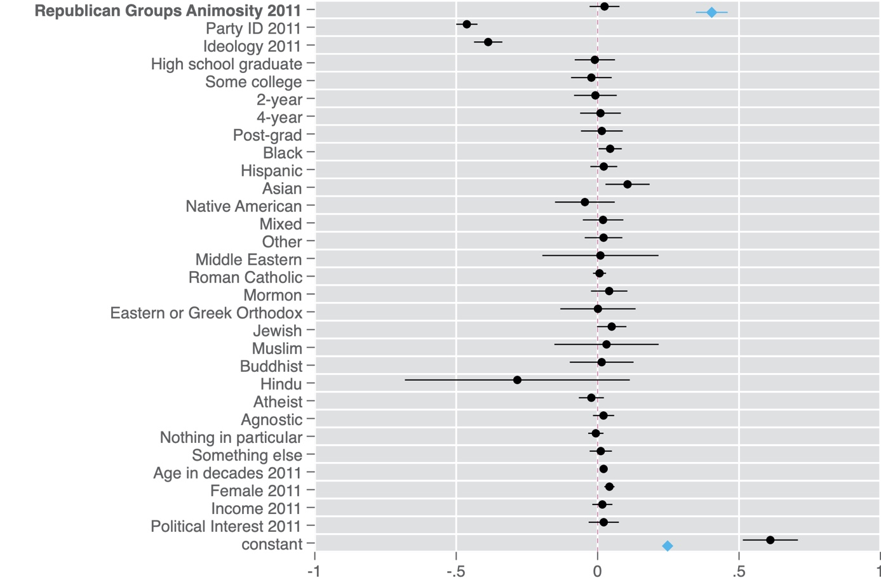

Note: Points are OLS regression coefficients. 95 percent confidence intervals shown by horizontal lines. Blue diamonds are estimates from the bivariate model, while black dots are estimates from the full model. All variables coded to range from 0 to 1. The dependent variable is Chuck Schumer Favorability in 2018. Bivariate model: N=3,813, R-squared = 0.05. Full model: N=3.696, R-squared=0.49.

**Figure A4e. Democratic Party Favorability 2017**

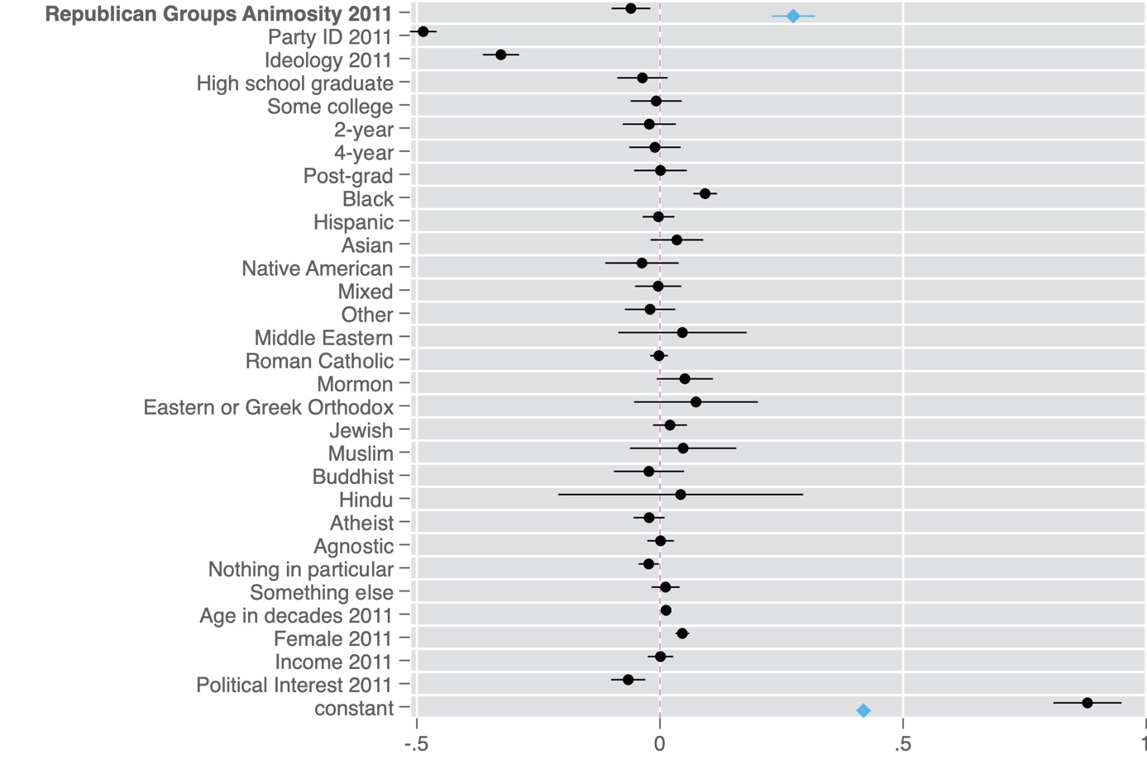

Note: Points are OLS regression coefficients. 95 percent confidence intervals shown by horizontal lines. Blue diamonds are estimates from the bivariate model, while black dots are estimates from the full model. All variables coded to range from 0 to 1. The dependent variable is Democratic Party Feeling Thermometer in 2017. Bivariate model: N=5,540, R-squared = 0.02. Full model: N=5,365. R-squared=0.52.

**Figure A5. Non-linear relationship between Trump Support and Animus toward Democratic Groups**

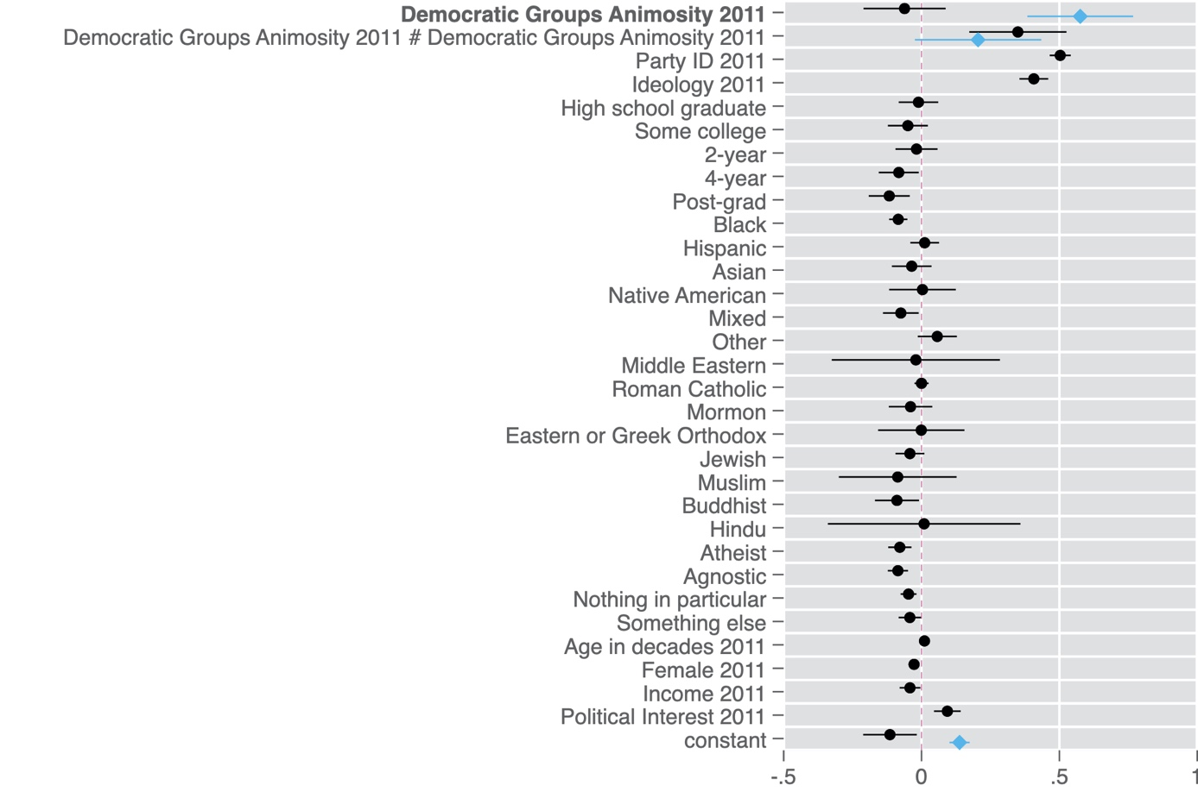

Note: Points are OLS regression coefficients. 95 percent confidence intervals shown by horizontal lines. Blue diamonds are estimates from the quadratic model without controls, while black dots are estimates from the full model. All variables coded to range from 0 to 1. The dependent variable is Trump Favorability in 2018. Simple model: N=4,526, R-squared = 0.12. Full model: N=4,378. R-squared=0.51.

**Figure A6. Trump Support and Animus toward Each Democratic Group**

**Figure A6a. Black Americans -Linear**

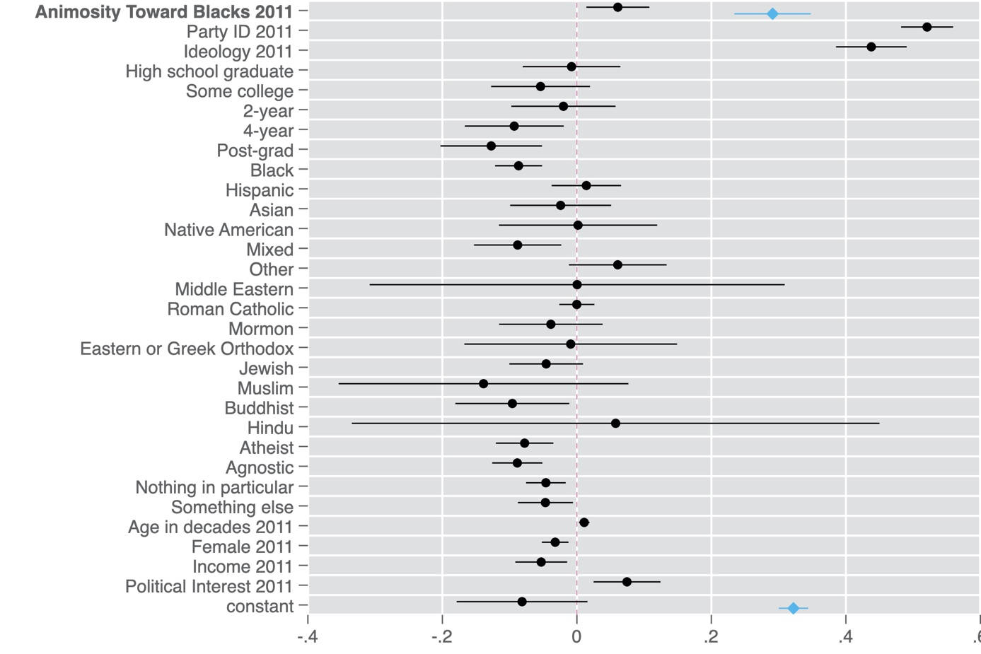

Note: Points are OLS regression coefficients. 95 percent confidence intervals shown by horizontal lines. Blue diamonds are estimates from the bivariate model, while black dots are estimates from the full model. All variables coded to range from 0 to 1. The dependent variable is Trump Favorability in 2018. Bivariate model: N=4,441, R-squared = 0.02. Full model: N=4,296. R-squared=0.50.

**Figure A6b. Black Americans -Non-linear**

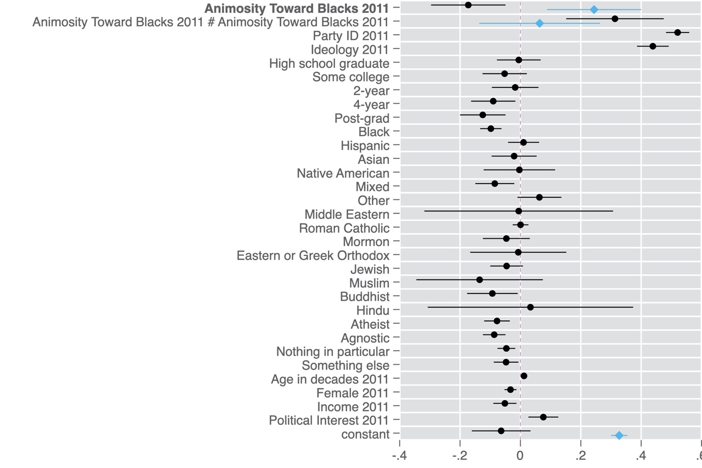

Note: Points are OLS regression coefficients. 95 percent confidence intervals shown by horizontal lines. Blue diamonds are estimates from the quadratic model without controls, while black dots are estimates from the full model. All variables coded to range from 0 to 1. The dependent variable is Trump Favorability in 2018. Simple model: N=4,441, R-squared = 0.02. Full model: N=4,296. R-squared=0.50.

**Figure A6c. Hispanics – Linear**

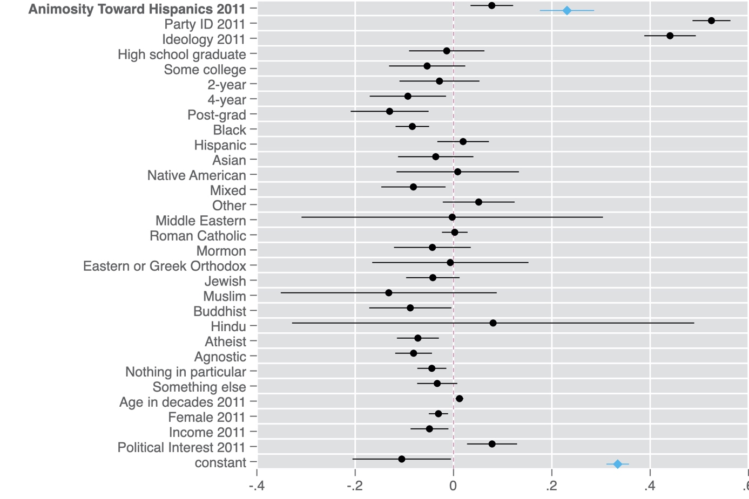

Note: Points are OLS regression coefficients. 95 percent confidence intervals shown by horizontal lines. Blue diamonds are estimates from the bivariate model, while black dots are estimates from the full model. All variables coded to range from 0 to 1. The dependent variable is Trump Favorability in 2018. Bivariate model: N=4,386, R-squared = 0.02. Full model: N=4,244. R-squared=0.50.

**Figure A6d. Hispanics – Non-linear**

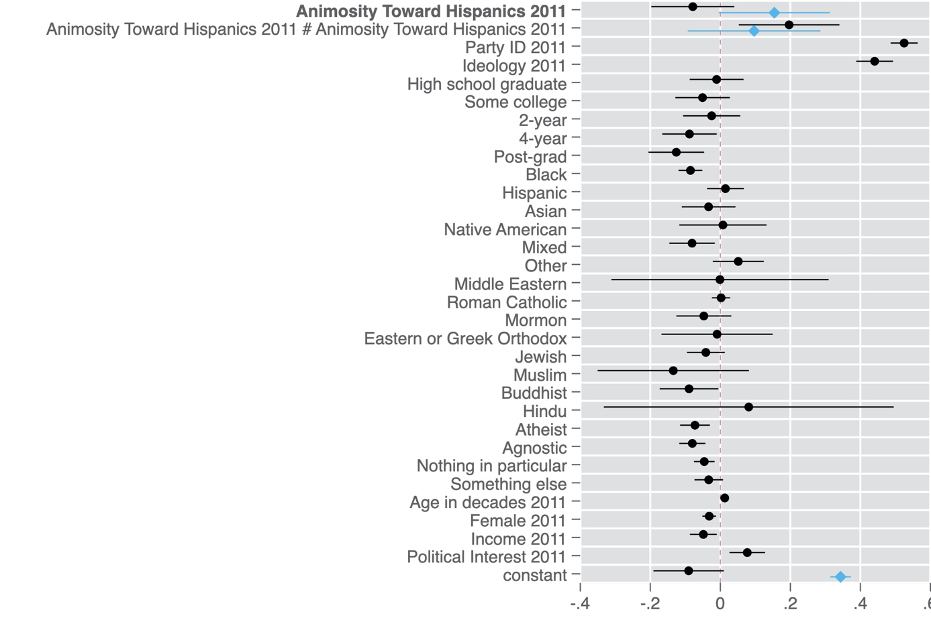

Note: Points are OLS regression coefficients. 95 percent confidence intervals shown by horizontal lines. Blue diamonds are estimates from the quadratic model without controls, while black dots are estimates from the full model. All variables coded to range from 0 to 1. The dependent variable is Trump Favorability in 2018. Simple model: N=4,386, R-squared = 0.02. Full model: N=4,244. R-squared=0.51.

**Figure A6e. Muslims – Linear**

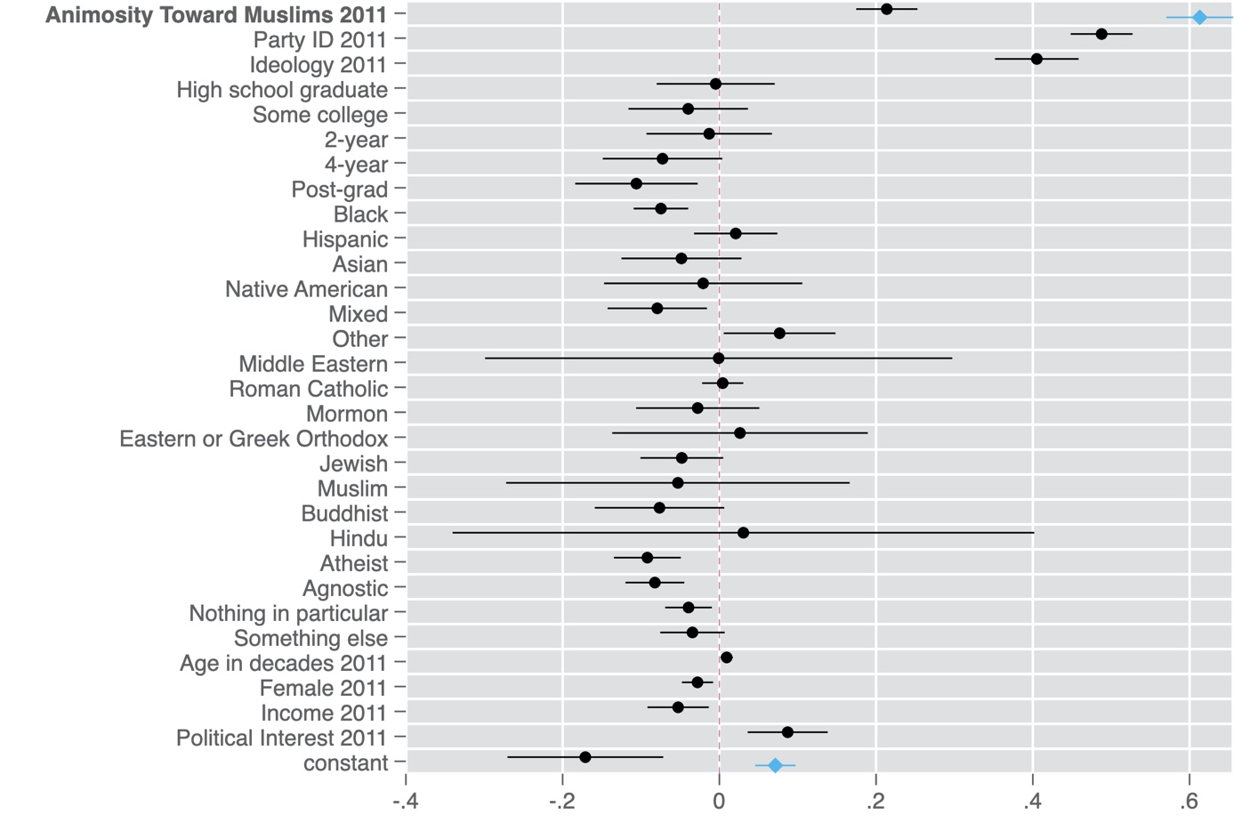

Note: Points are OLS regression coefficients. 95 percent confidence intervals shown by horizontal lines. Blue diamonds are estimates from the bivariate model, while black dots are estimates from the full model. All variables coded to range from 0 to 1. The dependent variable is Trump Favorability in 2018. Bivariate model: N=4,203, R-squared = 0.15. Full model: N=4,071. R-squared=0.51.

**Figure A6f. Muslims – Non-linear**

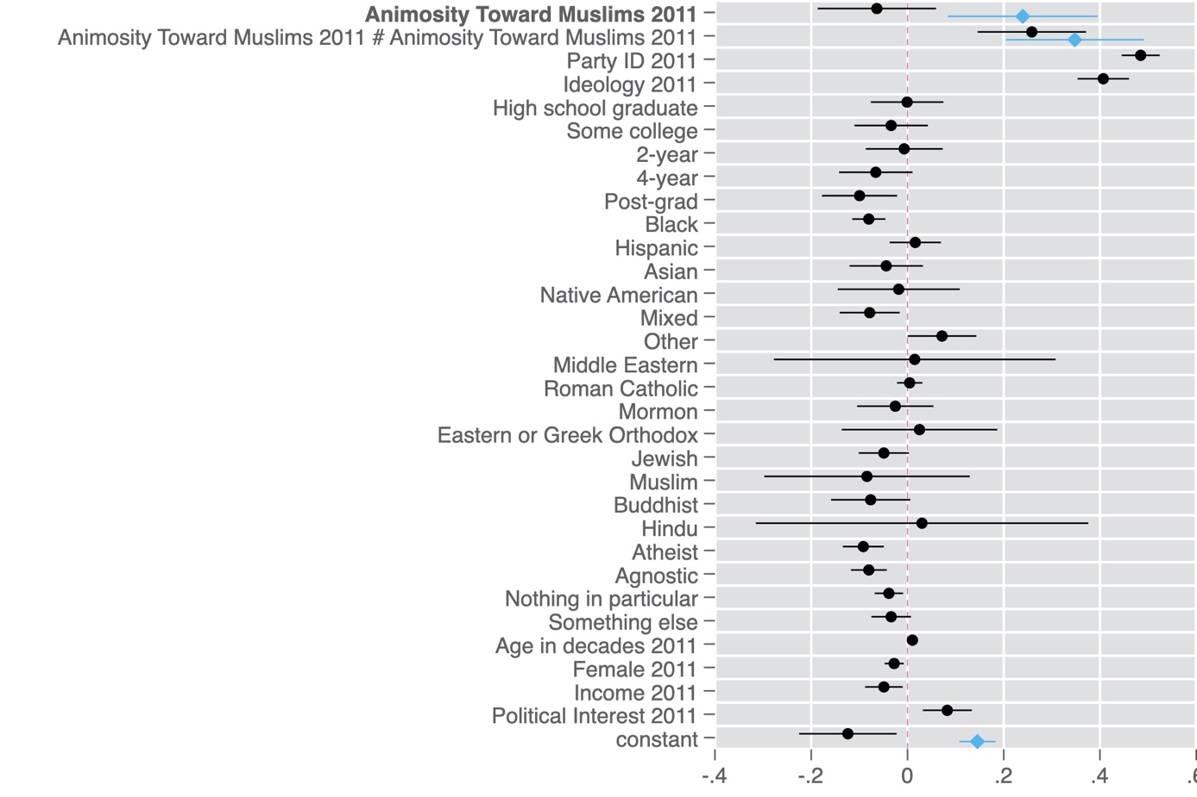

Note: Points are OLS regression coefficients. 95 percent confidence intervals shown by horizontal lines. Blue diamonds are estimates from the quadratic model without controls, while black dots are estimates from the full model. All variables coded to range from 0 to 1. The dependent variable is Trump Favorability in 2018. Simple model: N=4,203, R-squared = 0.15. Full model: N=4,071. R-squared=0.52.

**Figure A6g. Gays and Lesbians – Linear**

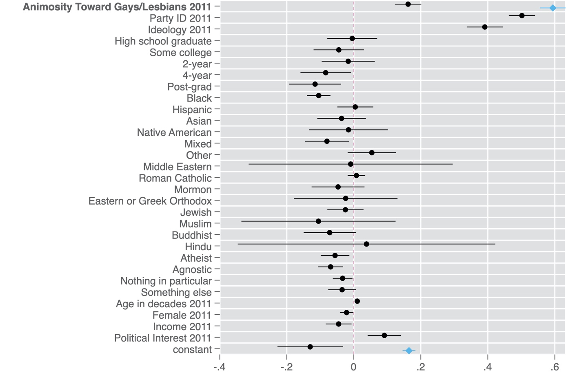

Note: Points are OLS regression coefficients. 95 percent confidence intervals shown by horizontal lines. Blue diamonds are estimates from the bivariate model, while black dots are estimates from the full model. All variables coded to range from 0 to 1. The dependent variable is Trump Favorability in 2018. Bivariate model: N=4,362, R-squared = 0.16. Full model: N=4,221. R-squared=0.51.

**Figure A6h. Gays and Lesbians – Non-linear**

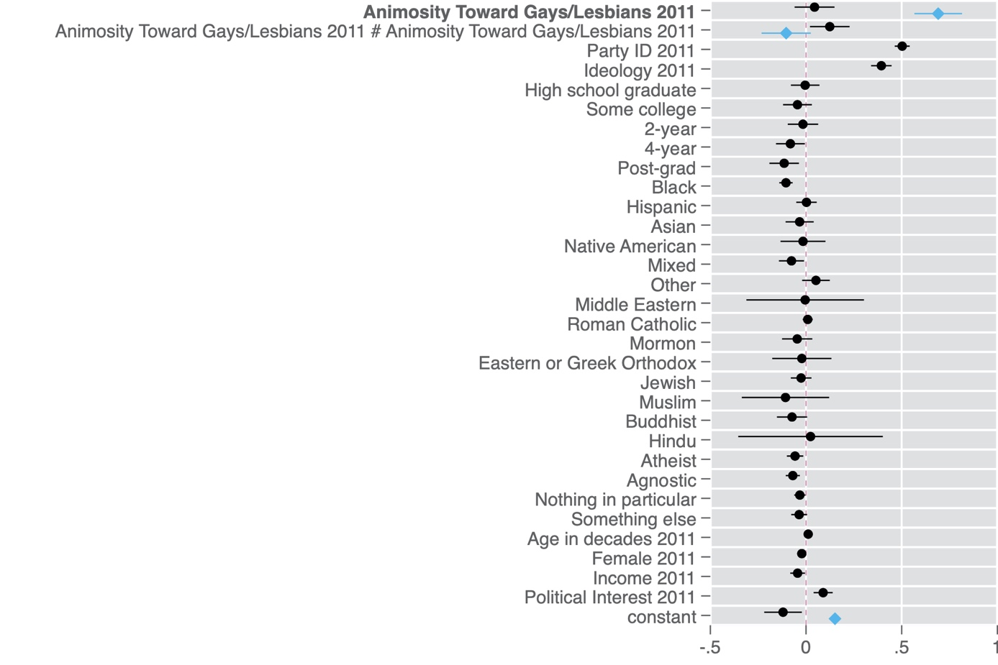

Note: Points are OLS regression coefficients. 95 percent confidence intervals shown by horizontal lines. Blue diamonds are estimates from the quadratic model without controls, while black dots are estimates from the full model. All variables coded to range from 0 to 1. The dependent variable is Trump Favorability in 2018. Simple model: N=4,362, R-squared = 0.16. Full model: N=4,221. R-squared=0.51.

**Figure B. Party-Specific Effects by Democratic Sub-Group.**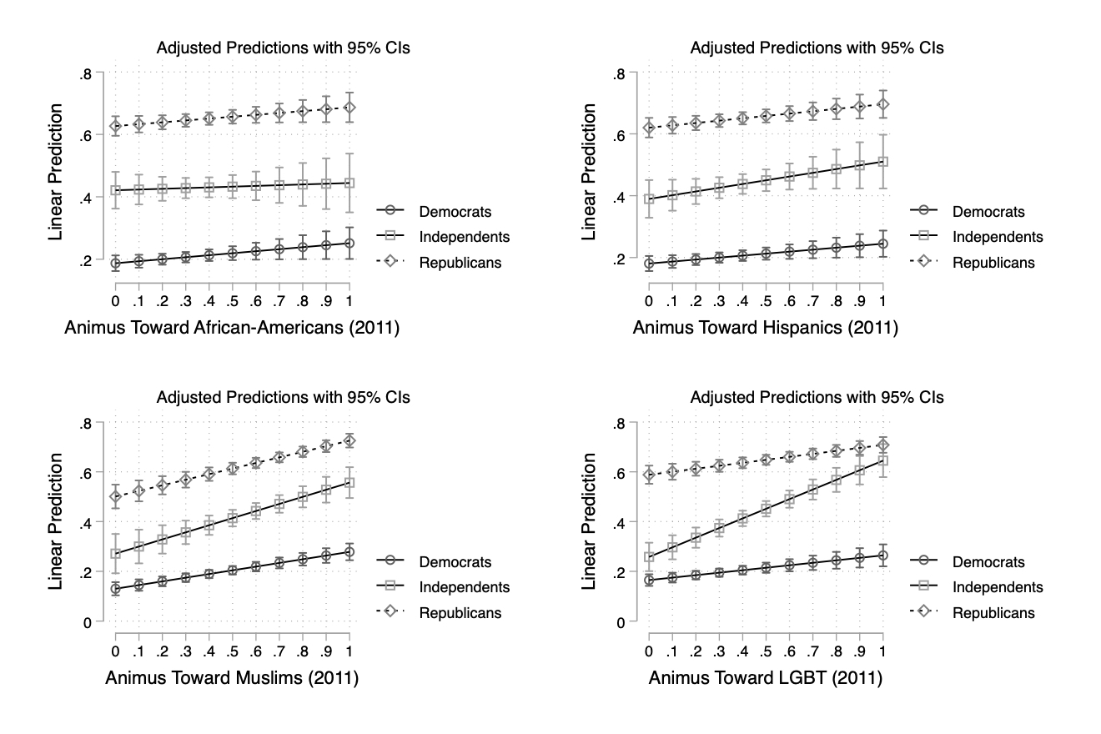

Note: Predicted values from OLS models controlling for ideology, education, race, religion, age, gender, income, and political interest, and interacting party with group animus. Animus toward each group is the feeling thermometer score for African-Americans, Hispanics, Muslims, and LGBT, coded to indicate less warmth.

**Figure C1. Democratic Groups Animus & Trump Favorability, 2016 versus 2018 (Linear)**



**Figure C2. Democratic Groups Animus & Trump Favorability, 2016 versus 2018 (Non-Linear)**Note: Points are OLS regression coefficients. 95 percent confidence intervals shown by horizontal lines (robust SEs). Estimates in blue (black) specify Trump favorability in 2016 (2018) as the dependent variable. Bottom panel features a squared transformation of the *Democratic Group Animus* variable to allow for non-linear effects. All variables coded to range from 0 to 1. 2016 model: N=7,568, R-squared = 0.51. 2018 model: N=4,378. R-squared=0.51.

**Table A1. Group Animus Items and Scale Correlations**

**Pairwise correlations**

|  |  |  |  |  |  |  |  |  |  |  |
| --- | --- | --- | --- | --- | --- | --- | --- | --- | --- | --- |
|  | (1) | (2) | (3) | (4) | (5) | (6) | (7) | (8) | (9) | (10) |
| (1) Democratic Groups | 1.000 |
| (2)Republican Groups | 0.184* | 1.000 |
| (3)Blacks | 0.769* | 0.345* | 1.000 |
| (4)Hispanics | 0.780* | 0.319* | 0.622* | 1.000 |
| (5)Muslims | 0.814* | 0.041* | 0.482* | 0.496* | 1.000 |
| (6)Gays & Lesbians | 0.767* | -0.063* | 0.376* | 0.386* | 0.523* | 1.000 |
| (7)Whites | -0.279* | -0.812* | -0.343* | -0.342* | -0.096* | -0.140* | 1.000 |
| (8)Christians | -0.064* | -0.897* | -0.262* | -0.221* | 0.014 | 0.203* | 0.460* | 1.000 |
| (9)2011 Party ID | 0.311* | -0.257* | 0.166* | 0.098* | 0.340* | 0.358* | 0.127* | 0.298* | 1.000 |
| (10)2011 Ideology | 0.340* | -0.317* | 0.128* | 0.107* | 0.354* | 0.449* | 0.125* | 0.393* | 0.679* | 1.000 |
|  | | | | | | | | | | |
| * shows significance at the .05 level | | | | | | | | | | |