Online Appendix: “When are legislators responsive to ethnic minorities? Testing the role of electoral incentives and candidate selection for mitigating ethnocentric responsiveness”

December 2, 2020

List of contents for the appendix
Appendix A – Overview over data sources and variables 2
Appendix B – Aliases 8
Appendix C – Response time 9
Appendix D – Quality measures 10
Appendix E – Details on simulation of electoral closeness 11
Appendix F – Distribution of immigration/integration policy measure 12
Appendix G – Comparison of samples 13
Appendix H – Effect of the gender cue 14
Appendix I – Are the treatments perceived as realistic? 15
Appendix J – ATE across municipality size 16
Appendix K – Electoral incentives and responsiveness 17
Appendix L – Further analyses of interactions between Voting cue and Minority Alias 19
Appendix M – Comparison of ethnocentric responsiveness/majority favoritism between parties 20
Appendix N – ATE across parties including controls 21
Appendix O – Interactions with and without party FE 23
Appendix P – Interactions between ethnic cue and policy stances 24
References 25

Appendix A – Overview over data sources and variables
Data sources
The primary data source of the study is a field experimental audit study among incumbent legislators before the 2017 municipal election (i.e. incumbents elected in the 2013 municipal election). The experiment involved sending a request to all incumbent politicians (including both politicians with a leave of absence and alternates – both of which plausibly had a reason to respond) with a publicly available email address (taken from the municipalities’ websites). 50 randomly selected incumbents (non-mayors) were used for a pilot test of the phrasing of the request (not the experimental variations). These were not included in the final sample. A few incumbents, for whom the email address turned out to be invalid, were also excluded from the sample. The final overall sample consists of 2,395 incumbents. Of these, 2,326 are majority legislators (another primary sample).
The incumbent data from the audit study was linked to results from a voting advice application (“Kandidattest”)—published by the Danish Broadcasting Corporation (DR)—in which candidates responded to 15 different policy questions in order to facilitate voters’ choice of a candidate. 1,522 majority incumbents running for reelection providing valid answers to the two questions on immigration/integration that form the basis of the sample in the analyses of candidate positions as heuristics for identifying responsive legislators (which is then reduced in subsequent analyses).
Additionally, data for incumbents’ (rerunning for office) electoral performance in 2013 and in 2017 was merged with data from the audit study to gauge ethnocentric responsiveness under various levels of closeness in the elections. These data were simulations (see Appendix E) based on electoral data from The Danish Election Database (https://valgdatabase.dst.dk/?lang=en).
We also linked biographical data to the legislators as well as information about their parties. These data were retrieved through publicly available information (names of legislators, parties’ electoral methods etc.) coded by us. Lastly, we used sociodemographic information about incumbents’ municipalities in some analyses.
Table A.1 below outlines details about the variables used in the analyses, including descriptive statistics.

Table A.1: Overview of the variables used in the analyses, including descriptive statistics.
Variable | Function | Coding and remarks | Mean/Std. Dev. (number of obs.) | Source
Legislator response | Outcome variable in primary analyses | 0 = no response,  1 = response | 0.628/0.483ª | Audit study on legislator responsiveness.
Constituent’s ethnic affiliation | Experimental treatment in primary analyses | Treatment embedded in constituent request in terms of name of the constituent (see Appendix B)  0 = native Danish (ethnic majority) alias;  1 = immigrant (ethnic minority) alias. | 0.499/0.500ª | Audit study on legislator responsiveness.
Vote cue | Experimental  treatment in primary analyses. | Treatment embedded in terms of cue in the constituent request.  0 = statement “I am looking for information regarding where my polling station for the municipal election is located”  1 = statement “I expect to vote for you once again in the municipal election” included in the legislator request | 0.500/0.500ª | Audit study on legislator responsiveness.
Constituent’s gender | Experimental treatment not used in primary analyses, but see Appendix I. | Treatment embedded in constituent request in terms of name of the constituent (see Appendix A)  0 = male alias,  1 = female alias | 0.496/0.500ª | Audit study on legislator responsiveness.
Seeking reelection | Moderator used to define sample in analyses reported in Table 2 (column 2 and 3) as well as in auxiliary analyses (Appendix L) | Dummy indicating if a legislator stands for reelection in the 2017 election.  0 = does not seek reelection,  1 = does seek reelection | 0.830/0.376^{b} | Auxiliary information collected by the authors.
Vote margin 2013 | Moderator used to define sample in analyses reported in Table 2 (column 3) as well as in auxiliary analyses (Appendix L) | Dummy indicating if a legislator faced a close election in 2013 based on a simulation (see Appendix E).  0 = not clear winner,  1 = clear winner (winning all 1,000 simulated elections). | 0.646/0.478^{b}  (N = 2,324) | Auxiliary information collected by the authors.
Legislator ethnic background | Moderator used to examine how responsiveness toward ethnic minorities/majorities varies by ethnic background of the legislator in Table 1, column 2 and Figure 2. | Dummy indicating ethnic background of legislator based on their names as classified by two coders (See note 11 in the manuscript).  0 = Middle Eastern/North African (Arabic/Turkish) (minority),  1 = otherwise (majority) | 0.029/0.167ª | Auxiliary data collected by the authors.
Legislator’s gender | Moderator used in auxiliary analyses examining how responsiveness toward males and females vary by legislators’ gender (see Appendix H). | Dummy indicating gender of legislator based on their names.  0 = Male,  1 = Female | 0.296/0.456ª | Auxiliary data collected by the authors.
Legislator party affiliation | Moderator used to examine how responsiveness toward ethnic minorities varies by party affiliation of majority legislators | Parties  - Venstre (the Liberals) (V) (N = 724)  - Social democrats (A) (N = 697)  - Danish People’s Party (N = 219)  - Conservatives (C) (N = 195)  - The Red-Green Alliance (Ø) (N = 112)  - The Socialist People’s Party (SF) (N = 110)  - Social Liberals (R) (N = 63)  - Liberal Alliance (LA) (N = 42)  - Others (N = 164) | 0.311/0.463^{b}  0.300/0.458  0.094/0.292  0.084/0.277  0.048/0.214  0.047/0.212  0.027/0.162  0.018/0.133  0.071/0.256 | Auxiliary information collected by the authors.
Legislator stance on immigration/ethnic minorities | Moderator used in primary analyses to examine how responsiveness toward ethnic minorities varies by majority legislator stances on immigration/ethnic minorities | Composite measure based on of stances on  legislator positions on refugees and religious minorities (reversed) (see below).  The immigration/integration policy scale is coded to range from 0 (most negative) to 8 (most positive). | 4.352/2.390^{c} | Voting advice application
Legislator policy stance: Privatization | Moderator used in auxiliary analyses to examine how responsiveness toward ethnic minorities varies by majority legislator stances on other policy issues | Response to question:  “Private companies should be in charge of a larger part of the elderly care” (Q1)  Measured on a 5-point Likert scale from “Completely disagree” (1) to “Completely agree” (5) | 2.256/1.331^{c} | Voting advice application
Legislator policy stance: Volunteers | Moderator used in auxiliary analyses to examine how responsiveness toward ethnic minorities varies by majority legislator stances on other policy issues | Response to question:  “Municipalities should involve volunteers to help employees at nursing homes” (Q2)  Measured on a 5-point Likert scale from “Completely disagree” (1) to “Completely agree” (5) | 2.601/1.331^{c} | Voting advice application
Legislator policy stance: Taxes | Moderator used in auxiliary analyses to examine how responsiveness toward ethnic minorities varies by majority legislator stances on other policy issues | Response to question:  “The municipality should lower taxes” (Q3)  Measured on a 5-point Likert scale from “Completely disagree” (1) to “Completely agree” (5) | 2.599/1.500^{c} | Voting advice application
Legislator policy stance: Welfare services | Moderator used in auxiliary analyses to examine how responsiveness toward ethnic minorities varies by majority legislator stances on other policy issues | Response to question:  “The municipality can save money without a decrease in welfare services” (Q4)  Measured on a 5-point Likert scale from “Completely disagree” (1) to “Completely agree” (5) | 3.195/1.474^{c} | Voting advice application
Legislator policy stance: Schools I | Moderator used in auxiliary analyses to examine how responsiveness toward ethnic minorities varies by majority legislator stances on other policy issues | Response to question:  “The municipality should ensure socially diverse schools” (Q5)  Measured on a 5-point Likert scale from “Completely disagree” (1) to “Completely agree” (5) | 3.911/1.161^{c} | Voting advice application
Legislator policy stance: Kindergartens | Moderator used in auxiliary analyses to examine how responsiveness toward ethnic minorities varies by majority legislator stances on other policy issues | Response to question:  “Municipalities should set a cap on the number of kids per pedagogue in kindergartens” (Q6)  Measured on a 5-point Likert scale from “Completely disagree” (1) to “Completely agree” (5) | 3.940/1.236^{c} | Voting advice application
Legislator policy stance: Bicycle lanes | Moderator used in auxiliary analyses to examine how responsiveness toward ethnic minorities varies by majority legislator stances on other policy issues | Response to question:  “The municipality should spend more money on bicycle lanes” (Q7)  Measured on a 5-point Likert scale from “Completely disagree” (1) to “Completely agree” (5) | 4.184/0.972^{c} | Voting advice application
Legislator policy stance: Refugees | Moderator used in primary analyses as part of the composite measure of majority legislators’ stance on immigration/ethnic minorities (see above) | Response to question:  “The municipality should accept more refugees” (Q8)  Measured on a 5-point Likert scale from “Completely disagree” (1) to “Completely agree” (5) | 2.825/1.346^{c} | Voting advice application
Legislator policy stance: Religious minorities | Moderator used in primary analyses as part of the composite measure of majority legislators’ stance on immigration/ethnic minorities (see above) | Response to question:  “Local municipal institutions try too hard to accommodate religious minorities” (Q9)  Measured on a 5-point Likert scale from “Completely disagree” (1) to “Completely agree” (5) | 2.473/1.358^{c} | Voting advice application
Legislator policy stance: Libraries and cultural institutions | Moderator used in auxiliary analyses to examine how responsiveness toward ethnic minorities varies by majority legislator stances on other policy issues | Response to question:  “The municipality spends too much on libraries and cultural institutions” (Q10)  Measured on a 5-point Likert scale from “Completely disagree” (1) to “Completely agree” (5) | 1.998/1.113^{c} | Voting advice application
Legislator policy stance: Nursing homes | Moderator used in auxiliary analyses to examine how responsiveness toward ethnic minorities varies by majority legislator stances on other policy issues | Response to question:  “Elderly people who can afford it should be able to choose additional services at nursing homes” (Q11)  Measured on a 5-point Likert scale from “Completely disagree” (1) to “Completely agree” (5) | 3.468/1.410^{c} | Voting advice application
Legislator policy stance: Thrash and recycling | Moderator used in auxiliary analyses to examine how responsiveness toward ethnic minorities varies by majority legislator stances on other policy issues | Response to question:  “The municipalities should spend more on sorting and reusing trash” (Q12)  Measured on a 5-point Likert scale from “Completely disagree” (1) to “Completely agree” (5) | 4.233/1.003^{c} | Voting advice application
Legislator policy stance: Unemployed | Moderator used in auxiliary analyses to examine how responsiveness toward ethnic minorities varies by majority legislator stances on other policy issues | Response to question:  “The municipality should demand more from unemployed citizens” (Q13)  Measured on a 5-point Likert scale from “Completely disagree” (1) to “Completely agree” (5) | 3.260/1.408^{c} | Voting advice application
Legislator policy stance: Schools II | Moderator used in auxiliary analyses to examine how responsiveness toward ethnic minorities varies by majority legislator stances on other policy issues | Response to question:  “Children spend too much time in schools” (Q14)  Measured on a 5-point Likert scale from “Completely disagree” (1) to “Completely agree” (5) | 3.499/1.265^{c} | Voting advice application
Legislator policy stance: Organic food | Moderator used in auxiliary analyses to examine how responsiveness toward ethnic minorities varies by majority legislator stances on other policy issues | Response to question:  “Public institutions should serve organic food” (Q15)  Measured on a 5-point Likert scale from “Completely disagree” (1) to “Completely agree” (5) | 2.794/1.469^{c} | Voting advice application
Open list | Moderator variable used to define sample in auxiliary analyses reported in Appendix L | Measure if the legislators’ party use an open-list system or not.  0 = Non-open list,  1 = Open list | 0.877/0.328^{b}  (N = 1,931)  (candidates rerunning in 2017) | Auxiliary information collected by the authors.
Municipal population size | Control variable | Average number of inhabitants in incumbents’ municipality as of the first quarter of 2016. Based on account “FOLK1C”. | 71,373/95,872ª | Statistikbanken (www.statistikbanken.dk)
Number of non-Western immigrants in incumbents’ municipality | Control variable used in auxiliary analyses reported in the Appendix. | Number of non-Western immigrants (see definition here: https://www.dst.dk/ext/6688068247/0/befolkning/Bilag-4-Notat-om-ny-landegruppering--pdf)) as of the first quarter of 2016. Based on account “FOLK1C”. | 4264/9486ª | Statistikbanken (www.statistikbanken.dk)
Number of descendants of non-Western immigrants in incumbents’ municipality | Control variable used in auxiliary analyses reported in the Appendix. | Number of descendants of non-Western immigrants (see definition here: https://www.dst.dk/ext/6688068247/0/befolkning/Bilag-4-Notat-om-ny-landegruppering--pdf) ) as of the first quarter of 2016. Based on account “FOLK1C”. | 1897/4693ª | Statistikbanken (www.statistikbanken.dk)
Municipal share of immigrant-origin minority inhabitants | Control variable used in auxiliary analyses reported in the Appendix. | Non-Western immigrants and descendants as share of the total population in the municipality as of the first quarter of 2016. Number of non-Western immigrants and descendants divided by the total number of inhabitants in the municipality (see above). | 6.707/4.665ª | Statistikbanken
Share of female incumbents in the municipality | Control variable used in auxiliary analyses reported in Appendix G. | Share of female incumbents in the municipality (based on the 2,395 incumbent legislators in the sample) | 0.296/0.096ª | Based on incumbents in city councils
Response content 1: Name greeting | Outcome variable in alternative models reported in Appendix D | 0 = not included,  1 = included | 0.577/0.494ª | Audit study on legislator responsiveness
Response content 2: Invitation to follow up | Dependent variable in alternative models reported in Appendix D | 0 = not included,  1 = included | 0.195/0.396ª | Audit study on legislator responsiveness
Response content 3: Answering the question | Dependent variable in alternative models reported in Appendix D | 0 = not included,  1 = included | 0.604/0.489ª | Audit study on legislator responsiveness
Response content 4: Sign-off | Dependent variable in alternative models reported in Appendix D | 0 = not included,  1 = included | 0.611/0.488ª | Audit study on legislator responsiveness
Response content 5: length of response | Dependent variable in alternative models reported in Appendix D | Number of words beside greeting and sign off | 22.625/27.055ª | Audit study on legislator responsiveness
Response content 6: Urge to remember to vote | Dependent variable in alternative models reported in Appendix D | 0 = not included,  1 = included | 0.079/0.270ª | Audit study on legislator responsiveness
Response content 7: Inclusion of a link or phone number to retrieve additional information | Dependent variable in alternative models reported in Appendix D | 0 = not included,  1 = included | 0.145/0.352ª | Audit study on legislator responsiveness
Vote margin 2017 | Moderator used to define sample in analyses reported in auxiliary analyses in Appendix L. | Dummy indicating if a legislator faced a close election in 2017 based on a simulation (see Appendix D).  0 = not clear winner,  1 = clear winner (winning all 1,000 simulated elections). | 0.601/0.490 ^{b}  (1,931) | Auxiliary information collected by the authors.
Note: Descriptive statistics are based on the following samples:
ª Full sample of legislators (N = 2,395, unless noted)
^{b} Full sample of majority legislators (N = 2,326, unless noted).
^{c} Sample of majority legislators that have valid values on the index tapping legislators’ stance on immigration/integration in the voting advice application (N = 1,516–1,522).

Appendix B – Aliases
This appendix provides an overview of the 20 aliases used as treatments in the field experiment in Table B.1 below. Each last name was paired with one male and one female first name. The names were chosen in order to resemble the most commonly used majority (Danish) and minority (Non-Western) names in Denmark. Average response rates to each name are reported in parentheses. F-tests for the hypothesis that response rates to senders across names are equivalent (tested for majority names and minority names separately) reveal no systematic differences (p-values of .65 and .48, respectively). As email-addresses, we used the treatment-name and a number (e.g. JensenAnne78@gmail.com, AishaAbdi78@gmail.com).
Table B.1: Response rates for different aliases
Majority alias |  |  |  |  | Minority alias
Male (response rate) |  |  | Female (response rate) |  | Male (response rate) |  |  | Female (response rate)
Peter Jensen | (0.68) |  | Anne Jensen | (0.70) | Mohammad Ibrahim | (0.54) |  | Hatice Ibrahim | (0.52)
Jens Nielsen | (0.69) |  | Kirsten Nielsen | (0.66) | Ahmad Omar | (0.50) |  | Fatma Omar | (0.58)
Michael Pedersen | (0.68) |  | Anna Pedersen | (0.69) | Mustafa Abdi | (0.58) |  | Aisha Abdi | (0.53)
Henrik Andersen | (0.71) |  | Hanne Andersen | (0.78) | Ali Mohamed | (0.48) |  | Amina Mohamed | (0.55)
Lars Hansen | (0.75) |  | Mette Hansen | (0.74) | Ibrahim Hussain | (0.63) |  | Fatima Hussain | (0.57)
H₀: |  | P = 0.65 |  |  |  |  | P = 0.49
Note: N (Majority alias) = 1,201; N (Minority alias) = 1,194

Appendix C – Response time
Figure C.1 shows the distribution of response time. Most responses arrived within the first five hours on the first day, and 96% of the responses arrived within three days.
Figure C.1: Response time
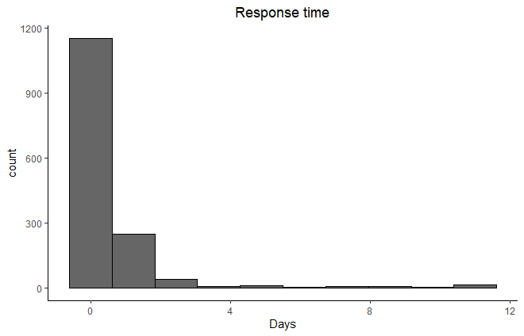
Note: Based on 1,504 responses.

Appendix D – Quality measures
In this appendix, we compare the quality of responses to majority and minority requesters using a number of outcomes. Following the convention in the literature, we code all non-replies as 0 to avoid post-treatment bias (Coppock, 2019; Kalla, Rosenbluth, and Teele, 2018). Inspired by the measure developed by Costa (2017), we assess the quality of the answers by relying on the following six content criteria: name greeting, invitation to follow up, answering the question, sign-off, length, inclusion of a link or phone number to retrieve additional information. We add an additional outcome by coding if politicians urged the requester to remember to vote at the election (or to vote immediately using the postal voting). Figure D.1 depicts the mean quality of replies by treatment condition for each of the criteria, with vertical lines representing 95% confidence intervals. We observe that when the requester holds a minority name, the replies are significantly shorter, less friendly (name greeting and sign off), less likely to provide a useful answer to the question (an answer and including a link/phone number), and less likely to include an invitation to follow up.
Figure D.1: Treatment effect of ethnic cue on qualitative response measures
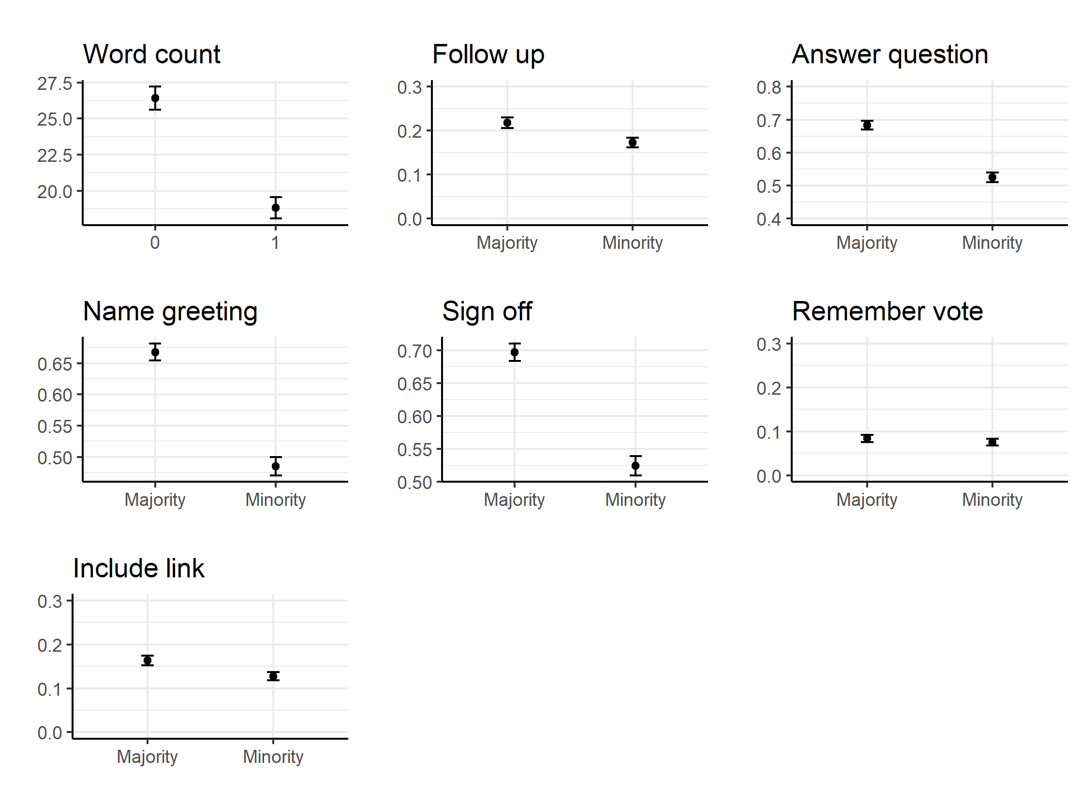
Note: Differences in responses to minority and majority aliases among all legislators (N = 2,395). All outcomes are dichotomous (included in response (1) or not (0)) except for “Word count”, which is the number of words in response (see Appendix A for details).

Appendix E – Details on simulation of electoral closeness
To measure individual candidates’ electoral competition in the Danish PR-system, we used a bootstrapping-method inspired by Kotakorpi, Poutvaara, and Terviö (2017) and Dahlgaard (2016). In short, we rely on the actual distribution of votes in the 2013 election to simulate a number of alternative realizations of the election outcome for each incumbent to retrieve a simulated distribution of how often candidates re-win a seat. The procedure is essentially to (i) sample with replacement a vector of votes from the election in each municipality and (ii) distribute votes to parties according to the votes in the sampled vector, before finally (iii) distributing seats to each candidate. In order to simulate uncertainty in who is elected, this process is repeated 1,000 times, which for each candidate creates a distribution of alternative election outcomes in which individual candidates are either elected or not. Hence, for each candidate we estimate the share of simulations where she or he is elected. Clear winners are elected in all simulated elections. Candidates who won (or lost) their seat with a small margin will be elected in fewer of the simulations. A majority of the incumbents are elected in all simulations, but a substantial share of candidates loses some of the simulated elections, thus indicating that they run in more competitive elections.

Appendix F – Distribution of immigration/integration policy measure
Figure F.1 depicts the distribution of ethnic majority incumbent candidates’ distribution on the index of immigration/integration stances based on the two questions concerning these issues (as used in the main paper; see Appendix A for details).
Figure F.1
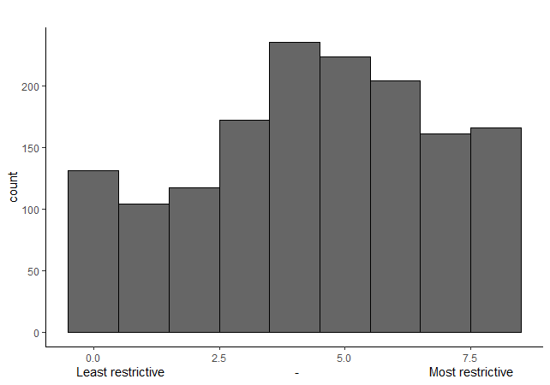
Note: Figure F.1 shows the distribution of candidates’ position on the immigration policy measure. Scores of 0 and 8 indicate, respectively, the most and the least restrictive immigration policy stances. N = 1,522. The analysis is based on the same respondents as Figure 6 in the main paper.

Appendix G – Comparison of samples
Table G.1 compares key municipality characteristics (from 2016) of the subset of ethnic majority incumbents who answered the questions in the voting advice application with the full sample of incumbents as well as the full sample of majority incumbents. From the comparison, it is evident that the subset of incumbents, who provided responses to the voting advice application, are largely representative of incumbents at large, as well as majority incumbents more specifically, on a number of municipality-level characteristics.
Table G.1: Comparison of samples
 | Full sample  (N = 2,395) | Full sample (majorities)  (N = 2,326) | Voting advice subset (majorities)  (N = 1,522)
Share of female incumbents in municipality | 0.296  (0.456) | 0.300  (0.458) | 0.298  (0.457)
Average number of inhabitants in incumbents’ municipality | 71373  (95872) | 70196  (93411) | 73589  (99415)
Average number of non-Western immigrants in incumbents’ municipality | 4264  (9486) | 4121  (9237) | 4451  (9896)
Average number of descendants of non-Western immigrants in incumbents’ municipality | 1897  (4693) | 1812  (4567) | 1977  (4877)
Note: Entries are averages with standard deviations in parentheses.

Appendix H – Effect of the gender cue
This appendix reports the effect of the gender treatment. Table H.1. indicates that the gender cue had no systematic effect on the likelihood of receiving a reply neither in general nor across incumbents’ own gender.
Table H.1: Gender-treatment and incumbents’ gender
 | Dependent variable: Response (0/1)
Female alias | 0.007 | 0.007 | -0.002
 | (0.020) | (0.020) | (0.024)
Female politician |  | 0.033 | 0.018
 |  | (0.022) | (0.031)
Female alias * Female politician |  |  | 0.029
 |  |  | (0.043)
Constant | 0.624*** | 0.615*** | 0.619***
 | (0.014) | (0.015) | (0.017)
Observations | 2,395 | 2,395 | 2,395
R² | 0.001 | 0.001 | 0.001
Adjusted R² | -0.0004 | 0.0002 | -0.00005
Note: The dependent variable is receiving a reply or not (coded as 0/1). All models are estimated by OLS regression. Coefficients are reported as percentage points (divided by 100). Standard errors are reported in parentheses. *p < 0.05; **p < 0.01; ***p < 0.001.

Appendix I – Are the treatments perceived as realistic?
Candidates from the most immigration-skeptic parties (Danish People’s Party (DF), Liberal Alliance (LA) and the new party The New Right (Nye Borgerlige) (NB)) may have perceived the requests from minority constituents as unrealistic, which could inflate the estimated ethnocentric responsiveness. In this appendix, we test if the main results (reported in Table 1, column 1 and Table 2, column 1 in the main text) hold up when excluding incumbents from these parties. As evidenced by the results in Table I.1, the overall differential treatment in responsiveness remains statistically significant in this subset, although the estimate is somewhat smaller. Moreover, the interaction between the vote cue and the minority alias remains very similar to that estimated in the analysis based on the full sample.
Table I.1: Main analyses in the restricted sample
 | Dependent variable: Response (0/1)
 | (1) | (2)
Minority alias | -0.132*** | -0.118***
 | (0.021) | (0.030)
Vote cue |  | 0.090**
 |  | (0.030)
Minority alias * Vote cue |  | -0.052
 |  | (0.042)
Constant | 0.698*** | 0.659***
 | (0.015) | (0.021)
Observations | 2,121 | 2,052
R² | 0.019 | 0.027
Adjusted R² | 0.018 | 0.026
Note: The dependent variable is receiving a reply or not (coded as 0/1). Both models are estimated by OLS regression. Coefficients are reported as percentage points (divided by 100). Standard errors are reported in parentheses. The samples are subsets excluding incumbents from the three most immigration-skeptic parties from the samples used in Table 1, column 1 and Table 2, column 1. *p < 0.05; **p < 0.01; ***p < 0.001.

Appendix J – ATE across municipality size
Incumbents from demographically small municipalities may be more inclined to perceive requests from immigrant-origin constituents to be unrealistic due to their knowledge of the demographics of their constituents and/or simply because they know a larger share of their constituents. Figure J.1 depicts the ATE of the minority alias across subsets of the data ordered by the number of inhabitants in the municipalities. The plot indicates that even when including only the seven smallest municipalities, where these concerns should be most pertinent, the estimated treatment effect of the ethnic cue is essentially identical to in the full sample (ATE = 16.8; SE = 10.6 compared with ATE = 16.2; SE = 0.019).
Figure J.1: ATE in subsets across municipality size (inhabitants)
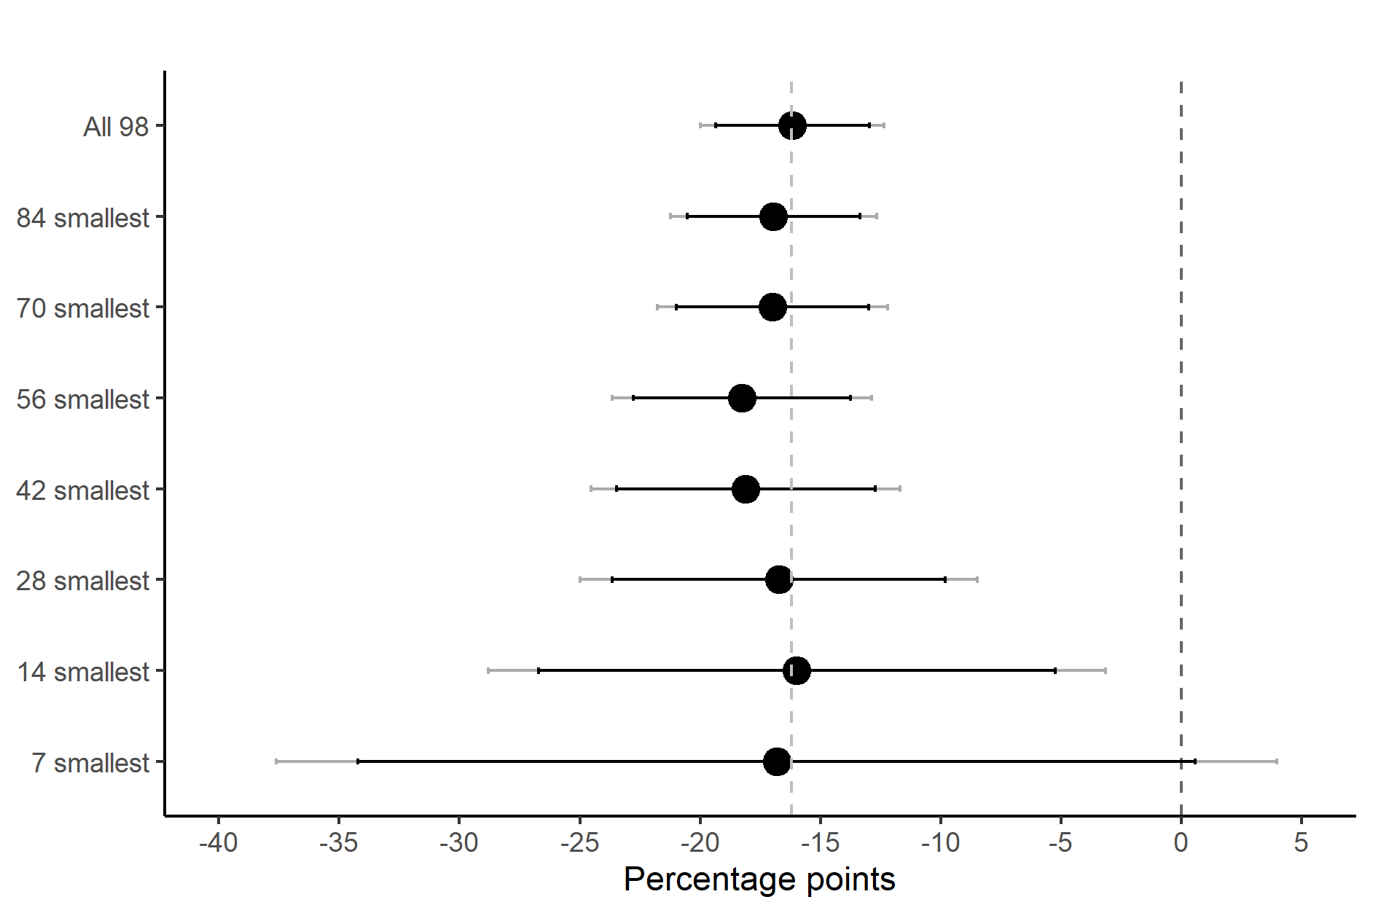
Note: Each estimate represents the ATE among incumbents in subsets of municipalities of a given size. The grey line indicates the average treatment effect. 90% (black) and 95% (gray) confidence intervals reported around point estimates.

Appendix K – Electoral incentives and responsiveness
This appendix examines how observational variations in electoral incentives affect majority incumbents’ responsiveness more generally, and whether such variations moderate the effect of the ethnic alias of constituents. These analyses are reported in Table K.1 below. Column 1 shows that the decision to rerun increases the likelihood of responding to a request in general. However, the electoral incentive from running for re-election does not mitigate the effect of the ethnic minority cue as evidenced by the results reported in column 2. In fact, the effect of the ethnic minority cue appears to be larger (although not statistically significantly) among candidates that rerun as indicated by the negative interaction between the ethnic minority cue and the decision to rerun. One likely explanation for this finding is that the final term-incumbents that do provide an answer are relatively more intrinsically motivated to provide constituency service, which crowds out part of the effect of the ethnic cue. It could also be that re-running candidates are busier and thus put more weight on strategic considerations about the likelihood of who votes.
In the same vein, column 3 introduces a dichotomous variable indicating whether candidates were clear winners (=1) or if they faced a risk of losing their seat in the previous election in 2013. Higher levels of electoral certainty in 2013 is positively and statistically significantly associated with responding to requests. This runs counter to the expectation that experiencing close elections should animate candidates to become more responsive. As suggested by Butler, Pope, and Karpowitz (2012), this may reflect reverse causality: legislators who fail to prioritize service do not do as well during elections. More important for our purposes, the margin of seat win in 2013 does not significantly moderate the effect of the group cue (column 4), thus suggesting that this electoral incentive does not dampen ethnocentric responsiveness.

Table K.1: OLS regression results across variations in electoral incentives
 | Dependent variable: Response (0/1)
 | (1) | (2) | (3) | (4)
Minority alias | -0.172***  (0.019) | -0.102*  (0.047) | -0.172***  (0.020) | -0.199***  (0.033)
Rerun | 0.222***  (0.026) | 0.264***  (0.037)
Minority alias * Rerun |  | -0.084  (0.051)
Clear winner |  |  | 0.065**  (0.021) | 0.045  (0.029)
Minority alias * Clear winner |  |  |  | 0.040  (0.041)
Constant | 0.297*  (0.149) | 0.273  (0.149) | 0.448**  (0.149) | 0.460**  (0.150)
Controls | Yes | Yes | Yes | Yes
Observations | 2,326 | 2,326 | 2,324 | 2,324
R² | 0.090 | 0.092 | 0.066 | 0.066
Adjusted R² | 0.084 | 0.084 | 0.059 | 0.059
Note: The dependent variable is receiving a reply or not (coded as 0/1). Coefficients are reported as percentage points (divided by 100). Standard errors are reported in parentheses. Control variables include candidates’ party, the share of immigrant-origin minority inhabitants in respondents’ municipality as well as the size of the population in the municipality. All models are estimated by OLS regression. *p < 0.05; **p < 0.01; ***p < 0.001.

Appendix L – Further analyses of interactions between Voting cue and Minority Alias
In this appendix, we probe the results reported in Table 2 in the paper by using a different sample and different specifications. In column 1, we further restrict the sample used in column 3 in Table 2 in the paper to only contain those politicians competing in parties with open lists (for whom electoral incentives are especially strong because votes more directly translate into seats). The results using this subset are again highly parallel to those reported in Table 2, thus further substantiating that ethnocentric responsiveness is not curbed by strong electoral incentives. In column 2-4, we re-estimate the results in Table 2 (column 1-3) when including the following control variables: candidates’ party, the share of immigrant-origin minority inhabitants in respondents’ municipality as well as the size of the population in the municipality. Reassuringly, the estimates are robust to inclusion of these controls. Lastly, in column 5, we report results using a close reelection subset based on the 2017 election. Recall that the experiment was conducted six weeks prior to the election; thus, at the time of the experiment, many incumbents could have an impression of their chances of being reelected. The results are also robust to using this alternative indicator of electoral incentives.
Table L.1: Interactions between Voting cue and Minority Alias
 | Dependent variable: Response (0/1)
 | Sample in col. 3 in Table 2 (open list) | All majority politicians | Reelection subset | Close reelection subset | Close reelection subset (2017 election)
 | (1) | (2) | (3) | (4) | (5)
Minority alias | -0.207*** | -0.153*** | -0.158*** | -0.186*** | -0.175***
 | (0.057) | (0.028) | (0.030) | (0.053) | (0.050)
Vote cue | 0.087 | 0.078** | 0.090** | 0.095 | 0.083
 | (0.056) | (0.028) | (0.029) | (0.051) | (0.049)
Minority alias * Vote cue | -0.069  (0.079) | -0.038  (0.039) | -0.061  (0.042) | -0.040  (0.072) | -0.072  (0.068)
Constant | 0.689*** | 0.440** | 0.448** | 0.571* | 0.319
 | (0.041) | (0.150) | (0.163) | (0.238) | (0.214)
Controls | No | Yes | Yes | Yes | Yes
Observations | 569 | 2,326 | 1,931 | 675 | 770
R² | 0.067 | 0.066 | 0.073 | 0.093 | 0.083
Adjusted R² | 0.062 | 0.059 | 0.064 | 0.068 | 0.063
Note: The dependent variable is receiving a reply or not (coded as 0/1). Coefficients are reported as percentage points (divided by 100). Standard errors are reported in parentheses. Control variables include candidates’ party, the share of immigrant-origin minority inhabitants in respondents’ municipality as well as the size of the population in the municipality. All models are estimated by OLS regression. *p < 0.05; **p < 0.01; ***p < 0.001.

Appendix M – Comparison of ethnocentric responsiveness/majority favoritism between parties
As we discuss in the subsection “Using Party Affiliation and Stated Policy Preferences to Identify Responsive Politicians” in the main text, we compare differences in ethnocentric responsiveness/majority favoritism between parties. More precisely, we test the difference in the effect of the ethnic cue (i.e. responsiveness toward ethnic minorities vis-à-vis majorities) between the parties by adding (to the model generating the results reported in Figure 4 in the manuscript) an interaction between the ethnic cue and the party in samples consisting of each party-pair. Table M.1 shows the predicted differences in ethnocentric responsiveness and associated statistical uncertainty from this model.
Table M.1: Differences in the effect of the ethnic minority cue between parties
 | DF | LA | V | K | S | RV | SF
LA | -0.091  (0.152)  [261] | - | - | - | - | - | -
V | -0.234**  (0.074)  [943] | -0.142  (0.156)  [766] | - | - | - | - | -
K | -0.271**  (0.092)  [414] | -0.179  (0.167)  [237] | -0.037  (0.079)  [919] | - | - | - | -
S | -0.290***  (0.071)  [916] | -0.198  (0.147)  [739] | -0.056  (0.050)  [1,421] | -0.019  (0.076)  [892] | - | - | -
RV | -0.400**  (0.131)  [282] | -0.309  (0.196)  [105] | -0.167  (0.130)  [787] | -0.129  (0.144)  [258] | -0.110  (0.123)  [760] | - | -
SF | -0.232*  (0.099)  [329] | -0.141  (0.149)  [152] | 0.002  (0.098)  [834] | 0.039  (0.108)  [305] | 0.058  (0.092)  [807] | 0.168  (0.135)  [173] | -
E | -0.504***  (0.104)  [331] | -0.413*  (0.17)  [154] | -0.271**  (0.099)  [836] | -0.233*  (0.114)  [307] | -0.215*  (0.094)  [809] | -0.104  (0.150)  [175] | -0.272*  (0.114)  [222]
Note: The coefficients are the differences in the effect of the ethnic minority cue between legislators from different parties estimated by OLS regression (i.e. a negative number indicates a stronger ethnocentric responsiveness for the party on the column than the party on the row). Number of observations in each party-pair in brackets. The base sample consists of all available majority legislators from the eight largest parties (N = 2,162). *p < 0.05; **p < 0.01; ***p < 0.001.

Appendix N – ATE across parties including controls
Figure N.1 compares the results from Figure 4 in the paper with a model also including control variables (municipality population size and share of immigrant-origin inhabitants in the municipality). As is evident, the estimates are essentially identical with and without municipality controls.
Figure N.1: ATE across parties with and without control variables
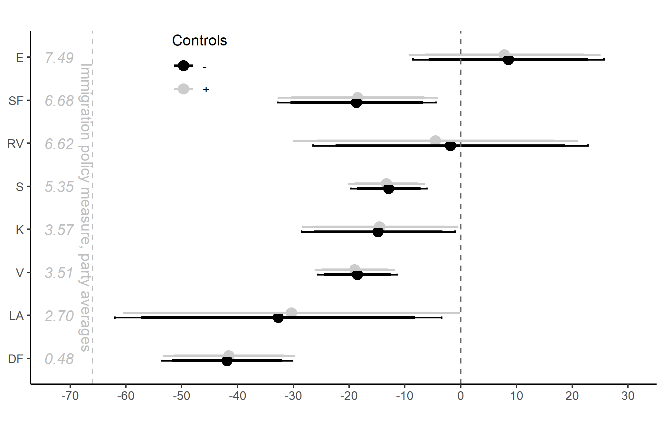
Note: The Figure depicts ATE across parties with and without controls. 90% (short) and 95% (long) confidence intervals reported around point estimates. Sample: all available legislators from the eight largest parties (N = 2,162).

In the models reported in Figure 4, we utilize the full available sample of legislators from each party. In Figure N.2 we compare the result using this sample with a sample of the subset of legislators having responded to the questions in the voting advice application. Although the figure reveals some differences between the samples, the results are relatively parallel, broadly speaking.
Figure N.2: Comparison of responsiveness by party in full and restricted samples
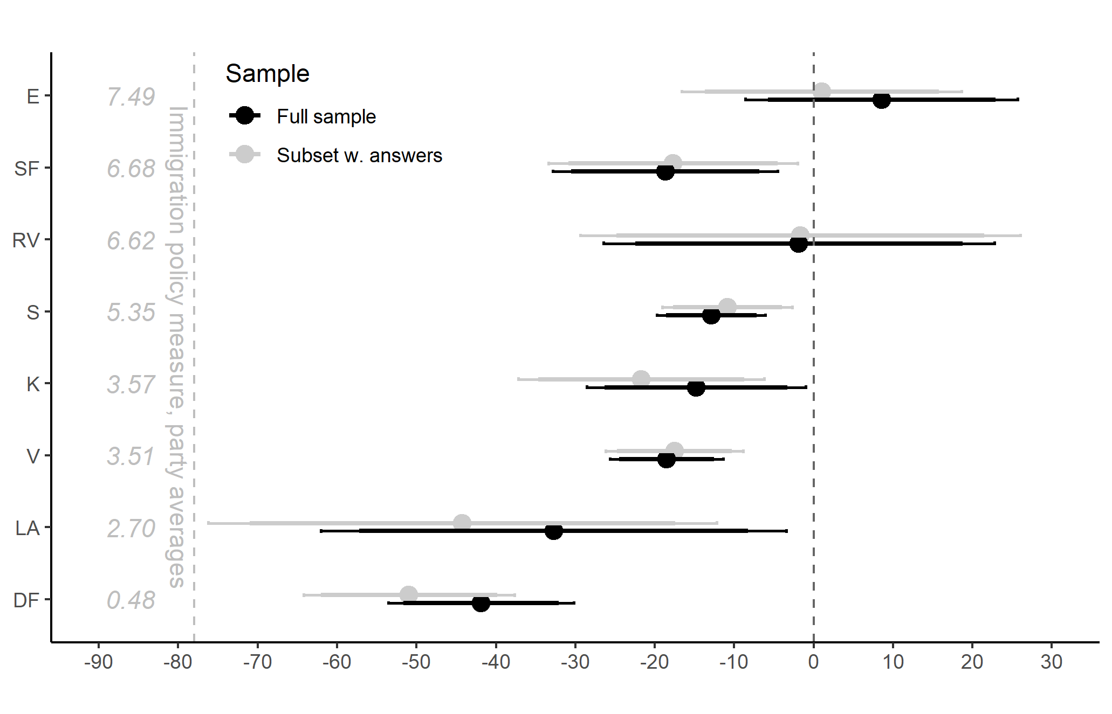
Note: The Figure depicts ATE across parties in the full sample and in the subset, who provided a valid answer to the immigration questions in the voting advice application. N (full sample) = 2,162; N (voting advice sample) = 1,444.

Appendix O – Interactions with and without party FE
This appendix compares the interaction between the ethnic minority treatment and the immigration/integration policy index with (coloumn 1) and without (coloumn 2) party fixed effects, respectively. The results from the models are highly similar.
Table O.1: Interaction between minority alias and candidate stance on immigration in models with and without party fixed effects
 | Dependent variable: Response (0/1)
 | (1) | (2)
Minority alias | -0.334*** | -0.325***
 | (0.048) | (0.048)
Immigration Policy Index | -0.020* | -0.005
 | (0.009) | (0.007)
Minority alias * Immigration Policy Index | 0.035*** | 0.034***
 | (0.010) | (0.010)
Constant |  | 0.799***
 |  | (0.034)
Party fixed effects | Yes | No
Observations | 1,522 | 1,522
R² | 0.069 | 0.047
Adjusted R² | 0.059 | 0.045
Note: The dependent variable is receiving a reply or not (coded as 0/1). Coefficients are reported as percentage points (divided by 100). Standard errors are reported in parentheses. Both models are estimated by OLS regression. *p < 0.05; **p < 0.01; ***p < 0.001.

Appendix P – Interactions between ethnic cue and policy stances
Table P.1 and P.2 below report analyses of the extent to which legislators’ policy stances on the 15 issues in the Vote Compass test (see Appendix A above for full wording) moderate the impact of the ethnic cue in the experiment (separately for each issue). More specifically, the interaction term between each issue and the ethnic cues indicates if and how a given policy stance moderate (dampen or enhance) the level of ethnocentric responsiveness. As noted in the subsection “Using party affiliation and policy preferences to identify responsive politicians” in the main text, the analyses show that stances on the two immigration-related issue (Q8 and Q9) are among the strongest moderators of ethnocentric responsiveness—that is, legislators’ stances on these issues are among the most predictive of their differential responsiveness towards ethnic minority constituents. The other two stances with the strongest predictive function vis-à-vis ethnocentric responsiveness is on cultural activities (Q10) and unemployment (Q13)—both relatively strongly correlated with immigration/integration policy stances as we note in footnote 26 in the paper.
Table P.1: Interactions between ethnic cue and policy stances (Q1-Q7)
Issue | Q1  (privatizati.) | Q2  (volunteers) | Q3  (taxes) | Q4  (welf. saving) | Q5  (schools) | Q6  (kindergart.) | Q7  (bicycle lanes)
Ethnic cue | -0.176*** | -0.163** | -0.104* | -0.095 | -0.298** | -0.239** | -0.319**
 | (0.046) | (0.051) | (0.047) | (0.055) | (0.082) | (0.078) | (0.103)
Q | -0.021 | 0.001 | 0.047 | 0.024 | -0.033 | -0.010 | -0.014
 | (0.016) | (0.013) | (0.014) | (0.013) | (0.014) | (0.014) | (0.017)
Ethnic cue x Q | -0.002 | -0.006 | -0.029 | -0.027 | 0.030 | 0.015 | 0.033
 | (0.018) | (0.018) | (0.016) | (0.016) | (0.020) | (0.019) | (0.024)
Observations | 1,522 | 1,522 | 1,522 | 1,520 | 1,518 | 1,522 | 1,517
R² | 0.062 | 0.061 | 0.068 | 0.063 | 0.064 | 0.061 | 0.061
Adjusted R² | 0.052 | 0.051 | 0.058 | 0.053 | 0.054 | 0.051 | 0.051
Note: Parameter estimates estimated by OLS regression with standard errors in parenthesis. The estimated model is parallel to that underlying Figure 6 in the paper, but substituting the immigration/integration policy index with individual policy stances on 15 different issues. The sample is restricted to observations with valid values on the immigration/integration policy index.
*p < 0.05; **p < 0.01; ***p < 0.001

Table P.2: Interactions between ethnic cue and policy stances (Q8-Q15)
Issue | Q8  (refugees) |  | Q9  (religious minorities) |  | Q10  (librar./cult. institutions) |  | Q11  (nursing homes) |  | Q12 (sorting of thrash) |  | Q13  (unempl.) |  | Q14  (children in schools) |  | Q15 (organic food)
Ethnic cue | -0.333** |  | -0.043 |  | -0.078 |  | -0.056 |  | -0.362*** |  | -0.012 |  | -0.081 |  | -0.275***
 | (0.054) |  | (0.048) |  | (0.048) |  | (0.062) |  | (0.101) |  | (0.059) |  | (0.068) |  | (0.050)
Q | -0.042** |  | 0.018 |  | 0.030 |  | 0.012 |  | -0.027 |  | 0.007 |  | 0.010 |  | -0.024
 | (0.014) |  | (0.014) |  | (0.016) |  | (0.013) |  | (0.017) |  | (0.014) |  | (0.014) |  | (0.014)
Ethnic cue x Q | 0.054** |  | -0.056** |  | -0.051* |  | -0.036* |  | 0.043 |  | -0.051** |  | -0.028 |  | 0.034*
 | (0.017) |  | (0.017) |  | (0.021) |  | (0.017) |  | (0.023) |  | (0.017) |  | (0.018) |  | (0.016)
Observations | 1,522 | 1,522 |  | 1,519 |  | 1,516 |  | 1,518 |  | 1,519 |  | 1,521 |  | 1,522
R² | 0.068 | 0.068 |  | 0.065 |  | 0.063 |  | 0.064 |  | 0.068 |  | 0.062 |  | 0.064
Adjusted R² | 0.058 | 0.058 |  | 0.055 |  | 0.053 |  | 0.054 |  | 0.058 |  | 0.052 |  | 0.054
Note: Parameter estimates estimated by OLS regression with standard errors in parenthesis. The estimated model is parallel to that underlying Figure 6 in the paper, but substituting the immigration/integration policy index with individual policy stances on 15 different issues. The sample is restricted to observations with valid values on the immigration/integration policy index. *p < 0.05; **p < 0.01; ***p < 0.001.

References
Butler, Daniel M., Christopher F. Karpowitz, and Jeremy C. Pope. 2012. “A Field Experiment on Legislators’ Home Styles: Service versus Policy.” The Journal of Politics 74 (2): 474-86.
Coppock, Alexander. 2019. “Avoiding Post-Treatment Bias in Audit Experiments.” Journal of Experimental Political Science 6 (1): 1-4.
Costa, Mia. 2017. “Improving measures of Responsiveness for Elite Audit Experiments.” Working paper.
Dahlgaard, Jens Olav. 2016. “You Just Made It: Individual Incumbency Advantage under Proportional Representation.” Electoral Studies 44: 319–328.
Kalla, Joshua, Frances Rosenbluth, and Dawn Langan Teele. 2018. “Are You My Mentor? A Field Experiment on Gender, Ethnicity, and Political Self-Starters.” The Journal of Politics 80 (1): 337–41.
Kotakorpi, Kaisa, Panu Poutvaara, and Marko Terviö. 2017. “Returns to office in national and local politics: A bootstrap method and evidence from Finland.” The Journal of Law, Economics, and Organization 33 (3): 413–42.
The Danish Election Database: https://valgdatabase.dst.dk/?lang=en

Their inclusion explains why the final sample (2,395) is not equivalent to the the number of elected officials (2,444) in 2013 minus the 50 legislators included in the pilot test.

