Supplemental Appendix to “How Empathic Concern Fuels Partisan Polarization.”
Appendix A – The Interpersonal Reactivity Index (IRI)
Appendix B – YouGov Sample Materials and Alternative Models
Appendix C – Student Sample Materials and Alternative Models

Supplemental Online Appendix A: The Interpersonal Reactivity Inventory
Derived by Davis (1983), the following 28 questions are used to measure empathy in both studies. The letters following each question denote the dimension of empathy to which the question corresponds:
PT= perspective-taking
EC= empathic concern
PD = personal distress
F = fantasy

The following statements inquire about your thoughts and feelings in a variety of situations. For each item, indicate how well it describes you by choosing the appropriate letter on the scale: A (does not describe me well), B, C, D, or E (describes me very well). Read each item carefully before responding. Answer as honestly as you can. Thank you.
- I day dream and fantasize, with some regularity, about things that might happen to me (F1)
- I often have tender concerned feelings for people less fortunate than me (EC1)
- I sometimes find it difficult to see things from the “other guy’s” point of view (PT1)
- Sometimes I don’t feel very sorry for other people when they are having problems (EC2)
- I really get involved with the feelings of characters in a novel (F2)
- In emergency situations, I feel apprehensive and ill-at-ease (PD1)
- I am usually objective when I watch a movie or play, and I don’t often get completely caught up in it (F3)
- I try to look at everybody’s side of a disagreement before I make a decision (PT2)
- When I see someone being taken advantage of, I feel kind of protective towards them (EC3)
- I sometimes feel helpless when I am in the middle of a very emotional situation (PD2)
- I sometimes try to understand my friends better by imagining how things look from their perspective. (PT3)
- Becoming extremely involved in a good book or movie is somewhat rare for me (F4)
- When I see someone get hurt, I tend to remain calm (PD3)
- Other people’s misfortunes do not usually disturb me a great deal (EC4)
- If I’m sure I’m right about something, I don’t waste much time listening to other people’s arguments (PT4)
- After seeing a play or movie, I have felt as though I were one of the characters (F5)
- Being in a tense emotional situation scares me (PD4)
- When I see someone being treated unfairly, I sometimes don’t feel very much pity for them (EC5)
- I am usually pretty effective in dealing with emergencies (PD5)
- I am often quite touched by things I see happen (EC6)
- I believe there are two sides to every question and try to look at both of them (PT5)
- I would describe myself as a pretty soft-hearted person (EC7)
- When I watch a good movie, I can very easily put myself in the place of a leading character (F6)
- I tend to lose control during emergencies (PD6)
- When I’m upset at someone, I usually try to “put myself in his shoes” for a while (PT6)
- When I am reading an interesting story or novel, I imagine how I would feel if the events in the story were happening to me (F7)
- If you are paying attention, select A (Attention Check)
- When I see someone who badly needs help in an emergency, I go to pieces (PD7)
- Before criticizing somebody, I try to imagine how I would feel if I were in their place (PT7)
- A – Does not describe me well
- B
- C
- D
- E – Describes me very well

Table A1: Factor Loadings, YouGov Sample
 | Factor 1 | Factor 2 | Factor 3 | Factor 4
EC1 |  |  |  | .25
EC2 |  |  |  | .53
EC3 |  |  |  | .17
EC4 |  |  |  | .60
EC5 |  |  |  | .52
EC6 |  |  |  | .24
EC7 |  |  |  | .20
PD1 |  |  | .74
PD2 |  |  | .62
PD3 |  |  | .43
PD4 |  |  | .65
PD5 |  |  | .50
PD6 |  |  | .72
PD7 |  |  | .64
PT1 | .18
PT2 | .69
PT3 | .63
PT4 | -.05
PT5 | .61
PT6 | .61
PT7 | .68
FS1 |  | .40
FS2 |  | .68
FS3 |  | .20
FS4 |  | .41
FS5 |  | .71
FS6 |  | .71
FS7 |  | .71

Table A2: Factor Loadings, Student Sample
 | Factor 1 | Factor 2 | Factor 3
EC1 |  | .41
EC2 |  | .76
EC3 |  | .21
EC4 |  | .69
EC5 |  | .20
EC6 |  | -.13
EC7 |  | .21
PD1 |  |  | .58
PD2 |  |  | .62
PD3 |  |  | .24
PD4 |  |  | .71
PD5 |  |  | .43
PD6 |  |  | .68
PD7 |  |  | .51
PT1 | .24
PT2 | .62
PT3 | .61
PT4 | .05
PT5 | .62
PT6 | .61
PT7 | -.05

Table A3: Correlations between Additive Scale and and Corresponding Factor Scores, Both Samples
 | YouGov | Student Sample
Empathic Concern | .75 | .96
Personal Distress | .98 | .97
Perspective Taking | .84 | .92
Fantasy | .97 | --

Supplemental Online Appendix B: YouGov Sample Materials and Alternative Analyses
Table B1: Sample Demographics
 |  | Main Sample
Empathic Concern |  | 0.69
Perspective-Taking |  | 0.63
Personal Distress |  | 0.35
Fantasy |  | 0.55
Male |  | 44%
Mean Age |  | 48

Education
 | No High School | 4%
 | High School Graduate | 34%
 | Some College | 22%
 | 2-Year Degree | 10%
 | 4-Year Degree | 19%
 | Post-Graduate | 10%
Income
Less than $39,999 |  | 39%
$40,000 – 69,999 |  | 22%
$70,000 or more |  | 25%
Prefer not to say |  | 13%
Race and Ethnicity
 | White | 75%
 | Hispanic | 9%
 | Black | 10%
 | Asian | 2%
 | Native American | 1%
 | Mixed | 3%
 | Other | 1%
Partisanship
 | Strong Democrat | 23%
 | Democrat | 12%
 | Leaning Democrat | 9%
 | Pure Independent | 20%
 | Leaning Republican | 10%
 | Republican | 11%
 | Strong Republican | 14%

Ideology
 | Very Liberal | 12%
 | Liberal | 14%
 | Slightly Liberal | 6%
 | Moderate/Middle of the Road | 32%
 | Slightly Conservative | 10%
 | Conservative | 18%
 | Very Conservative | 7%

New Interest
 | Hardly at All to Some of the Time | 50%
 | Most of the Time | 47%
 | Don’t Know | 3%

Question Wording for the Dependent Variables in Table 1

Partisan Favoritism
How favorable or unfavorable are your feelings about each of the following groups?
- The Democratic Party
- The Republican Party
- Very favorable
- Favorable
- Slightly favorable
- Neither favorable nor unfavorable
- Slightly unfavorable
- Unfavorable
- Very unfavorable

Social Distance
How upset would you feel about each of the following scenarios?
- You had a family member marry a Democrat
- Your neighbor placed a "Hillary Clinton for President" sign in their yard
- Not upset at all
- Not too upset
- Somewhat upset
- Very upset
- Extremely upset

How upset would you feel about each of the following scenarios?
- You had a family member marry a Republican
- Your neighbor placed a "Ted Cruz for President" sign in their yard
- Not upset at all
- Not too upset
- Somewhat upset
- Very upset
- Extremely upset

Table B2: Correlations with Empathic Concern and Variance Inflation Factors

 | Correlation with Empathic Concern | VIF
Empathic Concern | 1.00 | 1.53
Personal Distress | -.07 | 1.24
Perspective-Taking | .52 | 1.48
Fantasy | .32 | 1.38
Partisan Strength | .12 | 1.10
Ideological Extremity | .02 | 1.14
News Interest | .05 | 1.27
Democratic Respondent | .18 | 1.15
Education | .01 | 1.14
Age | .13 | 1.30
Male | -.22 | 1.19
White | .04 | 1.15
Income | -.07 | 1.08

Table B3: Deconstructing the Social Distant Measure
 | Comfort with:
 | A family member marrying an outpartisan | A neighbor with the opposing party’s yard sign
 | Coefficient | Standard Error | Coefficient | Standard Error
Empathic Concern | -1.96* | (.75) | -1.47 | (.76)
Personal Distress | .90 | (.55) | 1.91* | (.55)
Perspective-Taking | -.73 | (.68) | -.70 | (.68)
Fantasy | .27 | (.55) | .46 | (.64)
Partisan Strength | .58* | (.14) | .48* | (.12)
Ideological Extremity | .30* | (.11) | .08 | (.09)
News Interest | .30* | (.14) | .48* | (.12)
Democratic Respondent | -.13 | (.20) | -.72* | (.19)
Education | .12 | (.06) | .09 | (.07)
Age | -.01* | (.01) | -.01 | (.01)
Male | -.06 | (.20) | .03 | (.20)
White | -.13 | (.22) | -.15 | (.21)
Income: Middle Third | -.10 | (.23) | -.28 | (.23)
Income: Top Third | .10 | (.25) | -.17 | (.25)
Income: Decline to State | -.01 | (.33) | -.23 | (.30)
N | 755 |  | 755
Coefficients and standard errors estimated using weighted ordinal logistic regression. Cutpoints are estimated but not shown.
*=p<.05

Table B4: Affect and Social Distance as a Function of Empathy Factor Scores

 | Relative Inparty Favoritism |  |  | Outparty Favorability |  |  | Social Distance
 | Coef. | S.E. |  | Coef. | S.E. |  | Coef. | S.E.
Empathic Concern Factor | .41* | (.13) |  | -.55* | (.15) |  | -.39* | (.14)
Personal Distress Factor | -.18 | (.11) |  | .20 | (.12) |  | .36* | (.10)
Perspective-Taking Factor | -.01 | (.13) |  | .22 | (.13) |  | -.23 | (.15)
Fantasy Factor | -.05 | (.12) |  | .25* | (.12) |  | .12 | (.14)
Partisan Strength | .87* | (.12) |  | -.34* | (.12) |  | .54* | (.12)
Ideological Extremity | .36* | (.10) |  | -.52* | (.10) |  | .20* | (.09)
News Interest | .34* | (.12) |  | -.66* | (.12) |  | .41* | (.13)
Democratic Respondent | .65* | (.17) |  | -.01 | (.19) |  | -.48* | (.19)
Education | -.16* | (.06) |  | .04 | (.07) |  | .10 | (.06)
Age | .00 | (.00) |  | .00 | (.01) |  | -.01 | (.01)
Male | .10 | (.19) |  | -.17 | (.20) |  | .00 | (.20)
White | -.21 | (.22) |  | .02 | (.21) |  | -.22 | (.21)
Income: Middle Third | -.15 | (.20) |  | -.01 | (.22) |  | -.29 | (.23)
Income: Top Third  Income: Decline to State | -.08  -.45 | (.22)  (.33) |  | -.07  .14 | (.24)  .29 |  | -.08  -.03 | (.24)  (.31)
N | 755
Coefficients and standard errors estimated using weighted ordinal logistic regression. Cutpoints are estimated but not shown.
*=p<.05

Table B5: Partisan Affect and Social Distance as a Function of Empathic Concern, Omitting Income Non-Responders

 | Relative Inparty Favoritism |  |  | Outparty Favorability |  |  | Social Distance
 | Coef. | S.E. |  | Coef. | S.E. |  | Coef. | S.E.
Empathic Concern | 1.71* | (.50) |  | -1.67* | (.60) |  | -1.69* | (.79)
Personal Distress | -.88 | (.63) |  | .59 | (.61) |  | 1.59* | (.54)
Perspective-Taking | -.40 | (.64) |  | 1.08 | (.71) |  | -.53 | (.72)
Fantasy | -.05 | (.53) |  | 1.23* | (.49) |  | .14 | (.63)
Partisan Strength | .90* | (.13) |  | -.36* | (.13) |  | .51* | (.13)
Ideological Extremity | .34* | (.11) |  | -.50* | (.12) |  | .21* | (.10)
News Interest | .26 | (.14) |  | -.64* | (.14) |  | .48* | (.14)
Democratic Respondent | .70* | (.17) |  | -.02 | (.20) |  | -.48* | (.19)
Education | -.14* | (.07) |  | -.02 | (.07) |  | .13 | (.07)
Age | -.00 | (.01) |  | .00 | (.01) |  | -.01 | (.01)
Male | .12 | (.20) |  | -.12 | (.23) |  | -.12 | (.21)
White | -.43 | (.23) |  | .18 | (.23) |  | -.22 | (.21)
Income | -.01 | (.03) |  | -.00 | (.03) |  | -.02 | (.03)
N | 667

Coefficients and standard errors estimated using weighted ordinal logistic regression. Cutpoints are estimated but not shown.
*=p<.05

Table B6: Affect and Social Distance by Empathic Concern and Party of the Respondent
 | Relative Inparty Favoritism |  |  | Outparty Favorability |  |  | Social Distance
 | Coef. | S.E. |  | Coef. | S.E. |  | Coef. | S.E.
Empathic Concern | 1.25 | (.84) |  | -1.33 | (.77) |  | -1.65 | (.96)
Democratic Respondent | .24 | (.81) |  | .07 | (.89) |  | -.45 | (.79)
Concern X Democrat | .63 | (.1.13) |  | -.17 | (1.19) |  | -.05 | (1.08)
Personal Distress | -.75 | (.50) |  | .77 | (.58) |  | 1.57* | (.50)
Perspective-Taking | -.51 | (60) |  | 1.19 | (.67) |  | -.68 | (.68)
Fantasy | -.20 | (.50) |  | .98* | (.47) |  | .32 | (.59)
Partisan Strength | .86* | (.12) |  | -.33* | (.12) |  | .53* | (.12)
Ideological Extremity | .65* | (.10) |  | -.50* | (.11) |  | .20* | (.09)
News Interest | .31* | (.13) |  | -.58* | (.07) |  | .44* | (.13)
Education | -.15* | (.06) |  | .03 | (.12) |  | .10 | (.06)
Age | .00 | (.00) |  | -.00 | (.01) |  | -.01 | (.01)
Male | .10 | (.19) |  | -.18 | (.21) |  | -.01 | (.20)
White | -.23 | (.22) |  | .04 | (.21) |  | -.19 | (.21)
Income: Middle Third | -.14 | (.20) |  | -.05 | (.23) |  | -.30 | (.23)
Income: Top Third | -.07 | (.22) |  | -.08 | (.25) |  | -.07 | (.25)
Income: Decline to State | -.28 | (.31) |  | -.06 | (.33) |  | -.13 | (.29)
N | 755
Coefficients and standard errors estimated using weighted ordinal logistic regression. Cutpoints are estimated but not shown.
*=p<.05

Table B7: Affect and Social Distance by Empathic Concern and Partisan Strength
 | Absolute Difference in Party Affect |  |  |  |  |  | Social Distance†
 | Coef. | S.E. |  | Coef. | S.E. |  | Coef. | S.E. |  | Coef. | S.E.
Empathetic Concern | .62 | (.67) |  | .63 | (.70) |  | -.93* | (.35) |  | -.89 | (.48)
Party Identifier | -2.02* | (0.71) |  |  |  |  | -.54 | (.37)
Concern X Identifier | 1.02 | (.87) |  |  |  |  | .16 | (.44)
Personal Distress | -.47 | (.42) |  | -.47 | (.42) |  | .83* | (.22) |  | ..85* | .22
Perspective Taking | -.36 | (.50) |  | -.36 | (.50) |  | -.32 | (.30) |  | -.31 | (.31)
Fantasy | -.22 | (.44) |  | -.23 | (.44) |  | .06 | (.24) |  | .09 | .24
Partisan Strength | 1.46* | (.17) |  |  |  |  | .39* | (.08)
Ideological Extremity | .22* | (.08) |  | .22* | (.08) |  | .09* | (.04) |  | .09* | (.04)
News Interest | .13 | (.09) |  | .13 | (.09) |  | .13* | (.05) |  | .14* | (.05)
Education | -.02 | (.05) |  | -.02 | (.05) |  | .05 | (.03) |  | .05 | (.03)
Age | .00 | (.00) |  | .00 | (.00) |  | -.01* | (.00) |  | -.01* | (.00)
Male | .16 | (.14) |  | .16 | (.14) |  | .03 | (.08) |  | .03 | (.08)
White | -.21 | (.16) |  | -.22 | (.16) |  | -.03 | (.09) |  | -.02 | (.09)
Income: Middle Third | -.12 | (.17) |  | -.13 | (.17) |  | -.15 | (.09) |  | -.14 | (.09)
Income: Top Third | .00 | (.17) |  | .00 | (.17) |  | -.02 | (.10) |  | -.02 | (.10)
Income: Decline to State | -.34 | (.25) |  | -.33 | (.25) |  | -.06 | (.13) |  | -.07 | (.13)
Independent Leaner |  |  |  | 1.52 | (.82) |  |  |  |  | .25 | (.46)
Weak Partisan |  |  |  | 1.01 | (.78) |  |  |  |  | .00 | (.47)
Strong Partisan |  |  |  | 2.33* | (.74) |  |  |  |  | .73 | (.46)
Concern X Leaner |  |  |  | -.01 | (1.19) |  |  |  |  | -.08 | (.63)
Concern X Weak Partisan |  |  |  | .93 | (1.13) |  |  |  |  | .29 | (.64)
Concern X Strong Partisan |  |  |  | 1.09 | (1.04) |  |  |  |  | -.03 | (.63)
Constant | .35 | (.52) |  | .34 | (.53) |  | 1.67* | (.36) |  | 1.65* | (.44)
N | 945
R² | .41 |  |  | .41 |  |  | .20 |  |  | .20
Coefficients and standard errors estimated using weighted OLS regression. We present the OLS results to ease presentation of the interaction terms. However, ordinal logistic regression produces substantively similar results.
*=p<.05
†The party featured in the questions presented to independents was randomly assigned.
Table B8: Affect and Social Distance without the Other Dimensions of Empathy
 | Relative Inparty Favoritism |  |  | Outparty Favorability |  |  | Social Distance
 | Coef. | S.E. |  | Coef. | S.E. |  | Coef. | S.E.
Empathic Concern | 1.30* | (.54) |  | -.70 | (.55) |  | -1.88* | (.54)
Partisan Strength | .86* | (.12) |  | -.34* | (.13) |  | .52* | (.11)
Ideological Extremity | .34* | (.10) |  | -.48* | (.11) |  | .24* | .09
News Interest | .32* | (.13) |  | -.58* | (.13) |  | .40* | .12
Democratic Respondent  Education  Age  Male  White  Income: Middle Third  Income: Top Third  Income: Decline to State | .65*  -.15*  .00  .19  -.24  -.12  -.07  -.28 | (.17)  (.06)  (.00)  (.19)  (.22)  (.20)  (.23)  (.31) |  | -.02  .04  -.01  -.30  .10  -.10  -.08  -.06 | (.20)  (.06)  (.00)  (.22)  (.22)  (.23)  (.25)  (.33) |  | -.47*  .09  -.01*  -.16  -.20  -.31  -.10  -.08 | .18  .06  .00  .20  .21  .22  .24  .28
N | 763
Coefficients and standard errors estimated using weighted ordinal logistic regression. Cutpoints are estimated but not shown.
*=p<.05
Table B9: Affect and Social Distance by Empathic Concern with Ideological Identification
 | Relative Inparty Favoritism |  |  | Outparty Favorability |  |  | Social Distance
 | Coef. | S.E. |  | Coef. | S.E. |  | Coef. | S.E.
Empathic Concern | 2.87* | (1.12) |  | -3.77* | (1.44) |  | -1.31 | (1.32)
Ideology  Concern X Ideology | .11  -.31 | (.20)  (.28) |  | -.40  .55 | (.24)  (.32) |  | -.07  -.08 | (.22)  (.29)
Personal Distress  Perspective Taking  Fantasy  Partisan Strength  Ideological Extremity | -.72  -.61  -.26  .85*  .33* | (.50)  (.59)  (.51)  (.12)  (.10) |  | .68  1.18  1.09*  -.32*  -.50* | (.57)  (.68)  (.49)  (.13)  (.11) |  | 1.59*  -.80  .30  .54*  .18 | (.49)  (.68)  (.57)  (.12)  (.10)
News Interest | .29* | (.13) |  | -.59* | (.14) |  | .43* | (.13)
Democratic Respondent  Education  Age  Male  White  Income: Middle Third  Income: Top Third  Income: Decline to State | .42  -.16*  .00  .09  -.24  -.12  -.06  -.30 | (.29)  (.06)  (.00)  (.19)  (.21)  (.20)  (.23)  (.30) |  | -.12  .03  .00  -.19  .04  -.08  -.09  -.08 | (.32)  (.07)  (.01)  (.21)  (.21)  (.23)  (.25)  (.33) |  | -.79*  .09  -.01  -.03  -.21  -.28  -.08  -.14 | (.27)  (.06)  (.01)  (.02)  (.20)  (.23)  (.25)  (.29)
N | 755
Coefficients and standard errors estimated using weighted ordinal logistic regression. Cutpoints are estimated but not shown.
*=p<.05
Table B10: Correlations between Empathy and the Big Five Personality Factors
 | Empathic Concern | Personal Distress | Perspective-Taking | Fantasy | Extraversion | Agreeableness | Conscientiousness | Stability | Openness
Empathic Concern | 1.00
Personal Distress | -.07 | 1.00
Perspective-Taking | .52 | -.27 | 1.00
Fantasy | .32 | .17 | .21 | 1.00
Extraversion | .11 | -.26 | .16 | .02 | 1.00
Agreeableness | .52 | -.13 | .40 | .11 | .06 | 1.00
Conscientiousness | .21 | -.35 | .21 | -.09 | .09 | .33 | 1.00
Stability | .07 | -.56 | .25 | -.15 | .16 | .33 | .48 | 1.00
Openness | .27 | -.32 | .30 | .15 | .21 | .18 | .23 | .24 | 1.00

Table B11: Affect and Social Distance Including the Big 5
 | Relative Inparty Favoritism |  |  | Outparty Favorability |  |  | Social Distance
 | Coef. | S.E. |  | Coef. | S.E. |  | Coef. | S.E.
Empathetic Concern  Empathetic Distance  Perspective Taking  Fantasy  Extraversion  Agreeableness  Conscientiousness  Stability  Openness  Partisan Strength  Ideological Extremity | 1.34*  -.44  -.71  -.13  -.56  .14  .56  .27  .49  .88*  .35* | (.65)  (.71)  (.60)  (.50)  (.34)  (.43)  (.44)  (.52)  (.49)  (.12)  (.10) |  | -1.20  1.27  1.26  .96*  .91*  -.67  .15  .39  -.23  -.36*  -.48* | (.64)  (.81)  (.68)  (.49)  (.38)  (.51)  (.52)  (.55)  (.44)  (.12)  (.11) |  | -1.22  1.14  -.59  .26  .15  -.66  .03  -.88  .11  .55*  .19* | (.69)  (.68)  (.67)  (.58)  (.43)  (.66)  (.43)  (.59)  (.43)  (.12)  (.10)
News Interest | .32* | (.13) |  | -.60* | (.13) |  | .44* | (.13)
Democratic Respondent  Education  Age  Male  White  Income: Middle Third  Income: Top Third  Income: Decline to State | .69*  -.16*  .00  .08  -.26  -.11  -.07  -.22 | (.16)  (.06)  (.00)  (.19)  (.21)  (.20)  (.22)  (.31) |  | -.03  .02  .00  -.15  .10  -.11  -.12  -.07 | (.19)  (.07)  (.01)  (.22)  (.22)  (.22)  (.24)  (.32) |  | -.55*  .12  -.01  -.01  -.24  -.34  -.12  -.18 | (.20)  (.07)  (.01)  (.21)  (.21)  (.23)  (.24)  (.29)
N | 753
Coefficients and standard errors estimated using weighted ordinal logistic regression. Cutpoints are estimated but not shown.
*=p<.05
Table B12: Affect and Social Distance Including the Big 5 and without Empathy
 | Relative Inparty Favoritism |  |  | Outparty Favorability |  |  | Social Distance
 | Coef. | S.E. |  | Coef. | S.E. |  | Coef. | S.E.
Extraversion  Agreeableness  Conscientiousness  Stability  Openness  Partisan Strength  Ideological Extremity | -.45  .53  .72  .22  .72  .88*  .36* | (.34)  (.41)  (.43)  (.42)  (.42)  (.12)  (.10) |  | .65  -.68  -.08  .15  -.47  -.37*  -.47* | .39  (.48)  (.48)  (.45)  (.40)  (.13)  (.11) |  | .00  -.99  -.15  -1.28*  -.18  .55*  .18 | (.38)  (.52)  (.43)  (.43)  (.43)  (.12)  (.10)
News Interest | .30* | (.13) |  | -.56* | (.13) |  | .36* | (.12)
Democratic Respondent  Education  Age  Male  White  Income: Middle Third  Income: Top Third  Income: Decline to State | .71*  -.17*  .00  .07  -.26  -.10  -.11  -.23 | (.16)  (.06)  (.00)  (.20)  (.21)  .20  (.22)  (.30) |  | .02  .04  -.01  -.26  .13  -.14  -0.09  -.06 | (.20)  (.06)  (.01)  (.24)  (.22)  (.22)  (.24)  (.33) |  | -.69*  .13  -.01  -.01  -.28  -.41  -.17  -.20 | (.19)  (.07)  (.01)  (.21)  (.21)  (.22)  (.25)  (.28)
N | 770
Coefficients and standard errors estimated using weighted ordinal logistic regression. Cutpoints are estimated but not shown.
*=p<.05
Table B13: Affect and Social Distance with Perspective-Taking but without the Other Dimensions of Empathy
 | Relative Inparty Favoritism |  |  | Outparty Favorability |  |  | Social Distance
 | Coef. | S.E. |  | Coef. | S.E. |  | Coef. | S.E.
Perspective-Taking | .36 | (.52) |  | .35 | (.57) |  | -1.70* | (.54)
Partisan Strength | .85* | (.12) |  | -.34* | (.13) |  | .51* | (.11)
Ideological Extremity | .34* | (.10) |  | -.48* | (.11) |  | .23* | (.09)
News Interest | .32* | (.13) |  | -.58* | (.13) |  | .36* | (.12)
Democratic Respondent  Education  Age  Male  White  Income: Middle Third  Income: Top Third  Income: Decline to State | .72*  -.16*  .00  .07  -.25  -.10  -.09  -.32 | (.17)  (.06)  (.00)  (.20)  (.22)  (.21)  (.23)  (.31) |  | -.09  .04  -.01  -.21  .09  -.13  -.08  -.02 | (.20)  (.06)  (.00)  (.22)  (.22)  (.23)  (.25)  (.33) |  | -.51*  .10  -.01  -.05  -.21  -.34  -.09  -.08 | (.19)  (.06)  (.00)  (.19)  (.21)  (.22)  (.24)  (.28)
N | 761
Coefficients and standard errors estimated using weighted ordinal logistic regression. Cutpoints are estimated but not shown.
*=p<.05

Table B14: Affect and Social Distance by Empathic Concern and Ideological Extremity
 | Relative Inparty Favoritism |  |  | Outparty Favorability |  |  | Social Distance
 | Coef. | S.E. |  | Coef. | S.E. |  | Coef. | S.E.
Empathic Concern | 1.97 | (1.10) |  | -1.44 | (1.05) |  | -2.55* | (1.03)
Ideological Extremity | .55 | (.48) |  | .51 | (.48) |  | -.23 | (.38)
Concern X Extremity | -.28 | (.60) |  | .02 | (.61) |  | .62 | (.51)
Personal Distress | -.79 | (.50) |  | .78 | (.56) |  | 1.59* | (.51)
Perspective-Taking | -.50 | (60) |  | 1.17 | (.67) |  | -.71 | (.68)
Fantasy | -.20 | (.50) |  | .97* | (.48) |  | .36 | (.60)
Partisan Strength | .85* | (.12) |  | -.33* | (.12) |  | .53* | (.12)
News Interest | .30* | (.13) |  | -.58* | (.13) |  | .46* | (.13)
Democratic Respondent | .67* | (.17) |  | -.05 | (.20) |  | -.50* | (.19)
Education | -.15* | (.06) |  | .03 | (.07) |  | .10 | (.06)
Age | .00 | (.00) |  | -.00 | (.01) |  | -.01 | (.01)
Male | .10 | (.19) |  | -.18 | (.21) |  | -.02 | (.20)
White | -.22 | (.22) |  | .04 | (.22) |  | -.19 | (.21)
Income: Middle Third | -.13 | (.20) |  | -.05 | (.23) |  | -.32 | (.23)
Income: Top Third | -.06 | (.22) |  | -.08 | (.25) |  | -.10 | (.25)
Income: Decline to State | -.26 | (.32) |  | -.06 | (.33) |  | -.17 | (.29)
N | 755
Coefficients and standard errors estimated using weighted ordinal logistic regression. Cutpoints are estimated but not shown.
*=p<.05

Table B15: Affect and Social Distance by Empathic Concern and Interest
 | Relative Inparty Favoritism |  |  | Outparty Favorability |  |  | Social Distance
 | Coef. | S.E. |  | Coef. | S.E. |  | Coef. | S.E.
Empathic Concern | 1.91 | (1.98) |  | -1.19 | (2.00) |  | -3.28 | (1.94)
News Interest | .38 | (.47) |  | .52 | (.51) |  | -.09 | (.42)
Concern X Interest | -.11 | (.63) |  | .08 | (.65) |  | .51 | (.56)
Personal Distress | -.77 | (.50) |  | .78 | (.56) |  | 1.56* | (.50)
Perspective-Taking | -.50 | (63) |  | 1.18 | (.70) |  | -.72 | (.67)
Fantasy | -.19 | (.50) |  | .97* | (.47) |  | .33 | (.59)
Partisan Strength | .86* | (.12) |  | -.33* | (.12) |  | .52* | (.12)
Ideological Extremity | .35* | (.10) |  | -.50* | (.11) |  | .21* | (.09)
Democratic Respondent | .67* | (.17) |  | -.05 | (.20) |  | -.48* | (.19)
Education | -.15* | (.06) |  | .03 | (.07) |  | .11 | (.06)
Age | .00 | (.00) |  | -.00 | (.01) |  | -.01 | (.01)
Male | .10 | (.19) |  | -.18 | (.21) |  | -.01 | (.20)
White | -.23 | (.22) |  | .04 | (.21) |  | -.18 | (.21)
Income: Middle Third | -.14 | (.20) |  | -.05 | (.23) |  | -.28 | (.23)
Income: Top Third | -.07 | (.22) |  | -.08 | (.25) |  | -.07 | (.25)
Income: Decline to State | -.28 | (.31) |  | -.06 | (.33) |  | -.12 | (.29)
N | 755
Coefficients and standard errors estimated using weighted ordinal logistic regression. Cutpoints are estimated but not shown.
*=p<.05
Supplemental Appendix C: Student Sample Materials and Alternative Models
Table C1: Sample Demographics
Male |  | 46%
Race and Ethnicity
 | White | 23%
 | Hispanic | 28%
 | Black | 12%
 | Asian | 31%
 | Other | 6%
Partisanship
 | Strong Democrat | 16%
 | Democrat | 37%
 | Leaning Democrat | 13%
 | Pure Independent | 10%
 | Leaning Republican | 5%
 | Republican | 13%
 | Strong Republican | 6%

Table C2: Demographics by Treatment
 | Inparty Speaker  N=547 | Outparty Speaker  N=518 | Difference
Male | .47 | .42 | .05
White | .23 | .22 | .01
Mean Partisanship | 3.12 | 2.93 | .19
Mean Ideology | 3.20 | 3.23 | .03
*=p<.05

Experimental Treatments
Prompt [shown to all]:
As you may know, there has been a lot of talk about controversial speakers on campus lately. We’re interested in your thoughts on the subject. On the next page, we’ll show you an excerpt of a news article about a recent campus event. Please read it carefully and we’ll have some questions for you about it.

Republican Speaker Treatment [randomly shown to half]
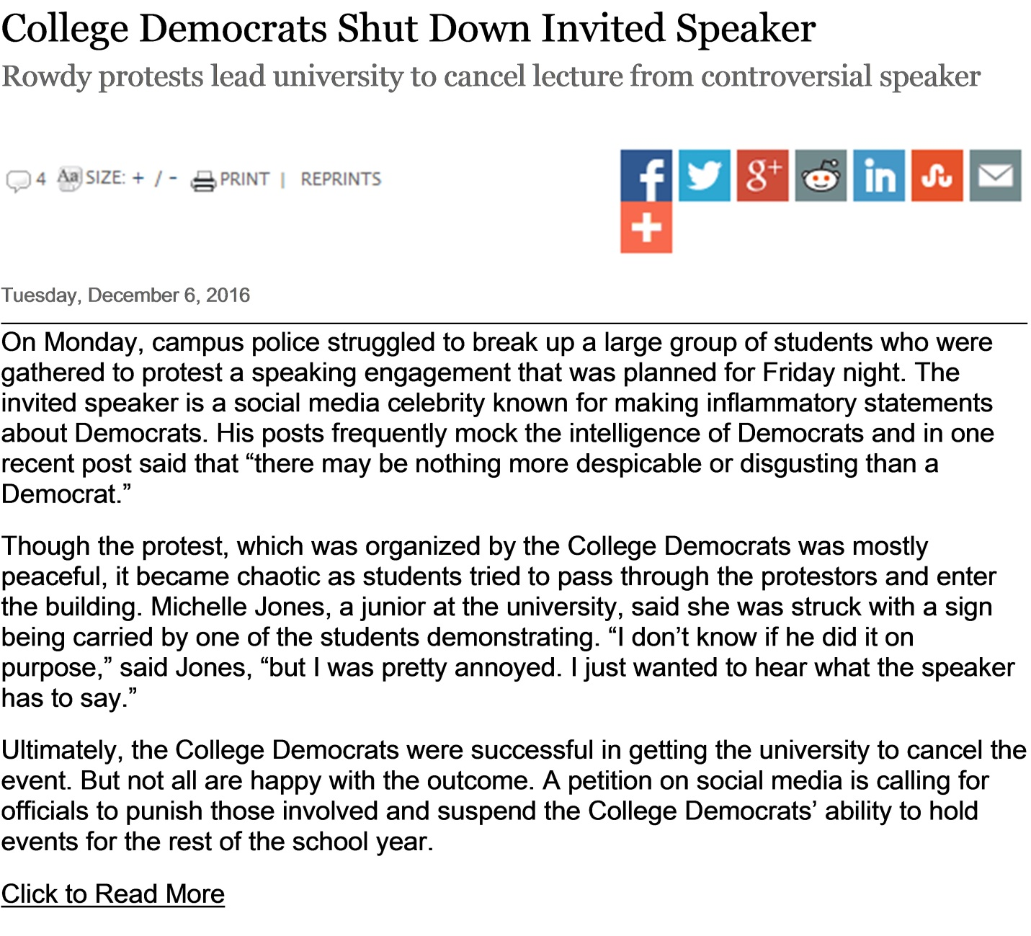
Democratic Speaker Treatment [Randomly shown to half]
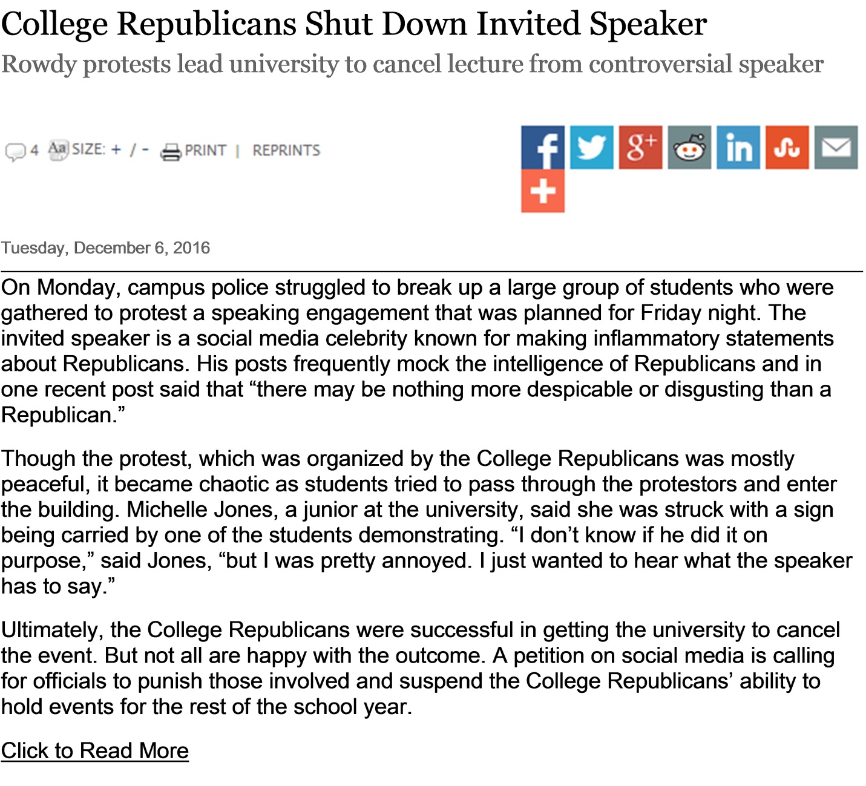

Question Wording for Dependent Variables in Table 2
Censorship
We’d like to know your opinions about this event. To what extent do you agree or disagree with the following statements?
1. This speaker should have never been invited in the first place.
2. The protestors were justified in their actions.
3. The speech should have been allowed in spite of the protest.
4. The university should have done more to protect the speech.
- Strongly Agree
- Agree
- Slightly Agree
- Neither Agree nor Disagree
- Slightly Disagree
- Disagree
- Strongly Disagree

Punishment
Some students called for punishing those who were involved in the protest. How strongly do you favor or oppose each of the following actions by the university?
1. Banning the College [Democrats/Republicans] from holding events on campus for the rest of the year.
2. Suspending students involved in the protest.
3. Expelling students involved in the protest.
- Strongly Favor
- Favor
- Slightly Favor
- Neither Favor nor Oppose
- Slightly Oppose
- Oppose
- Strongly Oppose

Sympathy
As you may recall, Michelle Jones was hit in the head with a sign while trying to enter the talk.

How compassionate do you feel for Michelle, if at all?
- Not compassionate at all
- Not too compassionate
- Somewhat compassionate
- Very compassionate
- Extremely compassionate

How sympathetic do you feel for Michelle, if at all?
- Not sympathetic at all
- Not too sympathetic
- Somewhat sympathetic
- Very sympathetic
- Extremely sympathetic

Schadenfreude
When you think about what happened to Michelle, how amused do you feel, if at all?
- Not amused at all
- Not too amused
- Somewhat amused
- Very amused
- Extremely amused

When you think about what happened to Michelle, how funny do you find it, if at all?
- Not funny at all
- Not too funny
- Somewhat funny
- Very funny
- Extremely funny

Table C3: The Interaction of the Partisan Treatments and the Empathic Concern Factor
 | Censorship  (OLS) |  |  | Punishment  (OLS) |  |  | Sympathy  (Ordinal Logit) |  |  | Schadenfreude  (Ordinal Logit)
 | Coef. | S.E. |  | Coef. | S.E. |  | Coef. | S.E. |  | Coef. | S.E.
Outparty Speaker Treatment | .46* | (.06) |  | -.51* | (.08) |  | -.17 | (.11) |  | .39* | (.11)
Empathic Concern Factor | -.04 | (.05) |  | -.31* | (.06) |  | .79* | (.09) |  | -.65* | (.09)
Outparty X Empathic Concern Factor | .14 | (.07) |  | .04 | (.09) |  | -.05 | (.13) |  | .31* | (.13)
Intercept | 3.25* | (.05) |  | 3.05* | (.05) |  | --- | --- |  | --- | ---
N | 1,061 |  |  | 1,060 |  |  | 1,061 |  |  | 1,061
Coefficients and standard errors estimated using OLS and ordinal logistic regression as noted. Cutpoints for the logistic regression models are estimated but not shown.
*=p<.05

Table C4: The Interaction of the Partisan Treatments, Empathic Concern, and Subject Party Identification
 | Censorship  (OLS) |  |  | Punishment  (OLS) |  |  | Sympathy  (Ordinal Logit) |  |  | Schadenfreude  (Ordinal Logit)
 | Coef. | S.E. |  | Coef. | S.E. |  | Coef. | S.E. |  | Coef. | S.E.
Outparty Speaker Treatment | -.29 | (.46) |  | -1.33* | (.53) |  | -.47 | (.82) |  | -.41 | (.82)
Empathic Concern | -.56 | (.46) |  | -2.09* | (.53) |  | 3.76* | (.83) |  | -4.09* | (.88)
Democratic Subject | .53 | (.39) |  | -.94* | (.45) |  | -.65 | (.70) |  | -.27 | (.71)
Outparty X Concern | 1.29 | (.69) |  | 1.00 | (.80) |  | .53 | (1.22) |  | 1.55 | (1.23)
Outparty X Democrat | .03 | (.58) |  | 1.34* | (.67) |  | 1.21 | (1.03) |  | -1.00 | (1.01)
Concern X Democrat | .18 | (.57) |  | .83 | (.66) |  | 1.01 | (1.02) |  | .61 | (1.05)
Outparty X Concern X Democrat | -.33 | (.84) |  | 1.60 | (.97) |  | -1.84 | (1.48) |  | .93 | (1.48)
Intercept | 3.38* | (.31) |  | 4.74* | (.35) |  | --- | --- |  | --- | ---
N | 1,062 |  |  | 1,061 |  |  | 1,062 |  |  | 1,062
Coefficients and standard errors estimated using OLS and ordinal logistic regression as noted. Cutpoints for the logistic regression models are estimated but not shown.
*=p<.05

Table C5: The Interaction of the Partisan Treatments, Empathic Concern, and Subject Ideological Identification
 | Censorship  (OLS) |  |  | Punishment  (OLS) |  |  | Sympathy  (Ordinal Logit) |  |  | Schadenfreude  (Ordinal Logit)
 | Coef. | S.E. |  | Coef. | S.E. |  | Coef. | S.E. |  | Coef. | S.E.
Outparty Speaker Treatment | -.58 | (.64) |  | -.54 | (.75) |  | 2.05 | (.82) |  | -3.04* | (1.14)
Empathic Concern | -1.47* | (.59) |  | -2.58* | (.68) |  | 6.74* | (.83) |  | -4.60* | (1.10)
Subject Ideology | -.33* | (.11) |  | -.11 | (.13) |  | .51* | (.70) |  | -.27 | (.21)
Outparty X Concern | 1.20 | (.87) |  | .42 | (1.01) |  | -3.26* | (1.22) |  | 4.41* | (1.57)
Outparty X Ideology | .09 | (.17) |  | .02 | (.20) |  | -.53 | (1.03) |  | .58 | (.30)
Concern X Ideology | .31 | (.16) |  | .31 | (.19) |  | -.68* | (1.02) |  | .26 | (.30)
Outparty X Concern X Ideology | -.04 | (.24) |  | -.15 | (.28) |  | .80 | (1.48) |  | -.67 | (.43)
Intercept | 4.63* | (.42) |  | 4.49* | (.49) |  | --- | --- |  | --- | ---
N | 1,062 |  |  | 1,061 |  |  | 1,062 |  |  | 1,062
Coefficients and standard errors estimated using OLS and ordinal logistic regression as noted. Cutpoints for the logistic regression models are estimated but not shown. Ideology coded so that higher values indicate more conservative identification.
*=p<.05

Table C6: Censorship and Schadenfreude, Accounting for Subject Interest

 | Censorship |  | Schadenfreude
 | Coef. | S.E. |  | Coef. | S.E.
Outparty Treatment | -.71* | (.33) |  | -1.58* | (.58)
Empathic Concern | -.17 | (.27) |  | -3.51* | (.49)
Subject Interest | -.17* | (.05) |  | -.21* | (.09)
Outparty X Empathic Concern | .87* | (.38) |  | 1.89* | (.68)
Outparty X Interest | .19* | (.07) |  | .23 | (.12)
Intercept | 3.86* | (.22)
N | 1,062 |  |  | 1,062

Coefficients and standard errors estimated using OLS or ordinal logit as appropriate.
*=p<.05

