SUPPLEMENTAL MATERIAL for
Clan Governance and State Stability:
The Relationship Between Female Subordination and Political Order

Table S1: Clan Governance Index Scores, 2014
COUNTRY
Afghanistan 11
Albania 6
Algeria 7
Angola 7
Argentina 4
Armenia 5
Australia 0
Austria 0
Azerbaijan 9
Bahamas 4
Bahrain 7
Bangladesh 9
Barbados 4
Belarus 5
Belgium 0
Belize 6
Benin 9
Bhutan 6
Bolivia 3
Bosnia 5
Botswana 8
Brazil 4
Brunei 5
Bulgaria 3
Burkina Faso 11
Burundi 7
Cambodia 6
Cameroon 11
Canada 0
Cape Verde 2
Central Afr Rep 8
Chad 11
Chile 5
China 6
Colombia 6
Comoros 6
Congo 7
Costa Rica 4
Cote D'Ivoire 7
Croatia 4
Cuba 3
Cyprus 1
Czech Republic 2
D R Congo 10
Denmark 0
Djibouti 8
Dominican Rep 7
East Timor 8
Ecuador 5
Egypt 8
El Salvador 4
Equat Guinea 9
Eritrea 9
Estonia 1
Ethiopia 7
Fiji 8
Finland 0
France 1
Gabon 9
Gambia 10
Georgia 6
Germany 0
Ghana 10
Greece 3
Guatemala 7
Guinea 11
Guinea-Bissau 7
Guyana 5
Haiti 6
Honduras 6
Hungary 2
Iceland 1
India 10
Indonesia 9
Iran 10
Iraq 10
Ireland 1
Israel 6
Italy 0
Jamaica 3
Japan 3
Jordan 10
Kazakhstan 5
Kenya 11
Kosovo 7
Kuwait 7
Kyrgyzstan 8
Laos 5
Latvia 2
Lebanon 8
Lesotho 7
Liberia 11
Libya 7
Lithuania 1
Luxembourg 1
Macedonia 5
Madagascar 6
Malawi 10
Malaysia 6
Maldives 7
Mali 9
Malta 3
Mauritania 9
Mauritius 3
Mexico 6
Moldova 6
Mongolia 4
Montenegro 5
Morocco 10
Mozambique 9
Myanmar/Burma 6
Namibia 8
Nepal 9
Netherlands 0
New Zealand 1
Nicaragua 5
Niger 10
Nigeria 12
North Korea 4
Norway 0
Oman 6
Pakistan 10
Palestine 6
Panama 4
Papua New Gui 9
Paraguay 2
Peru 6
Philippines 5
Poland 1
Portugal 1
Qatar 8
Romania 4
Russia 5
Rwanda 9
Saudi Arabia 12
Senegal 10
Serbia 5
Sierra Leone 9
Singapore 3
Slovakia 3
Slovenia 2
Solomon Islands 9
Somalia 10
South Africa 7
South Korea 5
South Sudan 11
Spain 1
Sri Lanka 6
Sudan 12
Suriname 6
Swaziland 7
Sweden 0
Switzerland 1
Syria 7
Taiwan 2
Tajikistan 9
Tanzania 11
Thailand 6
Togo 8
Trinidad/Tobago 3
Tunisia 5
Turkey 9
Turkmenistan 8
Uganda 9
Ukraine 3
UAE 9
United Kingdom 1
United States 2
Uruguay 4
Uzbekistan 9
Venezuela 4
Vietnam 8
Yemen 12
Zambia 10
Zimbabwe 10

Figure S1: Details of Factor Analysis
Figure C: Scree plot for Imputed Clan data
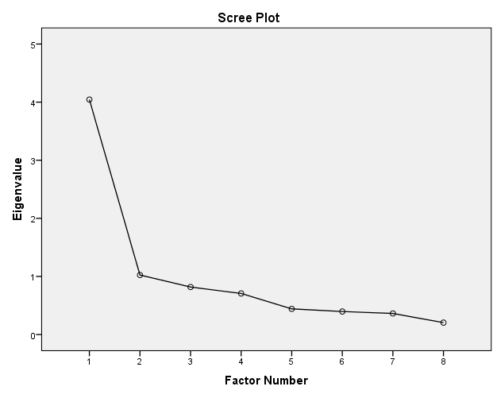
Table S2: Factor Loadings
Variables | Factor loadings
Inequitable Family Law | 0.91
Polygyny | 0.74
Violence against women | 0.72
Cousin marriage | 0.68
Patrilocality | 0.67
Age of marriage | 0.60
Property Rights | 0.56
Honor-based violence | 0.30

TABLES S3-A/B/C/D/E: Parameter Estimates for Best Models
TABLE S3-A: Best Model for Y-GPI 2014
Parameter Estimates
Dependent Variable: GPI2014
Parameter | B | Std. Error | t | Sig. | 95% Confidence Interval
 |  |  |  |  | Lower Bound | Upper Bound
Intercept | 1.094 | .147 | 7.465 | .000 | .805 | 1.384
NEWCLAN | .069 | .016 | 4.390 | .000 | .038 | .100
Dem72013 | .122 | .021 | 5.728 | .000 | .080 | .164
[CIV=1.0] | .244 | .112 | 2.183 | .031 | .023 | .464
[CIV=2.0] | .015 | .087 | .178 | .859 | -.156 | .187
[CIV=4.0] | .022 | .120 | .186 | .853 | -.214 | .258
[CIV=5.0] | 0ª | . | . | . | . | .
a. This parameter is set to zero because it is redundant.

TABLE S3-B: Best Model, Y=Corruption Perception Index 2014

Parameter Estimates
Dependent Variable: CPI2014
Parameter | B | Std. Error | t | Sig. | 95% Confidence Interval
 |  |  |  |  | Lower Bound | Upper Bound
Intercept | 8.055 | 9.692 | .831 | .407 | -11.090 | 27.199
NEWCLAN | -1.178 | .502 | -2.350 | .020 | -2.169 | -.188
Dem72013 | -4.129 | .632 | -6.538 | .000 | -5.377 | -2.882
LogGDP | 17.385 | 2.002 | 8.684 | .000 | 13.431 | 21.339
[CIV=1.0] | -14.921 | 3.133 | -4.763 | .000 | -21.110 | -8.733
[CIV=2.0] | -6.186 | 2.783 | -2.223 | .028 | -11.684 | -.689
[CIV=4.0] | -6.274 | 3.460 | -1.813 | .072 | -13.107 | .560
[CIV=5.0] | 0ª | . | . | . | . | .
a. This parameter is set to zero because it is redundant.

TABLE S3-C: Best Model, Y=Government Effectiveness 2013

Parameter Estimates
Dependent Variable: GovEffect2013
Parameter | B | Std. Error | t | Sig. | 95% Confidence Interval
 |  |  |  |  | Lower Bound | Upper Bound
Intercept | -2.273 | .406 | -5.599 | .000 | -3.074 | -1.471
NEWCLAN | -.037 | .021 | -1.721 | .087 | -.079 | .005
Dem72013 | -.221 | .027 | -8.345 | .000 | -.274 | -.169
LogGDP | .894 | .083 | 10.743 | .000 | .730 | 1.058
[CIV=1.0] | -.339 | .131 | -2.593 | .010 | -.597 | -.081
[CIV=2.0] | -.029 | .116 | -.248 | .805 | -.259 | .201
[CIV=4.0] | .081 | .148 | .548 | .584 | -.211 | .374
[CIV=5.0] | 0ª | . | . | . | . | .
a. This parameter is set to zero because it is redundant.

TABLE S3-D: Best Model, Y=Rule of Law 2013

Parameter Estimates
Dependent Variable: RuleLaw2013
Parameter | B | Std. Error | t | Sig. | 95% Confidence Interval
 |  |  |  |  | Lower Bound | Upper Bound
Intercept | -1.871 | .414 | -4.518 | .000 | -2.689 | -1.053
NEWCLAN | -.058 | .022 | -2.631 | .009 | -.101 | -.014
LogGDP | .866 | .085 | 10.170 | .000 | .698 | 1.034
DEM7 | -.235 | .027 | -8.725 | .000 | -.289 | -.182
[CIV=1.0] | -.669 | .134 | -4.999 | .000 | -.934 | -.405
[CIV=2.0] | -.164 | .118 | -1.384 | .168 | -.397 | .070
[CIV=4.0] | -.077 | .154 | -.501 | .617 | -.382 | .227
[CIV=5.0] | 0ª | . | . | . | . | .
a. This parameter is set to zero because it is redundant.

Table S3-D: Best Model, Y=Fragile States Index, 2014

Parameter Estimates
Dependent Variable: Fragile States Index 2014
Parameter | B | Std. Error | t | Sig. | 95% Confidence Interval |  | Noncent. Parameter | Observed Power^{b}
 |  |  |  |  | Lower Bound | Upper Bound
Intercept | 55.715 | 6.763 | 8.239 | .000 | 42.355 | 69.074 | 8.239 | 1.000
NEWCLAN | 3.610 | .482 | 7.484 | .000 | 2.657 | 4.563 | 7.484 | 1.000
DEM7 | 4.657 | .640 | 7.278 | .000 | 3.393 | 5.921 | 7.278 | 1.000
OverallLiteracyRate | -28.885 | 5.991 | -4.821 | .000 | -40.720 | -17.049 | 4.821 | .998
[CIV=1.0] | 4.440 | 3.013 | 1.474 | .143 | -1.512 | 10.393 | 1.474 | .310
[CIV=2.0] | -5.731 | 2.666 | -2.150 | .033 | -10.998 | -.464 | 2.150 | .570
[CIV=4.0] | .379 | 3.769 | .100 | .920 | -7.067 | 7.824 | .100 | .051
[CIV=5.0] | 0ª | . | . | . | . | . | . | .
a. This parameter is set to zero because it is redundant.
b. Computed using alpha = .05

