**The Adverse Effects of Sunshine**

**Evidence from a Field Experiment on Legislative Transparency in an Authoritarian Assembly**

**Web Appendix**

*This Appendix will not be in the published version, but includes information requested by anonymous reviewers. If the paper is published, we will make this Appendix available on our personal websites.*

**1. Summary of Experimental Design and Key Findings**

**2. Sample Website for an Individual Delegate**

**3. Portion of Chart Comparing Participations of Delegates**

**4. Sample Score Card of an Individual Delegate**

**5a. Relationship between Vote Share and Participation**

**5b: Determinants of Participation in June 2010 Session**

**6. Partial Effect of Internet Penetration on Page Views.**

**7. Interaction between Transparency Treatment and Stratification Variables** (5th v. 6th Session)

**8. Interaction between Transparency Treatment and Stratification Variables** (6th v. Average)

**9. Interaction between Transparency Treatment and Stratification Variables (Similar Ministers)**

**10. Intensity of Treatment Effect (Similar Ministers**)

**11. Robustness Tests for Treatment Intensity**

11a. Scatterplot Matrix of Alternative Measures of Treatment Intensity

11b. Robustness of Intensity of Treatment Effects (5th v. 6th Session, 6th v. Avg.)

11c. Robustness Tests for Treatment Intensity (Similar Ministers)

**12. Robustness Test for Threshold Levels of Internet Penetration**

**13. Alternative Hypotheses for Treatment*Internet Interactions**

**Appendix 1: Summary of Experimental Design and Key Findings**

This project was motivated by the desire to perform a limited test of transparency initiatives in an authoritarian environment. The VNA offered an ideal forum for such a test because of its biannual query sessions, where universally-elected delegates representing particular geographic regions are allowed to quiz the Prime Minister and cabinet on their performance, pending legislation, and other issues of the day. As part of the experiment, Vietnam’s highest profile online newspaper, *VietnamNet*, created a new political column called “Know Your Delegates.” Under this column, we developed individual websites for 144 randomly selected delegates, where we posted legislative debates, query transcripts, and scorecards for each delegate and updated them in real time throughout the 6th legislative session.

This experimental design allowed us to compare the changes in participation of treated delegates to a control group of 317 delegates, who did not have their performance posted. The treatment for the selected delegates was designed to be powerful; a *VietnamNet* reporter met each of the delegates in person and handed them an official letter explaining that they would be assessed based on the quantity of their participation in legislative and query sessions, as well as how well they represented their provincial constituencies. At the time of the treatment, delegates were well aware of the popularity of *VietnamNet*, which receives about thirty million page views a week. Indeed, during the time of the 6th query session, our “Your Delegates” column became well-known in the country’s political media, receiving over 1.3 million page views and 820,000 hits on individual delegates’ pages.

In the first set of analyses, we study the direct effects of the treatment on delegate behavior, looking specifically at whether delegates were more active and critical than in previous VNA sessions. While some delegates increased the level and quality of their activity, others significantly reined in their activities. As a result, the net treatment effect is not significantly different from zero in any of the specifications. Because our experiment protocol called for blocking on whether the delegate was a central versus local nominee, full-time or part-time, and delegate age, we also were able to study heterogeneous treatment effects by delegate type. In all cases, the treatment effect was not significantly different from zero. The findings make us cautious about the ability to successfully export legislative transparency initiatives to an authoritarian setting.

One element of our experimental design, however, did yield extremely important, but slightly more speculative, results. It is crucial to note that the proportion of the Vietnamese population who read online newspapers varies dramatically across Vietnam. As a result, our treatment intensity also varies across delegates, as their constituents are located in different provinces with varying levels of internet penetration and therefore varying levels of access to their delegates’ web pages. This variation allows us to observe the effects of different treatment intensities and provides important insights into our understanding of the adverse consequences of legislative transparency in authoritarian parliaments.

We find that as internet penetration increases, delegates increase their visible effort in non-sensitive activities by participating more frequently in legislative debates, where there are limited political consequences to their actions. However, these delegates also significantly reduce the quality of their engagement. Furthermore, treated delegates ask fewer questions and are less critical of the national government and its policies in the biannual query sessions. The results remain strong after controlling for structural covariates with internet penetration, such as wealth, population size, good governance, and transfer dependence. The results remain unchanged when we use alternative measures of treatment intensity such as the proportion of population living in urban areas or studying in colleges.

Finally, we probe the downstream electoral effects, finding that treated delegates are 9% less likely to be re-nominated, and ultimately re-elected, in the 2011 election. The key question is whether these electoral effects result from a voter selection mechanism, as hypothesized in democratic elections, or whether elections are used as a mechanism to allow central elites to reward (or punish) delegates who live up to (or fail to abide by) the cooptive agreement. Further analysis reveals that the mechanism appears to be the punishment of delegates, who do not conform by limiting their activity in query sessions. Treated delegates who spoke during query sessions were placed in more difficult to win districts, received lower vote shares, and were less likely to be promoted to higher office after the election. We find no evidence that voters were affected at all by the intervention. The treatment effects on turnout, spoiled ballots, and voter interest in the VNA were not significantly different from zero. This provides further evidence that transparency initiatives play a fundamentally different role in an authoritarian context, and that elections are one means by which authoritarian elites choose to structure political power-sharing.

**Appendix 2: Sample Website for an Individual Delegate**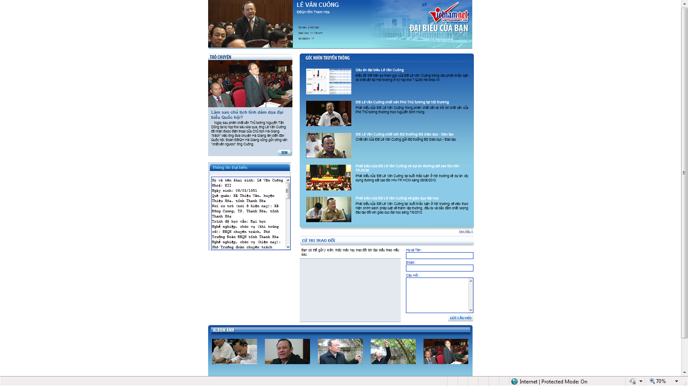

Page URL: <http://daibieuquochoi.vietnamnet.vn/lever.aspx?id=35>

**Appendix 3: Portion of Chart Comparing Participations of Delegates**

(The full chart showed all 154 treated delegates and was posted in the prime location on the political homepage of the newspaper throughout the two months of the National Assembly’s session)

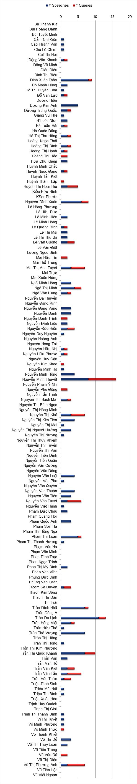

Chart URL: <http://daibieuquochoi.vietnamnet.vn/content.aspx?id=888>

**Appendix 4: Sample Score Card of an Individual Delegate**

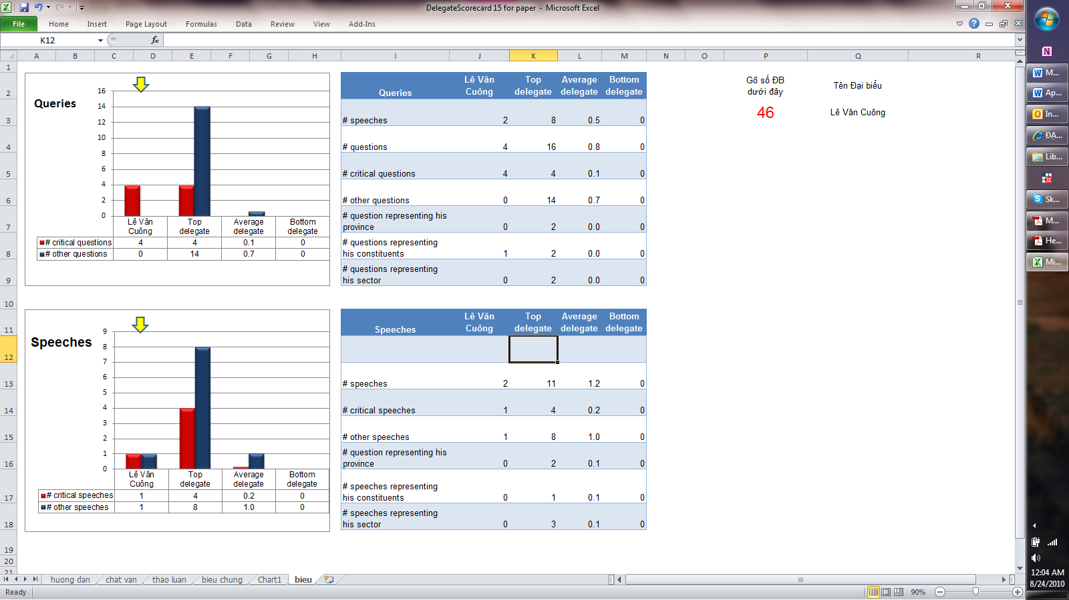

URL of the actual scorecard of this delegate: http://daibieuquochoi.vietnamnet.vn/content.aspx?id=1017



**Appendix 5a: Relationship between Vote Share and Participation**. We display the bivariate correlation between vote share and participation in query sessions in all six sessions. The statistically significant negative relationship in the final four sessions indicates that delegates are responding either to voters or local leaders who arrange provincial electoral districts. Note that Session 6 demonstrates the same pattern as previous sessions and the relationship is not altered by proximity to the 11th Party Congress.

**Appendix 5b: Determinants of Participation in June 2010 Session**This table depicts the results of the field-experiment across five different dependent variables and four different types of analyses. The dependent variable are: 1) Number of speeches made by a delegate; 2) Number of questions asked by a delegate; 3) Percentage of queries which were critical of ministers, ministries, or the national government; 4) Percentage of questions which used the name of the province the delegate represents; 5) Percentage of questions which used the words "constituency" or "voter." Analysis was divided into four separate tests: A) Difference-in-Levels within Session 6. For this analysis, negative binomial regression was employed for the first two variables, as they are count variables demonstrating evidence of over-dispersion. Log-linear regression was employed on the second three variables, as these were percentages censored at 0 on the left-side and 100 on the right-side. Robust standard errors, clustered at provincial-level are shown in parentheses (*** p<0.01, ** p<0.05, * p<0.1).



**Appendix 6: Partial Effect of Internet Penetration on Page Views.** This figure displays the partial correlation between internet penetration and total page views (measured in 100s) after controlling for stratification variables and provincial covariates (Models 4 & 5 of Table 4). The first panel uses the full sample of delegates, while the second panel drops the two outliers which appear to be driving the result. In the fully-specified model with dropped outliers, a 1% increase in internet penetration accounts for 3,700 additional page views on a delegate's main page, scorecard, or interview page.

**Appendix 7: Interaction between Transparency Treatment and Stratification Variables**(Difference in Differences between Session 5 (November 2009) and Session 6 (June 2010))  
This table depicts the results of the field-experiment across two different dependent variables. In this analysis, the transparency treatment is interacted with core determinants of query session participation that were used as stratification variables in the randomization process. The dependent variables are: 1) Number of questions asked by a delegate; 2) Percentage of queries which were critical of ministers, ministries, or the national government. OLS Coefficients are displayed with robust standard errors, clustered at provincial-level, in parentheses (*** p<0.01, ** p<0.05, * p<0.1).

**Appendix 8: Interaction between Transparency Treatment and Stratification Variables**(Difference in Differences between Average Delegate Performance Sessions (1-5) and Session 6 (June 2010))  
This table depicts the results of the field-experiment across two different dependent variables. In this analysis, the transparency treatment is interacted with core determinants of query session participation that were used as stratification variables in the randomization process. The dependent variables are: 1) Number of questions asked by a delegate; 2) Percentage of queries which were critical of ministers, ministries, or the national government. OLS Coefficients are displayed with robust standard errors, clustered at provincial-level, in parentheses (*** p<0.01, ** p<0.05, * p<0.1).

**Appendix 9: Interaction between Transparency Treatment and Stratification Variables**(Difference in Differences between similar ministers in previous sessions and Session 6 (June 2010))  
This table depicts the results of the field-experiment across two different dependent variables. In this analysis, the transparency treatment is interacted with core determinants of query session participation that were used as stratification variables in the randomization process. The dependent variables are: 1) Number of questions asked by a delegate; 2) Percentage of queries which were critical of ministers, ministries, or the national government. OLS Coefficients are displayed with robust standard errors, clustered at provincial-level, in parentheses (*** p<0.01, ** p<0.05, * p<0.1).

**Appendix 10: Intensity of Treatment Effects**(Interaction between Treatment and Internet Penetration)  
This table depicts the results of the field-experiment across four different dependent variables. In this analysis, the treatment is interacted with internet penetration to derive an exogenous intensity of treatment effect. The dependent variables are: 1) Number of questions asked by a delegate; 2) Percentage of queries which were critical of ministers, ministries, or the national government. All analyses used OLS on the first differences between sessions. Robust standard errors, clustered at provincial-level, are shown in parentheses (*** p<0.01, ** p<0.05, * p<0.1). The first model in each set is unadjusted, the second model controls for individual-level stratification variables, and the third model controls for provincial covariates that might be associated with internet penetration.

**Appendix 11: Robustness of Intensity of Treatment**

Before concluding that the adverse consequences hypothesis better explains behavior in authoritarian setting, additional robustness tests are required. Because internet penetration is a provincial-level variable that was not considered in the randomization exercise, its usage raises concerns about spurious correlation. If H1 is correct that delegates who faced greater public scrutiny as a result of the treatment would be most likely to act in a conformist manner, we should observe the same behavior with alternative measures of public scrutiny. In Appendix 11, we re-run the four full specifications from Table 5, but employ three alternative measures of intensity. First, we use the share of the population that lives in urban areas, as urban citizens have greater access to print media, which found and began to discuss the “Know Your Delegate” page. In addition, higher population density means that word travels faster about a delegate’s questions, and delegates are more likely to interact directly with constituents, co-workers, and local leaders, who may be aware of their participation. Secondly, we use the share of the population employed in government offices or state-owned-enterprises (SOEs) to capture the level of political awareness of the population. Third, we take the percentage of college students in the population, as the younger generation is more politically attuned and technologically savvy enough to access *VietnamNet.* Appendix 11a shows that these alternative measures of intensity are positively correlated with internet penetration, but are far from perfect substitutes.

**Appendix 11a: Scatterplot Matrix of Alternative Measures of Treatment Intensity**



Appendix 11b reveals that the alternative measures of treatment intensity demonstrate a similar pattern in all specifications. Although the findings are only statistically significant when it comes to the number of questions asked for urbanization and college share, the robustness of the pattern is telling. The interaction between the treatment and intensity measure is always negative and sizable, indicating that increased exposure reduces the willingness of delegates to participate and criticize. This is strong evidence for the adverse consequences hypothesis**.**

**Appendix 11b: Robustness of Intensity of Treatment Effects**  
This table replicates models 4,8, 9, and 10 of Table 5. Instead of internet penetration, however, three other measures of treatment intensity are employed to test for robustness (urban population share, state labor share, and college student share of population). The dependent variables are: 1) Number of questions asked by a delegate; 2) Percentage of queries which were critical of ministers, ministries, or the national government. Panel A uses Difference-in-Differences between Session 6 and Session 5. Panel B analyzes Difference-in-Differences between Average Questions and Session 6. All analyses used OLS on the first differences between sessions. Robust standard errors, clustered at provincial-level, are shown in parentheses (*** p<0.01, ** p<0.05, * p<0.1). All models include controls for stratification variables and provincial covariates.

**Appendix 11c: Robustness of Intensity of Treatment Effects**  
This table replicates models 3 and 6 of Appendix 10. Instead of internet penetration, however, three other measures of treatment intensity are employed to test for robustness (urban population share, state labor share, and college student share of population). The dependent variables are: 1) Number of questions asked by a delegate; 2) Percentage of queries which were critical of ministers, ministries, or the national government. Panel A uses Difference-in-Differences between Session 6 and Session 5. Panel B analyzes Difference-in-Difference between Average Questions and Session 6. All analyses used OLS on the first differences between sessions. Robust standard errors, clustered at provincial-level, are shown in parentheses (*** p<0.01, ** p<0.05, * p<0.1). All models include controls for stratification variables and provincial covariates.

**Appendix 12: Robust to Threshold Levels of Internet Penetration**This table replicates the fully-specified Models 4, 8, 9, and 10 (Table 5) and Model 4 (Table 6). Instead of a continuous measure of internet penetration, however, we test its robust to a dichotomous measure in order to see whether a threshold level of internet penetration is more appropriate. Panel A sets the cut-off level of internets in the household at 4%, while Panel B sets it at 6%. All analyses use OLS. Robust standard errors, clustered at provincial-level are shown in parentheses. All model include controls for stratification variables and provincial covariates and employ robust standard errors clustered at the provincial level (64 provinces, shown in parentheses, *** p<0.01, ** p<0.05, * p<0.1).

**Appendix 13: Alternative Hypotheses for Treatment*Internet Interactions**This table replicates the fully-specified Models 4 and 8 (Table 5) and Model 4 (Table 6). Instead of internet penetration, however, we test alternative hypotheses, by interacting the treatment with 1) transfers/own source revenue; 2) GDP per capita; and 3) Population size.. All model include controls for stratification variables and provincial covariates and employ robust standard errors clustered at the provincial level (64 provinces, shown in parentheses, *** p<0.01, ** p<0.05, * p<01). Two interesting results do emerge. First, treated delegates in richer provinces are more likely to engage in non-sensitive behavior. Second, treated delegates in populous provinces ask 0.34 questions than their counterparts, reinforcing the adverse consequences hypotheses.