Supplemental information 1:

Excavation Methods
The assemblage presented here is from a mission period midden (Feature 26) located on the slope of a river terrace just west of the Mission Guevavi church and convento. The midden was heavily rodent disturbed and was targeted by the National Park Service (NPS) for archaeological mitigation. The feature is located on land owned by Tumacácori National Historic Park. The land was purchased by the Arizona Archaeological Conservancy and donated to the NPS in 1991 over concerns of looting. The feature that produced the vertebrate samples reported here was excavated as part of the fieldwork portion of the 2013 Mission Guevavi Archaeological Field School, a collaborative effort among the Arizona State Museum, University of Arizona, and Tumacácori National Historic Park, and Desert Archaeology. Two 2-x-2-m units (Units 2 and 3) were excavated as part of the field school, in addition to a portion of an adobe structure likely from the colonial period and a roasting pit, and two, likely Hohokam, pit house hearths.
By far the greatest quantity of vertebrate remains was unearthed from Units 2 and 3 from Feature 26, a mission period midden. Vertebrate remains were the most abundant artifact class in both units, followed by native historical period plain ware ceramics and lithics, and to a lesser degree imported majolica, Chinese porcelains, olive jar style earthenware, and metal fragments. Charred macrobotanical samples of peach pits and maize as well as Sobaipuri points and glass beads found at every level, in addition to the ceramics listed above, make it highly probable that the vast majority of the materials were deposited while the Jesuit mission was active. Glassy and ferrous slag was also found in Units 2 and 3. Because of the large amount bioturbation and the location of the midden on an eroding incline, the slag wastes produced were either a result of mission period metallurgical activity or were the by-products of a later reoccupation of the site during the Mexican period by miners lasting a few years (Robinson and Barnes 1976).
The midden units were excavated in 10-cm arbitrary levels in 3 designated cultural strata: 4, 50, and 50.1. Field recovery employed ¼-inch mesh to recover materials during excavation. Additionally, the excavation collected 6 L per level of material sorted through ⅛-inch mesh, and 2-liter flotation samples per level. These materials are included in the final report of the 2013-2015 field school excavations (Thiel and Pavao-Zuckerman 2016). Three strata were identified in the units, and are described in Table S.1:
Table S.1 Mission Guevavi, Feature 26: Stratum Description
Stratum | Associated Levels | Description
4 | 1  (0–10 cm below surface) | Loose, silty organic surface overburden.
50 | 1, 2, 3, 4  (10–50 cm below surface) | Silty loam, ashy bioturbated loam. Ash pockets and large animal bone at Level 4
50.1 | 1, 2, 3  (50–80 cm below surface) | Silty loam with intact ash pockets and animal bone. Level 3 ended with a sterile cobble layer.

Figure S.2. Mission Guevavi, Feature 26, Unit 2: Counts of NISP and slag quantities by level.

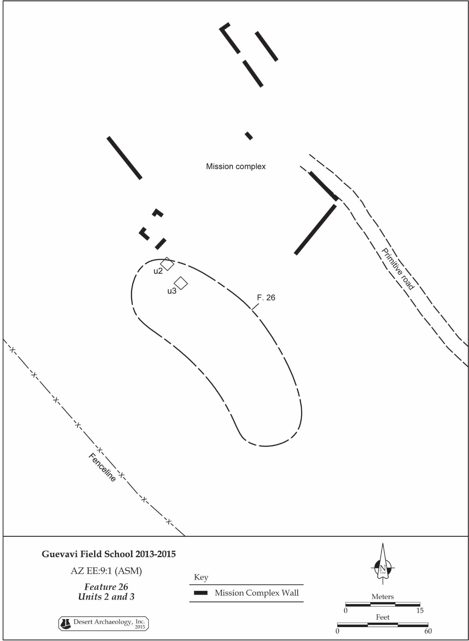
S2. Plan view showing the location of Feature 26 in relation to the mission chapel and convento, the Guevavi Mission, AZ EE:9:1 (ASM). From (Thiel and Pavao-Zuckerman 2016:24).

