Supplemental Material for Bayesian Modeling of the Clovis and Folsom Radiocarbon Records Indicates a 200-Year Multigenerational Transition
Briggs Buchanan, J. David Kilby, Jason M. LaBelle, Todd A. Surovell, Jacob Holland-Lulewicz, and Marcus J. Hamilton

Bayesian Chronological Modeling

Bayesian statistics allow us to “analyze new data we have collected about a problem in the context of our existing experiences and knowledge about that problem” (Bayliss 2007:75). By doing so, we can “arrive at a new understanding of the problem which incorporates existing understandings about the problem and our new data” (Bayliss 2007:75). To use the associated terminology, new data, or observations, can be referred to as ‘likelihoods.’ Existing experiences and knowledge are referred to as ‘prior beliefs’ or a priori information. The resulting understandings we achieve from incorporating our prior beliefs into the analysis of new data are understood to be ‘posterior beliefs.’ Bayesian statistics are uniquely situated for the analysis of radiocarbon data because of their focus on probabilities. As extensive overviews of Bayesian analysis of radiocarbon dates have been published by experts in the technique (e.g. Bayliss 2015, 2007; Bayliss et al. 2007; Bronk Ramsey 2009a; Buck et al. 1996; Whittle et al. 2011), only a brief introduction is provided here. The results of “scientific dating are always interpreted contextually” and Bayesian statistics “provide an explicit, quantitative method which can combine raw dates with other prior information included in a model to produce formal statistical date estimates which combine both sets of evidence” (Bayliss 2007:76). In the following case, radiocarbon determinations represent likelihoods. The association of radiocarbon dates and archaeological sites assigned to particular cultural traditions (especially based on particular stone tool technologies) represent our posterior beliefs. The results of the Bayesian modeling efforts (defined temporal ranges, spans, and overlaps for regional Clovis and Folsom traditions) represent the posteriors. All models were built using OxCal v 4.4 (Bronk Ramsey 2021, 2009a) and the IntCal20 calibration curve (Reimer et al. 2020).
Adopted by researchers for use in archaeological applications over two decades ago (e.g. Buck et al. 1991, 1992, 1994, 1996; Christen 1994; Christen and Litton 1995; Christen et al. 1995), Bayes’ theorem can be expressed mathematically as follows:

Where t represents a set of parameters, y represents observations or measurements, p(y|t) is the likelihood, and p(t|y) is the posterior probability, or the probability of a given parameter set given the measurements and the priors (Bronk Ramsey 2009a:338). This is expressed in a simpler manner by Bayliss (2007:76) and reads as follows:

Where the likelihood is determined by the probability of the data or observations given the set parameters and is proportional to the probability of the parameters themselves. The combination of these two, observations/measurements and prior information or beliefs is where the value of Bayesian statistical methods lie, especially in regards to interpreting radiocarbon data.
Because radiocarbon dates are actually measurements of isotopic ratios, in order to be read as proxies for calendrical dates they must be calibrated against an established calibration curve that reflects fluctuations in atmospheric carbon isotopes over time (see Scott and Reimer 2009 for a detailed overview; Reimer et al. 2020). The process of calibrating a radiocarbon determination thus results in a probability distribution along which the actual calendrical age of the sample likely lies. The incorporation of prior information about these observations allows for a formal assessment of observations as well as a formal evaluation of the prior assumptions used to interpret the data. Thus, a formalized Bayesian model allows for the simultaneous, quantitative evaluation of both radiocarbon data and our assumptions about the archaeological record. Through these efforts, the probability distributions of radiocarbon determinations can be modeled using this prior information and may significantly enhance both the precision and accuracy of chronometric dating by producing modeled posterior probability distributions. Arguably the strongest prior information we have as archaeologists are the depositional environments from which radiocarbon data are. More general priors including culture-historic frameworks, ceramic sequences, settlement patterns, stone tool traditions, and documentary evidence can also be employed as prior information. When using more generalized prior information, the assumptions employed may serve as a working hypothesis on which the analysis is based (Bronk Ramsey 2009a:348).

Terminology and Commands

A more thorough discussion of the mathematical expressions underlying each of the parameters discussed below is presented by Bronk Ramsey (2009a:348). One of the simplest parameters to impose on a group of radiocarbon dates is their inclusion in a phase. A phase is an unordered group of events. When dates are grouped in a phase, it is assumed that all dates within the group are equally likely to occur anywhere between the start and end boundaries of the phase. No information concerning order is assumed. For the grouping of dates into a phase to serve as an informative parameter (sensu Bayliss 2007), the phase must be given start and end boundaries. The use of particular kinds of boundaries defines how events (dates) are distributed within the phase. The distributional parameters imposed by particular types of boundaries provide another set of informative parameters that will produce variation in model outputs.
In this study, simple boundary commands were used as well as more complex trapezium boundaries. Whereas the use of the boundary command assumes a uniform distribution of observations within a phase, trapezium boundaries are used to account for the unknown temporalities of start and end events (Lee and Bronk Ramsey 2012). Trapezium boundaries include two transition parameters that allow for flexibility and “reflect archaeological situations in which start and end boundaries could be more realistically expressed by a transition period from a beginning to a peak, and a similar decline towards the end” (Higham et al. 2014: Supplemental 111). Thus, trapezium models are appropriate for evaluating the temporal ranges for stone tool traditions across a region that likely exhibit periods of transition that relate to their initial adoption and eventual abandonment as a valid technology.
Models can also be built by including multiple phases within a model and defining the relationships between those phases. The primary model presented below incorporates the dates from individual Clovis and Folsom sites into individual phases that correspond to each site within an overlapping model. For example, all dates from the Mountaineer site were included in a single phase and given simple start and end boundaries. These individual sites representing the regional Folsom tradition were then included together in an overarching phase for the Folsom tradition which was given trapezium boundaries to model the start and end estimates for the regional Folsom tradition. An overlapping model like this assumes no ordering of the phases (individual sites) included in the model and allows for start and end boundaries of each phase to overlap with temporally adjacent, or contemporaneous, phases (as defined by the radiocarbon determinations). Models were built in this way for both Clovis and Folsom traditions. This method represents the primary modeling procedures.
A range of alternative methods used are described below for each individual alternative model. One of these methods can be referred to as a ‘phase of boundaries’ method. Instead of grouping individual sites into overarching phases based on similar stone tool traditions (Clovis or Folsom), individual sites were modeled with no reference to other sites. Boundaries for each individual site model were then saved as priors. All end boundaries for modeled Clovis sites were then included in an independent phase using the prior command. Start and end boundaries were then modeled for this ‘phase of boundaries’ to determine an overall end boundary for the Clovis tradition. This method has recently been used by others to estimate age ranges for regional archaeological traditions and cultures (e.g., Becerra-Valdivia and Higham 2020; Higham et al. 2014; Whittle et al. 2011).
Another set of concepts relevant to the current study that need defining are outliers and outlier models. A full review of the kinds of outliers and outlier models that may be applied in Bayesian analyses for archaeological applications can be found in Bronk Ramsey (2009b). Outlier models are used to “determine whether there are problematic determinations that do not agree with the prior framework” (Higham et al. 2014: Supplemental 6). The model output is thus affected by the down-weighting of particular determinations based on the modeled fit of each outlier. To assess the effects of these model parameters on outputs, the same model frameworks for many of the alternative models were run with and without the application of outlier models.
Lastly, span and difference commands were included to estimate the length of the lifespan for each tradition as well as the potential overlap of the Clovis and Folsom traditions. The span command was used to produce an estimated length for the use of Clovis tools and for the use of Folsom tools. This command produces modeled span in years with associated credibility intervals. The difference command was applied to the start boundary for Folsom and the end boundary for Clovis. This command, with these criteria, produces the estimate overlap (or gap) between the two indicated boundaries, providing a length (in years) with an associated credibility interval.
In total, a primary modeling procedure and six alternative modeling procedures were used to evaluate the timing, temporality, and overlap of Clovis and Folsom traditions in the western United States. Although each alternative model represents alterations to prior information and model structures, all models produces comparable results for all outputs in question (e.g., Clovis end boundaries, Folsom start boundaries, and the overlap between these boundaries) within merely a few decades, indicating the reproducibility of our results given our particular data set. The models employing outlier commands do exhibit a lowered degree of precision, with broader and longer ranges of uncertainty, but still produce comparable age ranges to the primary model and the alternative models.

A Note on Data

The likelihoods for our Bayesian models are represented by 71 radiocarbon determinations. Of these 71 determinations, 34 are from 12 Clovis sites while 37 are from 14 Folsom sites. In all cases, each site represents a single component site. Further, in the majority of cases, no stratigraphic or depositional information could be used to model internal site chronologies. As such, the prior information used in our modeling efforts are twofold: 1) the association of radiocarbon determinations with particular single-component occupations (in the form of grouping determinations the same site into a single phase); 2) the association of individual sites with regional traditions (individual site models incorporated into regional models based on their associations with either Clovis or Folsom traditions). In addition, 6 of our sites yield but a single date. The nature of our dataset and available priors is what is used to justify our choice of primary model over any of the alternative models. In particular, the ‘phase of boundaries’ method that defines Alternative Models E and F would be more appropriate for cases with much larger datasets and much more informative prior information (e.g., stratigraphy). Our choice of separate, overlapping models for both Clovis and Folsom traditions is a strong, simple choice for our modeling goals and allows for sites with only a single date to be included in the regional models (unlike the ‘phase of boundaries’ method, which works only from sites with multiple dates in which start and end boundaries can be effectively modeled). Additionally, as the ‘phase of boundaries” models only work from the limited set of saved priors from independent models, they don’t take into account the full range of uncertainty associated with the entire set of radiocarbon data and prior information. That said, all models below, primary and alternative, produce virtually the same results.

Primary Model

For the primary model, dates from individual sites were grouped into phases that represent each individual site. Each individual site phase was given start and end boundaries to produce modeled start and end estimates for each individual site. Each of these individual site-based phase models was then included in an overarching, overlapping phase based on its associated traditions: either Clovis or Folsom. As such, one overlapping model of Clovis sites was used to produce age estimates for the regional Clovis tradition and one overlapping model of Folsom sites was used to produce age estimates for the regional Folsom tradition. Both Clovis and Folsom regional phases were modeled with trapezium boundaries. Span commands were used to produce length estimates for each tradition. While Clovis and Folsom models were independent of one another, they were run in the same OxCal plot that included a difference command to estimate the difference (in years) between the modeled start boundary for the Folsom tradition and the modeled end boundary for the Clovis tradition. The procedures employed to produce the primary models are consistent with recent published models for estimating Folsom age ranges in the same region (Buchanan et al. 2021).
The model exhibits an A_{model} of 97.8 and an A_{overall} of 98.1. The end boundary for the Clovis tradition is modeled to 12,690-12,570 cal BP (68% CI) or 12,710-12,460 cal BP (95% CI) while the start boundary for the Folsom tradition is modeled to 12,850-12,770 cal BP (68%) or 12,920-12,750 cal BP (95% CI) (Figure S1). The difference command estimates an overlap of 120-280 years (68% CI) or 80-400 years (95% CI) between the end of the Clovis tradition and the start of the Folsom tradition (Figure S2). The span of the Clovis tradition models to 610-780 years (68% CI) or 500-870 years (95% CI) (Figure S3) while the span of the Folsom tradition models to 360-530 years (68% CI) or 320-670 years (95% CI) (Figure S4). The modeled end boundaries for all Clovis sites and the modeled start boundaries for all Folsom sites are plotted as Figure S5.

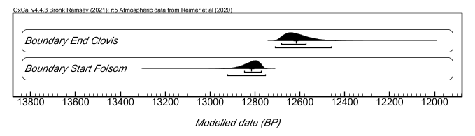
Figure S1. OxCal plot depicting the modeled end boundary for the Clovis tradition and the modeled start boundary for the Folsom tradition with bars representing the 68% and 95% credibility intervals and the median for each posterior distribution denoted by a black tick mark.

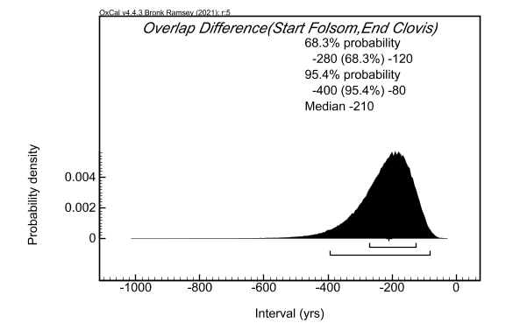
Figure S2. OxCal plot depicting the modeled difference (overlap) between the modeled start of the Folsom tradition boundary and the modeled start of the Clovis end boundary with bars representing the 68% and 95% credibility intervals and the median for the posterior distribution denoted by a black tick mark.
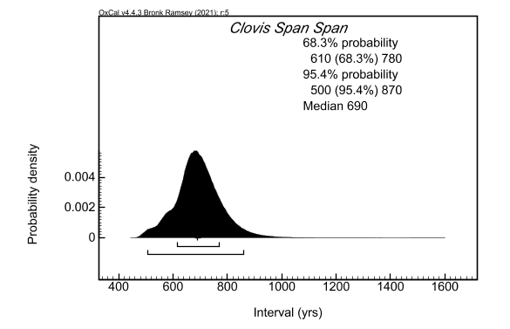
Figure S3. OxCal plot depicting the modeled span for the Clovis tradition with bars representing the 68% and 95% credibility intervals and the median for the posterior distribution denoted as a black tick mark.

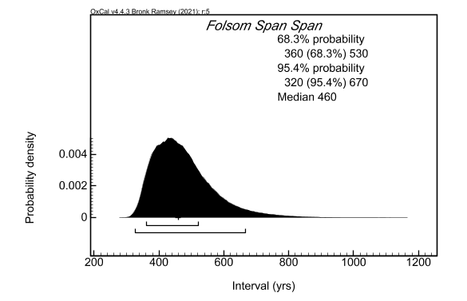
Figure S4. OxCal plot depicting the modeled span for the Folsom tradition with bars representing the 68% and 95% credibility intervals and the median for the posterior distribution denoted as a black tick mark.

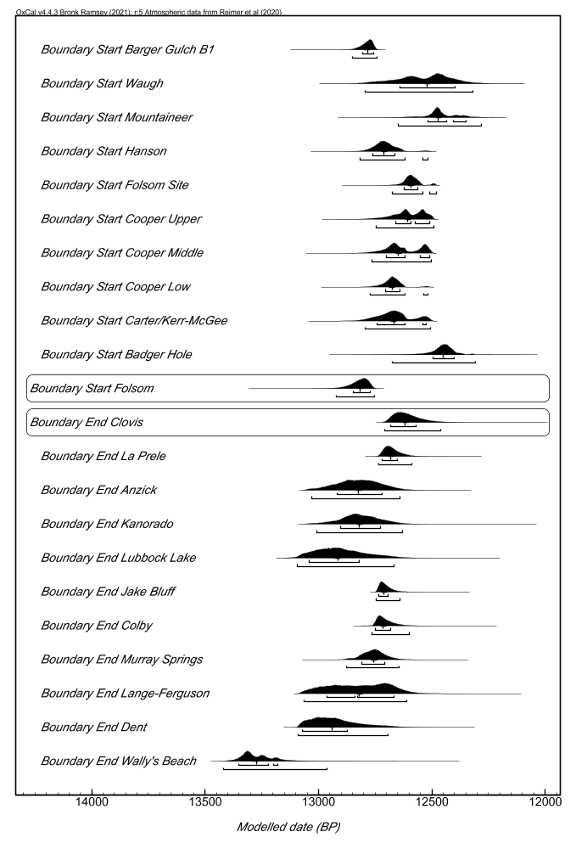
Figure S5. OxCal plot depicting modeled end boundaries for all Clovis sites (and the modeled end of the Clovis tradition) and the modeled start boundaries for all Folsom sites (and the modeled start of the Folsom tradition) with bars representing 68% and 95% credibility intervals and the medians for the posterior distributions denoted by black tick marks.

Alternative Model A

Alternative Model A is identical to the Primary model except for its use of simple boundary command in place of trapezium models for the overarching Clovis and Folsom phases. Dates from individual sites were grouped into phases that represent each individual site. Each individual site phase was given start and end boundaries to produce modeled start and end estimates for each individual site. Each of these individual site-based phase models was then included in an overarching, overlapping phase based on its associated traditions: either Clovis or Folsom. As such, one overlapping model of Clovis sites was used to produce age estimates for the regional Clovis tradition and one overlapping model of Folsom sites was used to produce age estimates for the regional Folsom tradition. Both Clovis and Folsom regional phases were modeled with simple boundaries. Span commands were used to produce length estimates for each tradition. While Clovis and Folsom models were independent of one another, they were run in the same OxCal plot that included a difference command to estimate the difference (in years) between the modeled start boundary for the Folsom tradition and the modeled end boundary for the Clovis tradition.
The model exhibits an A_{model} of 98.6 and an A_{overall} of 98.2. The end boundary for the Clovis tradition is modeled to 12,700-12,580 cal BP (68% CI) or 12,720-12,480 cal BP (95% CI) while the start boundary for the Folsom tradition is modeled to 12,830-12,760 cal BP (68%) or 12,900-12,740 cal BP (95% CI) (Figure S6). The difference command estimates an overlap of 100-240 years (68% CI) or 60-360 years (95% CI) between the end of the Clovis tradition and the start of the Folsom tradition (Figure S7). The span of the Clovis tradition models to 610-780 years (68% CI) or 500-880 years (95% CI) (Figure S8) while the span of the Folsom tradition models to 350-520 years (68% CI) or 320-660 years (95% CI) (Figure S9).

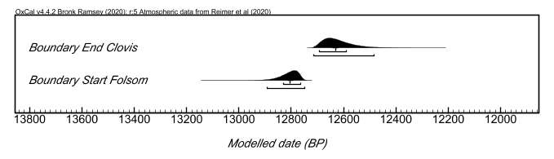
Figure S6. OxCal plot depicting the modeled end boundary for the Clovis tradition and the modeled start boundary for the Folsom tradition with bars representing the 68% and 95% credibility intervals and the median for each posterior distribution denoted by a black tick mark.

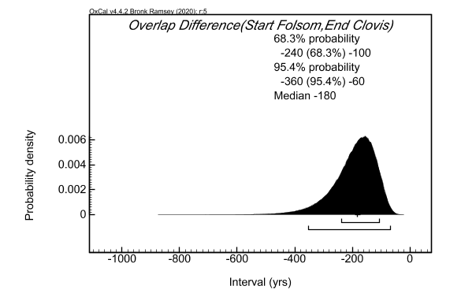
Figure S7. OxCal plot depicting the modeled difference (overlap) between the modeled start of the Folsom tradition boundary and the modeled start of the Clovis end boundary with bars representing the 68% and 95% credibility intervals and the median for the posterior distribution denoted by a black tick mark.

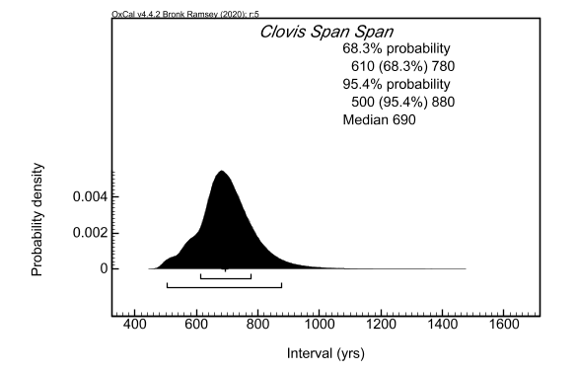
Figure S8. OxCal plot depicting the modeled span for the Clovis tradition with bars representing the 68% and 95% credibility intervals and the median for the posterior distribution denoted as a black tick mark.

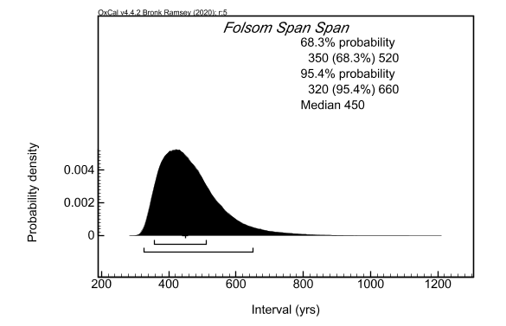
Figure S9. OxCal plot depicting the modeled span for the Folsom tradition with bars representing the 68% and 95% credibility intervals and the median for the posterior distribution denoted as a black tick mark.

Alternative Model B

Alternative Model B is identical to Alternative Model A except for its application of a general outlier model to all radiocarbon determinations. Dates from individual sites were grouped into phases that represent each individual site. Each individual site phase was given start and end boundaries to produce modeled start and end estimates for each individual site. Each of these individual site-based phase models was then included in an overarching, overlapping phase based on its associated traditions: either Clovis or Folsom. As such, one overlapping model of Clovis sites was used to produce age estimates for the regional Clovis tradition and one overlapping model of Folsom sites was used to produce age estimates for the regional Folsom tradition. Both Clovis and Folsom regional phases were modeled with simple boundaries. Span commands were used to produce length estimates for each tradition. While Clovis and Folsom models were independent of one another, they were run in the same OxCal plot that included a difference command to estimate the difference (in years) between the modeled start boundary for the Folsom tradition and the modeled end boundary for the Clovis tradition.
All but two posteriors exhibit convergence values above 95. The model exhibits an A_{model} of 94.4 and an A_{overall} of 86.6. No determination exceed an outlier probability above .42 with the majority below .05. The end boundary for the Clovis tradition is modeled to 12,710-12,580 cal BP (68% CI) or 12,730-12,440 cal BP (95% CI) while the start boundary for the Folsom tradition is modeled to 12,870-12,760 cal BP (68%) or 12,990-12,720 cal BP (95% CI) (Figure S10). The difference command estimates an overlap of 90-280 years (68% CI) or 40-460 years (95% CI) between the end of the Clovis tradition and the start of the Folsom tradition (Figure S11). The span of the Clovis tradition models to 340-820 years (68% CI) or 290-930 years (95% CI) (Figure S12) while the span of the Folsom tradition models to 390-660 years (68% CI) or 340-890 years (95% CI) (Figure S13).

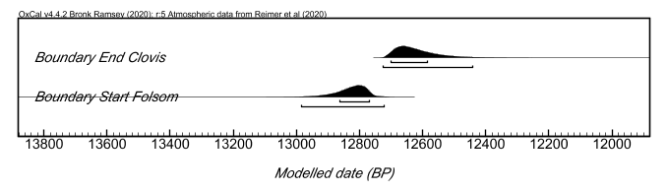
Figure S10. OxCal plot depicting the modeled end boundary for the Clovis tradition and the modeled start boundary for the Folsom tradition with bars representing the 68% and 95% credibility intervals and the median for each posterior distribution denoted by a black tick mark.

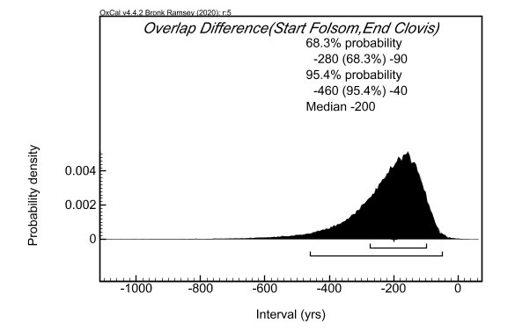
Figure S11. OxCal plot depicting the modeled difference (overlap) between the modeled start of the Folsom tradition boundary and the modeled start of the Clovis end boundary with bars representing the 68% and 95% credibility intervals and the median for the posterior distribution denoted by a black tick mark.
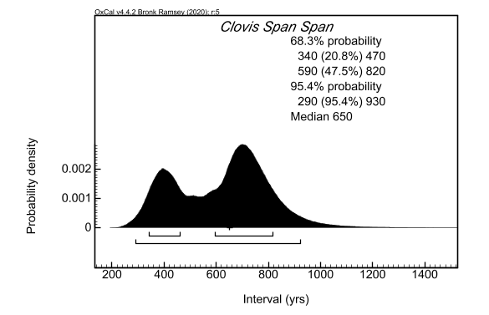
Figure S12. OxCal plot depicting the modeled span for the Clovis tradition with bars representing the 68% and 95% credibility intervals and the median for the posterior distribution denoted as a black tick mark.

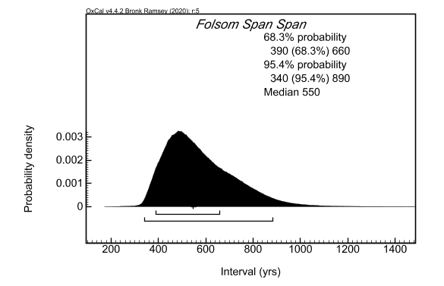
Figure S13. OxCal plot depicting the modeled span for the Folsom tradition with bars representing the 68% and 95% credibility intervals and the median for the posterior distribution denoted as a black tick mark.

Alternative Model C

Alternative Model C is identical to Alternative Model A except that the Clovis and Folsom overlapping phases were themselves grouped together in a wider overlapping phase. In this case, then, all dates, site models, and the two regional tradition models were modeled together. The added assumption, or prior information, is that the Clovis and Folsom traditions related to each other in some way both spatially and temporally. The overlapping nature of this model allows for the two regional models to formally overlap one another (or not, if the dataset of radiocarbon determinations and the prior information support a gap or a strictly sequential nature between the two traditions). Dates from individual sites were grouped into phases that represent each individual site. Each individual site phase was given start and end boundaries to produce modeled start and end estimates for each individual site. Each of these individual site-based phase models was then included in an overarching, overlapping phase based on its associated traditions: either Clovis or Folsom. Both regional models were then incorporated into a single overlapping phase. All simple boundaries were used. Span commands were used to produce length estimates for each tradition. A difference command was included to estimate the difference (in years) between the modeled start boundary for the Folsom tradition and the modeled end boundary for the Clovis tradition.
The model exhibits an A_{model} of 98.3 and an A_{overall} of 98. The end boundary for the Clovis tradition is modeled to 12,700-12,590 cal BP (68% CI) or 12,720-12,480 cal BP (95% CI) while the start boundary for the Folsom tradition is modeled to 12,830-12,760 cal BP (68%) or 12,890-12,740 cal BP (95% CI) (Figure S14). The difference command estimates an overlap of 100-240 years (68% CI) or 60-350 years (95% CI) between the end of the Clovis tradition and the start of the Folsom tradition (Figure S15). The span of the Clovis tradition models to 610-780 years (68% CI) or 500-880 years (95% CI) (Figure S16) while the span of the Folsom tradition models to 350-510 years (68% CI) or 320-650 years (95% CI) (Figure S17).

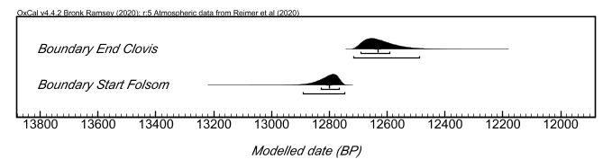
Figure S14. OxCal plot depicting the modeled end boundary for the Clovis tradition and the modeled start boundary for the Folsom tradition with bars representing the 68% and 95% credibility intervals and the median for each posterior distribution denoted by a black tick mark.

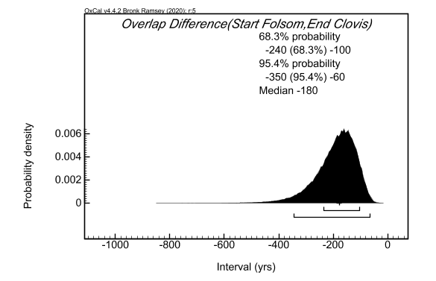
Figure S15. OxCal plot depicting the modeled difference (overlap) between the modeled start of the Folsom tradition boundary and the modeled start of the Clovis end boundary with bars representing the 68% and 95% credibility intervals and the median for the posterior distribution denoted by a black tick mark.

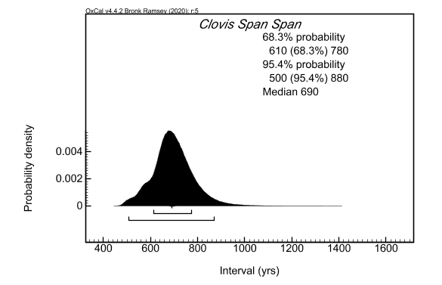
Figure S16. OxCal plot depicting the modeled span for the Clovis tradition with bars representing the 68% and 95% credibility intervals and the median for the posterior distribution denoted as a black tick mark.

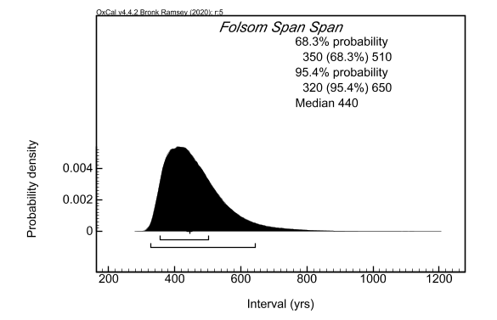
Figure S17. OxCal plot depicting the modeled span for the Folsom tradition with bars representing the 68% and 95% credibility intervals and the median for the posterior distribution denoted as a black tick mark.

Alternative Model D

Alternative Model D is identical to Alternative Model C except for its application of a general outlier model to all radiocarbon determinations. All dates, site models, and the two regional tradition models were modeled together. The added assumption, or prior information, is that the Clovis and Folsom traditions related to each other in some way both spatially and temporally. The overlapping nature of this model allows for the two regional models to formally overlap one another (or not, if the dataset of radiocarbon determinations and the prior information support a gap or a strictly sequential nature between the two traditions). Dates from individual sites were grouped into phases that represent each individual site. Each individual site phase was given start and end boundaries to produce modeled start and end estimates for each individual site. Each of these individual site-based phase models was then included in an overarching, overlapping phase based on its associated traditions: either Clovis or Folsom. Both regional models were then incorporated into a single overlapping phase. All simple boundaries were used. Span commands were used to produce length estimates for each tradition. A difference command was included to estimate the difference (in years) between the modeled start boundary for the Folsom tradition and the modeled end boundary for the Clovis tradition.
All but six posteriors exhibit convergence values above 95. The model exhibits an A_{model} of 93.9 and an A_{overall} of 93.3. No determination exceed an outlier probability above .36 with the majority below .05. The end boundary for the Clovis tradition is modeled to 12,700-12,540 cal BP (68% CI) or 12,730-12,270 cal BP (95% CI) while the start boundary for the Folsom tradition is modeled to 12,880-12,760 cal BP (68%) or 13,030-12,710 cal BP (95% CI) (Figure S18). The difference command estimates an overlap of 90-330 years (68% CI) or 40-680 years (95% CI) between the end of the Clovis tradition and the start of the Folsom tradition (Figure S19). The span of the Clovis tradition models to 370-880 years (68% CI) or 330-1150 years (95% CI) (Figure S20) while the span of the Folsom tradition models to 390-710 years (68% CI) or 330-980 years (95% CI) (Figure S21).

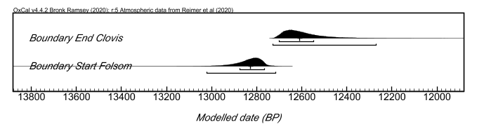
Figure S18. OxCal plot depicting the modeled end boundary for the Clovis tradition and the modeled start boundary for the Folsom tradition with bars representing the 68% and 95% credibility intervals and the median for each posterior distribution denoted by a black tick mark.

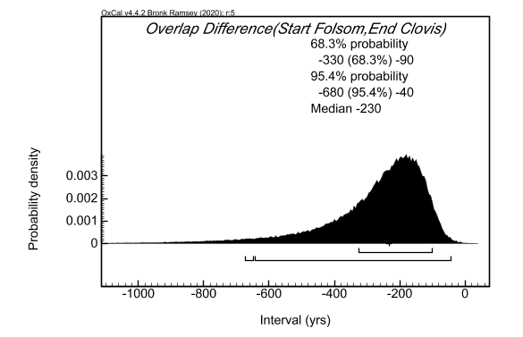
Figure S19. OxCal plot depicting the modeled difference (overlap) between the modeled start of the Folsom tradition boundary and the modeled start of the Clovis end boundary with bars representing the 68% and 95% credibility intervals and the median for the posterior distribution denoted by a black tick mark.

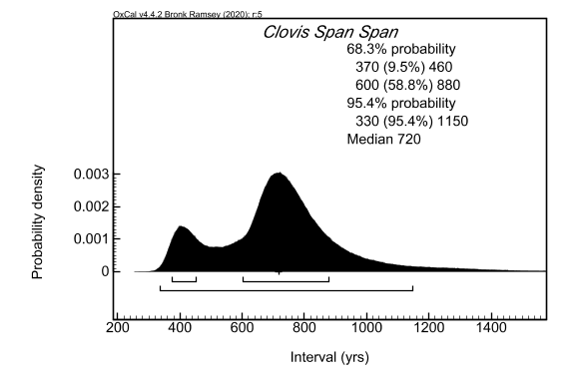
Figure S20. OxCal plot depicting the modeled span for the Clovis tradition with bars representing the 68% and 95% credibility intervals and the median for the posterior distribution denoted as a black tick mark.

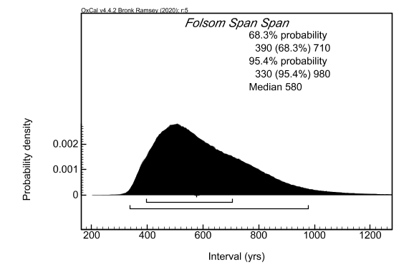
Figure S21. OxCal plot depicting the modeled span for the Folsom tradition with bars representing the 68% and 95% credibility intervals and the median for the posterior distribution denoted as a black tick mark.

Alternative Model E

Alternative Model E is significantly different in its structure and procedures than the primary model and all previous alternative models. Dates from individual sites were grouped into phases that represent each individual site. Each individual site phase was given start and end boundaries to produce modeled start and end estimates for each individual site. As such, each site was built as a single, independent model. The end boundaries for all of the Clovis sites were then saved as priors while the start boundaries for all of the Folsom site models were saved as priors. All Clovis end boundary priors were then modeled within a single phase with start and end boundaries. The end boundary for this phase of Clovis site end boundaries represents the modeled end of the Clovis regional tradition. Similarly, all Folsom start boundary priors were then modeled within a single phase with start and end boundaries. The start boundary for this phase of Folsom site start boundaries represents the modeled start of the Folsom regional tradition. Thus, the code provided below includes code for modeling each individual site as well as code for modeling the ‘phases of boundaries.’ To use this ‘phase of boundaries’ code, you must first run the single site models code. Once you’ve run that code, you must click on each individual boundary and save the raw data as a prior, making sure that the name matching the name of the prior in the ‘phase of boundaries’ code. Once all of the priors are saved, you can run the ‘phase of boundaries’ code.
The ‘phase of boundaries’ model exhibits an A_{model} of 85.3 and an A_{overall} of 75.3. The end boundary for the Clovis tradition is modeled to 12,720-12,640 cal BP (68% CI) or 12,740-12,520 cal BP (95% CI) while the start boundary for the Folsom tradition is modeled to 12,870-12,760 cal BP (68%) or 12,980-12,740 cal BP (95% CI) (Figures S22 and S23). The difference command estimates an overlap of 70-230 years (68% CI) or 30-380 years (95% CI) between the end of the Clovis tradition and the start of the Folsom tradition (Figure S24).

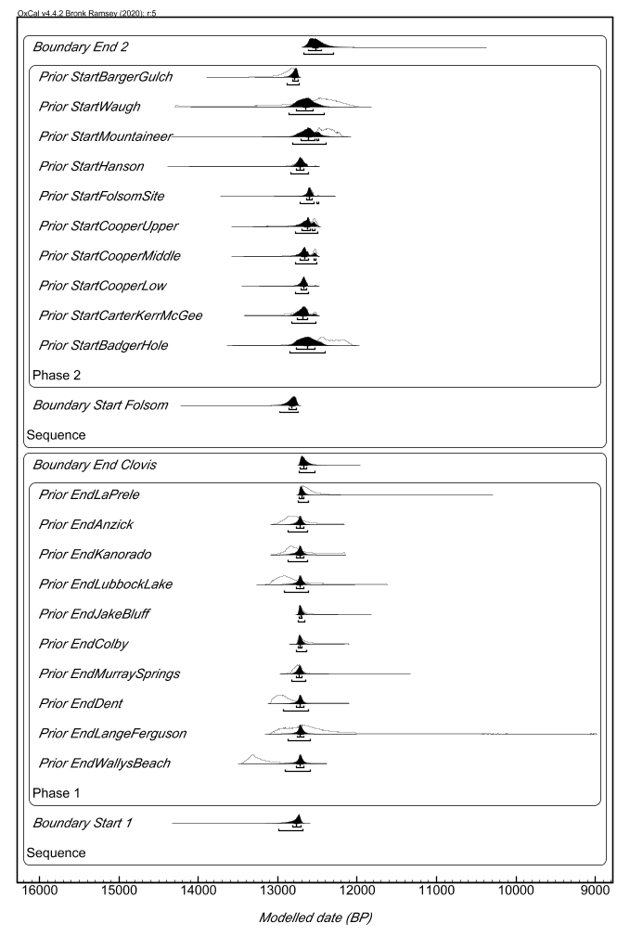
Figure S22. OxCal plot of the two ‘phase of boundaries’ models: one for Clovis site end boundaries (bottom plot) and one for Folsom site start boundaries (top plot).The “Boundary End Clovis” distribution represents the modeled end for the regional Clovis tradition while the “Boundary Start Folsom” distribution represents the modeled start for the regional Folsom tradition.

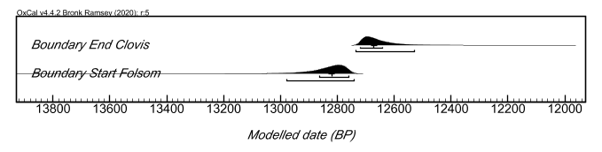
Figure S23. OxCal plot depicting the modeled end boundary for the Clovis tradition and the modeled start boundary for the Folsom tradition (from Figure S22) with bars representing the 68% and 95% credibility intervals and the median for each posterior distribution denoted by a black tick mark.

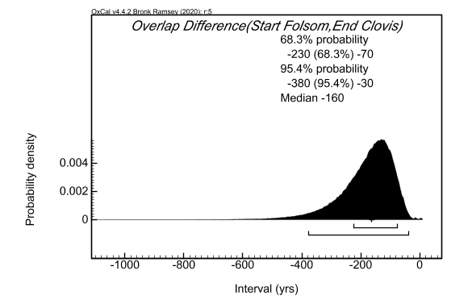
Figure S24. OxCal plot depicting the modeled difference (overlap) between the modeled start of the Folsom tradition boundary and the modeled start of the Clovis end boundary with bars representing the 68% and 95% credibility intervals and the median for the posterior distribution denoted by a black tick mark.

Alternative Model F

Alternative Model F is identical to Alternative Model E except for its application of a general outlier model to all radiocarbon determinations in the single site models used to produce the boundary priors modeled in the ‘phase of boundaries’ model. Dates from individual sites were grouped into phases that represent each individual site. Each individual site phase was given start and end boundaries to produce modeled start and end estimates for each individual site. As such, each site was built as a single, independent model. The end boundaries for all of the Clovis sites were then saved as priors while the start boundaries for all of the Folsom site models were saved as priors. All Clovis end boundary priors were then modeled within a single phase with start and end boundaries. The end boundary for this phase of Clovis site end boundaries represents the modeled end of the Clovis regional tradition. Similarly, all Folsom start boundary priors were then modeled within a single phase with start and end boundaries. The start boundary for this phase of Folsom site start boundaries represents the modeled start of the Folsom regional tradition. Thus, the code provided below includes code for modeling each individual site as well as code for modeling the ‘phases of boundaries.’ To use this ‘phase of boundaries’ code, you must first run the single site models code. Once you’ve run that code, you must click on each individual boundary and save the raw data as a prior, making sure that the name matching the name of the prior in the ‘phase of boundaries’ code. Once all of the priors are saved, you can run the ‘phase of boundaries’ code.
The ‘phase of boundaries’ model exhibits an A_{model} of 85.3 and an A_{overall} of 75.3. The end boundary for the Clovis tradition is modeled to 12,730-12,620 cal BP (68% CI) or 12,740-12,470 cal BP (95% CI) while the start boundary for the Folsom tradition is modeled to 12,900-12,630 cal BP (68%) or 13,030-… cal BP (95% CI) (Figures S25 and S26). The difference command estimates an overlap of -70-230 years (68% CI) or -90-480 years (95% CI) between the end of the Clovis tradition and the start of the Folsom tradition (Figure S27). These overlap estimates are different from the other alternative models in that they suggest the potential for a gap between Clovis and Folsom traditions (the negative values). When reviewing the posterior distributions for both the individual site models as well as the ‘phase of boundaries’ models, the general outlier modeling seems to have introduced an anomalous peak towards the more recent end of the calibration range. More specifically, the Folsom start boundary is being significantly affected by this anomaly. When this peak is excluded from the age ranges, the estimations mirror the results from the primary model and previous alternative models.

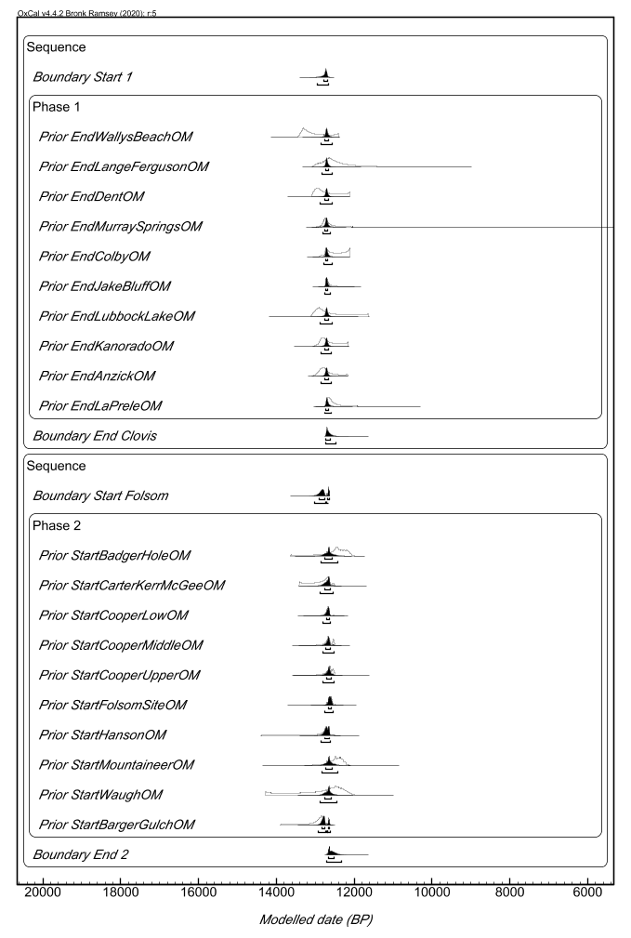
Figure S25. OxCal plot of the two ‘phase of boundaries’ models: one for Clovis site end boundaries (bottom plot) and one for Folsom site start boundaries (top plot).The “Boundary End Clovis” distribution represents the modeled end for the regional Clovis tradition while the “Boundary Start Folsom” distribution represents the modeled start for the regional Folsom tradition.
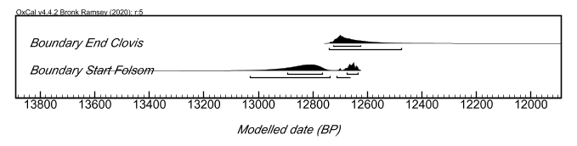
Figure S26. OxCal plot depicting the modeled end boundary for the Clovis tradition and the modeled start boundary for the Folsom tradition (from Figure S25) with bars representing the 68% and 95% credibility intervals and the median for each posterior distribution denoted by a black tick mark.

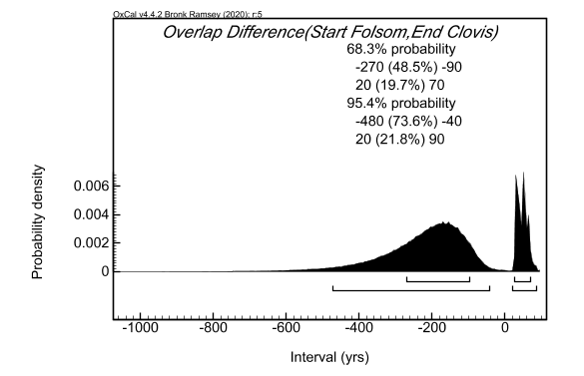
Figure S27. OxCal plot depicting the modeled difference (overlap) between the modeled start of the Folsom tradition boundary and the modeled start of the Clovis end boundary with bars representing the 68% and 95% credibility intervals and the median for the posterior distribution denoted by a black tick mark.

Primary Model Code

Plot()
{
Sequence()
{
Boundary("Start Clovis")
{
Start("Start of Start Clovis");
Transition("Period of Start Clovis");
End("End of Start Clovis");
};
Phase("Clovis")
{
Sequence( )
{
Boundary("Start Wally's Beach");
Phase("Wally's Beach")
{
R_Date("OxA-X-2736-8", 11530, 50);
R_Date("OxA-X-2736-10", 11445, 55);
};
Boundary("End Wally's Beach");
};
Sequence( )
{
Boundary("Start Dent");
Phase("Dent")
{
R_Date("OxA-X-2736-11", 11055, 50);
R_Date("OxA-X-2736-12", 11155, 50);
};
Boundary("End Dent");
};
Sequence( )
{
Boundary("Start Lange-Ferguson");
Phase("Lange-Ferguson")
{
R_Date("AA-905", 11140, 140);
R_Date("UCIAMS-11344", 10710, 130);
R_Date("UCIAMS-11345", 11110, 40);
};
Boundary("End Lange-Ferguson");
};
Phase("Domebo")
{
R_Date("UCIAMS-11341", 10960, 30);
};
Sequence( )
{
Boundary("Start Murray Springs");
Phase("Murray Springs")
{
R_Date("SMU-18", 11190, 180);
R_Date("A-805", 11150, 450);
R_Date("TX-1413", 11080, 180);
R_Date("TX-1462", 10930, 170);
R_Date("SMU-27", 10890, 180);
R_Date("SMU-41", 10840, 70);
R_Date("SMU-42", 10840, 140);
R_Date("TX-1459", 10710, 160);
};
Boundary("End Murray Springs");
};
Sequence( )
{
Boundary("Start Colby");
Phase("Colby")
{
R_Date("UCIAMS-11342", 10790, 30);
R_Date("UCIAMS-11343", 10950, 30);
};
Boundary("End Colby");
};
Sequence( )
{
Boundary("Start Jake Bluff");
Phase("Jake Bluff")
{
R_Date("CAMS-79940", 10750, 40);
R_Date("CAMS-90968", 10840, 45);
R_Date("CAMS-90969", 10700, 45);
};
Boundary("End Jake Bluff");
};
Phase("Indian Creek")
{
R_Date("Beta-4619", 10980, 110);
};
Sequence( )
{
Boundary("Start Lubbock Lake");
Phase("Lubbock Lake")
{
R_Date("SMU-548", 11100, 100);
R_Date("SMU-263", 11100, 80);
};
Boundary("End Lubbock Lake");
};
Sequence( )
{
Boundary("Start Kanorado");
Phase("Kanorado")
{
R_Date("CAMS-112741", 10950, 60);
R_Date("CAMS-112742", 11005, 50);
};
Boundary("End Kanorado");
};
Sequence( )
{
Boundary("Start Anzick");
Phase("Anzick")
{
R_Date("OxA-X-2739-54", 10915, 50);
R_Combine("Antler Rod SR-7599")
{
R_Date("OxA-X-35,731", 11065, 55);
R_Date("OxA-X-35,732", 11145, 55);
R_Date("OxA-X-2734-19", 11020, 45);
R_Date("OxA-X-2739-55", 10900, 50);
};
R_Combine("Antler Rod SR-7602")
{
R_Date("OxA-X-35,733", 11120, 55);
R_Date("OxA-X-35,781", 11120, 50);
R_Date("OxA-X-2734-20", 11070, 45);
R_Date("OxA-X-2739-56", 11050, 55);
};
};
Boundary("End Anzick");
};
Sequence()
{
Boundary("Start La Prele");
Phase("La Prele")
{
R_Date("AA108894", 10654, 58);
R_Date("AA108895", 10776, 59);
R_Date("AA107104", 11190, 130);
R_Date("AA108893", 11066, 61);
R_Date("OxA-X-2736-14", 11035, 50);
};
Boundary("End La Prele");
};
Span("Clovis Span");
};
Boundary("End Clovis")
{
Start("Start of End Clovis");
Transition("Period of End Clovis");
End("End of End Clovis");
};
};
Sequence()
{
Boundary("Start Folsom")
{
Start("Start of Start Folsom");
Transition("Period of Start Folsom");
End("End of Start Folsom");
};
Phase("Folsom")
{
Sequence( )
{
Boundary("Start Badger Hole");
Phase("Badger Hole")
{
R_Date("UCIAMS-98369", 10300, 25);
R_Date("PSU-5144UCIAMS-111184", 10395, 35);
R_Date("PSU-5457/UCIAMS-122579", 10370, 25);
};
Boundary("End Badger Hole");
};
Sequence( )
{
Boundary("Start Carter/Kerr-McGee");
Phase("Carter/Kerr-McGee")
{
R_Date("UCIAMS-122572", 10600, 25);
R_Date("UCIAMS-122573", 10520, 25);
};
Boundary("End Carter/Kerr-McGee");
};
Sequence( )
{
Boundary("Start Cooper Low");
Phase("Cooper Lower")
{
R_Date("CAMS-94850", 10600, 40);
R_Date("PSU-6077/UCIAMS-140849", 10560, 30);
R_Date("PSU-6078/UCIAMS-140520", 10570, 30);
R_Date("PSU-6079/UCIAMS-140581", 10630, 30);
};
Boundary("End Cooper Low");
};
Sequence( )
{
Boundary("Start Cooper Middle");
Phase("Cooper Middle")
{
R_Date("CAMS-82407", 10530, 45);
R_Date("PSU-6075/UCIAMS-140847", 10565, 30);
R_Date("PSU-6076/UCIAMS-140848", 10575, 30);
};
Boundary("End Cooper Middle");
};
Sequence( )
{
Boundary("Start Cooper Upper");
Phase("Cooper Upper")
{
R_Date("CAMS-94849", 10505, 45);
R_Date("PSU-6073/UCIAMS-140845", 10550, 30);
R_Date("PSU-6074/UCIAMS-140846", 10525, 30);
};
Boundary("End Cooper Upper");
};
Sequence( )
{
Boundary("Start Folsom Site");
Phase("Folsom Site")
{
R_Date("CAMS-74656", 10450, 50);
R_Date("CAMS-74658", 10450, 50);
R_Date("CAMS-96034", 10475, 30);
R_Date("CAMS-74657", 10500, 40);
R_Date("CAMS-74659", 10510, 50);
R_Date("CAMS-74655", 10520, 50);
};
Boundary("End Folsom Site");
};
Sequence( )
{
Boundary("Start Hanson");
Phase("Hanson")
{
R_Date("AA-106384", 10626, 77);
R_Date("AA-106385", 10600, 77);
R_Date("AA-106386", 10688, 77);
};
Boundary("End Hanson");
};
Sequence( )
{
Boundary("Start Mountaineer");
Phase("Mountaineer")
{
R_Date("CAMS-105764", 10440, 50);
R_Date("CAMS-105765", 10295, 50);
R_Date("UCIAMS-11240", 10380, 30);
R_Date("UCIAMS-11241", 10445, 25);
R_Date("AA-98753", 10328, 100);
};
Boundary("End Mountaineer");
};
Sequence( )
{
Boundary("Start Waugh");
Phase("Waugh")
{
R_Date("NZA-3602", 10379, 85);
R_Date("NZA-3603", 10404, 87);
};
Boundary("End Waugh");
};
Sequence( )
{
Boundary("Start Barger Gulch B1");
Phase("Barger Gulch B1")
{
R_Date("AA-109925", 10874, 61);
R_Date("AA-109926", 10922, 61);
};
Boundary("End Barger Gulch B1");
};
Phase("Agate Basin")
{
R_Date("UCIAMS-122570", 10430, 25);
};
Phase("Hell Gap")
{
R_Date("AA-77592UF", 10490, 62);
};
Phase("Lindenmeier")
{
R_Date("CMPA-5LR13-L16-4A", 10335, 35);
};
Phase("Barger Gulch B2")
{
R_Date("AA-112887", 10718, 41);
};
Span("Folsom Span");
};
Boundary("End Folsom")
{
Start("Start of End Folsom");
Transition("Period of End Folsom");
End("End of End Folsom");
};
};
Difference("Overlap", "Start Folsom", "End Clovis");
};

Alternative Model A Code

Plot()
{
Sequence()
{
Boundary("Start Clovis");
Phase("Clovis")
{
Sequence( )
{
Boundary("Start Wally's Beach");
Phase("Wally's Beach")
{
R_Date("OxA-X-2736-8", 11530, 50);
R_Date("OxA-X-2736-10", 11445, 55);
};
Boundary("End Wally's Beach");
};
Sequence( )
{
Boundary("Start Dent");
Phase("Dent")
{
R_Date("OxA-X-2736-11", 11055, 50);
R_Date("OxA-X-2736-12", 11155, 50);
};
Boundary("End Dent");
};
Sequence( )
{
Boundary("Start Lange-Ferguson");
Phase("Lange-Ferguson")
{
R_Date("AA-905", 11140, 140);
R_Date("UCIAMS-11344", 10710, 130);
R_Date("UCIAMS-11345", 11110, 40);
};
Boundary("End Lange-Ferguson");
};
Phase("Domebo")
{
R_Date("UCIAMS-11341", 10960, 30);
};
Sequence( )
{
Boundary("Start Murray Springs");
Phase("Murray Springs")
{
R_Date("SMU-18", 11190, 180);
R_Date("A-805", 11150, 450);
R_Date("TX-1413", 11080, 180);
R_Date("TX-1462", 10930, 170);
R_Date("SMU-27", 10890, 180);
R_Date("SMU-41", 10840, 70);
R_Date("SMU-42", 10840, 140);
R_Date("TX-1459", 10710, 160);
};
Boundary("End Murray Springs");
};
Sequence( )
{
Boundary("Start Colby");
Phase("Colby")
{
R_Date("UCIAMS-11342", 10790, 30);
R_Date("UCIAMS-11343", 10950, 30);
};
Boundary("End Colby");
};
Sequence( )
{
Boundary("Start Jake Bluff");
Phase("Jake Bluff")
{
R_Date("CAMS-79940", 10750, 40);
R_Date("CAMS-90968", 10840, 45);
R_Date("CAMS-90969", 10700, 45);
};
Boundary("End Jake Bluff");
};
Phase("Indian Creek")
{
R_Date("Beta-4619", 10980, 110);
};
Sequence( )
{
Boundary("Start Lubbock Lake");
Phase("Lubbock Lake")
{
R_Date("SMU-548", 11100, 100);
R_Date("SMU-263", 11100, 80);
};
Boundary("End Lubbock Lake");
};
Sequence( )
{
Boundary("Start Kanorado");
Phase("Kanorado")
{
R_Date("CAMS-112741", 10950, 60);
R_Date("CAMS-112742", 11005, 50);
};
Boundary("End Kanorado");
};
Sequence( )
{
Boundary("Start Anzick");
Phase("Anzick")
{
R_Date("OxA-X-2739-54", 10915, 50);
R_Combine("Antler Rod SR-7599")
{
R_Date("OxA-X-35,731", 11065, 55);
R_Date("OxA-X-35,732", 11145, 55);
R_Date("OxA-X-2734-19", 11020, 45);
R_Date("OxA-X-2739-55", 10900, 50);
};
R_Combine("Antler Rod SR-7602")
{
R_Date("OxA-X-35,733", 11120, 55);
R_Date("OxA-X-35,781", 11120, 50);
R_Date("OxA-X-2734-20", 11070, 45);
R_Date("OxA-X-2739-56", 11050, 55);
};
};
Boundary("End Anzick");
};
Sequence()
{
Boundary("Start La Prele");
Phase("La Prele")
{
R_Date("AA108894", 10654, 58);
R_Date("AA108895", 10776, 59);
R_Date("AA107104", 11190, 130);
R_Date("AA108893", 11066, 61);
R_Date("OxA-X-2736-14", 11035, 50);
};
Boundary("End La Prele");
};
Span("Clovis Span");
};
Boundary("End Clovis");
};
Sequence()
{
Boundary("Start Folsom");
Phase("Folsom")
{
Sequence( )
{
Boundary("Start Badger Hole");
Phase("Badger Hole")
{
R_Date("UCIAMS-98369", 10300, 25);
R_Date("PSU-5144UCIAMS-111184", 10395, 35);
R_Date("PSU-5457/UCIAMS-122579", 10370, 25);
};
Boundary("End Badger Hole");
};
Sequence( )
{
Boundary("Start Carter/Kerr-McGee");
Phase("Carter/Kerr-McGee")
{
R_Date("UCIAMS-122572", 10600, 25);
R_Date("UCIAMS-122573", 10520, 25);
};
Boundary("End Carter/Kerr-McGee");
};
Sequence( )
{
Boundary("Start Cooper Low");
Phase("Cooper Lower")
{
R_Date("CAMS-94850", 10600, 40);
R_Date("PSU-6077/UCIAMS-140849", 10560, 30);
R_Date("PSU-6078/UCIAMS-140520", 10570, 30);
R_Date("PSU-6079/UCIAMS-140581", 10630, 30);
};
Boundary("End Cooper Low");
};
Sequence( )
{
Boundary("Start Cooper Middle");
Phase("Cooper Middle")
{
R_Date("CAMS-82407", 10530, 45);
R_Date("PSU-6075/UCIAMS-140847", 10565, 30);
R_Date("PSU-6076/UCIAMS-140848", 10575, 30);
};
Boundary("End Cooper Middle");
};
Sequence( )
{
Boundary("Start Cooper Upper");
Phase("Cooper Upper")
{
R_Date("CAMS-94849", 10505, 45);
R_Date("PSU-6073/UCIAMS-140845", 10550, 30);
R_Date("PSU-6074/UCIAMS-140846", 10525, 30);
};
Boundary("End Cooper Upper");
};
Sequence( )
{
Boundary("Start Folsom Site");
Phase("Folsom Site")
{
R_Date("CAMS-74656", 10450, 50);
R_Date("CAMS-74658", 10450, 50);
R_Date("CAMS-96034", 10475, 30);
R_Date("CAMS-74657", 10500, 40);
R_Date("CAMS-74659", 10510, 50);
R_Date("CAMS-74655", 10520, 50);
};
Boundary("End Folsom Site");
};
Sequence( )
{
Boundary("Start Hanson");
Phase("Hanson")
{
R_Date("AA-106384", 10626, 77);
R_Date("AA-106385", 10600, 77);
R_Date("AA-106386", 10688, 77);
};
Boundary("End Hanson");
};
Sequence( )
{
Boundary("Start Mountaineer");
Phase("Mountaineer")
{
R_Date("CAMS-105764", 10440, 50);
R_Date("CAMS-105765", 10295, 50);
R_Date("UCIAMS-11240", 10380, 30);
R_Date("UCIAMS-11241", 10445, 25);
R_Date("AA-98753", 10328, 100);
};
Boundary("End Mountaineer");
};
Sequence( )
{
Boundary("Start Waugh");
Phase("Waugh")
{
R_Date("NZA-3602", 10379, 85);
R_Date("NZA-3603", 10404, 87);
};
Boundary("End Waugh");
};
Sequence( )
{
Boundary("Start Barger Gulch B1");
Phase("Barger Gulch B1")
{
R_Date("AA-109925", 10874, 61);
R_Date("AA-109926", 10922, 61);
};
Boundary("End Barger Gulch B1");
};
Phase("Agate Basin")
{
R_Date("UCIAMS-122570", 10430, 25);
};
Phase("Hell Gap")
{
R_Date("AA-77592UF", 10490, 62);
};
Phase("Lindenmeier")
{
R_Date("CMPA-5LR13-L16-4A", 10335, 35);
};
Phase("Barger Gulch B2")
{
R_Date("AA-112887", 10718, 41);
};
Span("Folsom Span");
};
Boundary("End Folsom");
};
Difference("Overlap", "Start Folsom", "End Clovis");
};

Alternative Model B Code

Plot()
{
Outlier_Model("General", T(5), U(0,4),"t");
Sequence()
{
Boundary("Start Clovis");
Phase("Clovis")
{
Sequence( )
{
Boundary("Start Wally's Beach");
Phase("Wally's Beach")
{
R_Date("OxA-X-2736-8", 11530, 50)
{
Outlier("General", 0.05);
};
R_Date("OxA-X-2736-10", 11445, 55)
{
Outlier("General", 0.05);
};
};
Boundary("End Wally's Beach");
};
Phase("La Prele")
{
R_Date("OxA-X-2736-14", 11035, 50)
{
Outlier("General", 0.05);
};
};
Sequence( )
{
Boundary("Start Dent");
Phase("Dent")
{
R_Date("OxA-X-2736-11", 11055, 50)
{
Outlier("General", 0.05);
};
R_Date("OxA-X-2736-12", 11155, 50)
{
Outlier("General", 0.05);
};
};
Boundary("End Dent");
};
Sequence( )
{
Boundary("Start Lange-Ferguson");
Phase("Lange-Ferguson")
{
R_Date("AA-905", 11140, 140)
{
Outlier("General", 0.05);
};
R_Date("UCIAMS-11344", 10710, 130)
{
Outlier("General", 0.05);
};
R_Date("UCIAMS-11345", 11110, 40)
{
Outlier("General", 0.05);
};
};
Boundary("End Lange-Ferguson");
};
Phase("Domebo")
{
R_Date("UCIAMS-11341", 10960, 30)
{
Outlier("General", 0.05);
};
};
Sequence( )
{
Boundary("Start Murray Springs");
Phase("Murray Springs")
{
R_Date("SMU-18", 11190, 180)
{
Outlier("General", 0.05);
};
R_Date("A-805", 11150, 450)
{
Outlier("General", 0.05);
};
R_Date("TX-1413", 11080, 180)
{
Outlier("General", 0.05);
};
R_Date("TX-1462", 10930, 170)
{
Outlier("General", 0.05);
};
R_Date("SMU-27", 10890, 180)
{
Outlier("General", 0.05);
};
R_Date("SMU-41", 10840, 70)
{
Outlier("General", 0.05);
};
R_Date("SMU-42", 10840, 140)
{
Outlier("General", 0.05);
};
R_Date("TX-1459", 10710, 160)
{
Outlier("General", 0.05);
};
};
Boundary("End Murray Springs");
};
Sequence( )
{
Boundary("Start Colby");
Phase("Colby")
{
R_Date("UCIAMS-11342", 10790, 30)
{
Outlier("General", 0.05);
};
R_Date("UCIAMS-11343", 10950, 30)
{
Outlier("General", 0.05);
};
};
Boundary("End Colby");
};
Sequence( )
{
Boundary("Start Jake Bluff");
Phase("Jake Bluff")
{
R_Date("CAMS-79940", 10750, 40)
{
Outlier("General", 0.05);
};
R_Date("CAMS-90968", 10840, 45)
{
Outlier("General", 0.05);
};
R_Date("CAMS-90969", 10700, 45)
{
Outlier("General", 0.05);
};
};
Boundary("End Jake Bluff");
};
Phase("Indian Creek")
{
R_Date("Beta-4619", 10980, 110)
{
Outlier("General", 0.05);
};
};
Sequence( )
{
Boundary("Start Lubbock Lake");
Phase("Lubbock Lake")
{
R_Date("SMU-548", 11100, 100)
{
Outlier("General", 0.05);
};
R_Date("SMU-263", 11100, 80)
{
Outlier("General", 0.05);
};
};
Boundary("End Lubbock Lake");
};
Sequence( )
{
Boundary("Start Kanorado");
Phase("Kanorado")
{
R_Date("CAMS-112741", 10950, 60)
{
Outlier("General", 0.05);
};
R_Date("CAMS-112742", 11005, 50)
{
Outlier("General", 0.05);
};
};
Boundary("End Kanorado");
};
Sequence( )
{
Boundary("Start Anzick");
Phase("Anzick")
{
R_Date("OxA-X-2739-54", 10915, 50)
{
Outlier("General", 0.05);
};
R_Combine("Antler Rod SR-7599")
{
R_Date("OxA-X-35,731", 11065, 55)
{
Outlier("General", 0.05);
};
R_Date("OxA-X-35,732", 11145, 55)
{
Outlier("General", 0.05);
};
R_Date("OxA-X-2734-19", 11020, 45)
{
Outlier("General", 0.05);
};
R_Date("OxA-X-2739-55", 10900, 50)
{
Outlier("General", 0.05);
};
};
R_Combine("Antler Rod SR-7602")
{
R_Date("OxA-X-35,733", 11120, 55)
{
Outlier("General", 0.05);
};
R_Date("OxA-X-35,781", 11120, 50)
{
Outlier("General", 0.05);
};
R_Date("OxA-X-2734-20", 11070, 45)
{
Outlier("General", 0.05);
};
R_Date("OxA-X-2739-56", 11050, 55)
{
Outlier("General", 0.05);
};
};
};
Boundary("End Anzick");
};
Sequence()
{
Boundary("Start La Prele");
Phase("La Prele")
{
R_Date("AA108894", 10654, 58)
{
Outlier("General", 0.05);
};
R_Date("AA108895", 10776, 59)
{
Outlier("General", 0.05);
};
R_Date("AA107104", 11190, 130)
{
Outlier("General", 0.05);
};
R_Date("AA108893", 11066, 61)
{
Outlier"General", (0.05);
};
};
Boundary("End La Prele");
};
Span("Clovis Span");
};
Boundary("End Clovis");
};
Sequence()
{
Boundary("Start Folsom");
Phase("Folsom")
{
Sequence( )
{
Boundary("Start Badger Hole");
Phase("Badger Hole")
{
R_Date("UCIAMS-98369", 10300, 25)
{
Outlier("General", 0.05);
};
R_Date("PSU-5144UCIAMS-111184", 10395, 35)
{
Outlier("General", 0.05);
};
R_Date("PSU-5457/UCIAMS-122579", 10370, 25)
{
Outlier"General", (0.05);
};
};
Boundary("End Badger Hole");
};
Sequence( )
{
Boundary("Start Carter/Kerr-McGee");
Phase("Carter/Kerr-McGee")
{
R_Date("UCIAMS-122572", 10600, 25)
{
Outlier("General", 0.05);
};
R_Date("UCIAMS-122573", 10520, 25)
{
Outlier("General", 0.05);
};
};
Boundary("End Carter/Kerr-McGee");
};
Sequence( )
{
Boundary("Start Cooper Low");
Phase("Cooper Lower")
{
R_Date("CAMS-94850", 10600, 40)
{
Outlier("General", 0.05);
};
R_Date("PSU-6077/UCIAMS-140849", 10560, 30)
{
Outlier("General", 0.05);
};
R_Date("PSU-6078/UCIAMS-140520", 10570, 30)
{
Outlier("General", 0.05);
};
R_Date("PSU-6079/UCIAMS-140581", 10630, 30)
{
Outlier("General", 0.05);
};
};
Boundary("End Cooper Low");
};
Sequence( )
{
Boundary("Start Cooper Middle");
Phase("Cooper Middle")
{
R_Date("CAMS-82407", 10530, 45)
{
Outlier("General", 0.05);
};
R_Date("PSU-6075/UCIAMS-140847", 10565, 30)
{
Outlier("General", 0.05);
};
R_Date("PSU-6076/UCIAMS-140848", 10575, 30)
{
Outlier("General", 0.05);
};
};
Boundary("End Cooper Middle");
};
Sequence( )
{
Boundary("Start Cooper Upper");
Phase("Cooper Upper")
{
R_Date("CAMS-94849", 10505, 45)
{
Outlier("General", 0.05);
};
R_Date("PSU-6073/UCIAMS-140845", 10550, 30)
{
Outlier("General", 0.05);
};
R_Date("PSU-6074/UCIAMS-140846", 10525, 30)
{
Outlier("General", 0.05);
};
};
Boundary("End Cooper Upper");
};
Sequence( )
{
Boundary("Start Folsom Site");
Phase("Folsom Site")
{
R_Date("CAMS-74656", 10450, 50)
{
Outlier("General", 0.05);
};
R_Date("CAMS-74658", 10450, 50)
{
Outlier("General", 0.05);
};
R_Date("CAMS-96034", 10475, 30)
{
Outlier("General", 0.05);
};
R_Date("CAMS-74657", 10500, 40)
{
Outlier("General", 0.05);
};
R_Date("CAMS-74659", 10510, 50)
{
Outlier("General", 0.05);
};
R_Date("CAMS-74655", 10520, 50)
{
Outlier("General", 0.05);
};
};
Boundary("End Folsom Site");
};
Sequence( )
{
Boundary("Start Hanson");
Phase("Hanson")
{
R_Date("AA-106384", 10626, 77)
{
Outlier("General", 0.05);
};
R_Date("AA-106385", 10600, 77)
{
Outlier("General", 0.05);
};
R_Date("AA-106386", 10688, 77)
{
Outlier("General", 0.05);
};
};
Boundary("End Hanson");
};
Sequence( )
{
Boundary("Start Mountaineer");
Phase("Mountaineer")
{
R_Date("CAMS-105764", 10440, 50)
{
Outlier("General", 0.05);
};
R_Date("CAMS-105765", 10295, 50)
{
Outlier("General", 0.05);
};
R_Date("UCIAMS-11240", 10380, 30)
{
Outlier("General", 0.05);
};
R_Date("UCIAMS-11241", 10445, 25)
{
Outlier("General", 0.05);
};
R_Date("AA-98753", 10328, 100)
{
Outlier("General", 0.05);
};
};
Boundary("End Mountaineer");
};
Sequence( )
{
Boundary("Start Waugh");
Phase("Waugh")
{
R_Date("NZA-3602", 10379, 85)
{
Outlier("General", 0.05);
};
R_Date("NZA-3603", 10404, 87)
{
Outlier("General", 0.05);
};
};
Boundary("End Waugh");
};
Sequence( )
{
Boundary("Start Barger Gulch B1");
Phase("Barger Gulch B1")
{
R_Date("AA-109925", 10874, 61)
{
Outlier("General", 0.05);
};
R_Date("AA-109926", 10922, 61)
{
Outlier("General", 0.05);
};
};
Boundary("End Barger Gulch B1");
};
Phase("Agate Basin")
{
R_Date("UCIAMS-122570", 10430, 25)
{
Outlier("General", 0.05);
};
};
Phase("Hell Gap")
{
R_Date("AA-77592UF", 10490, 62)
{
Outlier("General", 0.05);
};
};
Phase("Lindenmeier")
{
R_Date("CMPA-5LR13-L16-4A", 10335, 35)
{
Outlier("General", 0.05);
};
};
Phase("Barger Gulch B2")
{
R_Date("AA-112887", 10718, 41)
{
Outlier("General", 0.05);
};
};
Span("Folsom Span");
};
Boundary("End Folsom");
};
Difference("Overlap", "Start Folsom", "End Clovis");
};

Alternative Model C Code

Plot()
{
Phase()
{
Sequence()
{
Boundary("Start Clovis");
Phase("Clovis")
{
Sequence( )
{
Boundary("Start Wally's Beach");
Phase("Wally's Beach")
{
R_Date("OxA-X-2736-8", 11530, 50);
R_Date("OxA-X-2736-10", 11445, 55);
};
Boundary("End Wally's Beach");
};
Sequence( )
{
Boundary("Start Dent");
Phase("Dent")
{
R_Date("OxA-X-2736-11", 11055, 50);
R_Date("OxA-X-2736-12", 11155, 50);
};
Boundary("End Dent");
};
Sequence( )
{
Boundary("Start Lange-Ferguson");
Phase("Lange-Ferguson")
{
R_Date("AA-905", 11140, 140);
R_Date("UCIAMS-11344", 10710, 130);
R_Date("UCIAMS-11345", 11110, 40);
};
Boundary("End Lange-Ferguson");
};
Phase("Domebo")
{
R_Date("UCIAMS-11341", 10960, 30);
};
Sequence( )
{
Boundary("Start Murray Springs");
Phase("Murray Springs")
{
R_Date("SMU-18", 11190, 180);
R_Date("A-805", 11150, 450);
R_Date("TX-1413", 11080, 180);
R_Date("TX-1462", 10930, 170);
R_Date("SMU-27", 10890, 180);
R_Date("SMU-41", 10840, 70);
R_Date("SMU-42", 10840, 140);
R_Date("TX-1459", 10710, 160);
};
Boundary("End Murray Springs");
};
Sequence( )
{
Boundary("Start Colby");
Phase("Colby")
{
R_Date("UCIAMS-11342", 10790, 30);
R_Date("UCIAMS-11343", 10950, 30);
};
Boundary("End Colby");
};
Sequence( )
{
Boundary("Start Jake Bluff");
Phase("Jake Bluff")
{
R_Date("CAMS-79940", 10750, 40);
R_Date("CAMS-90968", 10840, 45);
R_Date("CAMS-90969", 10700, 45);
};
Boundary("End Jake Bluff");
};
Phase("Indian Creek")
{
R_Date("Beta-4619", 10980, 110);
};
Sequence( )
{
Boundary("Start Lubbock Lake");
Phase("Lubbock Lake")
{
R_Date("SMU-548", 11100, 100);
R_Date("SMU-263", 11100, 80);
};
Boundary("End Lubbock Lake");
};
Sequence( )
{
Boundary("Start Kanorado");
Phase("Kanorado")
{
R_Date("CAMS-112741", 10950, 60);
R_Date("CAMS-112742", 11005, 50);
};
Boundary("End Kanorado");
};
Sequence( )
{
Boundary("Start Anzick");
Phase("Anzick")
{
R_Date("OxA-X-2739-54", 10915, 50);
R_Combine("Antler Rod SR-7599")
{
R_Date("OxA-X-35,731", 11065, 55);
R_Date("OxA-X-35,732", 11145, 55);
R_Date("OxA-X-2734-19", 11020, 45);
R_Date("OxA-X-2739-55", 10900, 50);
};
R_Combine("Antler Rod SR-7602")
{
R_Date("OxA-X-35,733", 11120, 55);
R_Date("OxA-X-35,781", 11120, 50);
R_Date("OxA-X-2734-20", 11070, 45);
R_Date("OxA-X-2739-56", 11050, 55);
};
};
Boundary("End Anzick");
};
Sequence()
{
Boundary("Start La Prele");
Phase("La Prele")
{
R_Date("AA108894", 10654, 58);
R_Date("AA108895", 10776, 59);
R_Date("AA107104", 11190, 130);
R_Date("AA108893", 11066, 61);
R_Date("OxA-X-2736-14", 11035, 50);
};
Boundary("End La Prele");
};
Span("Clovis Span");
};
Boundary("End Clovis");
};
Sequence()
{
Boundary("Start Folsom");
Phase("Folsom")
{
Sequence( )
{
Boundary("Start Badger Hole");
Phase("Badger Hole")
{
R_Date("UCIAMS-98369", 10300, 25);
R_Date("PSU-5144UCIAMS-111184", 10395, 35);
R_Date("PSU-5457/UCIAMS-122579", 10370, 25);
};
Boundary("End Badger Hole");
};
Sequence( )
{
Boundary("Start Carter/Kerr-McGee");
Phase("Carter/Kerr-McGee")
{
R_Date("UCIAMS-122572", 10600, 25);
R_Date("UCIAMS-122573", 10520, 25);
};
Boundary("End Carter/Kerr-McGee");
};
Sequence( )
{
Boundary("Start Cooper Low");
Phase("Cooper Lower")
{
R_Date("CAMS-94850", 10600, 40);
R_Date("PSU-6077/UCIAMS-140849", 10560, 30);
R_Date("PSU-6078/UCIAMS-140520", 10570, 30);
R_Date("PSU-6079/UCIAMS-140581", 10630, 30);
};
Boundary("End Cooper Low");
};
Sequence( )
{
Boundary("Start Cooper Middle");
Phase("Cooper Middle")
{
R_Date("CAMS-82407", 10530, 45);
R_Date("PSU-6075/UCIAMS-140847", 10565, 30);
R_Date("PSU-6076/UCIAMS-140848", 10575, 30);
};
Boundary("End Cooper Middle");
};
Sequence( )
{
Boundary("Start Cooper Upper");
Phase("Cooper Upper")
{
R_Date("CAMS-94849", 10505, 45);
R_Date("PSU-6073/UCIAMS-140845", 10550, 30);
R_Date("PSU-6074/UCIAMS-140846", 10525, 30);
};
Boundary("End Cooper Upper");
};
Sequence( )
{
Boundary("Start Folsom Site");
Phase("Folsom Site")
{
R_Date("CAMS-74656", 10450, 50);
R_Date("CAMS-74658", 10450, 50);
R_Date("CAMS-96034", 10475, 30);
R_Date("CAMS-74657", 10500, 40);
R_Date("CAMS-74659", 10510, 50);
R_Date("CAMS-74655", 10520, 50);
};
Boundary("End Folsom Site");
};
Sequence( )
{
Boundary("Start Hanson");
Phase("Hanson")
{
R_Date("AA-106384", 10626, 77);
R_Date("AA-106385", 10600, 77);
R_Date("AA-106386", 10688, 77);
};
Boundary("End Hanson");
};
Sequence( )
{
Boundary("Start Mountaineer");
Phase("Mountaineer")
{
R_Date("CAMS-105764", 10440, 50);
R_Date("CAMS-105765", 10295, 50);
R_Date("UCIAMS-11240", 10380, 30);
R_Date("UCIAMS-11241", 10445, 25);
R_Date("AA-98753", 10328, 100);
};
Boundary("End Mountaineer");
};
Sequence( )
{
Boundary("Start Waugh");
Phase("Waugh")
{
R_Date("NZA-3602", 10379, 85);
R_Date("NZA-3603", 10404, 87);
};
Boundary("End Waugh");
};
Sequence( )
{
Boundary("Start Barger Gulch B1");
Phase("Barger Gulch B1")
{
R_Date("AA-109925", 10874, 61);
R_Date("AA-109926", 10922, 61);
};
Boundary("End Barger Gulch B1");
};
Phase("Agate Basin")
{
R_Date("UCIAMS-122570", 10430, 25);
};
Phase("Hell Gap")
{
R_Date("AA-77592UF", 10490, 62);
};
Phase("Lindenmeier")
{
R_Date("CMPA-5LR13-L16-4A", 10335, 35);
};
Phase("Barger Gulch B2")
{
R_Date("AA-112887", 10718, 41);
};
Span("Folsom Span");
};
Boundary("End Folsom");
};
};
Difference("Overlap", "Start Folsom", "End Clovis");
};

Alternative Model D Code

Plot()
{
Outlier_Model("General", T(5), U(0,4),"t");
Phase()
{
Sequence()
{
Boundary("Start Clovis");
Phase("Clovis")
{
Sequence( )
{
Boundary("Start Wally's Beach");
Phase("Wally's Beach")
{
R_Date("OxA-X-2736-8", 11530, 50)
{
Outlier("General", 0.05);
};
R_Date("OxA-X-2736-10", 11445, 55)
{
Outlier("General", 0.05);
};
};
Boundary("End Wally's Beach");
};
Sequence( )
{
Boundary("Start Dent");
Phase("Dent")
{
R_Date("OxA-X-2736-11", 11055, 50)
{
Outlier("General", 0.05);
};
R_Date("OxA-X-2736-12", 11155, 50)
{
Outlier("General", 0.05);
};
};
Boundary("End Dent");
};
Sequence( )
{
Boundary("Start Lange-Ferguson");
Phase("Lange-Ferguson")
{
R_Date("AA-905", 11140, 140)
{
Outlier("General", 0.05);
};
R_Date("UCIAMS-11344", 10710, 130)
{
Outlier("General", 0.05);
};
R_Date("UCIAMS-11345", 11110, 40)
{
Outlier("General", 0.05);
};
};
Boundary("End Lange-Ferguson");
};
Phase("Domebo")
{
R_Date("UCIAMS-11341", 10960, 30)
{
Outlier("General", 0.05);
};
};
Sequence( )
{
Boundary("Start Murray Springs");
Phase("Murray Springs")
{
R_Date("SMU-18", 11190, 180)
{
Outlier("General", 0.05);
};
R_Date("A-805", 11150, 450)
{
Outlier("General", 0.05);
};
R_Date("TX-1413", 11080, 180)
{
Outlier("General", 0.05);
};
R_Date("TX-1462", 10930, 170)
{
Outlier("General", 0.05);
};
R_Date("SMU-27", 10890, 180)
{
Outlier("General", 0.05);
};
R_Date("SMU-41", 10840, 70)
{
Outlier("General", 0.05);
};
R_Date("SMU-42", 10840, 140)
{
Outlier("General", 0.05);
};
R_Date("TX-1459", 10710, 160)
{
Outlier("General", 0.05);
};
};
Boundary("End Murray Springs");
};
Sequence( )
{
Boundary("Start Colby");
Phase("Colby")
{
R_Date("UCIAMS-11342", 10790, 30)
{
Outlier("General", 0.05);
};
R_Date("UCIAMS-11343", 10950, 30)
{
Outlier("General", 0.05);
};
};
Boundary("End Colby");
};
Sequence( )
{
Boundary("Start Jake Bluff");
Phase("Jake Bluff")
{
R_Date("CAMS-79940", 10750, 40)
{
Outlier("General", 0.05);
};
R_Date("CAMS-90968", 10840, 45)
{
Outlier("General", 0.05);
};
R_Date("CAMS-90969", 10700, 45)
{
Outlier("General", 0.05);
};
};
Boundary("End Jake Bluff");
};
Phase("Indian Creek")
{
R_Date("Beta-4619", 10980, 110)
{
Outlier("General", 0.05);
};
};
Sequence( )
{
Boundary("Start Lubbock Lake");
Phase("Lubbock Lake")
{
R_Date("SMU-548", 11100, 100)
{
Outlier("General", 0.05);
};
R_Date("SMU-263", 11100, 80)
{
Outlier("General", 0.05);
};
};
Boundary("End Lubbock Lake");
};
Sequence( )
{
Boundary("Start Kanorado");
Phase("Kanorado")
{
R_Date("CAMS-112741", 10950, 60)
{
Outlier("General", 0.05);
};
R_Date("CAMS-112742", 11005, 50)
{
Outlier("General", 0.05);
};
};
Boundary("End Kanorado");
};
Sequence( )
{
Boundary("Start Anzick");
Phase("Anzick")
{
R_Date("OxA-X-2739-54", 10915, 50)
{
Outlier("General", 0.05);
};
R_Combine("Antler Rod SR-7599")
{
R_Date("OxA-X-35,731", 11065, 55)
{
Outlier("General", 0.05);
};
R_Date("OxA-X-35,732", 11145, 55)
{
Outlier("General", 0.05);
};
R_Date("OxA-X-2734-19", 11020, 45)
{
Outlier("General", 0.05);
};
R_Date("OxA-X-2739-55", 10900, 50)
{
Outlier("General", 0.05);
};
};
R_Combine("Antler Rod SR-7602")
{
R_Date("OxA-X-35,733", 11120, 55)
{
Outlier("General", 0.05);
};
R_Date("OxA-X-35,781", 11120, 50)
{
Outlier("General", 0.05);
};
R_Date("OxA-X-2734-20", 11070, 45)
{
Outlier("General", 0.05);
};
R_Date("OxA-X-2739-56", 11050, 55)
{
Outlier("General", 0.05);
};
};
};
Boundary("End Anzick");
};
Sequence()
{
Boundary("Start La Prele");
Phase("La Prele")
{
R_Date("AA108894", 10654, 58)
{
Outlier("General", 0.05);
};
R_Date("AA108895", 10776, 59)
{
Outlier("General", 0.05);
};
R_Date("AA107104", 11190, 130)
{
Outlier("General", 0.05);
};
R_Date("AA108893", 11066, 61)
{
Outlier("General", 0.05);
};
R_Date("OxA-X-2736-14", 11035, 50)
{
Outlier("General", 0.05);
};
};
Boundary("End La Prele");
};
Span("Clovis Span");
};
Boundary("End Clovis");
};
Sequence()
{
Boundary("Start Folsom");
Phase("Folsom")
{
Sequence( )
{
Boundary("Start Badger Hole");
Phase("Badger Hole")
{
R_Date("UCIAMS-98369", 10300, 25)
{
Outlier("General", 0.05);
};
R_Date("PSU-5144UCIAMS-111184", 10395, 35)
{
Outlier("General", 0.05);
};
R_Date("PSU-5457/UCIAMS-122579", 10370, 25)
{
Outlier("General", 0.05);
};
};
Boundary("End Badger Hole");
};
Sequence( )
{
Boundary("Start Carter/Kerr-McGee");
Phase("Carter/Kerr-McGee")
{
R_Date("UCIAMS-122572", 10600, 25)
{
Outlier("General", 0.05);
};
R_Date("UCIAMS-122573", 10520, 25)
{
Outlier("General", 0.05);
};
};
Boundary("End Carter/Kerr-McGee");
};
Sequence( )
{
Boundary("Start Cooper Low");
Phase("Cooper Lower")
{
R_Date("CAMS-94850", 10600, 40)
{
Outlier("General", 0.05);
};
R_Date("PSU-6077/UCIAMS-140849", 10560, 30)
{
Outlier("General", 0.05);
};
R_Date("PSU-6078/UCIAMS-140520", 10570, 30)
{
Outlier("General", 0.05);
};
R_Date("PSU-6079/UCIAMS-140581", 10630, 30)
{
Outlier("General", 0.05);
};
};
Boundary("End Cooper Low");
};
Sequence( )
{
Boundary("Start Cooper Middle");
Phase("Cooper Middle")
{
R_Date("CAMS-82407", 10530, 45)
{
Outlier("General", 0.05);
};
R_Date("PSU-6075/UCIAMS-140847", 10565, 30)
{
Outlier("General", 0.05);
};
R_Date("PSU-6076/UCIAMS-140848", 10575, 30)
{
Outlier("General", 0.05);
};
};
Boundary("End Cooper Middle");
};
Sequence( )
{
Boundary("Start Cooper Upper");
Phase("Cooper Upper")
{
R_Date("CAMS-94849", 10505, 45)
{
Outlier("General", 0.05);
};
R_Date("PSU-6073/UCIAMS-140845", 10550, 30)
{
Outlier("General", 0.05);
};
R_Date("PSU-6074/UCIAMS-140846", 10525, 30)
{
Outlier("General", 0.05);
};
};
Boundary("End Cooper Upper");
};
Sequence( )
{
Boundary("Start Folsom Site");
Phase("Folsom Site")
{
R_Date("CAMS-74656", 10450, 50)
{
Outlier("General", 0.05);
};
R_Date("CAMS-74658", 10450, 50)
{
Outlier("General", 0.05);
};
R_Date("CAMS-96034", 10475, 30)
{
Outlier("General", 0.05);
};
R_Date("CAMS-74657", 10500, 40)
{
Outlier("General", 0.05);
};
R_Date("CAMS-74659", 10510, 50)
{
Outlier("General", 0.05);
};
R_Date("CAMS-74655", 10520, 50)
{
Outlier("General", 0.05);
};
};
Boundary("End Folsom Site");
};
Sequence( )
{
Boundary("Start Hanson");
Phase("Hanson")
{
R_Date("AA-106384", 10626, 77)
{
Outlier("General", 0.05);
};
R_Date("AA-106385", 10600, 77)
{
Outlier("General", 0.05);
};
R_Date("AA-106386", 10688, 77)
{
Outlier("General", 0.05);
};
};
Boundary("End Hanson");
};
Sequence( )
{
Boundary("Start Mountaineer");
Phase("Mountaineer")
{
R_Date("CAMS-105764", 10440, 50)
{
Outlier("General", 0.05);
};
R_Date("CAMS-105765", 10295, 50)
{
Outlier("General", 0.05);
};
R_Date("UCIAMS-11240", 10380, 30)
{
Outlier("General", 0.05);
};
R_Date("UCIAMS-11241", 10445, 25)
{
Outlier("General", 0.05);
};
R_Date("AA-98753", 10328, 100)
{
Outlier("General", 0.05);
};
};
Boundary("End Mountaineer");
};
Sequence( )
{
Boundary("Start Waugh");
Phase("Waugh")
{
R_Date("NZA-3602", 10379, 85)
{
Outlier("General", 0.05);
};
R_Date("NZA-3603", 10404, 87)
{
Outlier("General", 0.05);
};
};
Boundary("End Waugh");
};
Sequence( )
{
Boundary("Start Barger Gulch B1");
Phase("Barger Gulch B1")
{
R_Date("AA-109925", 10874, 61)
{
Outlier("General", 0.05);
};
R_Date("AA-109926", 10922, 61)
{
Outlier("General", 0.05);
};
};
Boundary("End Barger Gulch B1");
};
Phase("Agate Basin")
{
R_Date("UCIAMS-122570", 10430, 25)
{
Outlier("General", 0.05);
};
};
Phase("Hell Gap")
{
R_Date("AA-77592UF", 10490, 62)
{
Outlier("General", 0.05);
};
};
Phase("Lindenmeier")
{
R_Date("CMPA-5LR13-L16-4A", 10335, 35)
{
Outlier("General", 0.05);
};
};
Phase("Barger Gulch B2")
{
R_Date("AA-112887", 10718, 41)
{
Outlier("General", 0.05);
};
};
Span("Folsom Span");
};
Boundary("End Folsom");
};
};
Difference("Overlap", "Start Folsom", "End Clovis");
};

Alternative Model E Code (Single Site Models)

Plot()
{
Sequence( )
{
Boundary("Start Wally's Beach");
Phase("Wally's Beach")
{
R_Date("OxA-X-2736-8", 11530, 50);
R_Date("OxA-X-2736-10", 11445, 55);
};
Boundary("End Wally's Beach");
};
Sequence( )
{
Boundary("Start Dent");
Phase("Dent")
{
R_Date("OxA-X-2736-11", 11055, 50);
R_Date("OxA-X-2736-12", 11155, 50);
};
Boundary("End Dent");
};
Sequence( )
{
Boundary("Start Lange-Ferguson");
Phase("Lange-Ferguson")
{
R_Date("AA-905", 11140, 140);
R_Date("UCIAMS-11344", 10710, 130);
R_Date("UCIAMS-11345", 11110, 40);
};
Boundary("End Lange-Ferguson");
};
Sequence( )
{
Boundary("Start Murray Springs");
Phase("Murray Springs")
{
R_Date("SMU-18", 11190, 180);
R_Date("A-805", 11150, 450);
R_Date("TX-1413", 11080, 180);
R_Date("TX-1462", 10930, 170);
R_Date("SMU-27", 10890, 180);
R_Date("SMU-41", 10840, 70);
R_Date("SMU-42", 10840, 140);
R_Date("TX-1459", 10710, 160);
};
Boundary("End Murray Springs");
};
Sequence( )
{
Boundary("Start Colby");
Phase("Colby")
{
R_Date("UCIAMS-11342", 10790, 30);
R_Date("UCIAMS-11343", 10950, 30);
};
Boundary("End Colby");
};
Sequence( )
{
Boundary("Start Jake Bluff");
Phase("Jake Bluff")
{
R_Date("CAMS-79940", 10750, 40);
R_Date("CAMS-90968", 10840, 45);
R_Date("CAMS-90969", 10700, 45);
};
Boundary("End Jake Bluff");
};
Sequence( )
{
Boundary("Start Lubbock Lake");
Phase("Lubbock Lake")
{
R_Date("SMU-548", 11100, 100);
R_Date("SMU-263", 11100, 80);
};
Boundary("End Lubbock Lake");
};
Sequence( )
{
Boundary("Start Kanorado");
Phase("Kanorado")
{
R_Date("CAMS-112741", 10950, 60);
R_Date("CAMS-112742", 11005, 50);
};
Boundary("End Kanorado");
};
Sequence( )
{
Boundary("Start Anzick");
Phase("Anzick")
{
R_Date("OxA-X-2739-54", 10915, 50);
R_Combine("Antler Rod SR-7599")
{
R_Date("OxA-X-35,731", 11065, 55);
R_Date("OxA-X-35,732", 11145, 55);
R_Date("OxA-X-2734-19", 11020, 45);
R_Date("OxA-X-2739-55", 10900, 50);
};
R_Combine("Antler Rod SR-7602")
{
R_Date("OxA-X-35,733", 11120, 55);
R_Date("OxA-X-35,781", 11120, 50);
R_Date("OxA-X-2734-20", 11070, 45);
R_Date("OxA-X-2739-56", 11050, 55);
};
};
Boundary("End Anzick");
};
Sequence()
{
Boundary("Start La Prele");
Phase("La Prele")
{
R_Date("AA108894", 10654, 58);
R_Date("AA108895", 10776, 59);
R_Date("AA107104", 11190, 130);
R_Date("AA108893", 11066, 61);
R_Date("OxA-X-2736-14", 11035, 50);
};
Boundary("End La Prele");
};
Sequence( )
{
Boundary("Start Badger Hole");
Phase("Badger Hole")
{
R_Date("UCIAMS-98369", 10300, 25);
R_Date("PSU-5144UCIAMS-111184", 10395, 35);
R_Date("PSU-5457/UCIAMS-122579", 10370, 25);
};
Boundary("End Badger Hole");
};
Sequence( )
{
Boundary("Start Carter/Kerr-McGee");
Phase("Carter/Kerr-McGee")
{
R_Date("UCIAMS-122572", 10600, 25);
R_Date("UCIAMS-122573", 10520, 25);
};
Boundary("End Carter/Kerr-McGee");
};
Sequence( )
{
Boundary("Start Cooper Low");
Phase("Cooper Lower")
{
R_Date("CAMS-94850", 10600, 40);
R_Date("PSU-6077/UCIAMS-140849", 10560, 30);
R_Date("PSU-6078/UCIAMS-140520", 10570, 30);
R_Date("PSU-6079/UCIAMS-140581", 10630, 30);
};
Boundary("End Cooper Low");
};
Sequence( )
{
Boundary("Start Cooper Middle");
Phase("Cooper Middle")
{
R_Date("CAMS-82407", 10530, 45);
R_Date("PSU-6075/UCIAMS-140847", 10565, 30);
R_Date("PSU-6076/UCIAMS-140848", 10575, 30);
};
Boundary("End Cooper Middle");
};
Sequence( )
{
Boundary("Start Cooper Upper");
Phase("Cooper Upper")
{
R_Date("CAMS-94849", 10505, 45);
R_Date("PSU-6073/UCIAMS-140845", 10550, 30);
R_Date("PSU-6074/UCIAMS-140846", 10525, 30);
};
Boundary("End Cooper Upper");
};
Sequence( )
{
Boundary("Start Folsom Site");
Phase("Folsom Site")
{
R_Date("CAMS-74656", 10450, 50);
R_Date("CAMS-74658", 10450, 50);
R_Date("CAMS-96034", 10475, 30);
R_Date("CAMS-74657", 10500, 40);
R_Date("CAMS-74659", 10510, 50);
R_Date("CAMS-74655", 10520, 50);
};
Boundary("End Folsom Site");
};
Sequence( )
{
Boundary("Start Hanson");
Phase("Hanson")
{
R_Date("AA-106384", 10626, 77);
R_Date("AA-106385", 10600, 77);
R_Date("AA-106386", 10688, 77);
};
Boundary("End Hanson");
};
Sequence( )
{
Boundary("Start Mountaineer");
Phase("Mountaineer")
{
R_Date("CAMS-105764", 10440, 50);
R_Date("CAMS-105765", 10295, 50);
R_Date("UCIAMS-11240", 10380, 30);
R_Date("UCIAMS-11241", 10445, 25);
R_Date("AA-98753", 10328, 100);
};
Boundary("End Mountaineer");
};
Sequence( )
{
Boundary("Start Waugh");
Phase("Waugh")
{
R_Date("NZA-3602", 10379, 85);
R_Date("NZA-3603", 10404, 87);
};
Boundary("End Waugh");
};
Sequence( )
{
Boundary("Start Barger Gulch");
Phase("Barger Gulch")
{
R_Date("AA-109925", 10874, 61);
R_Date("AA-109926", 10922, 61);
R_Date("AA-112887", 10718, 41);
};
Boundary("End Barger Gulch");
};
};

Alternative Model E Code (Phase of Boundaries Models)

Plot()
{
Sequence()
{
Boundary("Start 1");
Phase("1")
{
Date(Prior("EndWallysBeach"));
Date(Prior("EndLangeFerguson"));
Date(Prior("EndDent"));
Date(Prior("EndMurraySprings"));
Date(Prior("EndColby"));
Date(Prior("EndJakeBluff"));
Date(Prior("EndLubbockLake"));
Date(Prior("EndKanorado"));
Date(Prior("EndAnzick"));
Date(Prior("EndLaPrele"));
};
Boundary("End Clovis");
};
Sequence()
{
Boundary("Start Folsom");
Phase("2")
{
Date(Prior("StartBadgerHole"));
Date(Prior("StartCarterKerrMcGee"));
Date(Prior("StartCooperLow"));
Date(Prior("StartCooperMiddle"));
Date(Prior("StartCooperUpper"));
Date(Prior("StartFolsomSite"));
Date(Prior("StartHanson"));
Date(Prior("StartMountaineer"));
Date(Prior("StartWaugh"));
Date(Prior("StartBargerGulch"));
};
Boundary("End 2");
};
Difference("Overlap", "Start Folsom", "End Clovis");
};

Alternative Model F Code (Single Site Models)

Options()
{
kIterations=100;
};
Plot()
{
Outlier_Model("General", T(5), U(0,4),"t");
Sequence( )
{
Boundary("Start Wally's Beach");
Phase("Wally's Beach")
{
R_Date("OxA-X-2736-8", 11530, 50)
{
Outlier("General", 0.05);
};
R_Date("OxA-X-2736-10", 11445, 55)
{
Outlier("General", 0.05);
};
};
Boundary("End Wally's Beach");
};
Sequence( )
{
Boundary("Start Dent");
Phase("Dent")
{
R_Date("OxA-X-2736-11", 11055, 50)
{
Outlier("General", 0.05);
};
R_Date("OxA-X-2736-12", 11155, 50)
{
Outlier("General", 0.05);
};
};
Boundary("End Dent");
};
Sequence( )
{
Boundary("Start Lange-Ferguson");
Phase("Lange-Ferguson")
{
R_Date("AA-905", 11140, 140)
{
Outlier("General", 0.05);
};
R_Date("UCIAMS-11344", 10710, 130)
{
Outlier("General", 0.05);
};
R_Date("UCIAMS-11345", 11110, 40)
{
Outlier("General", 0.05);
};
};
Boundary("End Lange-Ferguson");
};
Sequence( )
{
Boundary("Start Murray Springs");
Phase("Murray Springs")
{
R_Date("SMU-18", 11190, 180)
{
Outlier("General", 0.05);
};
R_Date("A-805", 11150, 450)
{
Outlier("General", 0.05);
};
R_Date("TX-1413", 11080, 180)
{
Outlier("General", 0.05);
};
R_Date("TX-1462", 10930, 170)
{
Outlier("General", 0.05);
};
R_Date("SMU-27", 10890, 180)
{
Outlier("General", 0.05);
};
R_Date("SMU-41", 10840, 70)
{
Outlier("General", 0.05);
};
R_Date("SMU-42", 10840, 140)
{
Outlier("General", 0.05);
};
R_Date("TX-1459", 10710, 160)
{
Outlier("General", 0.05);
};
};
Boundary("End Murray Springs");
};
Sequence( )
{
Boundary("Start Colby");
Phase("Colby")
{
R_Date("UCIAMS-11342", 10790, 30)
{
Outlier("General", 0.05);
};
R_Date("UCIAMS-11343", 10950, 30)
{
Outlier("General", 0.05);
};
};
Boundary("End Colby");
};
Sequence( )
{
Boundary("Start Jake Bluff");
Phase("Jake Bluff")
{
R_Date("CAMS-79940", 10750, 40)
{
Outlier("General", 0.05);
};
R_Date("CAMS-90968", 10840, 45)
{
Outlier("General", 0.05);
};
R_Date("CAMS-90969", 10700, 45)
{
Outlier("General", 0.05);
};
};
Boundary("End Jake Bluff");
};
Sequence( )
{
Boundary("Start Lubbock Lake");
Phase("Lubbock Lake")
{
R_Date("SMU-548", 11100, 100)
{
Outlier("General", 0.05);
};
R_Date("SMU-263", 11100, 80)
{
Outlier("General", 0.05);
};
};
Boundary("End Lubbock Lake");
};
Sequence( )
{
Boundary("Start Kanorado");
Phase("Kanorado")
{
R_Date("CAMS-112741", 10950, 60)
{
Outlier("General", 0.05);
};
R_Date("CAMS-112742", 11005, 50)
{
Outlier("General", 0.05);
};
};
Boundary("End Kanorado");
};
Sequence( )
{
Boundary("Start Anzick");
Phase("Anzick")
{
R_Date("OxA-X-2739-54", 10915, 50)
{
Outlier("General", 0.05);
};
R_Combine("Antler Rod SR-7599")
{
R_Date("OxA-X-35,731", 11065, 55)
{
Outlier("General", 0.05);
};
R_Date("OxA-X-35,732", 11145, 55)
{
Outlier("General", 0.05);
};
R_Date("OxA-X-2734-19", 11020, 45)
{
Outlier("General", 0.05);
};
R_Date("OxA-X-2739-55", 10900, 50)
{
Outlier("General", 0.05);
};
};
R_Combine("Antler Rod SR-7602")
{
R_Date("OxA-X-35,733", 11120, 55)
{
Outlier("General", 0.05);
};
R_Date("OxA-X-35,781", 11120, 50)
{
Outlier("General", 0.05);
};
R_Date("OxA-X-2734-20", 11070, 45)
{
Outlier("General", 0.05);
};
R_Date("OxA-X-2739-56", 11050, 55)
{
Outlier("General", 0.05);
};
};
};
Boundary("End Anzick");
};
Sequence()
{
Boundary("Start La Prele");
Phase("La Prele")
{
R_Date("OxA-X-2736-14", 11035, 50)
{
Outlier("General", 0.05);
};
R_Date("AA108894", 10654, 58)
{
Outlier("General", 0.05);
};
R_Date("AA108895", 10776, 59)
{
Outlier("General", 0.05);
};
R_Date("AA107104", 11190, 130)
{
Outlier("General", 0.05);
};
R_Date("AA108893", 11066, 61)
{
Outlier("General",0.05);
};
};
Boundary("End La Prele");
};
Sequence( )
{
Boundary("Start Badger Hole");
Phase("Badger Hole")
{
R_Date("UCIAMS-98369", 10300, 25)
{
Outlier("General", 0.05);
};
R_Date("PSU-5144UCIAMS-111184", 10395, 35)
{
Outlier("General", 0.05);
};
R_Date("PSU-5457/UCIAMS-122579", 10370, 25)
{
Outlier("General",0.05);
};
};
Boundary("End Badger Hole");
};
Sequence( )
{
Boundary("Start Carter/Kerr-McGee");
Phase("Carter/Kerr-McGee")
{
R_Date("UCIAMS-122572", 10600, 25)
{
Outlier("General", 0.05);
};
R_Date("UCIAMS-122573", 10520, 25)
{
Outlier("General", 0.05);
};
};
Boundary("End Carter/Kerr-McGee");
};
Sequence( )
{
Boundary("Start Cooper Low");
Phase("Cooper Lower")
{
R_Date("CAMS-94850", 10600, 40)
{
Outlier("General", 0.05);
};
R_Date("PSU-6077/UCIAMS-140849", 10560, 30)
{
Outlier("General", 0.05);
};
R_Date("PSU-6078/UCIAMS-140520", 10570, 30)
{
Outlier("General", 0.05);
};
R_Date("PSU-6079/UCIAMS-140581", 10630, 30)
{
Outlier("General", 0.05);
};
};
Boundary("End Cooper Low");
};
Sequence( )
{
Boundary("Start Cooper Middle");
Phase("Cooper Middle")
{
R_Date("CAMS-82407", 10530, 45)
{
Outlier("General", 0.05);
};
R_Date("PSU-6075/UCIAMS-140847", 10565, 30)
{
Outlier("General", 0.05);
};
R_Date("PSU-6076/UCIAMS-140848", 10575, 30)
{
Outlier("General", 0.05);
};
};
Boundary("End Cooper Middle");
};
Sequence( )
{
Boundary("Start Cooper Upper");
Phase("Cooper Upper")
{
R_Date("CAMS-94849", 10505, 45)
{
Outlier("General", 0.05);
};
R_Date("PSU-6073/UCIAMS-140845", 10550, 30)
{
Outlier("General", 0.05);
};
R_Date("PSU-6074/UCIAMS-140846", 10525, 30)
{
Outlier("General", 0.05);
};
};
Boundary("End Cooper Upper");
};
Sequence( )
{
Boundary("Start Folsom Site");
Phase("Folsom Site")
{
R_Date("CAMS-74656", 10450, 50)
{
Outlier("General", 0.05);
};
R_Date("CAMS-74658", 10450, 50)
{
Outlier("General", 0.05);
};
R_Date("CAMS-96034", 10475, 30)
{
Outlier("General", 0.05);
};
R_Date("CAMS-74657", 10500, 40)
{
Outlier("General", 0.05);
};
R_Date("CAMS-74659", 10510, 50)
{
Outlier("General", 0.05);
};
R_Date("CAMS-74655", 10520, 50)
{
Outlier("General", 0.05);
};
};
Boundary("End Folsom Site");
};
Sequence( )
{
Boundary("Start Hanson");
Phase("Hanson")
{
R_Date("AA-106384", 10626, 77)
{
Outlier("General", 0.05);
};
R_Date("AA-106385", 10600, 77)
{
Outlier("General", 0.05);
};
R_Date("AA-106386", 10688, 77)
{
Outlier("General", 0.05);
};
};
Boundary("End Hanson");
};
Sequence( )
{
Boundary("Start Mountaineer");
Phase("Mountaineer")
{
R_Date("CAMS-105764", 10440, 50)
{
Outlier("General", 0.05);
};
R_Date("CAMS-105765", 10295, 50)
{
Outlier("General", 0.05);
};
R_Date("UCIAMS-11240", 10380, 30)
{
Outlier("General", 0.05);
};
R_Date("UCIAMS-11241", 10445, 25)
{
Outlier("General", 0.05);
};
R_Date("AA-98753", 10328, 100)
{
Outlier("General", 0.05);
};
};
Boundary("End Mountaineer");
};
Sequence( )
{
Boundary("Start Waugh");
Phase("Waugh")
{
R_Date("NZA-3602", 10379, 85)
{
Outlier("General", 0.05);
};
R_Date("NZA-3603", 10404, 87)
{
Outlier("General", 0.05);
};
};
Boundary("End Waugh");
};
Sequence( )
{
Boundary("Start Barger Gulch");
Phase("Barger Gulch")
{
R_Date("AA-109925", 10874, 61)
{
Outlier("General", 0.05);
};
R_Date("AA-109926", 10922, 61)
{
Outlier("General", 0.05);
};
R_Date("AA-112887", 10718, 41)
{
Outlier("General", 0.05);
};
};
Boundary("End Barger Gulch");
};
};

Alternative Model F Code (Phase of Boundaries Models)

Plot()
{
Sequence()
{
Boundary("Start 1");
Phase("1")
{
Date(Prior("EndWallysBeachOM"));
Date(Prior("EndLangeFergusonOM"));
Date(Prior("EndDentOM"));
Date(Prior("EndMurraySpringsOM"));
Date(Prior("EndColbyOM"));
Date(Prior("EndJakeBluffOM"));
Date(Prior("EndLubbockLakeOM"));
Date(Prior("EndKanoradoOM"));
Date(Prior("EndAnzickOM"));
Date(Prior("EndLaPreleOM"));
};
Boundary("End Clovis");
};
Sequence()
{
Boundary("Start Folsom");
Phase("2")
{
Date(Prior("StartBadgerHoleOM"));
Date(Prior("StartCarterKerrMcGeeOM"));
Date(Prior("StartCooperLowOM"));
Date(Prior("StartCooperMiddleOM"));
Date(Prior("StartCooperUpperOM"));
Date(Prior("StartFolsomSiteOM"));
Date(Prior("StartHansonOM"));
Date(Prior("StartMountaineerOM"));
Date(Prior("StartWaughOM"));
Date(Prior("StartBargerGulchOM"));
};
Boundary("End 2");
};
Difference("Overlap", "Start Folsom", "End Clovis");
};

References Cited

Bayliss, Alex
2015 Quality in Bayesian chronological models in archaeology. World Archaeology 47(4):677-700.

2007 Bayesian buildings: an introduction for the numerically challenged. Vernacular Architecture 38(1):75-86.

Bayliss, Alex, Christopher Bronk Ramsey, Johannes Van der Plicht, and Alasdair Whittle
2007 Bradshaw and Bayes: towards a timetable for the Neolithic. Cambridge Archaeological Journal 17(S1):1-28.

Becerra-Valdivia, Lorena and Thomas Higham
2020 The timing and effect of the earliest human arrivals in North America. Nature 584.7819:93-97.

Bronk Ramsey, Christopher
2021 OxCal Program, Version 4.4.

2009a Bayesian analysis of radiocarbon dates. Radiocarbon 51(1):337-360.

2009b Dealing with outliers and offsets in radiocarbon dating. Radiocarbon 51(3):1023-1045.

Buchanan, Briggs, et al.
2021 Bayesian revision of the Folsom age range using IntCal20. PaleoAmerica DOI:10.1080/20555563.2021.1890401.

Buck, Caitlin E., William G. Cavanagh, and Cliff Litton
1996 Bayesian approach to interpreting archaeological data. Wiley, New York. Buck,

Caitlin E., Cliff Litton, and E.M. Scott
1994 Making the most of radiocarbon dating: some statistical considerations. Antiquity 68(259):252-263.

Buck, Caitlin E., Cliff Litton, and A.F. Smith
1992 Calibration of radiocarbon results pertaining to related archaeological events. Journal of Archaeological Science 19(5):497-512.

Buck, Caitlin E., J.B. Kenworthy, Cliff Litton, and A.F. Smith
1991 Combining archaeological and radiocarbon information: a Bayesian approach to calibration. Antiquity 65(249):808-821.

Christen, J. Andres
1994 Summarizing a set of radiocarbon determinations: a robust approach. Applied Statistics 43(3):489-503.

Christen, J. Andres and Cliff Litton
1995 A Bayesian approach to wiggle-matching. Journal of Archaeological Science 22(6):719-725.

Christen, J. Andres., R.S. Clymo, and Cliff Litton
1995 A Bayesian approach to the use of 14C dates in the estimation of the age of peat. Radiocarbon 37(2):431-441.

Higham, Tom, et al.
2014 The timing and spatiotemporal patterning of Neanderthal disappearance. Nature 512.7514:306-309.

Lee, Sharen and Christopher Bronk Ramsey
2012 Development and application of the trapezoidal model for archaeological chronologies. Radiocarbon 54(1):107-122.

Reimer, P. J., W. E. Austin, E. Bard, A. Bayliss, P. G. Blackwell, C. B. Ramsey, M. Butzin, et al.
2020 The IntCal20 Northern Hemisphere Radiocarbon Age Calibration Curve (0–55 cal kBP. Radiocarbon 62 (4): 725–757.

Scott, Eric M. and Paul J. Reimer
2009 Calibration introduction. Radiocarbon 51(1):283-285.

Whittle, Alasdair W.R., Frances M.A. Healy, and Alex Bayliss
2011 Gathering time: dating the early Neolithic enclosures of southern Britain and Ireland. Oxbow Books, London.

