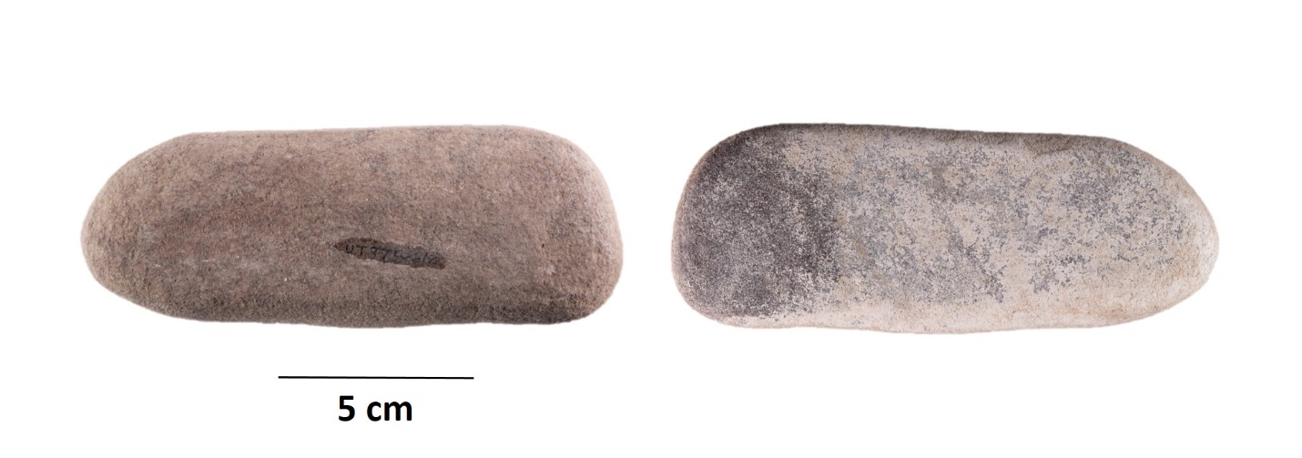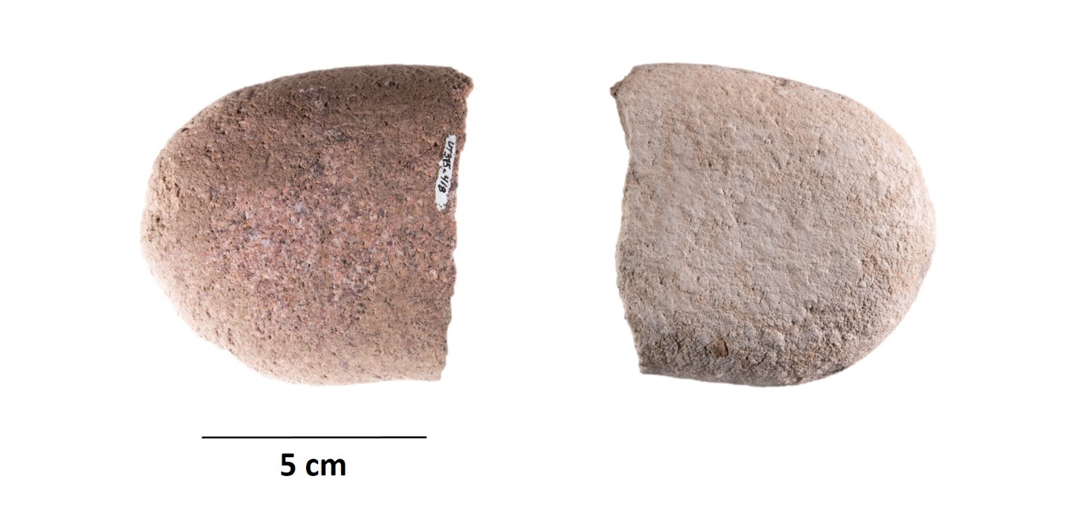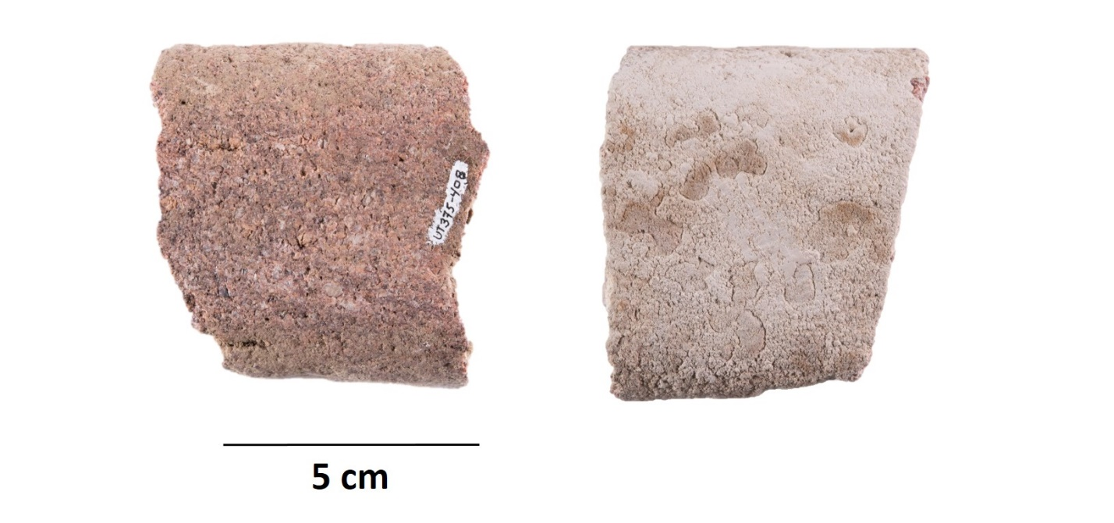

**C.**

**B.**

**A.**

Supplemental Figure 1. Ground stone tools from 48UT375 analyzed for starch. A) UT375-408; B) UT375-418; C) UT375-612.

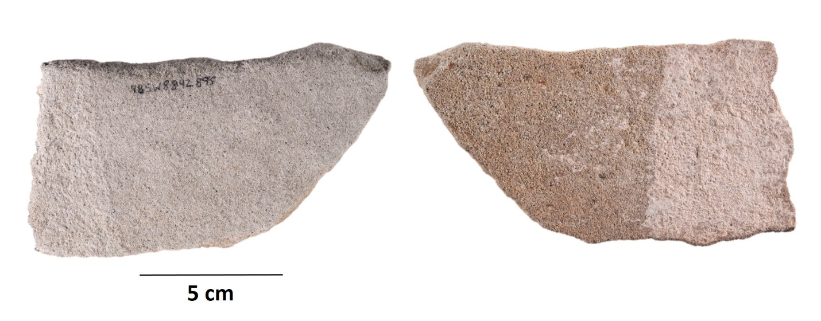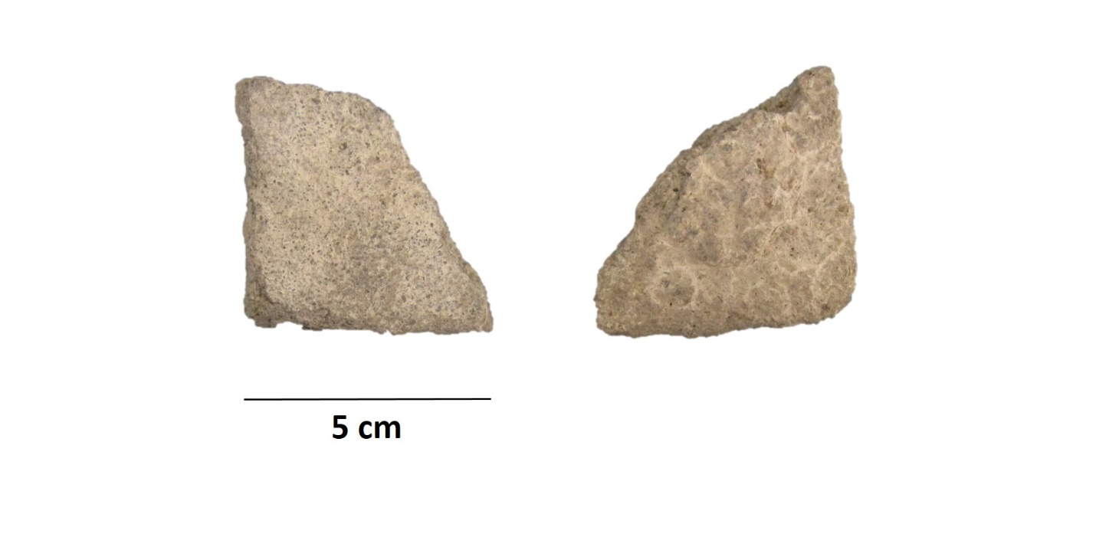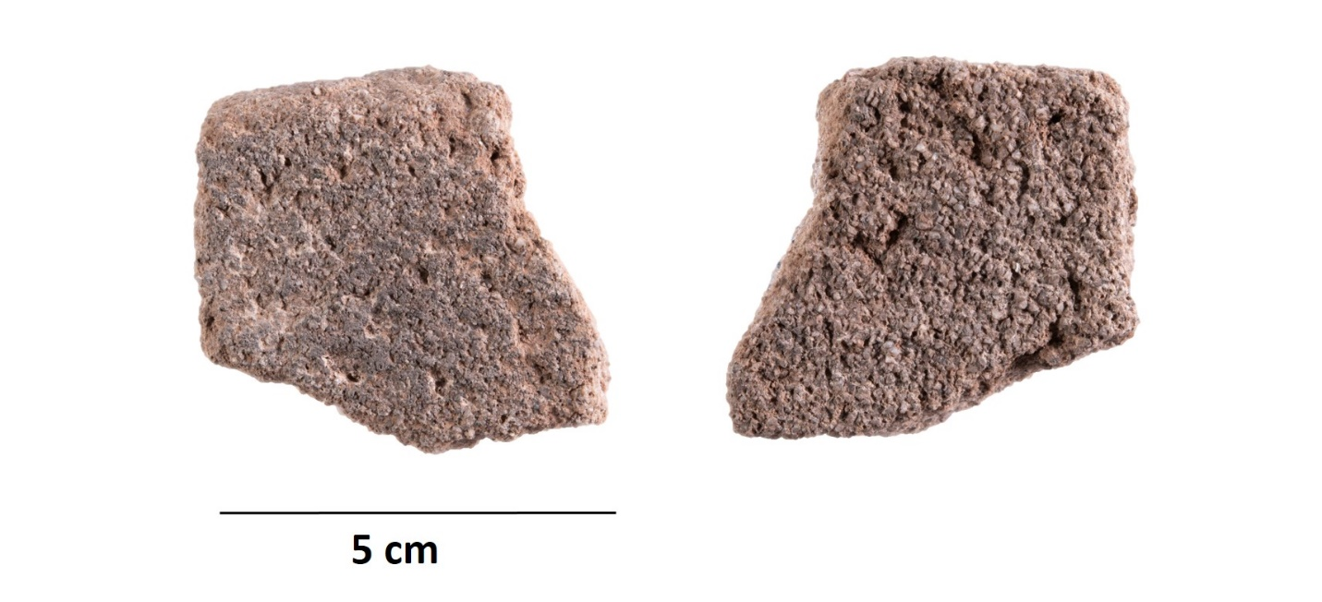

Supplemental Figure 1 (con’t.). Ground stone tools from 48SW8842 analyzed for starch. D) SW8842-239; E) SW8842-273; F) SW8842-895.

**E.**

**F.**

**D.**

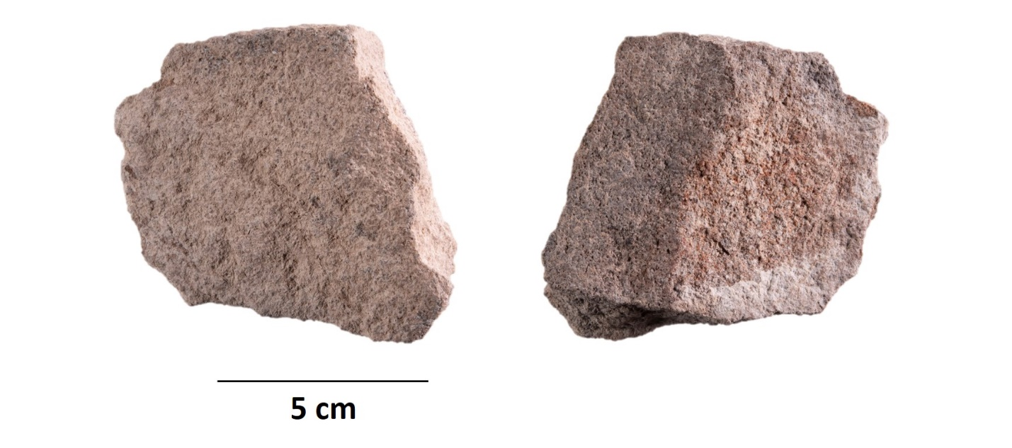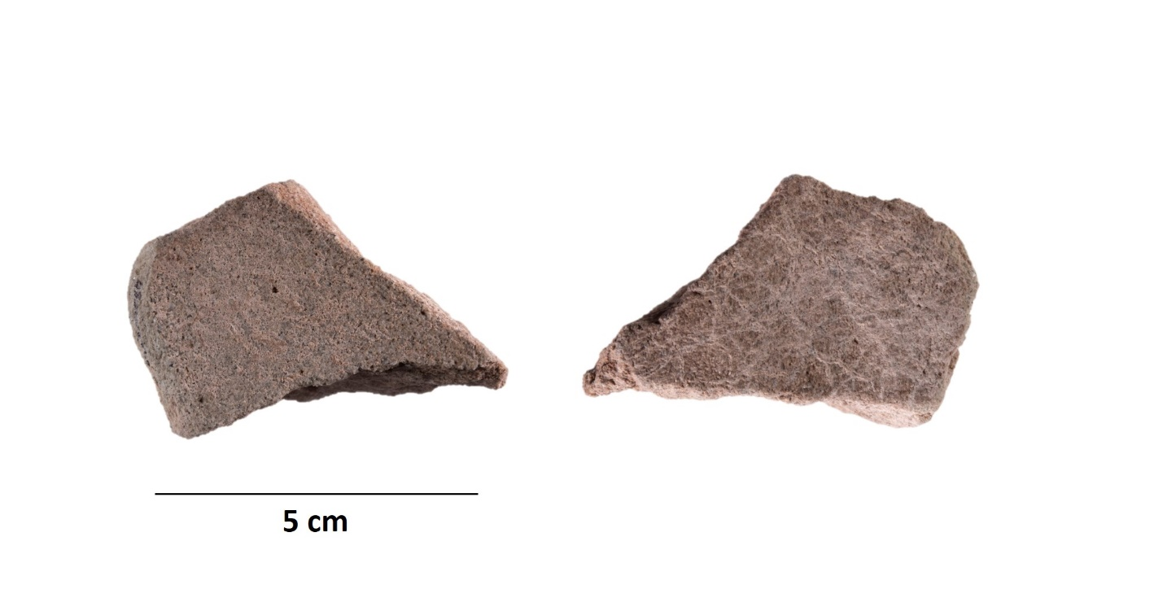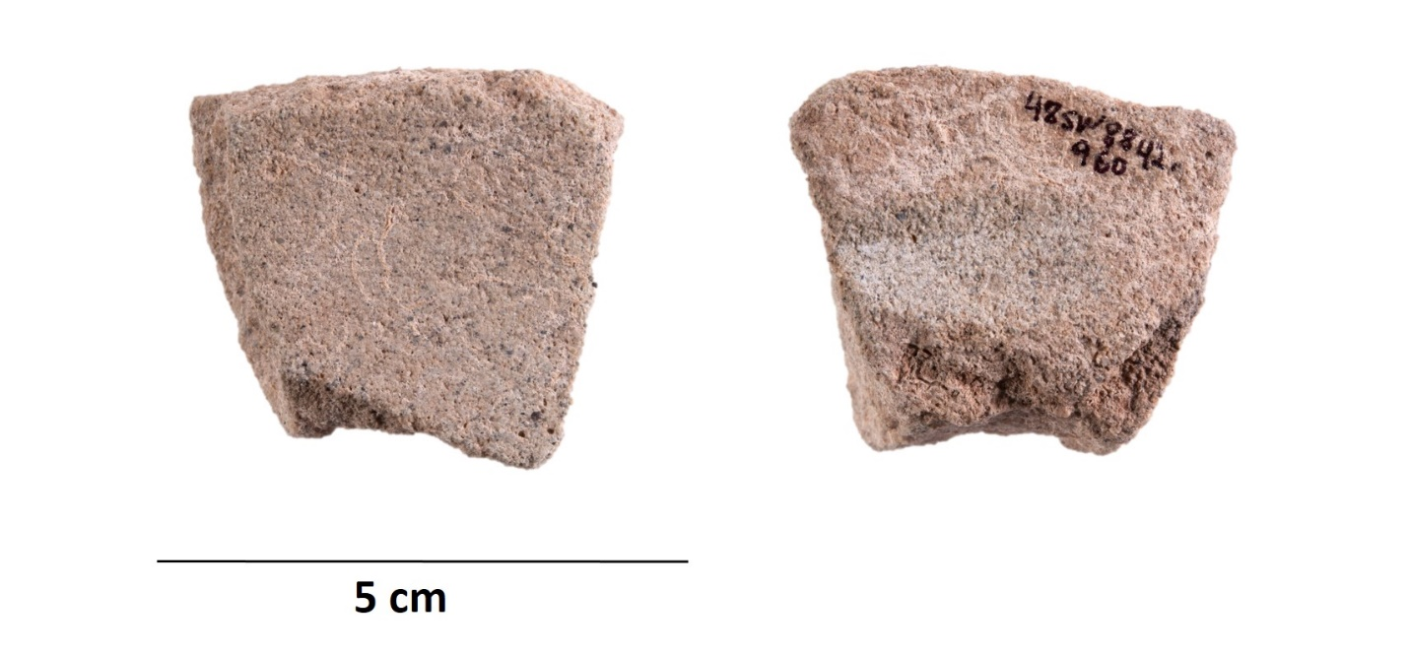

**I.**

**H.**

**G.**

Supplemental Figure 1 (con’t.). Ground stone tools from 48SW8842 analyzed for starch. G) SW8842-960; H) SW8842-1704; I) SW8842-1751.

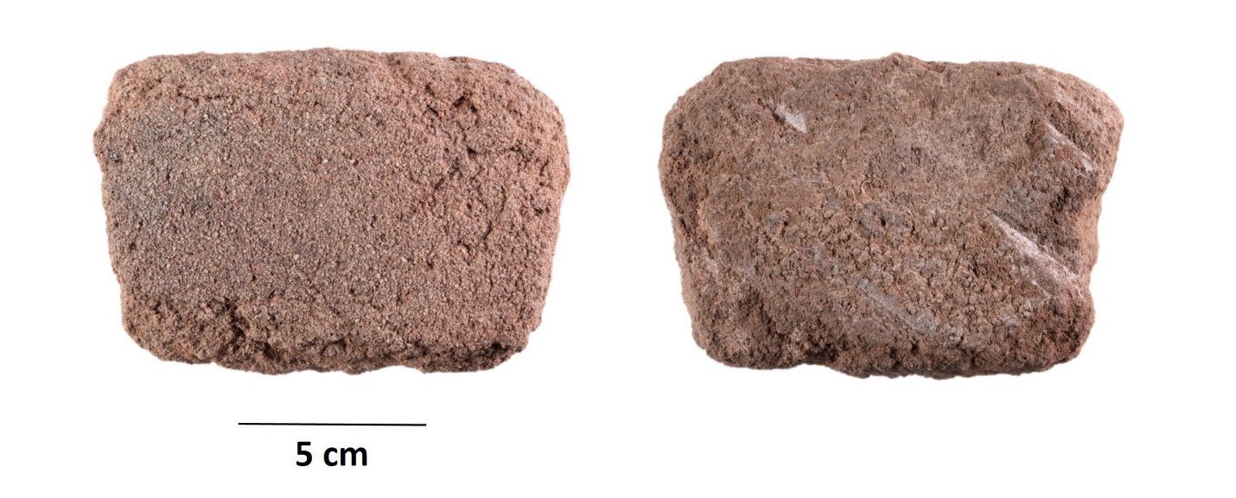

Supplemental Figure 1 (con’t.). Ground stone tool from 48SW8842 analyzed for starch. J) SW8842-1934.

**J.**