Supplemental Text 1. Description of Bayesian Models and Results.

Aztalan
Sixty-eight radiocarbon measurements are available from Aztalan and are described in Supplemental Table 1. The Bayesian chronological model for Aztalan places the radiocarbon measurements into ordered phases corresponding to their archaeological context and the code for this model is presented in Supplemental Text 2.

The following stratigraphic relationships between the dated radiocarbon samples from Aztalan have been documented and are reflected as sequences in the Bayesian model structure:
- The palisade superimposes a possible pit (Feature 30) dated with a sample of unidentified wood charcoal (WIS-191).
- A dated wooden post (WIS-160) from a structure on the Southwest Mound superimposes two dated maize samples obtained from mound fill (WIS-160; UGAMS-30800).
- The radiocarbon samples from the riverbank midden are stratified in the following depositional order presented in Richards (1985):
  - 1) Stratum 11-14/11-15 (lowest dated stratum and dated with a sample of unidentified wood charcoal; DIC-3136),
  - 2) Stratum 11-10 (dated with a sample of unidentified wood charcoal; DIC-3136),
  - 3) Dated unidentified wood charcoal (DIC-3135) and maize (ISGS-A2636) from a dump (Feature 6) directly above Stratum 11-4,
  - 4) Dated unidentified wood charcoal (DIC-3133) from a refuse heap (Feature 20) on the surface of Stratum 5, and
  - 5) Dated unidentified charcoal (Beta-360269) from a bastion post hole (Feature 2013-13) atop the riverbank midden.

The following samples have been modeled as termini post quos (TPQ) for their context in the chronological model for Aztalan:
- Measurements from radiocarbon samples obtained from mound fill (UGAMS-28210, Beta-420799, Beta-360267, WIS-160, UGAMS-30800), because it is feasible that these may have been redeposited from their original archaeological context.
- Measurements from three radiocarbon samples from the riverbank midden sequence that are much older than the dated samples that they superimpose (DIC-3135, ISGS-A2636, DIC-3133), because it is also feasible that these may have been redeposited from their original archaeological context.

The following measurements from charred residues adhering to ceramics have been completely excluded from modeling as too-old outliers: UGAMS-2727, UGAMS-2738, UGAMS-2723, UGAMS-2725, ISGS-A1251, ISGS-A1250, and UGAMS-2726. At 95% confidence, the calibrations from these measurements do not overlap with a calibration from the oldest AMS measurement from Aztalan obtained on a sample type other than charred residue (D-AMS-021795). Additionally, these excluded charred residue measurements are from samples adhering to diagnostically Mississippian period ceramics (Supplemental Table 1); however, at 95% confidence the calibration of these samples predate the approximate start of the Mississippian period in Wisconsin (AD 1000) by at least 100 years. Additionally, the following measurements have been completely excluded from modeling as too-young outliers, likely from intrusive historical activity: AA-46515, Beta-374817, Beta-374818, UGAMS-28208, AA-46511, and M-642.

The radiocarbon dates were modeled using the prior assumption that they are representative of a single, relatively uniform phase of activity. Boundaries were used in OxCal to estimate the start and end date of the overall ordered group. The model was run for 20 million MCMC iterations to ensure acceptable convergence greater than 95. The algorithm used for this model can be directly derived from the model structure shown in Figure S1 and Supplemental Text 2. The model shows good overall agreement (A_{model}=74.4) between the radiocarbon dates and the model assumptions. The posterior probabilities used for interpretation are presented in Tables 1–2 of the non-supplemental text.

An alternate Bayesian model was created for Aztalan by slightly modifying the primary model described above. Specifically, all measurements from charred residues were modeled as TPQ, otherwise the alternate model is identical to the primary model. The algorithm used for this alternative model can be directly derived from the model structure shown in Figure S2 and Supplemental Text 2. The alternate model for Aztalan shows good overall agreement (A_{model}=71.1) between the radiocarbon dates and the model assumptions. The posterior probabilities used for interpretation are presented in Tables 1–2 of the non-supplemental text.

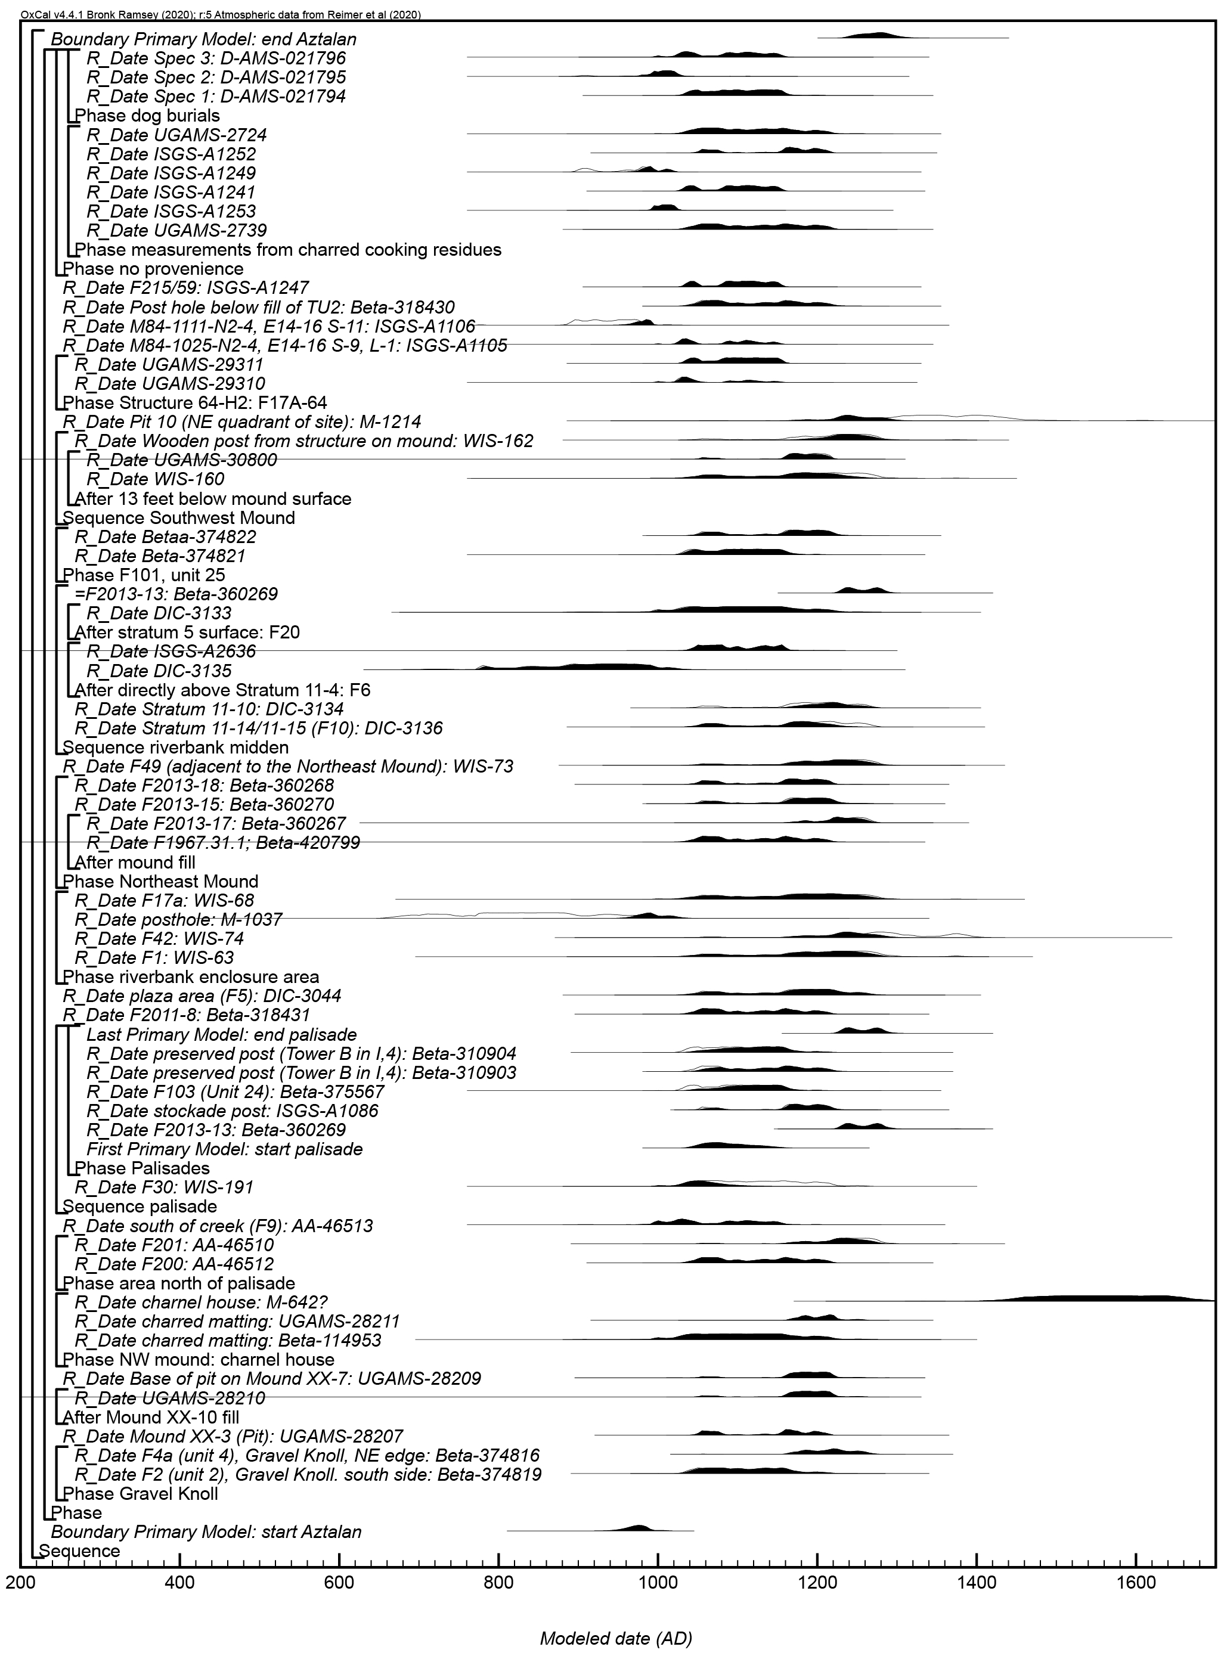
Figure S1. Results and structure of the primary chronological model for Aztalan. The brackets and keywords define the model structure. The outlined distributions are the result of radiocarbon calibrations and the solid distributions are the chronological model results.

Figure S2. Results and structure of the alternate chronological model for Aztalan. The brackets and keywords define the model structure. The format is as described in Figure S1.

Carcajou Point
Twelve radiocarbon measurements are available from Carcajou Point and are described in Supplemental Table 1. The Bayesian chronological model for Carcajou Point places the radiocarbon measurements into unordered phases corresponding to their archaeological context and the code for this model is presented in Supplemental Text 2.

The radiocarbon dates were modeled using the prior assumption that they are representative of a single, relatively uniform phase of activity. Boundaries were used in OxCal to estimate the start and end date of the overall group. The algorithm used for this model can be directly derived from the model structure shown in Figure S3 and Supplemental Text 2. The model shows good overall agreement (A_{model}=101.5) between the radiocarbon dates and the model assumptions. The posterior probabilities used for interpretation are presented in Tables 1–2 of the non-supplemental text.

An alternate Bayesian model was created for Carcajou Point by slightly modifying the primary model described above. Specifically, all measurements from charred residues were modeled as TPQ and the model was run for 20 million MCMC iterations to ensure acceptable convergence greater than 95. Otherwise, the alternate model is identical to the primary model. The algorithm used for this alternative model can be directly derived from the model structure shown in Figure S4 and Supplemental Text 2. The alternate model for Carcajou Point shows good overall agreement (A_{model}=100.5) between the radiocarbon dates and the model assumptions. The posterior probabilities used for interpretation are presented in Tables 1–2 of the non-supplemental text.

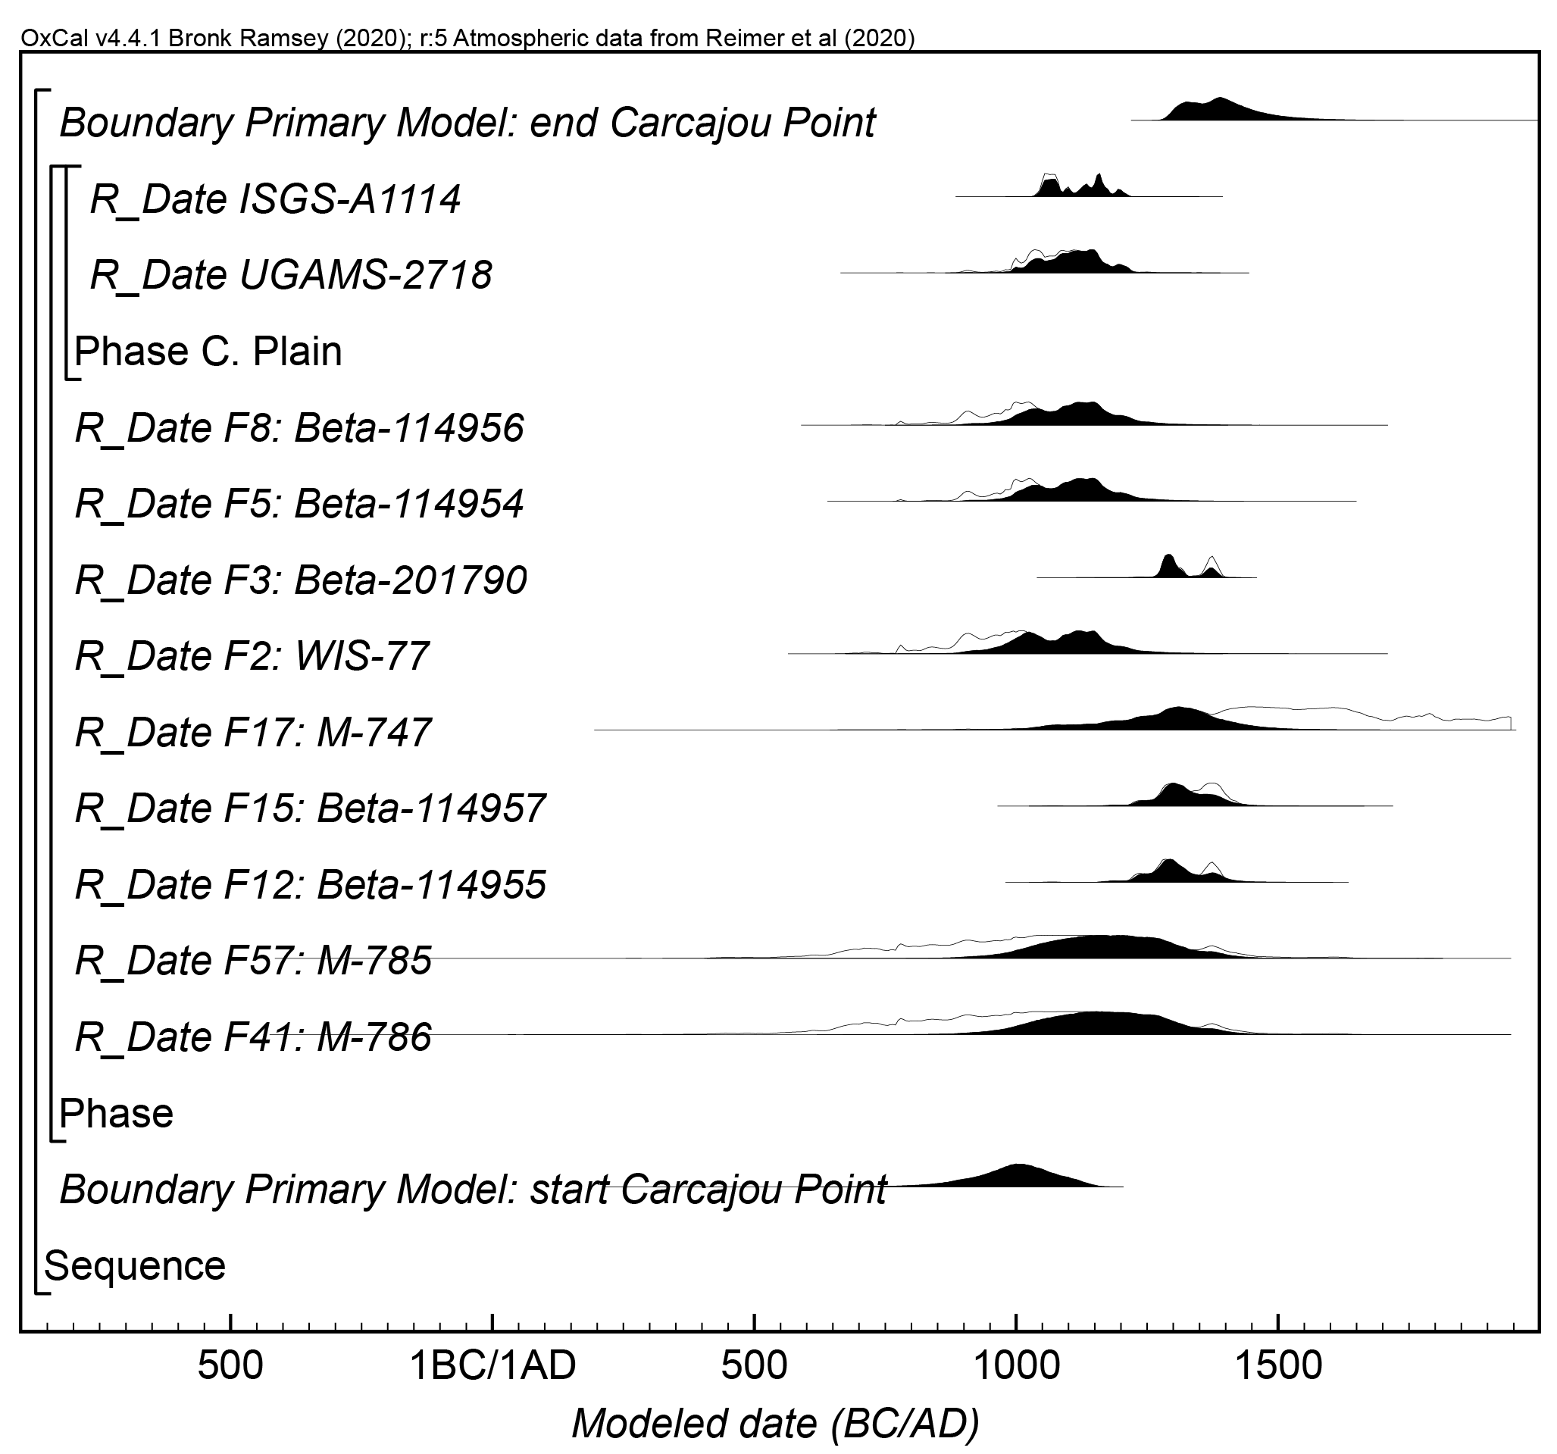
Figure S3. Results and structure of the primary chronological model for Carcajou Point. The brackets and keywords define the model structure. The format is as described in Figure S1.

Figure S4. Results and structure of the alternate chronological model for Carcajou Point. The brackets and keywords define the model structure. The format is as described in Figure S1.

Crescent Bay Hunt Club
Twenty-nine radiocarbon measurements are available from Crescent Bay Hunt Club and are described in Supplemental Table 1. The Bayesian chronological model for Crescent Bay Hunt Club places the radiocarbon measurements into unordered phases corresponding to their archaeological context and the code for this model is presented in Supplemental Text 2.

The radiocarbon dates were modeled using the prior assumption that they are representative of a single, relatively uniform phase of activity. Boundaries were used in OxCal to estimate the start and end date of the overall group. The algorithm used for this model can be directly derived from the model structure shown in Figure S5 and Supplemental Text 2. The model shows good overall agreement (A_{model}=67.2) between the radiocarbon dates and the model assumptions. The posterior probabilities used for interpretation are presented in Tables 1–2 of the non-supplemental text.

An alternate Bayesian model was created for Crescent Bay Hunt Club by slightly modifying the primary model described above. Specifically, all measurements from charred residues were modeled as TPQ, otherwise the alternate model is identical to the primary model. The algorithm used for this alternative model can be directly derived from the model structure shown in Figure S5 and Supplemental Text 2. The alternate model for Crescent Bay Hunt Club shows good overall agreement (A_{model}=102.6) between the radiocarbon dates and the model assumptions. The posterior probabilities used for interpretation are presented in Tables 1–2 of the non-supplemental text.

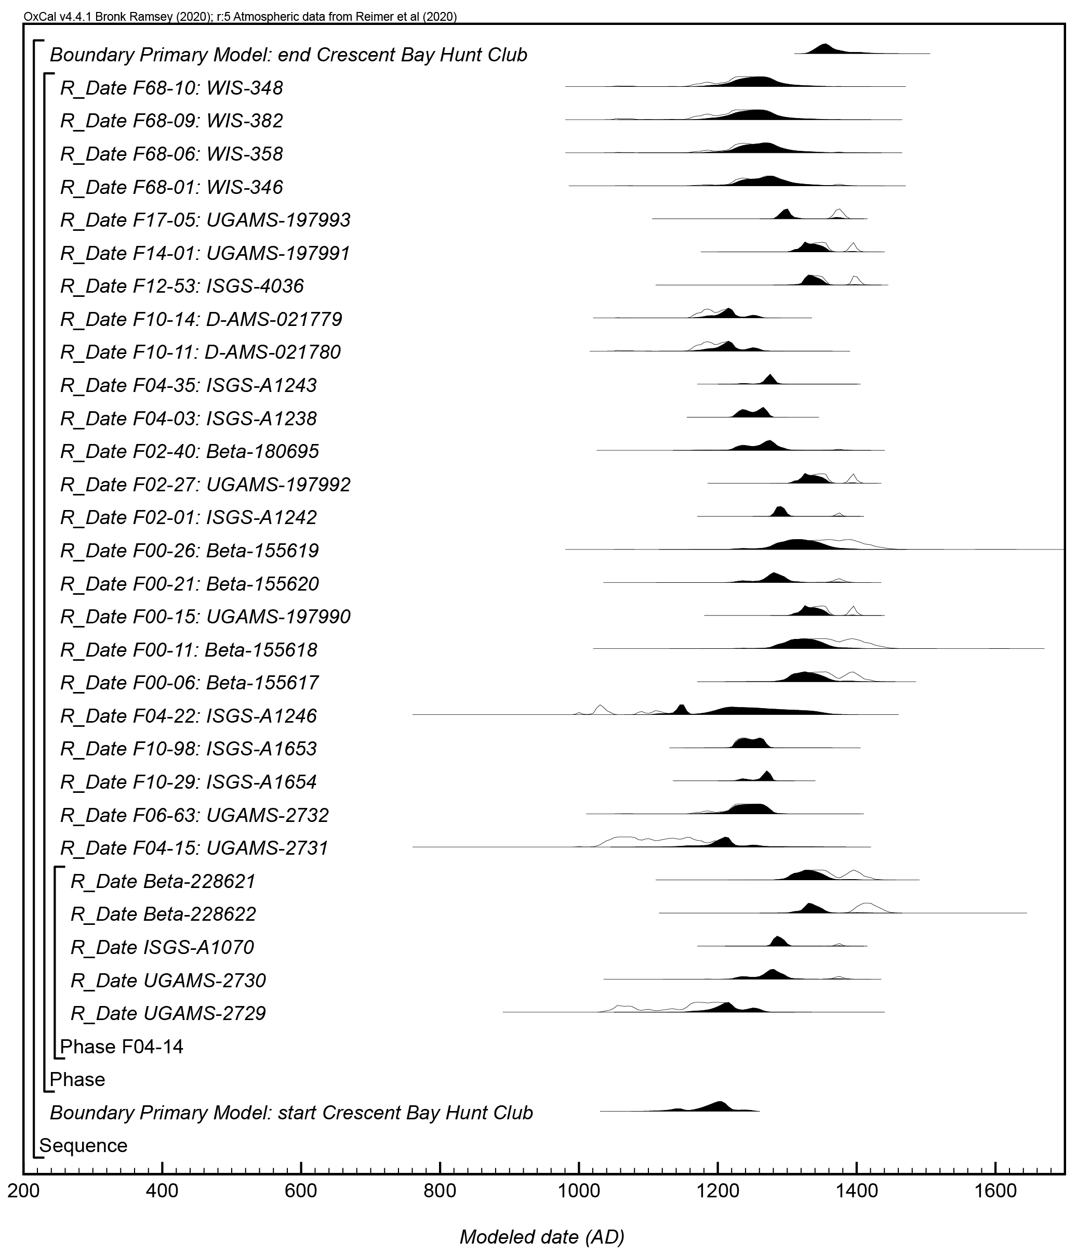
Figure S5. Results and structure of the primary chronological model for Crescent Bay Hunt Club. The brackets and keywords define the model structure. The format is as described in Figure S1.

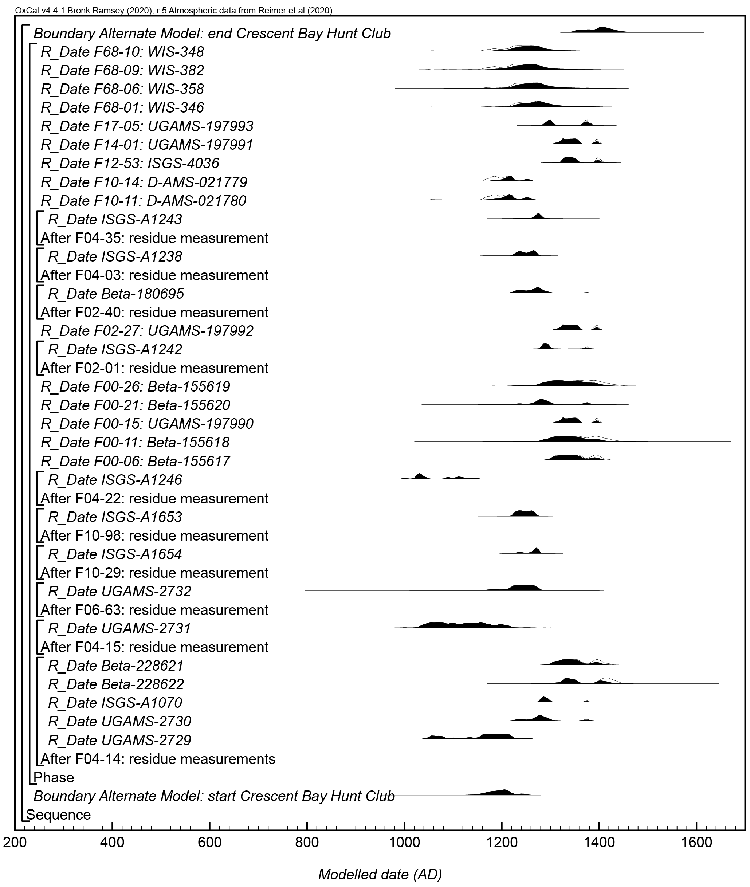
Figure S6. Results and structure of the alternate chronological model for Crescent Bay Hunt Club. The brackets and keywords define the model structure. The format is as described in Figure S1.

Koshkonong Creek Village
Seven radiocarbon measurements are available from Koshkonong Creek Village and are described in Supplemental Table 1. The Bayesian chronological model for Koshkonong Creek Village places the radiocarbon measurements into unordered phases corresponding to their archaeological context and the code for this model is presented in Supplemental Text 2.

The radiocarbon dates were modeled using the prior assumption that they are representative of a single, relatively uniform phase of activity. Boundaries were used in OxCal to estimate the start and end date of the overall group. The algorithm used for this model can be directly derived from the model structure shown in Figure S7 and Supplemental Text 2. The model shows good overall agreement (A_{model}=77.4) between the radiocarbon dates and the model assumptions. The posterior probabilities used for interpretation are presented in Tables 1–2 of the non-supplemental text.

An alternate Bayesian model was created for Koshkonong Creek Village by slightly modifying the primary model described above. Specifically, all measurements from charred residues were modeled as TPQ, otherwise the alternate model is identical to the primary model. The algorithm used for this alternative model can be directly derived from the model structure shown in Figure S8 and Supplemental Text 2. The alternate model for Koshkonong Creek Village shows good overall agreement (A_{model}=95.6) between the radiocarbon dates and the model assumptions. The posterior probabilities used for interpretation are presented in Tables 1–2 of the non-supplemental text.

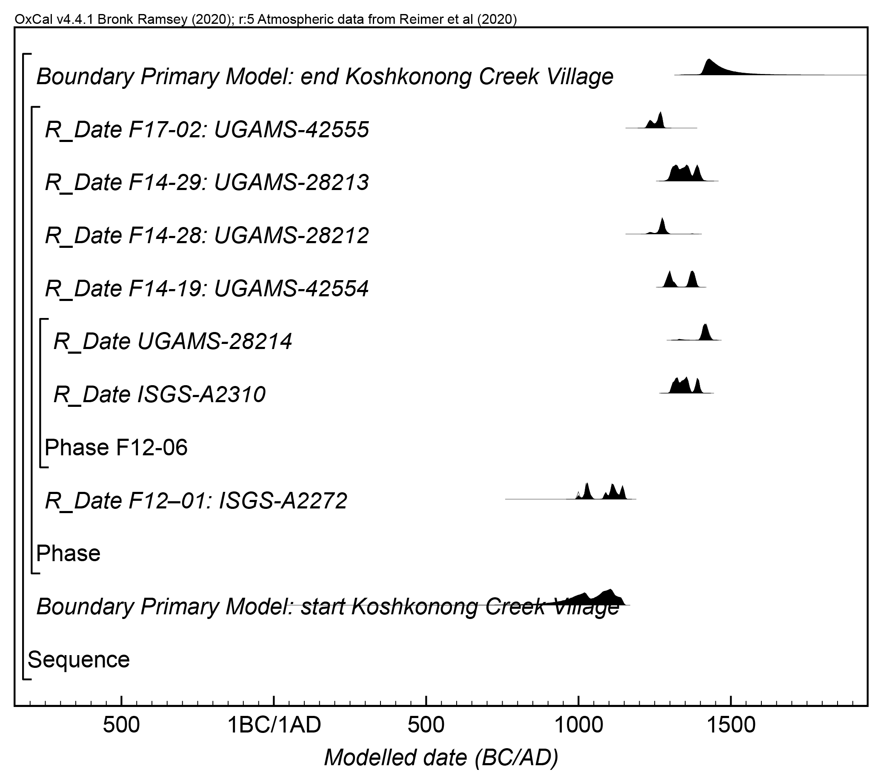
Figure S7. Results and structure of the primary chronological model for Koshkonong Creek Village. The brackets and keywords define the model structure. The format is as described in Figure S1.

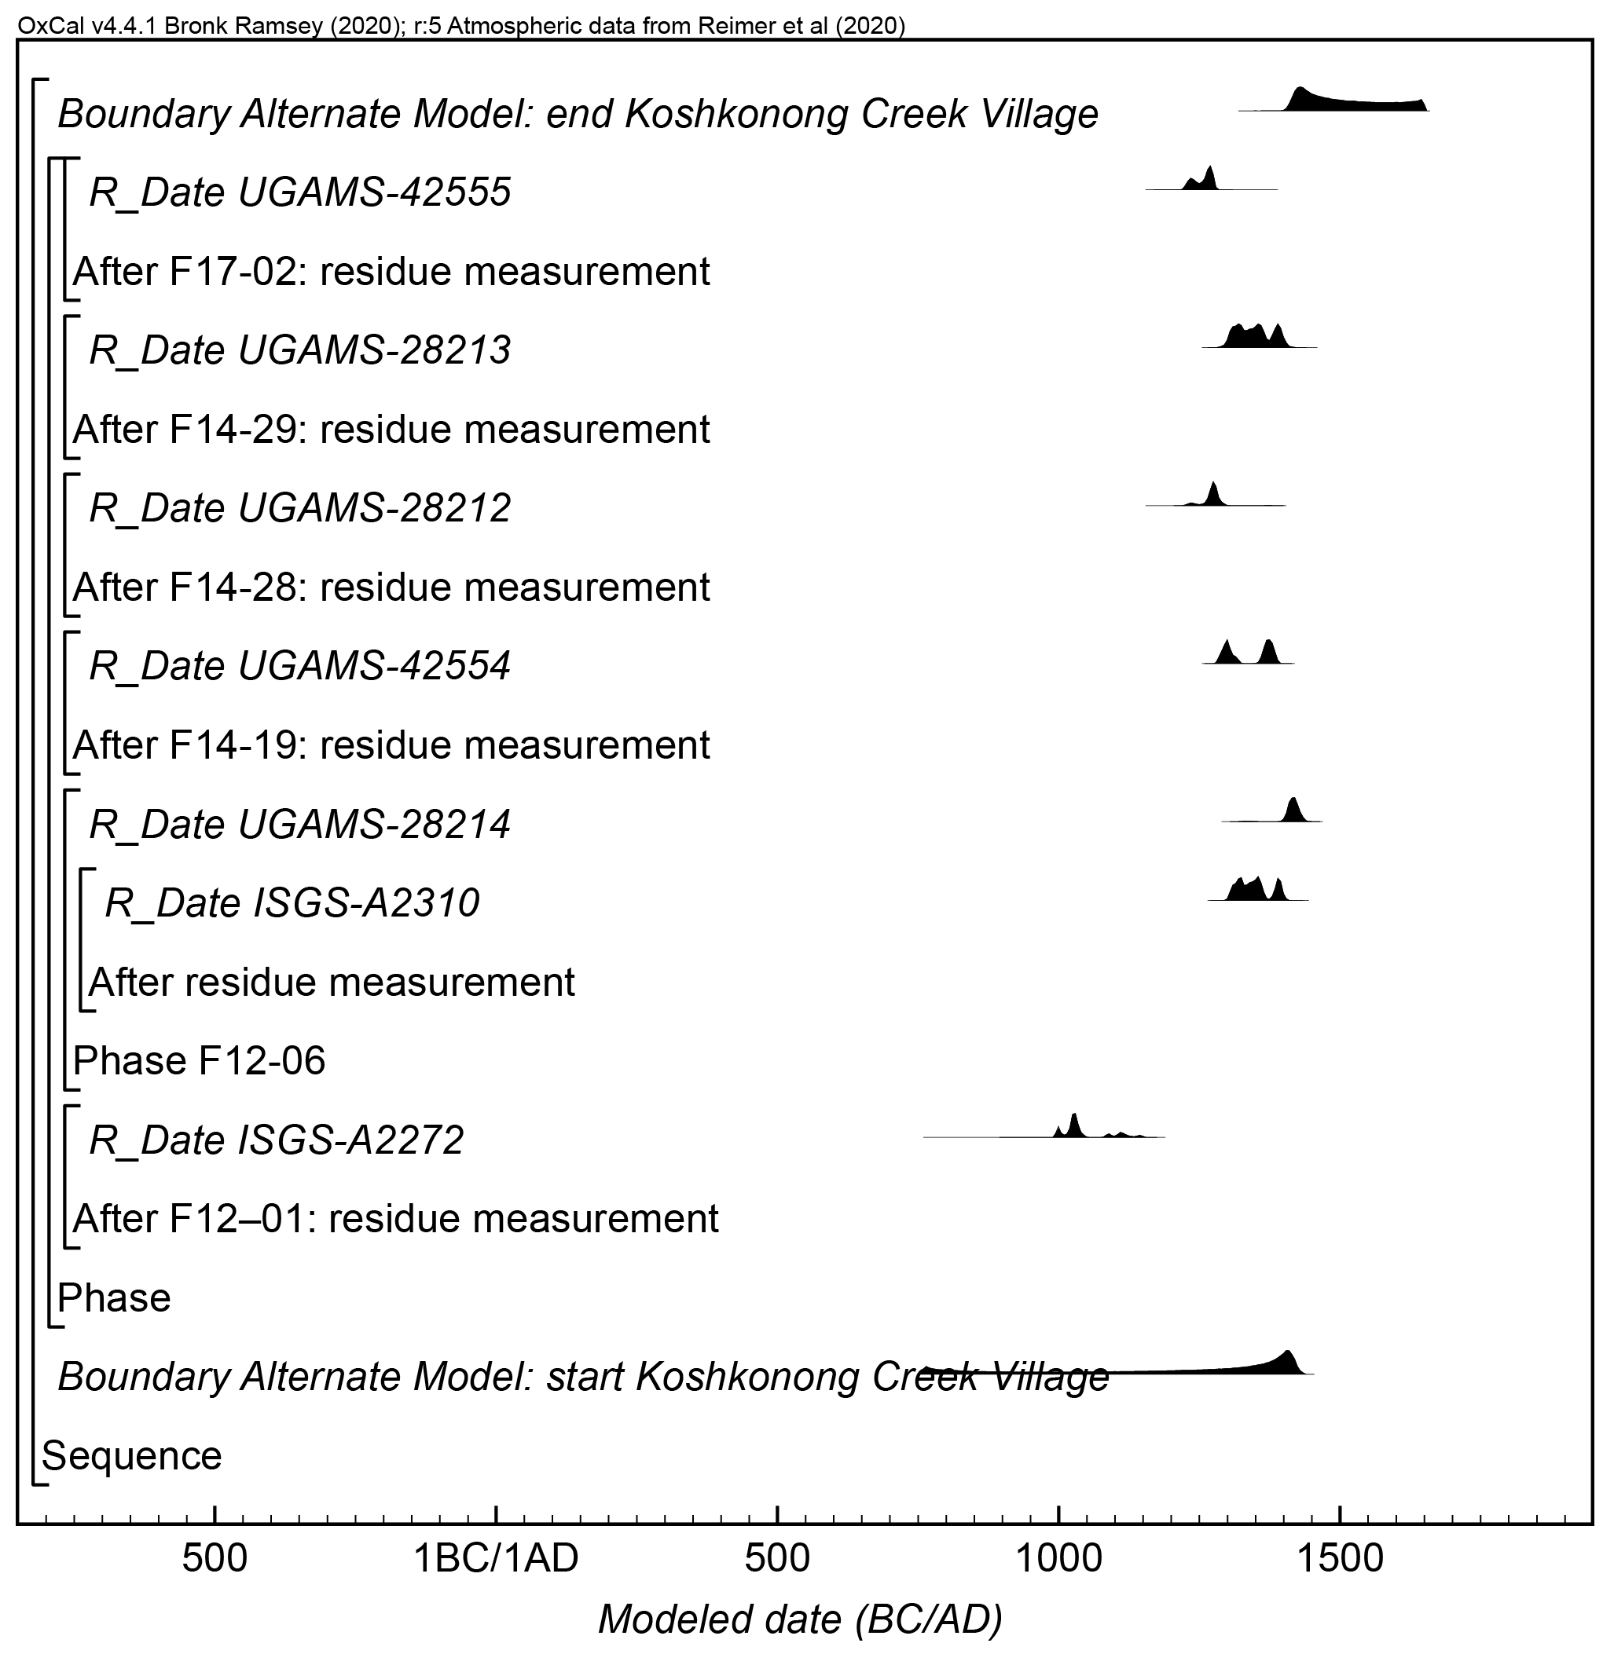
Figure S8. Results and structure of the alternate chronological model for Koshkonong Creek Village. The brackets and keywords define the model structure. The format is as described in Figure S1.

Regional Model: Oneota at Lake Koshkonong
After evaluating the above results, a regional-scale model for the entirety of Oneota activity at Lake Koshkonong was created. This model places the radiocarbon dates (52 total) from the five dated Oneota sites from Lake Koshkonong into a single unordered phases corresponding to their archaeological context and the code for this model is presented in Supplemental Text 2.

The radiocarbon dates were modeled using the prior assumption that they are representative of a single, relatively uniform phase of activity. Boundaries were used in OxCal to estimate the start and end date of the overall group. The algorithm used for this model can be directly derived from the model structure shown in Figure S9 and Supplemental Text 2. The model shows good overall agreement (A_{model}=75.8) between the radiocarbon dates and the model assumptions. The posterior probabilities used for interpretation are presented in Tables 1–2 of the non-supplemental text.

An alternate Bayesian model was created for Oneota activity at Lake Koshkonong by slightly modifying the primary model described above. Specifically, all measurements from charred residues were modeled as TPQ, otherwise the alternate model is identical to the primary model. The algorithm used for this alternative model can be directly derived from the model structure shown in Figure S10 and Supplemental Text 2. The alternate model for Oneota activity at Lake Koshkonong shows good overall agreement (A_{model}=94.3) between the radiocarbon dates and the model assumptions. The posterior probabilities used for interpretation are presented in Tables 1–2 of the non-supplemental text.

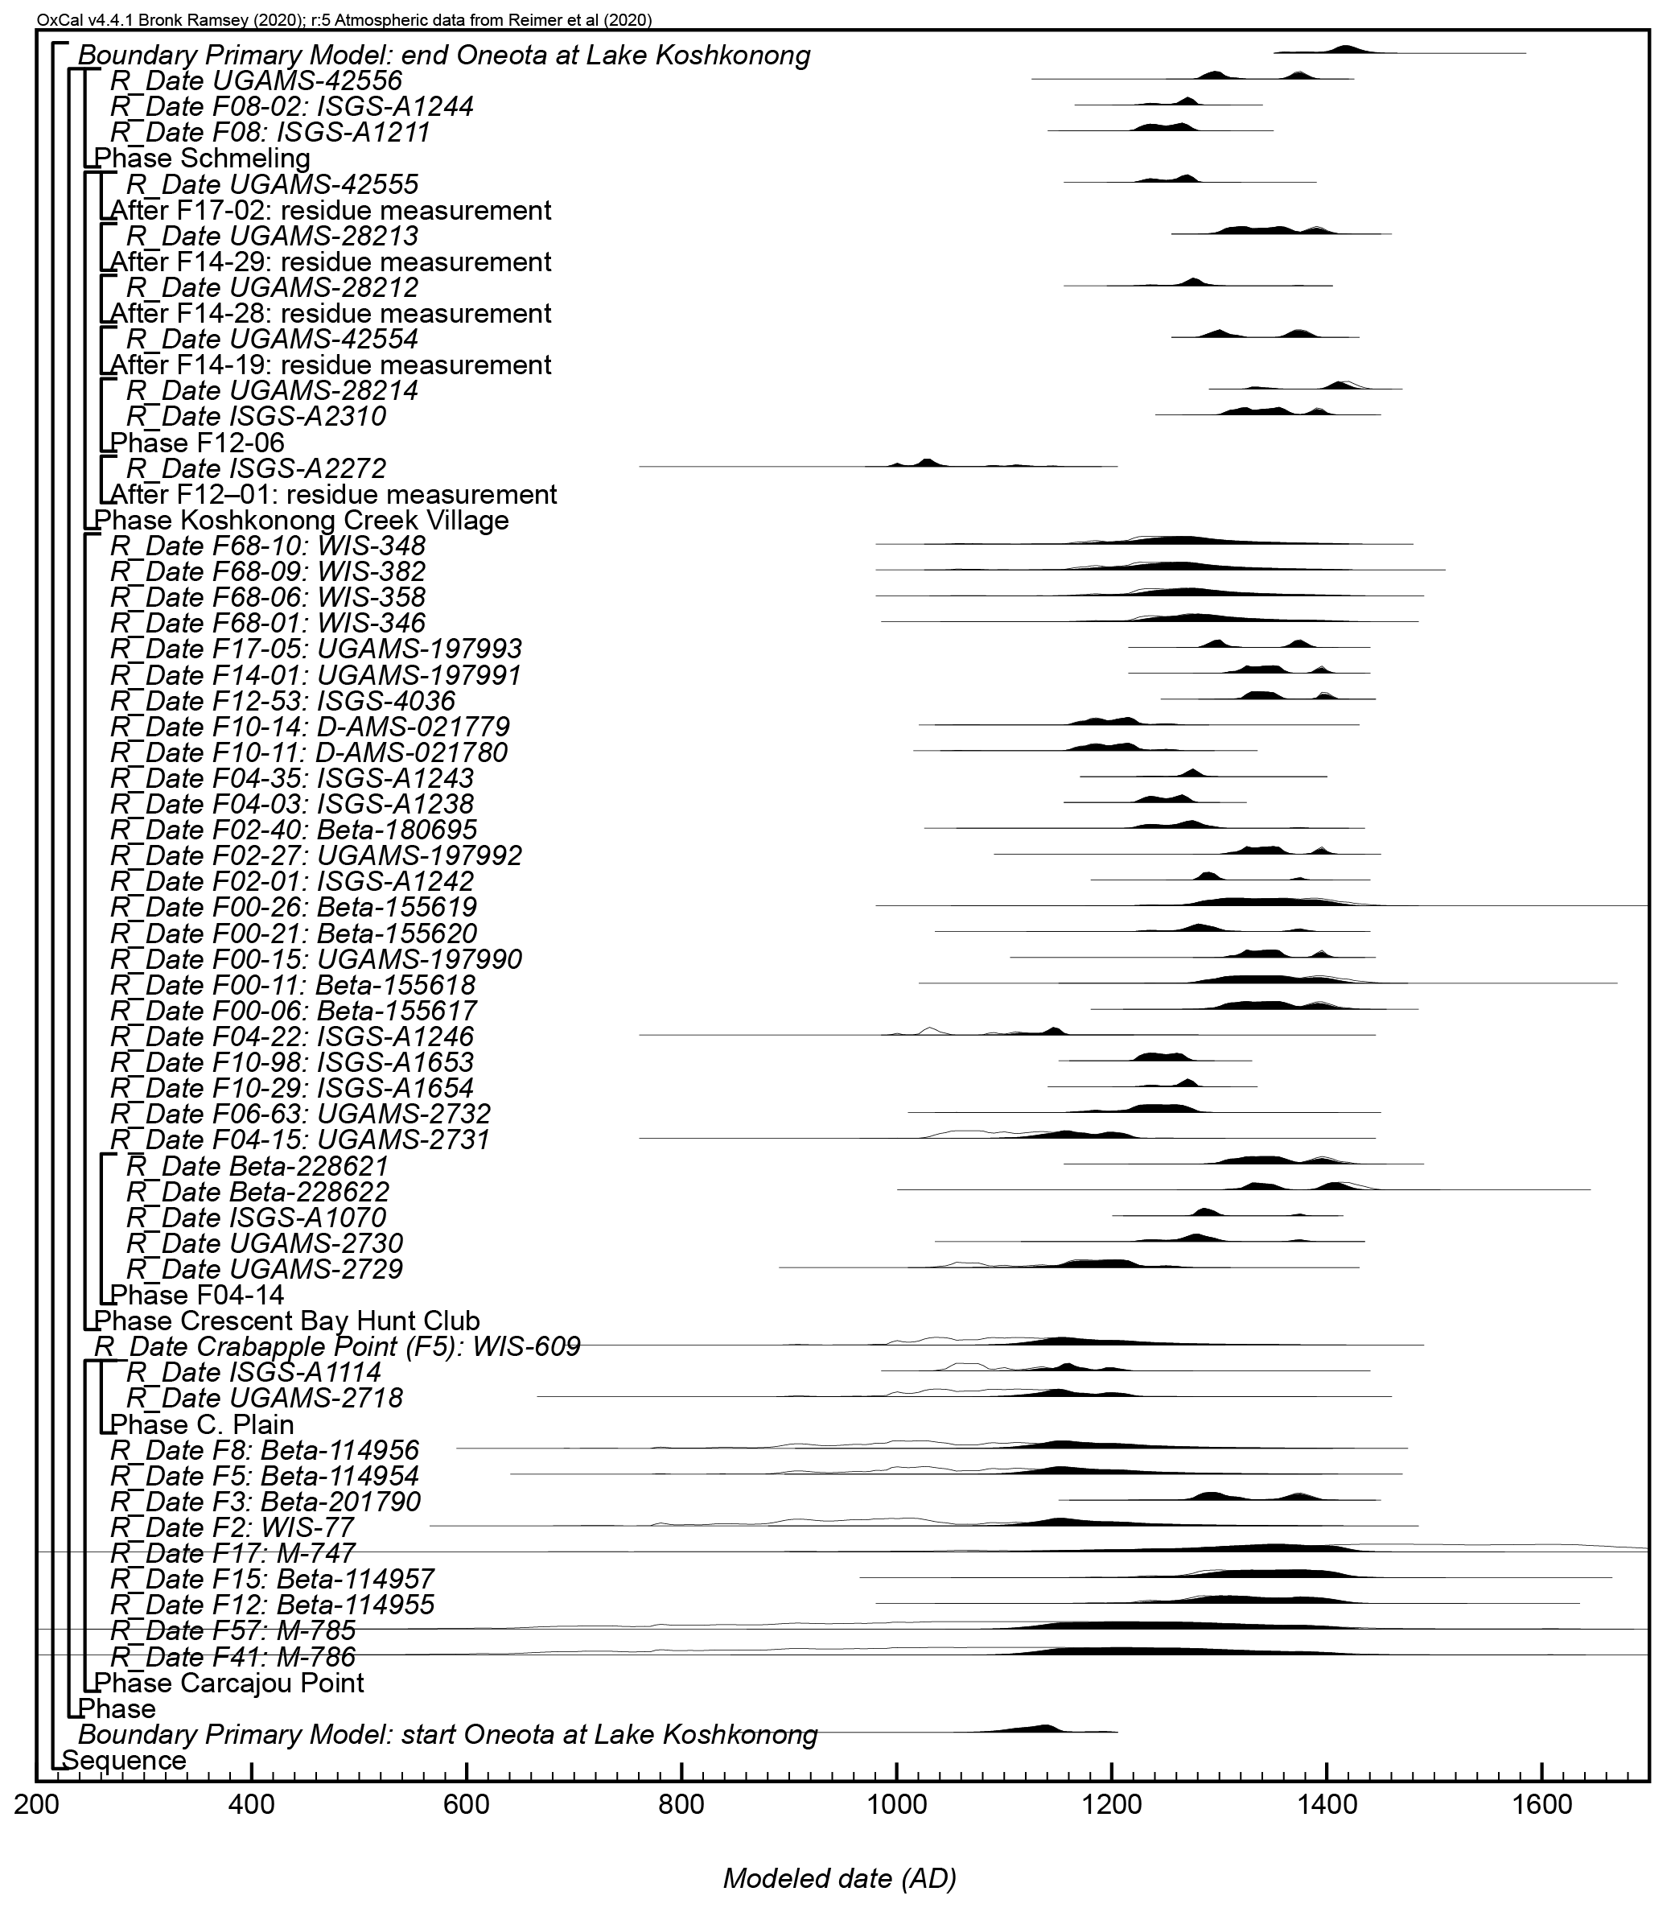
Figure S9. Results and structure of the primary chronological model for Oneota activity at Lake Koshkonong. The brackets and keywords define the model structure. The format is as described in Figure S1.

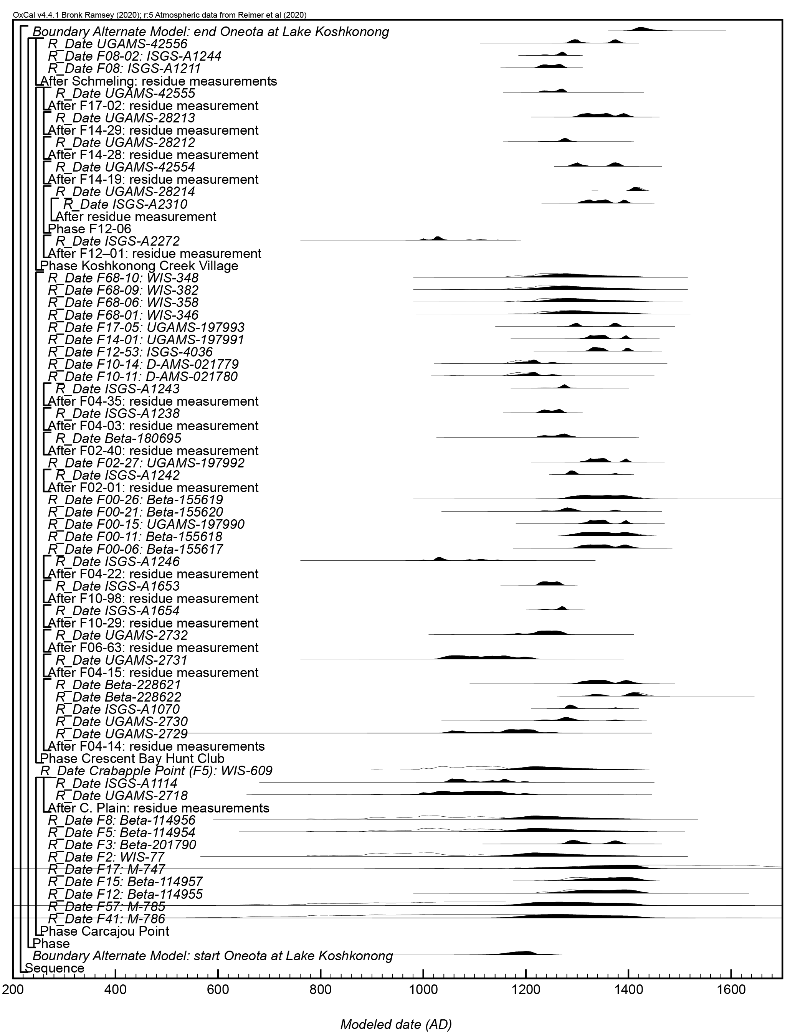
Figure S10. Results and structure of the alternate chronological model for Oneota activity at Lake Koshkonong. The brackets and keywords define the model structure. The format is as described in Figure S1.

