SUPPLEMENTARY APPENDIX A. LEHI HORSE STRATIGRAPHIC DESCRIPTION
Stratigraphic descriptions were extrapolated from a video recorded during excavation, which contained brief observations and interpretations from the excavator, and 3 published photos of the horse remains in-situ during various stages of the excavation. Because the authors did not visit the site or receive any samples of the subsurface stratigraphy and photos may have been taken after modification of the outcrops, these descriptions and interpretations of the units may require further study to fully understand the depositional context.
The Lehi horse was reported to be buried in Pleistocene sands from Lake Bonneville. At this location, the Lake Bonneville shoreline is generally described as Pleistocene sandy lacustrine and alluvial fan deposits overlain by Holocene alluvium (Biek, 2005). Using our observations from the video and photos, we divided the subsurface stratigraphy into four units based on color, grain size, and sedimentary structures. No absolute age control from any of the units was available from this site, aside from radiocarbon dating of the horse remains.
Unit 1 is at the base of the excavation. It is a light buff-colored medium to very coarse sand, with uncommon pebbles and small gravel (Supplementary Figure 2). The unit appears well sorted, with no visible grading, and may have some cross-bedding or ripples or horizontal laminations (unclear from the photos and video and outcrop may have been modified during excavation). Based on the photos and the description of the sand being a “clean” sand, Unit 1 is interpreted to be a beach sand or sandy lacustrine unit. Because of the coarseness of the grains, it is very likely near shore. Based on previous interpretations, this unit likely belongs to Pleistocene Lake Bonneville (Orviatt, 1997; Benson et al., 2011; Orviatt, 2015).
Unit 2 overlies Unit 1 with a minor unconformity (Supplementary Figure 2c, d), and as Unit 2 approaches the horse remains, it appears to cross-cut Unit 1 at a steep angle (Supplementary Figure 2a, b). The unit is a dark brown, finer-grained layer, although some sand and pebbles are visible in the photos. Laminations within Unit 2 appear nearly vertical on the left side of the horse remains (Supplementary Figure 2e, f). From the darker color in the photos, the unit likely has some organic material in it. Based on the darker color and near-vertical orientation near the horse remains, Unit 2 is interpreted to represent material on the margin of a pit.
Unit 3 overlies Unit 2 and the horse remains. The unit is composed of interbedded buff-colored horizontally laminated sands (likely medium- to coarse-grained?) and thin dark-brown horizontally laminated silts. These two interbedded layers are visible in the photos (Supplementary Figure 2e, f) overlying the horse remains. Unit 3 is interpreted to be fluvial sands and silts. Because Unit 3 overlies the horse remains, is distinct from Unit 1 in color and apparent grain size and separated from Unit 1 by Unit 2, Unit 3 is interpreted to be material that filled in the pit and covered the horse remains. Because the archaeological material (flaked chert artifact) was found in the overburden (Unit 3 and possibly Unit 4; context of artifact not recorded during excavation) and this unit overlies the horse remains dated to 1681-1939 cal. CE, we can interpret that this unit represents recent deposition.
Unit 4 is at the top of the excavation, and overlies Unit 3 in a minor angular unconformity. Unit 4 is buff-colored sands (likely medium- to coarse-grained?). Unit 4 is interpreted to be fluvial sands and silts. The rapid aggradation of Unit 3 and possibly Unit 4 may be due to increased erosion following the introduction of agriculture and grazing in the region after ~1850 CE.
SUPPLEMENTARY APPENDIX B. ZONKEY ANALYSIS REPORT.
The report is provided in html format and can be opened in any web-browser. It shows the results of each individual analysis, including (1) sex determination, (2) admixture, (3) TreeMix phylogenetic reconstruction based on autosomal SNP variation, and (4) RAxML phylogenetic reconstruction based on mitochondrial sequences. Full details are described in the original publication from Schubert and colleagues (Schubert et al. 2017).
SUPPLEMENTARY FIGURE 1.
Horse burial from the early 17th century Saxman site in Kansas, informally excavated and disposed of during the 1970s, on the assumption that it was modern. Mary Adair, 2018, personal communication.

SUPPLEMENTARY FIGURE 2
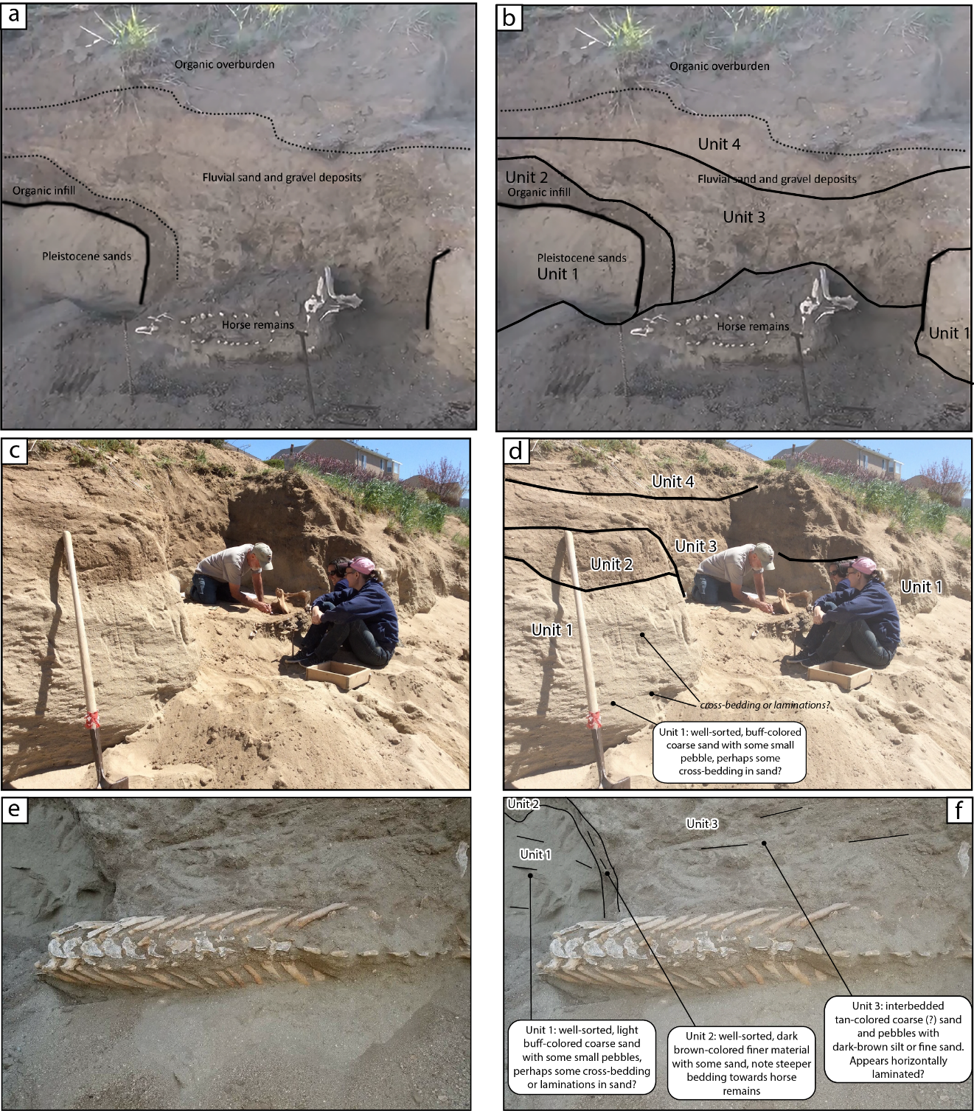
(a) Uninterpreted and (b) interpreted still photo from a video recorded during excavation. Boundaries of the 4 units and the horse remains are marked. (c) Uninterpreted and (d) interpreted photos of the subsurface stratigraphy during excavation. (e) Uninterpreted and (f) interpreted photos of the subsurface stratigraphy directly adjacent to the horse remains during excavation.

