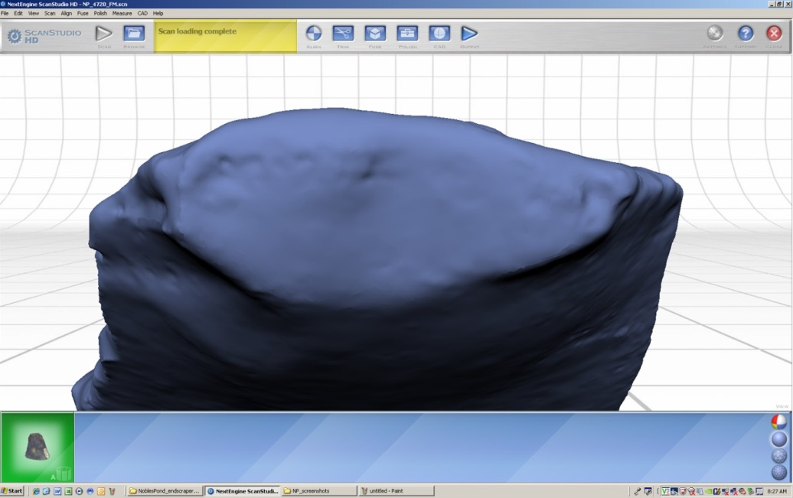
Supplementary Figure 1. ScanStudio image showing 3D model of an endscraper proximal end and platform.

