Image 1: The text in Arabic reads as follows: Use the heat-induced corset for a Kim Kardashian-like waist (posted on Alnairat, September 2016)
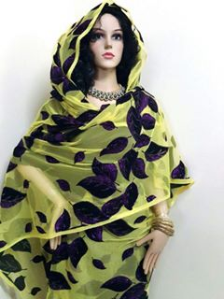
Image 2: Advertisement ad for a tobe (a traditional cloth that women in most part of Sudan wrap around their bodies. (posted on Alnairat by R. H. on 9 September 2016)

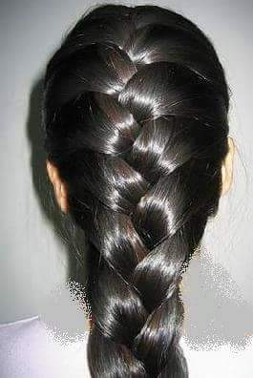
Image 3: “With Taj Al-Makhmal hair products your hair will be straight, long, and sleek.” Alnairat, August 2016

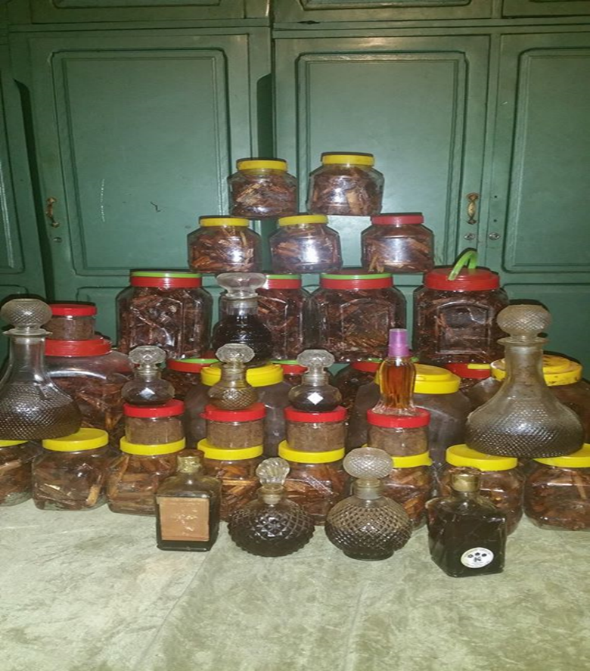
Image 4: A collection of traditional Khumra perfumes, and Bakhoor incense. Posted on Dilalat Alnairat al Daiman Mujayyahat (the market for radiant, always well-groomed women) then new Facebook group. Dilalat Alnairat November 23 2016.

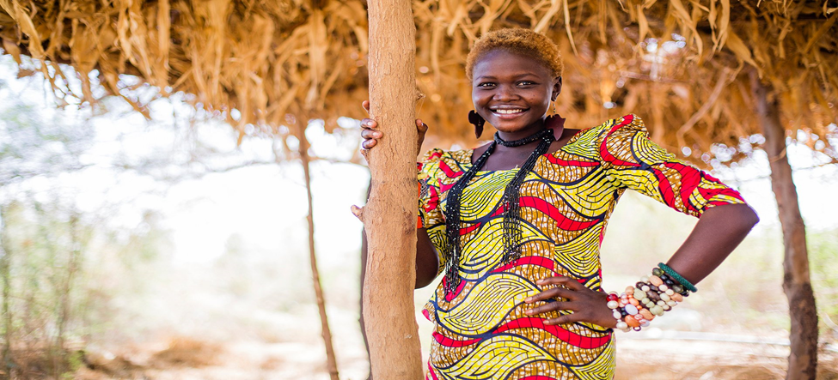
Image 5: An Example of Decolonial Aesthetic Practices and Images.Natalina Yaqoub was selected as Nuba Mountains Beauty Queen 2015 ©Photograph: Ala Kheir/Elephant Media.

- 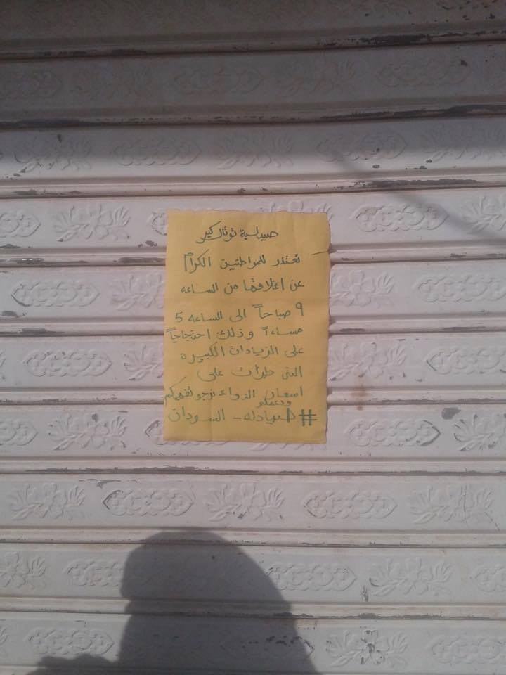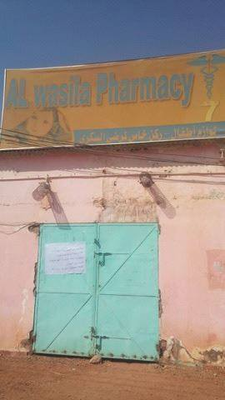
- Image 6: On 19 November, pharmacists in Sudan went on strike and closed 200 pharmacies across Sudan to protest the increase in the cost of medicines.

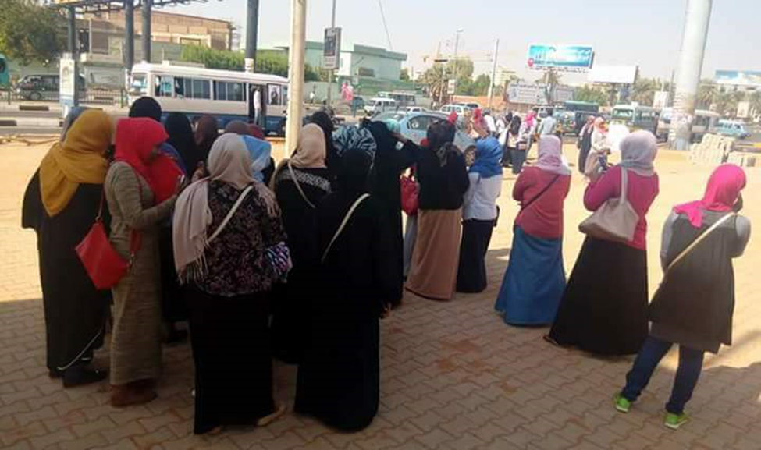
Image 7: Members of Fasikh wa Galikh (F.G.) and Alda’am Al Saree’ (Rapid Support) protesting the increase in the prices of medicine ©Khansaa Kantosha and Rashan Oshi, posted on 20 November 2016 on Facebook, including in Munbarshat, F.G., and Mihera.
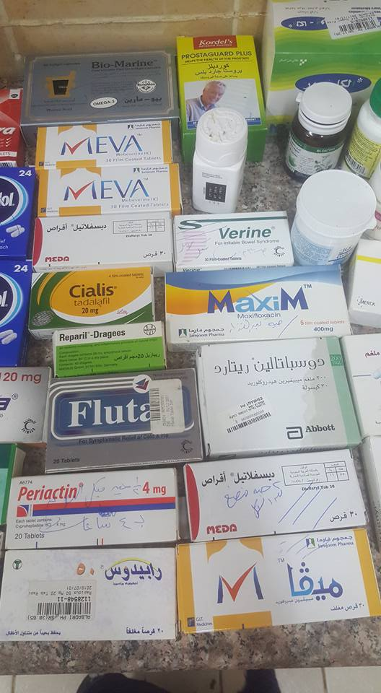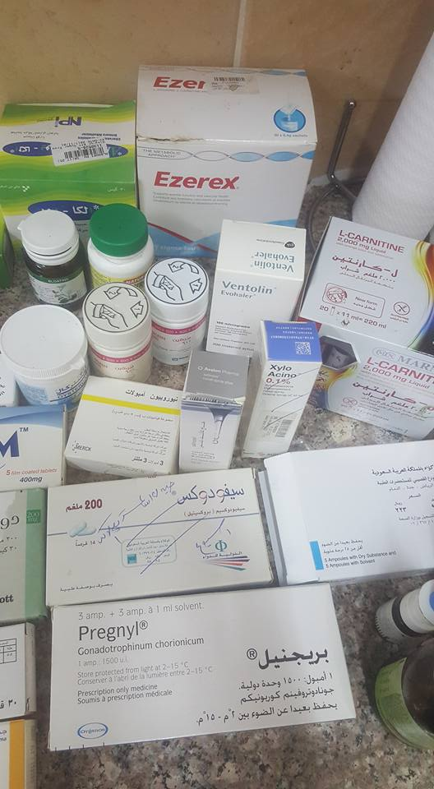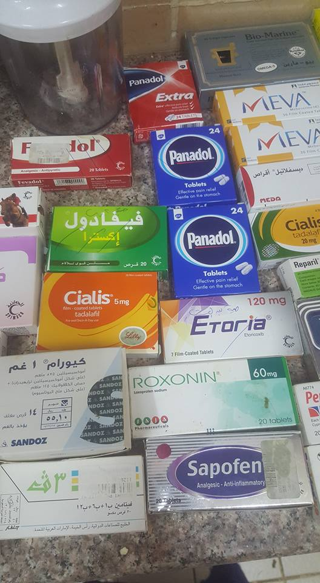
Image 8: Several members of F.G. offered free medicines for those in need (Source: H. H., F. G., November 20, 2016).
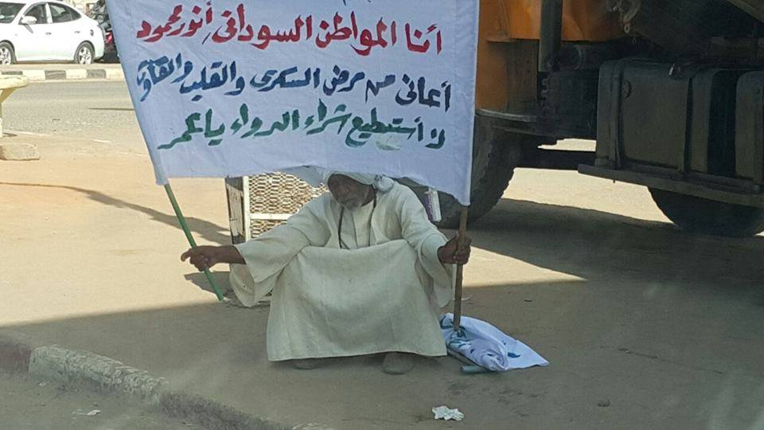
Image 9: The photo of this man, carrying a sign that reads: “I, Sudanese citizen Anwar Mahmoud, have Diabetes, heart disease, and gout, cannot purchase medicine Omer [Al-Bashir]”, photos of women in traditional wedding attire, gold, and beauty products and became the cover photo for several groups, including Munbarshat and F.G. Posted by Said El Tayib on Facebook, November 19, 2016.

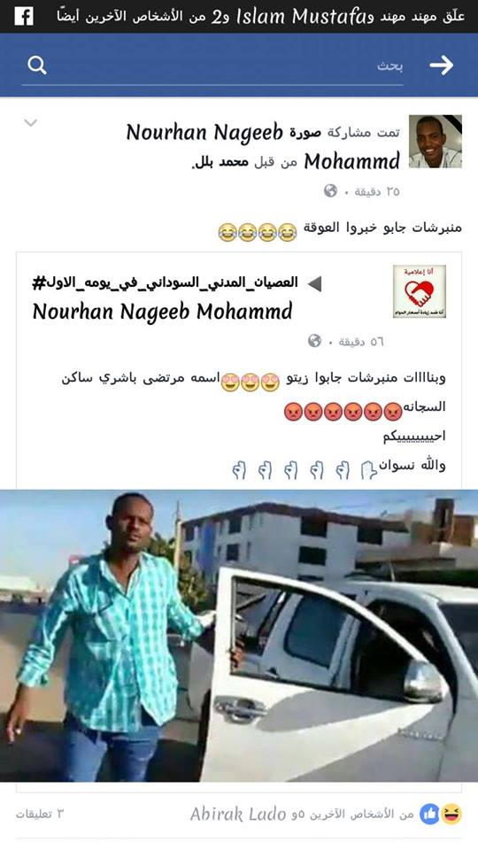
Image 10: National Congress Party’s Sudan's National Security is known for it’s brutality. In November 2016, security agents and the Central Reserve Police arrested and beat activists (including members of F.G. who mobilized for participation in civil disobedience. On November 27, an activist told a security agent who was about to arrest him that he was "live on Facebook," to which the security agent replied: “live da shinu?” [what is that thing called "live"? Activists captured the photo of the security agent, and soon enough, members of Munbarshat produced Alzeit: information that included the name, and the home address of the security agent. Munbarshat continued to play this role, at a larger scale, during the protests that started in Sudan in December 2018, which developed into a full-fledged uprising, calling for the fall of the NCP regime. Protestors arrested and detained reported in 2019 that they were questioned whether they were members of Munbarshat, and whether they knew who the Admin of this group was.

