Reviewer Comments:

Title:
- This study isn't just limited to 1.5-stage turbines therefore the title should be changed to Unsteady numerical investigation on gas ingestion into the rotor-stator disk cavities of a 1.5-stage turbine
After careful consideration, it was confirmed that the study isn't just limited to 1.5-stage turbines. The title of the article has been revised and noted in the paper.

Introduction:

- "the high pressure compressor" not "high compressor"
"efficiency of the engine" not "efficient"
After checking, it was found that there is indeed an error in the writing in the original text, which has been corrected and noted in the paper.

- Page 3 is one large paragraph - suggest breaking up.
The second paragraph has been split according to the meaning of the sentences to give the article a more logical structural distribution.

- "main steam" and "mainstream" - please standardise.
After checking and confirming, "main stream" has been consistently amended to "mainstream" and noted in the paper.

- Page 5 - "seal cavity" not "sealed cavity"
After checking, "sealed cavity" has been corrected to "seal cavity" and noted in the paper.

- Page 6 - "Referring to" not "Refer to"
Revised and noted in the paper.

- Figure 3 - convergence of effectiveness instead?
The variation of static pressure at the monitoring point of the front cavity and the leading edge of the blade with the accumulated time step and the variation of the sealing effectiveness of the aft cavity and the trailing edge of the blade with the accumulated time step are given in the modified Figure 3. It can be seen that after reaching approximately 2000 time steps, the key parameters at the intersection of the front and aft cavities and the main gas path change periodically and the calculation converges.
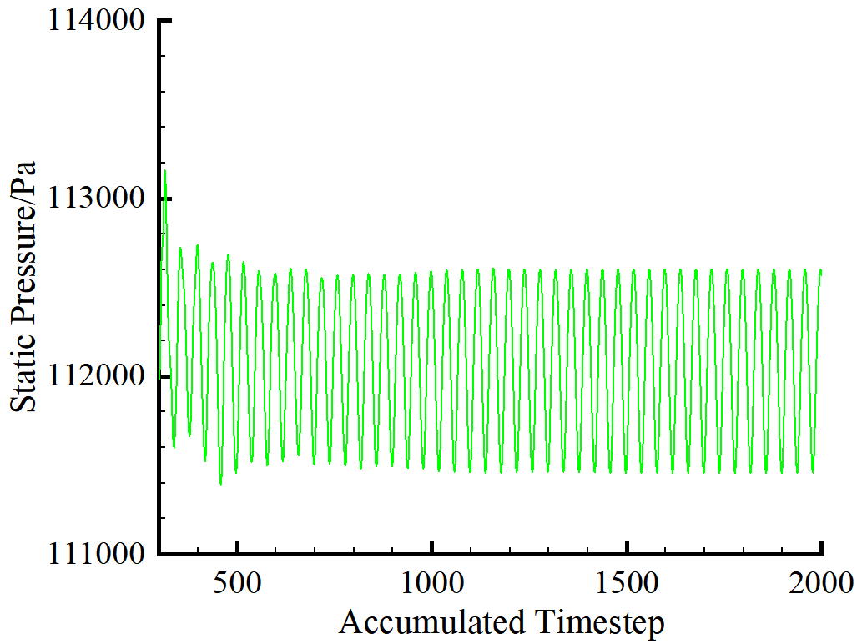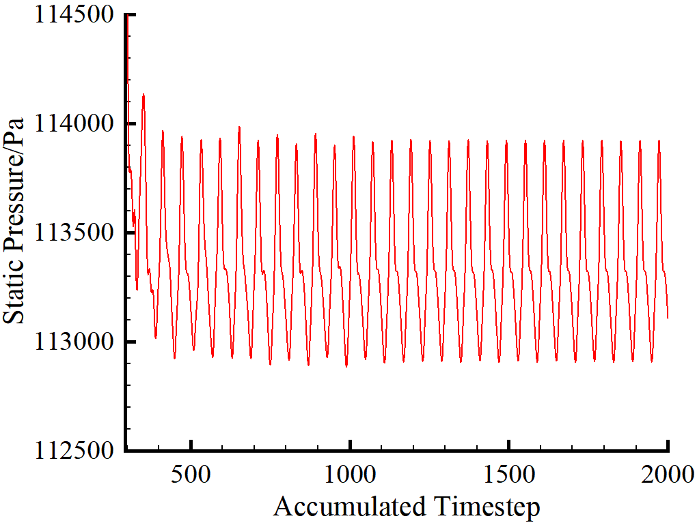
Monitoring Point
Monitoring Point
(a) (b)
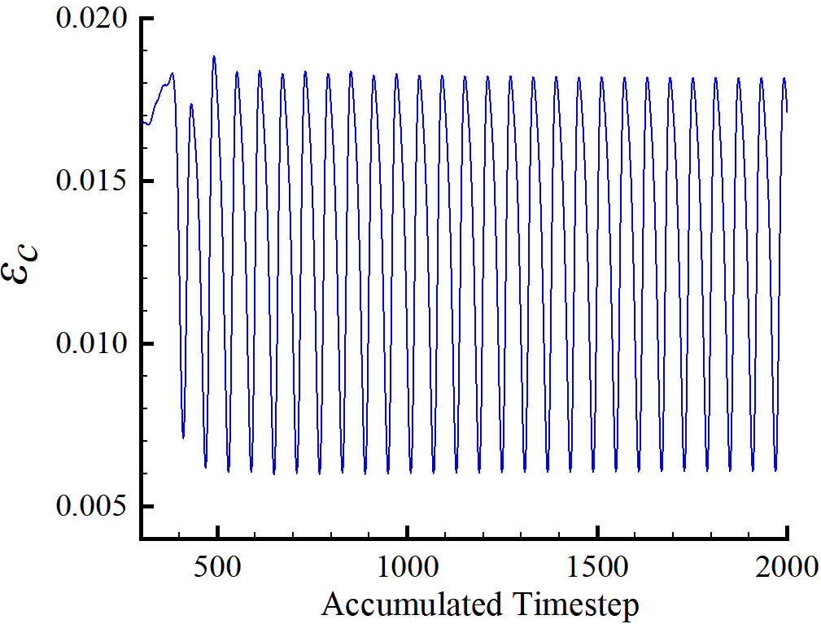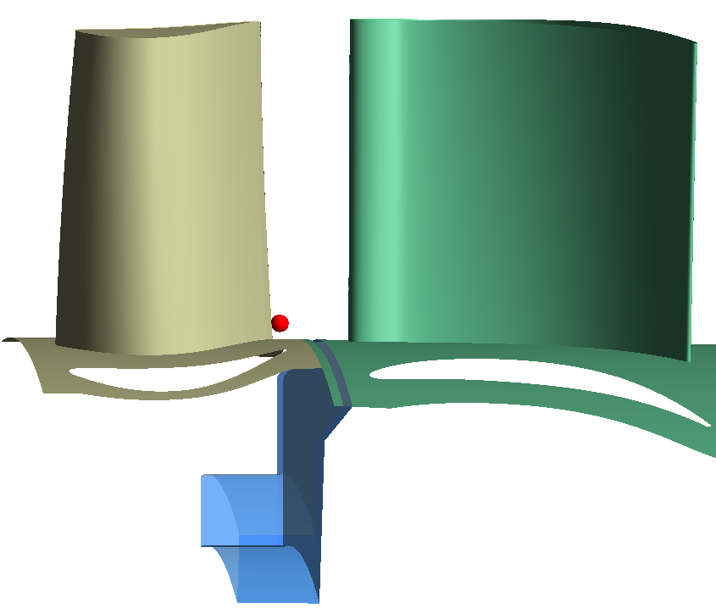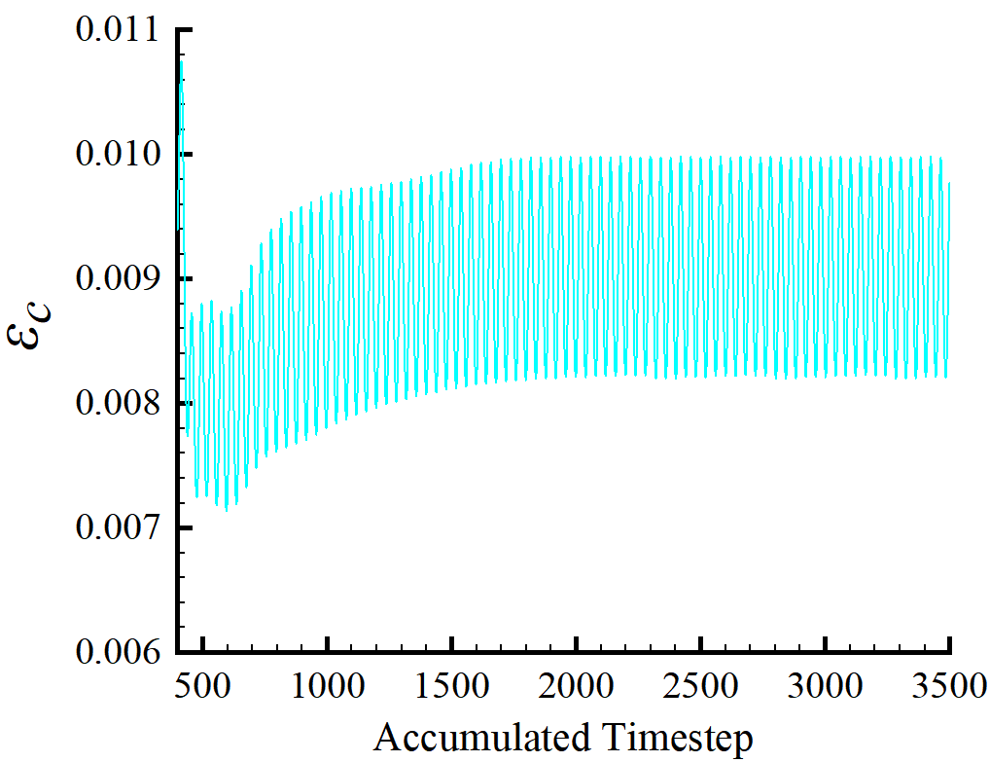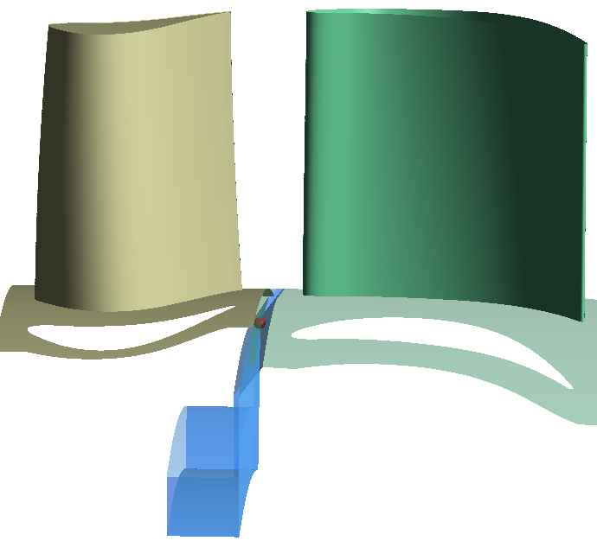
Monitoring Point
Monitoring Point
(c) (d)
Fig.3. Static pressure variation at monitoring points: (a) Static pressure monitor at the front rim seal cavity (b)Static pressure monitor at the leading edge of the rotor (c)Sealing effectiveness monitor at the trailing edge of the rotor (d)Sealing effectiveness monitor at the aft rim seal cavity

- Page 8 - "Except from close to the hub and shroud" not "Except that it is too close to the hub and shroud"
Revised and noted in the paper.

Results:

- Figure 6 - what do the data points represent? If these are computational results surely just a line will do? Perhaps mark hub radius (R_hub) on silhouette above? Caption: radial distribution of effectiveness not tracer gas concentration.
The data points in Figure 6 represent the distribution of sealing effectiveness in the front rim seal cavity near the stationary and rotating wall sides. The figure 6 shows the variation of the sealing effectiveness on the stationary and rotating wall sides when different purge flow rates are applied. As a result, different variation curves appear. R_hub has been labelled in the figure 6 for ease of reading. The caption does contain an error and has been corrected to show the sealing effectiveness.
Revised to read as follows:
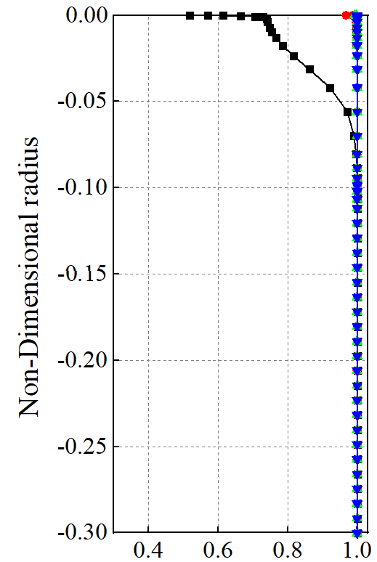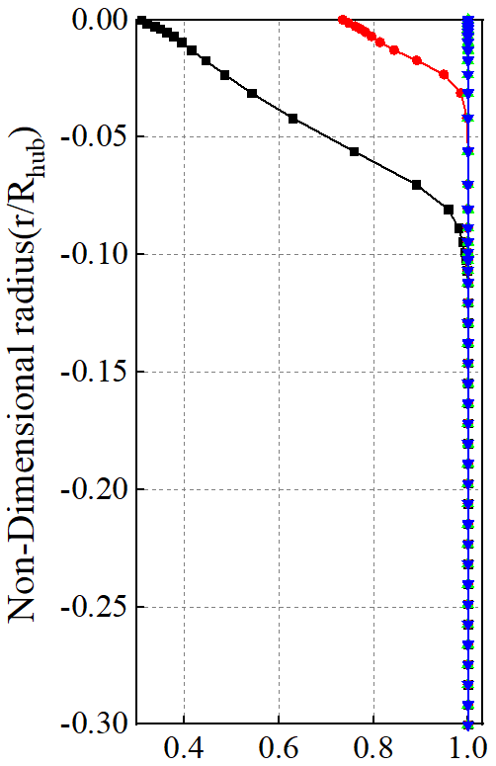
R_{hub}
R_{hub}
Sealing effectiveness ε_{c}
(a) Stationary wall side (b) Rotating wall side
Fig.6. The radial distribution of sealing effectiveness

- Figure 7 - captions don't make sense - in (a) and (b) the leading edge of what? The blade? - in (c) and (d) the trailing edge of what? Again the blade?
The captions to Figure 7 is missing key information and has been added. Revised to read as follows:
Fig.7. The radial distribution of pitchwise mass-averaged sealing effectiveness:(a) the leading edge of the blade without second vane (b) the leading edge of the blade with second vane (c) the trailing edge of the blade without second vane (d) the trailing edge of the blade with second vane

- Figure 8 - again captions are confusing - don't think you need the word 'of' in either (a) or (b). For a more scientific presentation, results should be non-dimensionalized instead of showing velocities in m/s.
The captioned presentation has been corrected and is noted in the paper. For a more scientific presentation, the second vane inlet radial velocity is used in Fig. 8 to non-dimensionalized represent the radial velocity of aft cavity exit. Revised to read as follows:
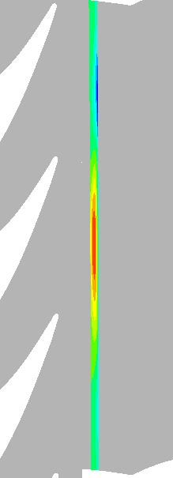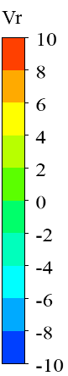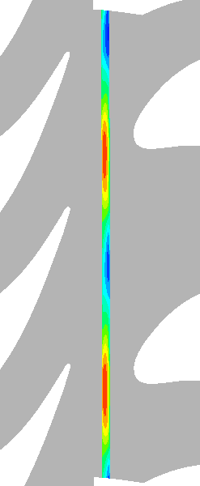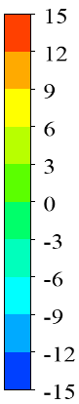
SS
Rotor
PS
V_{r}
SS
Stator
Rotor
PS
V_{r}
IR=0 IR=0.9%IR=1.3%IR=1.7% IR=0 IR=0.9%IR=1.3%IR=1.7%
(a) (b)
Fig.8. Contour of non-dimensionalized radial velocity :(a) aft cavity exit without second vane (b) aft cavity exit with second vane

- Figure 9 - add with second vanes to caption.
Revised and noted in the paper.

- You've noted that the positive radial velocity (egress) in Figure 8 corresponds to low total pressure coefficient (not low pressure) in Figure 9. Usually areas of low static pressure relative to the mainstream are associated with ingress not egress so please correct this to clarify you mean low total pressure coefficient not low pressure.
There was a writing error in the text regarding the total pressure coefficient. This has been corrected and noted in the paper.

- "The pressure at the deeper position of the wheel-space is higher than the inlet of the aft cavity" - again do mean total pressure coefficient here instead of just pressure?
The pressures in the text have been specified as total pressures and are noted in the paper.

- "the direction of airflow is consistent with the rotating wall" - do you mean that the rotor is moving from left to right? i.e. the same direction as the majority of the airflow?
The circumferential direction of airflow in the wheel-space is consistent with the rotor. Figure 9 has been modified to add the direction of rotating wall and the location of the second vane.
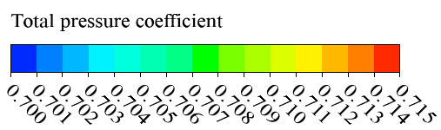
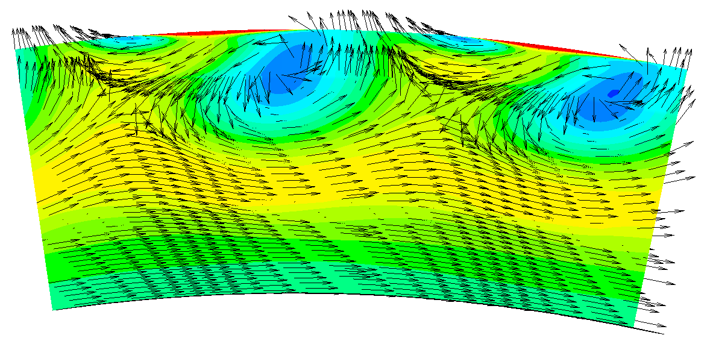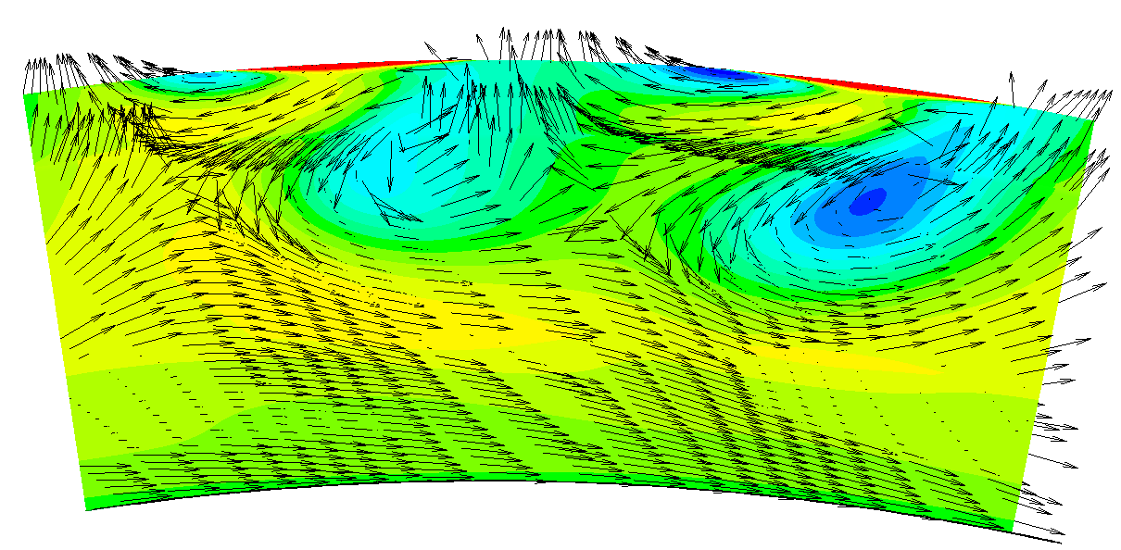
Rotational Direction
Pitch[-]
0
1
Rotational Direction
Pitch[-]
0
1
(a)IR=0 (b)IR=0.9%
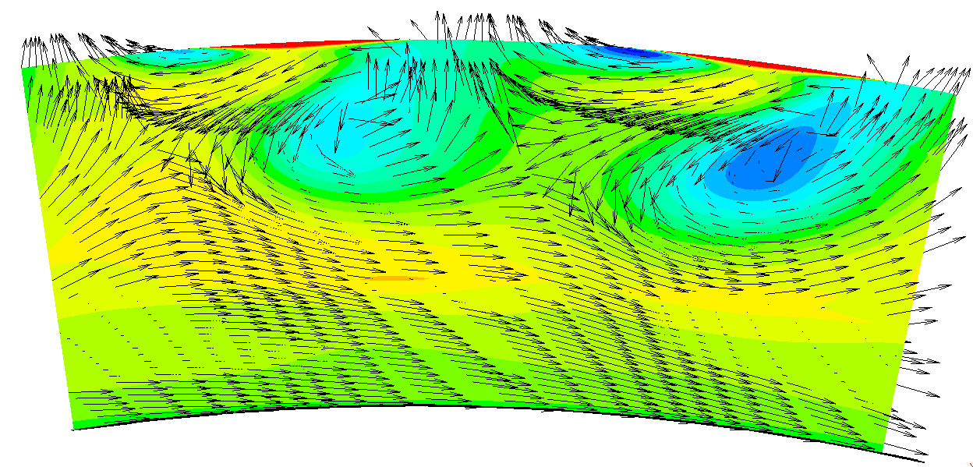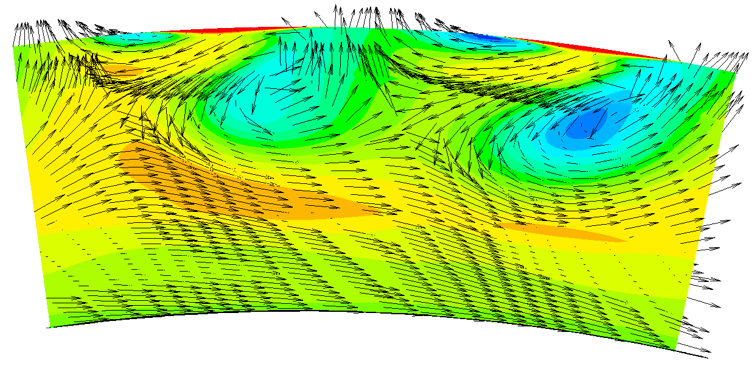
Rotational Direction
Pitch[-]
0
1
Rotational Direction
Pitch[-]
0
1
(c)IR=1.3% (d)IR=1.7%
Fig.9. Contour of velocity vector and total pressure coefficient in the middle section of the aft cavity with second vanes

- "mainstream ingresses the aft cavity from the high pressure area" - again, I think you mean 'area of high total pressure coefficient' instead of 'high pressure area'?
The pressures in the text have been specified as total pressures and are noted in the paper.

- "the pressure in the aft cavity increases and the low pressure area weakens" - again, I think you mean total pressure coefficient instead?
The pressures in the text have been specified as total pressures and are noted in the paper.

- "but the tracer gas concentration at the aft cavity exit increases overall, which indicates that the front egress increases the ingress into the aft cavity" - I'm not sure this is true. If you increase the flow exiting the upstream cavity you'll raise the concentration in the mainstream (Fig.7) and therefore increase the concentration in aft cavity. This doesn't mean the re-ingestion (or ingress downstream) has increased, it just means the concentration of the ingress from the mainstream is higher.
The idea that an increase in the front purge flow rate can indeed lead to increased gas ingestion in the aft seal cavity is also confirmed by the quantitative description in Figure 11. This phenomenon has been studied in detail and explained in the reference[18].
[18] Scobie J A, Hualca F P, Patinios M, et al. Re-ingestion of upstream egress in a 1.5-stage gas turbine rig [J]. Journal of Engineering for Gas Turbines and Power, 2018,140(7):072507.1-072507.10.

- "Monitoring point 1 and 2 are located in the middle of inclined axial seal and the leading edge of the blade near the hub" - please clarify in the text that monitor point 1 is in the front cavity.
Revised and noted in the paper.

- Figure 14 - you have two (b)'s and no (c). Please reposition the red dot in the two lower figures (currently labelled (b) and (d)) so they are the same position as Figure 13(a), i.e. in the middle of inclined axial seal.
Revised and noted in the paper.

- Is f=0.72f_{blade} an interaction frequency between the structure and blade passing frequencies? i.e. 1-0.29 ≈ 0.72
As can be seen from the analysis in Figure 13, the low frequency pulsations below the main frequency at IR=0 all originate from the mainstream gas ingestion for the front seal cavity. f=0.72f_{blade} is presumed to be caused by the interaction between the sealing structure and the blade passing frequencies, but there is a lack of sufficient evidence to support this in the study, so the idea is not explicitly presented in the paper.

- Why do you not see the blade passing frequency in Figure 13(b)? Is it because (a) is in the stationary domain and (b) is in the rotating domain? Where is the monitoring point in relation to the interface between the two domains shown in Figure 1? Please clarify this.
In agreement with your judgement, in Figure 13, monitoring point 1 of front cavity is in the stationary domain and monitoring point 2 of blade leading edge is in the rotating domain. In Figure 14, monitoring point 4 of aft cavity is in the stationary domain and monitoring point 3 of blade trailing edge is in the rotating domain. This description has been added and is noted in the paper.

- "When the purge flow rate is small, the low-frequency pulsation amplitude at the monitoring point 3 is larger" - larger relative to what? Do you mean smaller? (when the purge rate increases, the pulsation amplitudes get larger?)
The low frequency pulsation amplitude referred to in this description refers to f<0.66f_{blade}, but upon re-observation of the results, it was found that the description in the original text was not accurate. Therefore, "When the purge flow rate is small, the low-frequency pulsation amplitude at the monitoring point 3 is larger" was amended to read "The low frequency pulsation (f<0.66f_{blade}) at monitoring point 3 is less affected by the front purge flow rate".

- Could you analyse the low frequency fluctuations caused by the structures (shown in Figure 9) to determine the number and speed (relative to the rotor) of the structures?
The low-frequency pulsations in the static pressure frequency characteristic diagram resulting from the fast Fourier transform include the pressure fluctuations at each instant, and the time-averaged results are shown in Figure 9. Corresponding the changes in flow field pressure in the wheel-space to the low frequency pulsations in the static pressure spectra is difficult to achieve with the current results.

- Can you compare your frequency results with GT2016-56661 Modulation And Radial Migration Of Turbine Hub Cavity Modes By The Rim Seal Purge Flow?
The static pressure spectra of the reference GT2016-56661 were compared with those of the thesis at the position of the front seal cavity, as shown below. In the reference GT2016-56661 (Figure 1), the low frequency pulsation is strong at f<f_{RBPF} without purge flow and the rotor blade passing frequency f_{RBPF} with a small amplitude. As the purge flow rate increases the low frequency pulsation amplitude shows an increase and then a decrease. This is due to the interaction between the purge flow and the mainstream gas in the seal cavity, which results in strong pressure fluctuations making the low frequency pulsations strong. When the purge flow rate increases to IR=1.2%, the gas ingestion decreases and the purge flow injection enhances the low frequency pulsation. As the purge flow rate increases the amplitude of f_{RBPF} continues to increase due to the fact that the purge flow interacts with the mainstream gas in the seal cavity, which is influenced by the rotation of the blade.
The same phenomenon can be seen in the paper (Figure 2), where f<f_{RBPF} low-frequency pulsations are strong in the absence of the purge flow and the rotor blade passing frequency f_{RBPF} amplitude is small. After the appearance of the purge flow, the low-frequency pulsations are reduced and the amplitude of f_{RBPF} increases. The difference is that at IR=0.4% and IR=0.8% in Figure 1 and IR=0.5% and IR=0.9% in Figure 2, when the purge flow interacts strongly with the mainstream gas, the opening between the rim seal structure and the main gas path in the reference GT2016-56661 is large and it is difficult to suppress the mainstream gas ingestion with a small purge flow rate, so the low frequency pulsation shows a gradual weakening process. In the paper, the opening between the rim seal structure and the main gas path is smaller. For IR=0.5%, the low frequency pulsation is reduced accordingly, but the amplitude of f_{RBPF} is increased by the rotation of the blade. Afterwards the purge flow rate continues to increase, the gas ingestion almost disappears and the interaction position between the purge flow and the mainstream gas shifts to outside the seal cavity. The residence time of the purge flow in the seal cavity becomes shorter, the influence of the blade rotation is reduced and the amplitude of f_{RBPF} decreases.
It can be seen that reference GT2016-56661 and the paper seal structure is different, the purge flow and the mainstream gas interaction process is different, the static pressure spectrum of the monitoring point is not exactly the same.

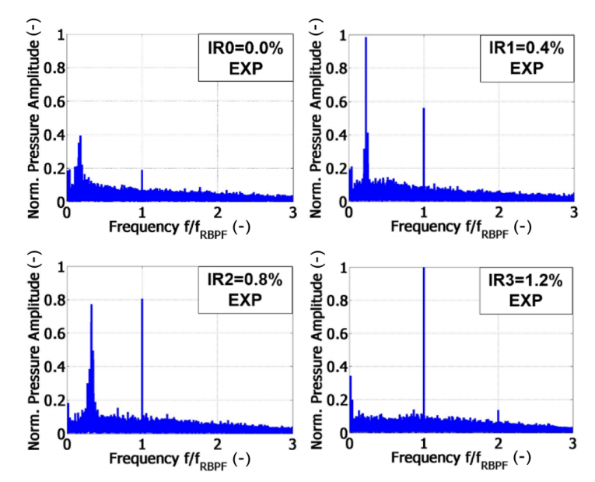
Fig.1. Experimentally determined pressure frequency spectra for four different injection rate cases inside the hub cavity at -12% span in GT2016-56661
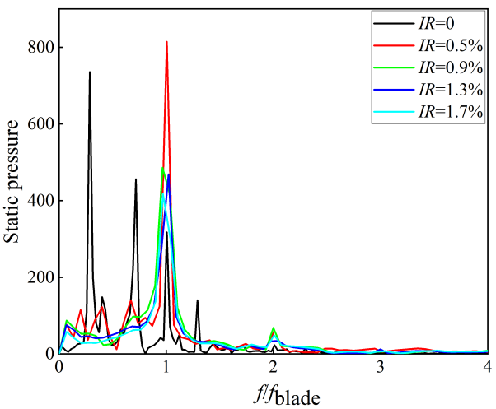
Fig.2. Static pressure frequency characteristic diagram at monitoring point 1 of front cavity in the paper

