Unsteady numerical investigation on gas ingestion into the rotor-stator disk cavities of 1.5-stage turbines

Paper Summary
The paper presents a detailed investigation of the effect of the downstream vane on the egress and flow characteristics inside the downstream seal of a 1.5 stage turbine. In particular, the potential field from the presence of the downstream vane appears to enhance ingestion into the downstream cavity but suppress the pressure fluctuations within the same cavity. The influence of the upstream cavity sealing flow rate on the flow within the downstream cavity is also investigated.

Reviewer Recommendation and Rationale
I’m recommending major revisions – this is because the paper is reasonably thorough in its examination of the data from the simulations and the investigation of the effect of the downstream vanes is new to me, but the several typos need to be fixed (I have pointed a few out below, but there are more), the clarity of the discussion around Fig. 9 needs to be improved, and some of the conclusions need to be adjusted so that they can be backed up with the data presented. Some more information of the validation could also be useful.

Reviewer Comments
1. The quality of the English is generally good, however there are many typos (sometimes omitting technical information, which is the main issue with them).
The statements in the paper have been read and checked in detail, where typos have been corrected and noted.

2. Section 1, paragraph 2 – This is a very long paragraph, it would aid readability if it were split up.
The second paragraph has been split according to the meaning of the sentences to give the article a more logical structural distribution.

3. Section 1, paragraph 2 – “1% of the purge flow volume…” is this a 1% increase in purge flow volume? Please clarify.
A review of the original reference shows that the expression should indeed be changed to "1% increase in purge flow volume". Revised and noted in the paper.

4. Section 1, paragraph 2 – I don’t follow your comments at the end of the discussion of work of Bunker et al. (“the potential field at the leading edge…”). Is there a way of rewording them to make it clearer? Can you be more specific about the effect of the vane on the pressure? “Greatly affects” does not tell the reader much, and I do not think that “variation of peak circumferential pressure” makes sense by itself.
In references [6,7], the effect of the blade leading edge bow wave and the vane trailing edge wake on the rim seal gap flow and cooling efficiency was investigated using a rotating cylinder instead of the blade. It was found that the circumferential pressure distribution peak-to-peak variations created by rotating cylinder of different diameters were different, and that the blade leading edge bow wave have an equal or even greater influence in generating this peak-to-peak variation than the vane trailing edge wake. The circumferential pressure distribution peak-to-peak variations increases the blockage effect and reduces the buffer cavity cooling effectiveness of the purge flow.
After confirmation, revised to read as follows:
Bunker and Laskowski et al [6,7] designed an experimental rig with a rotating cylinder replacing the blade and the corresponding numerical simulation method to study the development of the vane wake, the distribution of the circumferential pressure gradient and the blockage effect caused by the sealing flow. The results showed that the blade leading edge bow wave and the vane trailing edge wake are key to the resulting gas ingestion or more appropriately the forcing of hot gas inboard of the rim seal, which can increase the leading edge blockage and reduce buffer cavity cooling effectiveness by a factor of 0.1.

5. Section 1, paragraph 2 – “JIA et al.” should not be in caps.
Revised and noted in the paper.

6. Section 1, paragraph 3 – Please give examples of the complex factors.
The downstream rim seal of the blade is influenced by more complex factors, such as the combined effect of the front and aft purge flows, the upstream vane and blade wake, and the unsteady effect of blade rotation, which have a significant impact on the efficiency of the turbine.

7. Section 2.1, paragraph 2 – How valid is the reduction in number of blades from 36:54:36 to 2:3:2? Whilst this preserves the ratio of stator to rotor blades, the circumferential domain truncation (and imposition of periodicity) can influence the length scales of the flow structures that form within the cavities – especially flow structures that have a circumferential length scale that is larger than a few blade spacings. Was the sensitivity of the conclusions to this checked?
It needs to be acknowledged that the simplification of the number of blades from 36:54:36 to 2:3:2 is more in terms of saving computational resources and meeting numerical boundary condition. There is a large number of references[1-8] in recent years which has adopted this simplification. However, it is more important to acknowledge that the circumferential domain truncation and the imposition of periodicity have some influence on the flow field structure, especially in terms of the differences reflected in experimental measurements[9]. However, for numerical methods, the accuracy of the current URANS method is not sufficient to capture such differences, and the errors are within acceptable range. Therefore, in this study a simplification of the number of blades was carried out.
- Schuepbach P, Abhari R S, Rose M G,et al. Influence of Rim Seal Purge Flow on the Performance of an Endwall-Profiled Axial Turbine. Journal of Turbomachinery. April 2011; 133(2): 021011.
- Bunker R S, Laskowski G M, Bailey J C,et al. An investigation of turbine wheel space cooling flow interactions with a transonic hot gas path-part I: experimental measurements[J]. Journal of Turbomachinery, 2011,133(4) : 021015.
- Laskowski G M, Bunker R S, Bailey J C,et al. An investigation of turbine wheel space cooling flow interactions with a transonic hot gas path part II: cfd simulations [J]. Journal of Turbomachinery, 2011,133(10) : 041020.
- Yang F, Zhou L, Wang Z. Unsteady numerical investigation on viscous shear loss caused by rim seal purge flow. Proceedings of the Institution of Mechanical Engineers, Part A: Journal of Power and Energy. 2019;233(3):346-357.
- Li Z, Fan Y, Zhan-Xue W. Numerical investigation of the blockage effect caused by rim seal flow. Proceedings of the Institution of Mechanical Engineers, Part G: Journal of Aerospace Engineering. 2020;234(8):1433-1445.
- Cheng S, Li Z, Li J. Investigations on the Sealing Effectiveness and Unsteady Flow Field of 1.5-Stage Turbine Rim Seal. Journal of Engineering for Gas Turbines and Power. 2019; 141(8): 081003.
- ZHANG Z et al. Flow mechanism between purge flow and mainstream in different turbine rim seal configurations, Chinese Journal of Aeronautics (2020).
- Schreiner B D J, Wilson M, Li Y S, et al. Effect of Purge on the Secondary Flow-Field of a Gas Turbine Blade-Row. ASME. Journal of Turbomachinery. 2020; 142(10): 101006.
- Schädler R, Kalfas A I, Abhari R S, et al. Modulation and Radial Migration of Turbine Hub Cavity Modes by the Rim Seal Purge Flow. Journal of Turbomachinery, 2017, 139(1): 011011.

8. Section 2.1, paragraph 2 – There are a few typos in the discussion of the number of grid cells in various dub-domains. The “+” in y⁺should be in superscript. Giving some brief details of the mesh verification would be useful here – what mesh sizes were tested, how much effect did it have? It would be good to e.g. include a coarser/finer mesh data in Figs. 4 & 5 so readers could asses this for themselves.
The writing error of y⁺ has been corrected and noted in the paper.
The sensitivity verification of the computational grids has been carried out in the study and the chosen comparison parameter is the stage efficiency and the results are shown in the table below. After comparing the previous experimental and numerical results, a grid model of 9.37 million was chosen for the study in order to save computational resources.
Sensitivity verification of the computational grids
Grid number/millions | Stage efficiency
5.20 | 0.903196
7.54 | 0.909638
8.44 | 0.909727
9.37 | 0.909811
11.45 | 0.909812

9. Section 2.2, paragraph 1 – URANS has quite severe limitations in for predicting ingestion in these types of flows. (O’Mahoney and Chew, 2011.) Whilst I appreciate that URANS may be necessary for practical reasons, I think that it is necessary to at least acknowledge this somewhere.
It must be acknowledged that there is a difference between URANS model's prediction of gas ingestion and experimental results at rim seal. This has been demonstrated in much of the references. It has been stated in the paper.

10. Section 2.3 – I agree that the validation data shows that the flow in the main gas path is being captured correctly, I can’t see how it shows that the flow characteristics in the cavities is captured correctly.
The original experiments were simplified for the rim seal structure and the experimental data on the disc cavity flow was less disclosed for direct comparison. As the mainstream is influenced by the purge flow, the numerical simulation results at IR=0.9% in Figure 5 do not deviate from the experimental results, indicating that the prediction of the disc cavity flow is accurate.

11. Section 3.2, paragraph 1 – I agree that the radial outflow appears to be around where one would expect the blade wake to be. However, it seems strange that the blade wake would cause a high pressure in Fig. 8a. If this is not what you are suggesting it might be good to clarify – is this a static or total pressure?
Pressure in this paragraph refer to static pressure. Revised and noted in the paper. In Fig. 8(a), the aft cavity exit is only influenced from upstream blade due to the absence of the second vane. In this case, the blade wake creates a large pressure fluctuation at the aft cavity exit, resulting in a strong gas ingestion and a small amount of purge flow injection. The wake is formed by the convergence of the blade suction and pressure side airflow, which creates a high pressure area and causes gas ingestion. This has also been demonstrated in the reference [1,2].
[1] Cheng S, Li Z, Li J. Investigations on the Sealing Effectiveness and Unsteady Flow Field of 1.5-Stage Turbine Rim Seal. Journal of Engineering for Gas Turbines and Power. 141(8): 081003.
[2] T O'Mahoney, N Hills, J Chew. Sensitivity of LES results from turbine rim seals to changes in grid resolution and sector size. Progress in Aerospace Sciences. 2012 (52), 48-55.

12. Section 3.2, paragraph 2 - I have some issues with Fig. 9. It is not surprising that you have found a correspondence between the total pressure and radial velocity – the former is calculated in part from the latter – and presenting the data in the form of total pressure makes it hard to distinguish inertial from potential effects. I can see ingress and egress from high total pressure regions. Ingress into a high static pressure region (as the text seems to imply) does not make any sense. I think the effect of the vane potential would be clearer if the direction of rotor rotation and location of the vanes were indicated on Fig. 9.
Figure 9 has been modified to add the direction of rotating wall and the location of the vanes. Revised to read as follows:
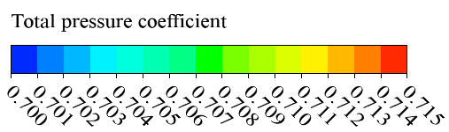
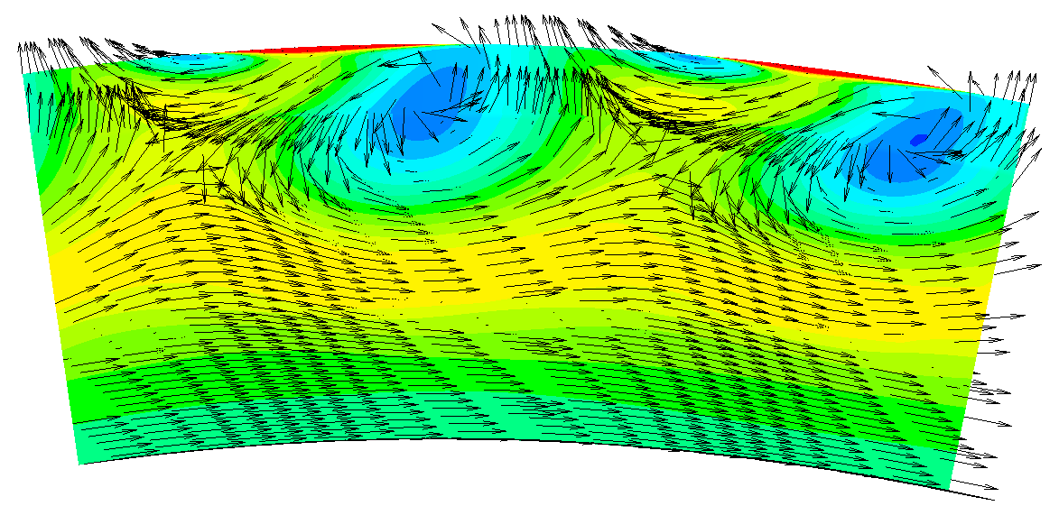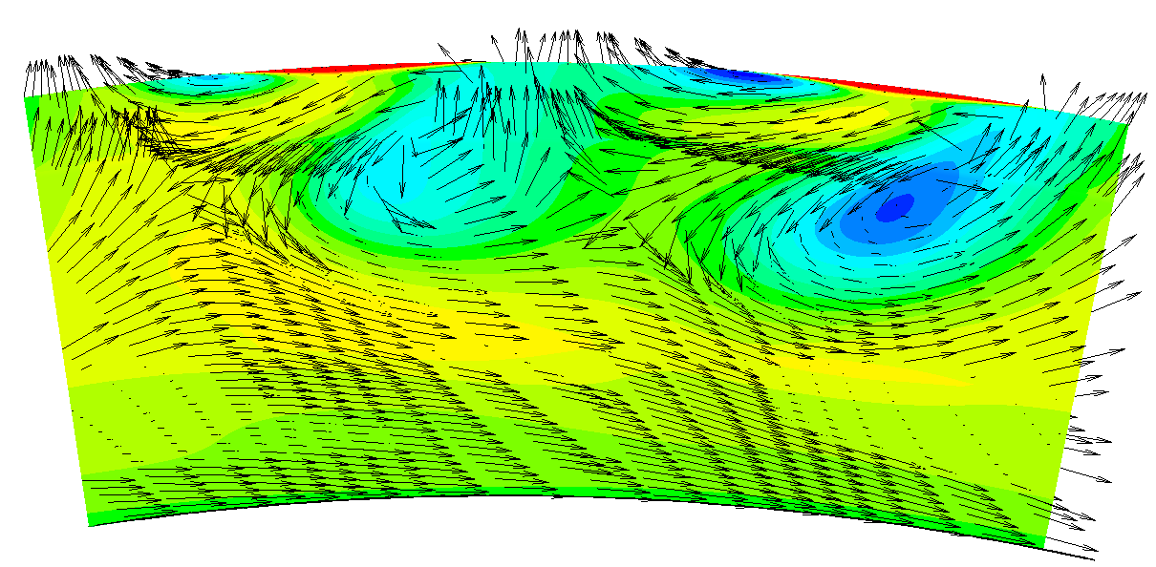
Rotational Direction
Pitch[-]
0
1
Rotational Direction
Pitch[-]
0
1
(a)IR=0 (b)IR=0.9%
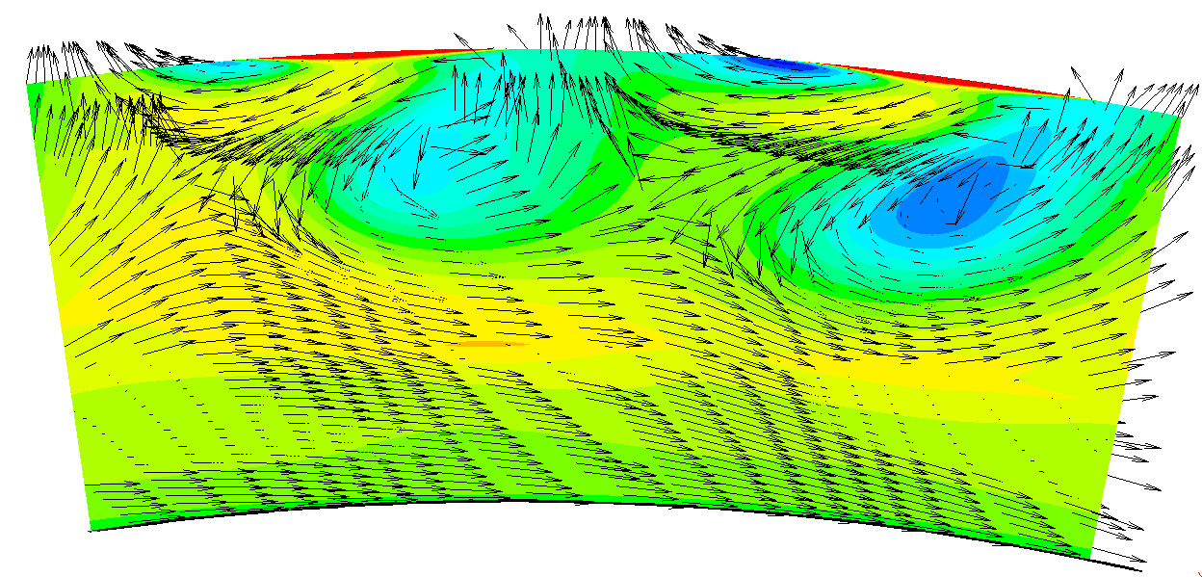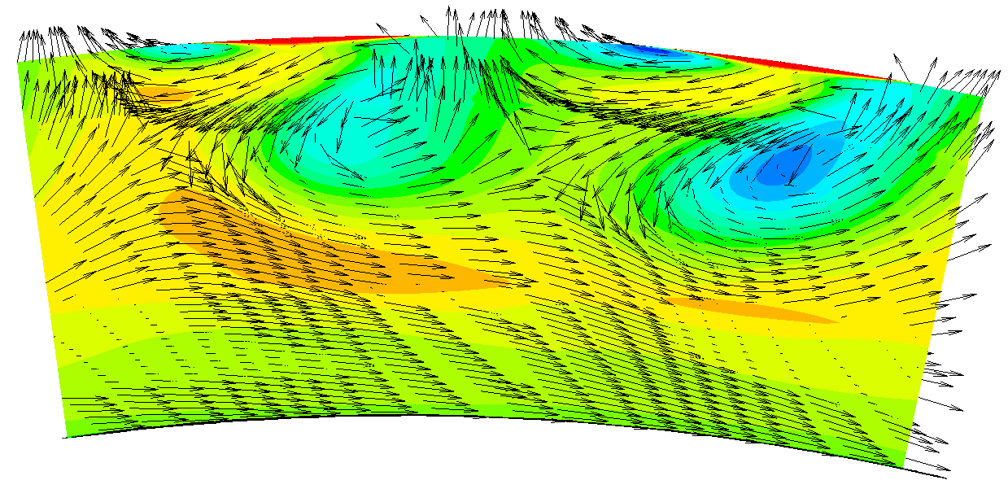
Rotational Direction
Pitch[-]
0
1
Rotational Direction
Pitch[-]
0
1
(c)IR=1.3% (d)IR=1.7%
Fig.9. Contour of velocity vector and total pressure coefficient in the middle section of the aft cavity with second vanes

13. Section 3.3 – In Fig. 13b and Figs. 14a & b, is the monitoring point in the rotor frame of reference or the stator frame of reference? If they were rotating with the rotor this would explain why there are no frequency components at the blade passing period. In Fig. 14c IR=1.7% appears to have a slightly higher peak than the other cases with IR > 0.5% - does this contradict the statement that when “purge flow increased, the amplitude of the main frequency is slightly reduced”?
In Fig. 13b and Figs. 14a & b, the monitoring point is indeed in the rotor frame of reference. Therefore, the rotor passage frequency does not appear in the static pressure frequency characteristic diagram. The description of Fig. 14(c) in the text "purge flow increased, the amplitude of the main frequency is slightly reduced" is indeed biased. It has been revised to read as follows:
The amplitude of main frequency drops after the emergence of the front purge flow. As the purge flow rate increases, the amplitude of main frequency rises slightly.

14. Section 4, points 2 & 4 – It is strange that the presence of the vane simultaneously enhances ingestion into the cavity yet suppresses unsteadiness. Intuitively I would expect increased unsteadiness to increase ingestion. Are we to take away that the (ingestion enhancing) flow structures caused by the vane are steady? I’d be interested in any comments you had on this!
The comparison in Figure 14(a)(c) shows that the presence of the second vane increases the amplitude of pressure fluctuations at the trailing edge of the blade. From the comparison in Figure 14 (b) (d), it can be seen that the presence of the second vane has a certain influence on the pressure fluctuation at the monitoring point in the aft seal cavity, but it is smaller than the monitoring point at the trailing edge of the blade. Combined with the analysis in Figures 8, 10 and 11 above, it can be seen that the potential field at the leading edge of the second vane enhances the gas ingestion in the aft seal cavity. Therefore, it can be concluded that the second vane creates a more unsteady flow structure and at the same time increases the gas ingestion in the aft seal cavity. This is consistent with your basic judgement.

15. Section 4, point 4 – The conclusion states that the “front purge flow suppresses the upstream and downstream pressure fluctuations in the aft cavity”. I don’t see how these statements are fully supported by the data in Fig. 14: in Fig. 14c (it is mislabelled in the manuscript as Fig. 14b) , IR=0.9% seems to have the greatest spectral energy in the cavity, but increasing the purge flow from IR=0.5% to 1.7% has the effect of increasing the unsteadiness within the aft cavity– not suppressing it as suggested in the conclusion. From the results, I suspect that there would not be a correlation between the spectral energy of the pressure fluctuations in the aft cavity and the purge flow rate.
After repeatedly comparing the results of the data, I have come to the same conclusion as you, that is: the increase of the front purge flow rate has a relatively limited effect on the pressure fluctuations in the trailing edge of the blade and the aft seal cavity, especially after the appearance of the second vane. In view of this, I amend the original conclusion "front purge flow suppresses the upstream and downstream pressure fluctuations in the aft cavity" to "The increase in the flow rate in the front cavity has a small effect on the pressure fluctuations in the aft cavity".

16. References – Referencing looks fine to me, except from [J], [R], and [D] included in most references. Also need to fix the authors names in caps in ref [23].
Revised and noted in the paper.

