Dear editor

Thank you very much for your letter. According to the editors' and reviewers' advice, we have revised the manuscript. We have addressed the comments raised by the reviewers and the amendments are highlighted in red in the revised manuscript. Point by point responses to the reviewers’ comments are listed below this letter.

Your efforts in the review process of this manuscript are greatly appreciated. We hope that the revised version of the manuscript is now acceptable for publication in your journal.

I look forward to hear from you soon.

Sincerely,
Huacheng Yuan

Reviewers' comments:
-Reviewer 1
The present paper provides experimentally-measured and numerically-predicted data for a supersonic engine inlet, with different bleed window and compression ramp arrangements. Schlieren flow visualization, and steady and time-varying pressure data are provided for different inlet Mach numbers, ranging from 1.5 to 4.0, and different TR throttling ratios, as altered using a throttling plug located at the exit of the test section. The configurations and conditions selected for investigation provide new information on the performance of engine intake inlets.
Results, and interpretations of results, are often provided in a confused manner. Presentations and discussion of results are not provided in a convincing or complete manner. For most of the discussions, adequate information is not provided which allows interpretation and understanding of figure contents or the exact inlet geometry configurations which are tested. Most all of the contour plot figures are of low quality, since most details are impossible to discern and understand. Numerous phasing and English language issues are also present throughout the entire manuscript.
As such, in its present form, the present paper is not suitable for publication within The Aeronautical Journal. Suggested changes and revisions to improve the paper are now provided.

1. Complete drawings showing the exact geometry configurations (which are tested) must be provided, with associated components labelled, for all presented results, so that readers can better understand relationships between results and tested configurations. A Table listing such tested configuration parameters is needed for data provided in Figures 11 to 26. For the data in these different figures, the use of the small or large bleed region, and the compression ramp arrangement are not apparent.
Thank you for your advice. The exact geometry model and configurations have been added in the section2.3. More details about the model and experiment have been added. Meanwhile, figures presented in this paper have been corrected and modified.
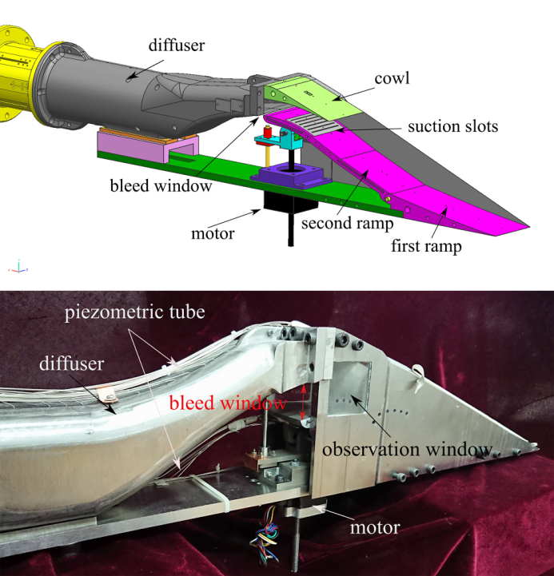

2. Examples of phrasing/English language usage/spelling issues include the following. Note that this is only a partial list of associated problems (which are too numerous to list). Abstract: "normal and stable work," "P/Po adds from 13 to…." Page 4: "easy to control." Page 5: "two-dimension." Section 2.1.1: "avoid mechanism stuck," "could be turned," "shock waves attach." Page 7: "three area adding." Page 8: "unless breaking the compression surface." Page 9: "et al.". Section 3.1: "shock located near the throat." Section 2.3 last lines, commas missing. Section 2.3: "direct connected temporary impulse."
Thank you for your advice. The author felt so sorry that there were so many mistakes ,the manuscript has been revised again.

3. Within the Abstract and throughout the manuscript, "aerodynamic performance," "pressure recovery coefficient," and "back pressure ratio" are sometimes used incorrectly, or are confused with each other.
Thank you for your advice. Some parameters could be used to quantify the aerodynamic performance of the inlet, including exit total pressure recovery coefficient σ_{e} ,exit Mach number Ma_{e} , and mass flow ratio ϕ. The coefficient σ_{e} and ϕ indicate the quality and quantity of the airflow respectively. σ_{e} is the total pressure ratio of exit to freestream while ϕ is the ratio of exit mass flow to the captured mass flow. Besides, starting performance and anti-backpressure performance are also important indexes to evaluate the performance of the inlet. Backpressure ratio P_{e}/P₀ indicates the static pressure ratio of exit to inflow where P_{e} and P₀ are the actual pressure of the exit and inflow respectively.

4. All important components within Figures 2, 3, and 6 need labels. Cases A and B need to be labelled within Figure 6. The shorter configuration B is not apparent from the arrangements shown in Figure 6.
Thank you for your advice. These figures have been optimized.
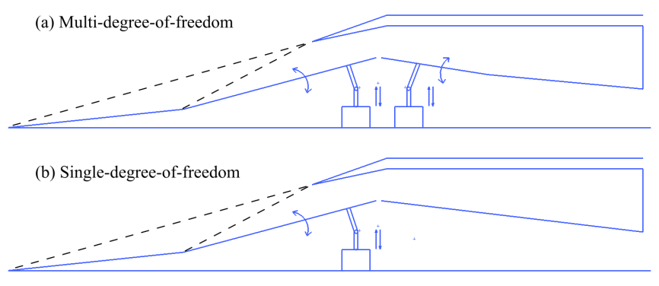

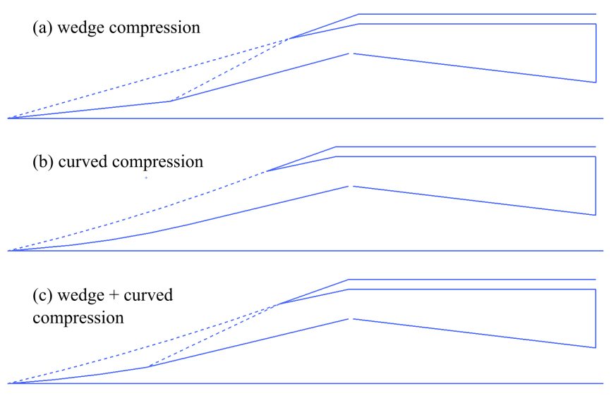

5. All test configurations which are examined must be summarized near the end of the Introduction.
Thank you for your advice. More details about the model and experiment have been added in the section 2.3.

6. Section 2.1.3. This section has no reference to Figures 6 and 7.
Figure6
K Y Zhang. Research progress of hypersonic inlet reverse design based on curved shock compression system. Acta Aeronautica et Astronautica Sinica.36(1)(2015)274-288.
F Y Zuo, G P Huang. A preliminary overview analysis on the internal waverider inlets for ramjet.AIAA-2017-2420.
Figure7
C C Lee, C Boedicke. Subsonic diffuser design and performance foe advanced fighter aircraft. AIAA-85-3073,1985.

7. A drawing and discussion are needed to clarify "six suction slots were set at the shoulder" in Section 2.1.4. Text after Figure 16, clarification is needed regarding, "fifth suction slot".
Thank you for your advice. Three-dimensional diagram and enlarged figure are presented below. Six suction slots were set at the shoulder of the internal contraction section.
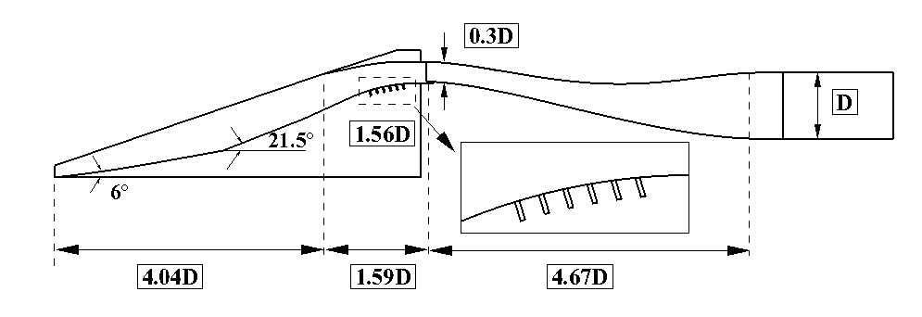
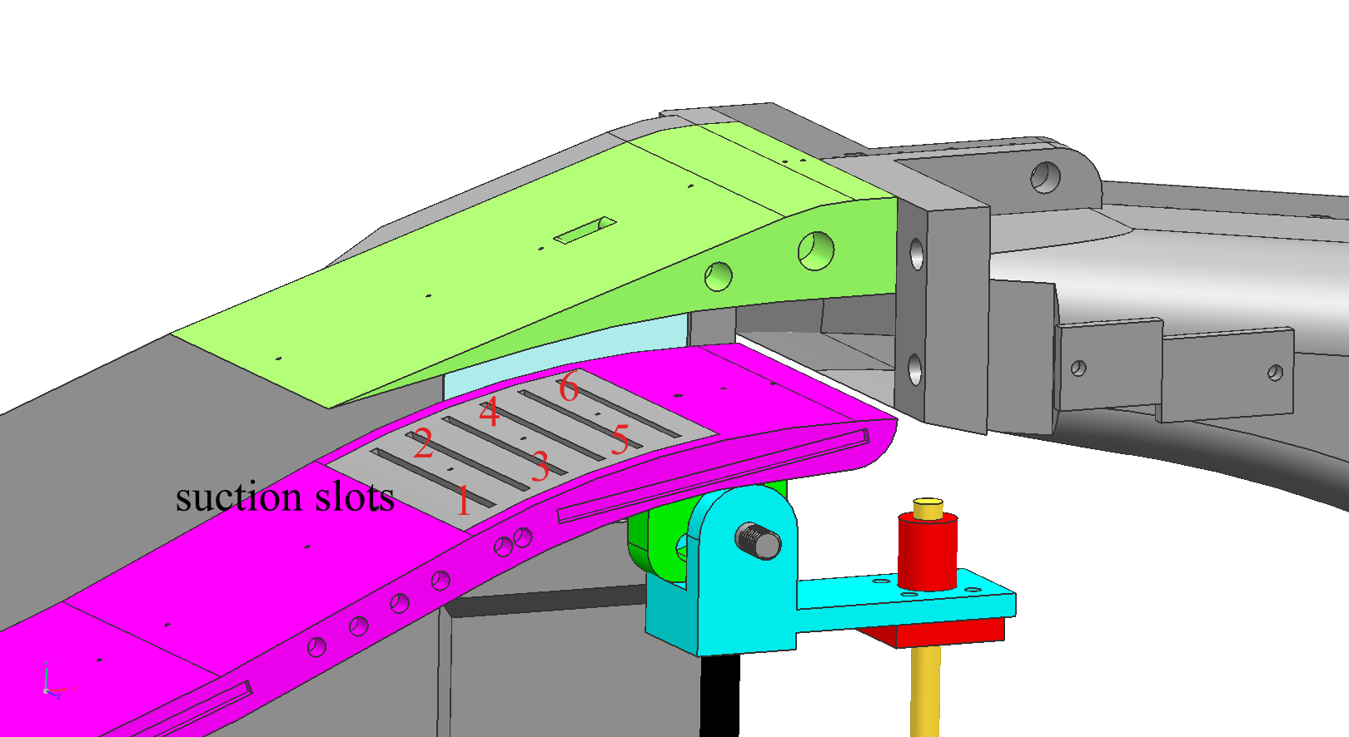

8. Section 2.2. Clarifications and appropriate referencing are needed in regard to: "inviscid flow scheme," "Roe's method," "monotonic upwind scheme," "viscid flow scheme," "one-equation SA."
Thank you for your advice. Some reference about CFD have been added.
D John, J R Anderson. Computational Fluid Dynamics: The Basics with Applications. McGraw-Hill Companies, Inc. 1995, NewYork.82–87.
P L Roe. Approximate Riemann solvers, Parameter Vectors, and difference scheme. Journal of Computational Physics. 43(2)(1981)357-372.
L B Van. Towards the ultimate conservative difference scheme. V.A second order sequel to Godunov's method. Journal of Computational Physics. 32(1)(1979)101-136.
P R Spalart, S R Allmaras. A one-equation turbulence model for aerodynamic flows, AIAA-92-0439

9. Section 2.3. As the throttling plug is changed, how are the investigators certain that the inlet Mach number does not change.
Thank you for your advice. The plug is at the end of the inlet. As the plug moves forward during the experiment, shock train generates and moves upstream. An observation window is set on the sidewall to observe the shock train and judge the working condition of the inlet. The supersonic disturbance cannot be transmitted forward, so the inlet Mach number does not change.
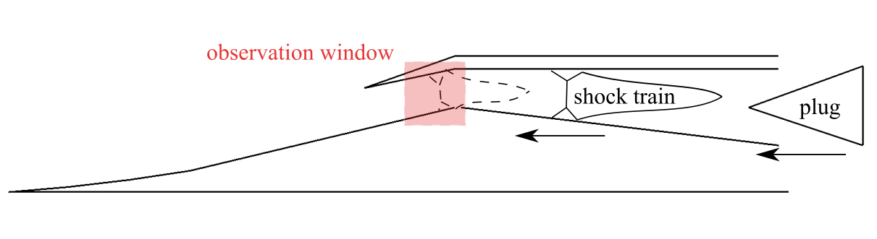

10. Section 3.1 and throughout the manuscript. The phrase "rotation angle" of the "compression ramp" requires re-wording.
Thank you for your advice. It has been revised.

11. Section 3.1. Revise and explain "confused shock wave."
Thank you for your advice. The author felt so sorry that "confused shock wave" misled the reviewer. It can been seen clearly from the figure below. Shock wave is generated as the supersonic flow passes through the suction slots.

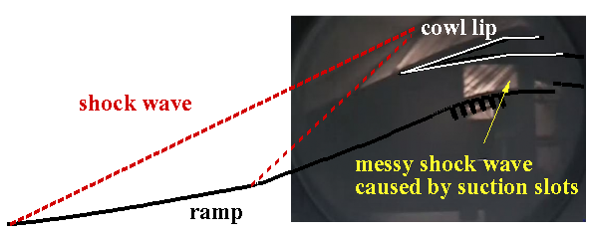

12. Section 3.1 Schlieren results in Figures 11 and 14 are not clear or understandable. The visualization volume needs to be identified on an associated figure. Schlieren images must be enlarged, with labels which identify flow and facility features. All image variations must be explained. At present, it is impossible to relate the text to the content within Figures 11 and 14.
Thank you for your advice. Because of the poor equipment, the schlieren results presented in this paper are not very clear. The author felt so sorry. Some auxiliary lines have been added to explain the schlieren.
The red dashed lines represent shock wave while the black solid lines represent surface of the inlet. It can be seen that as the inflow Mach number increased, the second adjustable compression wall rotated around the fixed hinge, the second compression angle increased gradually. Meanwhile, the curved shock wave and oblique shock wave moved toward the cowl lip and attached on the lip at Mach number 4
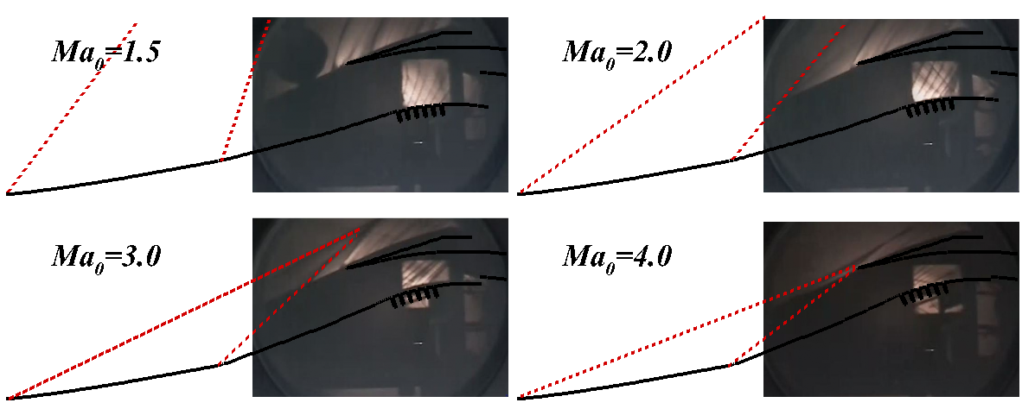

Some auxiliary lines have been added to explain the schlieren. The white solid lines represent the upper and lower wall of the inlet while the yellow dashed lines represent the terminal shock wave. Combining the schlieren and model sketch with the pressure distribution mentioned above , it can be seen that when the throttling ratio was 64%, the terminal shock train has not reached the entrance of the diffuser. Therefore an oblique shock generated by the outer wall of the diffuser could be clearly watched from the right local enlarged figure. With the increase of the throttling ratio to 68%,the oblique shock wave disappeared but shock wave structure in the schlieren window remained unchanged. This illustrated that the terminal shock has passed through the diffuser entrance and located in the region between the schlieren window and the diffuser entrance. As the throttling ratio increased to70%, the shock wave structure in the schlieren window changed, and an obvious terminal shock wave was stably stuck in the suction slot in the internal contraction section.
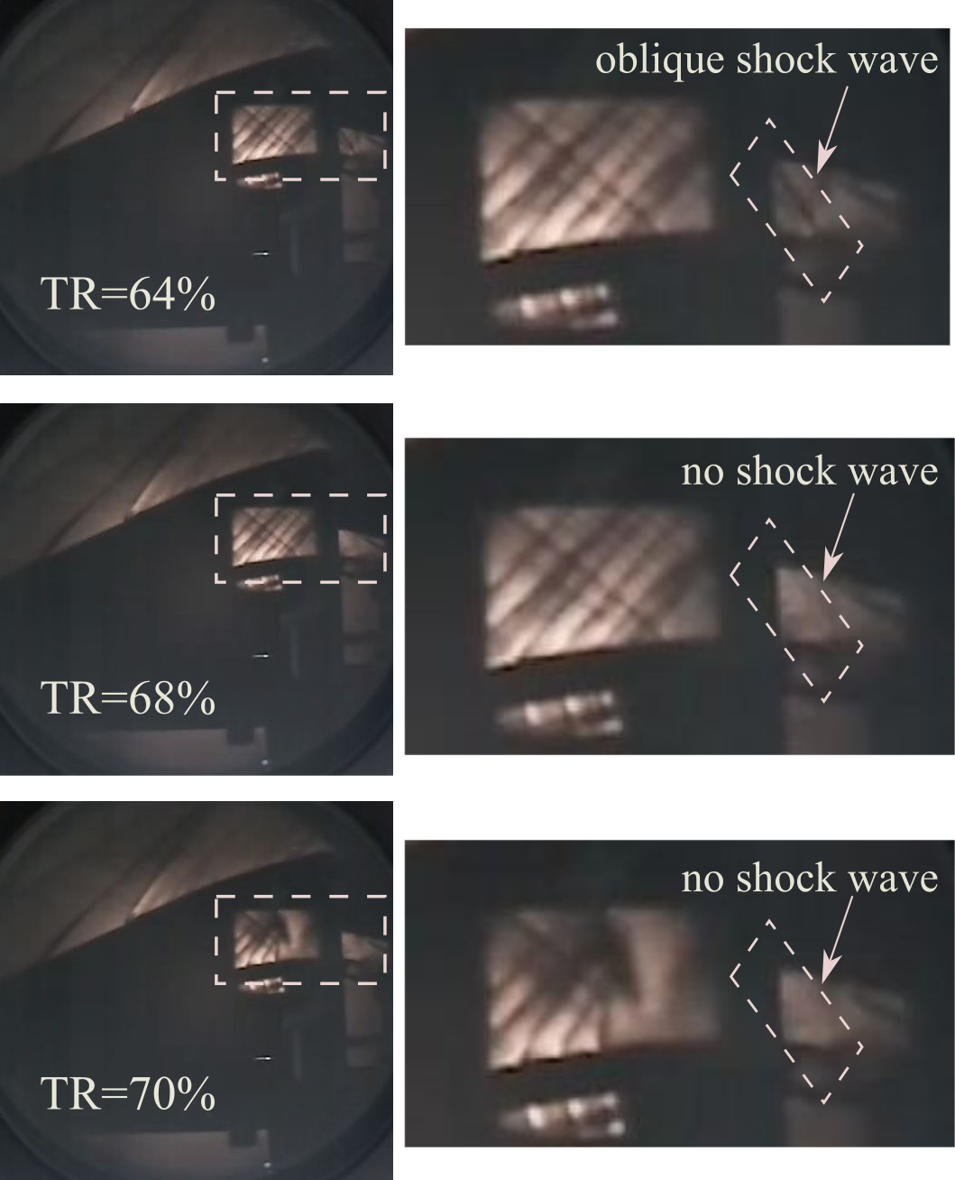

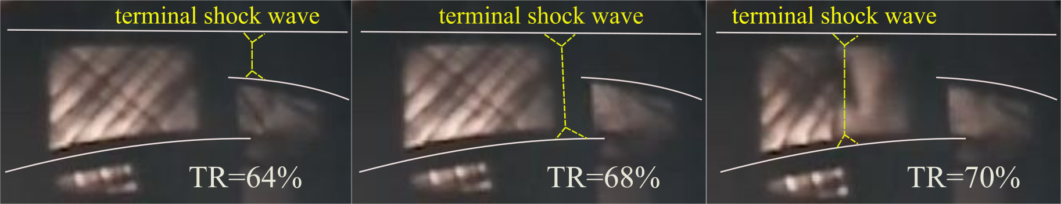

13. A nomenclature section is needed.
Thank you for your advice. The nomenclature section has been added.

14. Section 3.1. Clarification is needed regarding the meaning of "the inlet would unstart."
Thank you for your advice. Once TR continued to increase ,the terminal shock will be pushed out of the internal compression section, large separation bubble generates and the inlet will unstart. Total pressure recovery coefficient and mass flow ratio will decline greatly.

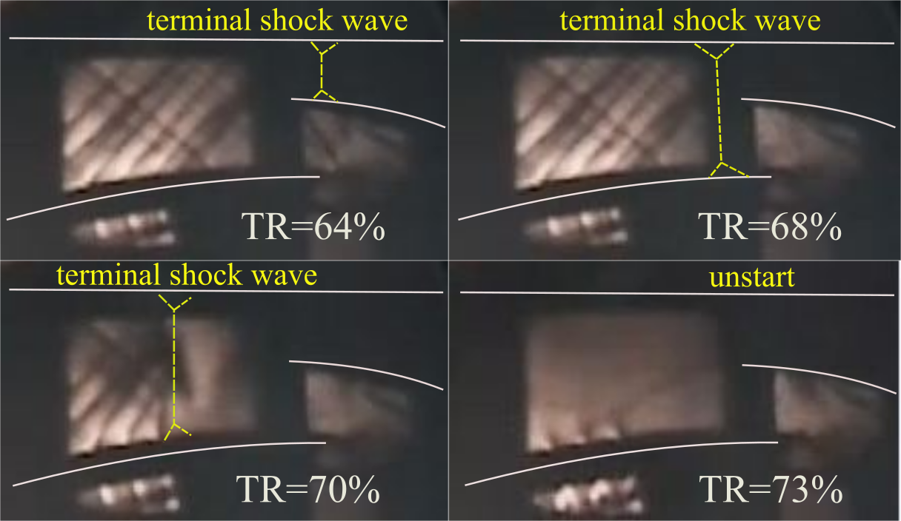

15. Figure 9. Enlargement location on large drawing is needed.
Thank you for your advice. Enlargement location on large drawing has been added.
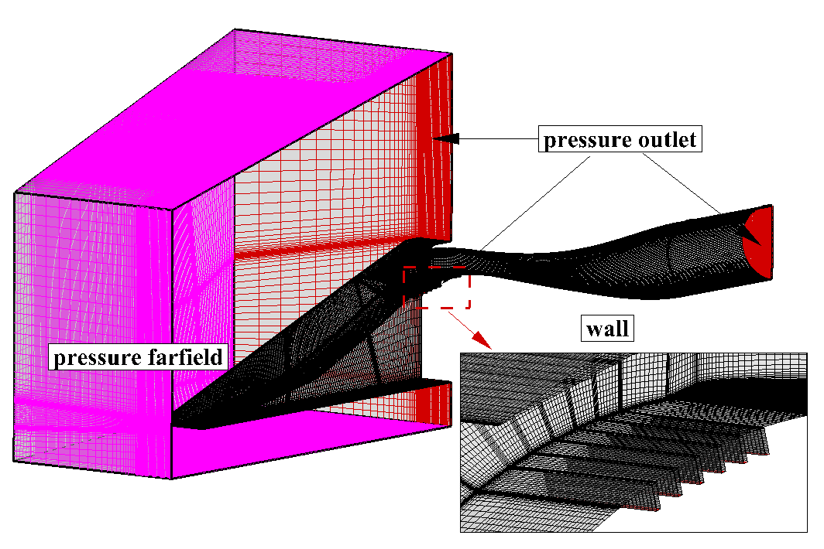

16. Section 2.2. Dimensional value of D is needed.
Thank you for your advice. D is 80mm. Due to some special reasons, the exact size cannot be presented in this paper. This is why the author used non-dimensional method.

17. Section 2.3. Definitions and additional explanation are needed in regard to aerodynamic performance, pressure recovery coefficient, mass flow rate, outlet distortion.
Thank you for your advice. The specific definitions of the performance has been added in the section 2.3. Some parameters could be used to quantify the performance of the inlet, including exit total pressure recovery coefficient σ_{e} ,exit Mach number Ma_{e} , and mass flow ratio ϕ. The coefficient σ_{e} and ϕ indicate the quality and quantity of the airflow respectively. σ_{e} is the total pressure ratio of exit to freestream while ϕ is the ratio of exit mass flow to the captured mass flow.

18. Section 2.3. Discussion of measurement techniques and procedures is incomplete. Additional information is needed in regard to signal processing hardware and procedures for the steady and time-varying pressure measurements.
Thank you for your advice. Discussion of measurement techniques and procedures have been added in the section2.3
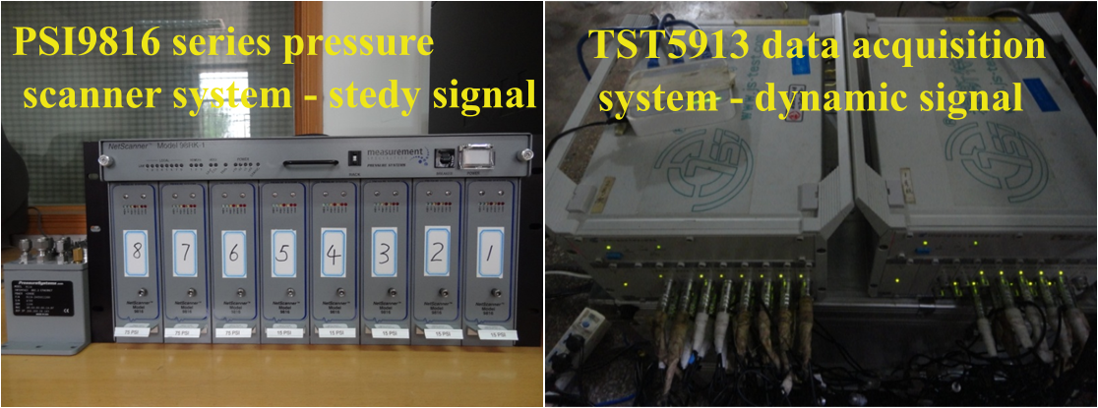

19. Figures 17, 18, 19, 21, 23, 25, 26, and other figures. Most details are impossible to discern and understand. Figure parts are often too small. Color contour scales are often missing. CFD and flow features require labels so that associated text is easily understood.
Thank you for your advice. These figures have been optimized.

20. Figure 16 discussion. Confusing text in reference to back pressure and P/Po requires clarification.
Thank you for your advice. In numerical simulation, the high backpressure produced by throttling device or combustor is simulated by changing P/P₀. Backpressure ratio P/P₀ indicates the static pressure ratio of exit to inflow where P_{e} and P₀ are the actual pressure of the exit and inflow respectively.

21. Figures 15 and 16. Additional discussion is needed in regard to differences and similarities for data on the upper and lower walls.
Thank you for your advice.Figure15 shows static pressure distribution along the lower and upper wall under different Mach numbers. This figure shows the critical conditions of the inlet under different Mach number. The terminal shock wave has reached the throat.
Figure 16 shows static pressure distribution along the lower and upper wall under different backpressures. This figure shows the process of moving upstream of the terminal shock wave.
In addition, the position of terminal shock would be indicated by a sharp rise in static pressure. So the function of the pressure distribution is to obtain the position of the terminal shock.

22. Conclusions require revision. Content of Conclusions 2 and 3 is not clear or convincing. In regard to Conclusion 1, configuration details for each set of data are needed throughout the paper. For Conclusion 4, higher frequency peaks could be harmonic signatures related to the primary oscillation, and additional discussion is needed regarding the physical effects related to use of different bleed window arrangements.
Thank you for your advice. The conclusion has been revised.

-Reviewer 2
Significant detailed comments are provided in highlighted and commented PDF.
This paper presents an experimental and numerical study for a supersonic inlet with bleed. The experiments and simulations are of seemingly high quality but more information is needed to build confidence in the results, such as uncertainty analysis in the experimental data, convergence study, mesh independence study, and explanation of numerical abnormalities in the data. Additionally, the background and motivation discusses hypersonic vehicles but the conditions studied here are primarily in the supersonic regime (Mach 1.5 - 4) with a focus on Mach 2.5. Hypersonic vehicles do not have subsonic diffusers in general. I encourage the authors to change the introduction and background and to bring in more of the existing literature on variable geometry inlets, supersonic bleed, and shock-boundary layer interaction into their literature review.
Overall, the paper is of good quality. It needs to be revised for English grammar and sentence structure in many places which I highlighted and commented on, however, the English and readability is quite good already.
The comparison of the experimental and numerical data is strong for the steady data but there are open questions to the validity of the unsteady simulations. There are some very interesting physics presented in the results, but the depth of the discussion on the physics is limited. The authors focus strongly on the shock position and structure but do not discuss the significant boundary layer separation that is clearly seen in the simulations which results in equal or greater performance loss. The numerical data could be analyzed deeper to provide insights such as unsteadiness in the separation location and extent of the separated regions, the unsteady mass flow through the bleed window during shock oscillation, and more. Further in-depth analysis and greater insight into the physics are the main improvements that could be added to this paper.

Thank you for your advice. According to the reviewer advise, this paper has been revised carefully. Some of them are listed as follow and explained separately.

1.Introduction about "Hypersonic"
"Hypersonic" has been changed to "supersonic". The inlet studied in this paper is designed at Mach number 4.0. Hypersonic is not involved in this paper. The author felt so sorry that it confused the reviewers.

2.The function of the large bleed window.
Pressure increases when the air flow passes through the shock wave. For the inlet with small bleed window, the region near the throat consists of low pressure area and high pressure area before and behind the terminal shock wave. However, for the inlet with large bleed window, the region near the throat consists of three areas adding the low pressure near the bleed window which could not be ignored. The low pressure area near the large bleed window neutralizes the original high pressure area behind the terminal shock wave, which leads to the decline of the overall pressure in the area from suction slots to entrance of the diffuser.
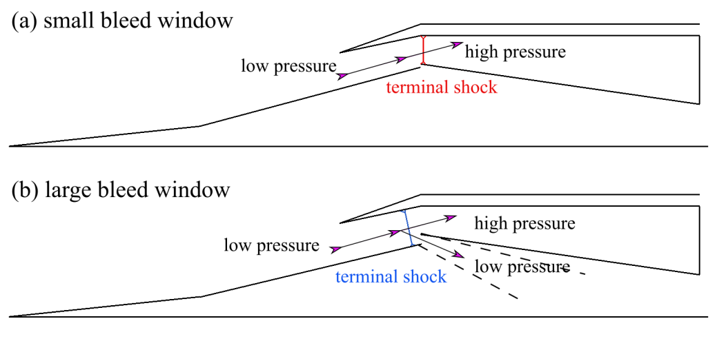
3. compression-expansion-recompression
There is a turning point on the surface in Case A. The second compression surface could rotate around the turning point. However, the surface of Case B is continuous and smooth. There are no rotatable and adjustable components unless breaking the compression surface.
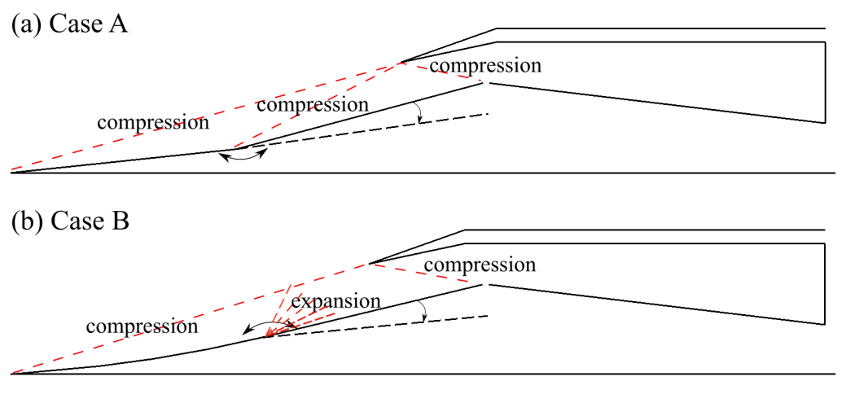

4.Comparison of the compression forms
The author compared the two compression forms before. The results are as flow where X-coordinate denotes flight Mach number Ma, Y-coordinate denote throat Mach number and pressure rise ratio. The red curve and blue curve represent curved compression and wedge compression respectively. From the figure, it can be seen that expect for the design Mach number, the compression efficiency of the curved compression is higher. Throat Mach number is lower and pressure rise ratio is higher.
However, the results maybe change case by case. So the quantitive results were not presented in this paper.

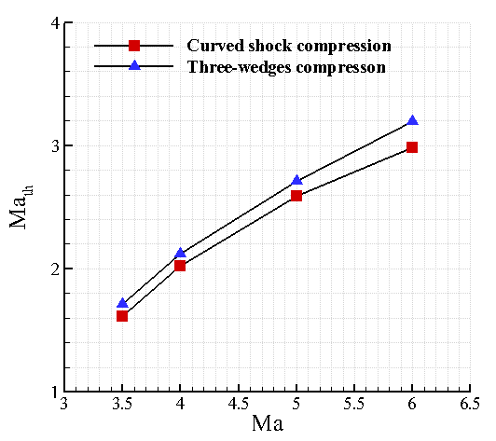 | 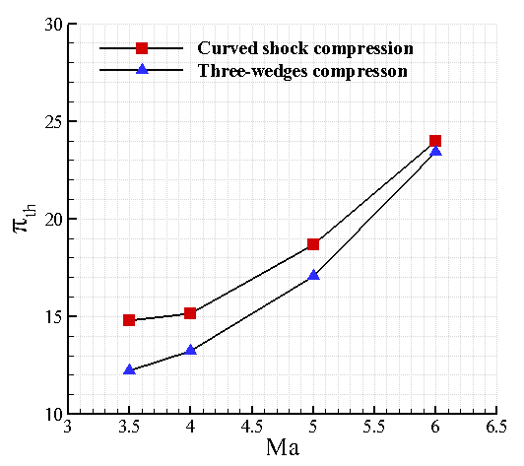

5.simulation method and grid dependence and convergence study
Selection of turbulent model and grid independent study were conducted to validate the simulation. The results are as follow. More details have been added in the section3.2
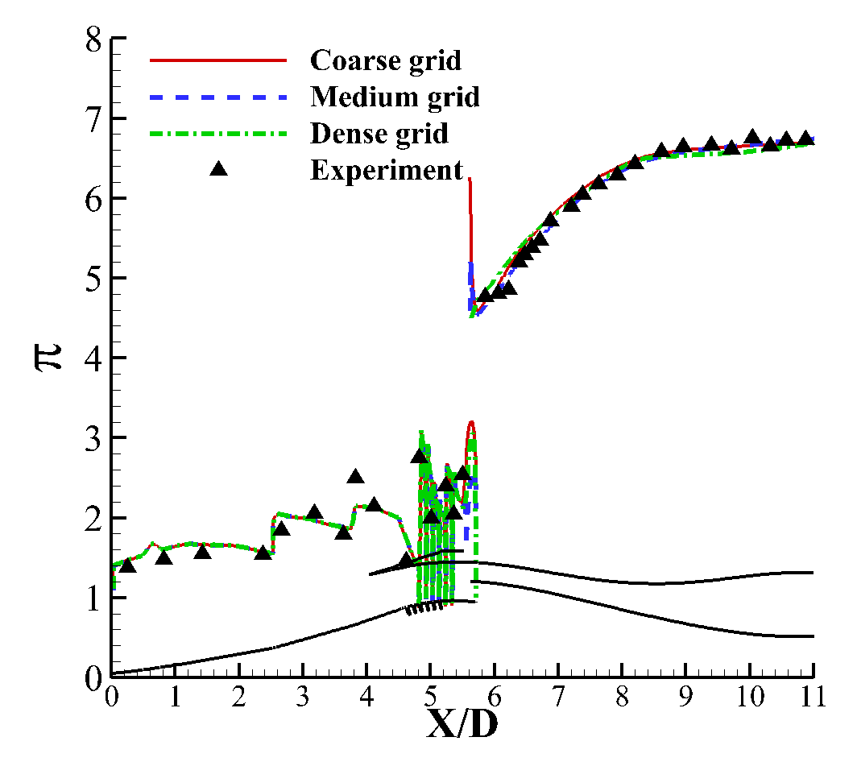 | 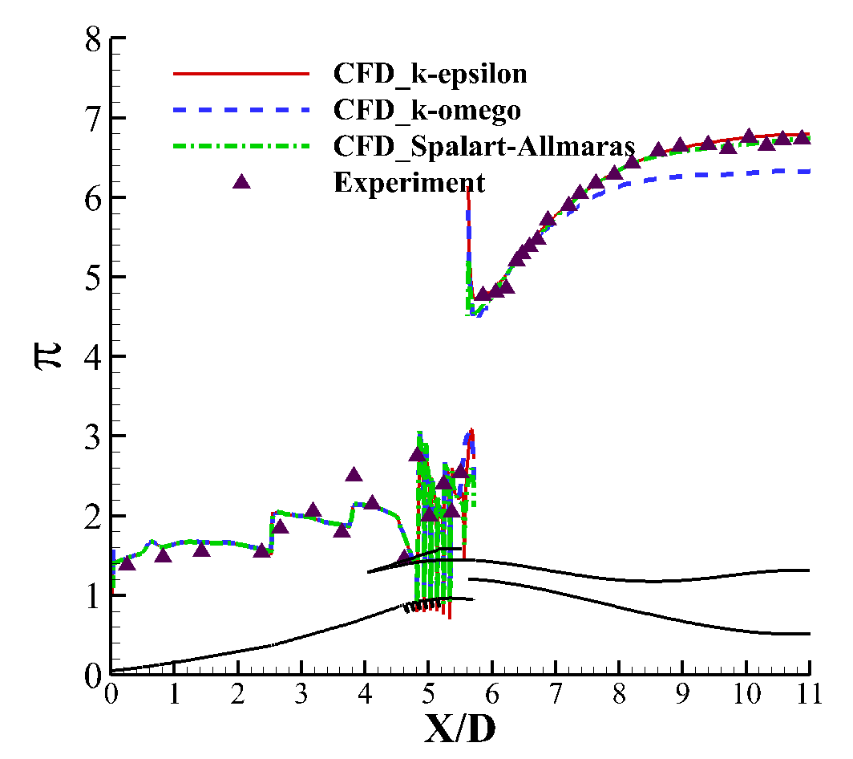

6.defination of aerodynamic performance
Some parameters could be used to quantify the aerodynamic performance of the inlet, including exit total pressure recovery coefficient σ_{e} ,exit Mach number Ma_{e} , and mass flow ratio ϕ. The coefficient σ_{e} and ϕ indicate the quality and quantity of the airflow respectively. σ_{e} is the total pressure ratio of exit to freestream while ϕ is the ratio of exit mass flow to the captured mass flow.

7. Pressure distribution along the lower and upper wall
"it can be inferred that the terminal shock located near thethroat during the whole process". The author felt so sorry this confused the review. What the author wants to say is that within the range of throttling ratios(TR60%-TR78%), the position of terminal shock is close and is not too far away from the throat. That does not mean the location is constant. To avoid the readers being misled, the sentence has been deleted.
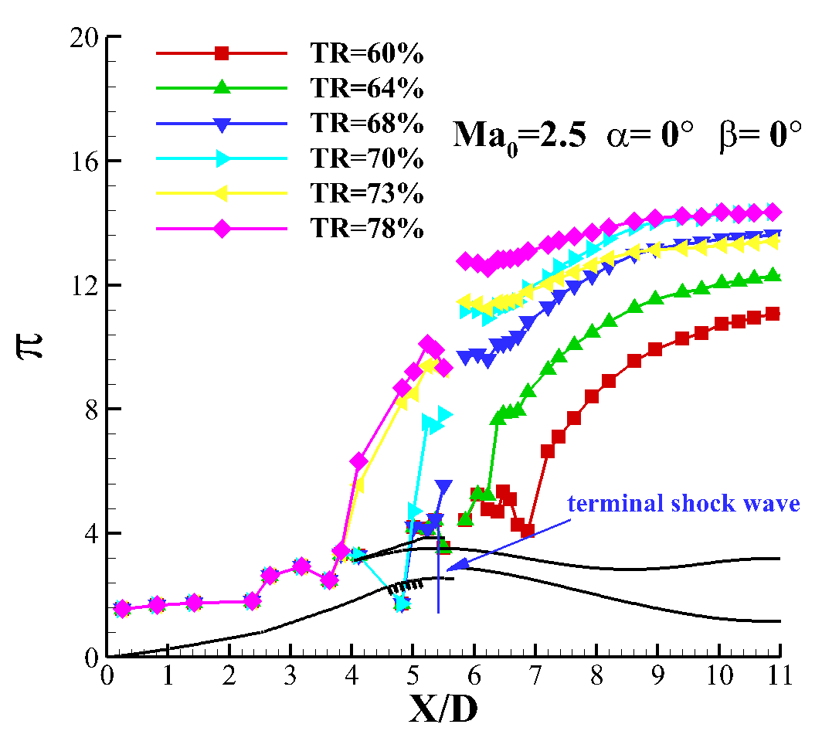 | 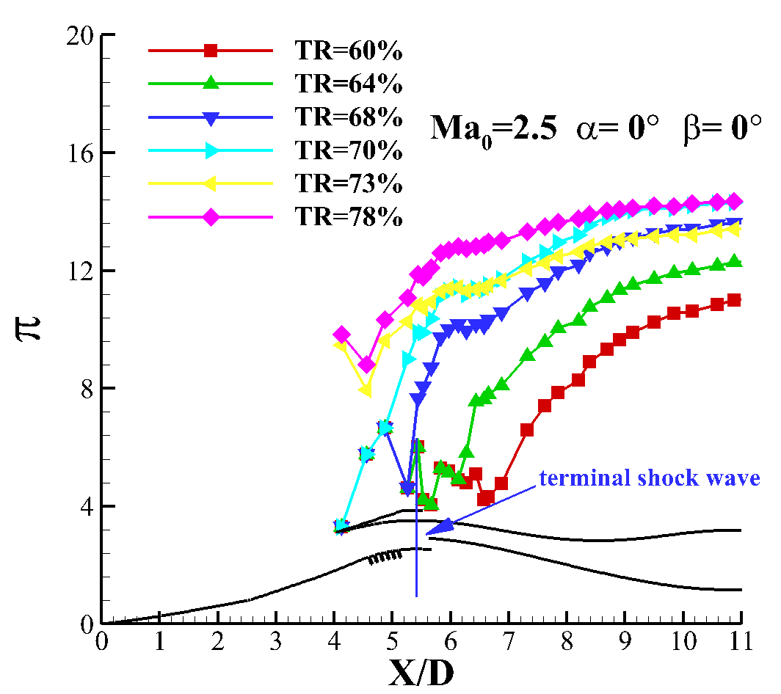

8.experiment schlieren
Because of the poor equipment, the schlieren results presented in this paper are not very clear. The author felt so sorry. Some auxiliary lines have been added to explain the schlieren.
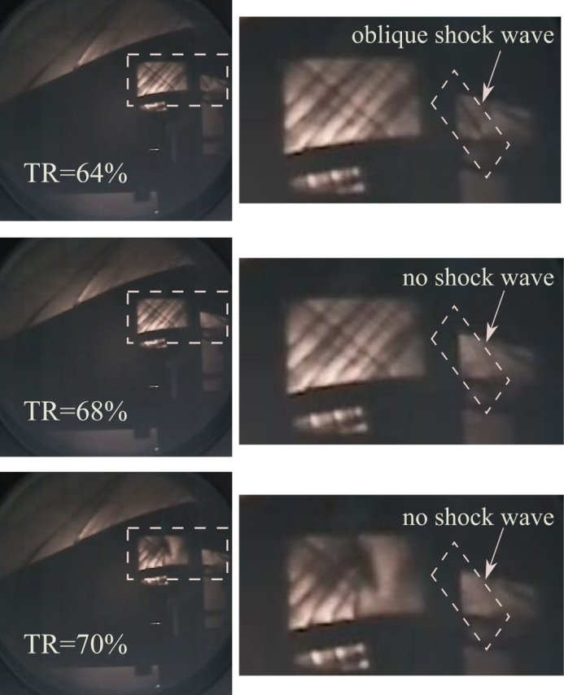

9.strong oscillations
It is worth noting that there is a large fluctuation of pressure in the internal compression section. The strong oscillation is caused by the suction slots instead of the shock train. According to the starting position of pressure rise, it can be inferred that the shock train has not reached the entrance and it is still in the diffuser.
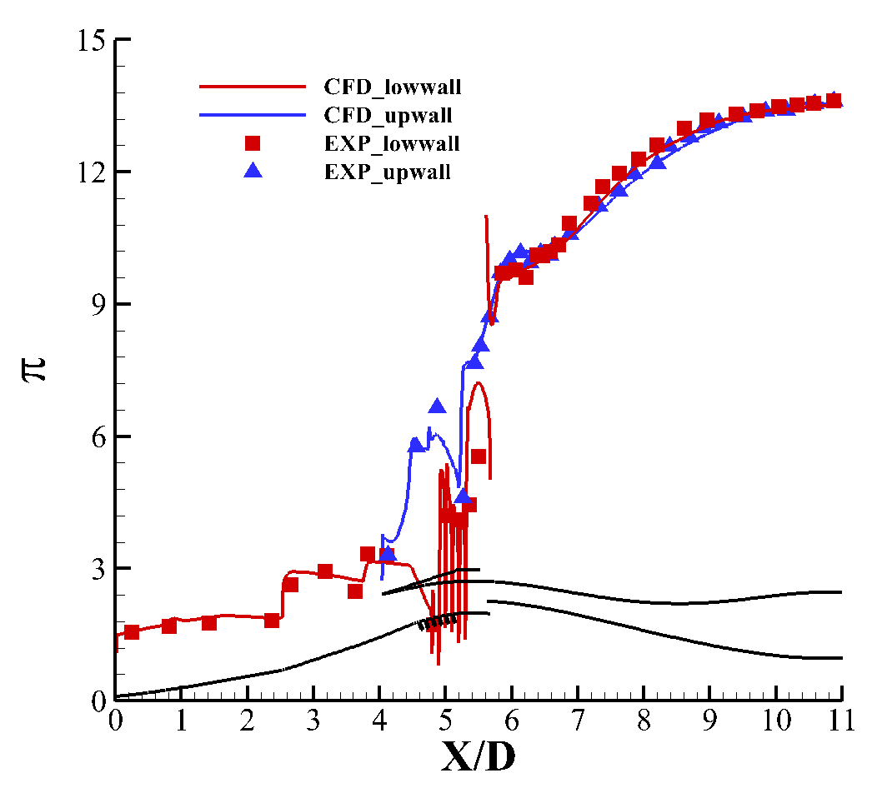 | 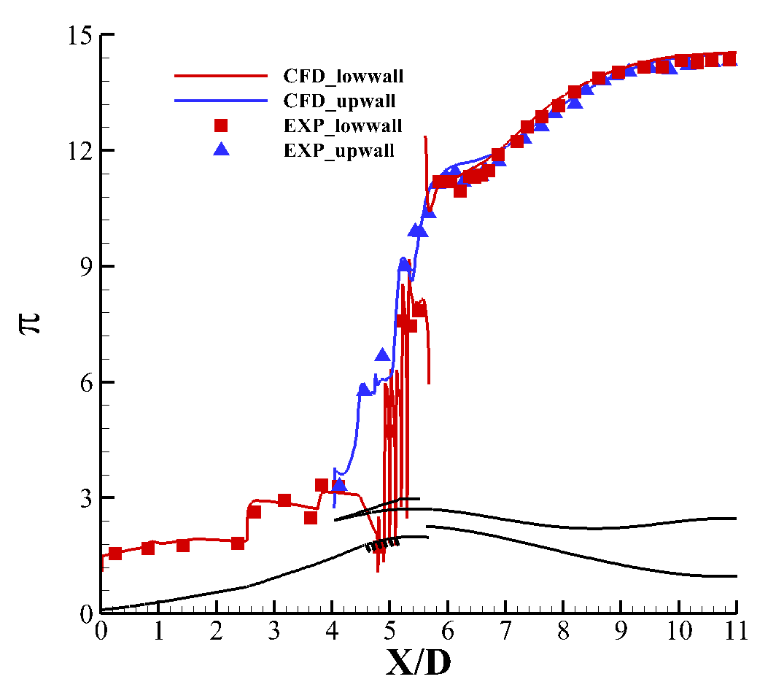

10. Corresponding relationship between P_{e}/P₀ and TR
Establishing the corresponding relationship between throttling ratio and backpressure ratio is beneficial to predict the characteristics of shock train according to simulation results.
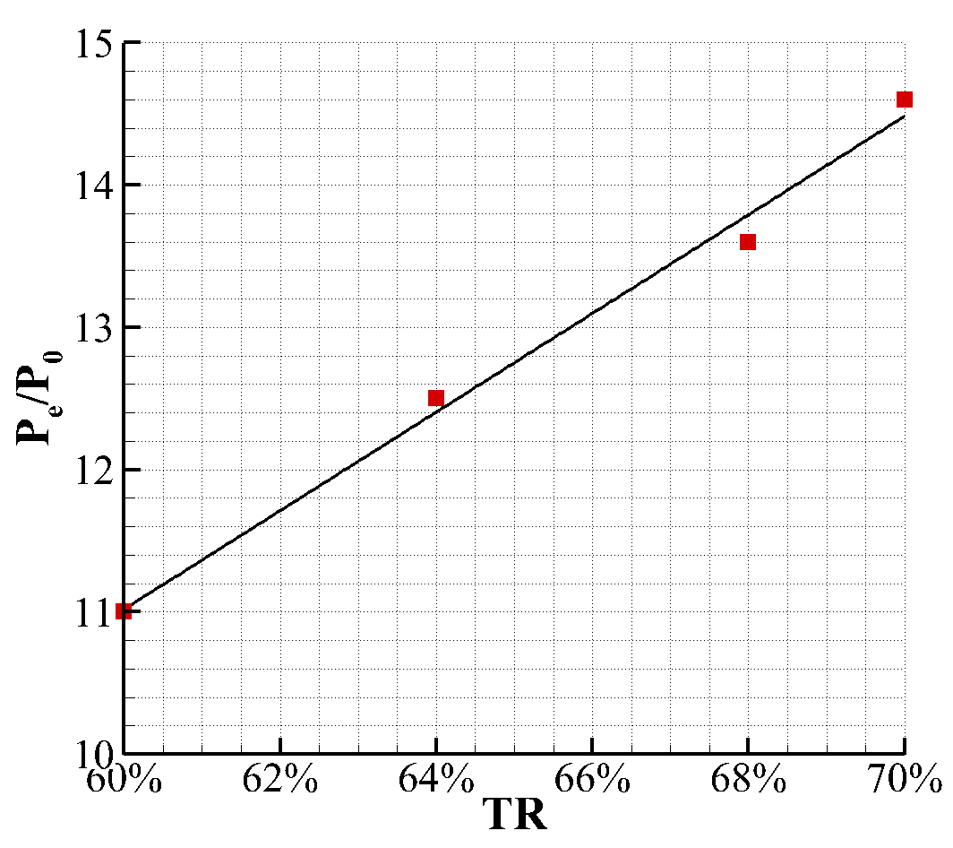

11. the additional pressure drop after the shock train
As the review said, the additional pressure drop this is due to the separated boundary layer from shock-boundary layer interaction. This pressure loss is as great or greater than the shock losses.
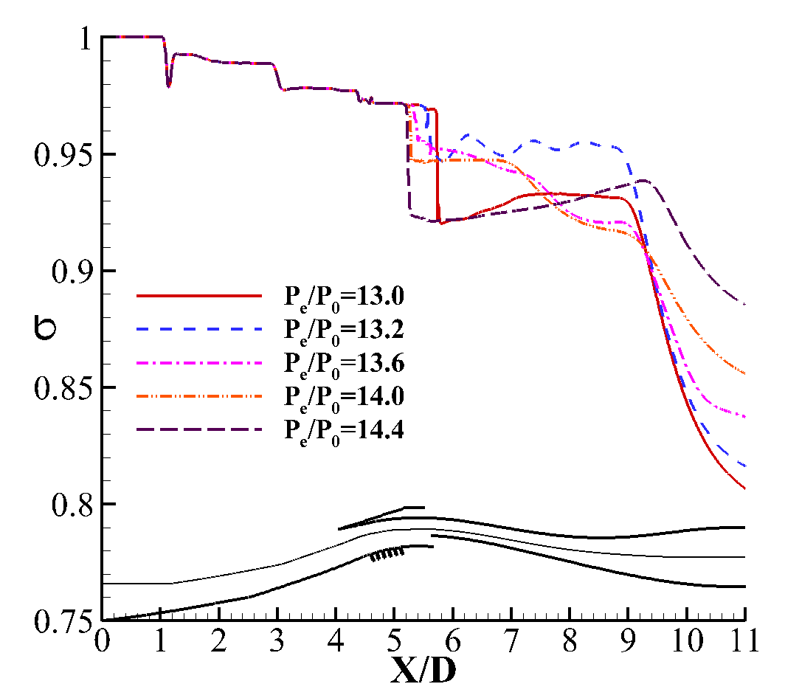 | 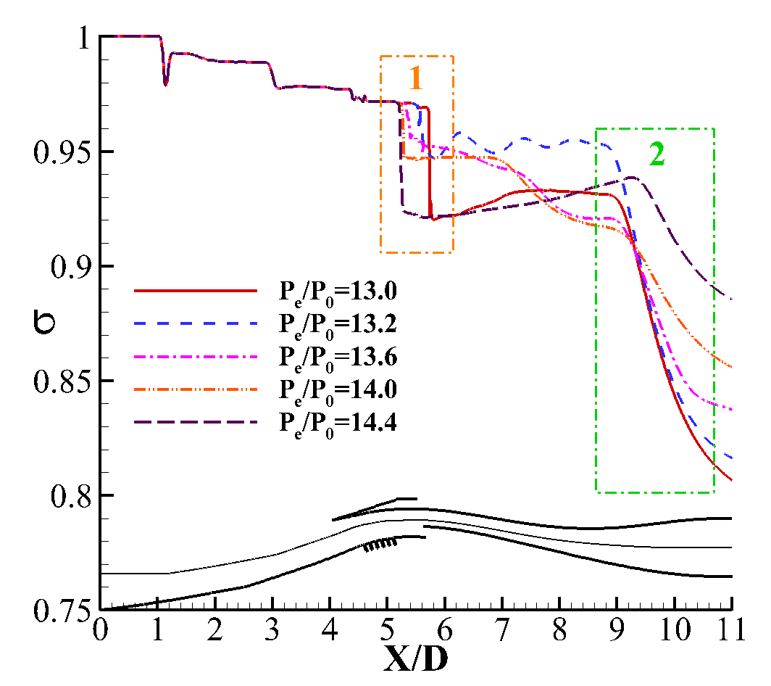
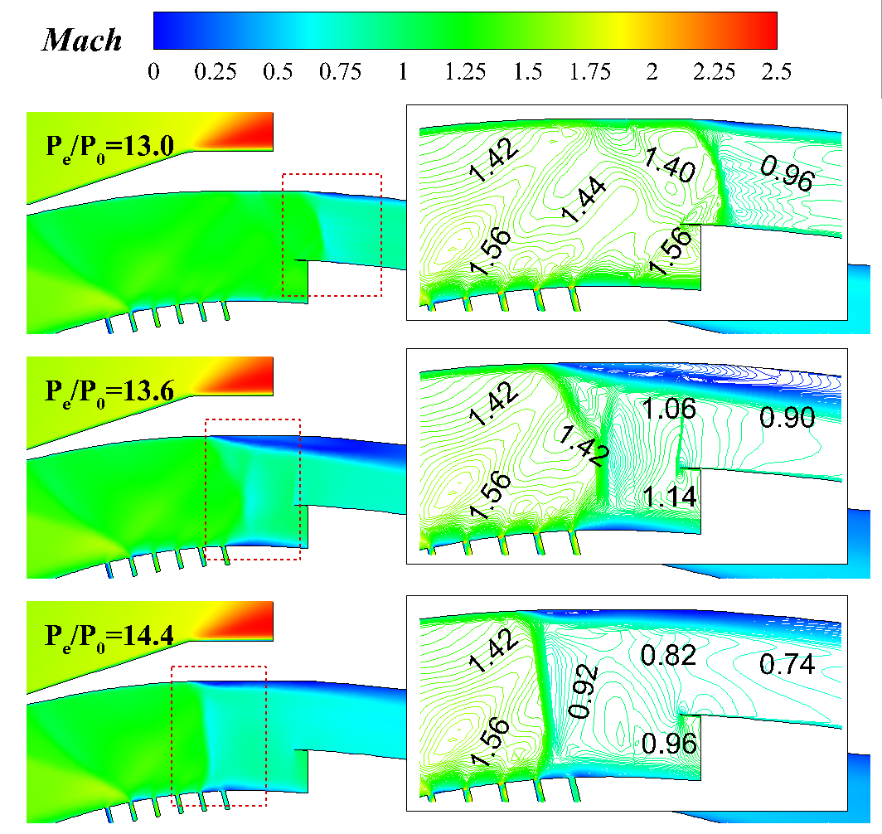  (1) | 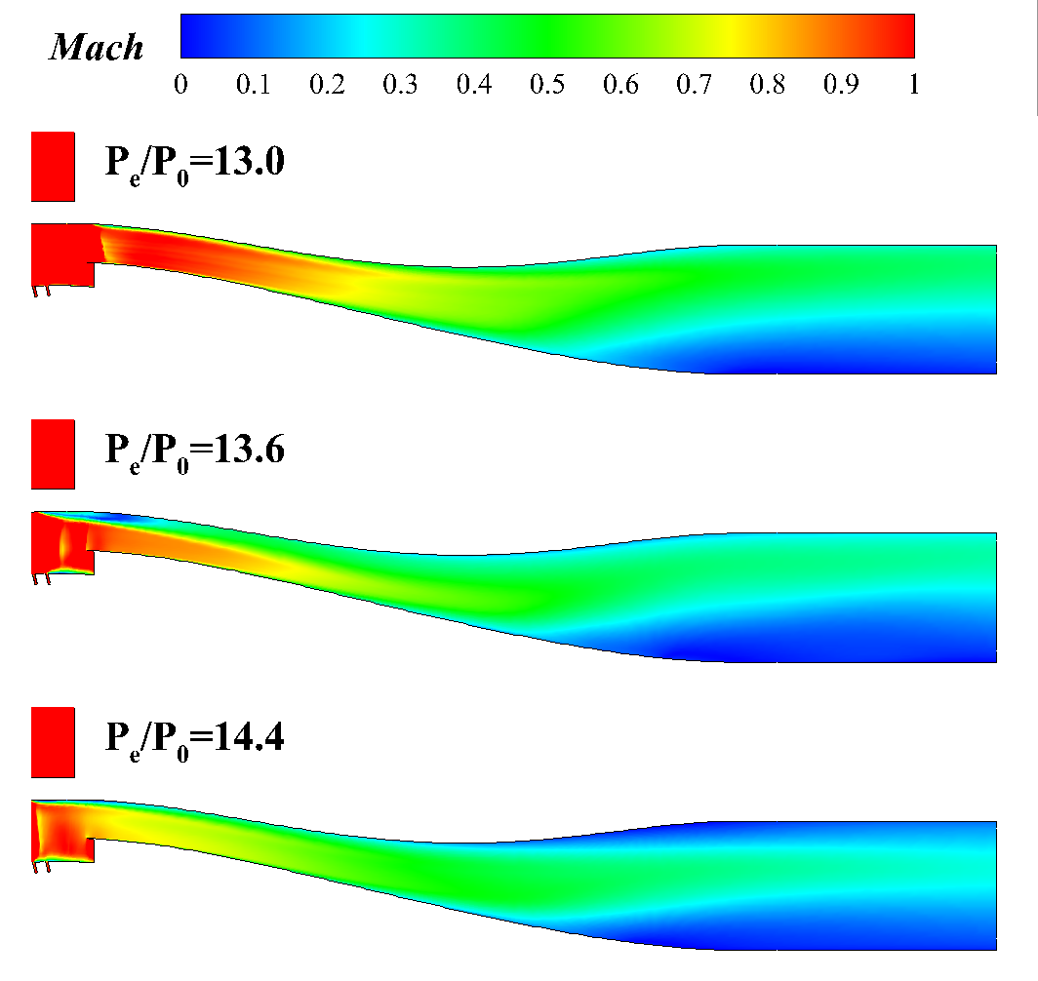  (2)

12.Change of shock structure and mass flow
As the reviewer said there is no discussion about the change of the shock structure and separation. That is because the oscillation range is narrow. The terminal shock presents weak-λ type during the whole oscillation. Except for the position ,the structure of the terminal shock almost remains unchanged. The change of the separation is not very obvious.
If the backpressure increases, the range of oscillation may become larger and the influence of the suction slots may not be ignored. So the large scale oscillation is not discussed in this paper.
The obvious structure change of the terminal shock could been seen in the section3.3.1. But the result is steady not unsteady.
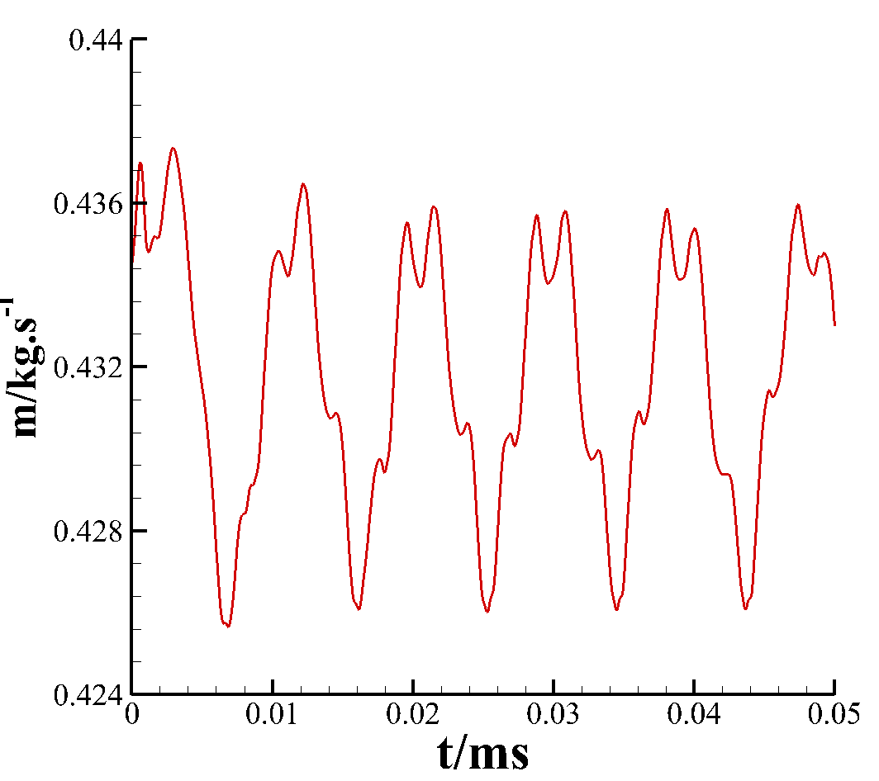 | 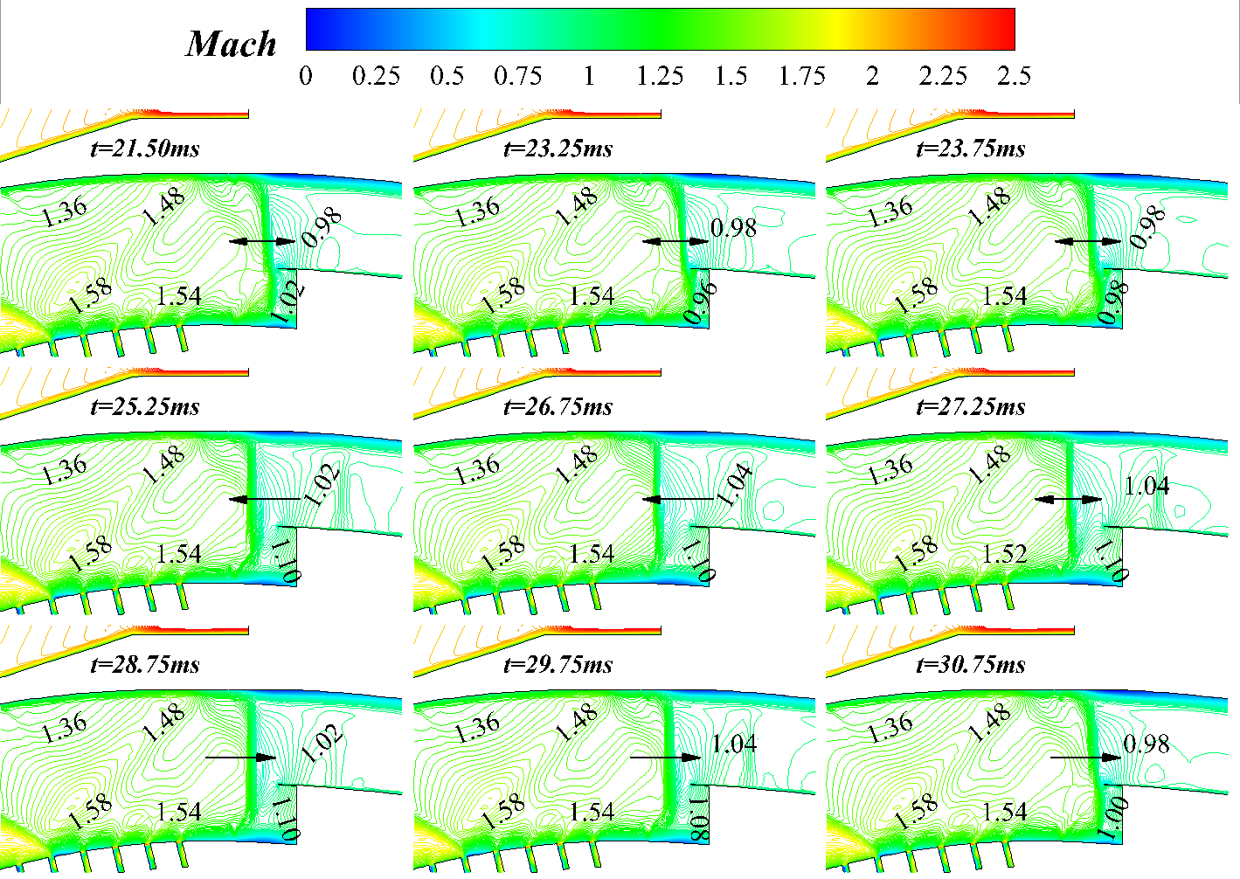

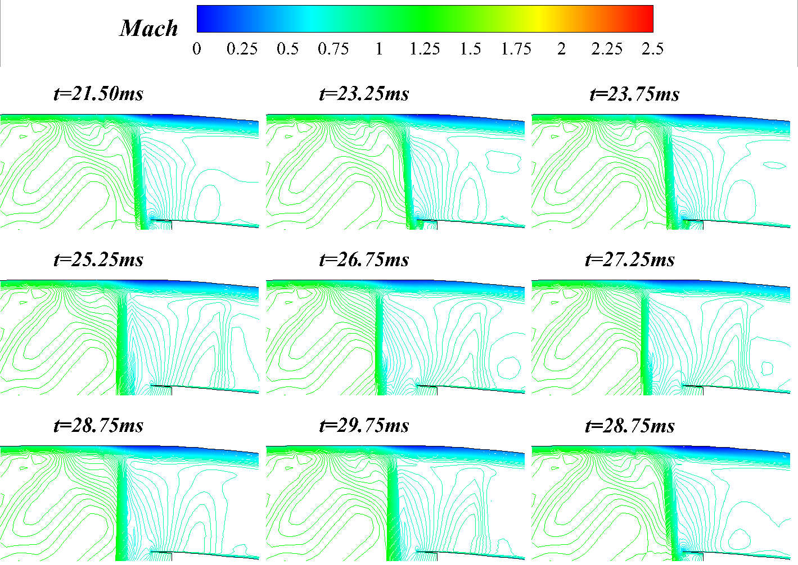  (a)upper wall | 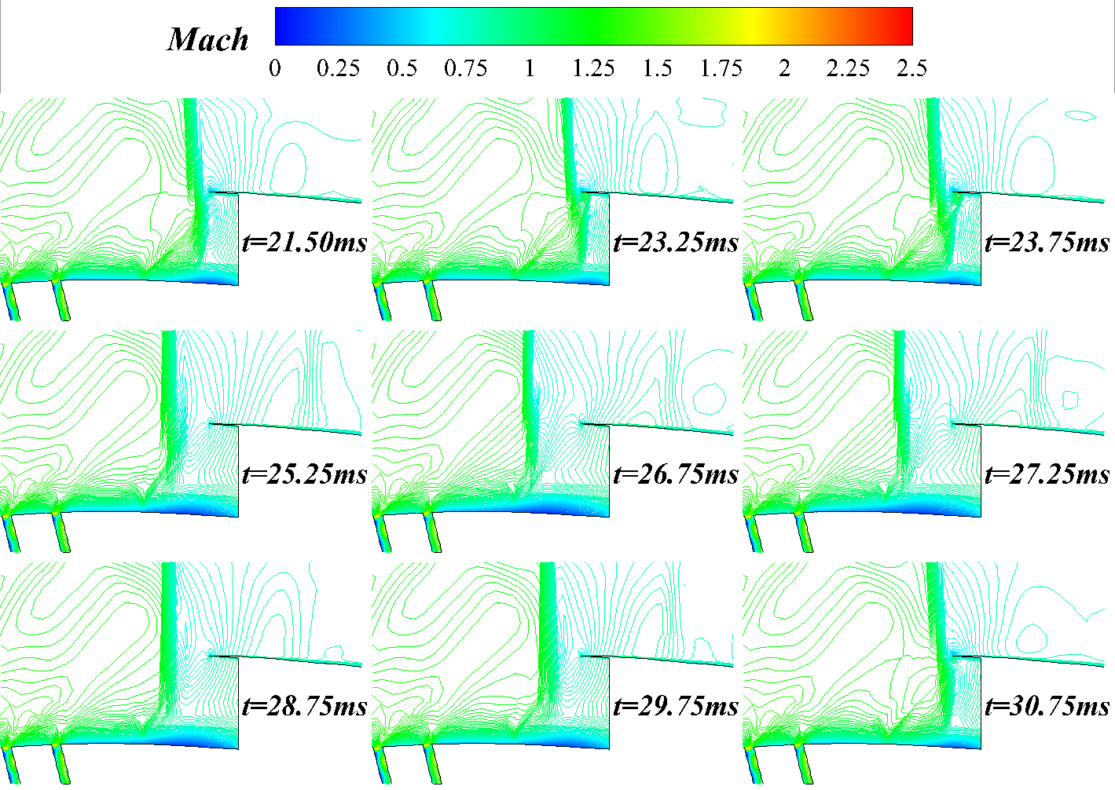  (a)lower wall

13.conclusions
(1) Low pressure near the large bleed window neutralizes the original high pressure behind the shock train

That means the air flow from the diffuser mixes the air flow from the bleed channel.

(2) improves to 8.5% as P/P₀ increases from 13 to 14.6
As the reviewer said the difference in pressure recovery is based on the back pressure ratio. The reason why the backpressure could increase to 14.6 is the bleed window. If the bleed window is not very large, P_{e}/P₀ might only increase to 14 or even lower. At the last moment, even if the anti-backpressure ratio increases a little, the performance of the inlet could improve a lot. This is why the author said "It proves that the scheme adopted in this paper has a great effect on terminal shock wave control and inlet performance improvement."

(3) Influence of background wave and the large bleed window
The background refers to reflect shock wave in the upstream of the internal compression section .
