Response to Reviewer 2 Comments

Point 1: There are major grammatical errors throughout the manuscript, even in sentence 1 of the abstract. Run-on sentences are common through, including sentences that are up to 6 lines long. There isn't enough space to list out every grammatical mistake.

Response 1: I apologize for the confusion caused to the reviewer due to the misrepresentation of the article. The first manuscript of the paper did contain many excessively long sentences that made it very difficult for the reader to read, and journal articles require rigorous and careful revision. The revised paper has been revised in detail for grammar, spelling, and expression, and the author has marked all the changes in the first draft in red to make it easier for reviewer to distinguish them. Particularly in the abstract, sections 1, 2, and 5 of the paper, excessively long sentences have been broken up and readjusted to make them easier for the reader to understand.

Point 2: The structure of the paper would be better with a methodology and results section. Instead the sections are rather ad-hoc and hard to follow. The nomenclature section is missing.

Response 2: Yes, the structure of the paper is crucial to an article, and a confusing structure is very detrimental to the reasoning and proof of the research. The revised paper has completely corrected the overall structure of the paper by firstly adding a nomenclature at the beginning of the article, and secondly modifying the sections 3 and 4 of the paper into a structure from methodology to simulation and validation, so that the reader can clearly understand the purpose of each part and the level of the article and the research process is more logical.

Point 3: The figure quality is poor. Most figures have transparent annotation boxes which overlap with the data lines, making it very hard to read the data. Some figures (13 and 15) have small, fuzzy fonts. Some figures are not necessary and impossible to read, such as Figure 19.

Response 3: Thank you, the authors are aware of this error and have already made changes to Figures 1, 9, 10, 11, 12(b), 13, 15, 20, 21, 23, and 25 in the revised paper to avoid unclear symbols, fonts, legends, and descriptions in the images.

Point 4: Sentence 2 in the abstract is a run-on sentence.

Response 4: Yes, the first three sentences of the abstract have been revised to:
“Full-wing solar-powered UAV has a large aspect ratio, special configuration, and excellent aerodynamic performance. This UAV converts light energy into electrical energy for level flight and storage to improve endurance performance. The UAV only uses a differential throttle for lateral control, and the insufficient control capability during crosswind landing results in a large lateral distance bias and leads to multiple landing failures.”

Point 5: Introduction sentence 1: this sentence is 6 lines long, which is too long.

Response 5: Yes, this sentence has been split into three sentences for the convenience of the reader, as following:
“With the development of photovoltaic (PV) technology, energy, and aeronautical technology, solar-powered unmanned aerial vehicles (UAVs) have attracted the attention of many areas such as clean energy and sustainable development [1-3]. These vehicles use the aircraft as the platform, the integrated PV cells and the Maximum Powered Point Tracking (MPPT) as the energy harvesting system, the battery as the energy storage system, and the motor-propeller as the engine system. This kind of “charging-storage-discharging” system from energy input to output confers a super-long flight endurance [4, 5].”

Point 6: Grammatical errors are common throughout the rest of the document.

Response 6: The revised paper has been revised in detail, and long sentences, misrepresentations, interpretation of letters in Equations, and grammatical errors have all been corrected.

Point 7: Need a better picture of the UAV.

Response 7: Yes, Figure 1 has been replaced with a much clearer picture of the full-wing solar-powered UAV.
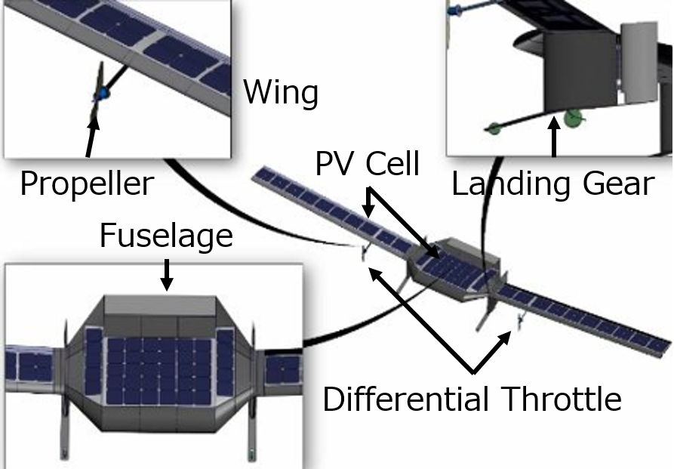  (a) 3D model of full-wing solar UAV | 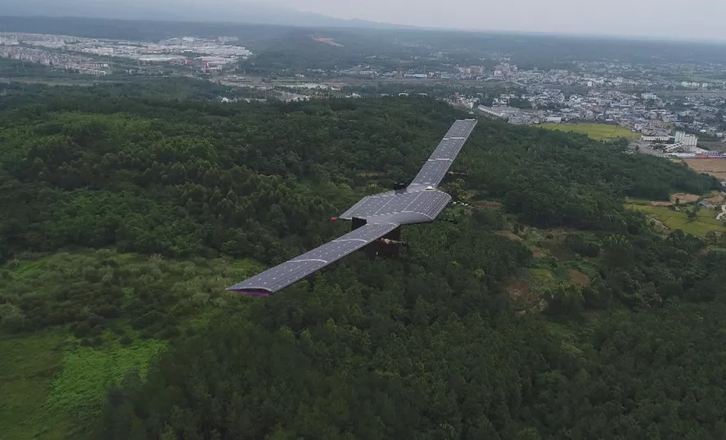  (b) Full-wing solar-powered UAV
Fig. 1 Full-wing configuration solar-powered UAV.

Point 8: Figure 19: recommend removing. Everything is so small, it's not useful. Provide a simplified top-level overview diagram instead.

Response 8: Yes, the diagram has been replaced with a more clearly structured concept diagram, with each part of the role and internal modules clearly listed, and the corresponding part of the text has been modified, as shown below:

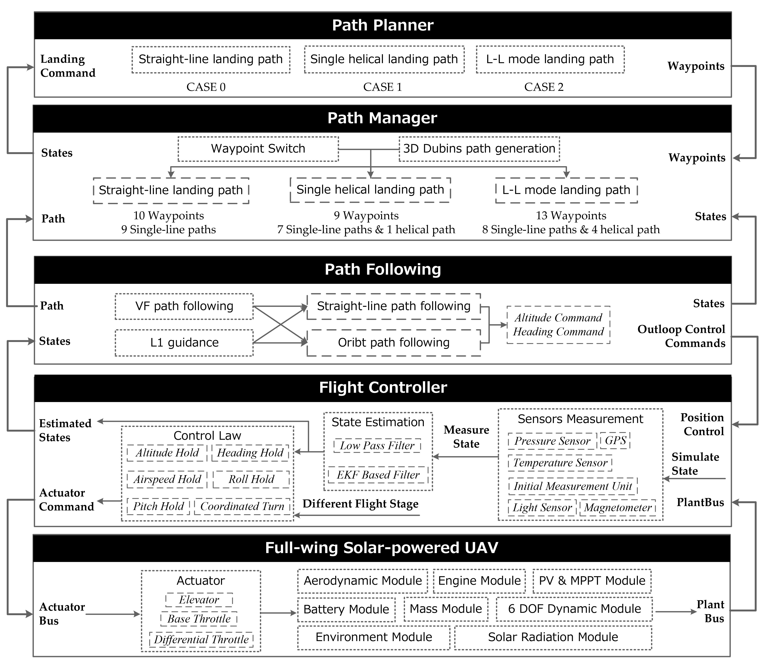
Fig. 20 Component level simulation system concept.
At the same time, Figure 15 has also been modified to a clearer form of expression as follows:
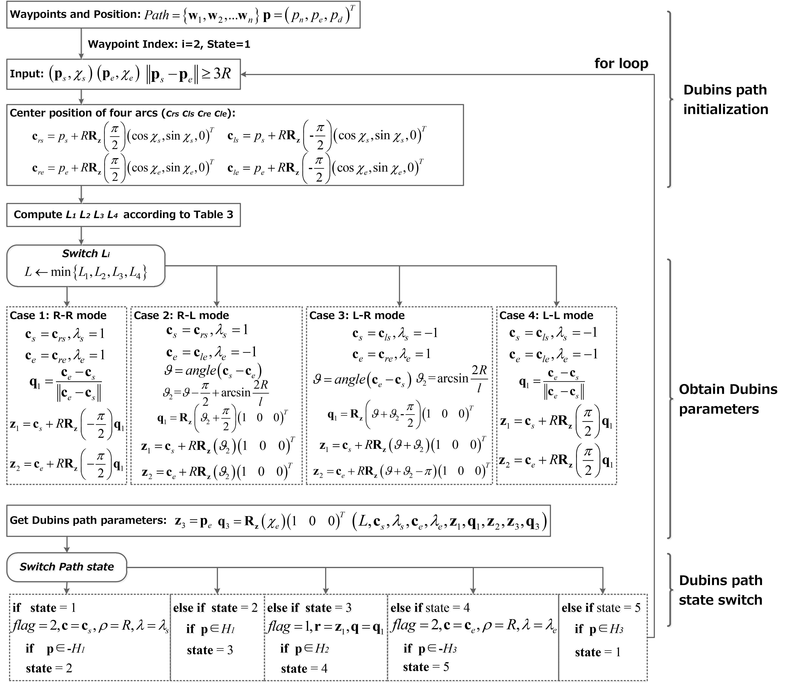
Fig. 15 Dubins paths generation algorithm structure.

Point 9: Don't use numbering in the conclusion.

Response 9: Yes, the conclusions of the paper were unnumbered and rewritten.

