**Enabling Robust and Accurate Navigation for UAVs Using Real-Time GNSS Precise Point Positioning and IMU Integration**

**Cheng Chi, Xingqun Zhan*, Shizhuang Wang and Yawei Zhai**

**xqzhan@sjtu.edu.cn**

School of Aeronautics and Astronautics, Shanghai Jiao Tong University No.800, Dongchuan Road, 200240, Shanghai, China

# ABSTRACT

Accurate navigation is required in many Unmanned Aerial Vehicle (UAV) applications. In recent years, GNSS Precise Point Positioning (PPP) has been recognized as an efficient approach for providing precise positioning services. Compared to the widely used Real-Time Kinematic (RTK), PPP is independent of reference stations, which greatly broadens the scope of applications. However, the accuracy and reliability of PPP can be significantly decreased by poor GNSS satellite geometry and outage. In response, a real-time 4-constellation GNSS PPP is applied to improve geometry in this work, and PPP is tightly coupled with Inertial Measurement Unit (IMU) to smooth the position and velocity output, and thus improving the robustness of navigation solution. Experimental flight tests are carried out using a UAV at open-sky area, and the GNSS challenged environments are simulated. Results show that the 4-constellation GNSS PPP/IMU integration reduces the root-mean-square (RMS) of 3D positioning and velocity error by 76.4% and 67.1% respectively in open-sky respect to the 1-GNSS PPP. Under the scenarios when GNSS measurements are insufficient, the coupled system can still provide continuous solutions. Moreover, the PPP/IMU coupled system can also keep the convergence of PPP during the GNSS challenged period, and can greatly shorten the re-converge period of PPP when the UAV returns to the open-sky.

**Keywords:** UAV, Real-time Precise Point Positioning, Multi-GNSS, Precise ephemeris, IMU, tight integration

# NOMENCLATURE

** error factors of satellite measurements

 bias error of inertial measurement unit (IMU)

 phase ambiguity *i* frequency

 velocity of light in vacuum

 rotation matrix

 receiver clock offset

 satellite clock offset

 differential code biases (DCB)

 vector from satellite to receiver

 elevation angle

 specific force

 frequency

 state transition matrix

 gravity vector

 transition matrix of state noise

 ionospheric delay at *i* frequency

 n-dimensional identity matrix

 cross-coupling error of IMU

 tropospheric wet mapping function

 position

 pseudorange of satellite measurements

 corrected pseudorange

 covariance matrix of states

 covariance matrix of measurement noise

 scale factor error of IMU

 tropospheric delay

 velocity

 white noises

 covariance matrix of white noise

 estimated states of filter

 troposphere zenith total delay (ZTD)

 state transition item of the first-order Gauss-Markov procedure

 radir angle

 geometry distance between satellite and receiver

 un-modeled errors

 wavelength

 corrected phase-range

 carrier-phase of satellite signal, including true phase and phase errors

 phase-range

 angular velocity

# Abbreviations

CNES centre national d’etudes spatiales

DCB differential code delay

ECEF earth-centered-earth-fixed

ENU east-north-up

EKF extended Kalman filter

GNSS global navigation satellite system

IMU inertial measurement unit

IGS international GNSS service

ISB inter-system bias

MEMS micro-electro-mechanical system

PPP precise point positioning

PPK post processed kinematic

PCO phase center offset

PCV phase center variation

RTK real-time kinematic

RMS root-mean-square

UAV unmanned aerial vehicle

UPD un-calibrated phase delay

URA user range accuracy

ZTD zenith total delay

## Introduction

Accurate navigation algorithms for Unmanned Aerial Vehicle (UAV) have been discussed in many application areas, such as agriculture, formation task, urban mobility, etc. Various approaches are available and widely used. Global Navigation Satellite System (GNSS) Real-Time Kinematic (RTK) is decent owing to its centimetre-level accuracy and ultra-rapid convergence. But RTK suffers from its requirement of static reference station (1), which makes it inconvenient and expensive. Similarly, Ultra-Wide Band (UWB) is a pseudo-satellite technology, which can provide 10 centimetre-level precise positioning solution (2). But it needs several stations and is also limited by the small communication distance. Besides, Simultaneous Localization and Mapping (SLAM) based on visual sensor or Light Detection and Ranging (LiDAR) is also a preferred high accuracy navigation technology. But these algorithms need prior or closed-loop mapping for high accuracy, or the positioning solution will slowly drift by time (3). Also, SLAM algorithm needs a large number of feature points, including building texture, trees and grass, etc. which are absent in open-sky area. Comparatively, Precise Point Positioning (PPP) can provide a stable accurate position in global coordinate frames after convergence without local reference station.

The PPP technique was introduced in the late nineties (4,5), which uses the ionosphere-free combination of dual-frequency GNSS phase and code observations. It utilizes precise ephemeris and precise error models to eliminate observing errors and estimates the incomplete modelled errors as parameters (5). There are two main advantages of PPP (6). Firstly, PPP has the capability to efficaciously provide centimetre-level absolute positioning solutions under open-sky environments. Secondly, PPP does not need base stations, which makes it possible to obtain high-accuracy solutions at any place as long as there are enough available GNSS observations. Traditional PPP works on post-processing case, since the precise correction products provided by International GNSS Service (IGS) have a latency of several hours to several days. Thanks to the works of IGS real-time service (IGS-RTS) and global stations (7,8,9), real-time precise products are officially launched through Networked Transport of RTCM via Internet Protocol (NTRIP) on April 1, 2013(10). The RTS products, which are formatted for state-space representation (SSR), consist of the corrections to the broadcast ephemerides, the code biases, the phase biases and the ionosphere VTEC (Vertical Total Electron Content) information(11). Currently, there are several RTS products provided by different agencies, such as GFZ (Deutsches GeoForschungsZentrum), CODE (Centre for Orbit Determination in Europe), CNES (Centre National d’Etudes Spatiales) and WHU (Wuhan University), but most of them are only available for either GPS or GPS + GLONASS. CNES is the first agency to provide the SSR corrections for BDS and Galileo satellites, which makes it possible for 4-constellation real-time PPP.

However, PPP position fix is vulnerable to poor GNSS observation, cycle-slip and data outage, which may cause divergence and make PPP takes several tens of minutes to re-converge. By contrast, the Inertial Measurement Unit (IMU) can provide continuous position, velocity, and attitude with high rate without any external information(12), but its accuracy degrades rapidly over time due to the accumulating character of IMU sensor errors, especially for the Micro-Electro-Mechanical System (MEMS) IMU(13). In practice, continuous and stable navigation solutions are demanded in UAV autopilot. The PPP-only system cannot provide continuous solutions under the GNSS challenged environments, and the IMU-only system cannot provide stable position and velocity outputs for a long duration. Hence, Integrating PPP and IMU can overcome the drawbacks of each individual system. In such integration, the continuous IMU solutions are utilized to bridge the discontinuous GNSS solutions under the poor satellite tracking conditions(14). The integration is first experimented in post-processing model by combining GPS PPP and tactical grade IMU(15). A land vehicle test(16) shown that GPS/IMU tightly couple can provide much higher robustness than loose coupling. According to studies of Roesler et al.(17) and Rabbou MA(13), the tightly coupled integration between PPP and IMU can provide land platform positions with an accuracy of better than 15cm in both horizontal and vertical, respectively. Besides, Gao et al.(18,24) confirmed that IMU can aid in the recovery of GNSS data outages or cycle-slips and rapid re-convergence in PPP/IMU tightly coupled integration.

Most of the previous studies were based on post-processing PPP model because of the absence of multi-GNSS real-time precise products(15,16,17). For the real-time case, previous works mainly focused on GPS only, double or triple-constellation PPP integrating with highlevel IMU(13,18,24), and no aerial test was presented. We introduce 4-constellation real-time PPP into the tightly coupled integration with a consumer-grade MEMS IMU on a UAV. The multi-GNSS PPP model and its tightly coupled integration with IMU are presented. The corresponding prototype system is designed, and the related software is realized. An on-board test is carried out using a quadrotor equipped with a SwiftNav PIKSI multi-GNSS receiver and an ADXRS620+ADXL203 consumer-grade MEMS IMU. The measurement data is tightly integrated in real-time on the on-board ARM core chip to test the positioning accuracy. To test the system performance under GNSS challenged environments, GNSS denied and GNSS degraded environments are simulated with different time duration. The computational load is also evaluated.

The paper is organized as follows. Section 2 introduces the 4-constellation GNSS real- time PPP model, the IMU model and the 4-constellation GNSS real-time PPP and IMU tight integration model. Section 3 shows the experimental setup and results, including an opensky flight test, a series of GNSS outage simulation, a GNSS insufficient simulation and the computational load test. The discussions of the results are also presented in this section. Finally, section 4 summarizes this study.

## Algorithms

### Multi-GNSS Real-Time PPP Model

Similar to the RTK algorithm, PPP utilizes both code and carrier phase measurements in filtering process, and also estimates integer ambiguity. Differently, PPP eliminates measurement errors by corrections, precise models and estimation, while RTK eliminates them by double difference between satellites and receivers. The observation equations of un-differenced GNSS pseudorange and carrier phase can be expressed as:





where:





$i$ and $j$ represents two different frequencies, $P_{r,i}^{s}$ is the pseudorange between satellite $s$ and receiver $r$, $Φ_{r,i}^{s}=λ_{t}ϕ_{r,i}^{s}$ is phase-range, where $ϕ_{r,i}^{s}$ is carrier phase measurement. $ρ_{r}^{s}=\left|p_{r}-p^{s}\right|$ is the geometry distance between the receiver antenna mass center and satellite mass center, $c$ is the speed of light in vacuum, $dt_{r}$ and $dT^{s}$ represent, respectively, the receiver clock offset at the signal receiving time and the satellite clock offset at the signal transmitting time, $I_{r,i}^{s}$ is the ionospheric delay along the signal propagation path at frequency $i$, $T_{r}^{s}$ is the tropospheric delay of the signal path, $D_{r,P_{i}}$ and $D_{P_{i}}^{s}$ are differential code biases (DCB) for receiver and satellite, $λ_{i}$ is the wavelength at frequency $i$, $B_{r,i}^{s}$ indicates the non-integer phase ambiguity, which contains integer phase ambiguity $N_{r,i}^{s}$ and un-calibrated phase delay (UPD) $ϕ_{r,0,i}$ and $ϕ_{0,i}^{s}$, where $ϕ_{r,0,i}$ is the initial phase (cycle) of receiver local oscillator and $ϕ_{0,i}^{s}$ is the initial phase of transmitted navigation signal at initial time. $dΦ_{r,i}^{s}$ represents carrier-phase correction terms, including antenna phase center offsets (PCO) $d_{r,pco,i}^{T}$, antenna phase center variations (PCV) $d_{r,pcv,i}$, station displacement by earth tides $d_{r,disp}^{T}$ and phase windup effect $ϕ_{pw}$, and $e_{r,enu}^{s}$ is the vector from satellite $s$ to receiver $r$ in East-North-Up (ENU) frame. $E^{s}$ is the coordinates transformation matrix from the satellite body-fixed frame to Earth-Centered-Earth-Fixed (ECEF) frame, $e_{r}^{s}$ is the vector from satellite to receiver in ECEF frame, $El$ is elevation angle of satellite, $θ$ is satellite nadir angle. Finally, the symbols $ε_{p}$ and $ε_{Φ,i}$ are pseudorange and phase-range observation noise and un-modeled multipath error.

In real-time PPP model, satellite orbit error, satellite clock error, code bias and phase delay can be corrected by applying internet broadcasted data, PCO and PCV can be eliminated by using IGS antenna files, and earth tide effect and phase windup can be modeled precisely. Besides, there are two dominant errors: ionospheric delay and tropospheric delay, which should be considered carefully in the data processing. The former is often eliminated by applying ionospheric-free combination of pseudorange and carrier phase measurements. The combination can be expressed as:



where $P_{IF}$ and $Φ_{IF}$ are ionospheric-free combination of pseudorange and phase-range, $f_{i}$ and $f_{j}$ are the frequency of two difference GNSS signals in the same constellation, $P_{i}$, $Φ_{i}$, $P_{j}$ and $Φ_{j}$ are pseudorange and phase-range of the corresponding frequency.

The tropospheric delay is often estimated. It is divided into zenith hydro-static delay and zenith delay, and the relative mapping functions:



where $Z_{H,r}$ is the tropospheric zenith hydro-static delay, which can be calculated by Saastamoinen model. $Z_{T,r}$ is the tropospheric Zenith Total Delay (ZTD), which should be estimated in filtering process. $m_{H}$ is the hydro-static mapping function, and $m_{W}$ is the wet mapping function. For the mapping functions, we use Niell Mapping Function (NMF) [17] in this paper. The ZTD is usually modeled as a random walk process:



where $ω_{z}∼N\left(0,q_{T}^{2}Δt\right)$, $q_{T}$ represents power spectral density (PSD) of ZTD, $Δt$ is time duration between $k$-th and $k-1$-th time step.

By applying corrections and ionospheric-free combination, the observation equations can be rewritten as follows:





where the subscript $IF$ indicates the ionosphere-free combination, $M$ is the satellite systems, including GPS, GLONASS, BDS and Galileo. The equations show different receiver clock error between satellite systems, which is called inter-system bias (ISB), which is due to the different signal structure and different hardware delay for each GNSS system. The ISB should be considered and estimated when multi-GNSS observations are used together in PPP data process . It can be written as:



where ${ISB}_{M,N}$ is the ISB of system $N$ respect to system $M$, and the subscripts $G,R,C,E$ correspond to GPS, GLONASS, BDS and Galileo, respectively. Similar to tropospheric ZTD, ISB is also modeled as random walk process (refer to equation (7)).

For each observation, the noise is not the same, which is related to atmospheric thickness along signal path, multipath, User Range Accuracy (URA) and carrier-to-noise ratio. We use the following coefficients to represent observation noise:



where $F_{M}^{s}$ is URA of system $M$, $R_{r}$ is the inverse of standardized carrier-to-noise error ratio, $a_{σ}$ and $b_{σ}$ is error factor. Empirically, we set $a_{σ}$ as 0.003m for phase-range measurement and 0.3m for pseudorange measurement, and set $b_{σ}$ as the same as $a_{σ}$.

Finally, the state parameters for 4-constellation real-time PPP is:



where $p_{r}={\left[x_{r},y_{r},z_{r}\right]}^{T}$ is position of the antenna mass center in ECEF coordinate, $dt_{r}={\left[dt_{r,G},{\text{ISB}}_{G,R},{\text{ISB}}_{G,C},{\text{ISB}}_{G,E}\right]}^{T}$ is the clock vector containing GPS receiver clock delay and ISBs of other three systems. $v_{r}$ represents velocity and ${d\dot{t}}_{r}$ is frequency drift. Because $v_{r}$ and ${d\dot{t}}_{r}$ can be respectively derived by $p_{r}$ and $dt_{r}$, the total number of states include 3 positions, $m$ clocks (for a $m$-constellation system), 1 tropospheric ZTD and $n$ cycle ambiguities (assuming there are $n$ satellites in view). Therefore, the minimum number of visible satellites to support PPP is $4+m$.

### IMU Model

IMU consists of accelerometer and gyroscope, which can provide 3-axis specific force and 3-axis angular velocity measurement. These measurements can be employed into Inertial Navigation System (INS) for dead reckoning and attitude determination. When using ECEF frame as navigation frame, the dynamic of INS can be written as :







where $e$ is the ECEF-frame, $m$ is IMU measurement reference frame, $i$ is the inertial frame, $ω_{xy}$ represents the angular velocity of the $y$-frame with respect to the $x$-frame, $C_{m}^{e}$ is rotation matrix from the m-frame to the e-frame, $[*]^{×}$ represents cross multiply matrix, $ω_{im}^{m}$ and $f^{m}$ is angular velocity and specific force of IMU output, respectively, and $G^{e}$ is the gravity vector in $e$-frame.

IMU device has a series of error sources both at specific force measurement and angular velocity measurement, especially for MEMS IMU. The error models can be written as follows:





where ${\tilde{ω}}_{im}^{m}$ and ${\tilde{f}}^{m}$ is the true angular rate and acceleration, respectively. $b_{i}(i=g,a)$ is the bias error, $I_{3}$ is three-dimension identity matrix. $M_{i}(i=g,a)$ is the mixed matrix of scale factor error ($S$) and cross-coupling error ($K$), which is shown in equation (18). $w_{i}(i=g,a)$ represents other un-modeled errors, which can be regarded as white noise.



The dynamic behavior of the variation of IMU cross-coupling error can be modeled as white noise, and can be absorbed into $w_{i}(i=g,a)$. The scale factor and bias can be described by the first order Gauss-Markov procedure , which can be expressed as:



where $w_{i}∼N\left(0,2σ^{2}Δt/τ_{i}\right)(i=b,s)$, $Δt$ is the time difference between the $k$-th time step and the $k-1$-th time step, $τ_{i}(i=b,S)$ is the correlation time, $w$ is white noise, and $σ$ is the variance of $w$ determined by the instability of IMU bias and scale factor error. Commonly, one can find the variance of the errors from the product specifications. But since there are many other unexpected factors like the temperature, device ageing and etc. that can affect the stability of biases and scale factor errors, we use larger measurement error variances than the specifications in our implementation to accommodate these uncertainties.

Finally, the estimated parameters for IMU model is:



where $s_{i}={\left[s_{x}^{i},s_{y}^{i},s_{z}^{i}\right]}^{T}(i=a,g)$ is the diagonal element of the $M_{i}$ matrix.

In IMU-only navigation, users have to apply compensation or calibration algorithms to make the IMU outputs are accurate. While in the GNSS/INS integration algorithms, the errors of IMU can be estimated in real-time with the assistance of GNSS. In this case, we just need to get proper initial states of IMU biases and scale factors, as well as their variances. In our implementation, the initial scale factors are set as zeros, and the biases are estimated using the first 1-second IMU data. Hence, the UAV must keep stable at the first 1-second after powering-on. The initial biases estimation is expressed as:





where the ${\overline{ω}}_{im}^{m}$ and ${\overline{f}}^{m}$ are the 1-second averaged IMU outputs.

### Multi-GNSS Real-Time PPP/IMU tight integration

The tight integration of PPP and IMU utilizes raw observations of GNSS (pseudorange and phase-range) and IMU (specific force and angular velocity) to achieve higher navigation quality than individual application. The Extended Kalman Filter (EKF) is used to deal with the nonlinear terms of states and measurements and combine the two kinds of signals. The estimated parameters for EKF processing is:



where $δ$ represents the error (update) between two adjacent measurement. The definitions of the parameters can be found in equations (12) and (21).

To apply the EKF algorithm, we should firstly derive the linearized state-space representation, which is given as:



where $F_{k}$ is the state transition matrix, $H_{k}$ is the measurement matrix.

The process model can be derived from vehicle motion model, GNSS model, INS dynamics model and INS error model:



where $δx$ is the state vector, which is given in equation (21), $w$ is the noise vector, which is:



The items represent the white noises from vehicle velocity, accelerometer bias and scale factor, gyroscope bias and scale factor, receiver clock offset (from different navigation systems) and frequency drift, tropospheric delay, and receiver phase ambiguity, respectively. We define the covariance matrix of $w$ as $W_{k}$, which is a diagonal matrix depended by user dynamics. The matrices $F$ and $G$ are given as follows:



where $F_{pp},F_{w},F_{vp},F_{pv}$ are system dynamics matrices, which represents the relationship between the position and velocity. $β_{i}=e^{-Δt/τ_{i}}$ is the state transition term of first-order Gauss-Markov process.



where $β$ has the same definition as it in equation (25). Finally, $F_{t}$ represents the relationship between the clock offset and frequency drift of GPS satellite clock and ISB items, which follows the following form:



The linearized measurement model of the PPP/IMU tight integration filter is formed by the IMU predicted pseudorange and phase-range and the GNSS measurements. The measurement equation is:



where ${\tilde{P}}_{i,IF}^{s}$ and ${\tilde{Φ}}_{i,IF}^{s}$ is the corrected GNSS pseudorange and phase-range measurements of GPS, GLONASS, BDS and Galileo. $e_{r,i}^{s}={\left[\left(p_{x}^{s}-p_{r,x}\right)/ρ_{r}^{s} \left(p_{y}^{s}-p_{r,y}\right)/ρ_{r}^{s} \left(p_{z}^{s}-p_{r,z}\right)/ρ_{r}^{s}\right]}^{T}$ is the vector from specific receiver to satellite, $m_{w}$ is a column vector containing four same tropospheric delay wet mapping function $m_{w}$, $λ_{I}F$ is the frequency containing each satellite system, and $ε_{i,k}$ is the GNSS measurement noise. The covariance matrix of $ε_{i,k}$ is $R_{i,k}$, which is a diagonal matrix with the elements described by equation (11). $P_{IMU}$ and $Φ_{IMU}$ are the IMU predicted GNSS measurements, which can be written as:



where $p_{r,IMU}$ is the IMU predicted position calculated by equation (23).

The EKF process can be described in two steps, the first of which is the prediction step:



where the $\hat{​}$ indicates the estimated values, the $​^{-}$ indicates the predicted values. $Q_{k}$ is the covariance matrix of states at the $k$-th time step. Commonly, we set the initial $Q$ matrix as an infinite diagonal matrix.

The second step of EKF is the update step, which is given as follows:



where $K_{k}$ is the Kalman gain.

The tight integration scheme is shown in figure 1. The raw data of GNSS receiver output is firstly combined with precise corrections, and then sent to the integration process. In the GNSS receiver and IMU combined system, IMU measurements always arrive more frequent than GNSS receiver. So the filter must process IMU-only measurements when GNSS data is not available, which just applies the prediction step using equation (30). When GNSS data arrives, the EKF measurement update will be applied. After updating the integrated state, IMU errors, including biases and scale factors of accelerometer and gyroscope, are fed back to IMU error models and employed to correct measurements.

## Experiment and Discussion

Real UAV test was conducted to evaluate the performance of the developed real-time 4-constellation GNSS PPP and consumer-grade MEMS IMU integrated system. The test is carried out in an open-sky area at Shanghai Jiao Tong University, China. A SwiftNav PIKSI multi-GNSS receiver is used to collect raw observation and ephemeris data. An ADXRS620+ADXL203 consumer-grade MEMS IMU is used to collect 3-axis specific force and angular velocity. A Raspberry Pi 3B embedded board is employed as real-time on-board processor. Post Processed Kinematic (PPK) technology is applied as the UAV reference position. In order to conduct the PPK technology, a service from QXWZ (Chinese reference network service provider) is applied.

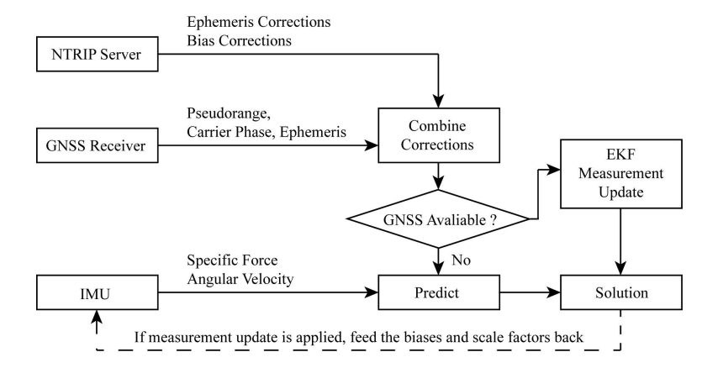

Figure 1. Description of the real-time multi-GNSS PPP/IMU tight integration algorithm

The time span of this test is about 1 hour. The UAV was firstly put on the ground waiting for PPP convergence, and then it took off at the 46-th min of test time, and landed at the 53-rd min. The trajectory is shown in figure 2. The speed limitation of our UAV is 18 m/s and the average speed during the test is 3 m/s. The sky-plot of observable satellites is shown in figure 3, where satellites in green trajectory mean two frequencies were tracked, and the orange trajectory means only one frequency was tracked. Since our GNSS receiver does not support the acquisition of BDS GEO signal, the available satellites of BDS system are not so abundant.

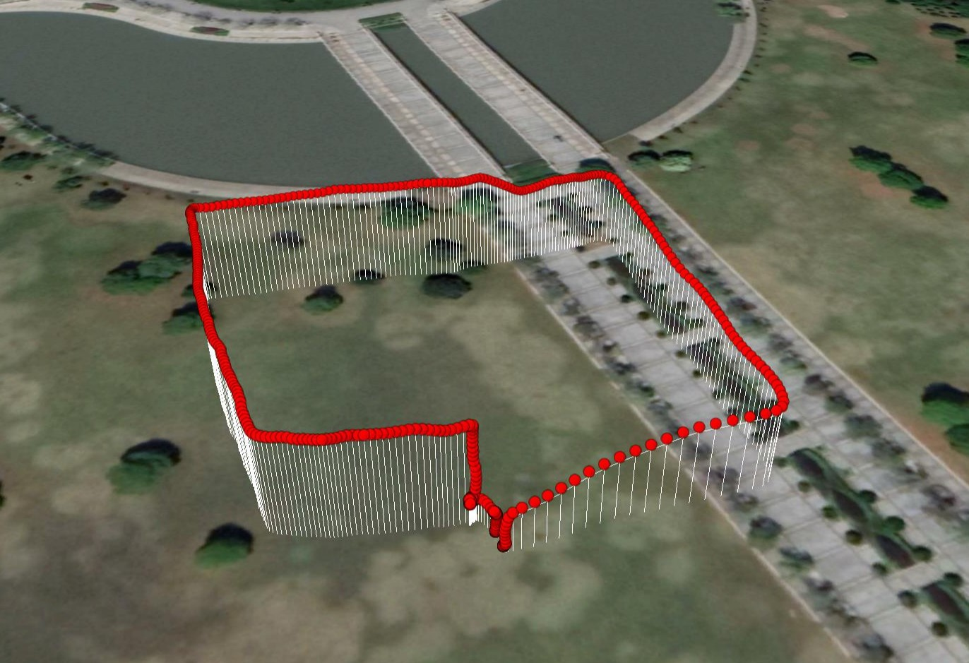

Figure 2. UAV trajectory during the test

In data processing, GNSS data are selected as three groups: BDS, GPS+BDS, GPS+BDS+GLONASS+Galileo. For real-time PPP, BKG NTRIP Client (BNC) software is used to collect correction data from the internet. We also modified the source of BNC to apply 4-constellation GNSS PPP and IMU tight integration. Precise stream from CNES (CLK93) is utilized for precise ephemeris correction. Satellites with elevation angle less than ${10}^{∘}$ were deleted to ensure high measurement quality. Satellite PCVs were corrected using IGS antenna file (igs14.atx). ZTD of tropospheric delay was estimated and other errors were corrected with corresponding precise models. For IMU processing, the biases and scale factors were estimated and corrected when GNSS data is available.

#### Open-Sky Performance

To compare PPP performance in terms of single constellation and multi-constellation GNSS, we applied different data processing with the same data set. Note that the on-board real-time processing was set as 4-constellation GNSS PPP/IMU combination mode, and all other modes were processed off-board. The available satellites during this process and the corresponding PDOP (Position Dilution of Precision) is shown in figure 4.

The three GNSS modes and three GNSS/IMU integration modes of data processing were conducted using the same settings. The performance comparison in NEU (North-East-Up) frame is shown in figure 5 and the corresponding RMS value is shown in table 1. Since PPP needs tens of minutes to achieve its convergence and only the performance of flight period is what we mainly focus on, we just take the time range from 46 min to 53 min for calculating bias and RMS. The biases of the three direction errors are subtracted to make the plot clearer. Since PPP bias is related to the quality of precise orbit and clock which is beyond the scope of this article, we do not discuss it in detail. Readers can refer to (23) for more detailed information. The relative statistics are given in figure 6.

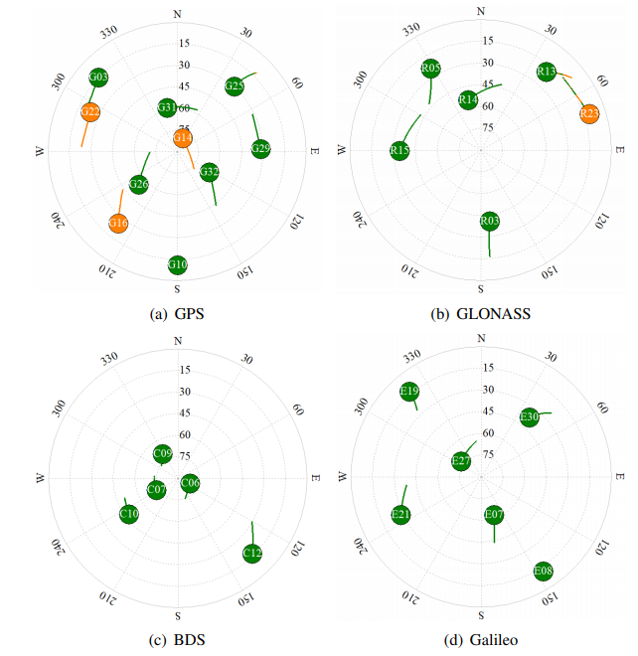

Figure 3. Sky-plot of observable satellites during the experiment. Satellites in green trajectory means two frequencies were tracked, and the orange trajectory means only one frequency was tracked.

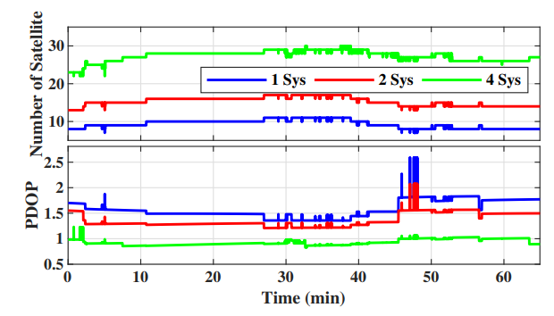

Figure 4. Number of satellites and corresponding PDOP, where 1 Sys, 2 Sys, 4 Sys refer to BDS, GPS+BDS and GPS+BDS+GLONASS+Galileo, respectively

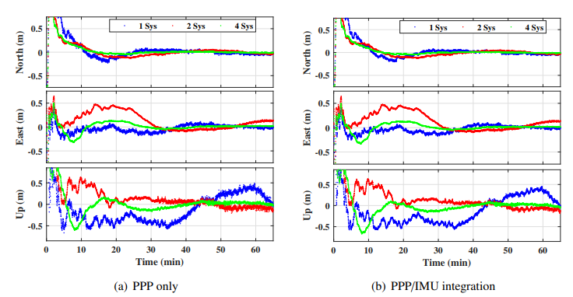

Figure 5. Positioning performance comparison of the 6 modes of data processing. The biases of the three direction errors are subtracted to make the plot clearer

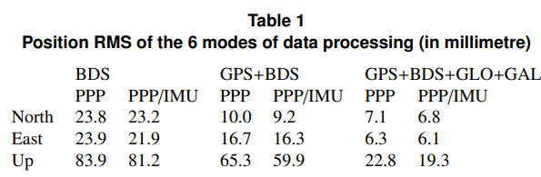

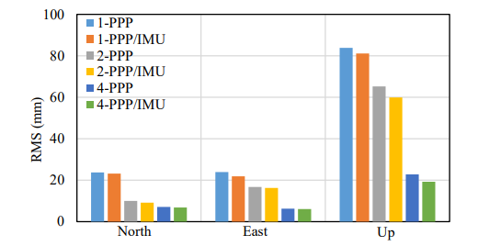

Figure 6. Positioning performance comparison of PPP and PPP/IMU tight integration

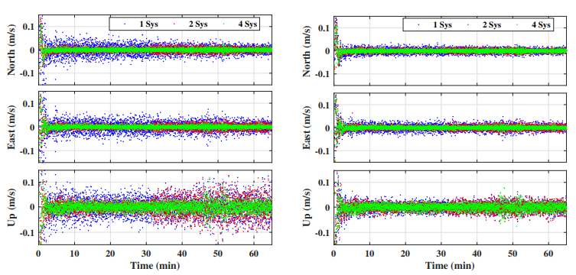

Figure 7. Velocity determination performance comparison of the 6 modes of data processing

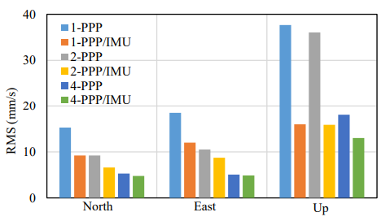

Figure 8. Velocity determination performance comparison of PPP and PPP/IMU tight integration

According to the results, real-time PPP can provide an accurate position output, with the RMS less than 0.025 m in horizontal and 0.1 m in vertical direction, after convergence. By applying 2-GNSS PPP, the RMS is reduced by 58.2%, 30.0% and 22.1% in north, east and up component respectively, with respect to single-GNSS PPP. The RMS is further reduced by 70.3%, 73.8% and 72.8% when using 4-system observation. Besides, PPP/IMU tight integration can provide a smoother position output and achieve a lower RMS. Compared to GNSS only processing, the combined system reduces the RMS by 2.7%, 8.4% and 3.1% in three directions respectively, for BDS only processing. For 2 system case, it decreases by 7.2%, 2.6% and 8.3% respectively. And for 4 system case, it is reduced by 3.9%, 3.1% and 15.3% respectively.

To evaluate the performance of vehicle velocity determination, the velocity error relative to the PPK velocity output is shown in figure 7. The corresponding RMS value is shown in table 2, and the relative statistics are given in figure 8. The results show a great improvement by applying multi-GNSS PPP and PPP/IMU tight integration. The 2-GNSS PPP reduces the RMS by 40.0%, 43.5% and 43.4% in north, east and up directions respectively, with respect to the single-GNSS PPP. The RMS is further reduced by 65.2%, 72.3% and 51.9% when using 4-system observation. Besides, by applying PPP/IMU tight integration, the RMS reduces by 40.0%, 35.2% and 57.5% in three directions respectively, for BDS only processing. For 2 system case, it decreases by 27.6%, 16.5% and 55.9% respectively. And for 4 system case, it is reduced by 9.1%, 3.8% and 28.4% respectively.

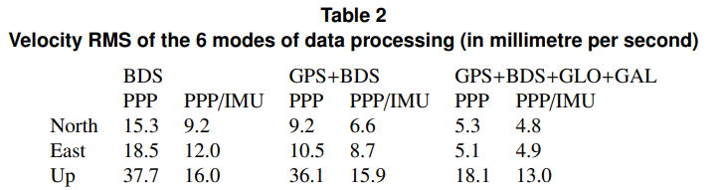

Consequently, the performance of real-time PPP can be improved significantly by applying multi-constellation GNSS systems. This is because of the improvement in satellite availability and geometric distribution. PPP/IMU tight integration can smooth the position and velocity output and supply a lower disturbance especially for kinematic vehicle motion because of the high short-term high-precision of IMU integral.

#### GNSS Outage Simulation

GNSS outage is a common scene in GNSS positioning, especially for carrier-phase based processing. Internally, it happens when GNSS receiver gets unlocked for some specific satellites, which leads to cycle-slip or phase jump. Externally, it occurs when vehicle passes through a bridge, crowded building, canyon, etc., which can cause data interrupt. Unfortunately, PPP is very vulnerable to GNSS outage. It may divergence after the outage and takes several minutes to re-converge, which could be a disaster to user.

To test system sensitivity to GNSS outage, we simulated an outage by removing all satellites for 10 seconds. The data outage began at 49 min and ended at 49.17 min. Since this test focused on the comparison between PPP only and PPP/IMU tight integration system, just the 4 system mode and its integration with IMU was utilized. The positioning result is shown in figure 9 and the velocity determination result is shown in figure 10. The corresponding RMS value is given in table 3. Note that just time range from 40 min to 65 min is plotted.

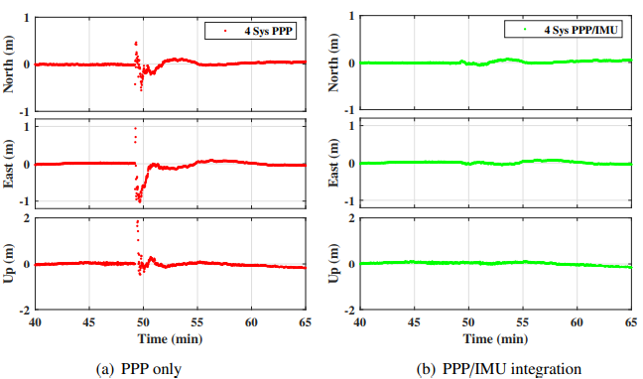

Figure 9. Positioning performance comparison of PPP and PPP/IMU positioning for outage simulation (10 s)

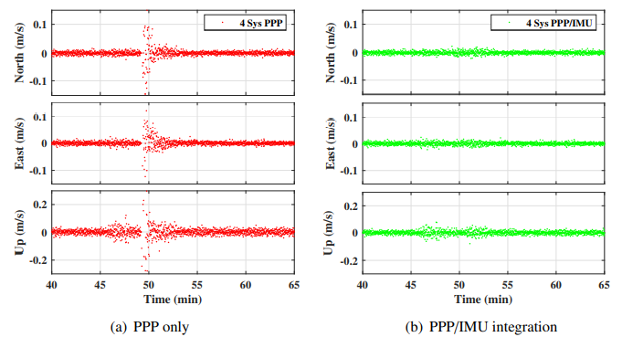

Figure 10. Velocity determination performance comparison of PPP and PPP/IMU positioning for outage simulation (10 s)

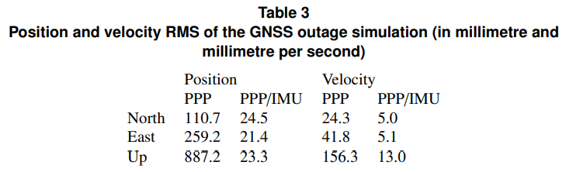

According to the results, PPP only system diverged when suffering an outage, while PPP/IMU system can keep a stable position output. RMS value of position for PPP only system is 110.7mm, 259.2mm and 887.2mm for north, east and up direction, respectively. And the PPP/IMU tight integration system reduces it to 24.5mm, 21.4mm and 23.3mm for each direction component, which indicates a 77.9%, 91.8% and 97.4% performance improvement in three directions, respectively. The RMS value of velocity is reduced from 24.3mm/s, 41.8mm/s and 156.3mm/s to 5.0mm/s, 5.1mm/s and 13.0mm/s in three directions, which indicates a 79.6%, 87.9% and 91.7% performance improvement in three directions, respectively. This is because that the position and velocity states of PPP can be estimated and kept through IMU short-term accurate position, the tropospheric delay, clock error and frequency drift can be maintained by system dynamic modelling, and only ambiguities are re-estimated after the outage.

The integration of IMU measurements leads to position and velocity drift when the period of GNSS outage goes long. To test the performance of the PPP/IMU system under a long period of GNSS outage, we further simulated 10 s - 60 s GNSS outage, with 10 s interval. The position and velocity drift respect to the outage period are shown in figure 11.

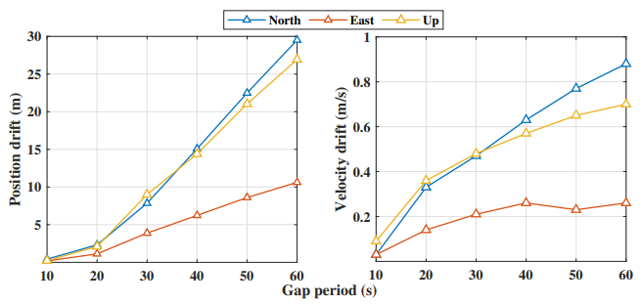

Figure 11. Position and velocity drift under different GNSS outage

According to figure 11, the position and velocity errors increase when the outage period gets longer. The solutions drift small when the outage period is short because the PPP/IMU integration provides a high resolution of IMU biases when the GNSS measurements are sufficient. The drift goes bigger because the variances of biases increase without the correction of GNSS information. Hence, users should mind the solution drift effect in city or canyon environments when GNSS is not available for a long period. From the control perspective, the speed controller and trajectory controller cannot work without accurate velocity and position feedback. So when the large drift occurs, the autopilot system of UAVs may not be reliable. But the UAV can still land safely with a stand-alone IMU because the basic flight control system can work only with the attitude feedback.

#### Insufficient GNSS Measurement Simulation

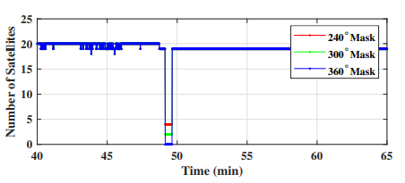

Figure 12. Number of observed satellites under different azimuth masks (30 s)

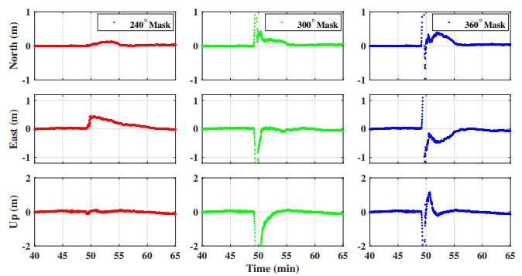

Figure 13. Positioning performance comparison of PPP/IMU positioning under different azimuth masks (30 s)

Besides of the outage, insufficient GNSS observation also happens in city and canyon environments, which makes the PPP-only system fail to provide navigation solutions. It is common that satellites are partially shadowed by tall buildings or cliffs. Hence, it is interesting to discuss the superiority of the proposed algorithm under this situation.

To test the performance of the proposed algorithm under the insufficient observation situation, we applied several azimuth masks to simulation the shadowing of satellites, including ${240}^{∘}$, ${300}^{∘}$ and ${360}^{∘}$ azimuth masks. The ${360}^{∘}$ azimuth mask equivalents to the GNSS outage. Because the position and velocity shows little drift under 10 s outage simulation in section 3.2, we simulate 30 s azimuth mask in this section to show the different performances of the simulations clearer. The masks began at 49 min and ended at 49.50 min. The number of satellites is shown in figure 12. According to section 2.1, it is not sufficient for PPP positioning during the azimuth mask period in all of the groups. The results are shown in figure 13 and 14. The corresponding RMS value is given in table 4.

According to figure 12, the number of observed satellites is 4, 2, and 0 for the ${240}^{∘}$, ${300}^{∘}$ and ${360}^{∘}$ mask, respectively. All of them are not sufficient for PPP-only positioning. According to figure 13, 14 and table 4, the position and velocity solutions drifts dramatically when the ${360}^{∘}$ mask is applied. The filter re-initialized after the 30 s mask because the position error is too large. The system performs better when the ${300}^{∘}$ mask is applied, which brings 2 observed satellites. Though the 2 satellites cannot be used in a common PPP filter, it helps to shrink the drift rate of position and velocity solutions in the proposed PPP/IMU system. It reduces the RMS of position by 41.9%, 5.6% and 22.1% in three directions respectively and reduces the RMS of velocity by 56.7%, 63.5% and 44.1% respectively. For the ${240}^{∘}$ mask case, when the number of satellites rises to 4, the drift rate of solutions is further reduced, which is 93.2%, 61.2% and 93.9% for the position and 97.1%, 90.2% and 86.1% for the velocity respectively.

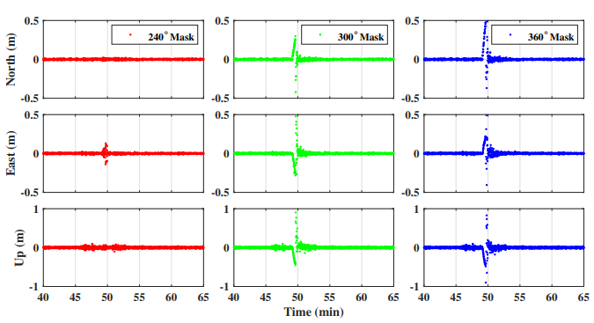

Figure 14. Velocity performance comparison of PPP/IMU positioning under different azimuth masks (30 s)

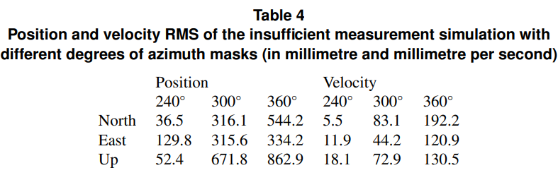

#### Computational Load

Computational time is an important specification of the embedded real-time system. To show the computation time of the proposed PPP/IMU integration system, we tested the 1, 2 and 4 system PPP/IMU integration in raspberry pi 3B platform. Results are shown in figure 15.

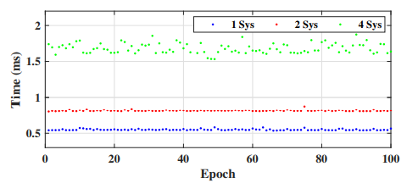

Figure 15. Computation time of the proposed PPP/IMU integration algorithm

According to figure 15, the computational time is stable over time steps. The average time of computation is 0.55 ms, 0.80 ms and 1.72 ms for 1 system, 2 system, and 4 system PPP/IMU integration, respectively. It indicates that the computational load is highly related to the number of observed satellites. Since the number of satellites influences the precision and convergence speed of the system, there is a trade-off between computational period and precision and convergence period. Users are free to decide the priority.

## Conclusion

This paper introduced a real-time PPP/IMU tight integration algorithm using multiple GNSS constellations. Models of real-time multi-GNSS PPP, IMU, and their integration were introduced in detail, and experiments were carried out using a 4 system GNSS receiver and a consumer grade MEMS IMU, through a UAV and an on-board chip. Results show that positioning performance can be improved significantly by applying both 4 system GNSS measurements and IMU data. The position RMS reduced from 23.8, 23.9 and 83.9 mm to 7.1, 6.3 and 22.8mm, with an improvement of 70.3%, 73.8% and 72.8%, in north, east and up component respectively when applying GPS+BDS+GLONASS+Gallileo PPP, compared with BDS only PPP. The RMS was further reduced to 6.8, 6.1 and 19.3 mm, with an improvement of 71.4%, 74.5% and 77.0% in the three directions respectively by using 4-constellation GNSS PPP/IMU tight integration. A 10s GNSS outage was simulated during flight. Results show that the PPP only processing diverged when passing a data outage, and took several minutes for re-convergence. By contrast, the tightly coupled system could overcome the outage and provide a continuous position output. The RMS decreased from 110.7, 259.2 and 887.2mm to 24.5, 21.4 and 23.3mm, with an improvement of 77.9%, 91.8% and 97.4% in the three components respectively in this case. To further investigate the solutions drift under longer period GNSS outage, we simulated 10 - 60 s outages with 10 s interval. Results show that both the velocity and the position error drift over the outage period. The position error keeps under 2.5 m and the velocity error keeps under 0.4 m/s when the outage period is less than 20 s. Moreover, the insufficient GNSS measurement was simulated by applying azimuth masks and it shows that the observed satellites can shrink the rate of solutions drift. Finally, a computational load test illustrates that the 4-constellation GNSS PPP/IMU integration takes 1.72 ms per circle on average on the raspberry pi 3B platform. The computational time could be shorter if fewer GNSS systems are used. Users are free to decide the trade-off between computational time and precision and convergence period.

Consequently, the real-time 4-constellation GNSS PPP and consumer grade MEMS IMU tight integration system can supply an accurate, robust and continuous navigation solution for multiple UAV applications under both open-sky and short-term GNSS challenged environments.

**ACKNOWLEDGEMENTS**

This work was supported by the Shanghai Jiao Tong University (SJTU) Global Strategic Partnership Fund (2019 SJTU - University of Toronto) and the National Science Foundation of China (N0. 61403253). The authors would like to thank IGS centers for providing the precise GNSS correction streams and BKG center for providing open-source BNC software.

**REFERENCES**

1. D. Odijk, S. Verhagen and P.J.G. Teunissen Medium-Distance GPS Ambiguity Resolution with Controlled Failure Rate. In Geodesy for Planet Earth, Berlin/Heidelberg, Germany, 2012; Volume 136, pp. 745 - 751.

2. S Gezici, Z Tian, GB Giannakis et al.. Localization via ultra-wideband radios: a look at positioning aspects for future sensor networks, IEEE Signal Processing Magazine, 2005, vol. 22, no. 4, pp. 70-84.

3. J. Delmerico and D. Scaramuzza. A benchmark comparison of monocular visual-inertial odometry algorithms for flying robots, 2018 IEEE International Conference on Robotics and Automation (ICRA), Brisbane, QLD, 2018, pp. 2502-2509.

4. J. F. Zumberge, M. B. Heflin, D. C. Jefferson, M. M. Watkins and F. H. Webb. Precise point positioning for the efficient and robust analysis of GPS data from large networks, Journal of Geophysical Research, March 1997, vol. 102, no. B3, pp. 5005-5017.

5. J. Kouba and P. J. G. S. Heroux ´ . Precise Point Positioning Using IGS Orbit and Clock Products, GPS Solutions, October 2001, vol. 5, no. 2, pp. 12-28.

6. Z. Gao, Y. Li, Y. Zhuang, H. Yang, Y. Pan, and H. Zhang. Robust Kalman Filter Aided GEO/IGSO/GPS Raw-PPP/INS Tight Integration, Sensors, 2019, vol. 19, no. 2, p. 417.

7. D. Laurichesse, and F. J. E. G. A. Mercier. Real-time PPP with undifferenced integer ambiguity resolution, experimental results, the 23nd International Technical Meeting of Satellite Division of the Institute of Navigation (ION GNSS 2010), 2010, vol. 7672, no. 6, p. 8801.

8. G. W. Mark Caissy, Loukis Agrotis, Gerhard Wubbena and Manuel HernandezPajares. The IGS Real-time Pilot Project – The Development of Real-time IGS Correction Products for Precise Point Positioning, presented at the Presentations of the EGU11 Vienna, Austria, April 6, 2011.

9. P. T. Y. Mireault, F. Lahaye, P. Collins, M. Caissy, and NrCan. Real-Time and Near Real-Time GPS Products and Services from Canada, presented at the IGS Analysis Center Workshop 2008, Miami Beach, lorida, USA, June 2-6, 2008.

10. M. Elsobeiey, and S. J. G. S. Al-Harbi. Performance of real-time Precise Point Positioning using IGS real-time service, GPS Solutions, 2016, vol. 20, no. 3, pp. 565-571.

11. L. Wang, Z. Li, M. Ge, F. Neitzel, X. Wang, and H. J. G. S. Yuan. Investigation of the performance of real-time BDS-only precise point positioning using the IGS real-time service, GPS Solutions, May 2019, vol. 23, no. 3, p. 66.

12. S. EH. Estimation techniques for low-cost inertial navigation, presented at the Report of Geomatics Engineering, University of Calgary, 2005.

13. M. A. Rabbou, and A. J. G. S. El-Rabbany. Tightly coupled integration of GPS precise point positioning and MEMS-based inertial systems, GPS Solutions, 2014, vol. 19, no. 4, pp. 601-609.

14. Z. Gao, M. Ge, Y. Li, Y. Pan, Q. Chen, and H. Zhang. Modeling of multi-sensor tightly aided BDS triple-frequency precise point positioning and initial assessments, Information Fusion, March 2020, Volume 55, pp. 184-198.

15. Y. Zhang, and Y. J. J. o. N. Gao. Integration of INS and Un-Differenced GPS Measurements for Precise Position and Attitude Determination, The Journal of Navigation, 2008, vol. 61, no. 1, pp. 87-97.

16. S. B. Shin E H. Inertially aided precise point positioning, the 22nd International Technical Meeting of Satellite Division of the Institute of Navigation (ION GNSS 2009), 2009, vol. 2001: 1892-1897.

17. M. H. Roesler G. Tightly coupled processing of precise point position (PPP) and INS data, Proceedings of ION GPS/GNSS 2009, Institute of Navigation, Savannah, GA, USA, 2009, pp. 1898–1905.

18. Z. Gao, et al. Tightly coupled integration of multi-GNSS PPP and MEMS inertial measurement unit data, GPS Solutions, 2017, vol. 21, no. 2, pp. 377-391.

19. A. E. Niell. Global mapping functions for the atmosphere delay, Journal of Geophysical Research, 1996, vol. 101, no. B2, pp. 3227-3246.

20. B. Liu, X. Zhan, M. Liu, and J. Liu. GNSS/INS Semi-deep Integration with Federated Filtering for High Dynamic Vehicle, Journal of Aeronautics, Astronautics and Aviation, 2018, vol. 50, pp. 223 - 235.

21. P. D. Groves. Principles of GNSS, Inertial, and Multisensor Integrated Navigation Systems – Second Edition, Artech House, 2013, 776 pp ISBN-13: 978-1-60807-005-3. 22. G. B. Robert and Patrick Y. C. Hwang. Introduction to random signals and applied kalman filtering (second edition), John Wiley, New York, 1992, 512 p.p., ISBN 0–47152–573–1.

23. K. S. Kamil Kazmierski and T. Hadas. Quality assessment of multi-GNSS orbits and clocks for real-time precise point positioning, GPS Solutions, 2017, vol. 22, no.1, pp. 11.

24. Z. Gao, et al. Evaluation on the impact of IMU grades on BDS + GPS PPP/INS tightly coupled integration, Advances in Space Research, 2017, vol. 60, no.6, pp. 1283 - 1299.