Appendix

Fungi

Table S1. Origin of the fungal strains used in this study.
Fungus | Origin
Fomes fomentarius | Isolated from a fruiting body found in Hamburg, Germany, by the Professorship of Fungal Biotechnology in Wood Science (Technical University of Munich); stock number 228
Ganoderma sessile | Isolated from a fruiting body from Louisville, USA; gifted by the Technical University of Dresden (stock number: 0688)
Pycnoporus sanguineus | Strain DSM 6762
Stereum hirsutum | Isolated from a fruiting body found in Freising, Germany, by the Professorship of Fungal Biotechnology in Wood Science (Technical University of Munich); stock number 214
Trametes pubescens | Strain CBS 696.94
Trametes versicolor | Isolated from a fruiting body found in Freising, Germany, by the Professorship of Fungal Biotechnology in Wood Science (Technical University of Munich); stock number 166

Media composition

Table S2. Composition of the media used.
Medium | Content
PDA | 40 g potato dextrose agar (Carl Roth GmbH + Co. KG, Karlsruhe, Germany) + 10 g agar-agar (Carl Roth GmbH + Co. KG, Karlsruhe, Germany) in 1 l of demineralized water
PDY | 24 g potato extract glucose broth (Carl Roth GmbH + Co. KG, Karlsruhe, Germany) + 5 g yeast extract (Carl Roth GmbH + Co. KG, Karlsruhe, Germany or Sigma Aldrich, St. Louis, USA) in 1 l of demineralized water
Sawdust substrate | 400 g beech sawdust (J. Rettenmaier & Söhne GmbH + Co KG, Rosenberg, Germany) + 100 g rye grains (Heinrichs Agrar GbR, Ingelheim, Germany) pulverized with a kitchen blender (MMB6172SN, Bosch, Gerlingen-Schillerhöhe, Germany) + 500 ml demineralized water

Mycelium density on PDA and sawdust

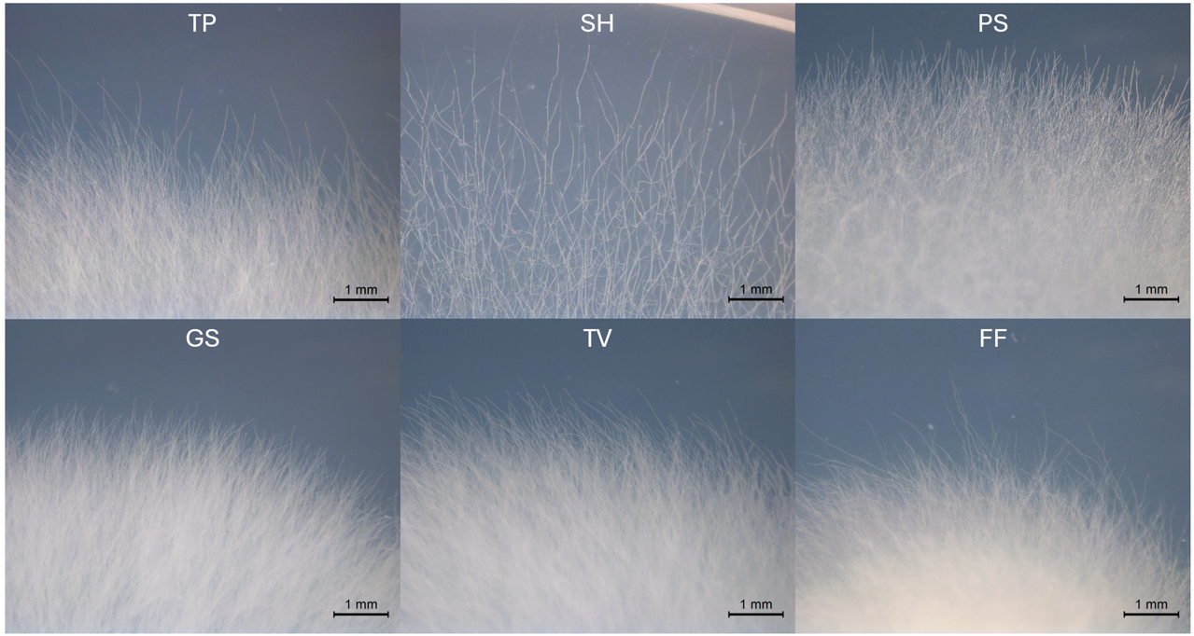
Figure S1. Microscope images of the mycelium growth fronts after 3 days on PDA. The mycelium of SH has a clearly lower density.

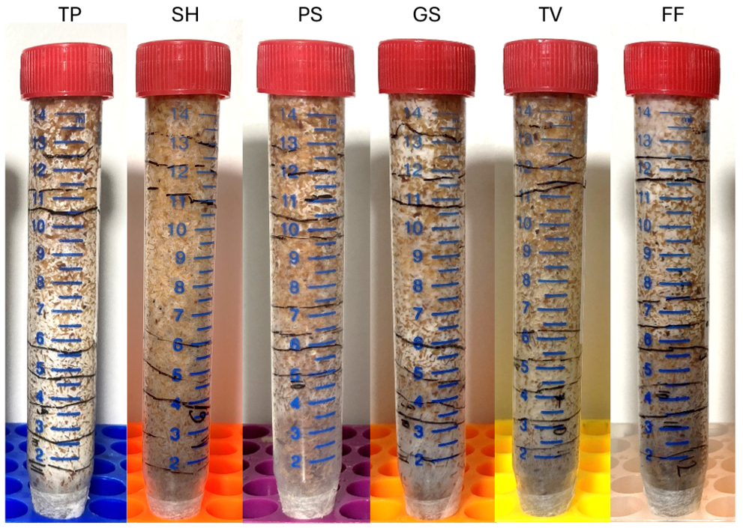
Figure S2. Representative pictures of the tubes for the determination of hyphal extension taken after 14 d. Besides the difference in extension rate, the mycelium density also varies depending on the fungal species, with TP showing the most dense surface colonization and SH being the least dense.

Composite density

Table S3. Density of all composites, where “λ” denotes the larger specimens used for thermal conductivity measurement.
Composite | Density in kg/m³
SH1F | 270 ± 8
SH4F | 273 ± 5
TV1Fλ | 248 ± 7
TV1Cλ | 294 ± 9
TV4Fλ | 218 ± 3
TV1C | 269 ± 5
TV4C | 254 ± 4
TV1F | 249 ± 7
TV2F_BB | 228 ± 4
TV2F_BT | 225 ± 5
TV2F_TT | 227 ± 4
TV4F | 232 ± 2
TV1FR | 260 ± 4
TV4FR | 246 ± 3

