Table S1. Rumen amplicon sequences in 121 lambs
Item | BM | Clean amplicons | ZOTU
Mean | 41.0±3.80 | 47905±10491 | 6470
Max | 48.0 | 67812 | -
Min | 35.1 | 18021 | -

Table S2. Rumen metagenomic sequences in the rumen of lambs with low (LLDH) and high (HLDH) ldh gene abundance (mean±SE, n = 6)
Item | LLDH | HLDH | P-value
Total short sequences
Mean | 50,913,323±6,870,447 | 35,048,383±275,364 | 0.055
Max | 83,147,122 | 41,938,644 | -
Min | 26,328,568 | 37,117,202 | -
Short sequences labeled as SSU
Mean | 148,175±20,513 | 105,375±6,373 | 0.09
Max | 241,654 | 124,882 | -
Min | 91,853 | 78,068 | -
Short sequences mapped in microbial genes
Mean | 48,193,258±6,427,080 | 32,530,278±2,382,242 | 0.06
Max | 78,368,612 | 39,211,045
Min | 35,525,807 | 24,153,563

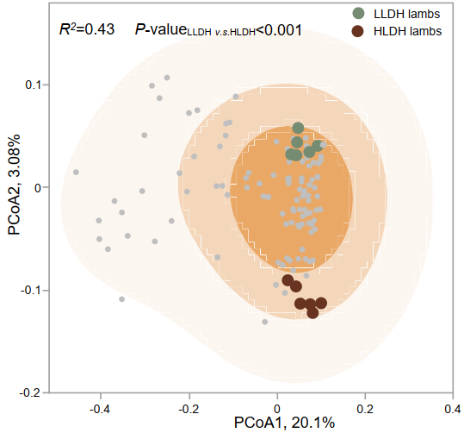
Fig. S1. Principal coordinate analysis of similarity of bacterial community among 121 lambs based on Bray-Curtis dissimilarity matrix at ZOTU level. The color of the background shadow represents the density of the scatter points in that area, with darker colors indicating higher point density. We highlighted the selected lambs with low (LLDH) and high (HLDH) ldh abundance in the rumen with different colors for clarity.

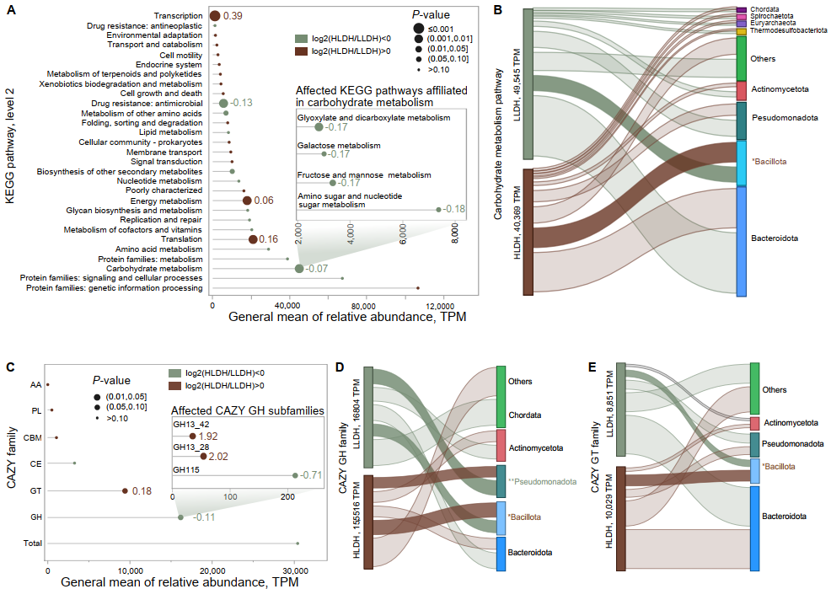
Fig. S2. Microbial KEGG pathways and CAZY family in the rumen of LLDH and HLDH lambs. A, comparison of the KEGG pathway of rumen microbes between LLDH and HLDH lambs. The figure displays the level 3 pathways that belong to carbohydrate metabolism pathway and had inter-group differences. The number after the bubble is the log2(HLDH/LLDH). B, Sankey diagram showing the top ten contributors to carbohydrate metabolism pathway. The left column represents the relative abundance of carbohydrate metabolism pathways, while the right column represents the relative abundance of contributors at phylum level. Contributors with intergroup differences in contribution have their names prefixed with a symbol, and the color of contributor names represents the group with higher contribution. #, 0.05 < P ≤ 0.10; *, 0.01 < P ≤ 0.05; **, 0.001 < P ≤ 0.01. C, comparison of the CAZY family of rumen microbes between LLDH lamb and the HLDH lamb. The figure shows the GH subfamilies that have inter-group differences. D & E, Sankey diagrams showing top five contributors to the GH family and GT family, respectively.

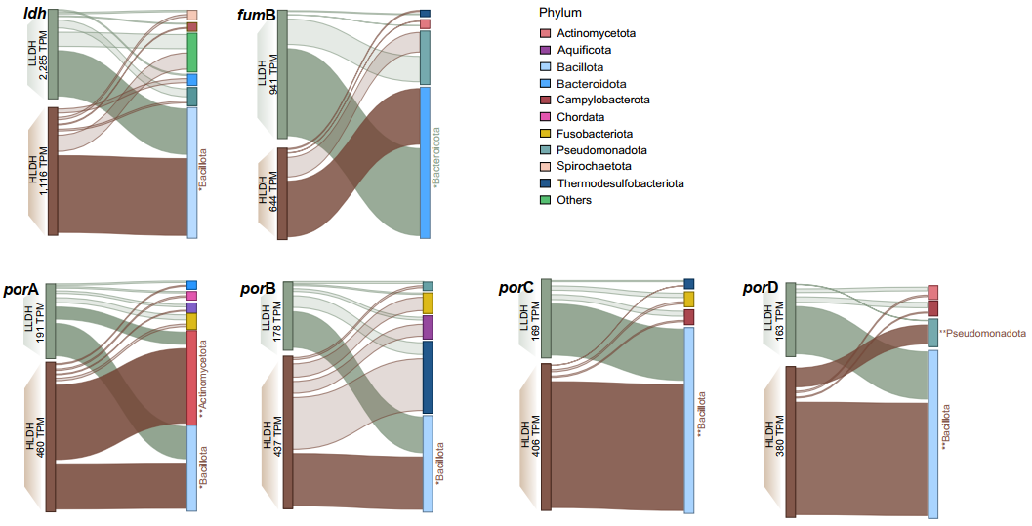
Fig. S3. Sankey diagram showing the contributors to affected key genes involving production of lactate, acetate, and propionate in the rumen. The left column represents the relative abundance of genes, while the right column represents the relative abundance of contributors at phylum level. Contributors with intergroup differences in contribution have their names prefixed with a symbol, and the color of contributor names represents the group with higher contribution. *, 0.01 < P ≤ 0.05; **, 0.001 < P ≤ 0.01.

