Supplementary information for

Gastrointestinal metabolite profiling in Bacillus-supplemented broiler chickens using NMR metabolomics
Charlie Tran¹, Darwin Horyanto^{2,3}, Luke Husdell^{1,4}, Dragana Stanley², Horst J. Schirra^{1,4,5}, Ian E. Cock⁵, Xiaojing Chen³, Yunjiang Feng^{1,5}*
¹Institute of Biomedicines and Glycomics (IBG), Griffith University, Nathan, QLD 4111, Australia
²Institute for Future Farming Systems, Central Queensland University, Rockhampton, QLD 4702, Australia
³Bioproton Pty Ltd., Acacia Ridge, QLD 4110, Australia.
⁴Centre for Advanced Imaging, The University of Queensland, Brisbane, QLD, 4072, Australia
⁵School of Environment and Science, Griffith University, Brisbane, QLD, 4111, Australia.

* Corresponding Author: Yunjiang Feng (Y.F.), y.feng@griffith.edu.au

List of supporting information:

Material and methods………………………………………………………………………..2
Table S1. Performance data of F1 fed broiler chickens over 28 days compared to control 6
Table S2. Extraction solvents, mass of the extracts and number of peaks in ¹H NMR spectra 7
Table S3. Resonance Assignments of Key metabolites from ¹H and C₁₃ spectrum 8
Figure S1. Stacked ¹H NMR spectra of extracts using different solvent combinations. 9

Materials and methods

Bacillus formulation F1
Three Bacillus strains, BPR-11, BPR-16, and BPR-17, were obtained from Bioproton (Acacia Ridge, Australia). Stock cultures of the Bacillus strains were stored at -80°C in tryptone soy broth (Thermofisher Scientific, Australia) mixed with 25% glycerol. Working cultures were maintained on tryptone soy agar plates at 4°C and prepared fresh as needed. The Bacillus formulation F1 mixes equal colony forming units (CFU) of BPR-11, BPR-16 and BPR-17 with the wheat-soybean basal diet. The CFU were determined using a colony counter.

Animal trial
The feeding experiment was conducted at the Central Queensland Innovation and Research Precinct (CQIRP) in Rockhampton, Australia, with approval from the Animal Ethics Committee (approval number: 0000023123). Twenty ROSS 308 broilers were hatched from eggs purchased from a commercial hatchery and randomly distributed into two groups of ten chickens each. Incubation took place in Brinsea Ova-Easy 380 incubators, monitored 24 hours a day and 7 days a week. The incubation settings were maintained at 37.5°C and 55% relative humidity (RH) until day 18 and subsequently adjusted to 37.5°C and 65% RH from day 18-21.

Following hatching, the chicks were provided with a basal medication-free wheat-soybean diet (Lacke Mills, Daeyton, South Australia) without inactive carrier for 28 days. The control group received the basal diet alone while the treatment group received the basal diet supplemented with F1. Each chicken was raised in floor pens with unrestricted access to their respective diets and water. The initial temperature was set at 32°C and decreased by 2°C weekly, ending at 22°C on day 28, while maintaining 40-50% relative humidity.

Several performance indicators, including body weight (BW), average daily gain (ADG), average daily food intake (ADFI) and food conversion rate (FCR) were monitored every 7 days to ensure the reliability of this trial, in accordance with the ROSS 308 Management Handbook guidelines. After 28 days, the animals were humanely euthanized using CO₂, and evisceration was performed to extract the cecal samples. These samples were collected, placed into 2 ml tubes, and subsequently stored at -80°C to quench their metabolism until further extraction.

Cecal metabolite extraction
The frozen cecal samples obtained from the trial were thawed at 4°C. To optimize extraction, a small sample (5 mg) of cecal content was weighed into a 2 ml centrifuge tube. Then, 1 ml of different solvent mixtures was added to determine the optimal extraction conditions. The solvent conditions were listed in Table S2. The samples were vortexed for 5 minutes and centrifuged at 2,000 × g for 30 min at 4°C. A 400 µl aliquot of the supernatant was transferred into clean tubes and lyophilized using a freeze-dryer to remove the solvent completely.

NMR spectroscopy
For NMR analysis, the dried residues were reconstituted in a solution containing 200 µL ultrapure water, 25 µL of potassium phosphate buffer (1.5 M, pH 7.44), D₂O, and 3.2 mM of DSS as an external reference compound, with the total volume brought to 250 µl. A 200 µL aliquot of this mixture was then transferred into a 3 mm NMR tube for spectral acquisition.

NMR spectra were recorded on a Bruker AVIIIHD spectrometer operating at a 1H frequency of 800.24 MHz and equipped with a TCI cryoprobe, and a SampleJet sample changer. To ensure a comprehensive metabolic profile, 10 samples from each treatment group were analyzed. For each sample a 1D NOESY spectrum was acquired at 298 K with the noesygppr1d pulse sequence [(RD) – 90° – t1 – 90° – τm – 90° – acq] (Bruker Biospin pulse program library). The transmitter frequency was set to the frequency of the water signal, and water suppression was achieved by continuous wave irradiation during both the relaxation delay of 4.0 s and the NOESY mixing time (τm) of 10 ms. After 4 dummy scans, 128 transients were collected into 32,768 data points using a spectral width of 30 ppm.

To provide an overview of spectral differences between the control and F1-supplemented groups, pooled quality control (PQC) samples were prepared by combining equal aliquots (50 µl) from each treatment group and recording 1D NOESY spectra as described. Visual assessment of the PQC spectra revealed notable differences in the F1-supplemented group within the δ_{H} 0.88-3.50 ppm region, indicating increased levels of certain metabolites in response to F1 supplementation. This region typically contains signals from aliphatic compounds, including amino acids, organic acids, and short-chain fatty acids.

To confirm metabolite identities, 2D NMR experiments (¹³C HSQC-TOCSY, and ¹³C HMBC) were conducted. In all 2D spectra, the ¹H carrier frequency was positioned on the water resonance. The HSQC-TOCSY spectra used spectral widths of 13.02 ppm in ¹H dimension, and a total of 2048 increments with 128 transients were recorded into 4,096 data points in the direct dimension. A relaxation delay of 1.5 s, and HSQC-TOCSY mixing time of 80 ms were used.

The HSQC experiment was performed with spectral widths of 13.02 ppm in the ¹H dimension and 165 ppm in the ¹³C dimension, and the ¹³C carrier frequency was set at 75 ppm, respectively. A total of 2048 increments with 64 transients were recorded into 4,096 data points in the direct dimension, and a relaxation delay of 1.5 s was used. GARP decoupling of the ¹³C channel was used during the acquisition time. The spectra were multiplied by a squared sine bell window function shifted by π/2 along the direct and indirect dimensions before two-dimensional Fourier transformation.

The acquired 1D NOESY NMR spectra were processed using MestreNOVA software (version 14.3.2). Initial data processing included an exponential window function with line broadening of 0.30 Hz, automatic phase correction, baseline correction, and referencing to the DSS signal (d=0.00 ppm). Manual spectral alignment was performed to ensure uniformity across all spectra. The chemical shift region between d_{H} 4.68–5.00 ppm was excluded to eliminate residual effects from imperfect water suppression. The spectra were then normalized to the total area under the curve to account for variations in sample concentration. Subsequently, both non-normalized and normalized spectra were binned into 0.001 ppm width "buckets" from 0.3–10.0 ppm.

Multivariate statistical analysis
The bucketed and normalized NMR spectra were subjected to multivariate statistical analysis (MVA) in SIMCA v 18 (Sartorius Stedim AB, Umeå, Sweden). Data were Pareto scaled, and principal component analysis (PCA) was used to identify key metabolites that distinguish between the control and treatment groups. The R² and Q² parameters were used to assess the reliability and predictive ability of the PCA model.

Spectral features representing altered metabolite levels were identified from a bivariate 1D loadings plot of the first PC, in which loadings coefficients p were plotted against the chemical shift values of their respective variables, and the absolute values of the correlation-scaled loadings coefficients |p(corr)| were superimposed on the loadings plot as a heatmap color scale (Cloarec et al., 2005). This plot facilitated the identification of which variables influence the model significantly and reliably, which were defined as those with both |p| and |p(corr)| > 0.5.

Metabolite identification and quantification
Metabolites were identified within their respective spectra using Chenomx NMR Suite 8.3 (Chenomx Inc., Edmonton, Canada). Identifications were further verified with 2D TOCSY and HSQC spectra and cross-referenced with the Livestock Metabolome Database (LMDB, https://www.lmdb.ca/). Table S3 presents the chemical shift assignments of ¹H and ¹³C resonances, along with their multiplicities. In total, 18 metabolites were identified to Metabolomics Standard Initiative Level 2 - Putatively annotated compounds (Sumner et al., 2007). Metabolite quantification was performed by integrating peaks with minimal overlap using a custom MATLAB script on non-normalized, full-resolution spectra. The quantification was visualized using bar plots in GraphPad Prism and statistically analysed using the Mann-Whitney U-test across the set of identified metabolites. Multiple testing correction was performed with the Benjamini-Hochberg method (Benjamini & Hochberg, 1995). Metabolites showing significant differences (p < 0.05) after the multiple testing correction were considered statistically significant.

Pathway analysis
To elucidate the biological relevance of the metabolic changes induced by F1 sup-plementation, we conducted a comprehensive pathway analysis. The significantly altered metabolites were mapped to known metabolic pathways using two complementary databases: the Kyoto Encyclopedia of Genes and Genomes (KEGG) and the Small Molecule Pathway Database (SMPDB) (Frolkis et al., 2010; Kanehisa et al., 2025). Both the metabolic pathways of Bacillus subtilis 168 and Gallus gallus were considered in the analysis. Pathway enrichment analysis was performed using MetaboAnalyst 5.0, with a hypergeometric test for overrepresentation analysis and relative-betweenness centrality for pathway topology analysis. Pathways with an adjusted p-value < 0.05 and impact score > 0.1 were considered significantly altered by F1 supplementation

Table S1. Performance data of F1 fed broiler chickens over 28 days compared to control.
 | Treatment group (n = 20)
 | Control | F1 Group |  | P value
BW0 days (g) | 39.4 ± 1.17 | 39.7 ± 3.34 |  | > 0.99
BW7 days (g) | 144.3 ± 12.17 | 147.5 ± 25.42 |  | > 0.99
BW14 days (g) | 424 ± 35.08 | 452.66 ± 36.45 |  | >0.99
BW21 days (g) | 942.3 ± 81.55 | 991.89 ± 91.08 |  | 0.93
BW28 days (g) | 1654 ± 158.54 | 1710.89 ± 149.10 |  | 0.87
ADG days 0-7 (g) | 14.99 ± 1.63 | 15.41 ± 3.62 |  | > 0.99
ADG days 7-14 (g) | 39.96 ± 3.55 | 42.63 ± 3.94 |  | >0.99
ADG days 14-21 (g) | 74.04 ± 7.06 | 77.03 ± 8.54 |  | >0.99
ADG days 21-28 (g) | 101.67 ± 12.56 | 102.71 ± 9.53 |  | >0.99
ADFI days 0-7 (g) | 98 | 99 |  | N/A
ADFI days 7-14 (g) | 321 | 311 |  | N/A
ADFI days 14-21 (g) | 651 | 632 |  | N/A
ADFI days 21-28 (g) | 1305.56 | 1107.00 |  | N/A
FCR days 0-7 (g/g) | 0.99 ± 0.42 | 0.95 ± 0.10 |  | >0.99
FCR days 7-14 (g/g) | 1.10 ± 0.08 | 1.06 ± 0.08 |  | >0.99
FCR days 14-21 (g/g) | 1.00 ± 0.10 | 1.02 ± 0.09 |  | >0.99
FCR days 21-28 (g/g) | 1.22 ± 0.10 | 1.06 ± 0.10 |  | 0.0106
Mortality (n) | 1 | 0
BW = Body Weight, recorded weekly
ADG = Average Daily Gain, calculated for every week interval
ADFI = Average Daily Feed Intake
FCR = Feed Conversion Ratio

Table S2. Extraction solvents, mass of the extracts and number of peaks in ¹H NMR spectra.

Solvents | Ratio | Mass | No. of Peaks*
ACN | - | 0.4mg | 57
ACN:MeOH | 1:1 | 0.8mg | 43
H₂O | - | 0.3mg | 68
H₂O:ACN | 1:1 | 1.0 mg | 72
MeOH | - | 0.5mg | 80
MeOH:H₂O | 1:1 | 1.4mg | 94
IPA | - | 0.3mg | 40
IPA:H₂O | 1:1 | 0.9mg | 72
EtOH | - | 0.4mg | 59
EtOH:H₂O | 1:1 | 1.2mg | 88

* Manually counted
ACN: Acetonitrile, EtOH: Ethanol, IPA: Isopropanol, MeOH: Methanol

Table S3. Resonance assignments of key metabolites from ¹H and ¹³C spectroscopic data.
ID | Metabolite | Observed resonance δ¹H [ppm] (multiplicity)/ δ¹³C [ppm)
1 | 3-hydroxyphenylacetic Acid | 7.24(t)/132.6, 6.87(d)/118.9, 6.78(d)/118.7, 3.49(s)/78.2
2 | 5-aminopentanoic acid | 3.01(d)/42.2, 2.23(t)/39.3, 1.63(m)/25.3
3 | Acetic acid | 1.91(s)/26.3
4 | Alanine | 1.47(s)/51.1
5 | Butyric acid | 2.15(t)/42.3, 1.55(d), 0.89(t)
6 | Choline + other -NMe₃ | 4.06(m)/58.6, 3.51(m), 3.19(s)/56.9
7 | D-glucose | 5.23(s)/95.1, 4.64(d)/98.8, 3.90(d)/63.7, 3.87(t)/59.9, 3.72(m) 3.48(s)/78.2, 3.41(d)/71.6, 3.23(s)
8 | Formate | 8.45(s)
9 | Hypoxanthine | 8.20(s), 8.18 (s)
10 | Lactate | 1.31(d)/23.1
11 | Methanol | 3.35(s)/51.3
12 | Methylamine | 2.60(s)/27.4
13 | Nicotinate | 8.93(s)/151.6, 8.60(d)/153.7, 8.25(d)/140.1, 7.52(t)/126.6
14 | Propionic acid | 2.18 (t), 1.05(t)/20.7
15 | Succinate | 2.40(s)/36.8
16 | Taurine | 3.42(s)/38.2
17 | Uridine | 5.90(s)/102.3
18 | Uracil | 7.53 (d), 5.79/103.7

Figure S1. Stacked ¹H NMR spectra of extracts using different solvent combinations.

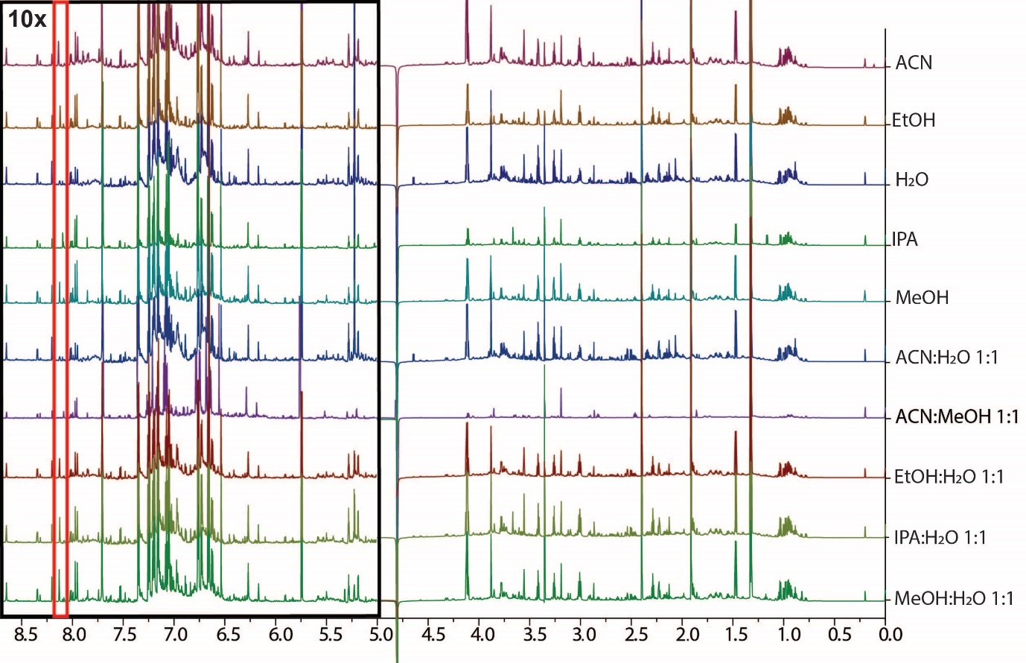
The water region from δ_{H} 4.68-5.00 was excluded to eliminate the interference from residual water signals. Black box indicates spectral regions with 10-fold increased intensity. The red box illustrates peak differences in 10 tested solvents.

