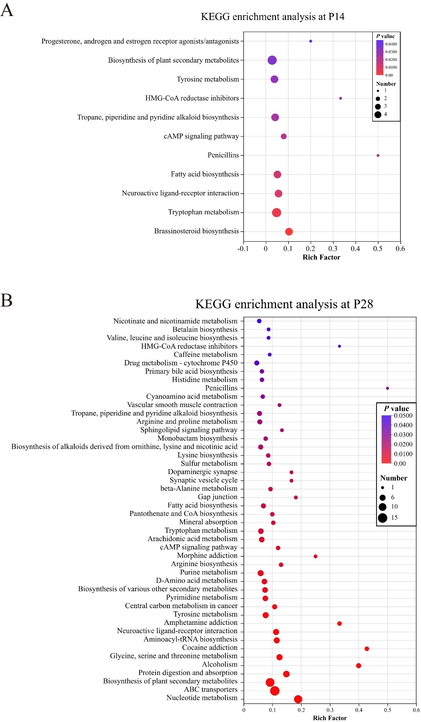
Supplementary figure 1: (A-B) KEGG pathway enrichment analysis for the different fecal metabolites at P14 (A) and P28 (B). Differential metabolites were defined as those with P < 0.05, VIP (from OPLS-DA) > 1, and |FC| > 1. Ctrl P14, n = 14; SB-SeY-SIF P14, n = 14; Ctrl P28, n = 14; SB-SeY-SIF P28, n = 12. Kyoto Encyclopedia of Genes and Genomes; Ctrl, control group; SB-SeY-SIF, sodium butyrate-selenium yeast-soy isoflavones treatment group; P14, pregnancy day 14; P28, pregnancy day 28.
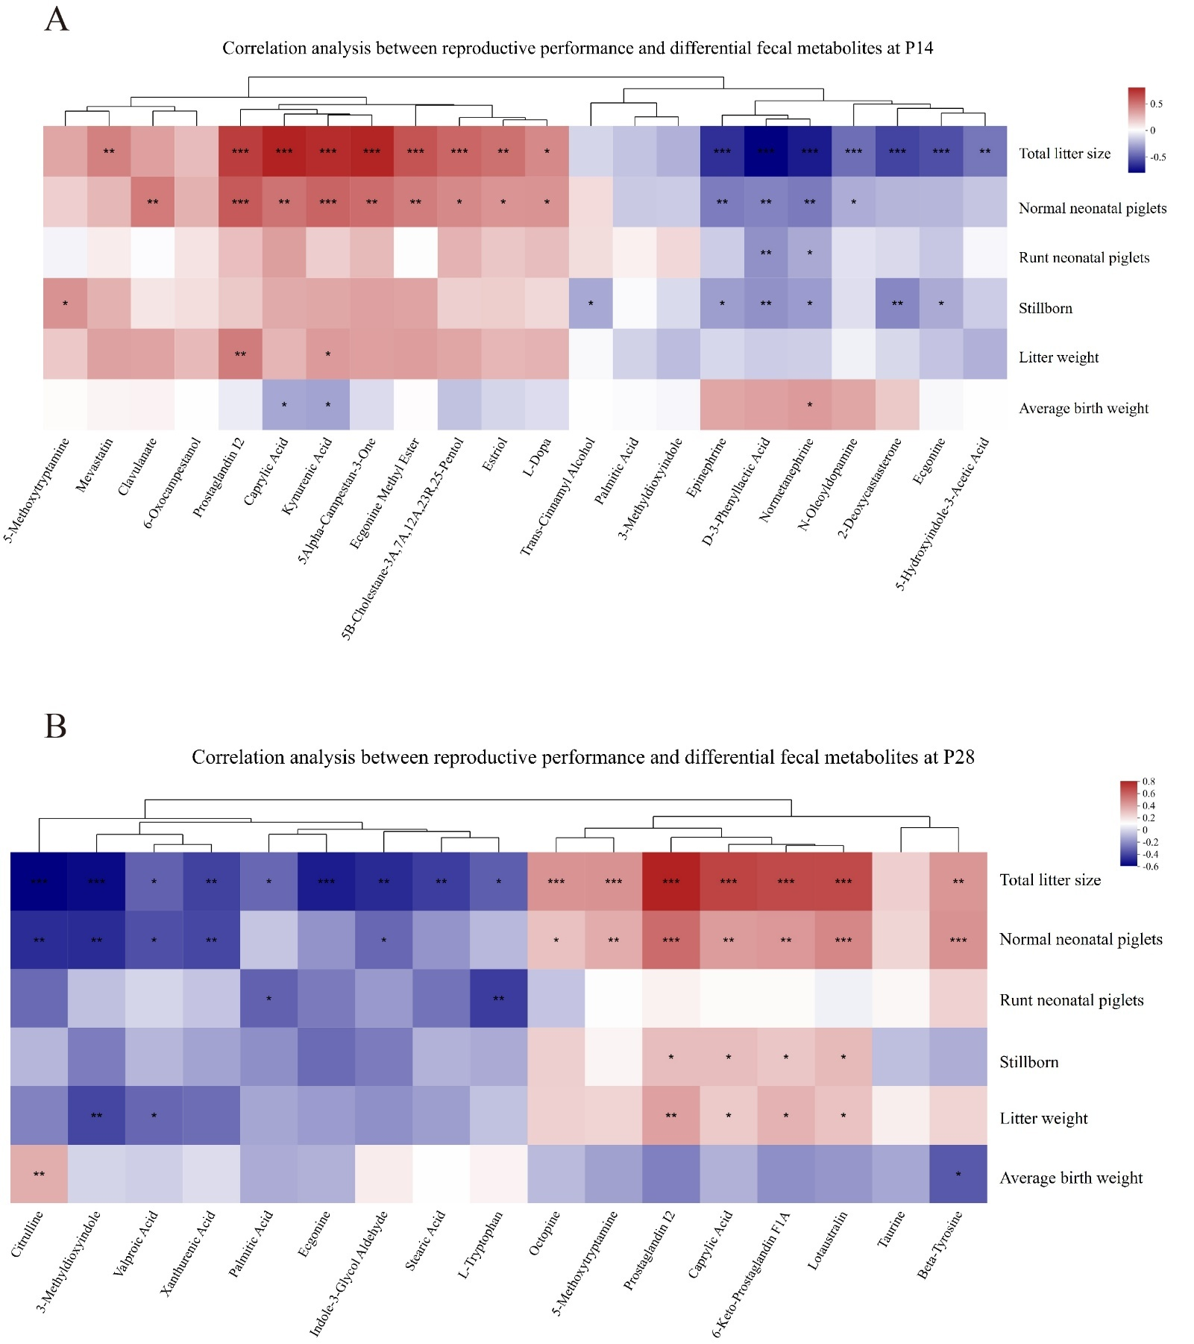

Supplementary figure 2: (A–B) Heatmap of Spearman correlation between sow litter performance and KEGG-annotated differential fecal metabolites at P14 (A) and P28 (B). Colors indicate the strength and direction of the correlations: red denotes positive correlations, while blue denotes negative correlations. *P < 0.05, **P < 0.01, and ***P < 0.001. Ctrl, control group; SB-SeY-SIF, sodium butyrate-selenium yeast-soy isoflavones treatment group; P14, pregnancy day 14; P28, pregnancy day 28.

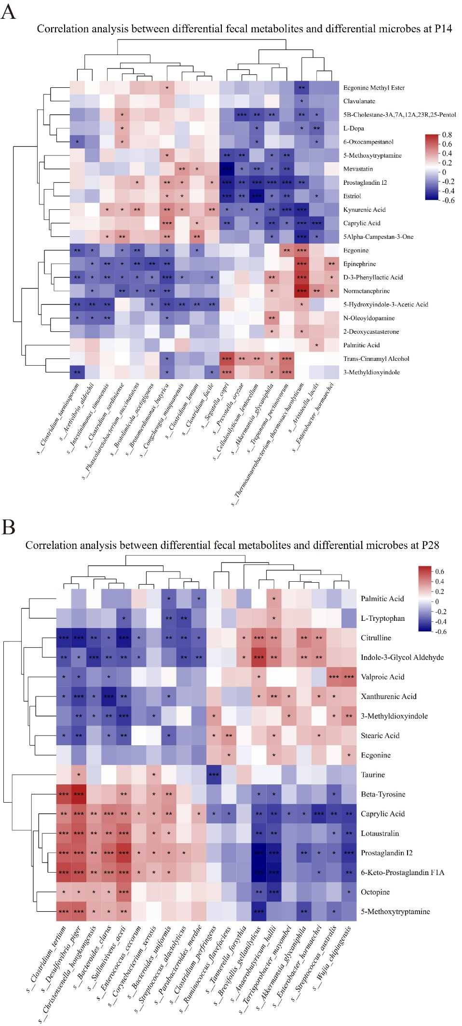
Supplementary figure 3: (A–B) Heatmap of Spearman correlation between differential microbial species and differential fecal metabolites at P14 (A) and P28 (B). Colors indicate the strength and direction of the correlations: red denotes positive correlations, while blue denotes negative correlations. *P < 0.05, **P < 0.01, and ***P < 0.001. Ctrl, control group; SB-SeY-SIF, sodium butyrate-selenium yeast-soy isoflavones treatment group; P14, pregnancy day 14; P28, pregnancy day 28.

