**Supplementary Figure**

**Supplementary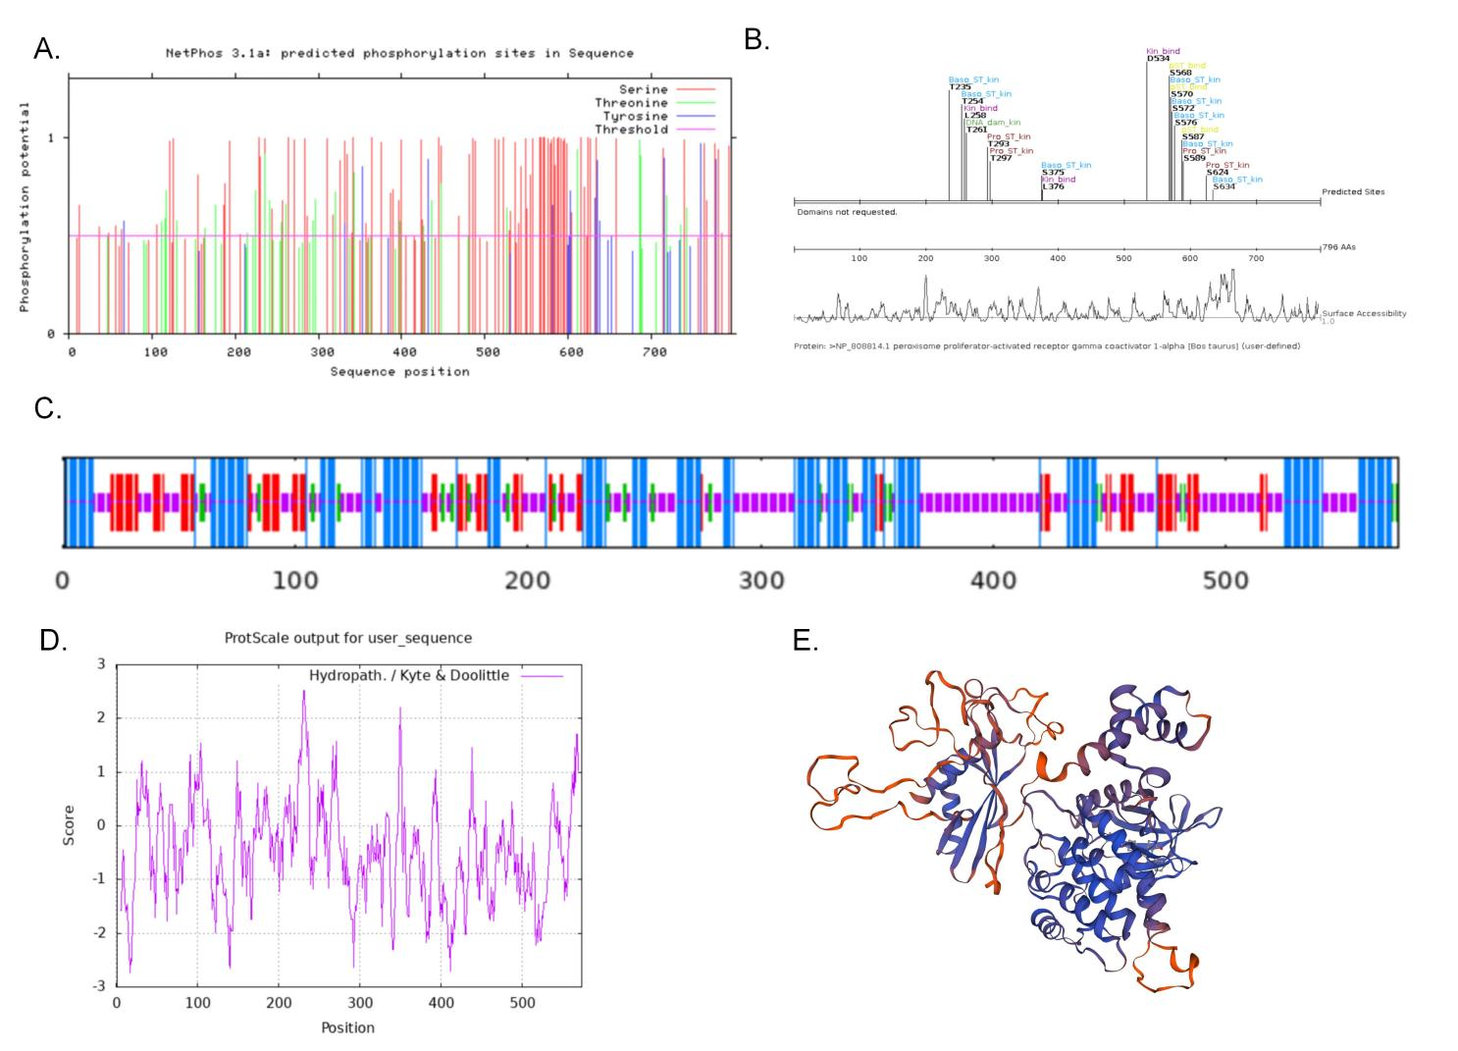 Figure 1.** PRKAA1 is a PGC-1α-phosphorylated kinase. A. NetPhos 3.1 Prediction of PGC-1α phosphorylation site. B. Scansite predicts protein kinase that may phosphorylate PGC-1α. C. Secondary structure analysis of the PRKAA1 protein with SOPMA. D. ProtScal analysis of the hydrophilic and hydrophobic properties of protein. E. Analysis of the tertiary spatial configuration of the PRKAA1 protein using SWISSMODEL.

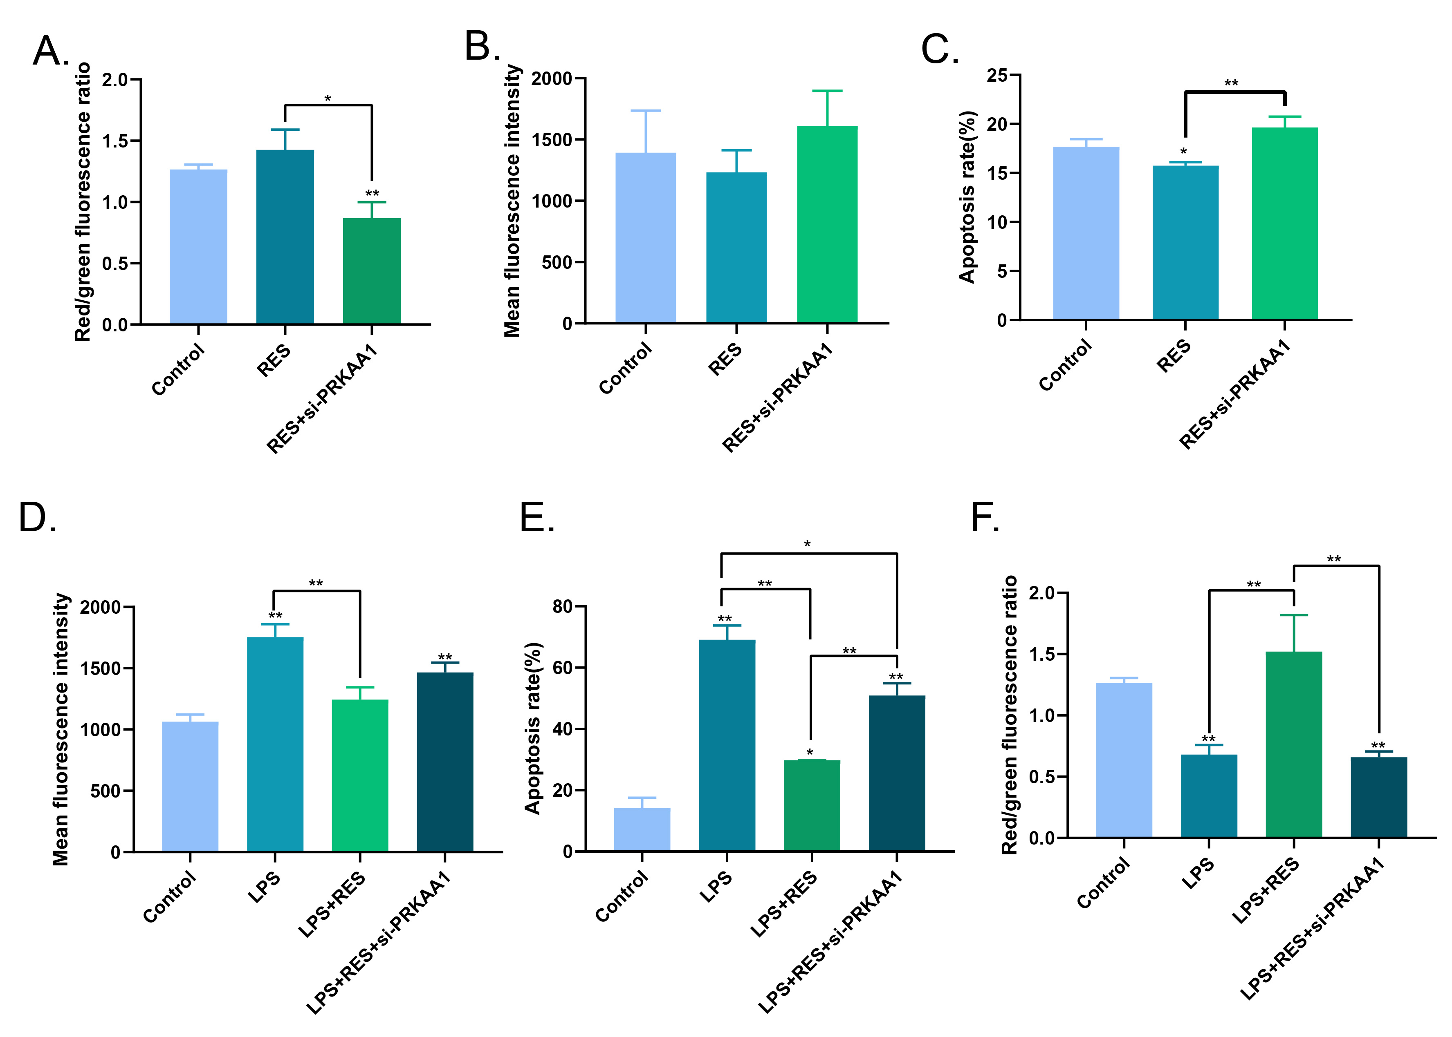

**Supplementary Figure 2.** A. Control, RES and RES+si-PRKAA1 group mitochondrial membrane potential red-green fluorescence ratio. B. Control RES and RES+si-PRKAA1 group ROS fluorescence value. C. Control, RES and RES+si-PRKAA1 group apoptosis rate. D. Control, LPS, LPS+RES and LPS+RES+si-PRKAA1 group ROS fluorescence value. E. Control, LPS, LPS+RES and LPS+RES+si-PRKAA1 group apoptosis rate. F. Control, LPS, LPS+RES and LPS+RES+si-PRKAA1 group mitochondrial membrane potential red-green fluorescence ratio.