Comparison of BMI and mental health symptoms across risk-status groups
Data on the following mental health symptoms, assessed at the last assessment, were analysed:
- Clinician-rated scales including the Quick Inventory of Depressive Symptomatology (QIDS) (Rush et al. 2003); Brief Psychiatric Rating Scale (BPRS) (Overall and Gorham 1962); Young Mania Rating Scale (YMRS) (Young et al. 1978); and Social and Occupational Functioning Assessment Scale (SOFAS) (Goldman et al. 1992)
- Self-rated measures, including Kessler Psychological Distress scale (K10) (Andrews and Slade 2001); and Overall Anxiety Severity and Impairment Scale (OASIS) (Norman et al. 2006)
Participants were categorised based on their risk status for insulin resistance or inflammation determined by HOMA-2-IR and CRP results at their initial blood assessment, and their recent BMI and mental health symptoms were compared. Individuals classified as low-risk for HOMA2-IR or CRP exhibited significantly lower BMI compared to those with elevated risk (24.65±5.04 vs. 29.46±7.23, p<0.001 for HOMA2-IR; 25.11±5.27 vs. 29.85±6.81, p<0.001 for CRP). No significant differences were found in depressive symptoms (measured by QIDS), psychotic symptoms (by BPRS), manic symptoms (by YMRS), or anxiety (by K10 or OASIS) between the low-risk and elevated-risk groups for both HOMA2-IR and CRP (Table S1). However, individuals with low-grade inflammation in the initial blood tests exhibited marginally poorer functioning compared to those with no risk of inflammation (62.97±19.81 vs. 69.56±13.77, p=0.051). The distribution of illness subtypes did not significantly differ between the risk status groups.

Table S1. Comparison of BMI and mental health symptoms among risk-status groups for insulin resistance and inflammation.
 | HOMA2-IR |  |  | CRP
 | Low-risk (n=80) | Elevated-risk (n=30) | p-value | Low-risk (n=81) | Elevated-risk (n=30) | p-value
BMI | 24.65±5.04 | 29.46±7.23 | F=14.99, p<0.001 | 25.11±5.27 | 29.85±6.81 | F=14.22, p<0.001
QIDS | 8.39±4.98 | 8.30±3.90 | F=0.008, p=0.931 | 8.35±4.75 | 8.83±5.01 | F=0.224, p=0.637
BPRS | 32.91±6.53 | 32.73±4.79 | F=0.019, p=0.891 | 33.2±5.75 | 33.2±6.78 | F<0.001, p=0.999
YMRS | 1.24±1.50 | 1.00±1.64 | F=0.518, p=0.473 | 1.53±2.00 | 0.90±1.35 | F=2.547, p=0.113
SOFAS | 68.38±14.61 | 64.70±15.47 | F=1.337, p=0.250 | 69.56±13.77 | 62.97±19.81 | F=3.903, p=0.051
K10 | 23.56±8.08 | 24.72±8.84 | F=0.411, p=0.523 | 23.12±7.85 | 25.00±9.40 | F=1.015, p=0.316
OASIS | 5.81±4.85 | 7.55±4.93 | F=2.665, p=0.101 | 5.90±4.60 | 7.38±5.18 | F=1.912, p=0.170
Illness subtype |  |  | χ2=1.964, p=0.455 |  |  | χ2=2.750, p=0.246
Hyperarousal-anxious | 59 (74%) | 18 (60%) |  | 52 (64%) | 24 (80%)
Circadian-bipolar | 7 (9%) | 4 (13%) |  | 11 (14%) | 3 (10%)
Neurodevelopmental-psychosis | 14 (18%) | 8 (27%) |  | 18 (22%) | 3 (10%)
Data presented as mean±standard deviation or n (%). BMI; body mass index, QIDS; quick inventory of depressive symptomatology, BPRS; brief psychiatric rating scale, YMRS; young mania rating scale, SOFAS; social and occupational functioning assessment scale, K10; Kessler psychological distress scale, OASIS, overall anxiety severity and impairment scale

Comparison of BMI and mental health symptoms across illness subtypes
The current BMI and mental health symptoms were compared between illness subtypes (Table S2). However, none of the variables showed significant differences between the subtypes. Although none of the variables showed significant differences between the subtypes, it was observed that the YMRS score is lower in the Circadian-bipolar subtype, contrary to expectations. We could speculate that people in this subtype may be in a depressed phase at the assessment.

Table S2. Comparison of BMI and mental health symptoms among illness subtypes for insulin resistance and inflammation.
 | HOMA2-IR |  |  |  | CRP
 | Hyperarousal-anxious (n=77) | Circadian-bipolar (n=11) | Neurodevelopmental-psychosis (n=22) | p-value | Hyperarousal-anxious (n=76) | Circadian-bipolar (n=14) | Neurodevelopmental-psychosis (n=21) | p-value
BMI | 25.78±6.14 | 28.42±6.35 | 25.42±5.73 | F=0.941, p=0.393 | 26.45±6.13 | 28.48±5.94 | 24.86±5.74 | F=1.398, p=0.252
QIDS | 8.01±4.60 | 10.27±4.73 | 8.64±4.94 | F=1.166, p=0.315 | 8.21±4.94 | 9.36±4.65 | 8.86±4.50 | F=0.413, p=0.663
BPRS | 32.23±5.72 | 34.27±5.14 | 34.36±7.50 | F=1.385, p=0.255 | 32.64±6.35 | 34.36±4.52 | 34.43±5.57 | F=1.021, p=0.364
YMRS | 1.18±1.42 | 0.82±1.47 | 1.32±1.96 | F=0.388, p=0.680 | 1.33±1.64 | 0.79±1.37 | 1.86±2.71 | F=1.436, p=0.243
SOFAS | 67.61±14.91 | 68.64±16.92 | 65.91±14.26 | F=0.154, p=0.858 | 68.41±16.39 | 67.00±15.75 | 66.00±14.16 | F=0.207, p=0.813
K10 | 23.53±8.48 | 26.90±8.02 | 23.68±7.78 | F=0.733, p=0.483 | 23.24±8.84 | 25.62±7.56 | 23.48±6.68 | F=0.450, p=0.639
OASIS | 5.90±4.91 | 7.90±5.17 | 6.86±4.80 | F=0.910, p=0.406 | 6.00±4.76 | 6.69±5.19 | 6.90±4.70 | F=0.344, p=0.709
Risk status
Elevated risk | 18 (23%) | 4 (36%) | 8 (36%) | χ2=1.96, p=0.467 | 24 (32%) | 3 (21%) | 3 (14%) | χ2=2.75, p=0.253
Data presented as mean±standard deviation or n (%). BMI; body mass index, QIDS; quick inventory of depressive symptomatology, BPRS; brief psychiatric rating scale, YMRS; young mania rating scale, SOFAS; social and occupational functioning assessment scale, K10; Kessler psychological distress scale, OASIS, overall anxiety severity and impairment scale

Repeated measures correlation between HOMA2-IR and CRP
Repeated measures correlation analyses were conducted to investigate the relationships between HOMA and CRP and their association with age over time (Figure S1). A significant positive correlation was observed between HOMA2-IR and CRP levels (r=0.27, p=0.005), indicating that higher HOMA2-IR levels were associated with higher CRP levels. Conversely, a significant negative correlation was found between age and HOMA2-IR levels (r=-0.15, p=0.026), suggesting that older age was linked to lower HOMA2-IR levels. However, no significant correlation was detected between age and CRP levels (r=0.02, p=0.73), indicating that age did not significantly influence CRP levels.
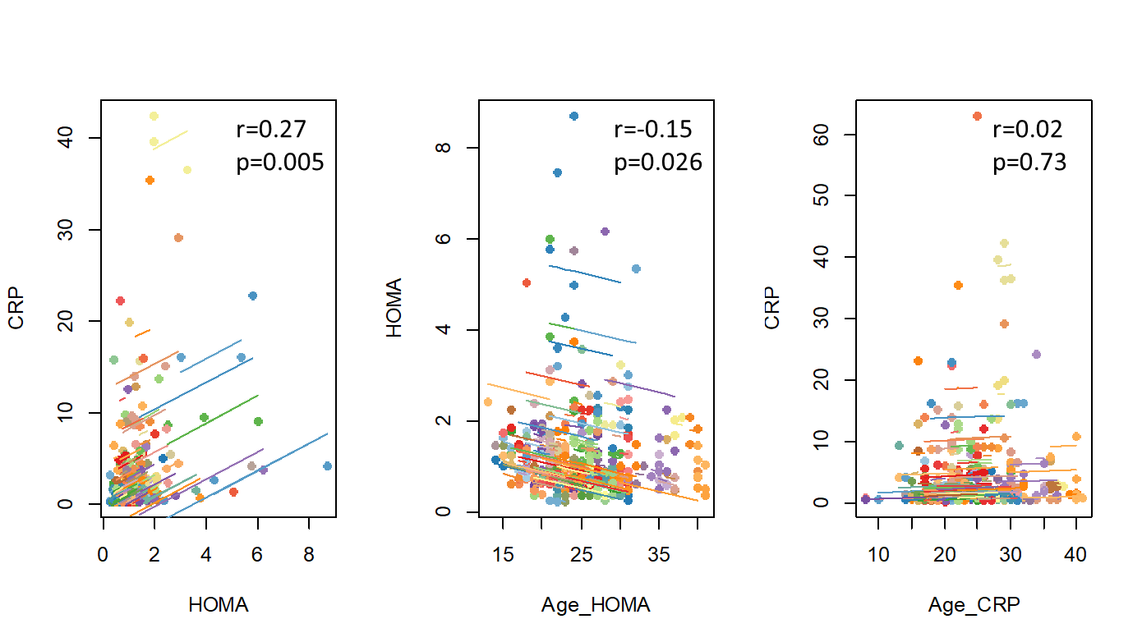
Figure S1. Repeated measure correlation between HOMA, CRP and the age at each assessment.

Supplementary References
Andrews G and Slade T (2001) Interpreting scores on the Kessler psychological distress scale (K10). Australian and New Zealand journal of public health 25(6), 494-497.
Goldman HH, Skodol AE and Lave TR (1992) Revising axis V for DSM-IV: a review of measures of social functioning. Am J Psychiatry 149(9), 1148-1156. https://doi.org/10.1176/ajp.149.9.1148.
Norman SB, Hami Cissell S, Means‐Christensen AJ and Stein MB (2006) Development and validation of an overall anxiety severity and impairment scale (OASIS). Depression and anxiety 23(4), 245-249.
Overall JE and Gorham DR (1962) The Brief Psychiatric Rating Scale. Psychological reports 10(3), 799-812. https://doi.org/10.2466/pr0.1962.10.3.799.
Rush AJ, Trivedi MH, Ibrahim HM, Carmody TJ, Arnow B, Klein DN, Markowitz JC, Ninan PT, Kornstein S, Manber R, Thase ME, Kocsis JH and Keller MB (2003) The 16-Item Quick Inventory of Depressive Symptomatology (QIDS), clinician rating (QIDS-C), and self-report (QIDS-SR): a psychometric evaluation in patients with chronic major depression. Biol Psychiatry 54(5), 573-583. https://doi.org/10.1016/s0006-3223(02)01866-8.
Young RC, Biggs JT, Ziegler VE and Meyer DA (1978) A rating scale for mania: reliability, validity and sensitivity. Br J Psychiatry 133, 429-435. https://doi.org/10.1192/bjp.133.5.429.

