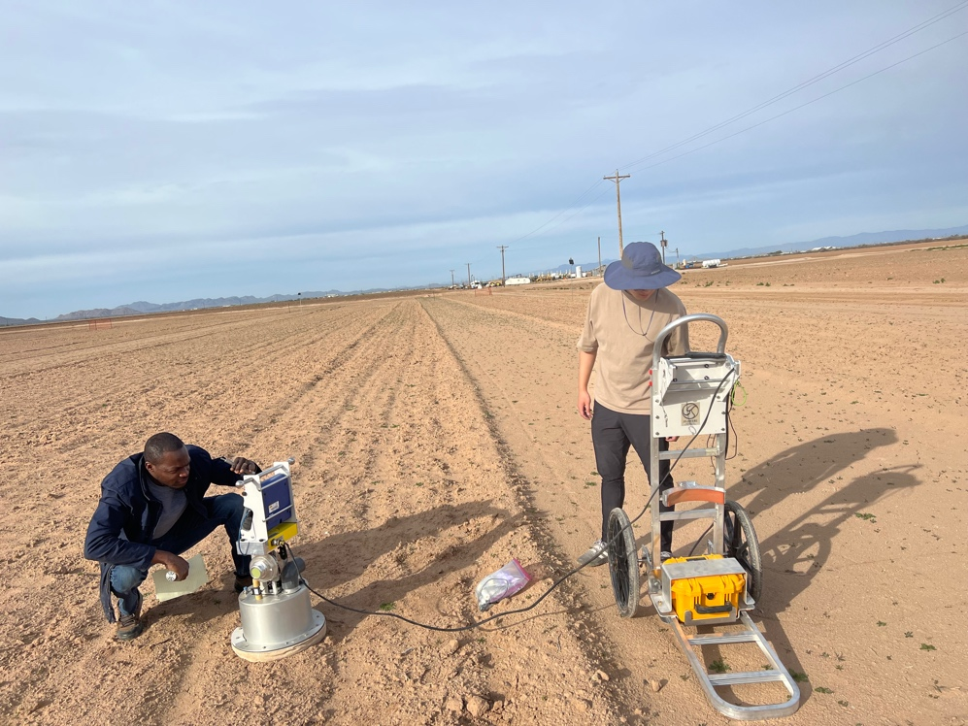

Supplemental Figure S1 – PI-SWERLTM device under use in the field showing typical fallow field conditions.

Fog
Rain

Supplemental Figure S2 – Effect of repeated wet/dry cycles on crust Strength. A single wet/dry cycle is sufficient to produce maximum crust strength for both Rain and Fog wetting. Error bars represent the standard deviation (n=3).

e
d
c
b
a

Supplemental Figure S3 – Example PI-SWERL chart showing PM10 concentration as a function of wind velocity. Interpretation as follows: As wind velocity increases from 0 m sec⁻¹, there is initially no PM10 (region-a). A small amount of loose dust on the surface of a crusted soil releases with increasing velocity (region-b), which ends in a characteristic spike; however, the small amount of dust is expelled from the chamber, and PM10 levels drop to near zero (region-c). As velocity continues to increase past ~7.5 m sec⁻¹, it appears the threshold detachment velocity has been reached, due to the steadily increasing PM10 levels (region-d); however, there is another characteristic spike followed by a drop a nominal levels (region-e), indicating the presence of more (higher density) surface material. The threshold detachment velocity, then, is represented by the end of region-e (~10.2 m sec⁻¹), where PM10 levels continue to rise unabated once the surface crust has been broken.

Dry, sieved soil
(i)
Rain (ave)
Fog (ave)

Supplemental Figure S4 – Typical penetrometer test results - sample Tol(c). Crust strength is the peak value, indicating the crust has broken. Outliers (in grey) are common, the result of several factors, for example heterogeneous distribution of soil particles (a large sand grain). False peaks (i) are also common due to a premature linear crack that is readily apparent to the operator, and the penetrometer tip advancement is continued until the true peak value is reached.


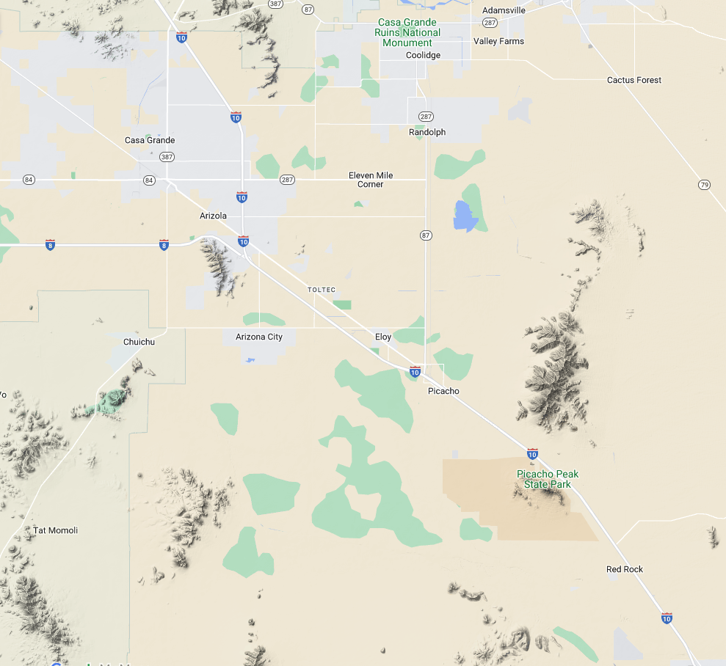
Low dust potential

High dust potential

Sample Areas

Figure S5 – Heat map showing dust formation potential of undisturbed surface soils in Pinal County based on carbonate content maps from the U.S. Geological Survey. Low carbonate = high dust potential. Map is intended demonstrate an approach to define dust hotspots. More accurate maps would require direct carbonate determinations, an would benefit from overlay with wind velocities, land use and geomorphic features and ground truthing.

Table S1 – Duplicate sample results for laboratory samples. Duplicate samples are listed with an asterix (*) and are not used in the correlative analyses. RPD = Relative Percent Difference = $\frac{x-y}{x/2+y/2}$. RPD of < 20% is considered acceptable.

Soil name | Potassium | pH | Sodium | Calcium | Magnesium | Sodium absorption ratio | Organic Matter  (%)
CG3(a) | 442 | 8 | 46 | 1768 | 220 | 1.46 | 1.7
CG3(a)* | 484 | 8 | 46 | 1836 | 226 | 1.43 | 1.7
RPD | 9% | 0% | 0% | 4% | 3% | 2% | 0%
Gil(a)* | 962 | 8.2 | 204 | 3606 | 415 | 4.55 | 1.5
Gil(a) | 967 | 8.4 | 195 | 3198 | 366 | 4.62 | 1.5
RPD | 1% | 2% | 5% | 12% | 13% | 2% | 0%
Tol(a) | 932 | 8.6 | 73 | 3767 | 161 | 1.65 | 0.8
Tol(a)* | 990 | 8.5 | 71 | 3592 | 165 | 1.64 | 0.9
RPD | 6% | 1% | 3% | 5% | 2% | 1% | 12%

Table S2 – Correlation of soil crust strength parameters with single primary predictive variables and two-variable combinations. Soil crust strength measures are: ΔCS_{F} = Fog-wetted strength. ΔCS_{R} = Rain-wetted strength, and DCS = Differential Crust Strength (CS_{R} – ΔCS_{F}). Among variables, SAR = Sodium Absorption Ratio, and OM for Organic Matter. Listed statistics are the probability that there is no correlation (p), the goodness of linear fit (R²). Adjusted R² was used for two-variable combinations. Akaike weights depict the cumulative contribution of each combination, in order of decreasing contributions.

Explanatory Variables | R²  ADJ R² | p | Cumulative Akaike Weight
Fog (ΔCS_{F})
Carbonate | 0.49 | 0.0001 | 0.23
Carbonate + Clay | 0.44 | 0.001 | 0.36
Carbonate + Na⁺ | 0.50 | 0.0004 | 0.49
Carbonate + Mg²⁺ | 0.44 | 0.001 | 0.60
Carbonate + SAR | 0.50 | 0.0004 | 0.70
Carbonate + K⁺ | 0.42 | 0.002 | 0.80
Carbonate + Ca²⁺ | 0.42 | 0.002 | 0.88
Carbonate + OM | 0.43 | 0.001 | 0.94
Carbonate + pH | 0.48 | 0.0005 | 1.00
Rain (ΔCS_{R})
Carbonate + Clay | 0.40 | 0.003 | 0.38
Carbonate + Mg²⁺ | 0.35 | 0.005 | 0.53
Carbonate + Na⁺ | 0.38 | 0.003 | 0.67
Carbonate + SAR | 0.37 | 0.004 | 0.76
Carbonate + Ca²⁺ | 0.30 | 0.01 | 0.84
Carbonate | 0.30 | 0.004 | 0.90
Carbonate + OM | 0.30 | 0.01 | 0.94
Carbonate + K⁺ | 0.39 | 0.003 | 0.98
Carbonate + pH | 0.25 | 0.03 | 1.00
Rain – Fog (DCS)
Clay + Carbonate | 0.21 | 0.03 | 0.23
Clay | 0.17 | 0.04 | 0.41
Clay + Mg²⁺ | 0.17 | 0.04 | 0.54
Clay + pH | 0.17 | 0.05 | 0.67
Clay + Na²⁺ | 0.15 | 0.06 | 0.76
Clay + SAR | 0.15 | 0.06 | 0.84
Clay + OM | 0.11 | 0.10 | 0.90
Clay + K⁺ | 0.11 | 0.10 | 0.95
Clay + Ca²⁺ | 0.11 | 0.10 | 1.00

