Oxidation of Fe(II)-carbonate (siderite) by anoxygenic phototrophic Fe(II)-oxidizing bacteria

Markus Maisch1,2 , Verena Nikeleit1,3 , Ulf Lüder1,4, Casey Bryce5 , Andreas Kappler1,6 and James Byrne5*

## 1 Geomicrobiology Group, Geo- and Environmental Research Centre (GUZ), University of Tuebingen, Schnarrenbergstrasse 94-96, D-72076 Tuebingen, Germany

2 Now: SPACY, Geo- and Environmental Research Centre (GUZ), University of Tuebingen, Schnarrenbergstrasse 94-96, D-72076 Tuebingen, Germany

3 Now: NORCE Norwegian Research Centre, Bergen, Norway

## 4 Now: Institute for Theoretical Physics, University of Tuebingen, Maria-von-Linden-Straße 6, D-72076 Tuebingen, Germany

## 5 School of Earth Sciences, University of Bristol, Wills Memorial Building, Queens Road, Bristol BS8 1RJ, United Kingdom

## 6 Cluster of Excellence: EXC 2124: Controlling Microbes to Fight Infection, Tübingen, Germany

**Supporting Information**

**\*To whom correspondence should be sent:**

Dr James Byrne, [james.byrne@bristol.ac.uk](mailto:james.byrne@bristol.ac.uk)

**Geochemical model to predict the extent of siderite dissolution at various HCO3– concentrations**

In order to suppress chemical siderite dissolution in setups containing cells in direct contact with siderite particles, HCO3– concentrations were gradually increased from 0 – 300 mM. Using a geochemical model in PhreeqC, expected dissolved Fe2+aq equilibrium concentrations from chemical siderite dissolution were calculated for each treatment with respective HCO3– concentrations ranging from 0 mM, 22 mM, 50 mM, 100 mM, 200 mM to 300 mM in triplicate setups with the following boundary conditions:

**Geochemical modelling in PhreeQC**

The expected equilibrium Fe2+aq concentrations originating from dissolution of siderite in solutions with different HCO3- concentrations (0, 22, 50, 100, 200, 300 mM) were modeled in PhreeqC (database wateq4f) using the keywords “EQUILIBRIUM_PHASES” for solid siderite and “GAS_PHASE” for N2 and CO2 gas headspace exchange. The model input (Table S1a) and selected output with equilibrium concentrations of Fe2+aq due to dissolution of siderite (Table S1b) are stated below:

**Table S1a: PhreeqC model input for siderite dissolution at varying HCO3– concentrations (solutions 1 – 6).**

|  |  |  |
| --- | --- | --- |
| **SOLUTION 1: 0 mM bicarbonate**  temp 20.0  pH 6.8  units mmol/L  K 3.67  P 3.67 as PO4-3  N(-3) 5.61 as NH4+  Cl 6.97  Mg 2  S(6) 2 as SO4-2  Ca 0.68  O(0) 0  N(0) 0.57 as N2  Alkalinity 0 as HCO3  EQUILIBRIUM_PHASES 1  siderite 0 0.003  GAS_PHASE 1  -fixed_volume  -pressure 1.0  -volume 0.85  -temp 20  N2(g) 1  CO2(g) 0  **END** | **SOLUTION 2: 22 mM bicarbonate**  temp 20.0  pH 6.8  units mmol/L  K 3.67  P 3.67 as PO4-3  N(-3) 5.61 as NH4+  Cl 6.97  Mg 2  S(6) 2 as SO4-2  Ca 0.68  O(0) 0  N(0) 0.57 as N2  Alkalinity 22 as HCO3  EQUILIBRIUM_PHASES 1  siderite 0 0.003  GAS_PHASE 1  -fixed_volume  -pressure 1.0  -volume 0.85  -temp 20  N2(g) 1  CO2(g) 0  **END** | **SOLUTION 3: 50 mM bicarbonate**  temp 20.0  pH 6.8  units mmol/L  K 3.67  P 3.67 as PO4-3  N(-3) 5.61 as NH4+  Cl 6.97  Mg 2  S(6) 2 as SO4-2  Ca 0.68  O(0) 0  N(0) 0.57 as N2  Alkalinity 50 as HCO3  EQUILIBRIUM_PHASES 1  siderite 0 0.003  GAS_PHASE 1  -fixed_volume  -pressure 1.0  -volume 0.85  -temp 20  N2(g) 1  CO2(g) 0  **END** |
| **SOLUTION 4: 100 mM bicarbonate**  temp 20.0  pH 6.8  units mmol/L  K 3.67  P 3.67 as PO4-3  N(-3) 5.61 as NH4+  Cl 6.97  Mg 2  S(6) 2 as SO4-2  Ca 0.68  O(0) 0  N(0) 0.57 as N2  Alkalinity 100 as HCO3  EQUILIBRIUM_PHASES 1  siderite 0 0.003  GAS_PHASE 1  -fixed_volume  -pressure 1.0  -volume 0.85  -temp 20  N2(g) 1  CO2(g) 0  **END** | **SOLUTION 5: 200 mM bicarbonate**  temp 20.0  pH 6.8  units mmol/L  K 3.67  P 3.67 as PO4-3  N(-3) 5.61 as NH4+  Cl 6.97  Mg 2  S(6) 2 as SO4-2  Ca 0.68  O(0) 0  N(0) 0.57 as N2  Alkalinity 200 as HCO3  EQUILIBRIUM_PHASES 1  siderite 0 0.003  GAS_PHASE 1  -fixed_volume  -pressure 1.0  -volume 0.85  -temp 20  N2(g) 1  CO2(g) 0  **END** | **SOLUTION 6: 300 mM bicarbonate**  temp 20.0  pH 6.8  units mmol/L  K 3.67  P 3.67 as PO4-3  N(-3) 5.61 as NH4+  Cl 6.97  Mg 2  S(6) 2 as SO4-2  Ca 0.68  O(0) 0  N(0) 0.57 as N2  Alkalinity 300 as HCO3  EQUILIBRIUM_PHASES 1  siderite 0 0.003  GAS_PHASE 1  -fixed_volume  -pressure 1.0  -volume 0.85  -temp 20  N2(g) 1  CO2(g) 0  **END** |

**Table S1b: PhreeqC model output for siderite dissolution at varying HCO3– concentrations.**

|  |
| --- |
| **0 mM HCO3:**  -----------------------------------Gas phase-----------------------------------  Total pressure: 1.0060 atmospheres  Gas volume: 8.50e-01 liters  Moles in gas  ----------------------------------  Component log P P Initial Final Delta  CO2(g) -2.02 9.609e-03 0.000e+00 3.395e-04 3.395e-04  N2(g) 0.02 1.050e+00 3.533e-02 3.712e-02 1.781e-03  -------------------------------Phase assemblage--------------------------------  Moles in assemblage  Phase SI log IAP log KT Initial Final Delta  Siderite 0.00 -10.86 -10.86 3.000e-03 1.632e-03 -1.368e-03 |
| **22 mM HCO3:**  -----------------------------------Gas phase-----------------------------------  Total pressure: 1.0345 atmospheres  Gas volume: 8.50e-01 liters  Moles in gas  ----------------------------------  Component log P P Initial Final Delta  CO2(g) -0.94 1.158e-01 0.000e+00 4.091e-03 4.091e-03  N2(g) 0.02 1.049e+00 3.533e-02 3.705e-02 1.720e-03  -------------------------------Phase assemblage--------------------------------  Moles in assemblage  Phase SI log IAP log KT Initial Final Delta  Siderite 0.00 -10.86 -10.86 3.000e-03 2.677e-03 -3.231e-04 |
| **50 mM HCO3:**  -----------------------------------Gas phase-----------------------------------  Total pressure: 1.0479 atmospheres  Gas volume: 8.50e-01 liters  Moles in gas  ----------------------------------  Component log P P Initial Final Delta  CO2(g) -0.63 2.361e-01 0.000e+00 8.344e-03 8.344e-03  N2(g) 0.02 1.049e+00 3.533e-02 3.705e-02 1.717e-03  -------------------------------Phase assemblage--------------------------------  Moles in assemblage  Phase SI log IAP log KT Initial Final Delta  Siderite 0.00 -10.86 -10.86 3.000e-03 2.809e-03 -1.914e-04 |

|  |
| --- |
| **100 mM HCO3:**  -----------------------------------Gas phase-----------------------------------  Total pressure: 1.0682 atmospheres  Gas volume: 8.50e-01 liters  Moles in gas  ----------------------------------  Component log P P Initial Final Delta  CO2(g) -0.36 4.394e-01 0.000e+00 1.553e-02 1.553e-02  N2(g) 0.02 1.049e+00 3.533e-02 3.706e-02 1.724e-03  -------------------------------Phase assemblage--------------------------------  Moles in assemblage  Phase SI log IAP log KT Initial Final Delta  Siderite 0.00 -10.86 -10.86 3.000e-03 2.893e-03 -1.070e-04 |
| **200 mM HCO3:**  -----------------------------------Gas phase-----------------------------------  Total pressure: 1.0756 atmospheres  Gas volume: 8.50e-01 liters  Moles in gas  ----------------------------------  Component log P P Initial Final Delta  CO2(g) -0.08 8.260e-01 0.000e+00 2.919e-02 2.919e-02  N2(g) 0.02 1.050e+00 3.533e-02 3.709e-02 1.753e-03  -------------------------------Phase assemblage--------------------------------  Moles in assemblage  Phase SI log IAP log KT Initial Final Delta  Siderite 0.00 -10.86 -10.86 3.000e-03 2.948e-03 -5.234e-05 |
| **300 mM HCO3:**  -----------------------------------Gas phase-----------------------------------  Total pressure: 1.0864 atmospheres  Gas volume: 8.50e-01 liters  Moles in gas  ----------------------------------  Component log P P Initial Final Delta  CO2(g) 0.08 1.198e+00 0.000e+00 4.233e-02 4.233e-02  N2(g) 0.02 1.051e+00 3.533e-02 3.712e-02 1.788e-03  -------------------------------Phase assemblage--------------------------------  Moles in assemblage  Phase SI log IAP log KT Initial Final Delta  Siderite 0.00 -10.86 -10.86 3.000e-03 2.967e-03 -3.280e-05 |

**Growth of *R. palustris* TIE-1 on H2 and elevated HCO3– concentrations**

A 10% inoculum of *R. palustris* TIE-1 was incubated on basal anoxic minimal salt medium with H2/CO2 (80/29; v/v) in the headspace as electron donor to test for negative effects of high HCO3– concentrations on cell growth and viability. Optical density (600 nm) was followed over the course of the incubation of 29 days (Figure S1).

**Figure S1** - **Inoculum of R. palustris TIE-1 grown on H2 as substrate amended with gradually increased HCO3– concentrations.** Optical density (600 nm) of a 10% inoculum over the course of the incubation with H2/CO2 (80/20; v/v) in headspace serving as substrate and different HCO3– concentrations (0 – 300 mM). Error bars represent standard deviation from biological triplicate setups. Note: Cells amended with 0 mM HCO3– are lacking bioavailable CO2 for biomass fixation, thus do not show a significant increase in cell density.

**Scanning electron microscopy**

Batch experiment 1

Mineral samples were collected at the end of the incubation from inside and outside the dialysis bags and preserved as mentioned in the main text. Image acquisition was performed on a FIB-SEM (Crossbeam 550L, Zeiss, Germany) in high resolution imaging mode with electron high tension (EHT) of 5 kV, working distance (WD) of 5 mm, probe current (IProbe) of 50 pA, dwell time of 50 ns and a secondary-electrons secondary ions (SESI) detector.

**Figure S2 - Representative scanning electron microscopy images from biotic incubations using dialysis bags filled with siderite to inhibit direct contact of R. palustris TIE-1 cells with siderite surface.** Samples for SEM images were collected at the end of the incubation from inside and outside the bag. (A) Siderite minerals inside the dialysis bag. (B) Mineral particles collected outside the dialysis bag.

Batch experiment 2

Samples for scanning electron microscopy were collected anoxically prior (Figure S3 A) and at the end of the incubation after 28 days from control microcosms (Figure S3 B-F) with different HCO3– concentrations (ranging from 0 – 300 mM). Image acquisition was performed on a FIB-SEM (Crossbeam 550L, Zeiss, Germany) in high resolution imaging mode with electron high tension (EHT) of 5 kV, working distance (WD) of 5 mm, probe current (IProbe) of 50 pA, dwell time of 50 ns and a secondary-electrons secondary ions (SESI) detector. All images show the platelet structures identified as siderite particles (identified by 57Fe Mössbauer spectroscopy).

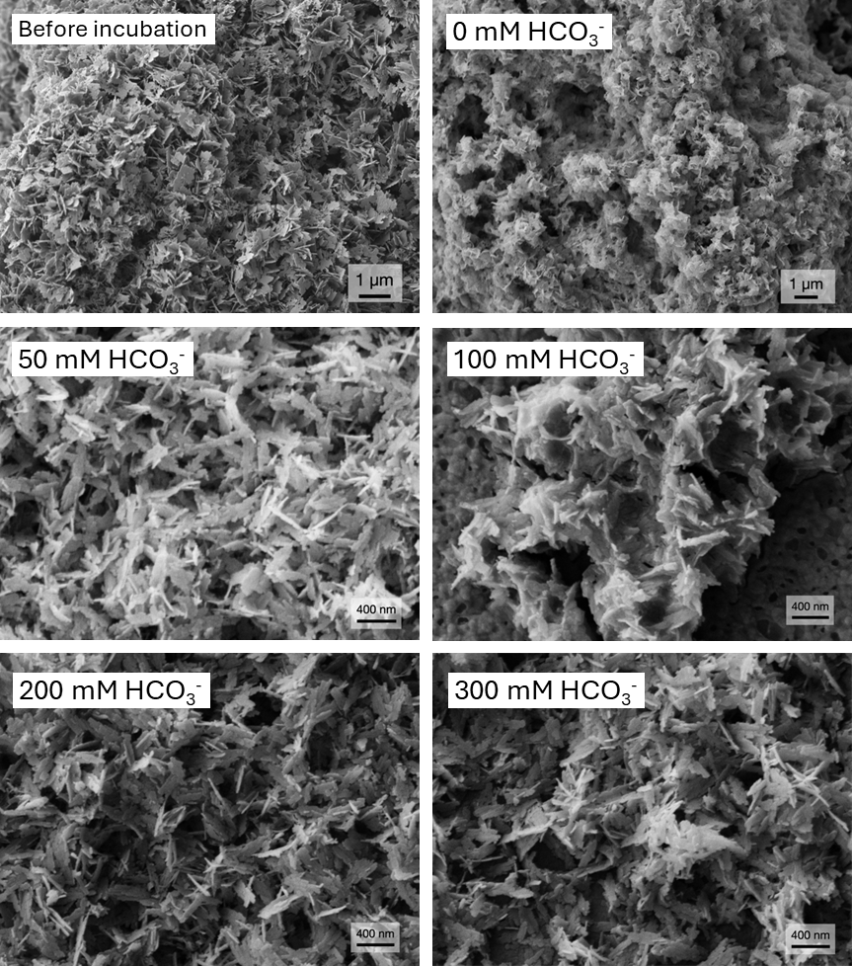

**Figure S 3 -** **Scanning electron microscopy images from abiotic control setups with siderite and different HCO3– concentrations (0 – 300 mM) without bacteria.** (A) Initial siderite minerals before incubation; (B) – (F) Siderite mineral particles collected from abiotic control setup amended with 0 mM – 300 mM HCO3–.

**Chemical Fe(II) dissolution and biological Fe(II) oxidation rates contrasted**

Measured Fe(II) oxidation rates in all biotic control setups exceeded calculated resulting Fe(II) concentrations from siderite dissolution (Figure S4). The extent in Fe(III) formation in all setups significantly exceeds the Fe(II) accumulation rates and concentrations available from siderite dissolution only. This suggests the microbial activity enhanced the overall Fe(II) oxidation compared to what was expected from siderite dissolution and subsequent microbial Fe(II) oxidation only.

**Figure S4 - Chemical Fe(II) dissolution rate from siderite and biological Fe(II) oxidation rates** in setups containing siderite and different HCO3– concentrations. Chemical Fe(II) dissolution rates from siderite (grey bars) and biological Fe(II) oxidation rates by R. palustris TIE-1 (orange bars) within the initial 16 days of incubation. Fe(II) dissolution rates from siderite gradually decrease with increasing buffer concentrations. Biological Fe(II) oxidation rates are significantly higher compared to Fe(II) dissolution rates in all treatments.

**Rates for chemical siderite dissolution / biotic Fe(II) oxidation (0 – 16 days)**

Rates for chemical siderite dissolution (in µM Fe(II) day-1) or biotic Fe(II) oxidation (via µM Fe(III) formation day-1) were calculated for the incubation time of 16 days. Within this time frame, biological Fe(II) oxidation was most pronounced before stagnation following day 16. Rates were estimated for each treatment by a linear approximation of Fe2+aq concentrations accumulating in abiotic controls (for siderite dissolution rates) and Fe(III) formation in biological setups (for biological Fe(II) oxidation rates), respectively.

**Table S2. Chemical siderite dissolution and biotic Fe(II) oxidation rates in treatments amended with elevated HCO3– concentrations.**

|  |  |  |
| --- | --- | --- |
| HCO3– concentration | chemical siderite dissolution rate  (derived from abiotic controls)  µM Fe2+aq accumulated day-1 | biological Fe(II) oxidation rate  (derived from biotic setups)  µM Fe(III) formed day-1 |
| 0 mM | 61.9 | 136.3 |
| 22 mM | 63.1 | 121.3 |
| 50 mM | 41.9 | 93.1 |
| 100 mM | 27.5 | 81.3 |
| 200 mM | 14.4 | 65.0 |
| 300 mM | 5.8 | 35.7 |

**57Fe Mössbauer spectroscopy**

Summary of the fitting parameters and results for measured 57Fe Mössbauer spectra

**Table S3 – Summary of the Mössbauer parameters obtained by fitting. δ - center shift; QS - quadrupole splitting; R. A. –relative spectral area. Db – doublet; Reduced (Red.) χ2 – goodness of the fit; Fe phase – identified iron speciation.**

|  |  |  |  |  |  |  |  |
| --- | --- | --- | --- | --- | --- | --- | --- |
| **Sample** | **Temp.** | **Phase** | **δ** | **ΔEQ** | **R.A. (±)** | **Red. χ2** | **Fe** |
| **[HCO3–]** | **K** |  | **mm/s** | **mm/s** | **%** |  | **phase** |
| **0 mM** | 77 | Db1 | 1.13 | 3.02 | 5.9 (0.3) | 1.22 | Fe(II) |
|  |  | Db2 | 0.48 | 0.78 | 94.1 (0.3) |  | Fe(III) |
|  |  |  |  |  |  |  |  |
| **22 mM** | 77 | Db1 | 1.25 | 2.85 | 10.0 (0.1) | 0.66 | Fe(II) |
|  |  | Db2 | 0.48 | 0.75 | 90.0 (0.1) |  | Fe(III) |
|  |  |  |  |  |  |  |  |
| **50 mM** | 77 | Db1 | 1.30 | 2.96 | 13.5 (0.2) | 0.79 | Fe(II) |
|  |  | Db2 | 0.47 | 0.77 | 86.5 (0.2) |  | Fe(III) |
|  |  |  |  |  |  |  |  |
| **100 mM** | 77 | Db1 | 1.32 | 3.01 | 30.8 (0.3) | 0.98 | Fe(II) |
|  |  | Db2 | 0.47 | 0.77 | 69.2 (0.3) |  | Fe(III) |
|  |  |  |  |  |  |  |  |
| **200 mM** | 77 | Db1 | 1.33 | 3.01 | 41.2 (0.4) | 1.37 | Fe(II) |
|  |  | Db2 | 0.47 | 0.79 | 58.8 (0.4) |  | Fe(III) |
|  |  |  |  |  |  |  |  |
| **300 mM** | 77 | Db1 | 1.25 | 2.21 | 79.3 (0.2) | 0.63 | Fe(II) |
|  |  | Db2 | 0.49 | 0.89 | 20.7 (0.2) |  | Fe(III) |

All spectra collected at 77 K showed the abundance of non-magnetically ordered iron phases at this temperature. The best-fit model suggests the presence of two phases forming a narrow and wide doublet (Db) in the absorption spectra (Table S3; Figure S5). The wide doublet (Db1) was characterized by hyperfine parameters with both a relative high center shift (δ) > 1.25 mm/s and a very high quadrupole splitting (ΔEQ) of ΔEQ = 2.94 – 3.02. Such high hyperfine parameters are indicative for a high-spin Fe(II) mineral phase to be present in all samples, such as siderite. The narrow doublet (Db2) showed lower values for δ ranging from 0.47 – 0.49 mm/s and ΔEQ between 0.75 – 0.79 mm/s, which can be attributed to the presence of an Fe(III) mineral phase, very similar to ferrihydrite, to be present in all samples.

The relative spectral areas of each mineral phase differed to a large extent depending on the HCO3– concentrations in each setup (Table S3). In setups with highest HCO3– concentrations (300 mM), Fe(II) in siderite was the most dominant iron mineral phase by approx. 80%. With decreasing buffer concentrations, however, the relative abundance of the Fe(III) oxyhydroxide mineral phase, likely ferrihydrite, gradually increased to up to more than 90% in setups with no additional HCO3– buffer, leaving only approx. 5% relative spectral area to siderite.

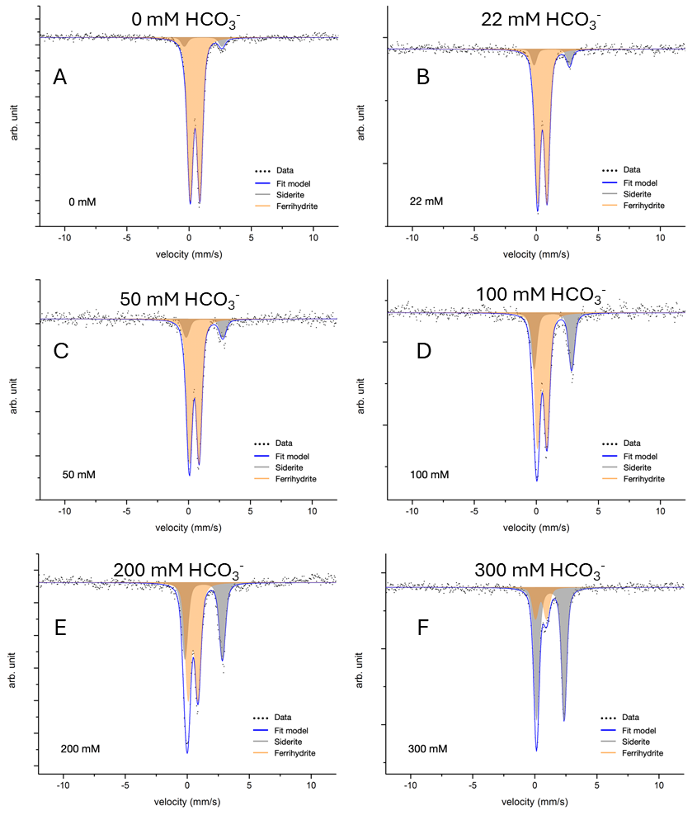

**Figure S5 -** **57Fe Mössbauer absorption spectra collected at 77 K from solid phase precipitates of all biotic setups with HCO3– concentrations from 0 – 300 mM (A – F) at the end of the incubation (after 35 days).** All samples show the presence of a two non-magnetically ordered phases forming a wide (grey) and narrow (orange) doublet (Db) which can be attributed to the presence of an Fe(II) phase, likely to be siderite (grey), and an Fe(III) phase similar to ferrihydrite (orange). The relative spectral area of each doublet varied between samples depending on the HCO3– concentration.

**References**

1. French, B.M., *Stability Relations of Siderite (Feco3) in System Fe-C-O.* American Journal of Science, 1971. **271**(1): p. 37-&.

2. Kappler, A. and D.K. Newman, *Formation of Fe(III)-minerals by Fe(II)-oxidizing photoautotrophic bacteria.* Geochimica Et Cosmochimica Acta, 2004. **68**(6): p. 1217-1226.

3. Lasaga, A.C., *Chemical-Kinetics of Water-Rock Interactions.* Journal of Geophysical Research, 1984. **89**(Nb6): p. 4009-4025.

4. Schwertmann, U., *Solubility and Dissolution of Iron-Oxides.* Plant and Soil, 1991. **130**(1-2): p. 1-25.