**Supplemental Information:**

**Piezometer Locations**

Supplemental Figure 1: Location of piezometers indicated by the white markers. These are located around the midpoint of the sampling sites. Shaded in blue is Clear Creek.

**Alpha diversity measurements:**

Supplemental Figure 2: Alpha diversity measured by Shannon, Simpson and Chao1 indices estimated between different iron types of Clear Creek for 16S rRNA. X-axis labels: No: no iron present, I: iridescent, P: iron precipitates, I,P: both iridescence and precipitates, and PIF: all three iron types. The black line indicates median values through iron types.

**Microbial Analysis:**

Supplemental Figure 3: Principal Coordinates Analyses conducted by contrast based on Bray-Curtis distance highlighted by site. Ellipses are plotted with a 95% confidence interval and plotted with the percentage of variability on the axis. No statistical difference was determined from a Permanova.

Supplemental Figure 4: Principal Coordinates Analyses conducted by contrast based on Bray-Curtis distance highlighted by season. Ellipses are plotted with a 95% confidence interval and plotted with the percentage of variability on the axis. Permanova found a significant statistical difference between seasons (<0.001).

Supplemental Figure 5: 16S abundance at the Phylum level based on iron mineralisation types.

Supplemental Figure 6: Principal Coordinates Analyses conducted by contrast based on Bray-Curtis distance highlighted by samples with clustering on left and right. Ellipses are plotted with a 95% confidence interval and plotted with the percentage of variability on the axis. Permanova found a significant statistical difference between left and right samples (<0.001).

Supplemental Figure 7: Top 30 abundance based on Phylum level in Left and Right Clusters from PCoA plot.

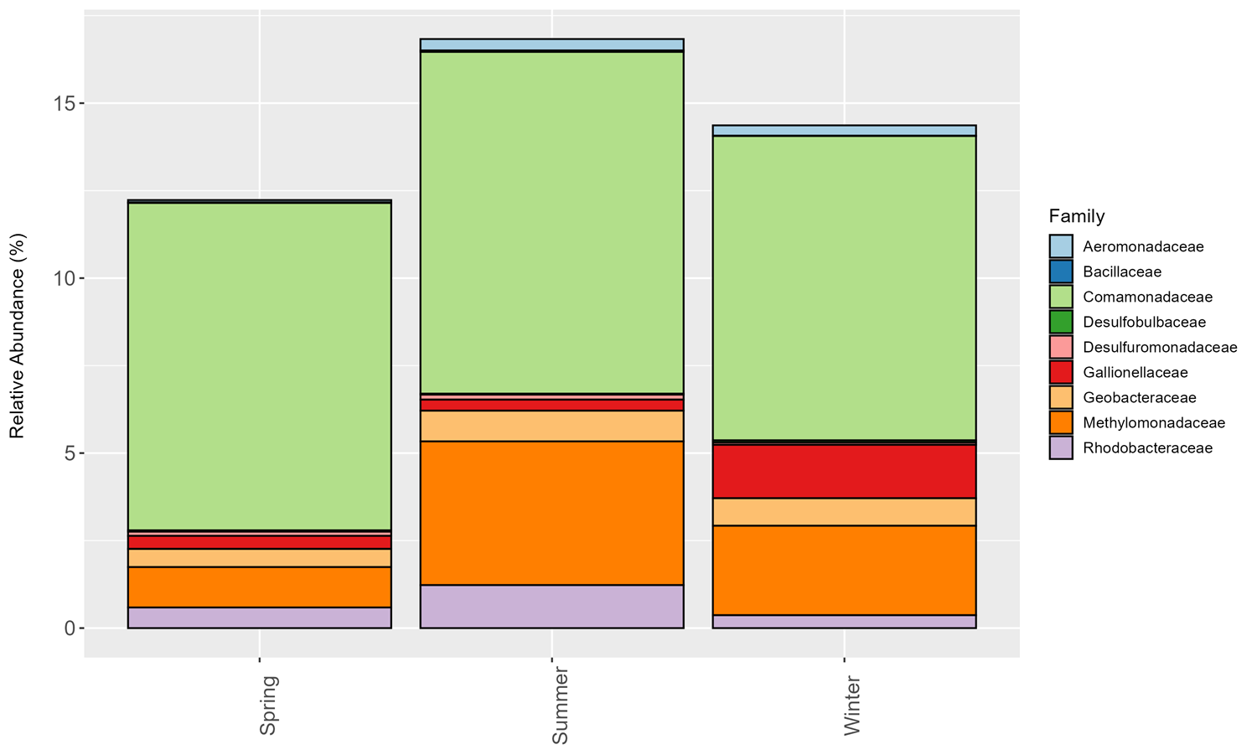

Supplemental Figure 8: Relative abundance at the Family level of putative iron cyclers + methane-oxidizing bacteria based on season.

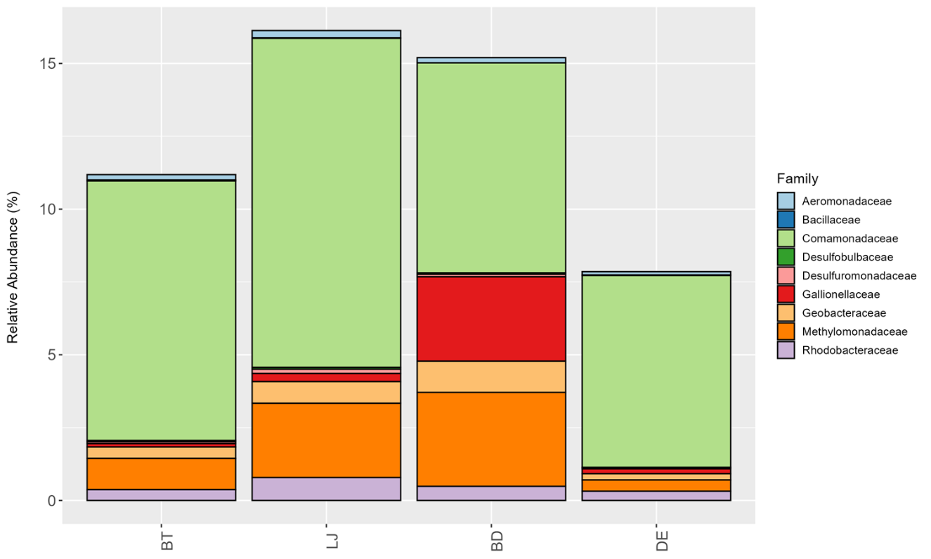

Supplemental Figure 9: Relative abundance at the Family level of putative iron cyclers + methane-oxidizing bacteria at the different sample sites.

**Low and High Loss Calibration EELS:**

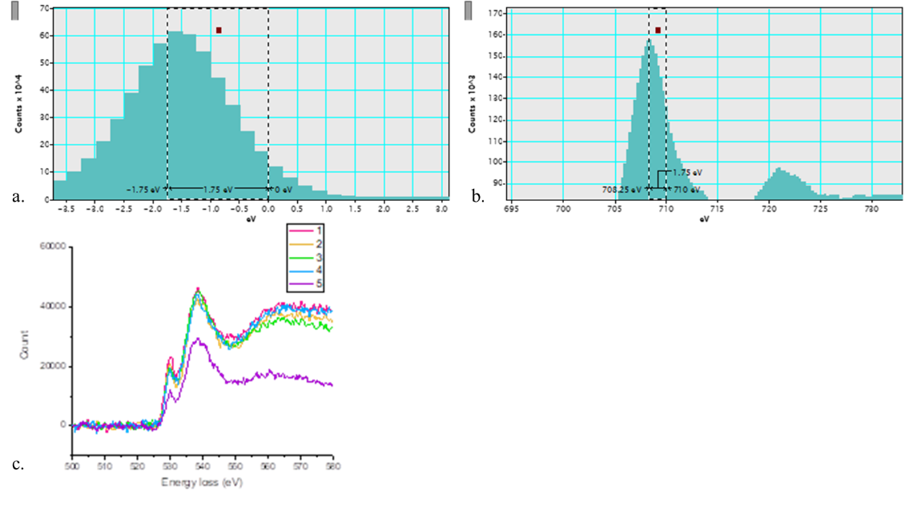

Supplemental Figure 10: a and b. Energy calibration of EELS: a) Prior to EELS analysis on the sample, a zero loss peak was acquired, showing a -1.75 eV shift from 0 eV; b) The -1.75 eV shift was applied to the collected high-loss data; c) O-K edge for 5 sample areas of interest from Figures 8 and 9.