**Supplementary Material for “Designing Out Microplastic Pollution Released from Textiles and Apparel During Laundering”**

Elisabeth Allen1*, Dr Claudia E Henninger1, Jane Wood1, Professor Arthur Garforth2 & Dr Edidiong Asuquo2

1Department of Materials & 2Department of Chemistry, University of Manchester, Oxford Road, M13

9PL

[*Corresponding author: elisabeth.allen@manchester.ac.uk](mailto:*Corresponding%20author:%20elisabeth.allen@manchester.ac.uk)

**Supporting information for: Methods**

To remove residual contamination such as airborne microplastics, dust and other residue the fabrics were prewashed in distilled water prior to microplastic fibre shedding analysis. The fabric swatches were dried overnight within the laminar flow cabinet before a pre-wash weight of each swatch was recorded using a Fisher PS-60 balance with a readability of 0.1mg.

As per the AATCC TM212-2021 and ISO 4484-1:2023 test standard, the fabric swatches were laundered within individual stainless-steel canisters placed within a laboratory wash stimulator for 45 minutes at 40°C with 360mL of distilled water and 50 6mm stainless-steel balls to provide agitation (AATCC, 2021; BSI, 2023).

After the wash test, the wash liquor was filtered through a pre-weighed Whatman GF/C 55mm glass microfibre filter with a pore size of 1.2µm with the aid of a vacuum filter apparatus. To ensure all microplastic fibres released during the laundering process, the fabric, steel balls, canister and canister lid were rinsed three times with distilled water. Finally, the glass filter funnel was rinsed with a pressurised wash bottle filled with distilled water, to dislodge any microplastic fibres that had adhered to the glass at any stage in the filtering process. The filter membranes were transferred to glass petri dishes to dry before being weighed to assess microplastic fibre shedding gravimetrically. The mass of fibre fragments released was presented as mg of released pollution per kg of washed fabric calculated via the equation below.

$$Mf= \frac{W_{2}- W_{1}}{P}$$

Mf= Microplastic fibres shed (mg kg-1)

= Pre-wash mass of dry filter membrane and weighing dish (mg)

W2= Post-wash mass of dry filter membrane and weighing dish (mg)

P= Pre-wash weight of fabric swatch (kg)

Equation 1: Calculation for the mass of fibre fragment release from each fabric swatch

Once created, fabrics were kept protected from further contamination within individual tin foil packets. Fabric samples were also pre-washed prior to laundry experiments to remove superficial dust and contamination during creation of fabrics. Removing contamination prior to washing has been done by previous studies such as Corami et al. (2020), Haap et al. (2019) and Zambrano et al. (2019).

As this work uses microscale changes in weight and microscopic fibres, contamination control is essential (Prata et al. 2020). Similar to other microplastic work, decontamination controls were taken such as cleaning of surfaces and floors before use and prior to wash tests, canisters, steel balls, filter funnel and glass petri dishes were triple rinsed with filtered water before use (Prata et al. 2021; Woodall et al. 2015). Sample preparation (following fabric creation), filtering and quantification of fibres was conducted within laminar flow cabinets to control airborne contamination. Researchers also wore white cotton lab coats to reduce potential self-contamination of laboratory environment and samples from clothing (Scopetani et al. 2020). Procedural blanks were undertaken and results were subtracted from test results (BSI 2023; Özkan and Gündoğdu 2020).

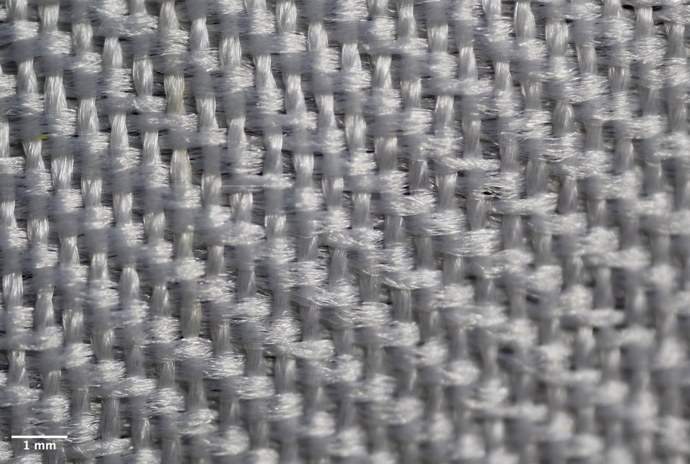

Figure 1: Measurement of weft (orange arrows) and warp (blue arrows) raised yarn length of the woven fabric using software ImageJ. Sample size of 6 warp and 6 weft raised yarn lengths were measured and averaged.

Figure 1: Measurement of raised yarn length of the knit fabric using software ImageJ. Sample size of 6 raised yarn lengths were measured and averaged.

**References**

**AATCC** (2021) Test method for fiber fragment release during home laundering In: *No. TM212-2021.* North Carolina: AATCC.

**British Standards Institute (BSI)** (2023) ISO 4484-1:2023 Textiles and textile products. Microplastics from textile sources. Determination of material loss from fabrics during washing. In. London: BSI Standards Limited.

**Corami F, Rosso B, Bravo B, Gambaro A and Barbante C** (2020) A novel method for purification, quantitative analysis and characterization of microplastic fibers using Micro-FTIR. *Chemosphere* **238,** 124564. https://doi.org/10.1016/j.chemosphere.2019.124564.

**Haap, Classen, Beringer, Mecheels and Gutmann** (2019) Microplastic Fibers Released by Textile Laundry: A New Analytical Approach for the Determination of Fibers in Effluents. *Water* **11**(10). https://doi.org/10.3390/w11102088.

**Özkan İ and Gündoğdu S** (2020) Investigation on the microfiber release under controlled washings from the knitted fabrics produced by recycled and virgin polyester yarns. *The Journal of The Textile Institute* **112**(2)**,** 264-272. https://doi.org/10.1080/00405000.2020.1741760.

**Prata JC, Castro JL, da Costa JP, Duarte AC, Rocha-Santos T and Cerqueira M** (2020) The importance of contamination control in airborne fibers and microplastic sampling: Experiences from indoor and outdoor air sampling in Aveiro, Portugal. *Mar Pollut Bull* **159,** 111522. https://doi.org/10.1016/j.marpolbul.2020.111522.

**Prata JC, Reis V, da Costa JP, Mouneyrac C, Duarte AC and Rocha-Santos T** (2021) Contamination issues as a challenge in quality control and quality assurance in microplastics analytics. *J Hazard Mater* **403,** 123660. https://doi.org/10.1016/j.jhazmat.2020.123660.

**Scopetani C, Esterhuizen-Londt M, Chelazzi D, Cincinelli A, Setala H and Pflugmacher S** (2020) Self-contamination from clothing in microplastics research. *Ecotoxicol Environ Saf* **189,** 110036. https://doi.org/10.1016/j.ecoenv.2019.110036.

**Woodall LC, Gwinnett C, Packer M, Thompson RC, Robinson LF and Paterson GL** (2015) Using a forensic science approach to minimize environmental contamination and to identify microfibres in marine sediments. *Marine Pollution Bulletin* **95**(1)**,** 40-46. https://doi.org/10.1016/j.marpolbul.2015.04.044.

**Zambrano MC, Pawlak JJ, Daystar J, Ankeny M, Cheng JJ and Venditti RA** (2019) Microfibers generated from the laundering of cotton, rayon and polyester based fabrics and their aquatic biodegradation. *Marine Pollution Bulletin* **142,** 394-407. https://doi.org/10.1016/j.marpolbul.2019.02.062.