Supplementary material

Title of Article:
Light-mediated temperature susceptibility of kelp species (Agarum clathratum, Saccharina latissima) in an Arctic summer heatwave scenario

Authors:
Sarina Niedzwiedz^{1*}, Tobias Reiner Vonnahme², Thomas Juul-Pedersen², Kai Bischof¹, Nora Diehl^{1*}
*corresponding authors: sarina@uni-bremen.de / ndiehl@uni-bremen.de

Affiliation:
¹Marine Botany, Faculty of Biology and Chemistry & MARUM, University of Bremen, 28359 Bremen, Germany
²Greenland Climate Research Centre, Greenland Institute for Natural Resources (GINR), Nuuk, Greenland

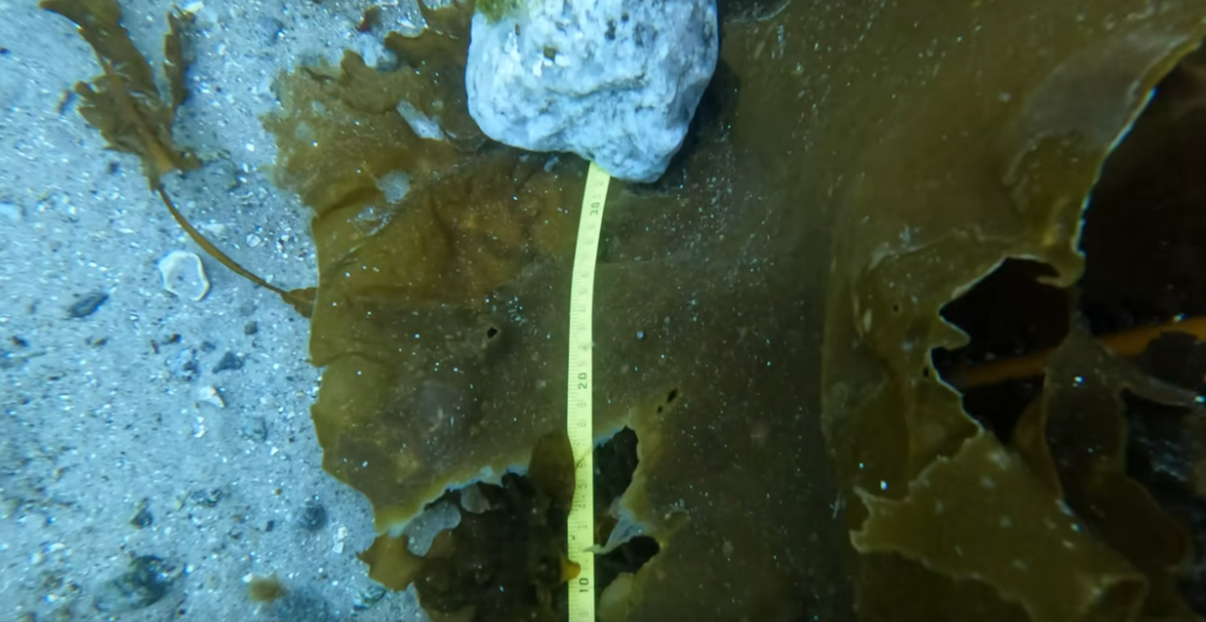
https://youtu.be/TaZxT9NBcTM
S1: Video transect (by Tobias Reiner Vonnahme) through a kelp forest near Nuuk (01.05.2022) taken 0.5 m (+-0.5m) over the bottom or kelp canopy. The transect starts at about 12 m water depth and ends at the surface. Between ca.12 m and 10 m (2:08 min) the kelp species Agarum clathratum, Saccharina latissima, and Alaria esculenta dominate. Between ca. 5 m (2:35 min) and 2 m, A. clathratum is absent, while and first-year A. esculenta is most abundant. Laminaria sp. becomes increasingly abundant from ca 3-1m depth.
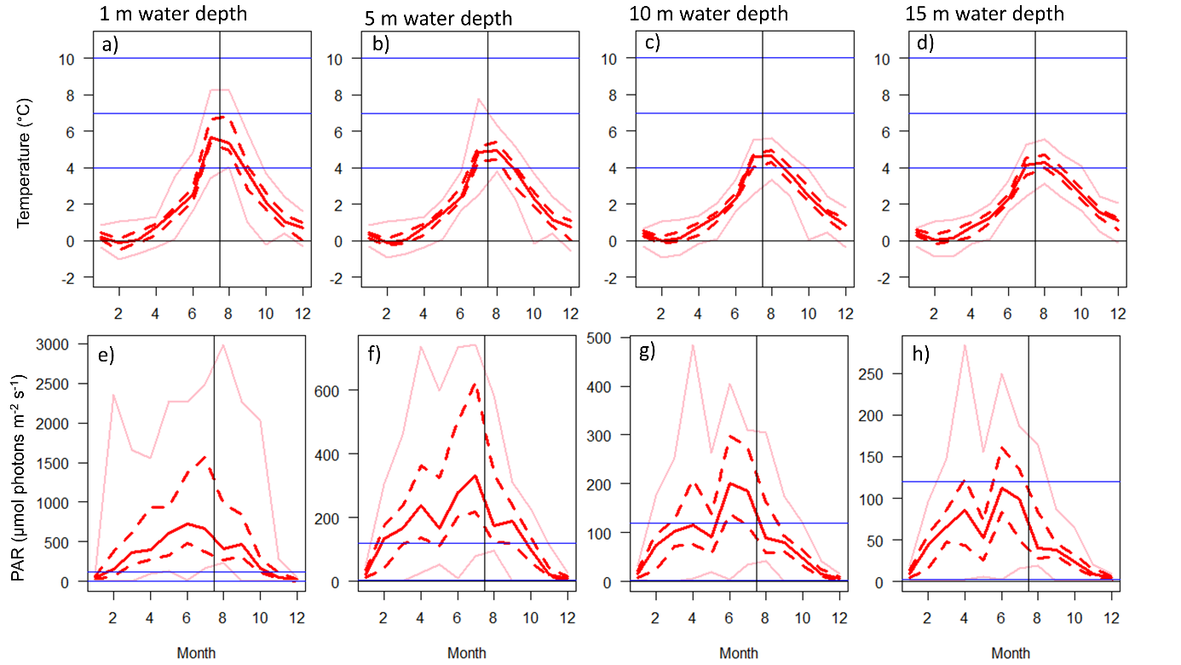
S2: Monthly temperature (a-d) and photosynthetically available radiation (PAR; µmol photons m⁻² s⁻¹) (e-h) from a marine monitoring station (GF3, G-E-M.dk/data; https://doi.org/10.17897/KMEK-TK21) showing median (solid red line), interquartile ranges (dotted lines), and the total range (light red) of the measurements at 1 m (a,e), 5 m (b,f), 10 m (c,g), and 15 m (d,h) depth between 2005 and 2021 at the nearby marine monitoring station (G-E-M.dk/data). Treatment light intensities and temperatures are shown as blue lines.
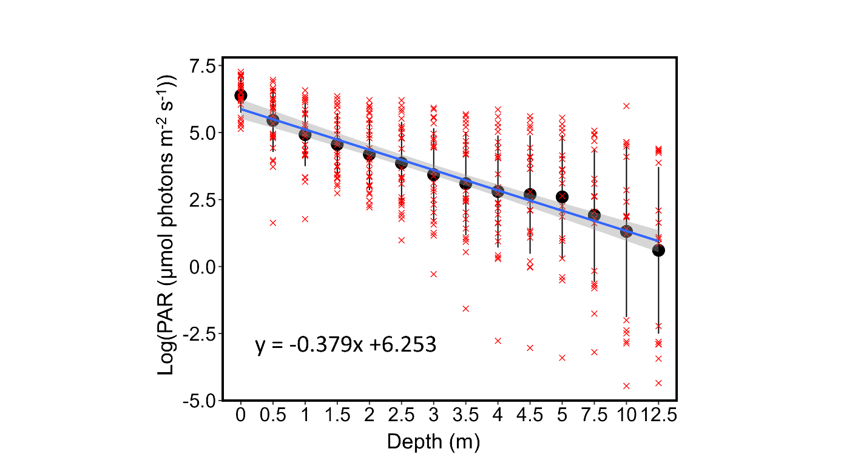
S3: Logarithm of photosynthetically available light (PAR) over water depth (m) in Kongsfjorden, Svalbard. Red crosses: single measurements. Black circles: Mean PAR±SD. Blue line: linear model of PAR intensities over depth ±95 % confidence interval. Data from Niedzwiedz & Bischof (2023b) https://doi.org/10.1594/PANGAEA.951173. The experiment's low-light conditions (3 µmol photons m⁻² s⁻¹) are at ~15 m water depth.
S4: Estimates of mean daily (sec) photosynthetically available radiation (PAR; µmol photons m⁻² s⁻¹) at 1 (a), 5 (b), 10 (c) and 15 (d) m depth in July since 2008 shown as median (solid red line) and interquartile ranges (dotted red line). Estimates are based on PAR measurements at 2 m over the bottom from ClimateBasis Nuuk (https://doi.org/10.17897/8Z2W-D993, Asiaq) and light attenuation based on PAR profiles measured at a nearby marine monitoring station (GF3, G-E-M.dk/data; https://doi.org/10.17897/KMEK-TK21). Treatment light intensities are shown as blue horizontal lines.

