Appendices

Appendix 1: Logic Model of the Kuujjuaq Dog Program. 2

Appendix 2: Matrix of data collection for the evaluation of the Kuujjuaq's Dog Program implementation. 3

Appendix 3. Guides for semi-structured individual interviews. 9

*Appendix 3.1. Interview guide for non-stakeholders participants.* 9

*Appendix 3.2. Interview guide for key stakeholders.* 11

Appendix 4. Demographics of the survey respondents that owned dog(s). 13

Appendix 1: Logic Model of the Kuujjuaq Dog Program.

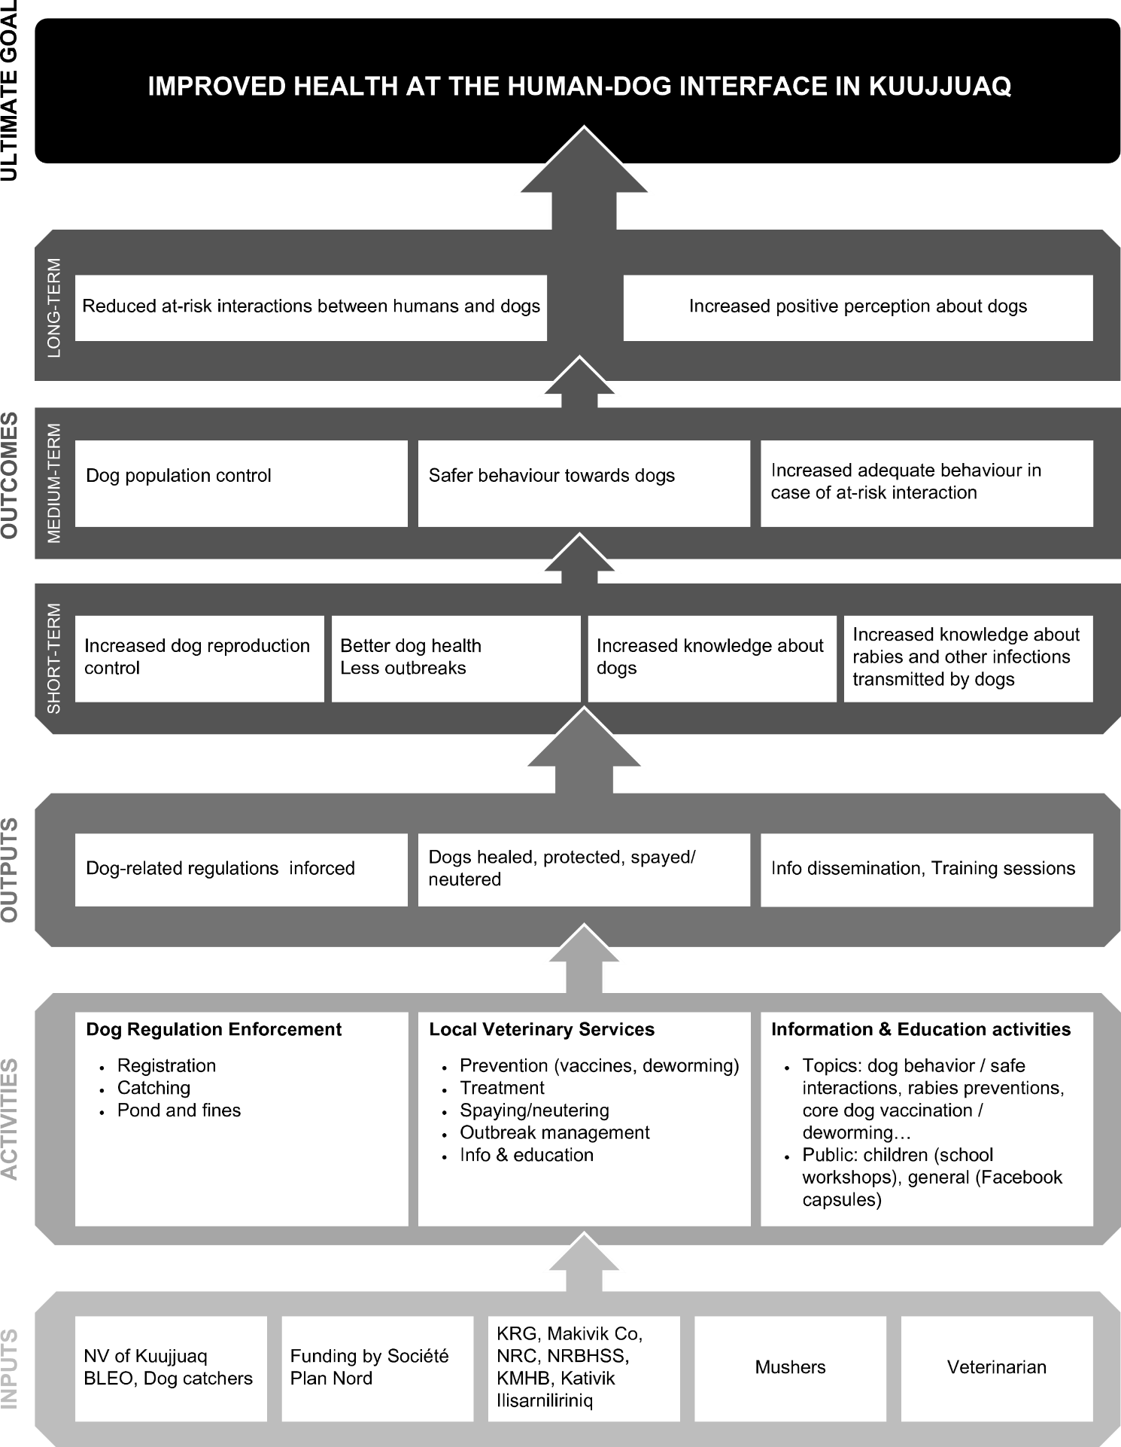NV: Northern Village; BLEO: By-law enforcement officer; KRG: Kativik Regional Government; NRC: Nunavik Research Center; NRBHSS: Nunavik Regional Board of Health and Social Services; KMHB: Kativik Municipal Housing Bureau; Kativik Ilisarniliriniq: School Board.

Appendix 2: Matrix of data collection for the evaluation of the Kuujjuaq's Dog Program implementation.

[LIKERT] indicates a 7-levels Likert-based questions (“Strongly disagree”, “Disagree”, “Somewhat disagree”, “Neither agree nor disagree”, “Somewhat agree”, “Agree”, “Strongly agree”). [LIKERT+] indicates a Likert-based questions with 7 levels plus an option for “I don’t know / I prefer not to answer”. Questions in grey were excluded from the analysis as deemed litigious, controversial, or misleading.

|  |  |  |  |  |
| --- | --- | --- | --- | --- |
| **Evaluation questions** | **Indicators** | **Survey** | **Interviews with inhabitants** | **Interviews with key stakeholders** |
| **Quality of delivery** | Relevance | **14 questions**  [LIKERT] SECTION 1: For each of the statements below, choose the response that indicates how much you agree or disagree based on your experiences and feelings:   1. Dogs are part of my community 2. Dogs are important to the Inuit culture 3. Dogs can keep my house safe 4. I like watching sledding or hearing that there is sledding around the village 5. Sled dogs are part of the Inuit culture    1. [LIKERT+] Publishing information about dogs-related topics on Facebook…       1. Met a need in Kuujjuaq       2. Should be carried out       3. Were not needed for the community    2. [LIKERT+] The special activities on dogs provided to Kuujjuaq students during spring 2021…       1. Met a need in Kuujjuaq       2. Should be carried out       3. Were not needed for the community    3. [LIKERT+] Having full-time veterinary services in Kuujjuaq…       1. Met a need in Kuujjuaq       2. Should be carried out       3. Is not needed for the community | **4 questions**   1. Could you tell me about your experience with the services and activities related to dogs in Kuujjuaq? 2. What do you think about having permanent veterinary services in Kuujjuaq? 3. What do you think about posting information about dogs, dog bites and rabies on Facebook? 4. What do you think about offering activities on dogs to children at school? | **1 question**   1. According to your experience, how do the services / activities affect the community of Kuujjuaq? |
| Integration of Inuit knowledge and perspectives | - | **4 questions**   1. Could you tell me about your experience with the services and activities related to dogs in Kuujjuaq? 2. What do you think about having permanent veterinary services in Kuujjuaq? 3. What do you think about posting information about dogs, dog bites and rabies on Facebook? 4. What do you think about offering activities on dogs to children at school? | **1 question**   1. According to your experience, how do the services / activities affect the community of Kuujjuaq? |
| Attitude and preparedness of the stakeholders | - | - | **1 question**   1. You were involved in *(name activity / service)*. Could you tell me about your experience with the services and activities related to dogs in Kuujjuaq? |
| **Participants’ responsiveness** | Awareness, exposure and interest | **13 questions**   * 1. Have you heard about the Facebook publications about dogs? *(Yes / No)*   2. How did you hear about these Facebook publications? Several answers possible. *(From family, friends, relatives, neighbors / From the veterinarian / From traditional media / From social media / From the municipality / From another source - precise)*   3. Did you happen to read any of these Facebook publications? *(Yes, one of them / Yes, several of them / No)*   4. What prevented you from reading the messages? One answer. *(I don’t have access to Facebook / I didn’t have time / I am not interested / Other reason – precise)*   5. [LIKERT] Publishing information about dogs-related topics on Facebook…      1. Encouraged you to use Kuujjuaq’s veterinary services      2. Encouraged people of Kuujjuaq to use Kuujjuaq’s veterinary services   6. Have you heard about the activities in Jaanimarik about dogs? *(Yes / No)*   7. How did you hear about the activities in Jaanimarik? Several answers possible. *(From my children, or children close to me / From family, friends, relatives, neighbors / From the school / From traditional media / From social media / From another source - precise)*   8. Did any of the children living with you participated in activities on dogs in 2021? *(Yes / No / I don’t know / Not concerned)*   9. [LIKERT] How did they feel about the activities on dogs? *(Very happy / Happy / Neutral / Unhappy / Very unhappy / I don’t know)*   10. Have you heard about the veterinary services? *(Y / N)*   11. How did you hear about the veterinary services? Several answers possible. *(From family, friends, relatives, neighbors / From the veterinarian / From traditional media / From social media / From the municipality / From another source - precise)*   12. Did you use the veterinary services of Kuujjuaq for a dog since January 2020? *(Yes, on time / Yes, several times / No)*   13. For what purpose did you use Kuujjuaq’s veterinary services? Several answers possible. *(To vaccinate my dog / My dog was sick or injured / To have my dog neutered / Other – precise)*   14. What prevents you from using Kuujjuaq’s veterinary services? One answer. *(I don’t have a dog / I have a dog but I didn’t need it / I didn’t have time / It’s too expensive / Other – precise)* | **4 questions**   1. Could you tell me about your experience with the services and activities related to dogs in Kuujjuaq? 2. What do you think about having permanent veterinary services in Kuujjuaq? 3. What do you think about posting information about dogs, dog bites and rabies on Facebook? 4. What do you think about offering activities on dogs to children at school? | - |
| Sociocultural acceptability | **3 questions**   * + 1. [LIKERT+] Publishing information about dogs-related topics on Facebook respected the values and beliefs of my community     2. [LIKERT+] The special activities on dogs provided to Kuujjuaq students during spring 2021 respected the values and beliefs of my community Helped their family learn more about rabies less afraid of dogs     3. [LIKERT+] Having full-time veterinary services in Kuujjuaq respected the values and beliefs of my community | **4 questions**   1. Could you tell me about your experience with the services and activities related to dogs in Kuujjuaq? 2. What do you think about having permanent veterinary services in Kuujjuaq? 3. What do you think about posting information about dogs, dog bites and rabies on Facebook? 4. What do you think about offering activities on dogs to children at school? | **1 question**   1. According to your experience, how do the services / activities affect the community of Kuujjuaq? |
| **Differentiation and uniqueness** | Perceived differentiation | - | **1 question**   1. What do you think of recently implemented activities and services related to dogs compare to what was available before in Kuujjuaq? | **1 question**   1. What do you think of recently implemented activities and services related to dogs compare to what was available before in Kuujjuaq? |
| Perceived strengths & weaknesses, possible improvements | - | **1 question**   1. What could be done to improve the services and activities about dogs that have been newly implemented in Kuujjuaq? | **1 question**   1. What could be done to improve the services and activities about dogs that have been newly implemented in Kuujjuaq? |
| **Adaptations and adjustments** | Significant dog-related events | - | **1 question**   1. Could you briefly tell me about the last interaction you had with a dog that was significant for you? | **2 questions**   1. Here is a timeline of the last two years. Could you use it to tell me about any event concerning dogs and the dogs-related activities or services that took place in Kuujjuaq since January 2020? 2. Could you tell me about any events that could have impacted the services/activities you were involved in? |
| Obstacles and facilitators | **6 questions**   * 1. What kind of dog(s) do you have? Check all that apply. *(Sled dogs / pure- or mixed-bred huskies / other purebred dogs / other – precise)*   2. Where do you keep your dogs most of the time? Check all that apply. *(Mostly inside / Mostly outside, free roaming / Mostly outside, on a leash or in a pen)*   3. Did you adopt at least one new dog over the past year? *(Yes / No)*   4. Have you ever used the services of a veterinarian for a dog before 2020 when there was no full-time veterinarian in Kuujjuaq? *(Yes, one time / Yes, several times / No)*   5. Did you use veterinary services outside of Kuujjuaq for a dog since January 2020? *(Yes, one time / Yes, several times / No)*   6. For what purpose did you use the veterinary services outside of Kuujjuaq? Several answers possible. *(To vaccinate my dog / My dog was sick or injured / To have my dog neutered / Other – precise)* | - | **3 questions**   1. Could you tell me about your experience with the services and activities related to dogs in Kuujjuaq? 2. Here is a timeline of the last two years. Could you use it to tell me about any event concerning dogs and the dogs-related activities or services that took place in Kuujjuaq since January 2020? 3. Could you tell me about any events that could have impacted the services/activities you were involved in? |
|  |  |  |  |  |

Appendix 3. Guides for semi-structured individual interviews.

*Appendix 3.1. Interview guide for key stakeholders.*



*Appendix 3.2. Interview guide for non-stakeholders participants.*



Appendix 4. Demographics of the survey respondents that owned dog(s).

[ - ] indicates 95% confidence interval.

|  |  |  |  |
| --- | --- | --- | --- |
|  | **All dog owners** | **Inuit dog owners** | **Non-Inuit dog owners** |
| **Total dog owners in each group** | **64% [52-74] (n = 47/74)** | **63% [49-75] (n = 29/46)** | **75% [53-89] (n = 15/20)** |
| **Sex (M/F)** | **(n = 42)** | **(n = 26)** | **(n = 15)** |
| Women | 62% [47-75] (n = 26) | 62% [43-78] (n = 16) | 60% [36-80] (n = 9) |
| Men | 38% [25-53] (n = 16) | 38% [22-57] (n = 10) | 40% [20-64] (n = 6) |
| **Age group** | **(n = 45)** | **(n = 29)** | **(n = 15)** |
| 18-34 years | 40% [27-57] (n = 18) | 45% [28-64] (n = 13) | 33% [13-63] (n = 5) |
| 35-54 years | 40% [27-57] (n = 18) | 34% [17-54] (n = 10) | 47% [27-76] (n = 7) |
| ≥ 55 years | 20% [7-37] (n = 9) | 21% [3-40] (n = 6) | 20% [0-49] (n = 3) |
| **Living with children ≤ 18 years old** | **(n = 47)** | **(n = 29)** | **(n = 15)** |
| Yes | 64% [50-76] (n = 30) | 72% [54-85] (n = 21) | 40% [20-64] (n = 6) |
| No | 36% [24-50] (n = 17) | 28% [15-46] (n =8) | 60% [36-80] (n = 9) |
| **Number of dogs owned** | **(n = 47)** | **(n = 29)** | **(n = 15)** |
| One | 60% [45-72] (n = 28) | 55% [38-72] (n = 16) | 67% [42-85] (n = 10) |
| Two or more | 47% [28-55] (n = 19) | 45% [28-62] (n = 13) | 33% [15-58] (n = 5) |
| Mushers excluded | *33% [21-48] (n = 14)* | *33% [18-53] (n = 8)* | *33% [15-58] (n = 5)* |
| **Got a new dog between 2020-2022** | 38% [26-53] (n = 18/47) | 41% [26-59] (n = 12/29) | 20% [7-45] (n = 3/15) |
| **Breeds** | **(n = 39)** | **(n = 26)** | **(n = 11)** |
| Sledding dogs | 13% [0-31] (n = 5) | 19% [4-41] (n = 5) | 0% [0-35] (n = 0) |
| Huskies2 (pure or mixed-breed) | 51% [38-69] (n = 20) | 50% [35-72] (n = 13) | 55% [36-89] (n = 6) |
| “Southern” breeds­3 | 28% [15-46] (n = 11) | 23% [8-45] (n = 6) | 36% [18-71] (n = 4) |
| Both huskies and southern breeds | 8% [0-25] (n = 3) | 8% [0-29] (n = 2) | 9% [0-44] (n = 1) |
| **Husbandry** | **(n = 44)** | **(n = 29)** | **(n = 13)** |
| Keep their dog(s) mostly inside | 30% [16-44] (n = 13) | 21% [7-39] (n = 6) | 54% [31-81] (n = 7) |
| Keep their dog(s) mostly outside | 59% [45-74] (n = 26) | 66% [52-84] (n = 19) | 38% [15-66] (n = 5) |
| Tied-up or in a pen | *88% [81-100] (n = 23)* | *95% [89-100] (n = 18)* | *60% [40-100] (n = 3)* |
| Free-roaming | *8% [0-20] (n = 2)* | *5% [0-14] (n = 1)* | *20% [0-72] (n = 1)* |
| Both | *4% [0-16] (n = 1)* | *0% [0-9] (n = 0)* | *20% [0-72] (n = 1)* |
| Keep dog(s) inside and outside | 11% [0-26] (n = 5) | 14% [0-32] (n = 4) | 8% [0-35] (n = 1) |

1Pure-bred Inuit huskies raised exclusively for dog sledding. 2Pure- or mixed- bred huskies that are not part of a dog sledding team. 3Pure- or mixed-bred dogs other than huskies, e.g. Labradors, Chihuahuas, Pit Bull…