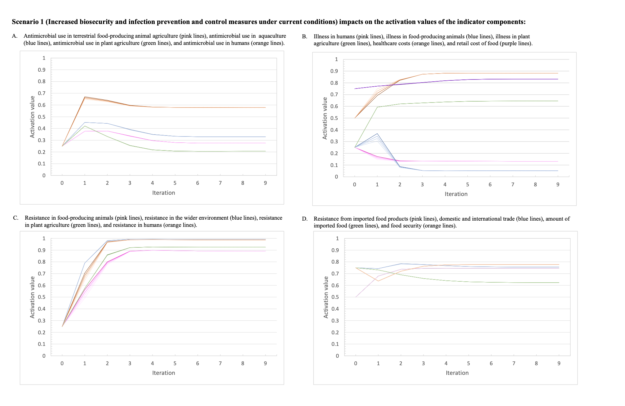
Supplementary Materials 1: Additional Figures
Figure S1: The activation values for the indicator variables over the nine iterations of the inference process for Scenario 1 which represents the intervention increasing infection prevention and control measures at three varying intensities (Scenarios 1.1, 1.2, 1.3) under current conditions.

The darkest line of each colour represents the baseline scenario, and the lightest dotted line represents the highest intensity of the intervention. (a) The activation values for: antimicrobial use in terrestrial food-producing animal agriculture (pink lines), antimicrobial use in aquaculture (blue lines), antimicrobial use in plant agriculture (green lines), and antimicrobial use in humans (orange lines). (b) The activation values for illness in humans (pink lines), illness in food-producing animals (blue lines), illness in plant agriculture (green lines), healthcare costs (orange lines), and retail cost of food (purple lines). (c) The activation values for: resistance in food-producing animals (pink lines), resistance in the wider environment (blue lines), resistance in plant agriculture (green lines), and resistance in humans (orange lines). (d) The activation values for: resistance from imported food products (pink lines), domestic and international trade (blue lines), amount of imported food (green lines), and food security (orange lines).
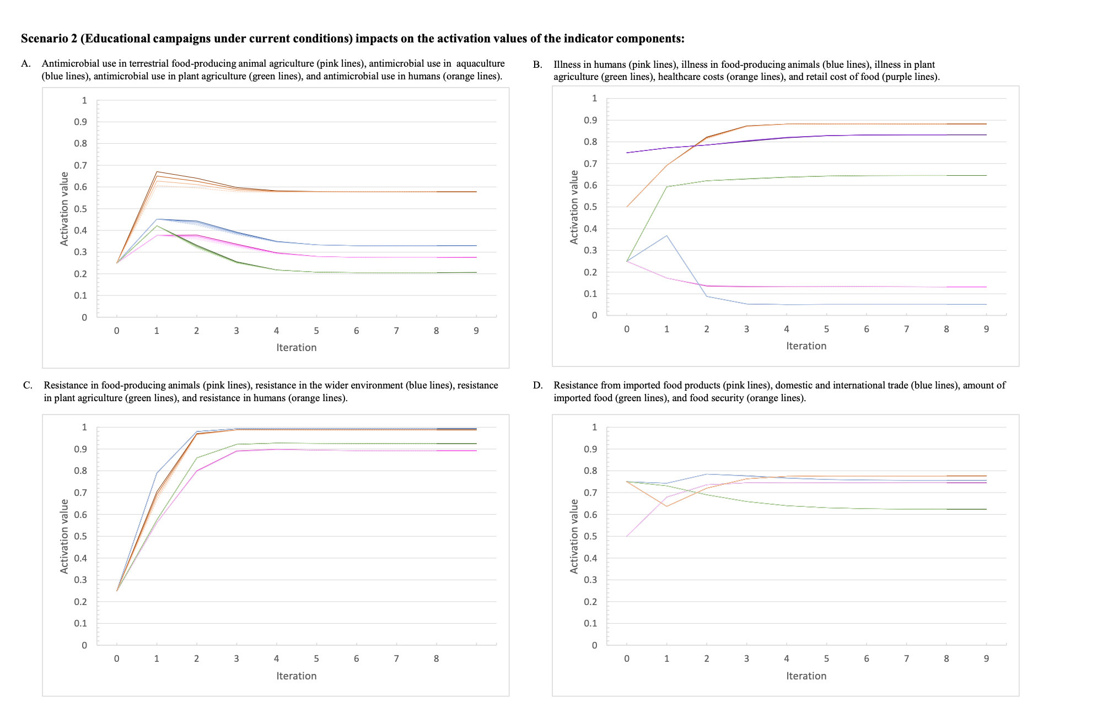
Figure S2: The activation values for the indicator variables over the nine iterations of the inference process for Scenario 2 which represents educational campaigns about appropriate antimicrobial use at three levels of intensity (Scenarios 2.1, 2.2, 2.3) under current conditions.

The darkest line of each colour represents the baseline scenario, and the lightest dotted line represents the highest intensity of the intervention. (a) The activation values for: antimicrobial use in terrestrial food-producing animal agriculture (pink lines), antimicrobial use in aquaculture (blue lines), antimicrobial use in plant agriculture (green lines), and antimicrobial use in humans (orange lines). (b) The activation values for illness in humans (pink lines), illness in food-producing animals (blue lines), illness in plant agriculture (green lines), healthcare costs (orange lines), and retail cost of food (purple lines). (c) The activation values for: resistance in food-producing animals (pink lines), resistance in the wider environment (blue lines), resistance in plant agriculture (green lines), and resistance in humans (orange lines). (d) The activation values for: resistance from imported food products (pink lines), domestic and international trade (blue lines), amount of imported food (green lines), and food security (orange lines).

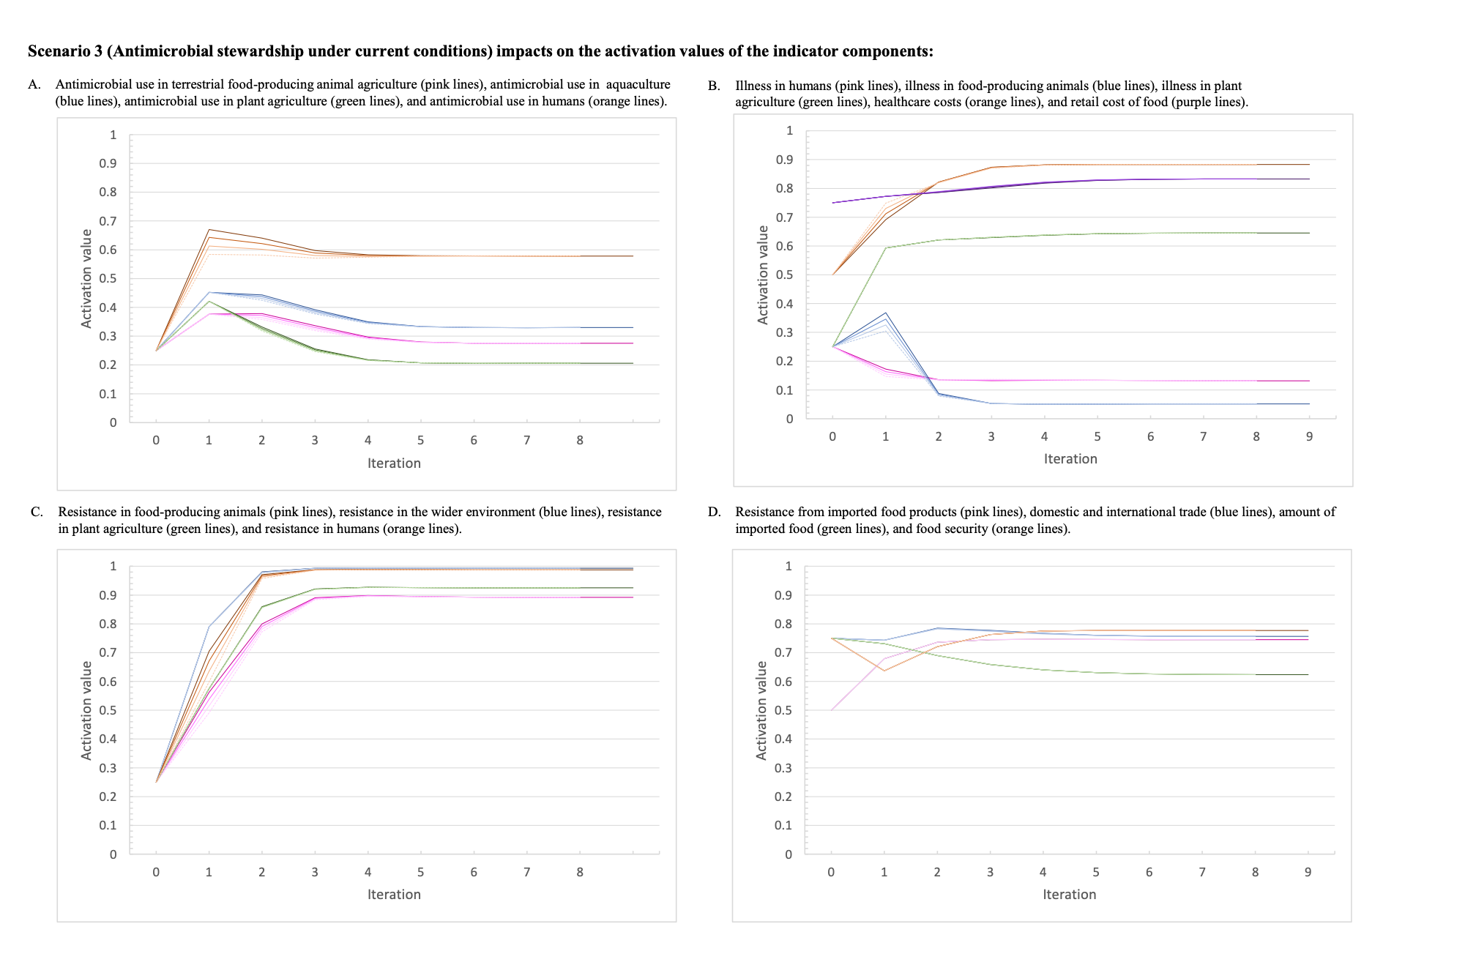
Figure S3: The activation values for the indicator variables over the nine iterations of the inference process for Scenario 3 which represents antimicrobial stewardship at three levels of intensity (Scenarios 3.1, 3.2, 3.3) under current conditions.

The darkest line of each colour represents the baseline scenario, and the lightest dotted line represents the highest intensity of the intervention. (a) The activation values for: antimicrobial use in terrestrial food-producing animal agriculture (pink lines), antimicrobial use in aquaculture (blue lines), antimicrobial use in plant agriculture (green lines), and antimicrobial use in humans (orange lines). (b) The activation values for illness in humans (pink lines), illness in food-producing animals (blue lines), illness in plant agriculture (green lines), healthcare costs (orange lines), and retail cost of food (purple lines). (c) The activation values for: resistance in food-producing animals (pink lines), resistance in the wider environment (blue lines), resistance in plant agriculture (green lines), and resistance in humans (orange lines). (d) The activation values for: resistance from imported food products (pink lines), domestic and international trade (blue lines), amount of imported food (green lines), and food security (orange lines).
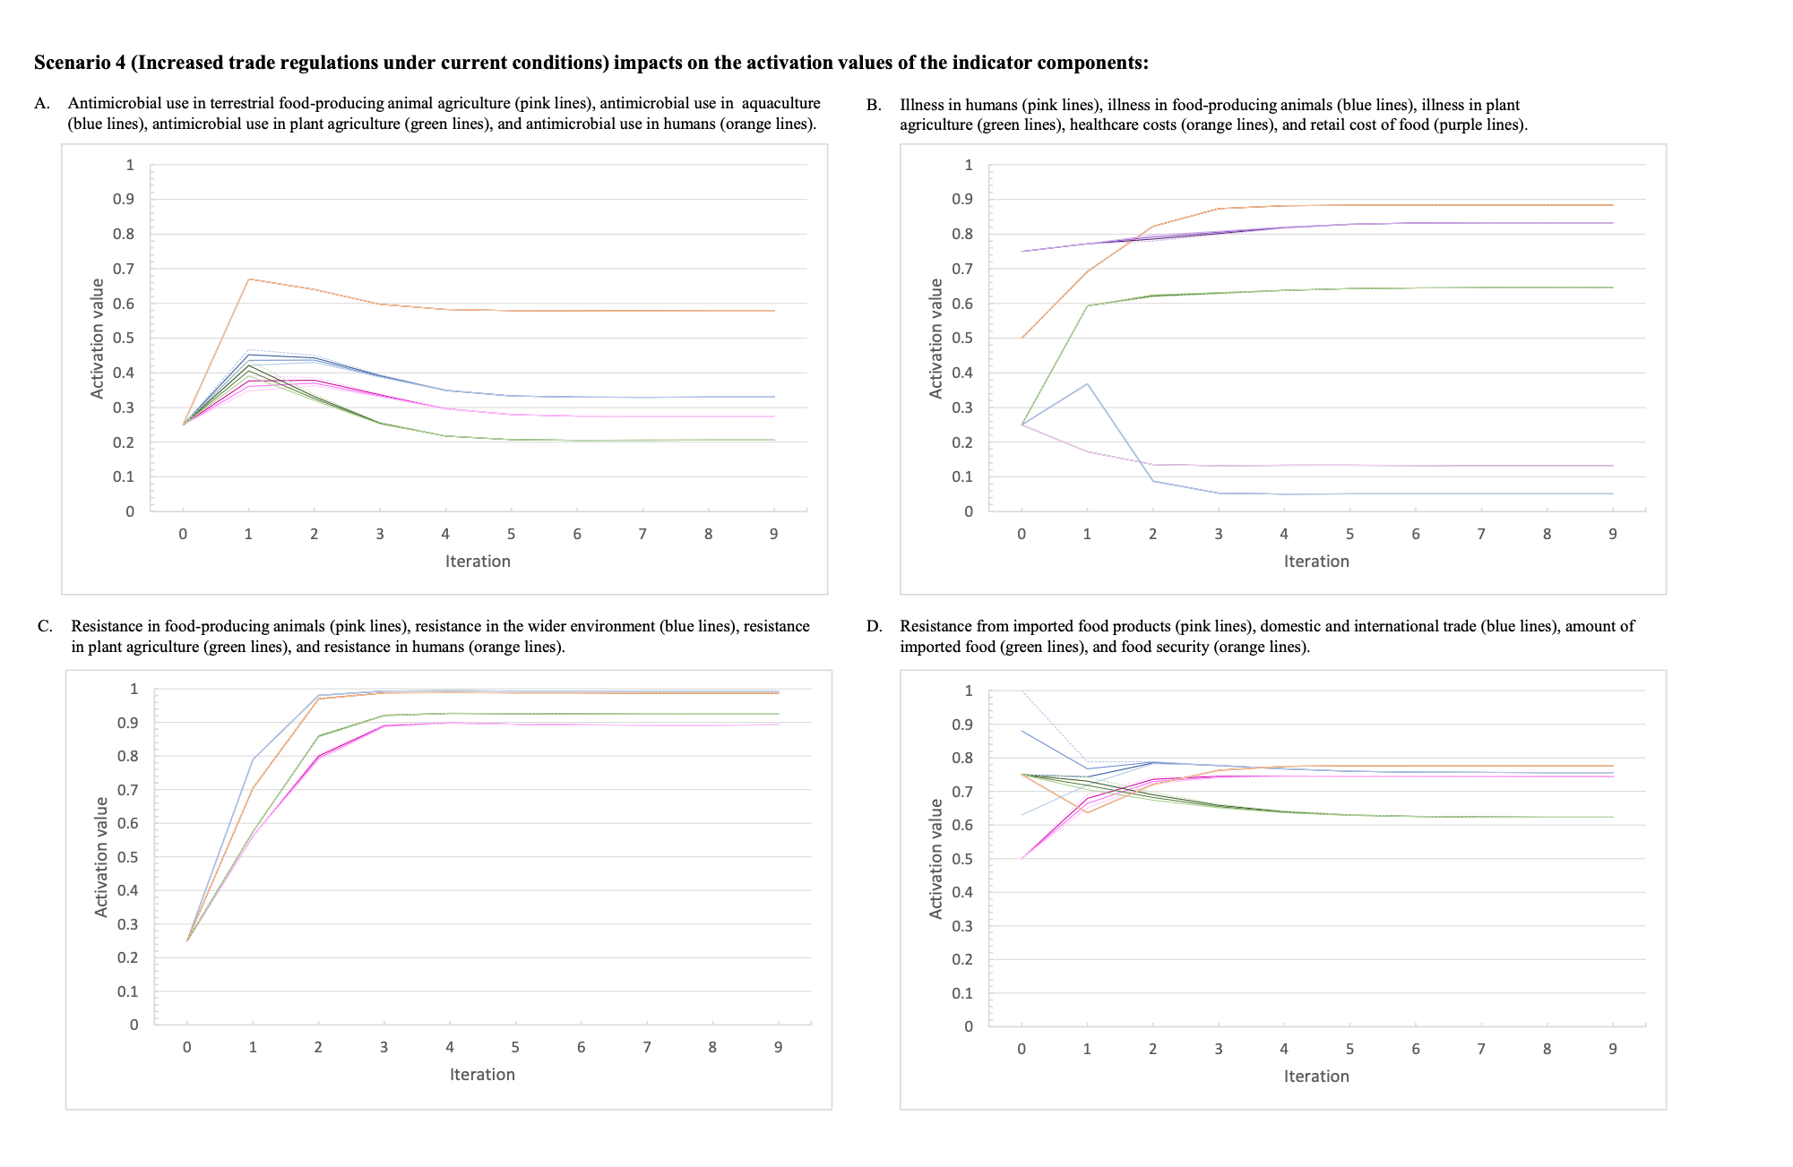
Figure S4: The activation values for the indicator variables over the nine iterations of the inference process for Scenario 4 which represents increased trade regulations at three levels (Scenarios 4.1, 4.2, 4.3) of intensity under current conditions.

The darkest line of each colour represents the baseline scenario, and the lightest dotted line represents the highest intensity of the intervention. (a) The activation values for: antimicrobial use in terrestrial food-producing animal agriculture (pink lines), antimicrobial use in aquaculture (blue lines), antimicrobial use in plant agriculture (green lines), and antimicrobial use in humans (orange lines). (b) The activation values for illness in humans (pink lines), illness in food-producing animals (blue lines), illness in plant agriculture (green lines), healthcare costs (orange lines), and retail cost of food (purple lines). (c) The activation values for: resistance in food-producing animals (pink lines), resistance in the wider environment (blue lines), resistance in plant agriculture (green lines), and resistance in humans (orange lines). (d) The activation values for: resistance from imported food products (pink lines), domestic and international trade (blue lines), amount of imported food (green lines), and food security (orange lines).

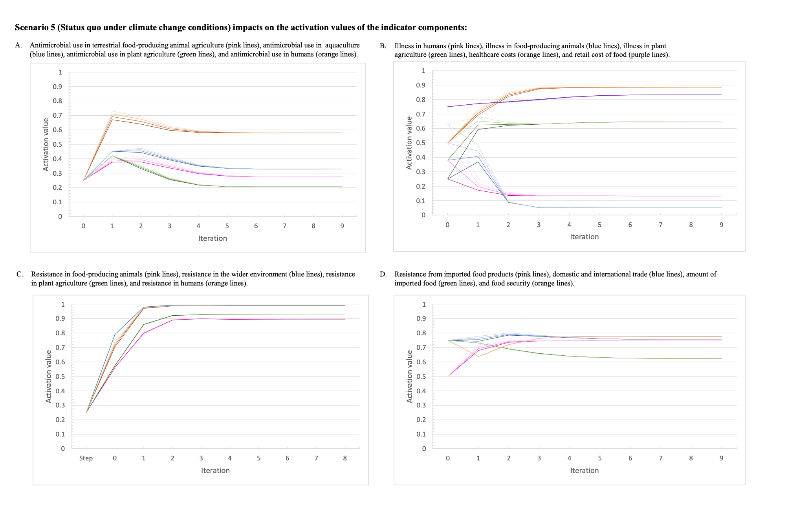
Figure S5: The activation values for the indicator variables over the nine iterations of the inference process for Scenario 5 which represents the baseline scenario under climate change conditions at three levels of intensity (Scenarios 5.1, 5.2, 5.3) under climate change conditions.

The dotted line represents the baseline scenario, the darkest line of each colour represents the baseline scenario under climate change and the lightest dotted line represents the highest intensity of the intervention. (a) The activation values for: antimicrobial use in terrestrial food-producing animal agriculture (pink lines), antimicrobial use in aquaculture (blue lines), antimicrobial use in plant agriculture (green lines), and antimicrobial use in humans (orange lines). (b) The activation values for illness in humans (pink lines), illness in food-producing animals (blue lines), illness in plant agriculture (green lines), healthcare costs (orange lines), and retail cost of food (purple lines). (c) The activation values for: resistance in food-producing animals (pink lines), resistance in the wider environment (blue lines), resistance in plant agriculture (green lines), and resistance in humans (orange lines). (d) The activation values for: resistance from imported food products (pink lines), domestic and international trade (blue lines), amount of imported food (green lines), and food security (orange lines).
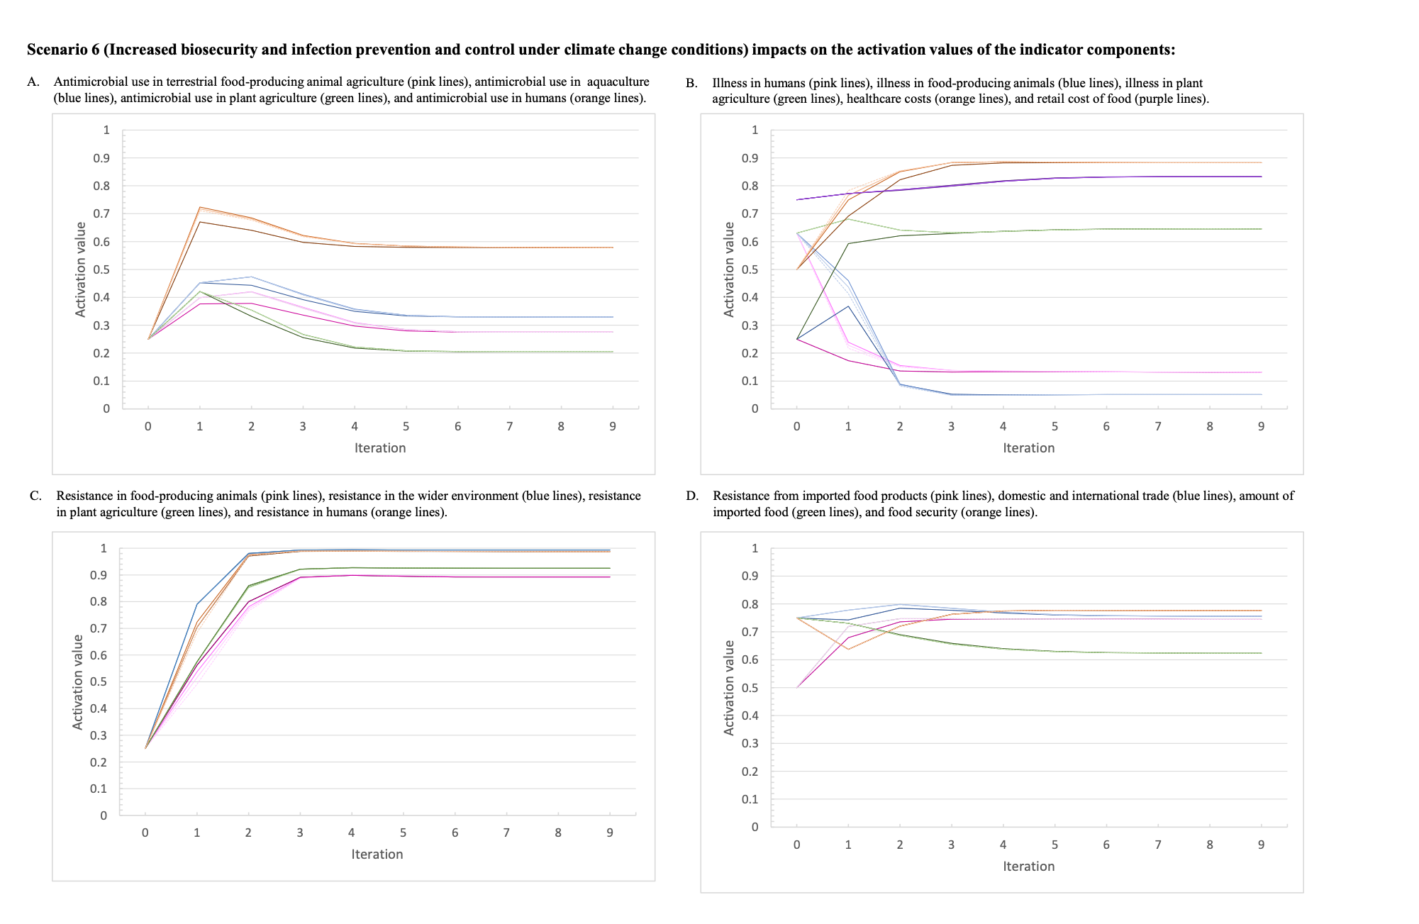
Figure S6: The activation values for the indicator variables over the nine iterations of the inference process for Scenario 6 which represents increased infection and prevention measures at three levels of intensity (Scenarios 6.1, 6.2, 6.3) under climate change conditions.

The dotted line represents the baseline scenario, the darkest line of each colour represents the baseline scenario under climate change and the lightest dotted line represents the highest intensity of the intervention. (a) The activation values for: antimicrobial use in terrestrial food-producing animal agriculture (pink lines), antimicrobial use in aquaculture (blue lines), antimicrobial use in plant agriculture (green lines), and antimicrobial use in humans (orange lines). (b) The activation values for illness in humans (pink lines), illness in food-producing animals (blue lines), illness in plant agriculture (green lines), healthcare costs (orange lines), and retail cost of food (purple lines). (c) The activation values for: resistance in food-producing animals (pink lines), resistance in the wider environment (blue lines), resistance in plant agriculture (green lines), and resistance in humans (orange lines). (d) The activation values for: resistance from imported food products (pink lines), domestic and international trade (blue lines), amount of imported food (green lines), and food security (orange lines).
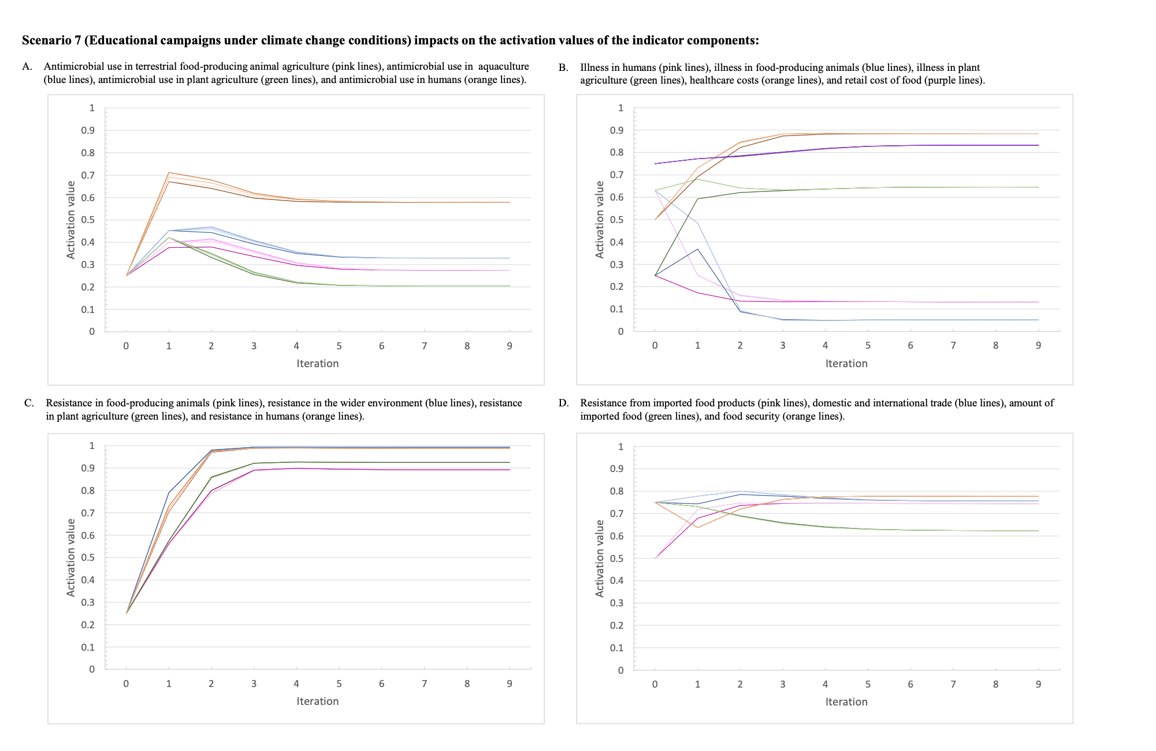
Figure S7: The activation values for the indicator variables over the nine iterations of the inference process for Scenario 7 (Scenarios 7.1, 7.2, 7.3) which represents educational campaigns at three levels of intensity under climate change conditions.

The dotted line represents the baseline scenario, the darkest line of each colour represents the baseline scenario under climate change and the lightest dotted line represents the highest intensity of the intervention. (a) The activation values for: antimicrobial use in terrestrial food-producing animal agriculture (pink lines), antimicrobial use in aquaculture (blue lines), antimicrobial use in plant agriculture (green lines), and antimicrobial use in humans (orange lines). (b) The activation values for illness in humans (pink lines), illness in food-producing animals (blue lines), illness in plant agriculture (green lines), healthcare costs (orange lines), and retail cost of food (purple lines). (c) The activation values for: resistance in food-producing animals (pink lines), resistance in the wider environment (blue lines), resistance in plant agriculture (green lines), and resistance in humans (orange lines). (d) The activation values for: resistance from imported food products (pink lines), domestic and international trade (blue lines), amount of imported food (green lines), and food security (orange lines).
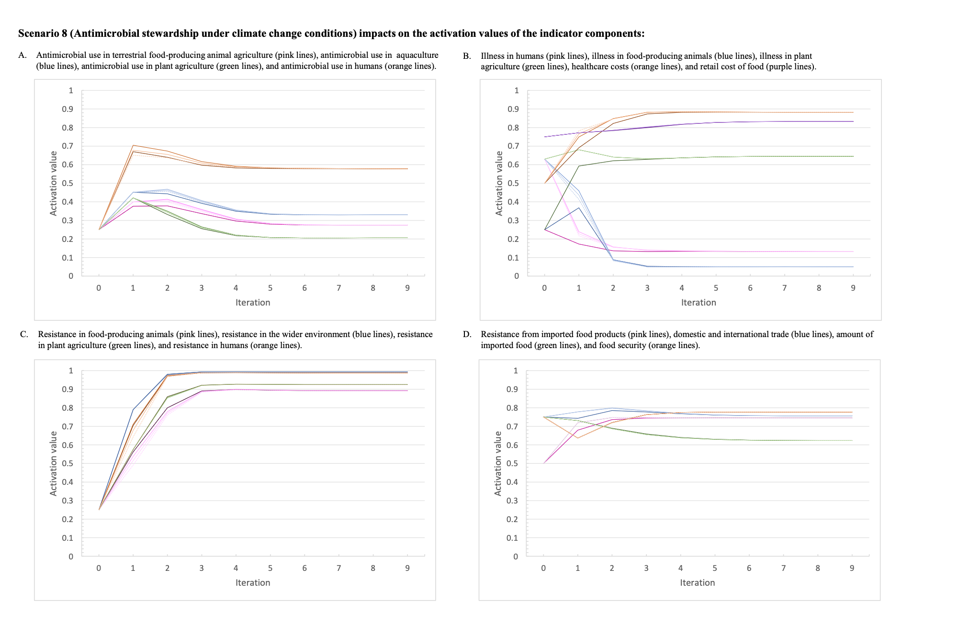
Figure S8: The activation values for the indicator variables over the nine iterations of the inference process for Scenario 8 which represents antimicrobial stewardship at three levels of intensity (Scenarios 8.1, 8.2, 8.3) under climate change conditions.

The dotted line represents the baseline scenario, the darkest line of each colour represents the baseline scenario under climate change and the lightest dotted line represents the highest intensity of the intervention. (a) The activation values for: antimicrobial use in terrestrial food-producing animal agriculture (pink lines), antimicrobial use in aquaculture (blue lines), antimicrobial use in plant agriculture (green lines), and antimicrobial use in humans (orange lines). (b) The activation values for illness in humans (pink lines), illness in food-producing animals (blue lines), illness in plant agriculture (green lines), healthcare costs (orange lines), and retail cost of food (purple lines). (c) The activation values for: resistance in food-producing animals (pink lines), resistance in the wider environment (blue lines), resistance in plant agriculture (green lines), and resistance in humans (orange lines). (d) The activation values for: resistance from imported food products (pink lines), domestic and international trade (blue lines), amount of imported food (green lines), and food security (orange lines).
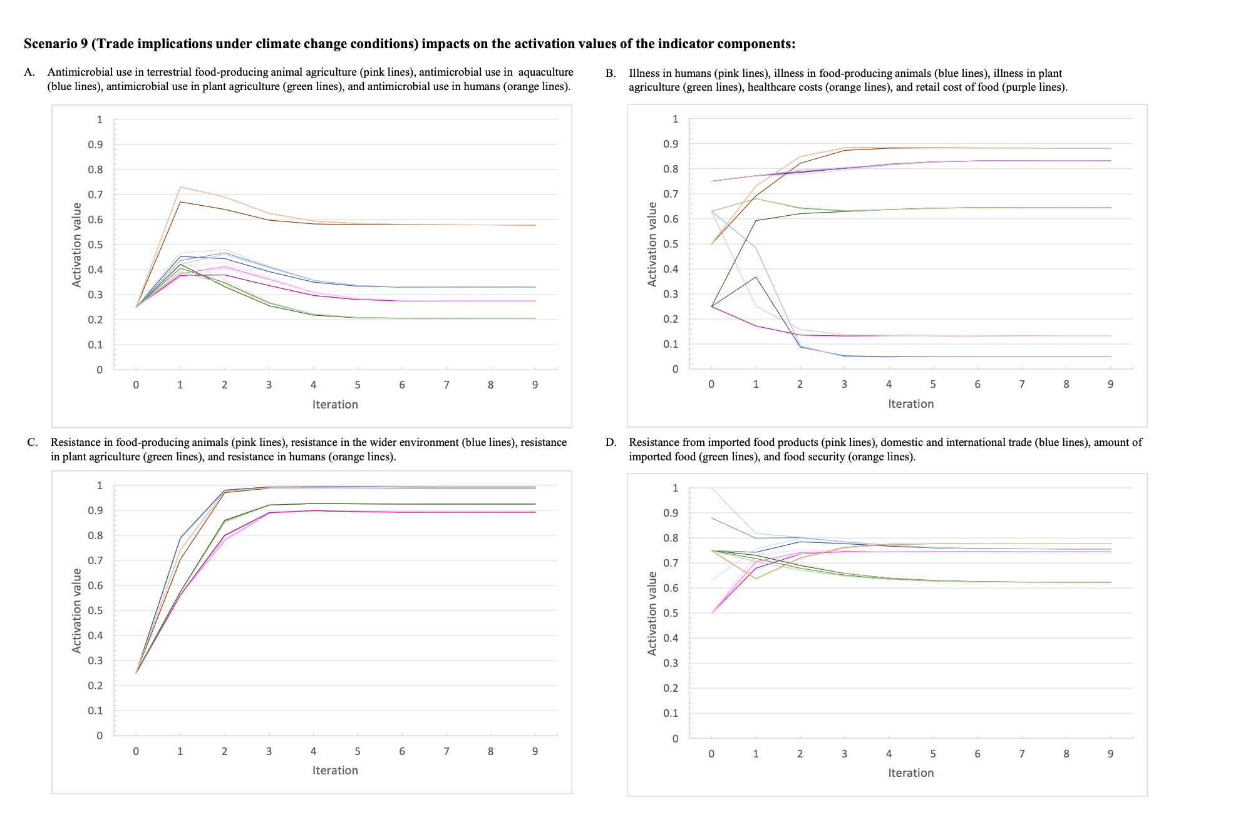
Figure S9: The activation values for the indicator variables over the nine iterations of the inference process for Scenario 9 which represents increased trade regulations at three levels of intensity (Scenarios 9.1, 9.2, 9.3) under climate change conditions.

The dotted line represents the baseline scenario, the darkest line of each colour represents the baseline scenario under climate change and the lightest dotted line represents the highest intensity of the intervention. (a) The activation values for: antimicrobial use in terrestrial food-producing animal agriculture (pink lines), antimicrobial use in aquaculture (blue lines), antimicrobial use in plant agriculture (green lines), and antimicrobial use in humans (orange lines). (b) The activation values for illness in humans (pink lines), illness in food-producing animals (blue lines), illness in plant agriculture (green lines), healthcare costs (orange lines), and retail cost of food (purple lines). (c) The activation values for: resistance in food-producing animals (pink lines), resistance in the wider environment (blue lines), resistance in plant agriculture (green lines), and resistance in humans (orange lines). (d) The activation values for: resistance from imported food products (pink lines), domestic and international trade (blue lines), amount of imported food (green lines), and food security (orange lines).
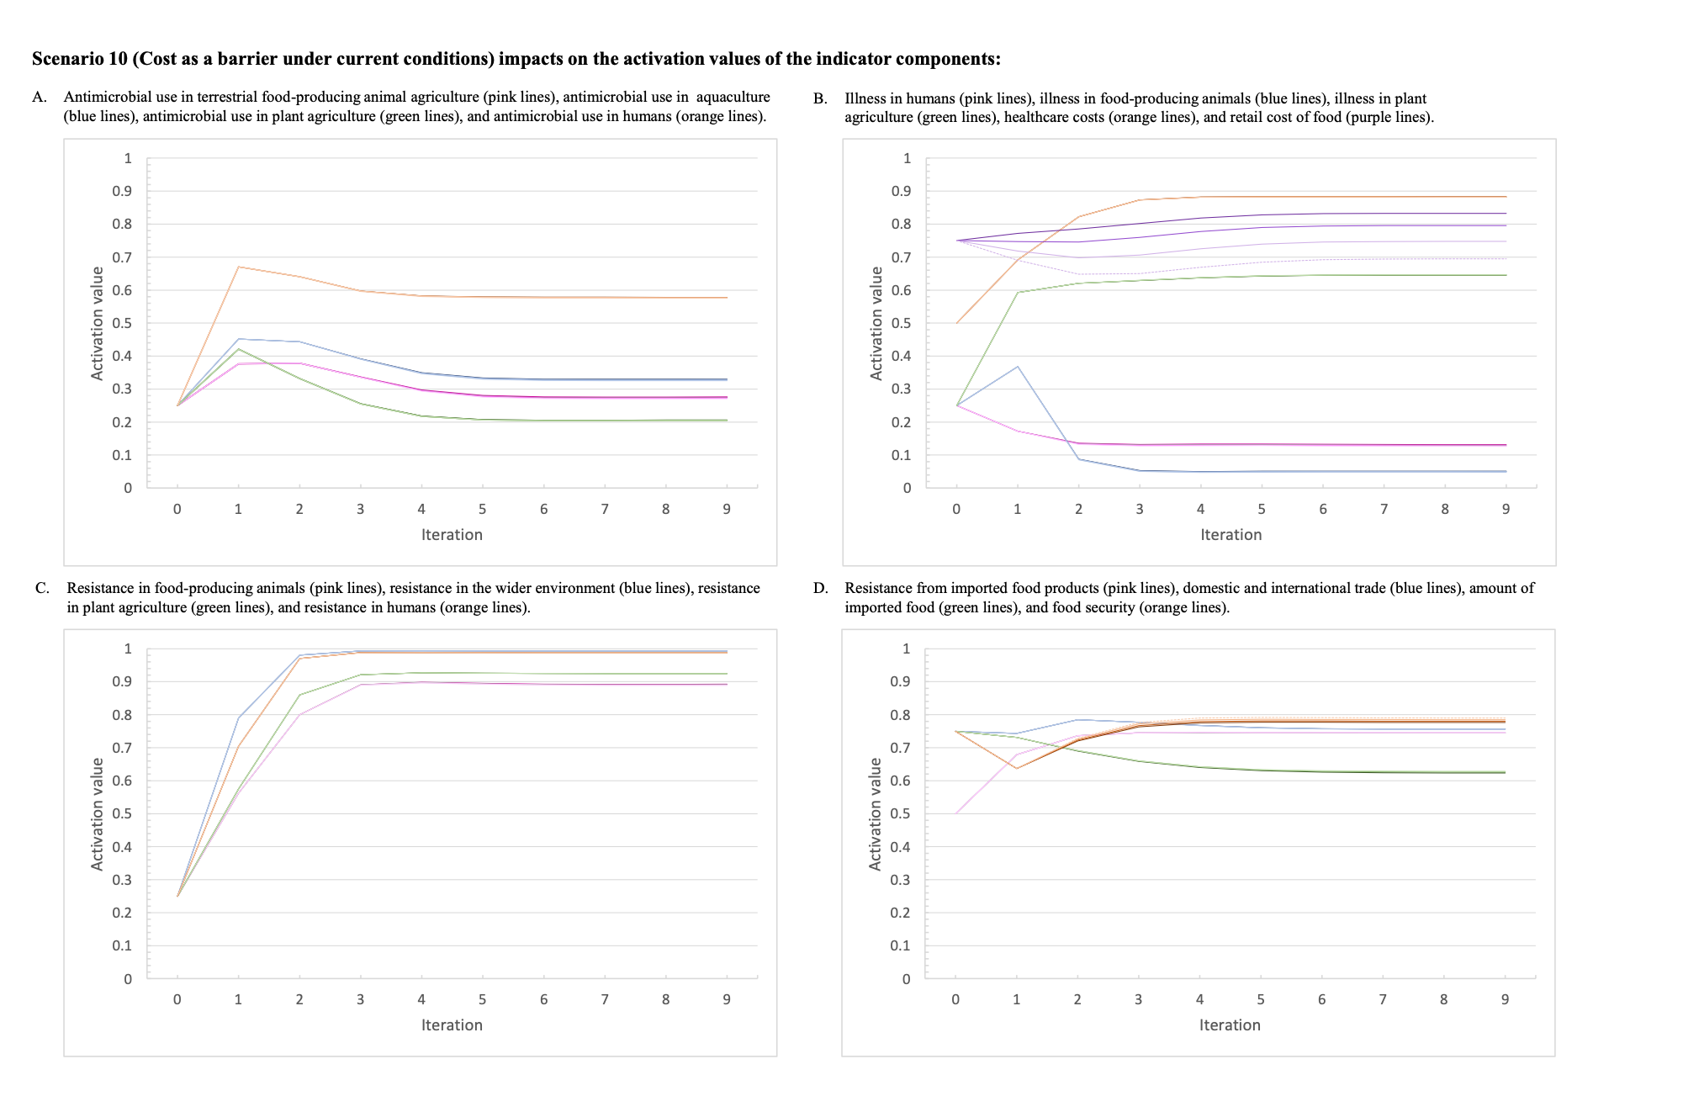
Figure S10: The activation values for the indicator variables over the nine iterations of the inference process for Scenario 10 which represents reducing cost as a barrier to sustainable and nutritious food at three levels of intensity (Scenarios 10.1, 10.2, 10.3) under current conditions.

The darkest line of each colour represents the baseline scenario and the lightest dotted line represents the highest intensity of the intervention. (a) The activation values for: antimicrobial use in terrestrial food-producing animal agriculture (pink lines), antimicrobial use in aquaculture (blue lines), antimicrobial use in plant agriculture (green lines), and antimicrobial use in humans (orange lines). (b) The activation values for illness in humans (pink lines), illness in food-producing animals (blue lines), illness in plant agriculture (green lines), healthcare costs (orange lines), and retail cost of food (purple lines). (c) The activation values for: resistance in food-producing animals (pink lines), resistance in the wider environment (blue lines), resistance in plant agriculture (green lines), and resistance in humans (orange lines). (d) The activation values for: resistance from imported food products (pink lines), domestic and international trade (blue lines), amount of imported food (green lines), and food security (orange lines).
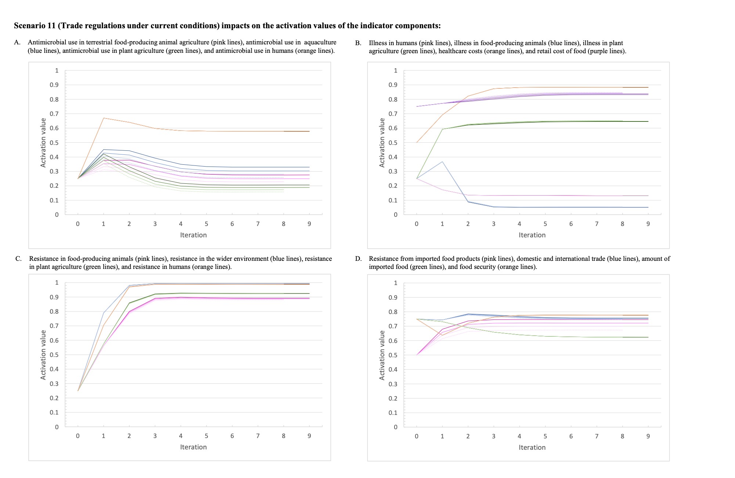
Figure S11: The activation values for the indicator variables over the nine iterations of the inference process for Scenario 11 which represents increased international trade regulations and implementation at three levels of intensity (Scenarios 11.1, 11.2, 11.3) under current conditions.

The darkest line of each colour represents the baseline scenario and the lightest dotted line represents the highest intensity of the intervention. (a) The activation values for: antimicrobial use in terrestrial food-producing animal agriculture (pink lines), antimicrobial use in aquaculture (blue lines), antimicrobial use in plant agriculture (green lines), and antimicrobial use in humans (orange lines). (b) The activation values for illness in humans (pink lines), illness in food-producing animals (blue lines), illness in plant agriculture (green lines), healthcare costs (orange lines), and retail cost of food (purple lines). (c) The activation values for: resistance in food-producing animals (pink lines), resistance in the wider environment (blue lines), resistance in plant agriculture (green lines), and resistance in humans (orange lines). (d) The activation values for: resistance from imported food products (pink lines), domestic and international trade (blue lines), amount of imported food (green lines), and food security (orange lines).
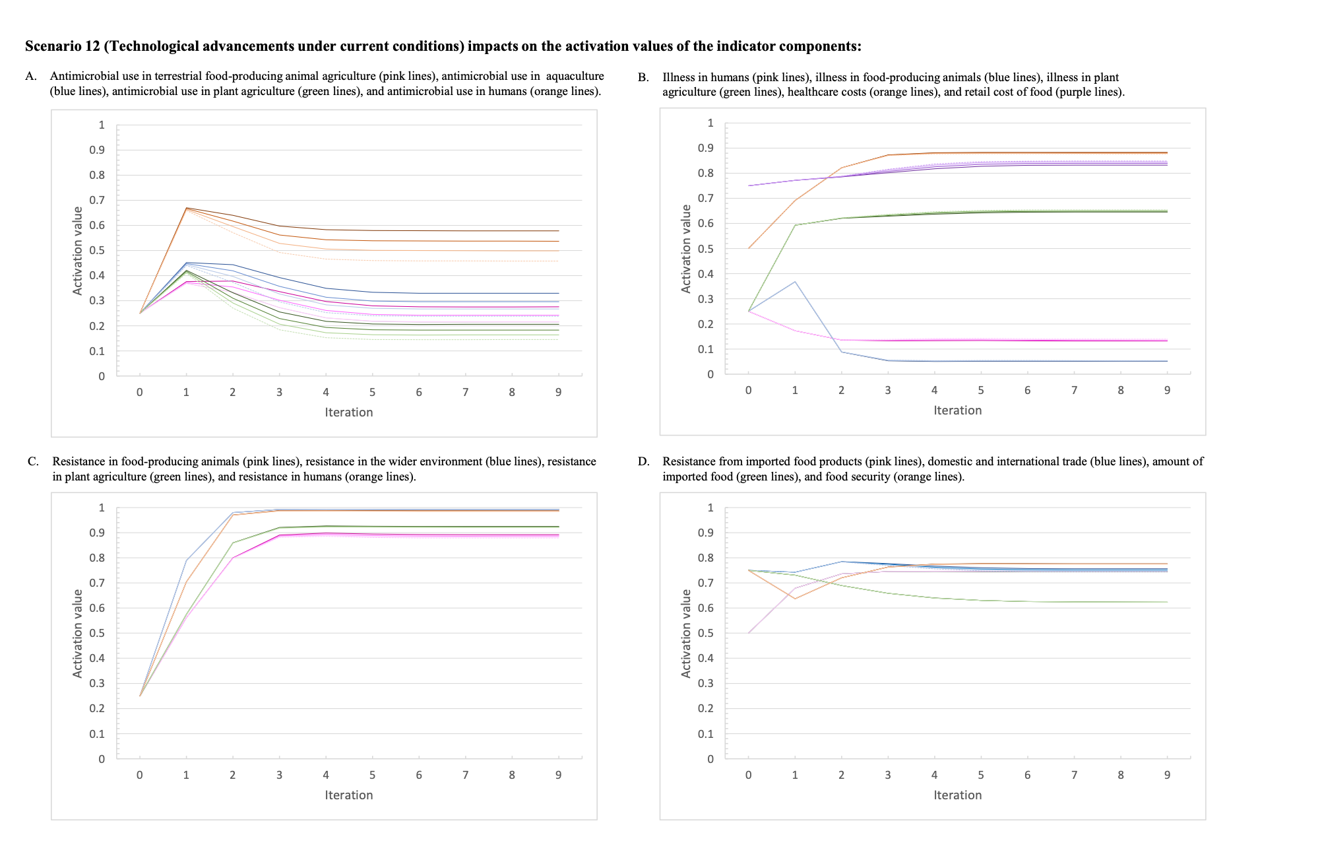
Figure S12: The activation values for the indicator variables over the nine iterations of the inference process for Scenario 12 which represents technological advancements and innovation at three levels of intensity (Scenarios 12.1, 12.2, 12.3) under current conditions.

The darkest line of each colour represents the baseline scenario and the lightest dotted line represents the highest intensity of the intervention. (a) The activation values for: antimicrobial use in terrestrial food-producing animal agriculture (pink lines), antimicrobial use in aquaculture (blue lines), antimicrobial use in plant agriculture (green lines), and antimicrobial use in humans (orange lines). (b) The activation values for illness in humans (pink lines), illness in food-producing animals (blue lines), illness in plant agriculture (green lines), healthcare costs (orange lines), and retail cost of food (purple lines). (c) The activation values for: resistance in food-producing animals (pink lines), resistance in the wider environment (blue lines), resistance in plant agriculture (green lines), and resistance in humans (orange lines). (d) The activation values for: resistance from imported food products (pink lines), domestic and international trade (blue lines), amount of imported food (green lines), and food security (orange lines).

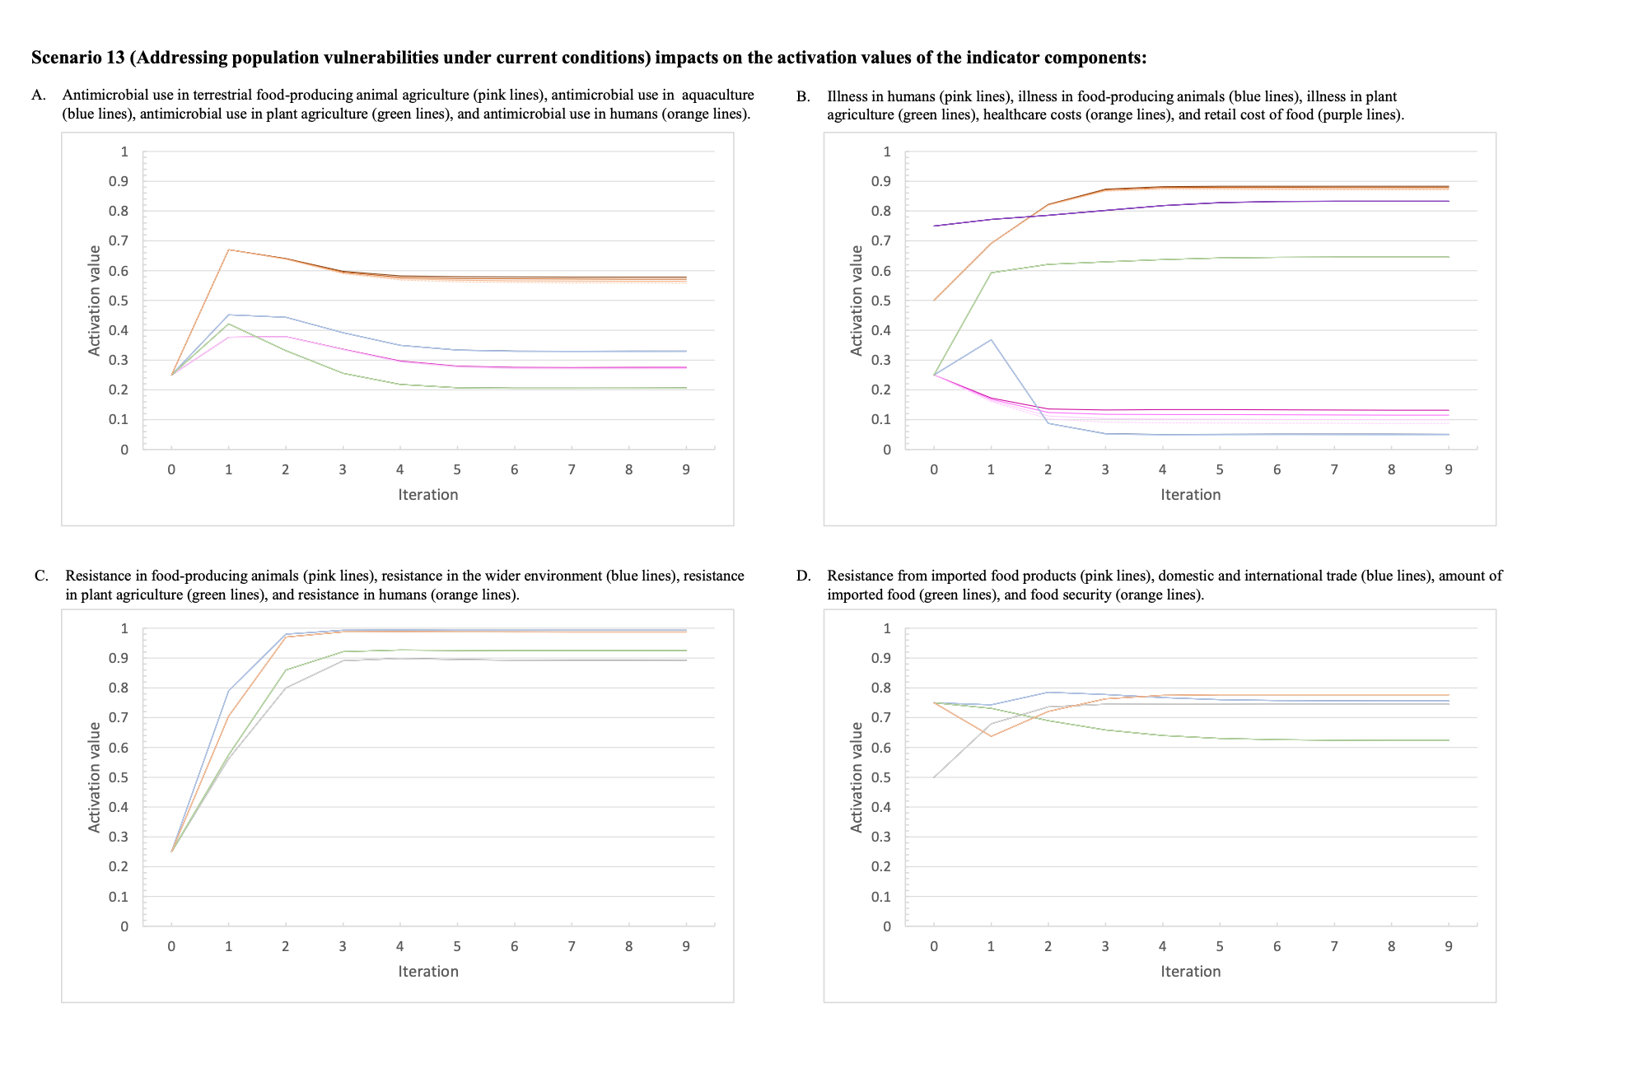
Figure S13: The activation values for the indicator variables over the nine iterations of the inference process for Scenario 13 which represents addressing poverty and social inequalities at three levels of intensity (Scenarios 13.1, 13.2, 13.3) under current conditions.

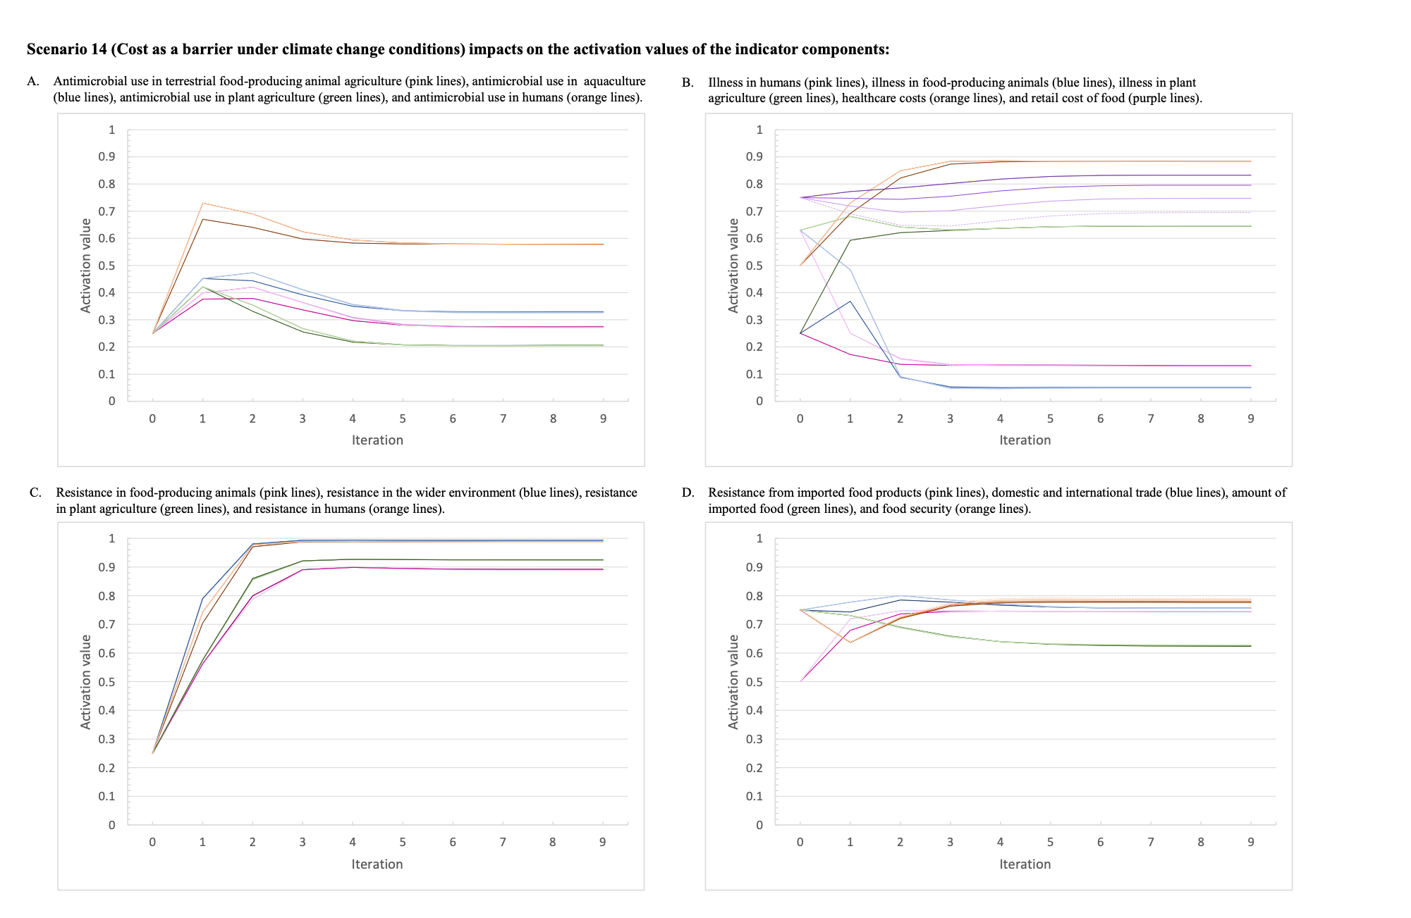
The darkest line of each colour represents the baseline scenario and the lightest dotted line represents the highest intensity of the intervention. (a) The activation values for: antimicrobial use in terrestrial food-producing animal agriculture (pink lines), antimicrobial use in aquaculture (blue lines), antimicrobial use in plant agriculture (green lines), and antimicrobial use in humans (orange lines). (b) The activation values for illness in humans (pink lines), illness in food-producing animals (blue lines), illness in plant agriculture (green lines), healthcare costs (orange lines), and retail cost of food (purple lines). (c) The activation values for: resistance in food-producing animals (pink lines), resistance in the wider environment (blue lines), resistance in plant agriculture (green lines), and resistance in humans (orange lines). (d) The activation values for: resistance from imported food products (pink lines), domestic and international trade (blue lines), amount of imported food (green lines), and food security (orange lines). Figure S14: The activation values for the indicator variables over the nine iterations of the inference process for Scenarios 14 which represents reducing cost as a barrier to nutritious food and sustainable agricultural practices at three levels of intensity (Scenarios 14.1, 14.2, 14.3) under climate change conditions.

The dotted line represents the baseline scenario, the darkest line of each colour represents the baseline scenario under climate change and the lightest dotted line represents the highest intensity of the intervention. (a) The activation values for: antimicrobial use in terrestrial food-producing animal agriculture (pink lines), antimicrobial use in aquaculture (blue lines), antimicrobial use in plant agriculture (green lines), and antimicrobial use in humans (orange lines). (b) The activation values for illness in humans (pink lines), illness in food-producing animals (blue lines), illness in plant agriculture (green lines), healthcare costs (orange lines), and retail cost of food (purple lines). (c) The activation values for: resistance in food-producing animals (pink lines), resistance in the wider environment (blue lines), resistance in plant agriculture (green lines), and resistance in humans (orange lines). (d) The activation values for: resistance from imported food products (pink lines), domestic and international trade (blue lines), amount of imported food (green lines), and food security (orange lines).
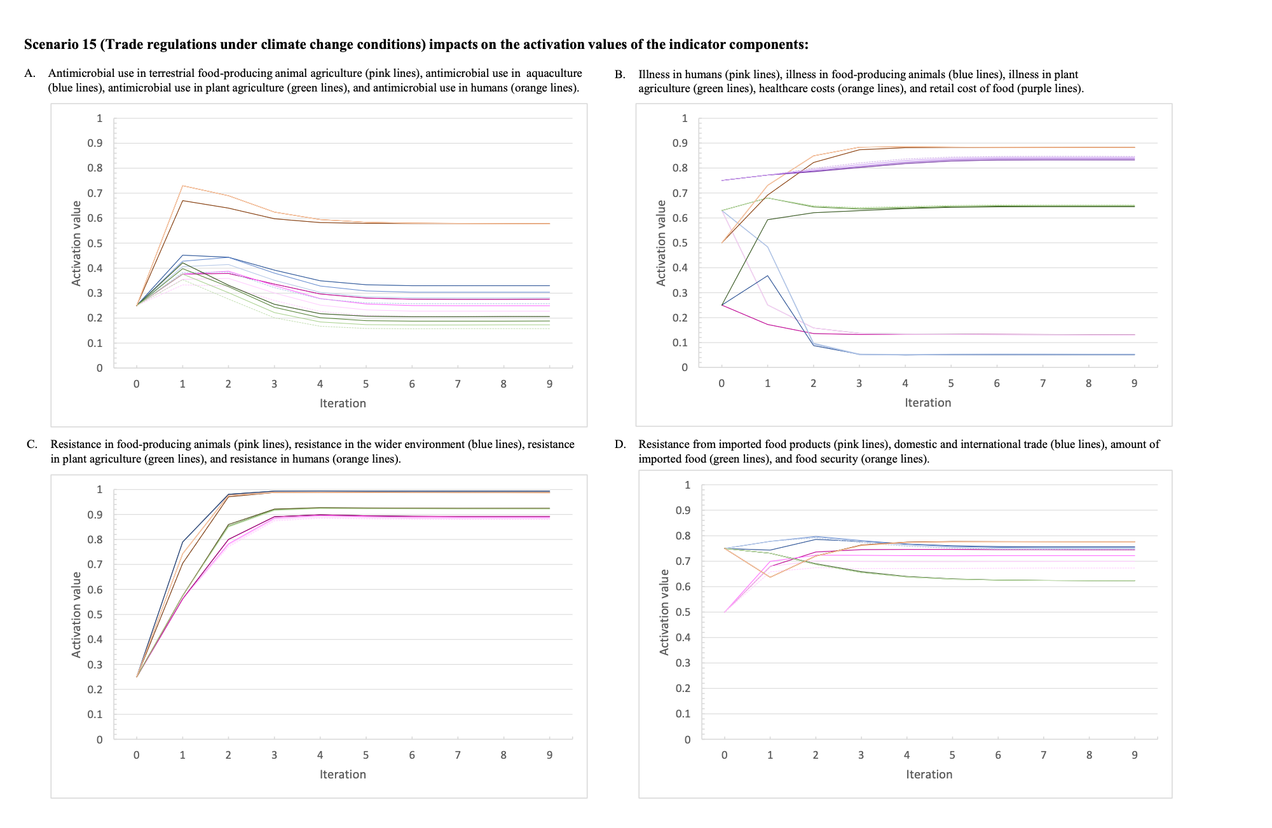
Figure S15: The activation values for the indicator variables over the nine iterations of the inference process for Scenario 15 which represents increased international trade regulations and implementation at three levels of intensity (Scenarios 15.1, 15.2, 15.3) under climate change conditions.

The dotted line represents the baseline scenario, the darkest line of each colour represents the baseline scenario under climate change and the lightest dotted line represents the highest intensity of the intervention. (a) The activation values for: antimicrobial use in terrestrial food-producing animal agriculture (pink lines), antimicrobial use in aquaculture (blue lines), antimicrobial use in plant agriculture (green lines), and antimicrobial use in humans (orange lines). (b) The activation values for illness in humans (pink lines), illness in food-producing animals (blue lines), illness in plant agriculture (green lines), healthcare costs (orange lines), and retail cost of food (purple lines). (c) The activation values for: resistance in food-producing animals (pink lines), resistance in the wider environment (blue lines), resistance in plant agriculture (green lines), and resistance in humans (orange lines). (d) The activation values for: resistance from imported food products (pink lines), domestic and international trade (blue lines), amount of imported food (green lines), and food security (orange lines).
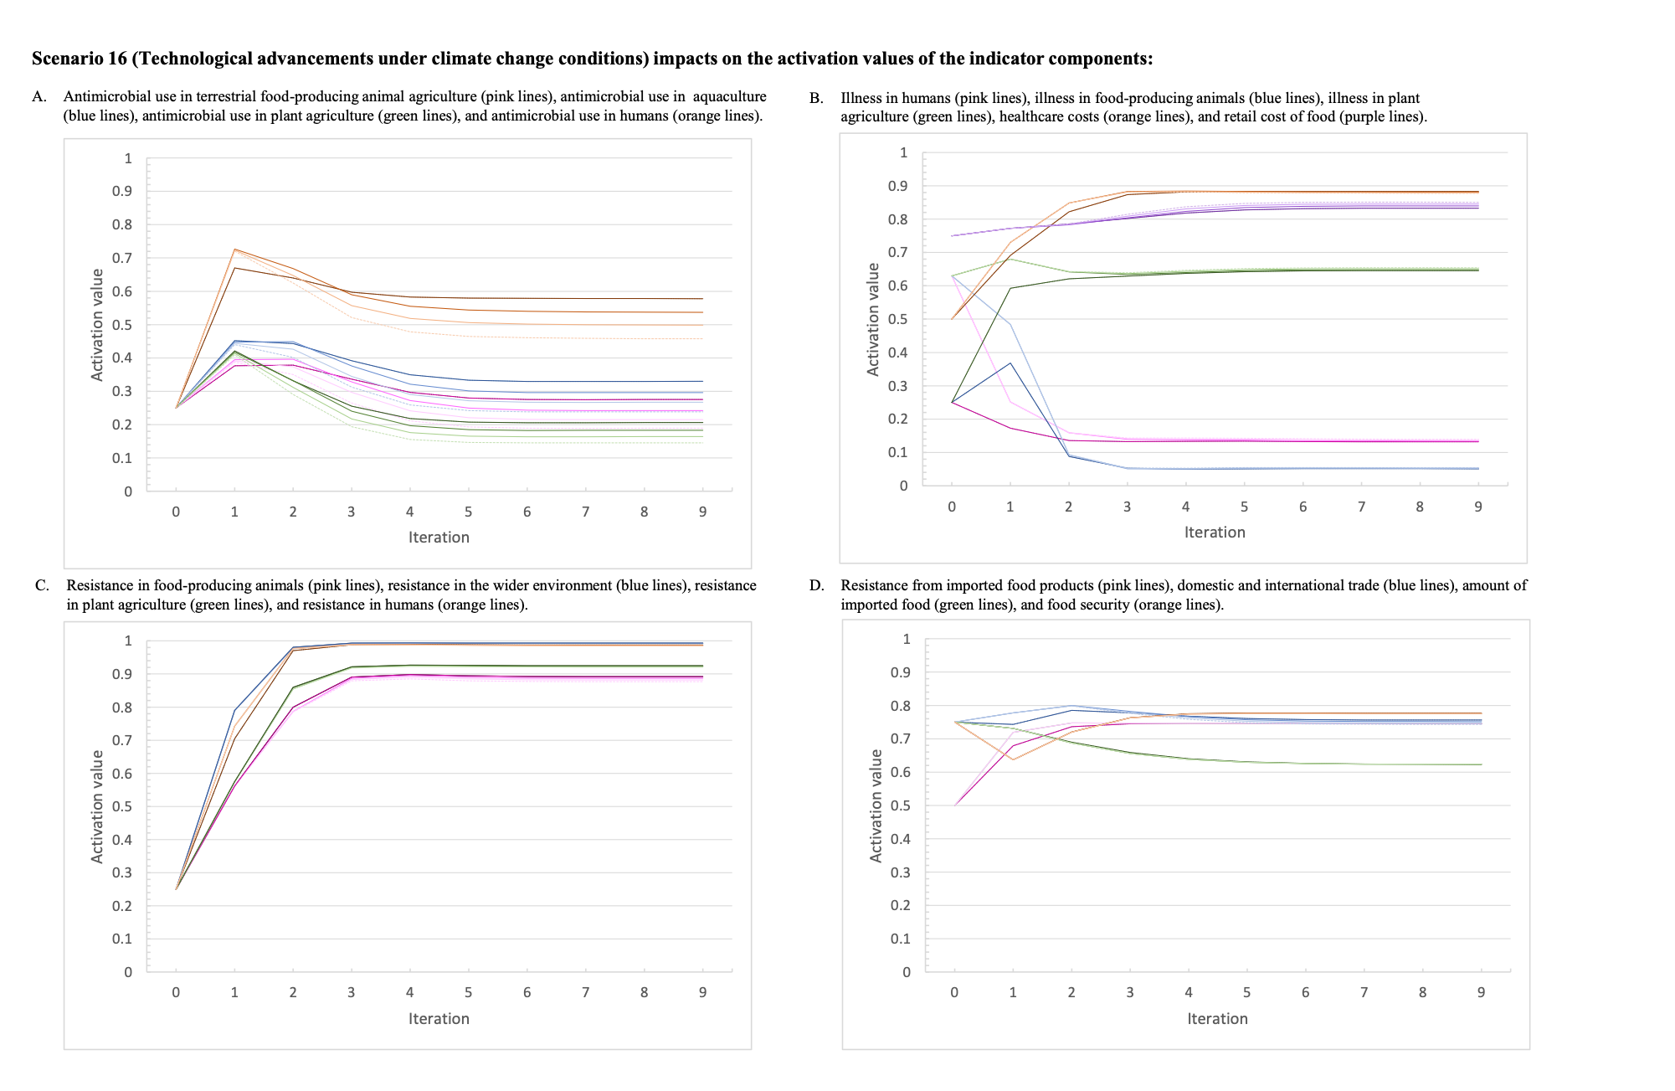
Figure S16: The activation values for the indicator variables over the nine iterations of the inference process for Scenario 16 which represents technological advancements and innovation at three levels of intensity (Scenarios 16.1, 16.2, 16.3) under climate change conditions.

The dotted line represents the baseline scenario, the darkest line of each colour represents the baseline scenario under climate change and the lightest dotted line represents the highest intensity of the intervention. (a) The activation values for: antimicrobial use in terrestrial food-producing animal agriculture (pink lines), antimicrobial use in aquaculture (blue lines), antimicrobial use in plant agriculture (green lines), and antimicrobial use in humans (orange lines). (b) The activation values for illness in humans (pink lines), illness in food-producing animals (blue lines), illness in plant agriculture (green lines), healthcare costs (orange lines), and retail cost of food (purple lines). (c) The activation values for: resistance in food-producing animals (pink lines), resistance in the wider environment (blue lines), resistance in plant agriculture (green lines), and resistance in humans (orange lines). (d) The activation values for: resistance from imported food products (pink lines), domestic and international trade (blue lines), amount of imported food (green lines), and food security (orange lines).
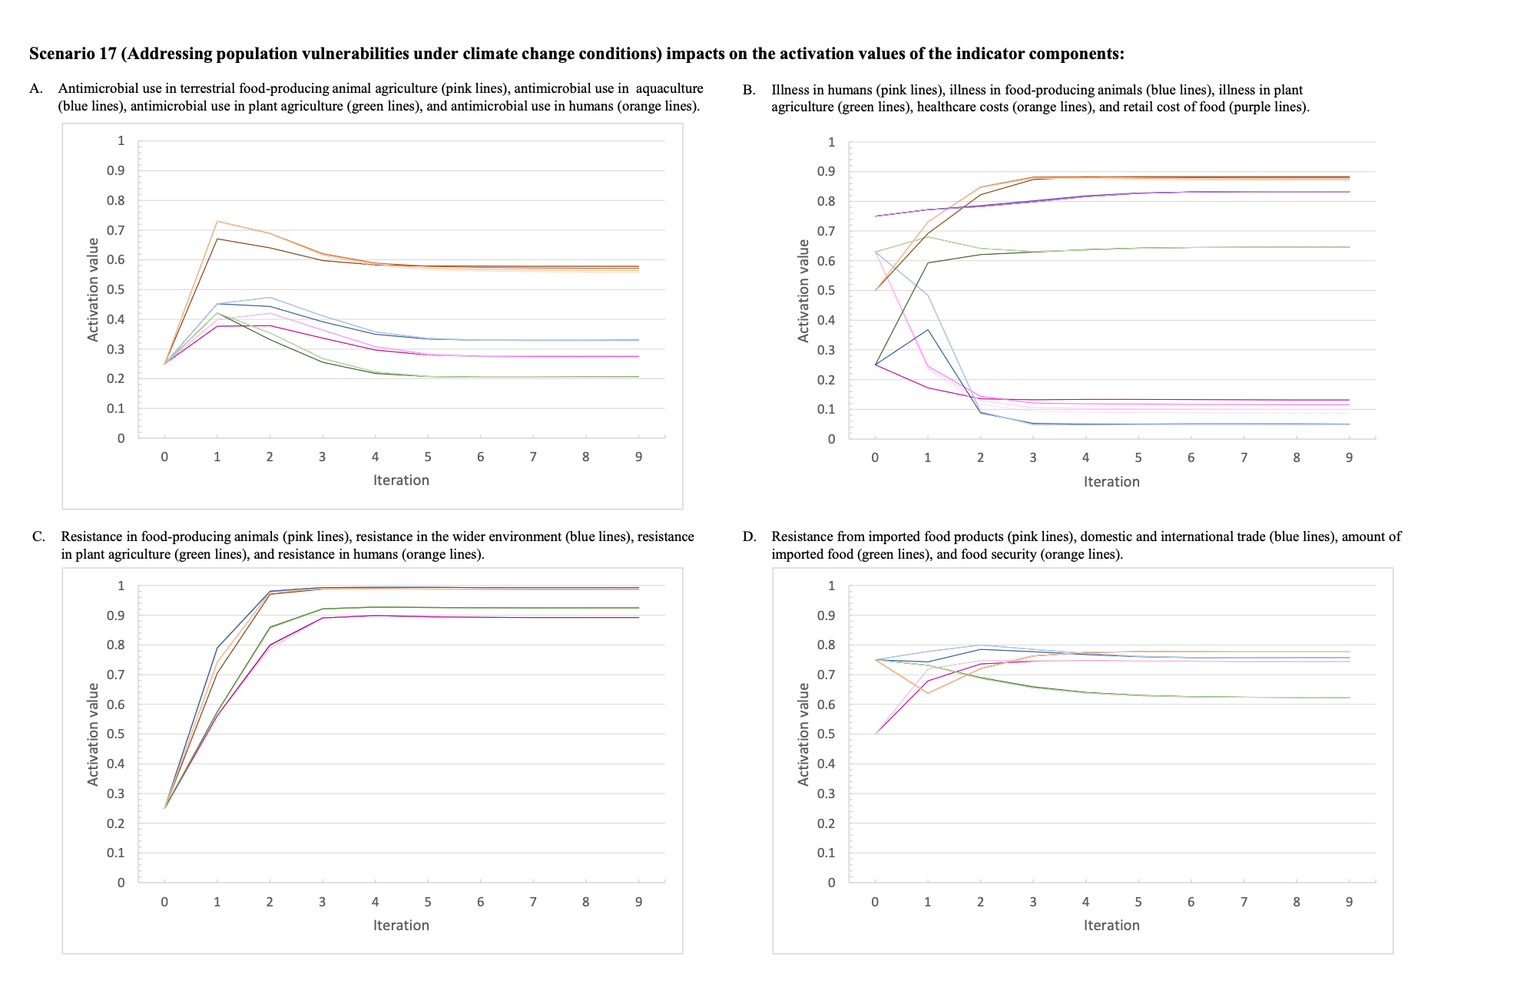
Figure S17: The activation values for the indicator variables over the nine iterations of the inference process for Scenario 17 which represents addressing poverty and social inequalities at three levels of intensity (Scenarios 17.1, 17.2, 17.3) under climate change conditions.

The dotted line represents the baseline scenario, the darkest line of each colour represents the baseline scenario under climate change and the lightest dotted line represents the highest intensity of the intervention. (a) The activation values for: antimicrobial use in terrestrial food-producing animal agriculture (pink lines), antimicrobial use in aquaculture (blue lines), antimicrobial use in plant agriculture (green lines), and antimicrobial use in humans (orange lines). (b) The activation values for illness in humans (pink lines), illness in food-producing animals (blue lines), illness in plant agriculture (green lines), healthcare costs (orange lines), and retail cost of food (purple lines). (c) The activation values for: resistance in food-producing animals (pink lines), resistance in the wider environment (blue lines), resistance in plant agriculture (green lines), and resistance in humans (orange lines). (d) The activation values for: resistance from imported food products (pink lines), domestic and international trade (blue lines), amount of imported food (green lines), and food security (orange lines).
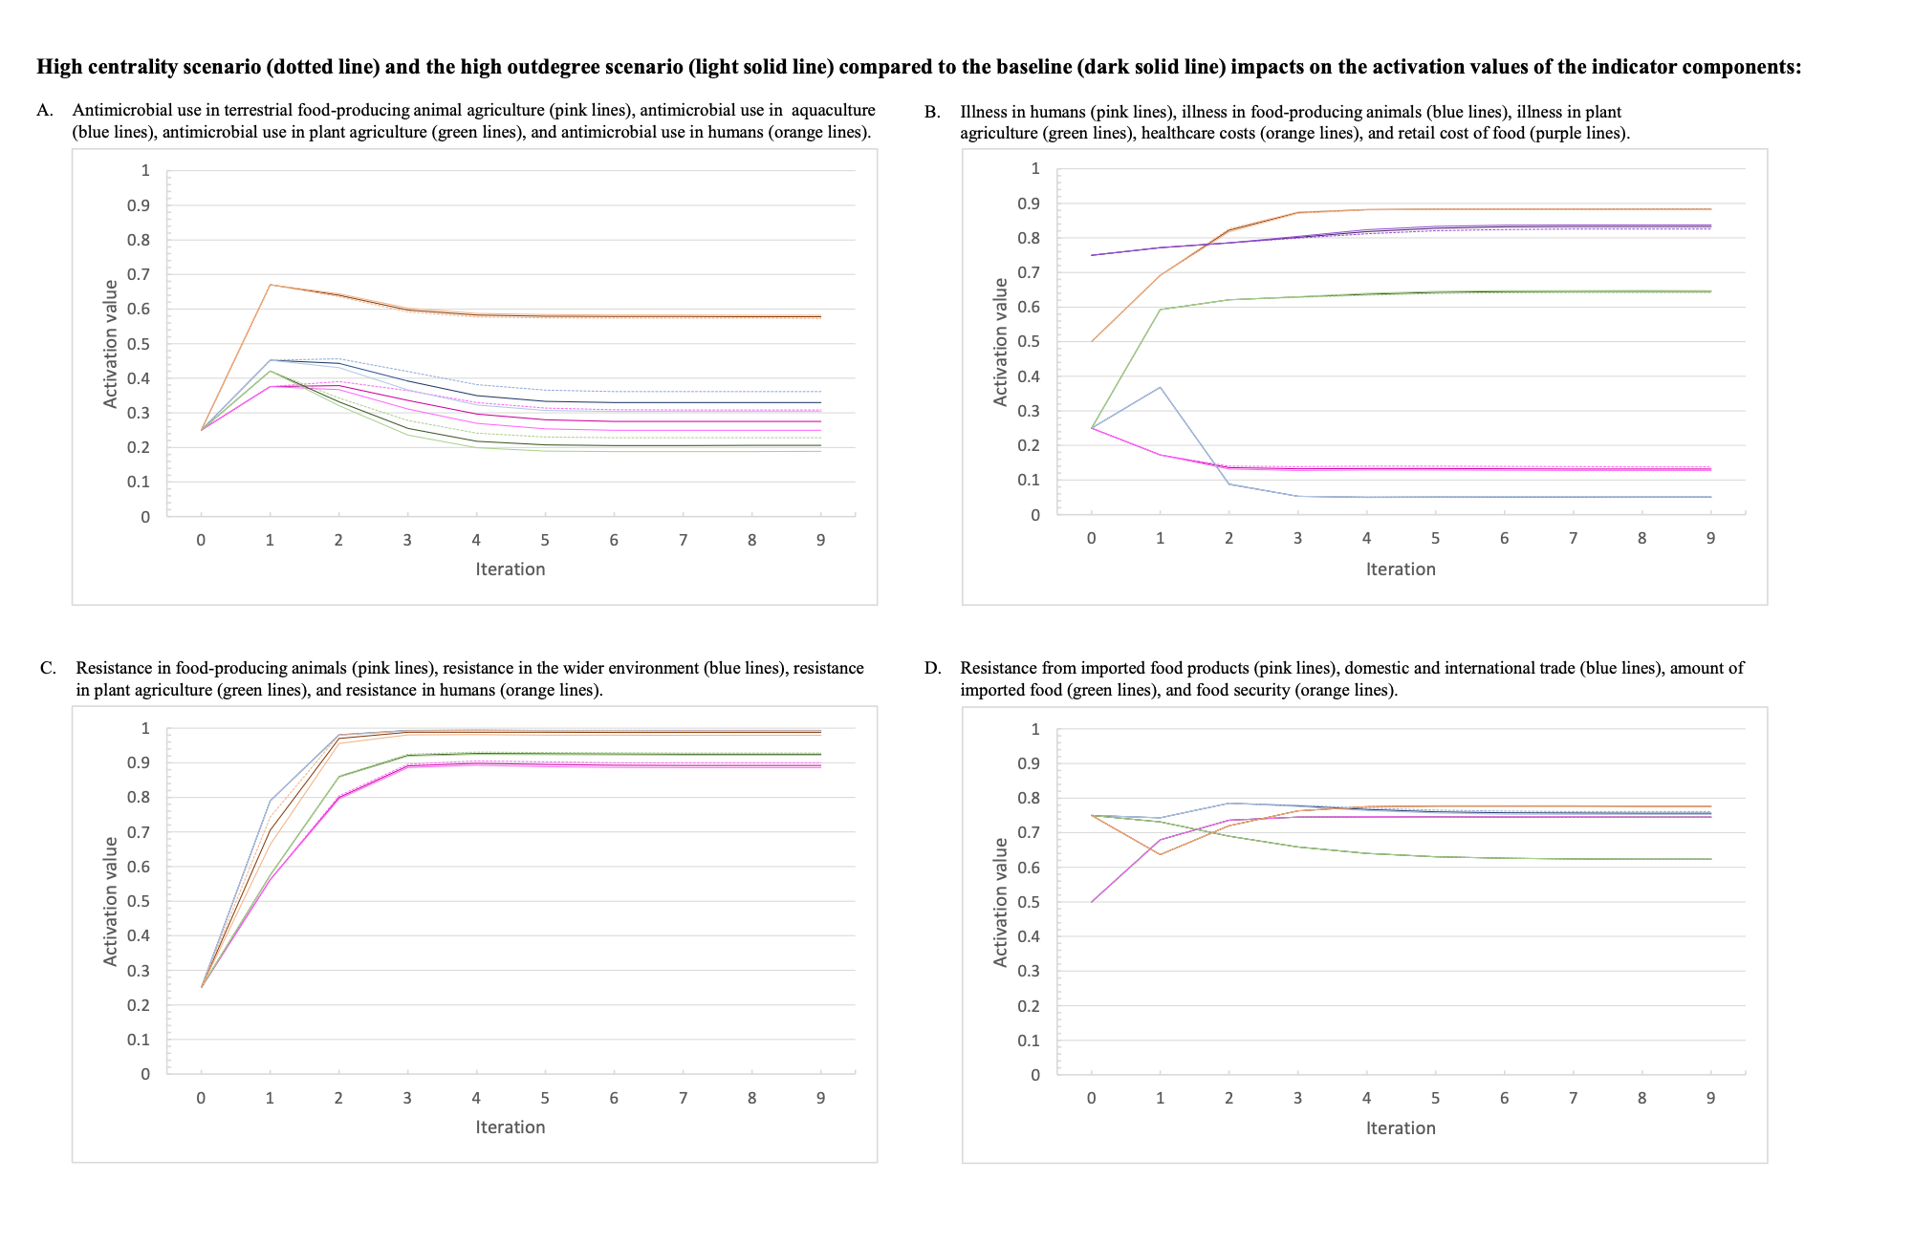
Figure S18: The activation values for the indicator variables over the nine iterations of the inference process for the high centrality scenario (dotted line) and the high outdegree scenario (light solid line) compared to the baseline (dark solid line).

(a) The activation values for: antimicrobial use in terrestrial food-producing animal agriculture (pink lines), antimicrobial use in aquaculture (blue lines), antimicrobial use in plant agriculture (green lines), and antimicrobial use in humans (orange lines). (b) The activation values for illness in humans (pink lines), illness in food-producing animals (blue lines), illness in plant agriculture (green lines), healthcare costs (orange lines), and retail cost of food (purple lines). (c) The activation values for: resistance in food-producing animals (pink lines), resistance in the wider environment (blue lines), resistance in plant agriculture (green lines), and resistance in humans (orange lines). (d) The activation values for: resistance from imported food products (pink lines), domestic and international trade (blue lines), amount of imported food (green lines), and food security (orange lines).

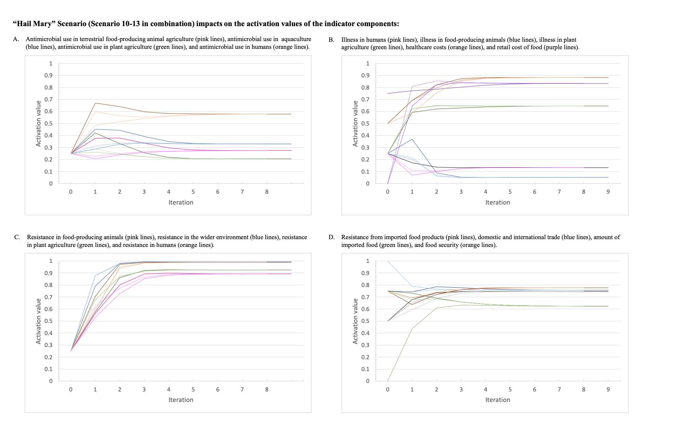
Figure S19: The activation values for the indicator variables over the nine iterations of the inference process for the “Hail Mary” scenario (dotted line), which was a combination of Scenario 10-13, compared to the baseline (solid line).

(a) The activation values for: antimicrobial use in terrestrial food-producing animal agriculture (pink lines), antimicrobial use in aquaculture (blue lines), antimicrobial use in plant agriculture (green lines), and antimicrobial use in humans (orange lines). (b) The activation values for illness in humans (pink lines), illness in food-producing animals (blue lines), illness in plant agriculture (green lines), healthcare costs (orange lines), and retail cost of food (purple lines). (c) The activation values for: resistance in food-producing animals (pink lines), resistance in the wider environment (blue lines), resistance in plant agriculture (green lines), and resistance in humans (orange lines). (d) The activation values for: resistance from imported food products (pink lines), domestic and international trade (blue lines), amount of imported food (green lines), and food security (orange lines).

