Sangosanya & Pistofidou 2023, supp data

Supplementary Data 1: complete list of questions and answers asked during the survey.
Surveyed people were given the non-dyed composite mycelium sample, then the dyed one.
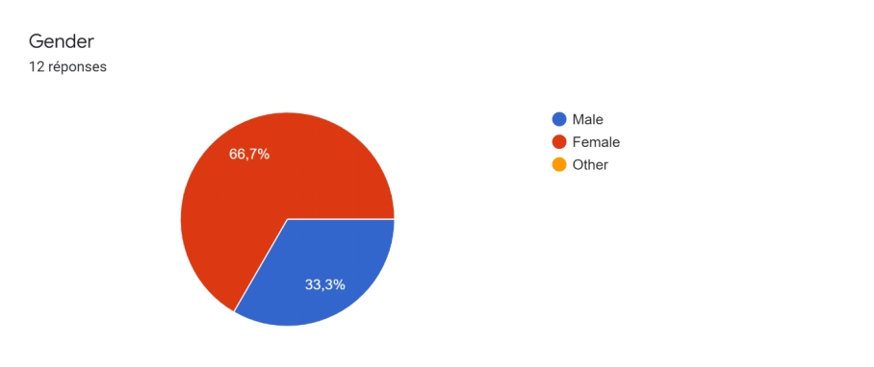
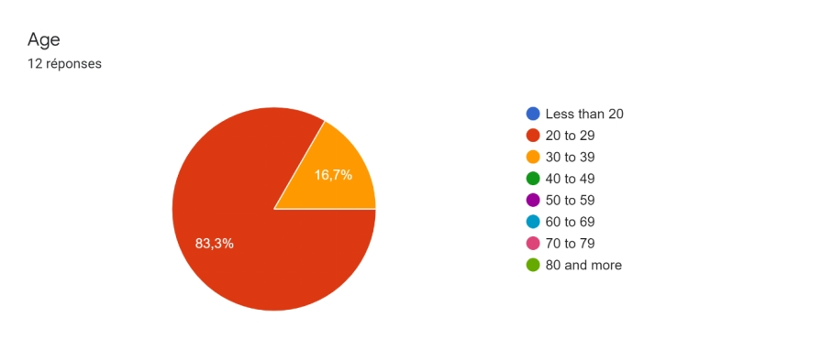
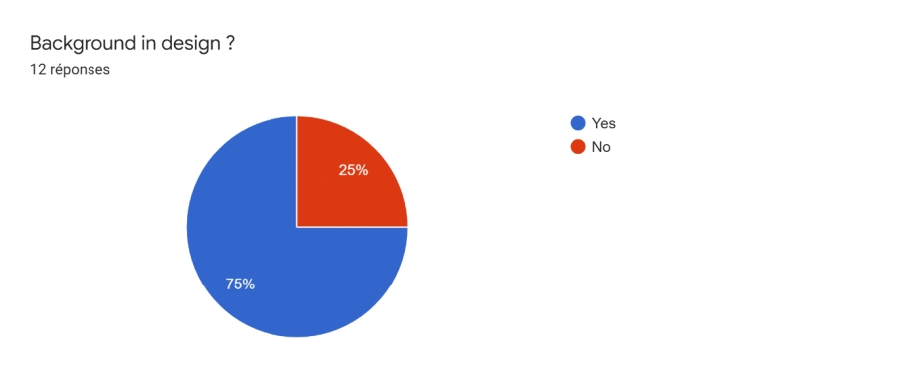
What does this material remind you of?
- Wounds crust
- Nothing
- Cork
- Insulation material for architechture. Mycelium pavillon
- Something to eat like roti bread (touch wise, thickness, and flexibility)
- Kombucha leather, moist leather, pressed flowers
- Plastic, leather, textile
- Indigo, leather, bougainviller,
- Plastic leather, dry chewing gum, dry glue, something with wax, peach skin

How does it feel like (touch, texture, flexibility, thickness...)?

- Pleasant texture, kind of rigid but seems comfortable, good temperature (not too hot), brittle
- Fragile
- Plastic rubber/leather. Flexible but not resistant.
- Thinner than usual leather (very thin), flexible but fragile, inconsistent (more textile feels stronger), very soft, waterproof
- A bit sticky, soft, fragile
- Suede, environmentally friendly leather for handbags or suede shoes or glasses case (Rayban), subtle texture, petite
- Softer than it looks, flexible, heterogeneous
- Brittle, soothing texture, feels edible (not look), thin, non-porous (protective) light
- Non-woven tablecloth, tree, mix of textures, sustainability, water repellant
- Wet, smooth, organic, sticky, pleasant to touch like silicone, not perfect, rubbery
- Soft but not flexible enough (brittle). Feels good. It shows from the looks that it is natural.
- Very solid leaf texture, fragile, irregular
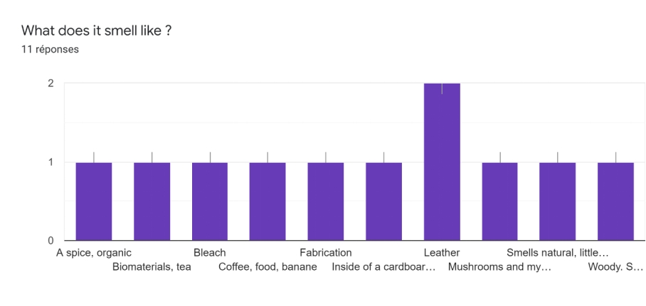
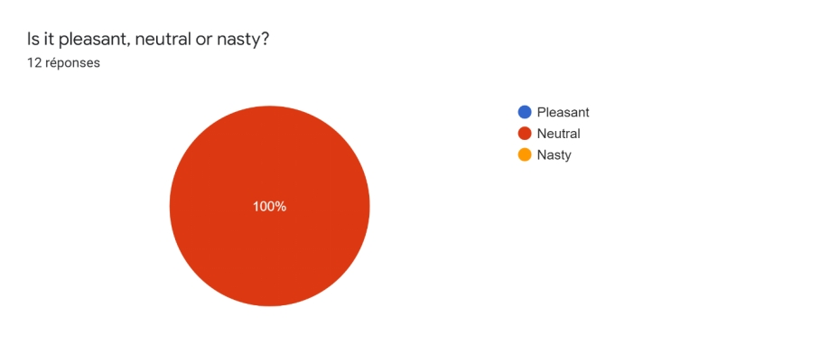

Comments on the dyed vs not dyed material? Preferences?

- Prefers the natural one, black one seems too fragile, likes the black but prefers the mix of colors, likes the temperature, feels like mixed soil
- Black one looks more pleasant and looks more industrial. But the other one looks more unique.
- Leathery because of the uniformity of the color. Likes the look of it but scary (reflection of light. Natural is more interesting to look at.
- Smells the same, would go for wearing something made from the black one (trust).
- Shinier, snakeskin texture. Prefers natural one
- Dyed sample looks good and is shiny. Similar texture.
- Feels moister, sweat, feels more alive than the natural one, layer of paint makes it feel more even, feels heavier. Prefers the natural one.
- The black one looks more like used leather or shoe sole because of the uniform color, the non-uniform one looks more organic with the threads looking like veins.
- Prefers the black one because it is black, feels oily and a bit like tar, the two sides are very different in touch and reflection
- More appealing when it is with a uniform color. Feels good

Supplementary data 2 : hyphal colonization area as function of time.

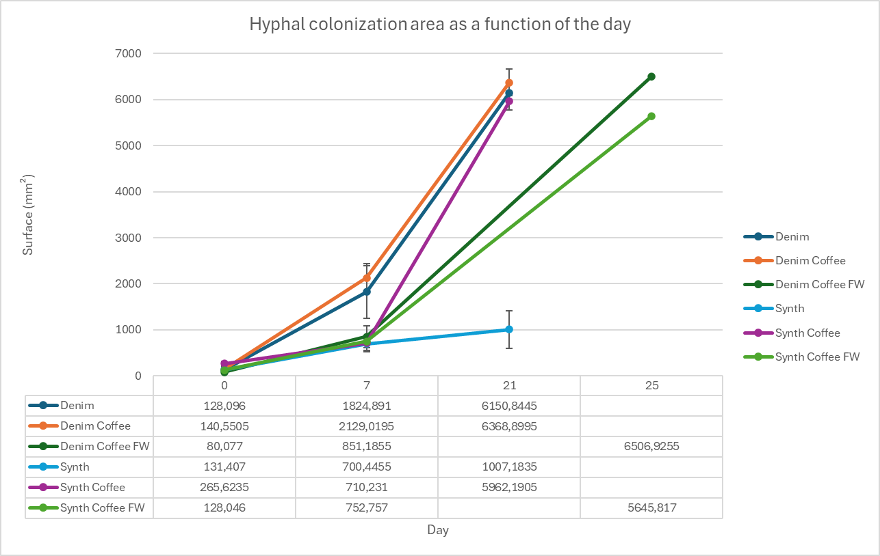
Supp data 3 : Mycelium growth: petri dishes pictures.
Table S3.1: Condition 1: Denim.
Day | Replicate 1 | Replicate 2
Day 0 | 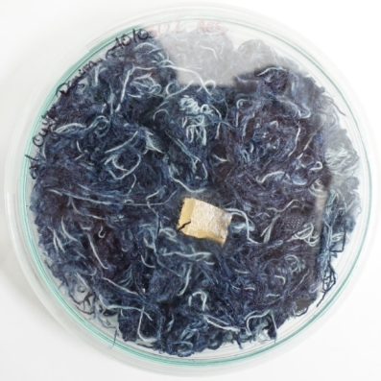 | 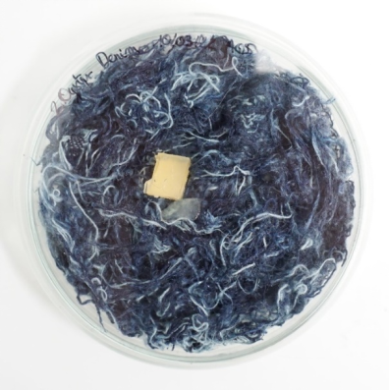
Day 7 | 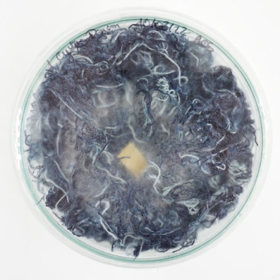 | 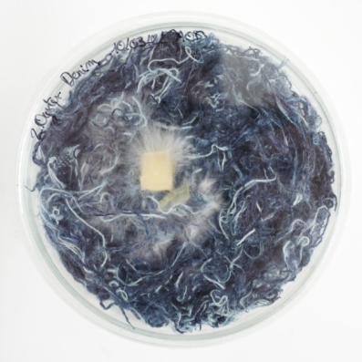
Day21 | 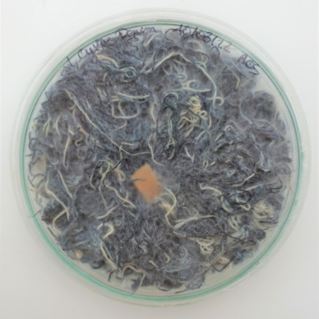 | 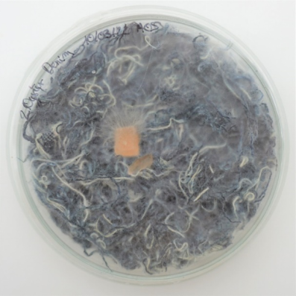

Table S3.2. Condition 2: Denim textile waste and coffee grounds.
Day | Replicate 1 | Replicate 2
Day 0 | 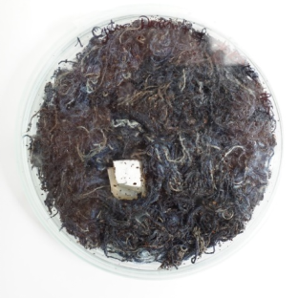 | 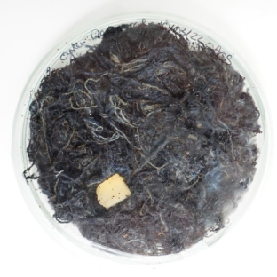
Day 7 | 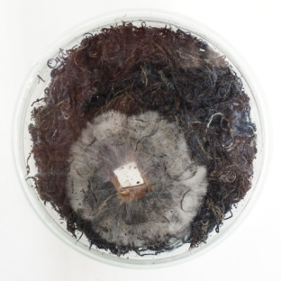 | 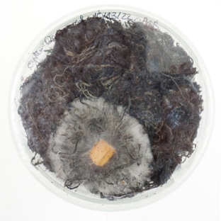
Day 21 | 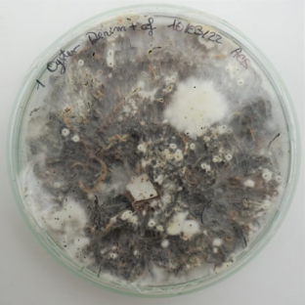 | 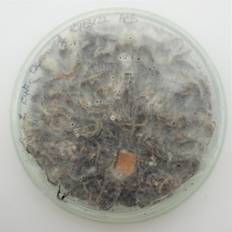
Day 56 | 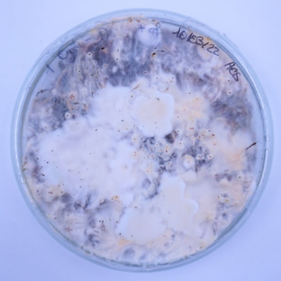 | 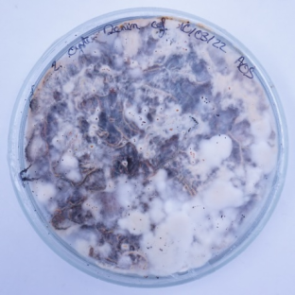
Table S3.3. Condition 3: Denim textile waste, food waste and coffee grounds.
Day | Replicate 1 | Replicate 2
Day 0 | 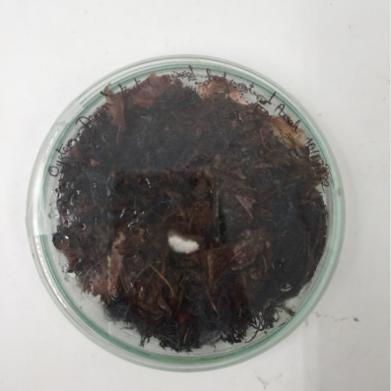 | 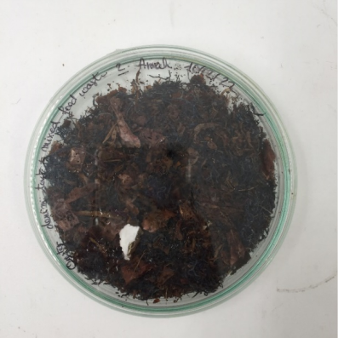
Day7 | 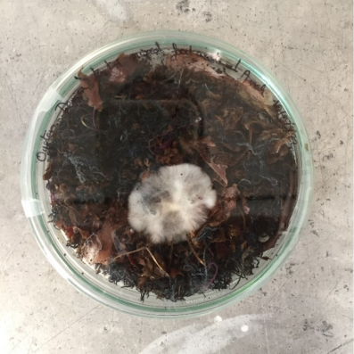 | 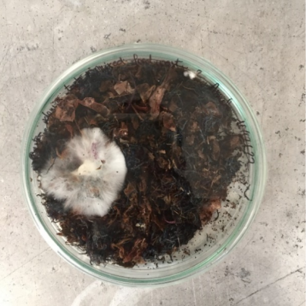
Day  25 | 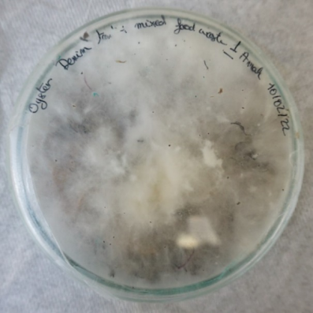 | 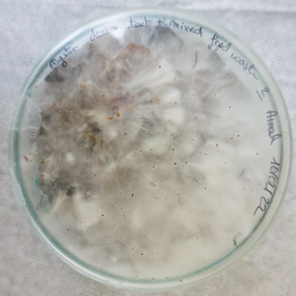

Table S3.4. Condition 4: synthetic textile waste.
Day | Replicate 1 | Replicate 2
Day0 | 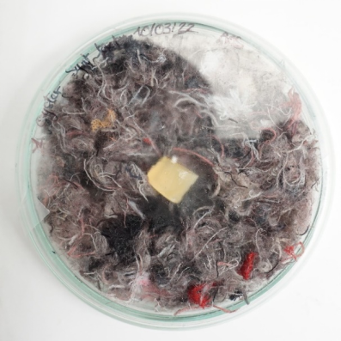 | 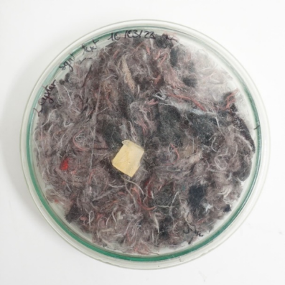
Day7 | 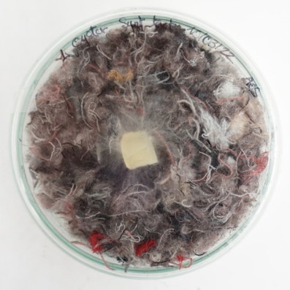 | 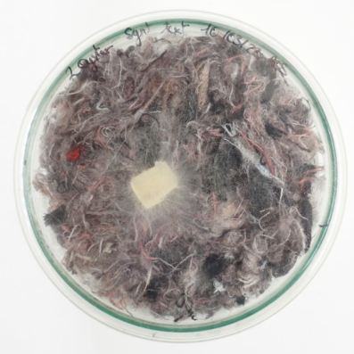
Day21 | 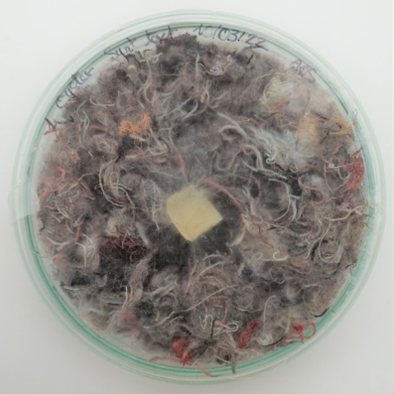 | 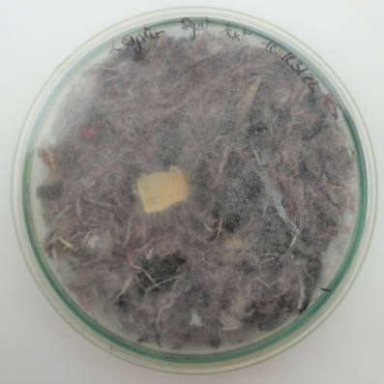

Table S3.5. Condition 5: Synthetic textile waste and coffee grounds.
Day | Replicate 1 | Replicate 2
Day 0 | 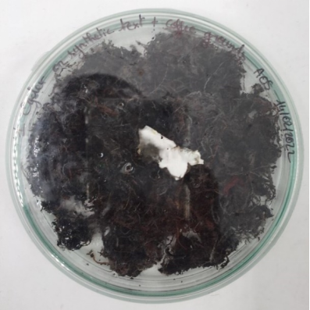 | 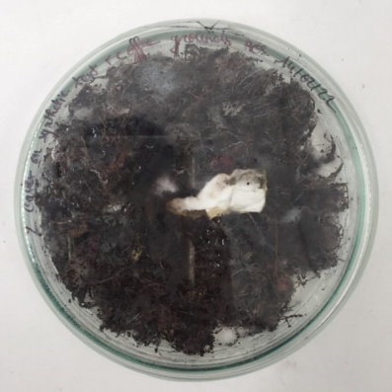
Day 7 | 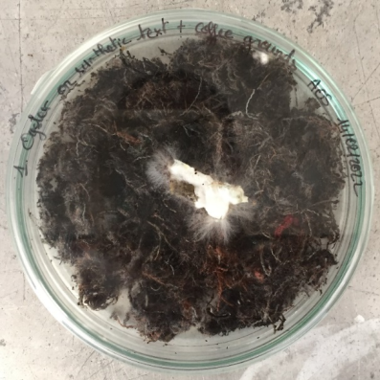 | 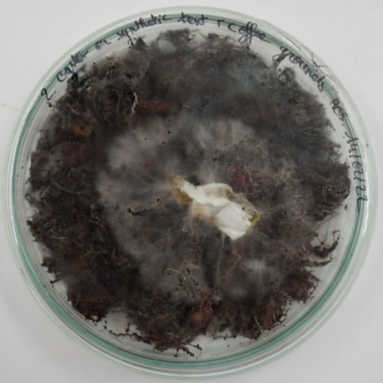
Day21 | 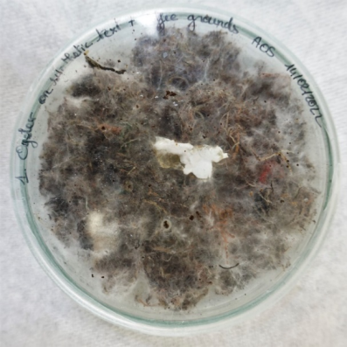 | 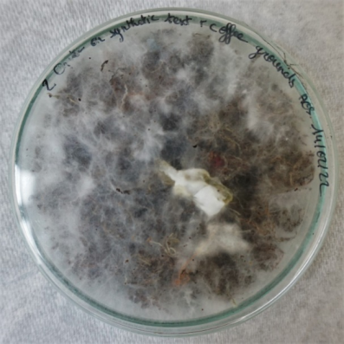

Table S3.6. Condition 6: Synthetic textile waste, food waste and coffee grounds.
Day | Replicate 1 | Replicate 2
Day 0 | 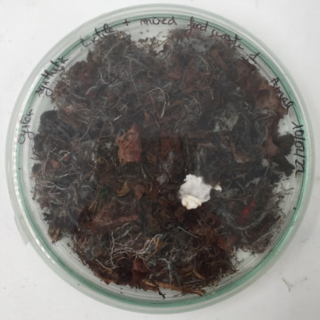 | 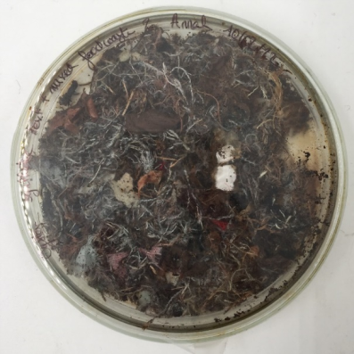
Day 7 | 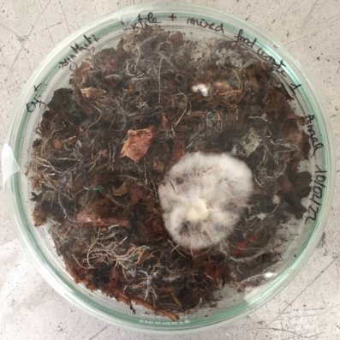 | 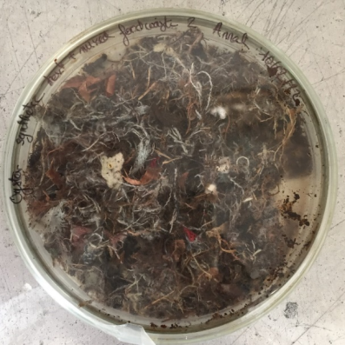
Day25 | 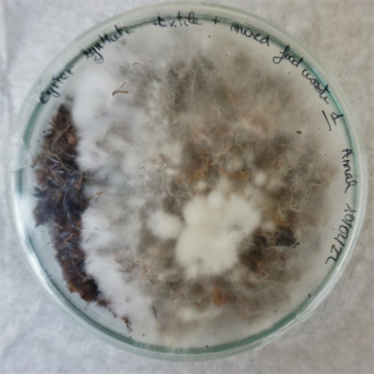 | 