**Selective near-infrared laser programming for shape memory polymer - carbon nanotube composite material 4D printing**

Honggeng Li1, 2, #,*, Zhe Chen1, 2, #, Shouyi Yu1, 2, Bingcong Jian1, 2, Hanlin Yin1, 2, Qi Ge1, 2, *

1Shenzhen Key Laboratory of Soft Mechanics & Smart Manufacturing, Southern University of Science and Technology, Shenzhen 518055, China.

2Department of Mechanical and Energy Engineering, Southern University of Science and Technology, Shenzhen 518055, China.

3School of Advanced Engineering, Great Bay University, Dongguan 523000, China

#These authors contributed equally: Honggeng Li, Zhe Chen.

*Corresponding Author:

Honggeng Li. Email: lihonggeng@hnu.edu.cn.

Qi Ge. Email: geq@sustech.edu.cn.

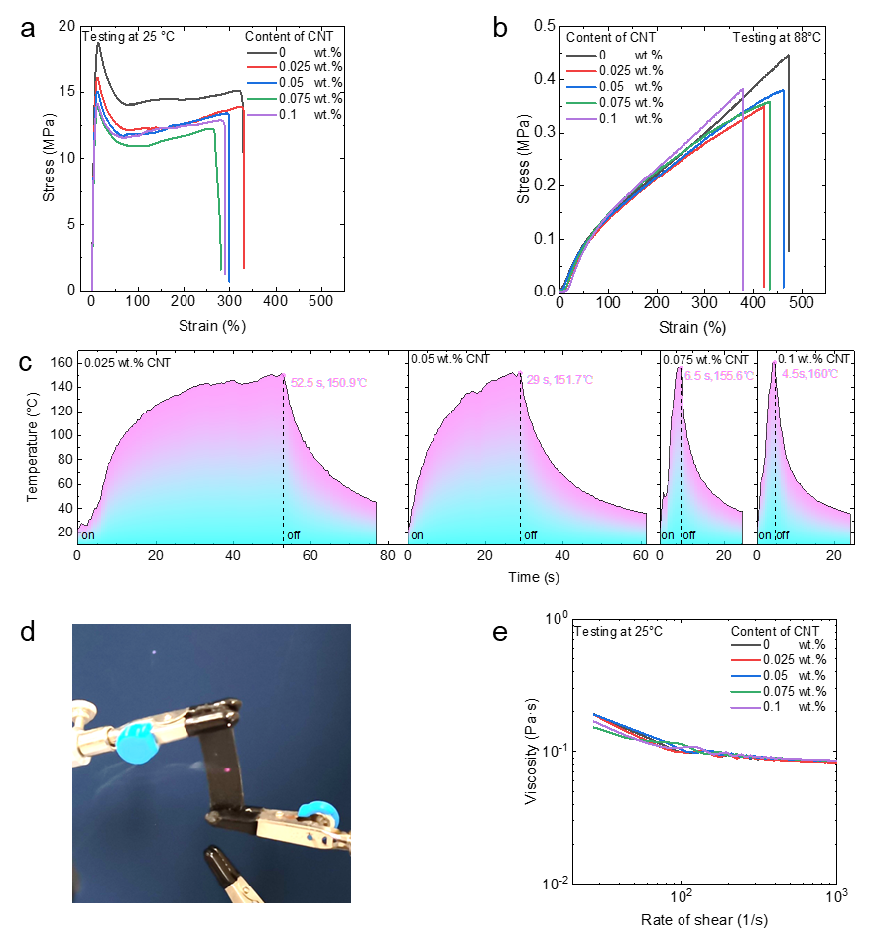

**Figure S1. The properties of IBBA-CNT with different content of CNT.** (a) Quasi static tensile test results at room temperature; (b) Quasi-static tensile test results at programming temperature; (c) Experimental results of near-infrared photothermal effect; (d) Combustion of IBBA-CNT with high CNT content under near infrared irradiation; (e) The rheological properties of the precursors.

CNT content has no significant effect on the mechanical properties of IBBA-CNT (Figure R1a-b), but has a significant effect on the photothermal conversion rate (Figure R1c). IBBA-CNT with more than 0.05wt% CNT will rapidly rise to more than 150 ℃ within 7s (Figure R1c). This temperature rise efficiency is too fast to control the programming temperature of SMP. More importantly, as shown in Figure R1d, IBBA-CNT with high CNT content will be ignited by near-infrared laser. Therefore, we chose IBBA-CNT with 0.05wt% CNT.

Increasing CNT content has no effect on the rheological properties of IBBA precursor (Figure R1e).