SUPPLEMENTARY MATERIAL

Hospitalizations for Congenital Infections in Brazil’s Unified Health System:
Nationwide Trends and Regional Disparities, 2008–2024

Callado, Siqueira, Corrêa, Delpino, Marra, Santana

TABLE OF CONTENTS:
SUPPLEMENTARY FIGURES
S. Figure 1. Number of hospitalizations, per year and congenital infection ………………………………………………………………………….. 4
S. Figure 2. Mean SUS reimbursement (in US$), per congenital infection and year ………………………………………………………….……... 7
S. Figure 3. Hospitalization rates for the five congenital infections (2008 vs. 2016 vs. 2024) ……………………………………………………...… 8
S. Figure 4. Proportion of hospitalizations with ICU use, per year and congenital infection …………..………….…………..…………..………... 9
S. Figure 5. Proportion of hospitalizations for the selected congenital infections with ICU use, per year and region …………..…………..…….. 10
S. Figure 6. In-hospital mortality rates, per congenital infection and year …………………..…………..…………………..………..…………..….. 11
S. Figure 7. Percentage of hospitalizations for congenital infections outside patients’ municipality of residence, per year and region ………….. 12
SUPPLEMENTARY TABLES
S. Table 1. Mean SUS cost per hospitalization (2008–2024) …………………………………………………………………………………….. 13
S. Table 2. Hospitalization rates (2008–2024) ………………………………………………………………………………….……………….….. 15
S. Table 3. Mean in-hospital Length of Stay (LOS), in days (2008–2024) …………………………………………………………………….. 17
S. Table 4. Percentage of hospitalizations with Intensive Care Unit (ICU) use (2008–2024) ………………………………………...…….. 19
S. Table 5. In-hospital mortality rate (2008–2024) ………………………………………………………………………………………………... 21
S. Table 6. Percentage of Hospitalizations Outside Patients’ Municipality of Residence (2008–2024) ………………………………….... 23

SUPPLEMENTARY MATERIAL – STATISTICAL ANALYSES
1. Differences Between Regions in 2024 …………………………………………………………………………………………………………… 25
1.1. Hospitalization Rate …………………………………………………………...………………………………………………………………… 25
1.2. Mean Hospitalization Cost ……………………….…………………………...………………………………………………………………… 25
1.3. Mean Length of Stay …………………………………………………………...………………………………………………………………… 26
2. Temporal Trends (2008–2024) …………………..……………………………...………………………………………………………………… 26
2.1. Hospitalization Rate by Congenital Infection ………...……………………………………………………………………………………… 26
2.2. Hospitalization Rate by Region ………...………………………………………………………………………………….…………………… 27
2.3. Mean Hospitalization Cost by Region ………...…………………………………………………..…………………………………………… 27
2.4. Mean Length of Stay by Region ………...……………………………………………………………………………………………………… 27
3. Differences Between Congenital Infections in 2024 ………...…………….…………………………………………………………………… 28
3.1. Hospitalization Rate 3.2. Mean Hospitalization Cost ………...…………..………………………………………………………………… 28
3.3. Mean Length of Stay ………...…………………………………………………………………………………………………………………… 29
4. In-Hospital Mortality by Region (2008–2024) ………...…………………………………...…………………………………………………… 29
4.1. Differences Between Regions ………...……………………………………………………………..…………………………………………… 29
4.2. Temporal Evolution of Mortality ………...…………………………………………………………..………………………………………… 30

S. Figure 1. Number of hospitalizations, per year and congenital infection

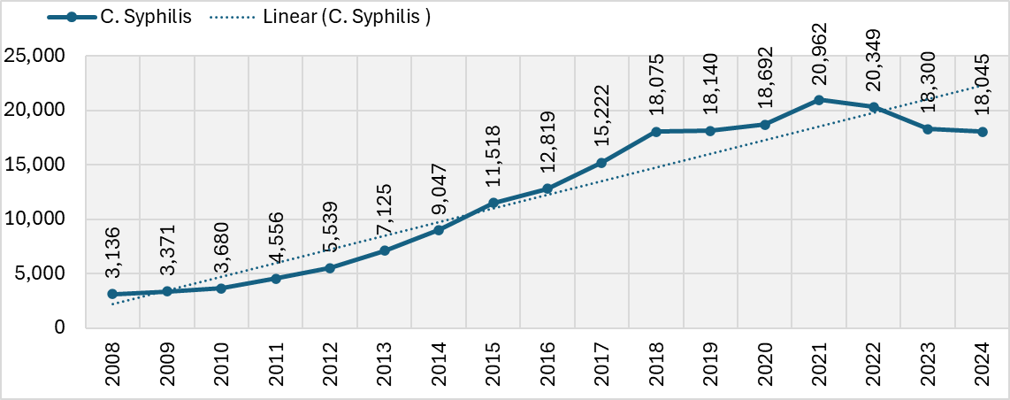
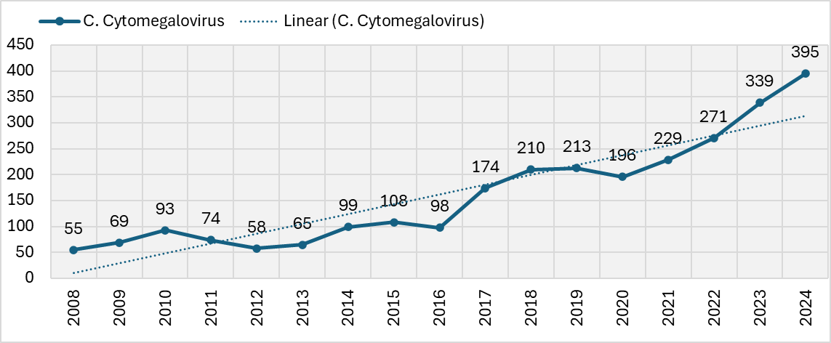
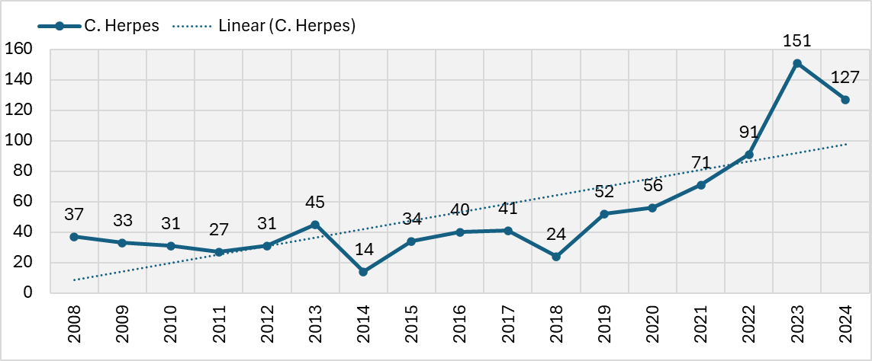
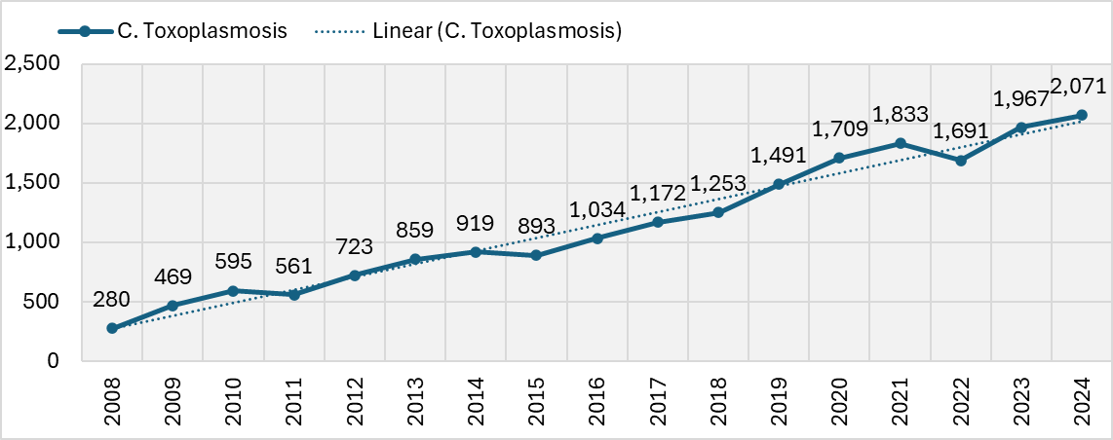
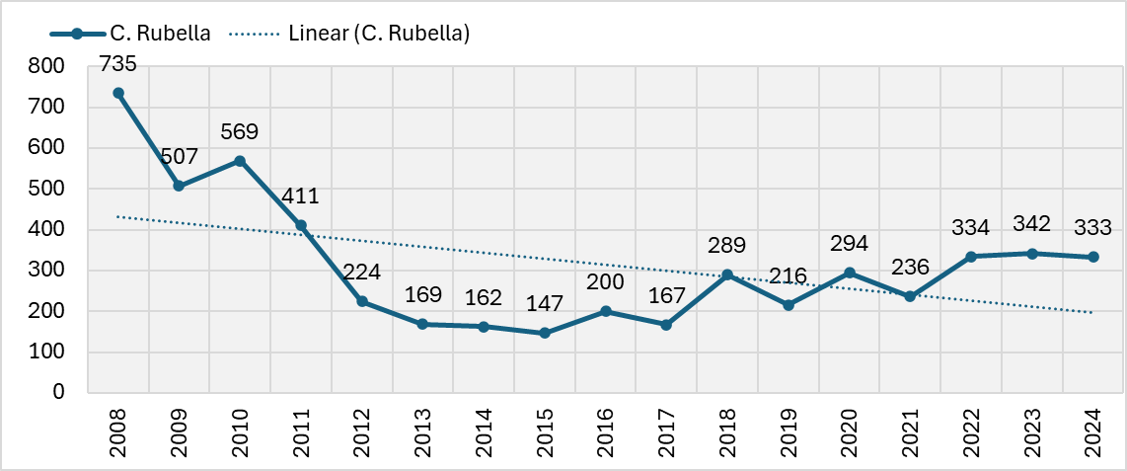
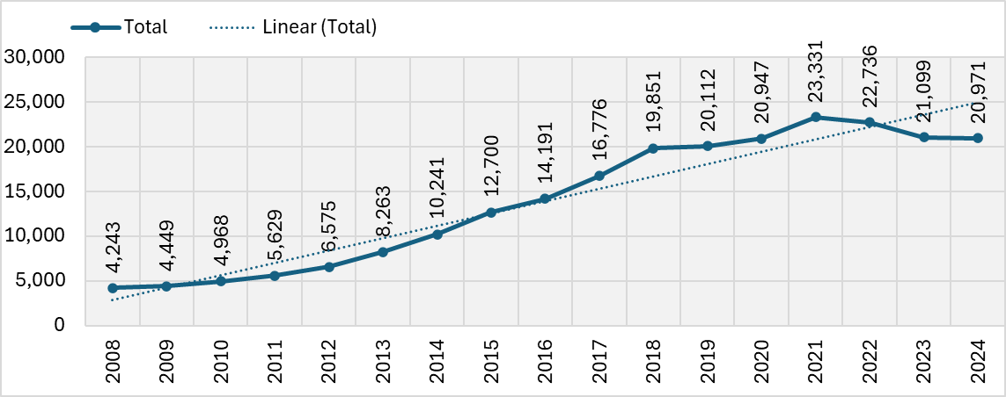
Source: Developed by authors, with data extracted from SIH/SUS, considering the selected ICD-10 codes.

S. Figure 2. Mean SUS' reimbursement (in US$), per congenital infection and year

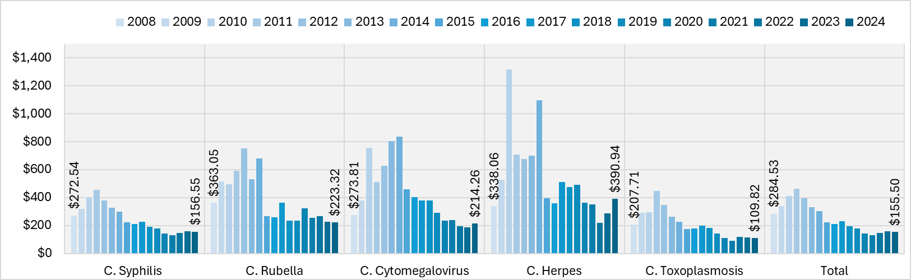
Source: Developed by authors, with data extracted from SIH/SUS, considering the selected ICD-10 codes.

S. Figure 3. Hospitalization rates for the five congenital infections (2008 vs. 2016 vs. 2024)

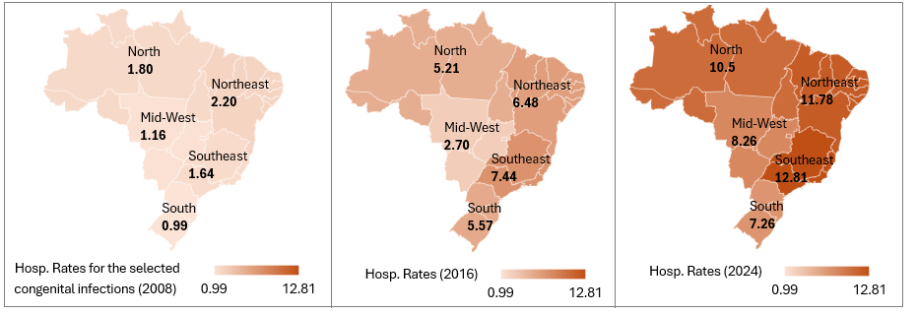
Source: Developed by authors, with data extracted from SIH/SUS, considering the selected ICD-10 codes.
** Hospitalizations per 1,000 inhabitants with up to 1 year old and no coverage by private health insurance

S. Figure 4. Proportion of hospitalizations with ICU use, per year and congenital infection
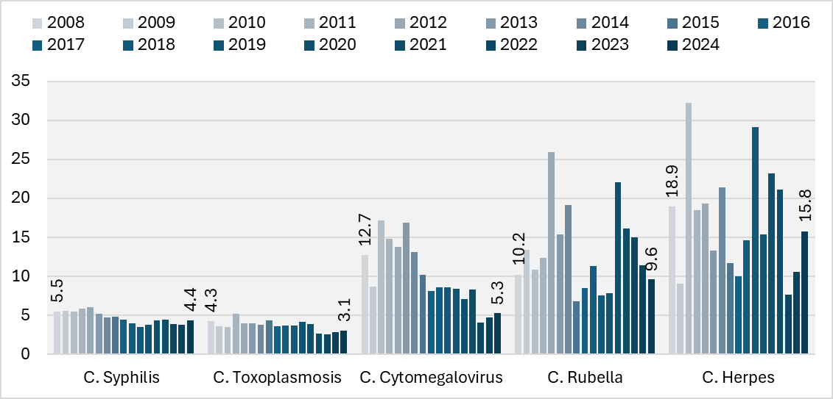
Source: Developed by authors, with data extracted from SIH/SUS, considering the selected ICD-10 codes.

S. Figure 5. Proportion of hospitalizations for the selected congenital infections with ICU use, per year and region
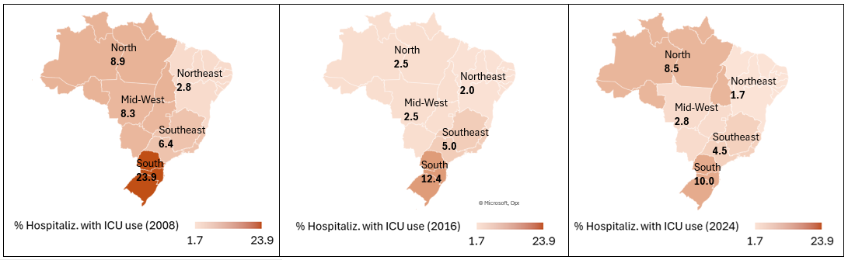
Source: Developed by authors, with data extracted from SIH/SUS, considering the selected ICD-10 codes.

S. Figure 6. In-hospital mortality rates, per congenital infection and year
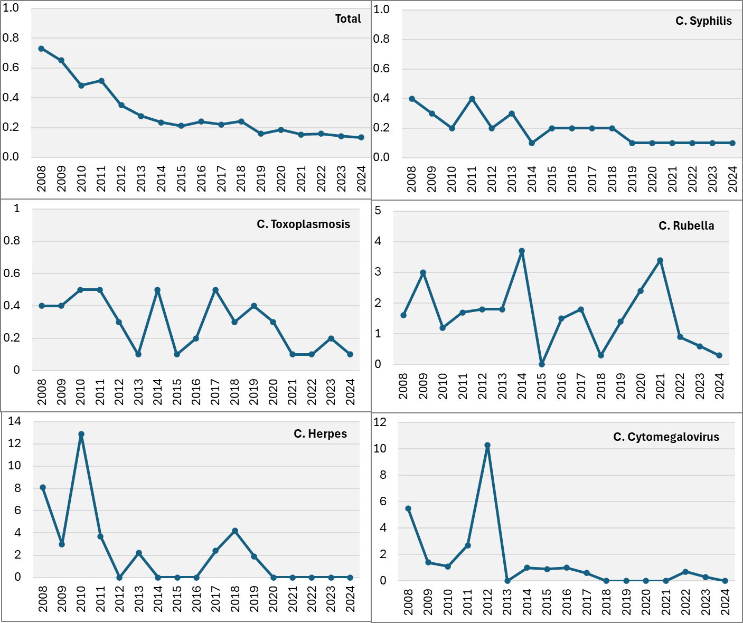
Source: Developed by authors, with data extracted from SIH/SUS, considering the selected ICD-10 codes. The rates represent the number of in-hospital deaths by 1,000 hospitalizations
S. Figure 7. Percentage of hospitalizations for congenital infections outside patients’ municipality of residence, per year and region
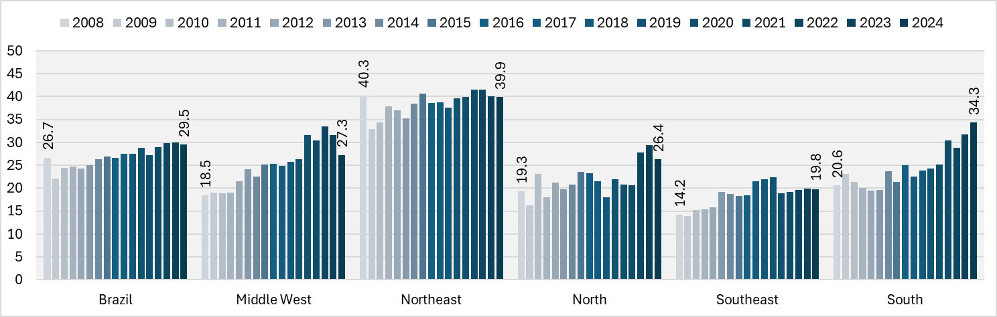
Source: Developed by authors, with data extracted from SIH/SUS, considering the selected ICD-10 codes.

S. Table 1. Mean SUS' cost per hospitalization
 |  |  |  |  | (2008-2024)
Infection | Region | 2008 | 2016 | 2024 | Min | Max | Mean | Median | SD
Congenital Syphilis | Brazil | $ 272.54 | $ 209.90 | $ 156.55 | $ 133.30 | $ 454.30 | $ 248.79 | $ 224.65 | $ 99.45
Congenital Syphilis | Central-West | $ 238.49 | $ 153.73 | $ 133.68 | $ 91.32 | $ 427.17 | $ 198.35 | $ 153.73 | $ 102.96
Congenital Syphilis | Northeast | $ 254.09 | $ 186.61 | $ 110.70 | $ 105.53 | $ 428.18 | $ 219.05 | $ 186.95 | $ 102.51
Congenital Syphilis | North | $ 308.90 | $ 206.83 | $ 219.93 | $ 136.65 | $ 463.48 | $ 275.34 | $ 242.09 | $ 97.73
Congenital Syphilis | Southeast | $ 203.54 | $ 196.26 | $ 157.33 | $ 127.30 | $ 335.14 | $ 206.42 | $ 203.54 | $ 60.16
Congenital Syphilis | South | $ 690.35 | $ 345.71 | $ 239.97 | $ 232.60 | $ 1,262.70 | $ 538.78 | $ 345.71 | $ 343.37
Congenital Rubella | Brazil | $ 363.05 | $ 259.76 | $ 223.32 | $ 223.32 | $ 752.95 | $ 387.50 | $ 325.25 | $ 172.92
Congenital Rubella | Central-West | $ 1,003.41 | $ 248.47 | $ 282.37 | $ 105.17 | $ 1,169.82 | $ 522.86 | $ 425.95 | $ 329.82
Congenital Rubella | Northeast | $ 227.74 | $ 255.00 | $ 137.34 | $ 131.45 | $ 763.49 | $ 305.71 | $ 276.35 | $ 157.95
Congenital Rubella | North | $ 357.20 | $ 72.79 | $ 325.84 | $ 43.18 | $ 2,070.44 | $ 393.76 | $ 220.70 | $ 553.09
Congenital Rubella | Southeast | $ 458.05 | $ 293.66 | $ 209.67 | $ 179.94 | $ 1,033.85 | $ 399.91 | $ 301.57 | $ 240.20
Congenital Rubella | South | $ 596.26 | $ 141.25 | $ 758.87 | $ 131.72 | $ 3,474.30 | $ 842.33 | $ 719.20 | $ 771.73
Congenital Cytomegalovirus | Brazil | $ 273.81 | $ 404.30 | $ 214.26 | $ 187.01 | $ 838.53 | $ 422.65 | $ 380.29 | $ 215.77
Congenital Cytomegalovirus | Central-West | $ 111.47 | $ 82.93 | $ 107.91 | $ 64.60 | $ 1,723.78 | $ 407.74 | $ 173.24 | $ 469.30
Congenital Cytomegalovirus | Northeast | $ 253.18 | $ 144.34 | $ 126.79 | $ 79.07 | $ 927.23 | $ 282.81 | $ 215.84 | $ 215.86
Congenital Cytomegalovirus | North | $ 622.00 | $ 2,365.60 | $ 56.29 | $ 56.29 | $ 2,365.60 | $ 440.57 | $ 263.34 | $ 544.21
Congenital Cytomegalovirus | Southeast | $ 254.99 | $ 398.96 | $ 281.24 | $ 136.36 | $ 959.58 | $ 464.91 | $ 398.96 | $ 251.01
Congenital Cytomegalovirus | South | $ 295.36 | $ 1,070.14 | $ 517.92 | $ 89.85 | $ 2,361.20 | $ 896.29 | $ 849.91 | $ 685.79
Congenital Herpes | Brazil | $ 338.06 | $ 358.69 | $ 390.94 | $ 221.29 | $ 1,315.95 | $ 542.06 | $ 474.47 | $ 289.28
Congenital Herpes | Central-West | $ 129.01 | $ 82.80 | $ 85.93 | - | - | - | - | -
Congenital Herpes | Northeast | $ 472.97 | $ 178.71 | $ 201.11 | $ 82.06 | $ 1,789.87 | $ 481.60 | $ 431.50 | $ 426.80
Congenital Herpes | North | $ 172.60 | $ 786.50 | $ 130.45 | - | - | - | - | -
Congenital Herpes | Southeast | $ 289.04 | $ 745.64 | $ 363.05 | $ 139.19 | $ 1,121.30 | $ 581.09 | $ 558.73 | $ 288.00
Congenital Herpes | South | $ 164.27 | $ 120.74 | $ 647.19 | $ 90.53 | $ 2,564.52 | $ 540.13 | $ 437.04 | $ 586.82
Congenital Toxoplasmosis | Brazil | $ 207.71 | $ 179.66 | $ 109.82 | $ 91.82 | $ 447.49 | $ 206.58 | $ 183.92 | $ 96.91
Congenital Toxoplasmosis | Central-West | $ 171.27 | $ 126.95 | $ 102.00 | $ 88.72 | $ 379.43 | $ 170.65 | $ 177.39 | $ 68.72
Congenital Toxoplasmosis | Northeast | $ 206.61 | $ 141.78 | $ 96.62 | $ 73.09 | $ 730.58 | $ 203.85 | $ 141.78 | $ 160.00
Congenital Toxoplasmosis | North | $ 516.22 | $ 123.83 | $ 97.05 | $ 97.05 | $ 516.22 | $ 182.00 | $ 157.62 | $ 100.71
Congenital Toxoplasmosis | Southeast | $ 182.44 | $ 225.41 | $ 128.18 | $ 100.69 | $ 609.42 | $ 229.54 | $ 223.25 | $ 123.62
Congenital Toxoplasmosis | South | $ 310.10 | $ 167.24 | $ 118.96 | $ 97.25 | $ 1,140.50 | $ 325.05 | $ 228.75 | $ 277.73
Total congenital infections | Brazil | $ 284.53 | $ 210.16 | $ 155.50 | $ 132.99 | $ 465.57 | $ 253.53 | $ 224.09 | $ 104.54
Total congenital infections | Central-West | $ 410.11 | $ 150.45 | $ 129.68 | $ 106.36 | $ 433.56 | $ 225.92 | $ 150.45 | $ 126.90
Total congenital infections | Northeast | $ 248.39 | $ 185.65 | $ 109.95 | $ 103.74 | $ 418.05 | $ 222.79 | $ 185.73 | $ 106.72
Total congenital infections | North | $ 316.50 | $ 205.92 | $ 215.96 | $ 135.95 | $ 433.97 | $ 263.96 | $ 238.05 | $ 88.22
Total congenital infections | Southeast | $ 230.13 | $ 202.42 | $ 161.27 | $ 129.65 | $ 390.97 | $ 220.91 | $ 213.07 | $ 73.83
Total congenital infections | South | $ 633.00 | $ 328.13 | $ 238.10 | $ 229.41 | $ 1,202.56 | $ 520.14 | $ 341.99 | $ 329.13

Source: Developed by authors, with data extracted from SIH/SUS, considering the selected ICD-10 codes.
* Number of hospitalizations/total SUS reimbursement value

S. Table 2. Hospitalization rates
 |  |  |  |  | (2008-2024)
Infection | Region | 2008 | 2016 | 2024 | Min | Max | Mean | Median | SD
Congenital Syphilis | Brazil | 1.29 | 5.61 | 9.39 | 1.29 | 10.28 | 5.74 | 5.61 | 2.99
Congenital Syphilis | Central-West | 0.59 | 2.23 | 6.87 | 0.59 | 6.87 | 3.03 | 2.44 | 1.86
Congenital Syphilis | Northeast | 1.55 | 5.92 | 9.99 | 1.55 | 11.01 | 6.19 | 5.92 | 3.13
Congenital Syphilis | North | 1.68 | 4.86 | 10.12 | 1.58 | 10.12 | 5.29 | 4.86 | 2.73
Congenital Syphilis | Southeast | 1.24 | 6.71 | 10.80 | 1.24 | 12.54 | 6.71 | 6.71 | 3.58
Congenital Syphilis | South | 0.67 | 4.89 | 6.20 | 0.67 | 7.93 | 4.58 | 4.89 | 2.50
Congenital Rubella | Brazil | 0.30 | 0.09 | 0.17 | 0.06 | 0.30 | 0.14 | 0.13 | 0.05
Congenital Rubella | Central-West | 0.29 | 0.04 | 0.06 | 0.02 | 0.38 | 0.12 | 0.07 | 0.08
Congenital Rubella | Northeast | 0.55 | 0.15 | 0.08 | 0.08 | 0.55 | 0.20 | 0.14 | 0.11
Congenital Rubella | North | 0.06 | 0.02 | 0.02 | 0.00 | 0.06 | 0.02 | 0.01 | 0.01
Congenital Rubella | Southeast | 0.18 | 0.09 | 0.44 | 0.06 | 0.44 | 0.17 | 0.13 | 0.08
Congenital Rubella | South | 0.22 | 0.02 | 0.04 | 0.01 | 0.22 | 0.07 | 0.05 | 0.05
Congenital Cytomegalovirus | Brazil | 0.02 | 0.04 | 0.21 | 0.02 | 0.21 | 0.08 | 0.05 | 0.04
Congenital Cytomegalovirus | Central-West | 0.01 | 0.03 | 0.20 | 0.01 | 0.20 | 0.06 | 0.04 | 0.04
Congenital Cytomegalovirus | Northeast | 0.03 | 0.05 | 0.23 | 0.01 | 0.26 | 0.08 | 0.05 | 0.06
Congenital Cytomegalovirus | North | 0.01 | 0.01 | 0.01 | 0.00 | 0.03 | 0.01 | 0.01 | 0.01
Congenital Cytomegalovirus | Southeast | 0.03 | 0.06 | 0.34 | 0.02 | 0.34 | 0.12 | 0.09 | 0.07
Congenital Cytomegalovirus | South | 0.01 | 0.03 | 0.04 | 0.01 | 0.07 | 0.03 | 0.03 | 0.01
Congenital Herpes | Brazil | 0.02 | 0.04 | 0.21 | 0.02 | 0.21 | 0.08 | 0.05 | 0.04
Congenital Herpes | Central-West | 0.01 | 0.03 | 0.20 | 0.01 | 0.20 | 0.06 | 0.04 | 0.04
Congenital Herpes | Northeast | 0.03 | 0.05 | 0.23 | 0.01 | 0.26 | 0.08 | 0.05 | 0.06
Congenital Herpes | North | 0.01 | 0.01 | 0.01 | 0.00 | 0.03 | 0.01 | 0.01 | 0.01
Congenital Herpes | Southeast | 0.03 | 0.06 | 0.34 | 0.02 | 0.34 | 0.12 | 0.09 | 0.07
Congenital Herpes | South | 0.01 | 0.03 | 0.04 | 0.01 | 0.07 | 0.03 | 0.03 | 0.01
Congenital Toxoplasmosis | Brazil | 0.12 | 0.45 | 1.08 | 0.12 | 1.08 | 0.54 | 0.45 | 0.25
Congenital Toxoplasmosis | Central-West | 0.26 | 0.40 | 1.13 | 0.26 | 1.13 | 0.56 | 0.54 | 0.15
Congenital Toxoplasmosis | Northeast | 0.06 | 0.32 | 1.42 | 0.04 | 1.42 | 0.49 | 0.32 | 0.36
Congenital Toxoplasmosis | North | 0.04 | 0.32 | 0.34 | 0.04 | 0.97 | 0.43 | 0.36 | 0.16
Congenital Toxoplasmosis | Southeast | 0.19 | 0.57 | 1.14 | 0.19 | 1.24 | 0.65 | 0.57 | 0.31
Congenital Toxoplasmosis | South | 0.06 | 0.63 | 0.84 | 0.06 | 0.85 | 0.50 | 0.61 | 0.27
Total congenital infections | Brazil | 1.74 | 6.21 | 10.92 | 1.74 | 11.49 | 6.52 | 6.21 | 3.28
Total congenital infections | Central-West | 1.16 | 2.70 | 8.26 | 1.16 | 8.26 | 3.78 | 3.02 | 1.97
Total congenital infections | Northeast | 2.20 | 6.48 | 11.78 | 1.98 | 12.20 | 7.00 | 6.48 | 3.50
Total congenital infections | North | 1.80 | 5.21 | 10.50 | 1.80 | 10.50 | 5.75 | 5.21 | 2.67
Total congenital infections | Southeast | 1.64 | 7.44 | 12.81 | 1.64 | 14.18 | 7.67 | 7.44 | 4.03
Total congenital infections | South | 0.99 | 5.57 | 7.26 | 0.99 | 8.71 | 5.21 | 5.57 | 2.77
Source: Developed by authors, with data from SIH/SUS (for the selected ICD-10 codes), the Brazilian Institute of Geography and Statistics – IBGE (Population Projections, 2024 revision); and the National Supplementary Health Agency – ANS (beneficiary consultation, December 2008 to December 2024)
* Number of hospitalizations per 1,000 population up to 1 year old with no private health insurance plan

S. Table 3. Mean in-hospital Length of Stay - LOS, in days

 |  |  |  |  | (2008-2024)
Infection | Region | 2008 | 2016 | 2024 | Min | Max | Mean | Median | SD
Congenital Syphilis | Brazil | 10.0 | 9.4 | 9.0 | 8.9 | 10.1 | 9.5 | 9.4 | 0.4
Congenital Syphilis | Central-West | 9.6 | 9.0 | 9.2 | 8.6 | 10.0 | 9.3 | 9.2 | 0.3
Congenital Syphilis | Northeast | 9.8 | 9.5 | 9.1 | 8.9 | 10.0 | 9.5 | 9.6 | 0.3
Congenital Syphilis | North | 9.9 | 9.2 | 9.0 | 8.9 | 10.3 | 9.5 | 9.5 | 0.3
Congenital Syphilis | Southeast | 10.1 | 9.3 | 8.8 | 8.6 | 10.3 | 9.4 | 9.3 | 0.6
Congenital Syphilis | South | 10.6 | 9.3 | 9.3 | 9.3 | 10.8 | 9.9 | 9.5 | 0.5
Congenital Rubella | Brazil | 7.0 | 7.2 | 5.7 | 5.7 | 8.5 | 7.2 | 7.2 | 0.6
Congenital Rubella | Central-West | 9.4 | 4.8 | 6.9 | 4.8 | 14.0 | 8.3 | 8.1 | 2.0
Congenital Rubella | Northeast | 6.5 | 7.7 | 6.6 | 5.1 | 9.6 | 7.3 | 7.1 | 0.8
Congenital Rubella | North | 7.5 | 3.7 | 7.5 | 2.0 | 14.0 | 6.5 | 6.2 | 2.1
Congenital Rubella | Southeast | 7.7 | 7.1 | 5.3 | 5.3 | 7.8 | 7.0 | 7.1 | 0.6
Congenital Rubella | South | 7.3 | 5.2 | 8.6 | 4.7 | 18.7 | 8.0 | 7.4 | 1.8
Congenital Cytomegalovirus | Brazil | 10.2 | 10.3 | 6.2 | 6.2 | 11.8 | 9.2 | 9.3 | 1.2
Congenital Cytomegalovirus | Central-West | 4.0 | 4.6 | 5.1 | 4.0 | 14.2 | 7.1 | 6.4 | 2.5
Congenital Cytomegalovirus | Northeast | 13.8 | 7.4 | 6.2 | 6.2 | 13.8 | 8.2 | 7.4 | 1.5
Congenital Cytomegalovirus | North | 11.0 | 24.0 | 3.0 | 3.0 | 27.0 | 11.2 | 9.5 | 5.5
Congenital Cytomegalovirus | Southeast | 7.5 | 11.2 | 6.2 | 6.2 | 13.9 | 9.7 | 9.3 | 1.8
Congenital Cytomegalovirus | South | 4.7 | 17.1 | 10.6 | 3.8 | 22.7 | 12.8 | 12.8 | 4.0
Congenital Herpes | Brazil | 9.6 | 8.2 | 9.4 | 7.6 | 16.3 | 9.5 | 9.3 | 1.0
Congenital Herpes | Central-West | 5.2 | 10.0 | 12.0 | 2.0 | 13.7 | 6.1 | 5.0 | 3.1
Congenital Herpes | Northeast | 12.9 | 5.5 | 7.1 | 5.3 | 15.5 | 8.9 | 8.6 | 2.0
Congenital Herpes | North | 7.5 | 14.0 | 9.0 | 3.0 | 30.0 | 10.7 | 10.5 | 3.9
Congenital Herpes | Southeast | 6.4 | 12.8 | 9.5 | 6.4 | 76.3 | 13.7 | 10.1 | 7.4
Congenital Herpes | South | 7.0 | 8.5 | 11.4 | 5.0 | 14.0 | 9.8 | 9.8 | 1.7
Congenital Toxoplasmosis | Brazil | 6.4 | 5.5 | 4.7 | 4.7 | 6.4 | 5.4 | 5.4 | 0.4
Congenital Toxoplasmosis | Central-West | 5.7 | 4.5 | 4.6 | 4.5 | 6.8 | 5.7 | 5.7 | 0.6
Congenital Toxoplasmosis | Northeast | 8.1 | 5.9 | 5.2 | 5.1 | 8.8 | 6.4 | 6.1 | 0.9
Congenital Toxoplasmosis | North | 9.0 | 5.0 | 5.4 | 3.5 | 9.0 | 5.1 | 5.0 | 1.0
Congenital Toxoplasmosis | Southeast | 5.8 | 5.7 | 4.1 | 4.1 | 7.1 | 5.3 | 5.3 | 0.6
Congenital Toxoplasmosis | South | 6.8 | 5.2 | 4.0 | 4.0 | 6.8 | 5.4 | 5.6 | 0.7
Total congenital infections | Brazil | 9.2 | 9.0 | 8.5 | 8.4 | 9.5 | 9.0 | 9.1 | 0.3
Total congenital infections | Central-West | 8.6 | 8.2 | 8.5 | 7.4 | 9.1 | 8.5 | 8.5 | 0.3
Total congenital infections | Northeast | 9.0 | 9.3 | 8.5 | 8.4 | 9.8 | 9.2 | 9.3 | 0.3
Total congenital infections | North | 9.8 | 8.9 | 8.9 | 8.1 | 9.8 | 9.0 | 8.9 | 0.4
Total congenital infections | Southeast | 9.3 | 9.0 | 8.2 | 8.2 | 9.5 | 8.9 | 9.0 | 0.5
Total congenital infections | South | 9.5 | 8.8 | 8.7 | 8.7 | 10.0 | 9.3 | 9.1 | 0.4
Source: Developed by authors, with data extracted from SIH/SUS, considering the selected ICD-10 codes.
* Total LOS in days/total number of hospitalizations

S. Table 4. Percentage of Hospitalizations with Intensive Care Unit - ICU use
 |  |  |  |  | (2008-2024)
Infection | Region | 2008 | 2016 | 2024 | Min | Max | Mean | Median | SD
Congenital Syphilis | Brazil | 5.5 | 4.5 | 4.4 | 3.5 | 6.0 | 4.7 | 4.5 | 0.7
Congenital Syphilis | Central-West | 5.8 | 2.3 | 2.9 | 1.1 | 6.1 | 2.9 | 2.7 | 1.3
Congenital Syphilis | Northeast | 1.7 | 1.9 | 1.6 | 1.3 | 3.1 | 1.8 | 1.6 | 0.3
Congenital Syphilis | North | 8.7 | 2.5 | 8.6 | 2.1 | 9.1 | 4.4 | 3.2 | 1.9
Congenital Syphilis | Southeast | 4.8 | 4.9 | 4.3 | 3.1 | 5.8 | 4.3 | 4.3 | 0.6
Congenital Syphilis | South | 26.5 | 13.3 | 9.7 | 9.4 | 37.9 | 18.7 | 16.7 | 7.3
Congenital Rubella | Brazil | 10.2 | 8.5 | 9.6 | 6.8 | 25.9 | 13.2 | 11.4 | 4.1
Congenital Rubella | Central-West | 19.6 | 12.5 | 18.2 | 7.7 | 44.4 | 21.9 | 18.9 | 8.3
Congenital Rubella | Northeast | 4.9 | 5.4 | 6.1 | 2.8 | 22.9 | 7.4 | 5.4 | 4.0
Congenital Rubella | North | 10.0 | - | 16.7 | 9.1 | 50.0 | 27.2 | 16.7 | 18.3
Congenital Rubella | Southeast | 18.9 | 14.5 | 7.1 | 5.4 | 51.1 | 15.0 | 12.1 | 6.5
Congenital Rubella | South | 20.6 | - | 66.7 | 9.1 | 71.4 | 44.7 | 46.8 | 13.2
Congenital Cytomegalovirus | Brazil | 12.7 | 8.2 | 5.3 | 4.1 | 17.2 | 10.1 | 8.6 | 3.3
Congenital Cytomegalovirus | Central-West | - | - | - | 3.9 | 50.0 | 20.6 | 20.8 | 12.7
Congenital Cytomegalovirus | Northeast | 4.2 | 2.8 | 2.1 | 1.3 | 15.0 | 5.5 | 2.9 | 3.9
Congenital Cytomegalovirus | North | 33.3 | 33.3 | - | 25.0 | 50.0 | 36.2 | 33.3 | 7.9
Congenital Cytomegalovirus | Southeast | 16.7 | 6.5 | 8.0 | 3.9 | 20.0 | 11.8 | 12.9 | 4.6
Congenital Cytomegalovirus | South | 33.3 | 37.5 | 16.7 | 11.8 | 66.7 | 30.5 | 33.3 | 13.6
Congenital Herpes | Brazil | 18.9 | 10.0 | 15.8 | 7.7 | 32.3 | 17.2 | 15.8 | 5.5
Congenital Herpes | Central-West | - | - | - | 16.7 | 16.7 | 16.7 | 16.7 | 0.0
Congenital Herpes | Northeast | 33.3 | 4.2 | 5.7 | 4.2 | 42.1 | 18.3 | 17.7 | 9.8
Congenital Herpes | North | - | - | - | 25.0 | 50.0 | 33.3 | 25.0 | 11.1
Congenital Herpes | Southeast | 12.5 | 25.0 | 11.5 | 5.9 | 37.5 | 19.2 | 18.2 | 7.4
Congenital Herpes | South | - | - | 33.3 | 16.7 | 100.0 | 37.8 | 33.3 | 13.7
Congenital Toxoplasmosis | Brazil | 4.3 | 3.6 | 3.1 | 2.6 | 5.2 | 3.7 | 3.7 | 0.5
Congenital Toxoplasmosis | Central-West | 2.2 | 2.6 | 2.3 | 0.8 | 4.6 | 2.4 | 2.3 | 0.8
Congenital Toxoplasmosis | Northeast | 2.0 | 1.7 | 2.4 | 0.7 | 6.7 | 1.8 | 1.5 | 0.8
Congenital Toxoplasmosis | North | 15.4 | 2.2 | 3.4 | 0.9 | 15.4 | 3.4 | 3.0 | 1.7
Congenital Toxoplasmosis | Southeast | 3.9 | 4.5 | 3.2 | 2.7 | 6.3 | 4.3 | 4.4 | 0.9
Congenital Toxoplasmosis | South | 12.5 | 4.8 | 6.1 | 4.8 | 30.0 | 10.9 | 8.1 | 5.6
Total congenital infections | Brazil | 6.5 | 4.5 | 4.4 | 3.6 | 6.6 | 5.0 | 4.6 | 0.9
Total congenital infections | Central-West | 8.3 | 2.5 | 2.8 | 1.3 | 8.6 | 3.8 | 2.9 | 1.9
Total congenital infections | Northeast | 2.8 | 2.0 | 1.7 | 1.3 | 3.5 | 2.2 | 2.0 | 0.5
Total congenital infections | North | 8.9 | 2.5 | 8.5 | 2.2 | 8.9 | 4.3 | 3.5 | 1.8
Total congenital infections | Southeast | 6.4 | 5.0 | 4.5 | 3.5 | 7.2 | 4.8 | 4.5 | 0.7
Total congenital infections | South | 23.9 | 12.4 | 10.0 | 9.3 | 38.2 | 18.4 | 16.3 | 7.2
Source: Developed by authors, with data extracted from SIH/SUS, considering the selected ICD-10 codes.
* Number of hospitalizations with ICU use/total number of hospitalizations

S. Table 5. In-hospital Mortality Rate
 |  |  |  |  | (2008-2024)
Infection | Region | 2008 | 2016 | 2024 | Min | Max | Mean | Median | SD
Congenital Syphilis | Brazil | 0.4 | 0.2 | 0.1 | 0.1 | 0.4 | 0.2 | 0.2 | 0.1
Congenital Syphilis | Central-West | - | - | 0.3 | 0.1 | 0.4 | 0.2 | 0.2 | 0.1
Congenital Syphilis | Northeast | 0.8 | 0.1 | 0.1 | 0.1 | 0.8 | 0.3 | 0.2 | 0.1
Congenital Syphilis | North | 0.4 | 0.4 | 0.2 | 0.1 | 0.6 | 0.3 | 0.3 | 0.1
Congenital Syphilis | Southeast | - | 0.2 | 0.1 | 0.0 | 0.3 | 0.1 | 0.1 | 0.1
Congenital Syphilis | South | - | 0.3 | 0.1 | 0.0 | 0.6 | 0.2 | 0.1 | 0.1
Congenital Rubella | Brazil | 1.6 | 1.5 | 0.3 | 0.3 | 3.7 | 1.7 | 1.7 | 0.7
Congenital Rubella | Central-West | 3.9 | - | - | 3.9 | 11.1 | 6.2 | 5.1 | 2.2
Congenital Rubella | Northeast | 1.5 | 0.9 | - | 0.6 | 5.2 | 2.3 | 1.8 | 1.4
Congenital Rubella | North | 5.0 | - | - | 5.0 | 5.0 | 5.0 | 5.0 | 0.0
Congenital Rubella | Southeast | 1.4 | 2.9 | 0.4 | 0.4 | 4.7 | 2.3 | 2.6 | 1.1
Congenital Rubella | South | - | - | - | 9.1 | 20.0 | 14.6 | 14.6 | 5.5
Congenital Cytomegalovirus | Brazil | 5.5 | 1.0 | - | 0.3 | 10.3 | 2.3 | 1.0 | 2.1
Congenital Cytomegalovirus | Central-West | - | - | - | 16.7 | 25.0 | 20.9 | 20.9 | 4.2
Congenital Cytomegalovirus | Northeast | 4.2 | - | - | 2.0 | 7.7 | 4.6 | 4.3 | 1.6
Congenital Cytomegalovirus | North | - | - | - | 25.0 | 25.0 | 25.0 | 25.0 | 0.0
Congenital Cytomegalovirus | Southeast | 8.3 | 2.2 | - | 1.3 | 11.1 | 4.5 | 2.2 | 3.5
Congenital Cytomegalovirus | South | - | - | - | 12.5 | 12.5 | 12.5 | 12.5 | 0.0
Congenital Herpes | Brazil | 8.1 | - | - | 1.9 | 12.9 | 4.8 | 3.4 | 2.9
Congenital Herpes | Central-West | - | - | - | 16.7 | 16.7 | 16.7 | 16.7 | 0.0
Congenital Herpes | Northeast | 16.7 | - | - | 3.4 | 21.1 | 10.7 | 11.1 | 5.3
Congenital Herpes | North | - | - | - | 0.0 | 0.0 | 0.0 | 0.0 | 0.0
Congenital Herpes | Southeast | - | - | - | 0.0 | 0.0 | 0.0 | 0.0 | 0.0
Congenital Herpes | South | - | - | - | 0.0 | 0.0 | 0.0 | 0.0 | 0.0
Congenital Toxoplasmosis | Brazil | 0.4 | 0.2 | 0.1 | 0.1 | 0.5 | 0.3 | 0.3 | 0.1
Congenital Toxoplasmosis | Central-West | 2.2 | - | 0.5 | 0.5 | 2.2 | 1.1 | 1.0 | 0.4
Congenital Toxoplasmosis | Northeast | - | - | - | 0.1 | 1.7 | 0.8 | 0.8 | 0.6
Congenital Toxoplasmosis | North | - | - | 1.1 | 0.3 | 2.0 | 1.2 | 1.1 | 0.4
Congenital Toxoplasmosis | Southeast | - | 0.5 | 0.2 | 0.1 | 1.2 | 0.4 | 0.3 | 0.2
Congenital Toxoplasmosis | South | - | - | - | 0.5 | 5.0 | 1.5 | 0.8 | 1.2
Total congenital infections | Brazil | 0.7 | 0.2 | 0.1 | 0.1 | 0.7 | 0.3 | 0.2 | 0.1
Total congenital infections | Central-West | - | - | 0.3 | 0.2 | 0.6 | 0.4 | 0.4 | 0.1
Total congenital infections | Northeast | 1.2 | 0.1 | - | 0.1 | 1.2 | 0.4 | 0.3 | 0.2
Total congenital infections | North | 0.5 | - | 0.2 | 0.2 | 0.5 | 0.3 | 0.3 | 0.1
Total congenital infections | Southeast | - | 0.3 | 0.1 | 0.1 | 0.6 | 0.2 | 0.2 | 0.1
Total congenital infections | South | - | - | - | 0.1 | 0.3 | 0.2 | 0.2 | 0.1
Source: Developed by authors, with data extracted from SIH/SUS, considering the selected ICD-10 codes.
* Number of in-hospital deaths per 100 hospitalizations

S. Table 6. Percentage of Hospitalizations that took place outside the patients' municipality of residence
 |  |  |  |  | (2008-2024)
Infection | Region | 2008 | 2016 | 2024 | Min | Max | Mean | Median | SD
Congenital Syphilis | Brazil | 23.4 | 26.1 | 27.9 | 21.3 | 28.9 | 25.8 | 26.2 | 2.0
Congenital Syphilis | Central-West | 20.2 | 24.0 | 26.1 | 16.9 | 33.2 | 24.8 | 24.4 | 3.2
Congenital Syphilis | Northeast | 34.2 | 38.9 | 37.8 | 30.3 | 40.6 | 37.0 | 37.8 | 2.5
Congenital Syphilis | North | 18.6 | 22.7 | 26.0 | 16.9 | 28.6 | 21.6 | 21.1 | 2.4
Congenital Syphilis | Southeast | 13.1 | 17.6 | 18.2 | 12.3 | 21.7 | 17.3 | 18.1 | 2.3
Congenital Syphilis | South | 22.2 | 22.7 | 32.1 | 18.9 | 32.1 | 23.5 | 22.5 | 3.0
Congenital Rubella | Brazil | 43.1 | 43.0 | 27.9 | 27.9 | 54.3 | 39.5 | 41.1 | 5.7
Congenital Rubella | Central-West | 23.5 | 37.5 | 72.7 | 19.1 | 100.0 | 41.9 | 35.3 | 17.5
Congenital Rubella | Northeast | 57.6 | 58.0 | 46.9 | 36.2 | 76.0 | 55.8 | 56.9 | 8.0
Congenital Rubella | North | 15.0 | 50.0 | 50.0 | 15.0 | 100.0 | 44.0 | 50.0 | 17.2
Congenital Rubella | Southeast | 21.6 | 18.8 | 22.0 | 13.3 | 42.2 | 21.8 | 20.8 | 3.8
Congenital Rubella | South | 14.3 | 40.0 | 25.0 | 5.9 | 50.0 | 27.3 | 33.3 | 11.3
Congenital Cytomegalovirus | Brazil | 30.9 | 20.4 | 33.7 | 17.8 | 33.7 | 25.8 | 26.2 | 3.6
Congenital Cytomegalovirus | Central-West | - | 60.0 | 35.9 | 11.1 | 66.7 | 32.0 | 25.0 | 13.9
Congenital Cytomegalovirus | Northeast | 45.8 | 13.9 | 44.8 | 10.0 | 45.8 | 31.6 | 34.0 | 9.6
Congenital Cytomegalovirus | North | 33.3 | 33.3 | 100.0 | 14.3 | 100.0 | 48.5 | 50.0 | 19.6
Congenital Cytomegalovirus | Southeast | 16.7 | 15.2 | 24.1 | 15.2 | 33.3 | 19.9 | 19.6 | 3.6
Congenital Cytomegalovirus | South | 33.3 | 50.0 | 41.7 | 12.5 | 66.7 | 40.9 | 40.0 | 12.6
Congenital Herpes | Brazil | 37.8 | 17.5 | 24.4 | 9.1 | 37.8 | 19.9 | 19.2 | 4.4
Congenital Herpes | Central-West | 25.0 | - | 50.0 | 14.3 | 50.0 | 32.9 | 29.2 | 11.5
Congenital Herpes | Northeast | 38.9 | 16.7 | 22.9 | 5.6 | 50.0 | 21.0 | 18.7 | 8.9
Congenital Herpes | North | - | - | - | 50.0 | 75.0 | 56.3 | 50.0 | 9.4
Congenital Herpes | Southeast | 50.0 | 25.0 | 23.1 | 10.0 | 50.0 | 24.0 | 24.3 | 7.1
Congenital Herpes | South | 40.0 | - | 27.8 | 17.2 | 100.0 | 38.1 | 33.3 | 14.1
Congenital Toxoplasmosis | Brazil | 18.2 | 30.7 | 43.5 | 18.2 | 45.4 | 30.9 | 30.7 | 7.0
Congenital Toxoplasmosis | Central-West | 8.7 | 28.9 | 30.3 | 8.7 | 42.0 | 26.7 | 30.3 | 8.7
Congenital Toxoplasmosis | Northeast | 36.0 | 28.8 | 54.0 | 28.6 | 57.8 | 40.4 | 37.0 | 9.0
Congenital Toxoplasmosis | North | 53.8 | 29.3 | 34.1 | 14.4 | 53.8 | 27.6 | 24.3 | 7.6
Congenital Toxoplasmosis | Southeast | 12.3 | 27.7 | 32.5 | 12.3 | 33.5 | 26.4 | 27.7 | 4.2
Congenital Toxoplasmosis | South | 18.8 | 41.3 | 51.5 | 12.9 | 53.1 | 34.9 | 36.8 | 7.9
Total congenital infections | Brazil | 26.7 | 26.6 | 29.5 | 22.1 | 30.0 | 26.8 | 26.9 | 1.7
Total congenital infections | Central-West | 18.5 | 25.2 | 27.3 | 18.5 | 33.5 | 25.0 | 25.2 | 3.7
Total congenital infections | Northeast | 40.3 | 38.5 | 39.9 | 32.9 | 41.5 | 38.5 | 38.8 | 1.9
Total congenital infections | North | 19.3 | 23.2 | 26.4 | 16.2 | 29.4 | 21.9 | 21.3 | 2.6
Total congenital infections | Southeast | 14.2 | 18.4 | 19.8 | 13.9 | 22.3 | 18.4 | 18.8 | 2.0
Total congenital infections | South | 20.6 | 25.0 | 34.3 | 19.4 | 34.3 | 24.4 | 23.8 | 3.4
Source: Developed by authors, with data extracted from SIH/SUS, considering the selected ICD-10 codes.
* Number of hospitalizations outside the patients’ municipality of residence/total number of hospitalizations

S. Material – Statistical Analysis
1. DIFFERENCES BETWEEN REGIONS IN 2024
1.1. Hospitalization Rate
Region | Mean | Standard Deviation
Central-West | 20.50 | 33.13
Northeast | 33.58 | 52.02
North | 2.60 | 3.89
Southeast | 70.32 | 71.06
South | 27.78 | 42.95
ANOVA: F(4, 20) = 1.447, p = 0.1
Conclusion: NO significant difference between regions (p > 0.05)

1.2. Mean Hospitalization Cost
Region | Mean (US$) | Standard Deviation (US$)
Central-West | 142.27 | 80.06
Northeast | 134.41 | 40.30
North | 165.76 | 52.14
Southeast | 227.71 | 95.28
South | 456.24 | 270.12
ANOVA: F(4, 20) = 4.426, p = 0.05
Conclusion: NO significant difference between regions (p = 0.05)

1.3. Mean Length of Stay
Region | Mean (days) | Standard Deviation (days)
Central-West | 7.56 | 3.07
Northeast | 6.84 | 1.44
North | 6.78 | 2.58
Southeast | 6.78 | 2.30
South | 8.78 | 2.89
ANOVA: F(4, 20) = 0.590, p = 0.1
Conclusion: No significant difference between regions (p > 0.05)

2. TEMPORAL TRENDS (2008-2024)
2.1. Hospitalization rate, by congenital infection
Infection | 2008 | 2024 | ρ (Spearman) | p-value | Trend
A50 Congenital Syphilis | 105.10 | 726.35 | 0.647 | 0.0048 | Increase
P35.0 Congenital Rubella | 24.64 | 13.40 | -0.186 | 0.4800 | Decrease
P35.1 Congenital Cytomegalovirus | 1.80 | 15.90 | 0.946 | < 0.001 | Increase
P35.2 Congenital Herpes | 1.20 | 5.10 | 0.750 | < 0.001 | Increase
P37.1 Congenital Toxoplasmosis | 9.40 | 83.40 | 0.993 | < 0.001 | Increase
All infections | 142.10 | 844.10 | 0.980 | < 0.001 | Increase

2.2. Hospitalization Rate, by region
Region | 2008 | 2024 | ρ (Spearman) | p-value | Trend
Central-West | 12.10 | 20.50 | 0.370 | 0.1 | Increase
Northeast | 39.66 | 33.58 | 0.578 | 0.01 | Increase
North | 10.08 | 2.60 | 0.458 | 0.1 | Increase
Southeast | 74.60 | 70.32 | 0.613 | 0.01 | Increase
South | 24.36 | 27.78 | 0.748 | <0.001 | Increase

2.3. Mean Hospitalization Cost, by region
Region | 2008 (US$) | 2024 (US$) | ρ (Spearman) | p-value | Trend
Central-West | 330.74 | 142.43 | -0.885 | < 0.001 | Decrease
Northeast | 283.03 | 134.52 | -0.961 | < 0.001 | Decrease
North | 395.53 | 165.93 | -0.598 | 0.002 | Decrease
Southeast | 277.59 | 227.97 | -0.870 | < 0.001 | Decrease
South | 411.27 | 456.56 | -0.941 | < 0.001 | Decrease
Conversion rate: 2008, 1US$ = 1,83 R$ / 2024, 1US$ = 5,39 R$

2.4. Mean Length of Stay, by region
Region | 2008 (days) | 2024 (days) | ρ (Spearman) | p-value | Trend
Central-West | 6.78 | 7.56 | 0.537 | 0.05 | Increase
Northeast | 10.22 | 6.84 | -0.760 | <0.001 | Decrease
North | 8.98 | 6.78 | 0.539 | 0.05 | Increase
Southeast | 7.50 | 6.78 | -0.689 | <0.001 | Decrease
South | 7.28 | 8.78 | 0.054 | 0.1 | Increase

3. DIFFERENCES BETWEEN CONGENITAL INFECTIONS IN 2024
3.1. Hospitalization Rate
Infection | Mean | Standard Deviation
A50 Congenital Syphilis | 8.40 | 5.84
P35.0 Congenital Rubella | 17.94 | 30.71
P35.1 Congenital Cytomegalovirus | 19.44 | 22.33
P35.2 Congenital Herpes | 7.40 | 7.65
P37.1 Congenital Toxoplasmosis | 101.60 | 65.83
ANOVA: F(4, 20) = 6.770, p = 0.05
Conclusion: NO significant difference between infections (p = 0.05)

3.2. Mean Hospitalization Cost
Infection | Mean (US$) | Standard Deviation (US$)
A50 Congenital Syphilis | 172.38 | 55.58
P35.0 Congenital Rubella | 342.97 | 243.42
P35.1 Congenital Cytomegalovirus | 218.03 | 187.45
P35.2 Congenital Herpes | 285.57 | 227.9
P37.1 Congenital Toxoplasmosis | 108.56 | 14.24
ANOVA: F(4, 20) = 1.417, p = 0.1
Conclusion: NO significant difference between infections (p > 0.05)

3.3. Mean Length of Stay
Infection | Mean (days) | Standard Deviation (days)
A50 Congenital Syphilis | 9.08 | 0.19
P35.0 Congenital Rubella | 6.98 | 1.21
P35.1 Congenital Cytomegalovirus | 6.22 | 2.78
P35.2 Congenital Herpes | 9.80 | 1.96
P37.1 Congenital Toxoplasmosis | 4.66 | 0.63
ANOVA: F(4, 20) = 8.194, p = 0.01
Conclusion: SIGNIFICANT difference between infections (p < 0.05)

4. IN-HOSPITAL MORTALITY BY REGION (2008-2024)
4.1. Differences Between Regions
Region | N | Mean (%) | Standard Deviation (%) | Min (%) | Max (%)
Central-West | 26 | 4.08 | 6.42 | 0.10 | 25.00
Northeast | 46 | 2.83 | 4.48 | 0.10 | 21.10
North | 26 | 2.60 | 6.67 | 0.10 | 25.00
Southeast | 45 | 1.35 | 2.18 | 0.00 | 11.10
South | 23 | 2.83 | 5.40 | 0.00 | 20.00
ANOVA: F(4, 161) = 1.353, p = 0.1
Conclusion: NO significant difference between regions (p > 0.05)

4.2. Temporal Evolution of Mortality
Region | 2008 (%) | 2024 (%) | Absolute Change (p.p.) | Relative Change (%)
Central-West | 1.22 | 0.16 | -1.06 | -86.9
Northeast | 4.64 | 0.02 | -4.62 | -99.6
North | 1.08 | 0.26 | -0.82 | -75.9
Southeast | 1.94 | 0.14 | -1.80 | -92.8
South | 0.00 | 0.02 | +0.02 | N/A
N/A: not applicable
Relative change could not be calculated for the South because the initial value in 2008 was zero, making percentage variation undefined.

