Supplementary Materials

Supplementary Table 1. Microbial etiology and infectious source within the study cohort

Name of Organism cultured | Blood | Urine | Respiratory | Abdomen | Soft tissue/skin
Actinomyces odontolyticus |  |  |  | 1
Aerococcus urinae |  | 1
Anaerobic gram-positive rods (unspeciated) |  |  |  | 1
Bacteroides fragilis | 1
Bacteroides pyogenes |  |  |  | 1
Bacteroides thetaiotaomicron |  |  |  | 1
Beta streptococcus, group B | 4 |  | 1
Beta streptococcus, group G | 1
Beta streptococcus, group A | 3 |  |  |  | 1
Bifidobacterium |  |  |  | 1
Candida albicans |  |  |  | 1
Candida (unspeciated) |  |  | 1
Candida glabrata | 3 | 1 | 1 | 1
Candida lusitaniae |  |  | 1 | 1
Clostridium clostridiforme |  |  |  | 1
Clostridium difficile |  |  |  | 1
Clostridium perfringens |  |  |  | 2
Corynebacterium striatum | 1
SARS-CoV-2 |  |  | 5
Enterobacter cloacae | 1 |  | 1 | 1
Enterococcus (unspeciated) | 1
Enterococcus faecalis |  | 2 |  | 1
Enterococcus faecium |  | 2 |  | 1
Escherichia coli | 8 | 6 | 2 | 5 | 1
Fusobacterium nucleatum | 1
Gemella morbillorum | 1
Gram-negative rods (unspeciated) |  |  | 2
Haemophilus influenza |  |  | 2
Influenza A |  |  | 2
Klebsiella oxytoca | 2 | 1 | 1
Klebsiella pneumoniae | 4 | 4 |  | 1
Staphylococcus aureus | 4 |  | 7 |  | 5
Morganella morganii | 1 |  |  | 1 | 1
Prevotella intermedia | 1 |  |  |  | 1
Proteus mirabilis | 5 | 6
Proteus vulgaris | 1
Pseudomonas aeruginosa |  | 1 | 2
Rhinovirus/enterovirus |  |  | 1
Rhodotorula |  |  | 1
Serratia marcescens |  | 1
Staphylococcus epidermidis (two positive blood cultures) | 2
Staphylococcus lugdenensis | 2 |  | 1
Streptococcus anginosus | 1 |  |  |  | 1
Streptococcus mutans | 1
Streptococcus viridans |  |  | 1
* If multiple microbes were isolated from a patient's microbial cultures, each microbe is listed individually.

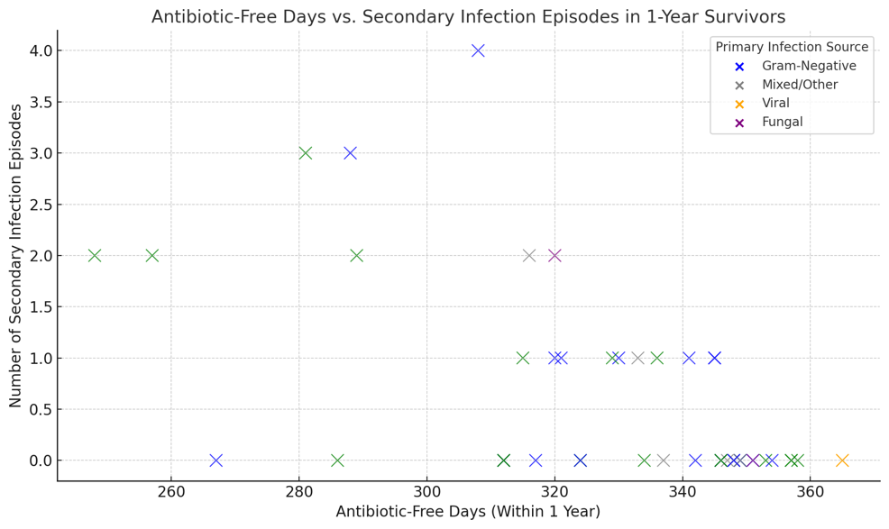
Supplementary Figure 1. Relationship between antibiotic-free days and secondary infection, in 1-year survivors, stratified by primary infection source. Each “X” represents one patient; n=49.

