Supplementary Materials

Efficacy of Priming and Commitment Posters on Urgent Care Patients’ Antibiotic Expectations and Knowledge: A Cluster Randomized Trial

Table S1. Knowledge and expectation score means by demographic and potential confounding variables
 | Knowledge Score Mean (SD) | p-value | Expectation Score Mean (SD) | p-value
Gender |  | < 0.001 |  | 0.958
Male | 2.13 (1.13) |  | 4.75 (2.04)
Female | 2.31 (1.05) |  | 4.75 (1.76)
Other | 2.20 (2.05) |  | 6.40 (2.51)
Did not Answer | 1.72 (1.14) |  | 5.00 (1.80)
Age Group |  | < 0.001 |  | < 0.001
18-29 years | 2.15 (1.13) |  | 5.19 (2.02)
30-49 years | 2.35 (1.08) |  | 4.80 (1.71)
50-64 years | 2.35 (1.01) |  | 4.63 (1.76)
≥ 65 years | 2.09 (1.08) |  | 4.39 (1.93)
Did not Answer | 1.85 (1.08) |  | 4.82 (1.54)
Ethnicity |  | 0.053 |  | 0.595
Hispanic | 2.13 (1.11) |  | 4.83 (2.05)
Non-Hispanic | 2.28 (1.07) |  | 4.76 (1.83)
Did not Answer | 1.65 (1.13) |  | 4.38 (2.11)
Race |  | < 0.001 |  | 0.160
White | 2.29 (1.08) |  | 4.74 (1.82)
Black | 1.93 (1.07) |  | 5.11 (2.13)
Other or Multiple | 2.20 (1.05) |  | 4.62 (1.91)
Chose not to Share | 1.98 (1.05) |  | 4.88 (2.19)
Did not Answer | 1.56 (1.11) |  | 4.80 (2.21)
Education |  | < 0.001 |  | < 0.001
< HS Diploma/ GED | 1.35 (1.19) |  | 6.00 (2.12)
HS Diploma/ GED | 2.00 (1.05) |  | 4.93 (2.01)
Trade/ Associate's Degree | 2.18 (1.05) |  | 4.78 (1.93)
Bachelor's Degree | 2.44 (1.06) |  | 4.70 (1.70)
Master's Degree | 2.60 (0.93) |  | 4.38 (1.60)
Doctoral/ Professional Degree | 2.71 (1.07) |  | 4.42 (1.52)
Did not Answer | 1.59 (1.10) |  | 4.79 (2.18)

Table S2. Knowledge and expectation scores and distribution of score components by arm
 | Clinic Arm, n (%)
 | Priming + Handout  (n = 432) | Commitment + Handout  (n = 118) | Handout  (n = 761) | Priming  (n = 604) | Commitment  (n = 249) | Control  (n = 755) | p-valueª
Knowledge Score, Mean (SD) | 2.13 (1.09) | 2.28 (1.08) | 2.29 (1.05) | 2.32 (1.10) | 2.24 (1.07) | 2.11 (1.13) | 0.004
Q6) What do antibiotics help treat? |  |  |  |  |  |  | 0.527
Cold/Flu | 20 (4.6) | 12 (10.2) | 22 (2.9) | 20 (3.3) | 13 (5.2) | 35 (4.6)
Virus | 22 (5.1) | 1 (0.9) | 28 (3.7) | 23 (3.8) | 14 (5.6) | 44 (5.8)
Bacteria | 290 (67.1) | 83 (70.3) | 539 (70.8) | 436 (72.2) | 165 (66.3) | 505 (66.9)
Cold/Flu & Virus | 0 (0.0) | 0 (0.0) | 3 (0.4) | 3 (0.5) | 1 (0.4) | 3 (0.4)
Cold/Flu & Bacteria | 19 (4.4) | 0 (0.0) | 24 (3.2) | 18 (3.0) | 8 (3.2) | 33 (4.4)
Virus & Bacteria | 23 (5.3) | 7 (5.9) | 41 (5.4) | 37 (6.1) | 14 (5.6) | 33 (4.4)
All of the Above | 29 (6.7) | 5 (4.2) | 53 (7.0) | 30 (5.0) | 17 (6.8) | 43 (5.7)
None of the Above | 13 (3.0) | 9 (7.6) | 34 (4.5) | 23 (3.8) | 9 (3.6) | 32 (4.2)
Did Not Answer | 16 (3.7) | 1 (0.9) | 17 (2.2) | 14 (2.3) | 8 (3.2) | 27 (3.6)
Q7) If a doctor is unsure if an antibiotic is needed, should one be prescribed just in case? |  |  |  |  |  |  | 0.101
True | 43 (10.0) | 17 (14.4) | 85 (11.2) | 58 (9.6) | 24 (9.6) | 94 (12.5)
False | 277 (64.1) | 79 (67.0) | 511 (67.2) | 420 (69.5) | 180 (72.3) | 467 (61.9)
I don't know | 105 (24.3) | 21 (17.8) | 148 (19.5) | 115 (19.0) | 42 (17.0) | 175 (23.2)
Did Not Answer | 7 (1.6) | 1 (0.9) | 17 (2.2) | 11 (1.8) | 3 (1.2) | 19 (2.5)
Q8) Are antibiotic resistant infections due to bacteria resistant to antibiotics |  |  |  |  |  |  | 0.147
True | 296 (68.5) | 83 (70.3) | 564 (74.1) | 435 (72.0) | 174 (69.9) | 510 (67.6)
False | 26 (6.0) | 8 (6.8) | 49 (6.4) | 43 (7.1) | 15 (6.0) | 45 (6.0)
I don't know | 105 (24.3) | 25 (21.2) | 133 (17.5) | 115 (19.0) | 56 (22.5) | 183 (24.2)
Did Not Answer | 5 (1.2) | 2 (1.7) | 15 (2.0) | 11 (1.8) | 4 (1.6) | 17 (2.3)
Q10) What increases risk of becoming infected by bacteria that are resistance to antibiotics? |  |  |  |  |  |  | 0.087
Taking an antibiotic can make a person resistant to antibiotics | 33 (7.6) | 8 (6.8) | 50 (6.6) | 49 (8.1) | 19 (7.6) | 43 (5.7)
Taking an antibiotic can make bacteria resistant to antibiotics | 57 (13.2) | 24 (20.3) | 129 (17.0) | 108 (17.9) | 40 (16.1) | 111 (14.7)
Both | 196 (45.4) | 45 (38.1) | 351 (46.1) | 275 (45.5) | 98 (39.4) | 328 (43.4)
I don't know | 130 (30.1) | 37 (31.4) | 200 (26.3) | 150 (24.8) | 75 (30.1) | 239 (31.7)
Did Not Answer | 16 (3.7) | 4 (3.4) | 31 (4.1) | 22 (3.6) | 17 (6.8) | 34 (4.5)
Expectation Score, Mean (SD) | 4.63 (1.91) | 4.46 (2.20) | 4.63 (1.96) | 4.60 (1.92) | 4.62 (2.10) | 4.40 (2.23) | 0.712
Q11) What do you expect an antibiotic for?
Cold | 64 (14.8) | 22 (18.6) | 107 (14.1) | 74 (12.3) | 38 (15.3) | 131 (17.4) | 0.009
Cough | 88 (20.4) | 23 (19.5) | 135 (17.7) | 108 (17.9) | 43(17.3) | 173 (22.9) | < 0.001
Virus | 116 (26.9) | 25 (21.2) | 200 (26.3) | 130 (21.5) | 62 (24.9) | 174 (23.1) | < 0.001
Strep Throat | 357 (82.6) | 89 (75.4) | 649 (85.3) | 508 (84.1) | 206 (82.7) | 585 (77.5) | < 0.001
Flu | 125 (28.9) | 27 (22.9) | 199 (26.2) | 166 (27.5) | 73 (29.3) | 217 (28.7) | 0.007
UTI | 361 (83.6) | 96 (81.4) | 656 (86.2) | 514 (85.1) | 208 (83.5) | 600 (79.5) | 0.003
Bronchitis | 308 (71.3) | 73 (61.9) | 518 (68.1) | 413 (68.4) | 175 (70.3) | 498 (66.0) | 0.042
Skin Infection | 255 (59.0) | 84 (71.2) | 496 (65.2) | 388 (64.2) | 153 (61.5) | 423 (56.0) | 0.001
Sinus Infection | 326 (75.5) | 87 (73.7) | 565 (74.2) | 478 (79.1) | 193 (77.5) | 519 (68.7) | < 0.001
a. comparing single intervention arms

Table S3. Intention-to-Treat comparison of a) knowledge scores, b) total expectation scores, and c) inappropriate expectation scores among each study arm (material group) to control (no materials), using a generalized linear mixed model clustered by clinic.
a. Knowledge Score | Unadjusted |  |  |  |  | Adjusted*
Material | N | Mean (95% CI) | SE | Estimate | p-value | N | Mean (95% CI) | SE | Estimate | p-value
Priming | 604 | 2.26 (2.08-2.45) | 0.09 | 0.06 | 0.67 | 579 | 2.09 (1.92-2.27) | 0.09 | 0.04 | 0.71
Handout + Priming | 432 | 2.14 (1.91-2.36) | 0.11 | -0.07 | 0.66 | 413 | 2.03 (1.83-2.23) | 0.10 | -0.02 | 0.84
Commitment | 249 | 2.18 (1.96-2.40) | 0.11 | -0.02 | 0.88 | 226 | 2.14 (1.93-2.35) | 0.11 | 0.09 | 0.48
Handout + Commitment | 118 | 2.27 (2.01-2.53) | 0.13 | 0.06 | 0.70 | 102 | 2.09 (1.84-2.34) | 0.13 | 0.03 | 0.81
Handout | 761 | 2.27 (2.09-2.45) | 0.09 | 0.07 | 0.62 | 727 | 2.11 (1.94-2.29) | 0.09 | 0.06 | 0.58
Control | 755 | 2.20 (2.00-2.40) | 0.10 | Ref | –– | 703 | 2.05 (1.87-2.24) | 0.09 | Ref | ––

b. Expectation Score | Unadjusted |  |  |  |  | Adjusted*
Material | N | Mean (95% CI) | SE | Estimate | p-value | N | Mean (95% CI) | SE | Estimate | p-value
Priming | 604 | 4.60 (4.43-4.78) | 0.09 | 0.20 | 0.11 | 579 | 4.56 (4.31-4.81) | 0.13 | 0.06 | 0.58
Handout + Priming | 432 | 4.64 (4.43-4.85) | 0.11 | 0.23 | 0.09 | 413 | 4.52 (4.25-4.80) | 0.14 | 0.03 | 0.84
Commitment | 249 | 4.63 (4.37-4.90) | 0.13 | 0.22 | 0.15 | 226 | 4.59 (4.27-4.91) | 0.16 | 0.09 | 0.54
Handout + Commitment | 118 | 4.46 (4.09-4.84) | 0.19 | 0.06 | 0.79 | 102 | 4.30 (3.89-4.71) | 0.21 | -0.20 | 0.34
Handout | 761 | 4.63 (4.47-4.79) | 0.08 | 0.23 | 0.05 | 727 | 4.57 (4.33-4.81) | 0.12 | 0.07 | 0.49
Control | 755 | 4.41 (4.24-4.57) | 0.08 | Ref | - | 703 | 4.50 (4.26-4.74) | 0.12 | Ref | -

c. Inappropriate Expectation Score | Unadjusted |  |  |  |  | Adjusted*
Material | N | Mean (95% CI) | SE | Estimate | p-value | N | Mean (95% CI) | SE | Estimate | p-value
Priming | 604 | 1.59 (1.34-1.84) | 0.13 | -0.10 | 0.57 | 579 | 1.78 (1.52-2.04) | 0.13 | -0.08 | 0.63
Handout + Priming | 432 | 1.69 (1.39-1.98) | 0.15 | -0.01 | 0.96 | 413 | 1.80 (1.50-2.10) | 0.15 | -0.06 | 0.73
Commitment | 249 | 1.71 (1.41-2.00) | 0.15 | 0.01 | 0.96 | 226 | 1.80 (1.50-2.11) | 0.15 | -0.06 | 0.76
Handout + Commitment | 118 | 1.59 (1.25-1.93) | 0.17 | -0.11 | 0.62 | 102 | 1.70 (1.35-2.05) | 0.18 | -0.16 | 0.44
Handout | 761 | 1.59 (1.35-1.84) | 0.12 | -0.10 | 0.58 | 727 | 1.76 (1.50-2.01) | 0.13 | -0.11 | 0.52
Control | 755 | 1.70 (1.43-1.96) | 0.14 | Ref | - | 703 | 1.86 (1.59-2.13) | 0.14 | Ref | -
* Fully adjusted model accounts for clinic arm, gender, age group, ethnicity, race, and education level

Table S4. As-treated analysis of a) knowledge scores, b) total expectation scores, and c) inappropriate expectation scores for participants who recalled seeing each intervention compared to control (did not recall seeing materials), using a generalized linear mixed model clustered by clinic.
a. Knowledge Score | Unadjusted |  |  |  |  | Adjusted*
Material | N | Mean (95% CI) | SE | Estimate | p-value | N | Mean (95% CI) | SE | Estimate | p-value
Priming | 330 | 2.32 (2.18-2.47) | 0.07 | 0.16 | 0.024 | 320 | 2.12 (1.96-2.29) | 0.08 | 0.09 | 0.182
Commitment | 161 | 2.39 (2.18-2.60) | 0.11 | 0.23 | 0.039 | 146 | 2.31 (2.09-2.53) | 0.11 | 0.27 | 0.008
Handout | 243 | 2.33 (2.17-2.49) | 0.08 | 0.16 | 0.033 | 230 | 2.22 (2.04-2.39) | 0.09 | 0.18 | 0.015
Control | 2132 | 2.16 (2.08-2.25) | 0.04 | Ref | - | 2001 | 2.04 (1.92-2.16) | 0.06 | Ref | -

b. Expectation Score | Unadjusted |  |  |  |  | Adjusted*
Material | N | Mean (95% CI) | SE | Estimate | p-value | N | Mean (95% CI) | SE | Estimate | p-value
Priming | 330 | 4.62 (4.39-4.85) | 0.12 | 0.07 | 0.55 | 320 | 4.53 (4.25-4.82) | 0.15 | -0.004 | 0.98
Commitment | 161 | 4.59 (4.26-4.92) | 0.17 | 0.04 | 0.82 | 146 | 4.44 (4.07-4.81) | 0.19 | -0.10 | 0.55
Handout | 243 | 4.65 (4.38-4.91) | 0.14 | 0.10 | 0.46 | 230 | 4.55 (4.23-4.87) | 0.16 | 0.01 | 0.92
Control | 2132 | 4.55 (4.45-4.65) | 0.05 | Ref | - | 2001 | 4.54 (4.33-4.75) | 0.11 | Ref | -

c. Inappropriate Expectation Score | Unadjusted |  |  |  |  | Adjusted*
Material | N | Mean (95% CI) | SE | Estimate | p-value | N | Mean (95% CI) | SE | Estimate | p-value
0.01Priming | 330 | 1.56 (1.37-1.74) | 0.09 | -0.12 | 0.17 | 320 | 1.75 (1.53-1.97) | 0.11 | -0.08 | 0.34
Commitment | 161 | 1.60 (1.33-1.87) | 0.14 | -0.08 | 0.56 | 146 | 1.63 (1.33-1.92) | 0.15 | -0.21 | 0.13
Handout | 243 | 1.59 (1.39-1.79) | 0.10 | -0.09 | 0.35 | 230 | 1.70 (1.47-1.93) | 0.12 | -0.13 | 0.16
Control | 2132 | 1.68 (1.57-1.79) | 0.06 | Ref | - | 2001 | 1.83 (1.67-2.00) | 0.09 | Ref | -

* Fully adjusted model accounts for clinic arm, gender, age group, ethnicity, race, and education level

Figure S1. Posters Displayed in Participating Urgent Care Centers
Handout (Front) | 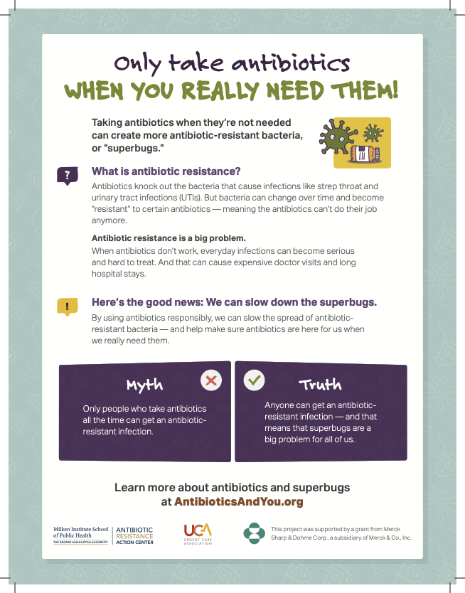  Handout (Back)
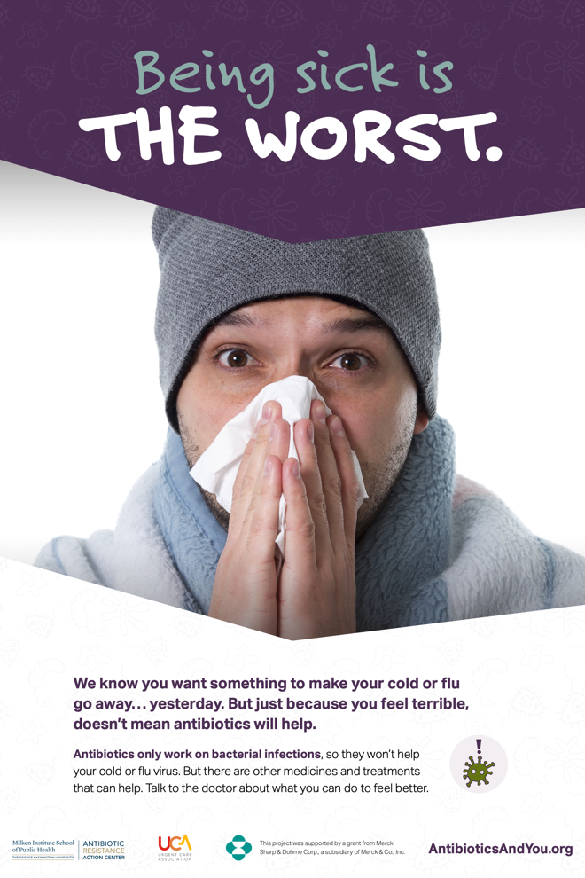  Priming Poster | 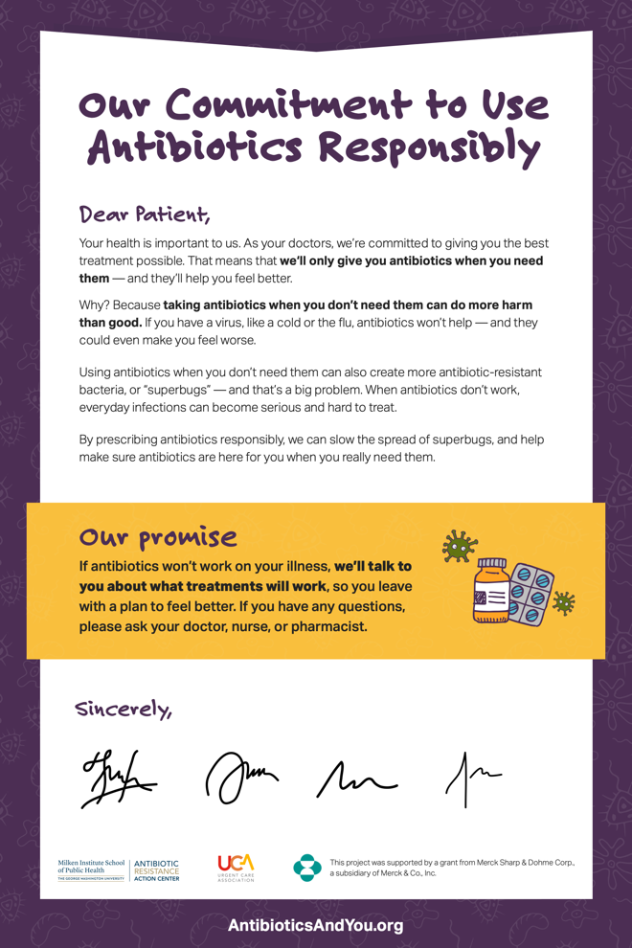  Commitment Poster

