Supplemental Figure 1AB. Flowsheet template in Epic for leaving stewardship progress notes (A). Formal notes additionally include a case summary and summary of data; an example of data summary for Gram negative bacteremia shown in (B). 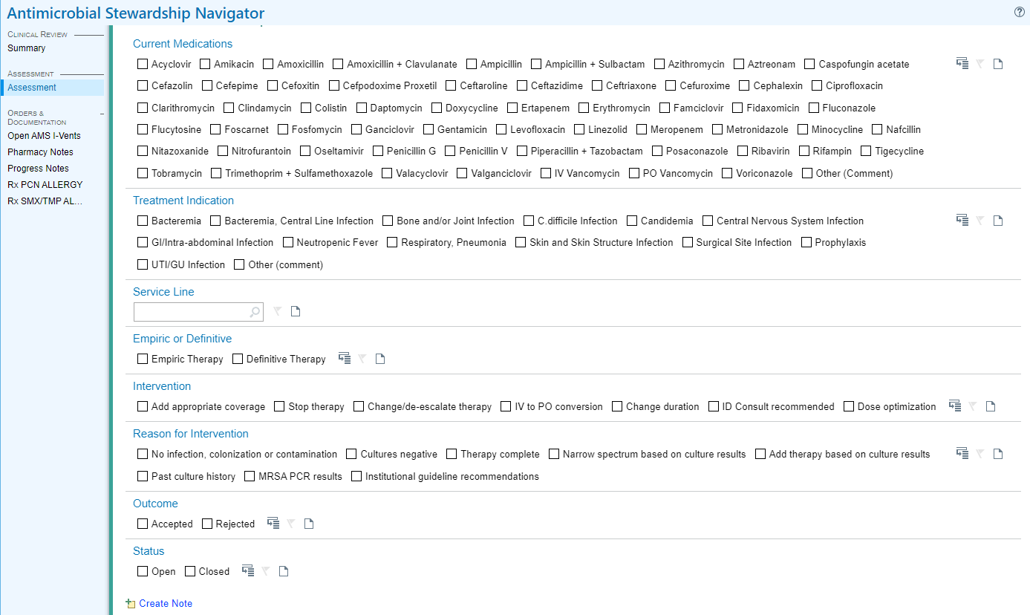

B.
