**Assessing a safety climate tool adapted to address respiratory illnesses in Canadian hospitals**

**Supplementary Table**

**Factor loading results from exploratory factor analysis excluding all “don’t know” responses; Canadian acute care hospital workers with direct patient care, 2010/11-2013/14**

|  | **HSCS factor** | **Factor loadings** | | | |
| --- | --- | --- | --- | --- | --- |
| Manage-ment support | Absence of job hindrances | Good communi-cation | Feedback/ training |
| **Items adapted* for respiratory illnesses, from the hospital safety climate scale (HSCS)12** | | | | | |
| 8. At my work, unsafe work practices are corrected by supervisors | Feedback/  training | 0.28 | 0.24 | 0.29 | **0.58** |
| 7. My supervisor often discusses safe work practices with me | Feedback/  training | 0.23 | 0.14 | 0.25 | **0.74** |
| 13. On my unit, there is open communication between supervisors and staff | Good communication | 0.31 | 0.23 | **0.72** | 0.30 |
| 12. Management and staff on my unit support one another | Good communication | 0.24 | 0.25 | **0.79** | 0.29 |
| 11. There are good employee relations within my work area | Good communication | 0.16 | 0.29 | **0.64** | 0.23 |
| 14. I have enough time in my work to protect myself from communicable respiratory illness | Absence of job hindrances | 0.30 | **0.68** | 0.31 | 0.22 |
| 5. My job duties do not interfere with my being able to protect myself from influenza | Absence of job hindrances | 0.38 | **0.48** | 0.19 | 0.21 |
| 4. Managers at my work do their part to ensure employees’ safety | Management support | **0.64** | 0.20 | 0.31 | 0.37 |
| 3. At my work, employees are encouraged to become involved in safety and health matters | Management support | **0.69** | 0.21 | 0.20 | 0.25 |
| 2. At my work, all reasonable steps are taken to minimize hazardous job tasks and procedures | Management support | **0.76** | 0.27 | 0.16 | 0.20 |
| 1. The protection of workers from occupational exposure to infectious respiratory disease is a high priority with management where I work | Management support | **0.69** | 0.25 | 0.16 | 0.16 |
| *Percentage of variance (adapted items)* |  | ***23%*** | *10%* | *12%* | *20%* |
| ***New items*** | | | | | |
| 10. In my current work area, safety is regularly discussed at staff meetings | N/A | 0.22 | 0.19 | 0.21 | **0.69** |
| 15. I can provide good quality care to my patients while protecting myself from respiratory illness | N/A | 0.25 | **0.78** | 0.23 | 0.16 |
| 6. At my work, employees are encouraged to identify unsafe work practices among themselves | N/A | **0.47** | 0.30 | 0.20 | 0.39 |
| 16. My supervisor enforces compliance with legislation and workplace policy regarding worker safety | N/A | 0.32 | ***0.47*** | 0.30 | ***0.47*** |
| 9. In my current work area, my coworkers support me in following safe work practices | N/A | 0.29 | 0.38 | 0.23 | 0.35 |
| *Percentage of variance (all items)* |  | *19%* | *14%* | *14%* | *15%* |

*See Supplementary figure for changes to wording

HSCS: hospital safety climate scale; Good communication: minimal conflict/good communication; N/A: not applicable

**Assessing a safety climate tool adapted to address respiratory illnesses in Canadian hospitals**

**Supplementary Figure**

**Path diagram for the structual equation model of the association between ratings of safety climate in healthcare settings and demographic and study-related variables**

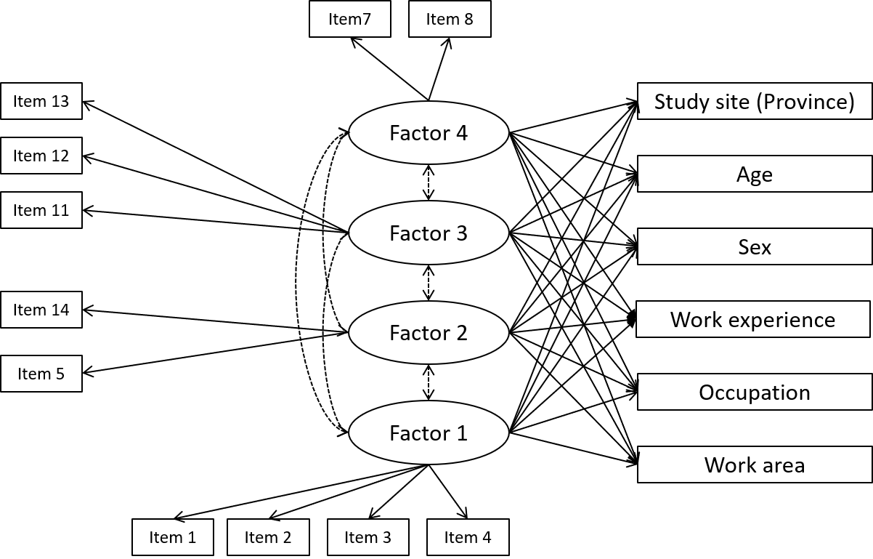

**Factors**

1. Management support
2. Absence of job hindrance
3. Minimal conflict/good communication
4. Feedback/training

**Items**

**Notes:** a) italics represent added wording and b) strikeouts represent words removed from the Health Safety Climate Scale 12 items

1. The protection of workers from occupational exposure to ~~HIV~~ *infectious respiratory disease* is a high priority with management where I work
2. ~~On my unit~~ *At my work*, all reasonable steps are taken to minimize hazardous job tasks and procedures
3. *At my work,* employees are encouraged to become involved in safety and health matters
4. Managers ~~on my unit~~ *at my work* do their part to ensure employees’ *safety* ~~protection from occupational HIV/AIDS~~
5. My job duties do not ~~often~~ interfere with my being able to *protect myself from influenza* ~~follow Universal Precautions~~
6. Excluded (new) *At my work, employees are encouraged to identify unsafe work practices among themselves*
7. My supervisor often discusses safe work practices with me
8. At my work, unsafe work practices are corrected by supervisors
9. Excluded (new) *In my current work area, my coworkers support me in following safe work practices*
10. Excluded (new) *In my current work area, safety is regularly discussed at staff meetings*
11. *There are good employee relations within my work area.* ~~There is minimal conflict within my department~~
12. ~~The members of~~ *Management and staff on* my unit support one another
13. On my unit, there is open communication between supervisors and staff
14. I have enough time in my work to *protect myself from communicable respiratory illness* ~~always follow Universal Precautions~~
15. Excluded (new) *I can provide good quality care to my patients while protecting myself from respiratory illness*
16. Excluded (new) *My supervisor enforces compliance with legislation and workplace policy regarding worker safety*