Supplementary Material

Materials and Methods

Study Population
We invited all 85 respondents who reported having had a positive COVID-19 test to participate in the study, of whom 82 agreed to participate. To avoid over-selecting staff from departments with higher representation in the screening survey, we weighted the respondents who did not report prior positive COVID-19 tests by department and then randomly selected 370 additional employees, 220 of whom agreed to participate (See Supplemental Figure 1).

Antibody Detection
We used the Roche Diagnostics Elecsys Anti-SARS-CoV-2 assay on a cobas e602 analyzer, which detects total antibodies (IgA, IgG, IgM) to the nucleocapsid (N) protein using a sandwich immunoassay format, with a cut-off index (COI) of 1.0 or higher indicating a positive result. The Roche assay is positive after infection with SARS-CoV-2. We also used the DiaSorin SARS-CoV-2 S1/S2 IgG assay on a DiaSorin Liaison XL analyzer, which detects IgG antibodies to the S1 and S2 domains of the spike (S) protein using an indirect immunoassay format, with a signal of 15 AU/mL or higher indicating a positive result. The DiaSorin assay is positive after either infection or vaccination.

From 10/30/2020 through 3/22/2021, we used the Diasorin assay to determine if participants with positive Roche anti-N tests had positive anti-S (i.e., reflexive testing). On 3/23/2021 and through the end of the study, we tested all specimens with both assays. During this latter period, we considered participants to have evidence of SARS-CoV-2 infection if they had positive Roche anti-N and positive Diasorin anti-S results. Participants’ results were considered indeterminate if the Roche anti-N was positive, but the Diasorin anti-S was negative.

Analysis of Risk Factors for Seropositivity at T0
To analyze risk factors for seropositivity at T0, we conducted a factor analysis to reduce the number of dimensions (i.e. variables) and to explain the correlation among the variables. We used data obtained through the COVID-19 sentiment instrument that comprised 12 Likert scale variables measuring participants’ perceptions of COVID-19 and their attitudes toward risk behaviors. Factor analysis allowed us to use observed composite variables that were strongly related to important underlying unmeasurable constructs (i.e., latent variables) to indirectly assess whether these constructs were related to seropositivity. To create the new variables in the factor analysis, we rotated the axes so that each observed variable was strongly related to only one factor. We performed a promax rotation to obliquely rotate the axes because we suspected that the underlying factors themselves would be correlated.

FIGURE LEGENDS
Supplemental Figure 1. Data Collection Flow Chart
Supplemental Figure 2. Stages of the Serosurvey Study Aligned with Stages of the COVID-19 Pandemic
Abbreviations: WHO, World Health Organization; US, United States; UIHC, University of Iowa Hospitals and Clinics; EUA, emergency use authorization; S, spike; N, nucleocapsid.

Supplemental Figure 1.

Supplemental Figure 2
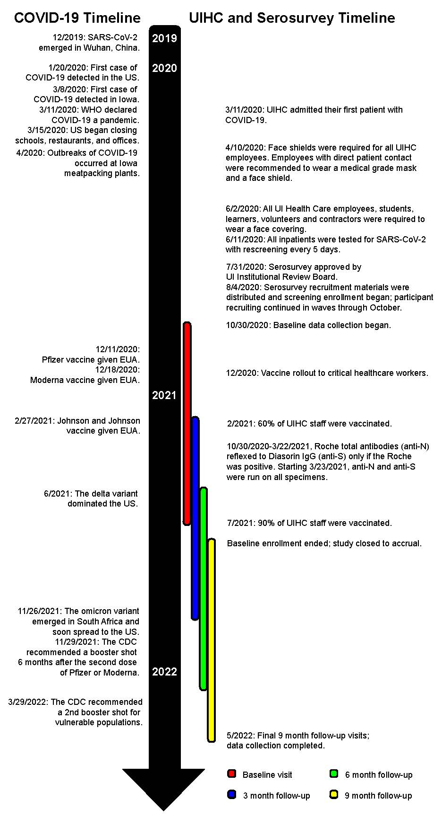
Supplemental Table 1. Healthcare Professionals’ Perceptions of COVID-19 at Each Time Point

Variable​ | T0  (N = 302)​ | T3  (N = 286)​ | T6  (N = 266)​ | T9  (N = 264)​
Perceived likelihood of contracting COVID-19 at the hospital in the next month, very likely (6-7)*​ | 7 (2.3%)​ | 6 (2.1%)​ | 4 (1.5%)​ | 3 (1.1%)​
Compared with coworkers, perceived likelihood of contracting COVID-19 in the next month, much more likely (6-7)*​ | 7 (2.3%)​ | 2 (0.7%)​ | 3 (1.1%)​ | 2 (0.8%)​
Perceived likelihood of contracting COVID-19 in the community in the next month, very likely (6-7)*​ | 3 (1.0%)​ | 2 (0.7%)​ | 6 (2.3%)​ | 6 (2.3%)​
Worried about contracting COVID-19, very worried (6-7)*​ | 34 (11.3%)​ | 5 (1.7%)​ | 7 (2.6 %)​ | 15 (5.7%)
Worried about household members catching COVID-19, very worried (6-7)*​ | 50 (16.6%)​ | 23 (8.0%)​ | 29 (10.9%)​ | 40 (15.2%)​
Worried about spreading asymptomatic COVID-19 infection, very worried (6-7)*​ | 136 (45.0%)​ | 73 (25.5%)​ | 55 (20.7%)​ | 61 (23.1%)​
Do you go out in public (stores, restaurants, etc.) like you did pre-pandemic, strongly agree (6-7)*​ | 22 (7.3%)​ | 39 (13.6%)​ | 74 (27.8%)​ | 40 (15.2%)​
Frequency of wearing a face covering in the community, always (6-7)*​ | 261 (86.4%)​ | 220 (76.9%)​ | 101 (40.0%)​ | 115 (43.6%)​

Supplemental Table 2. Rotated Factor Pattern for COVID Sentiment Factor Analysis
COVID Sentiment Survey Questions | ‘Infection Likelihood’ Factor | ‘Worried/Concern’ Factor | ‘Safe Behavior’ Factor
How likely do you think you are to contract COVID-19 from working at the hospital during the next month? | 0.57 | 0.20 | 0.05
How likely do you think you are to contract COVID-19 from activities in the community during the next month? | 0.33 | 0.14 | -0.07
Compared with other people you work with, how likely do you think you are to contract COVID-19 during the next month? | 0.71 | -0.17 | -0.002
How are worried are you that you will get COVID-19? | 0.15 | 0.67 | 0.04
How worried are you that people you live with will get COVID-19? | 0.01 | 0.65 | -0.05
How worried are you that you would spread the coronavirus if you were infected but didn’t have symptoms? | 0.08 | 0.49 | -0.07
If you were to get COVID-19, how sick do you think you would feel? | 0.10 | 0.59 | 0.03
If someone you lived with were to get COVID-19, how sick do you think they would feel? | -0.11 | 0.68 | -0.02
I am willing to go to stores, restaurants, and other public places the way I did before the coronavirus outbreak. | -0.14 | 0.42 | 0.10
In general, I avoid taking risks. | 0.04 | -0.04 | 0.86
I generally like to play it safe. | -0.01 | 0.03 | 0.94
I generally avoid risky situations. | -0.02 | 0.02 | 0.86

Supplemental Table 3. Multivariable Model to Assess Risk Factors for SARS-CoV-2 Seropositivity at Baseline—Excludes Vaccination Status
Variables | OR (95% CI)
Age (ref = 19-30)
31-38 | 0.32 (0.15, 0.69)
39-50 | 0.54 (0.26, 1.11)
51-69 | 0.46 (0.22, 0.96)
Nurse or Nursing Assistant (Ref = no) | 1.67 (0.87, 3.19)
Safe Behavior Factor | 0.78 (0.62, 0.98)
High Risk Unit (ref = no) | 0.42 (0.22, 0.82)
Note: CI, confidence interval; OR, odds ratio; ref, reference.

