Supplementary material

Title: A novel approach for safe and automated implementation of far ultraviolet-C light decontamination in clinical areas

Figure 1. Picture of the wall-mounted device showing the 3 krypton-chloride excimer lamps and adjustable arm that can be used to adjust the position of the lamps.
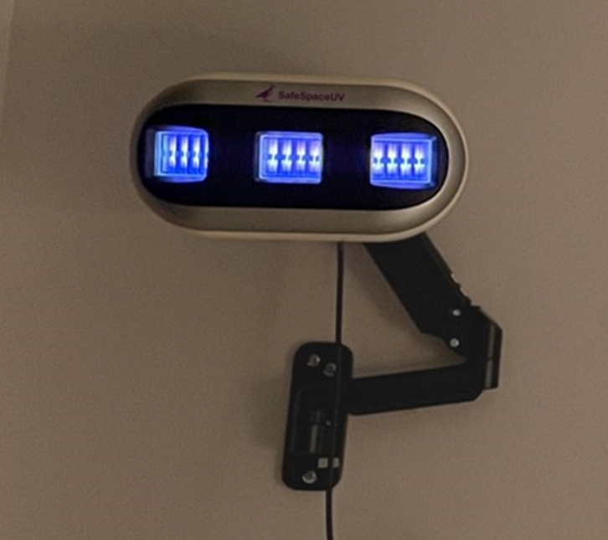

Figure 2. Patient room dimensions without the far UV-C devices
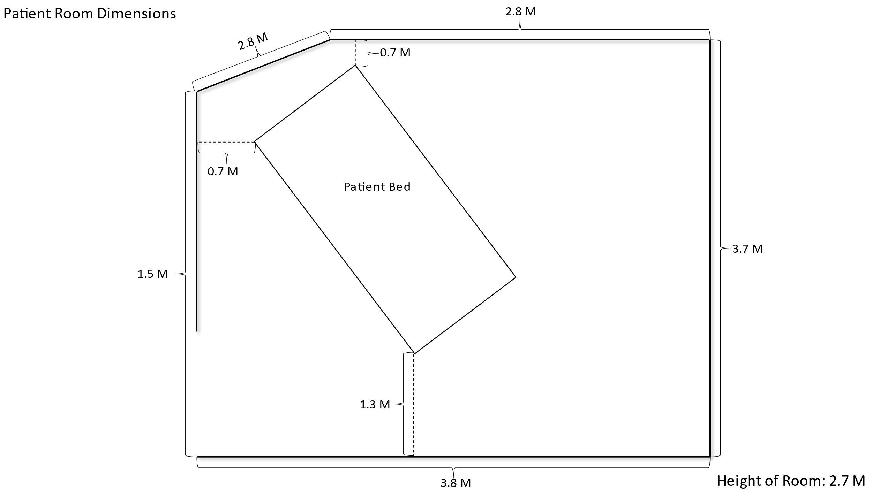

Figure 3. Far ultraviolet-C (UV-C) doses based on colorimetric indicator readings in an unoccupied patient room with 2 far UV-C devices positioned either along 1 wall (A) or at opposite sides of the room with the bed midway between the lamps (B) and reductions in methicillin-resistant Staphylococcus aureus (MRSA) after 45 minutes of exposure (C). Doses of far UV-C measured using colorimetric indicators are shown in parentheses. Error bars show standard error.

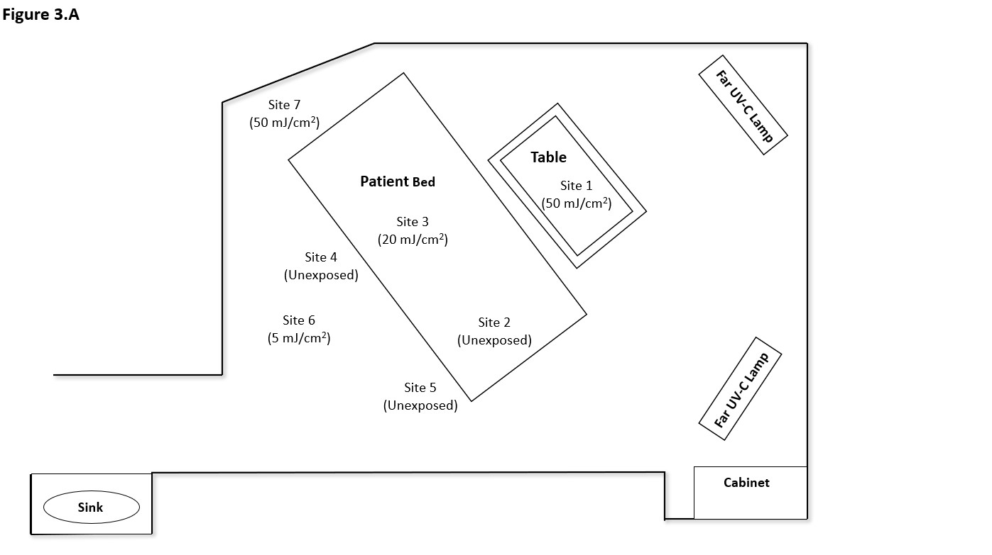

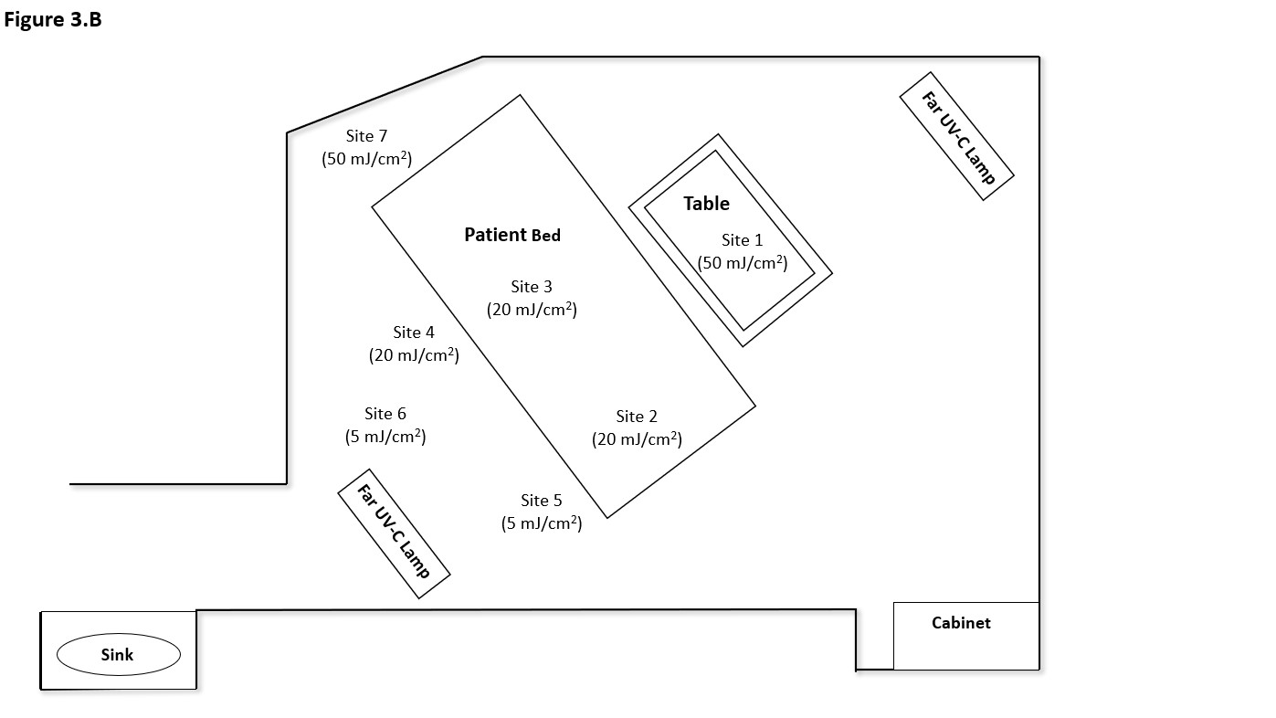

Figure 3.C
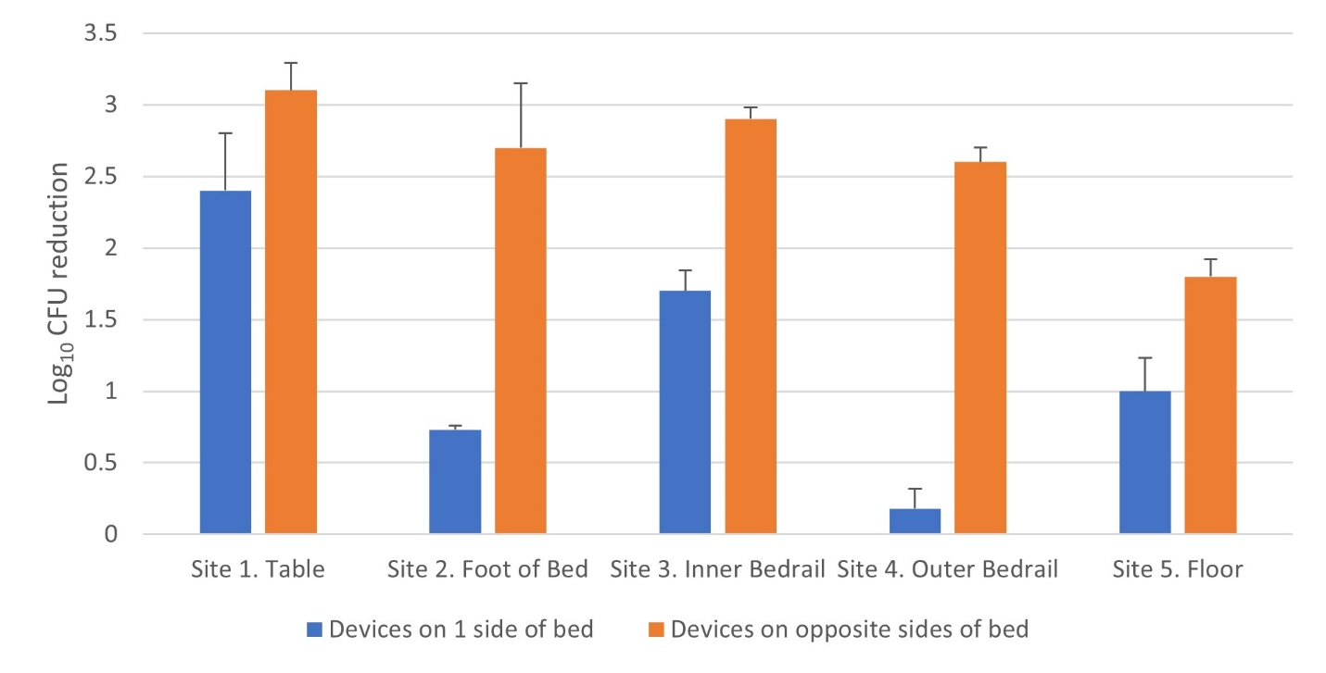

Figure 4. Reductions in methicillin-resistant Staphylococcus aureus (MRSA) after 45 minutes of exposure in a patient bathroom. Doses of far UV-C measured using colorimetric indicators are shown in parentheses. Error bars show standard error.

Figure 5. Pictures of the patient room and equipment room with the devices in place

- Patient room with 2 far UV-C devices positioned in parallel along 1 wall
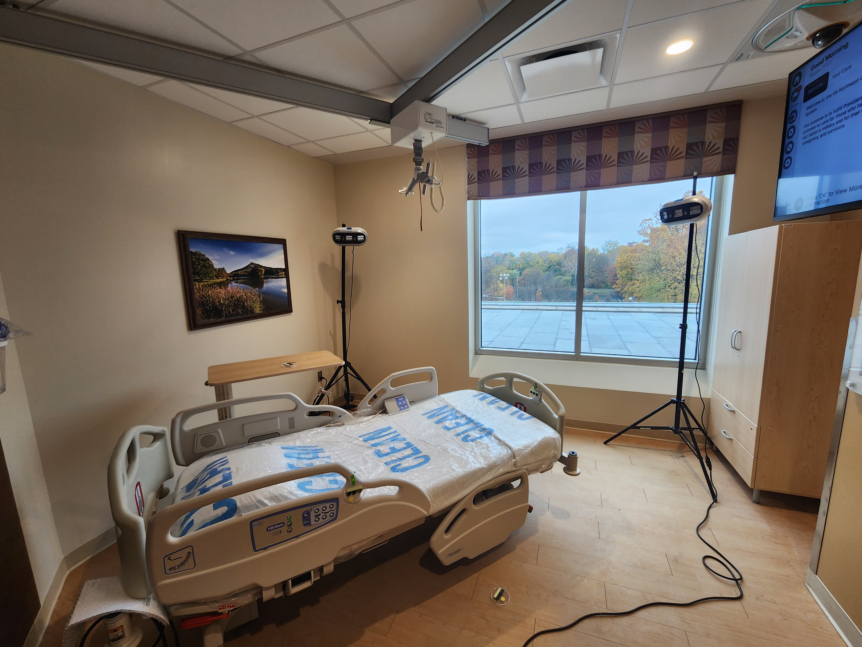

- Patient room with 2 devices positioned at opposite sides of the room on each side of the bed
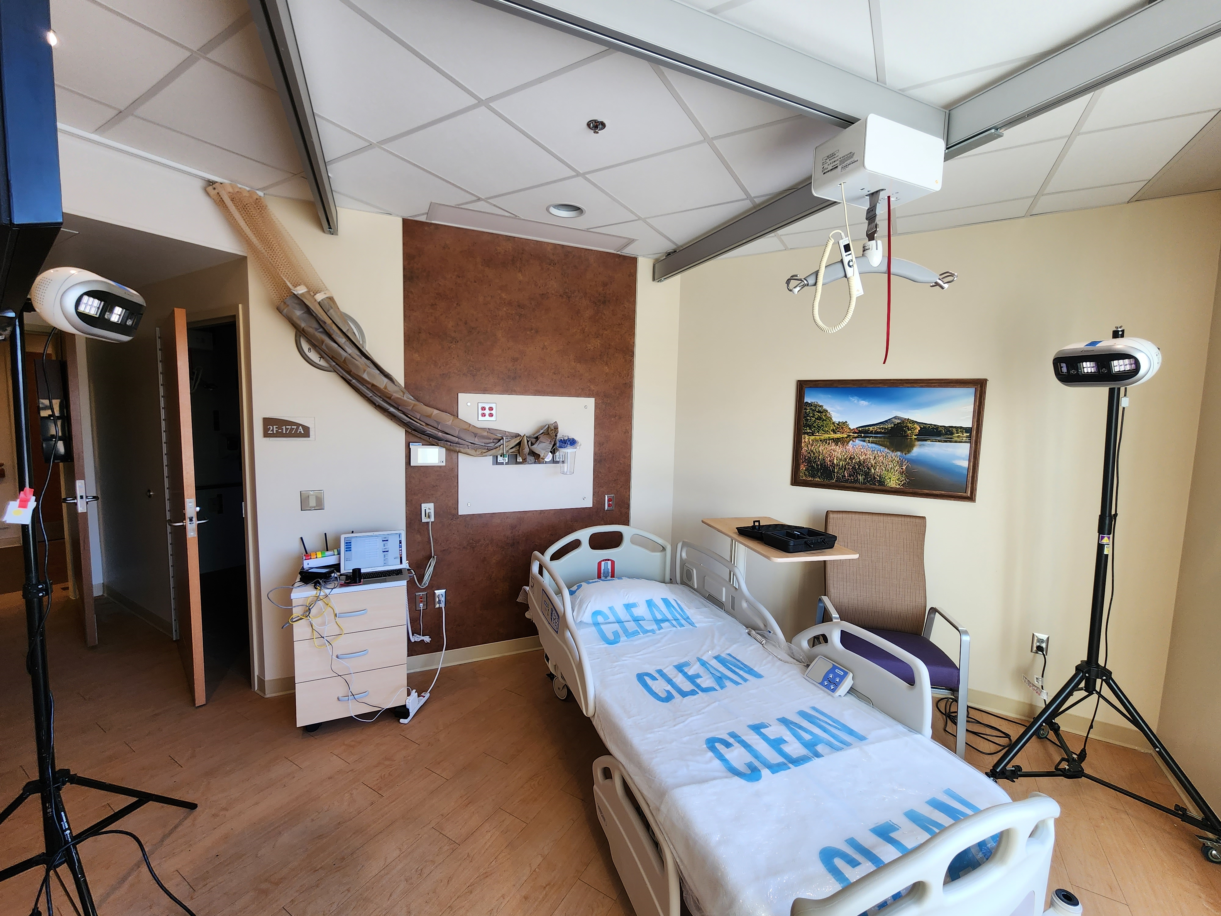
- Equipment room