**SUPPLEMENTS**

Supplement 1. Electronic medical record COVID-19 order set

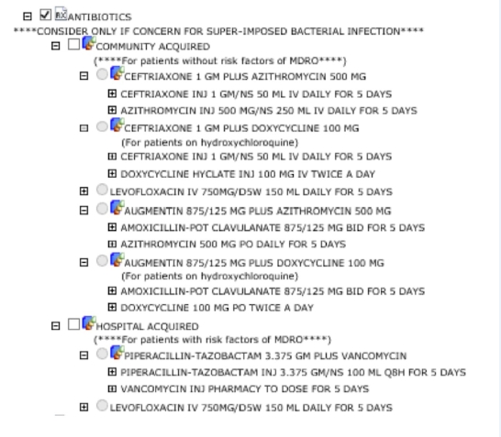

Supplement 2. DOT/1000 for anti-Pseudomonal beta-lactams and non-APBL before and after the intervention.

