Supplementary Table S1-S5
Supplementary table S1 Symptoms reported by the treating clinician
Specific urinary symptoms
Abdominal pain | 57 (31.7%)
Dysuria | 40 (22.2%)
Frequency | 69 (38.3%)
Purulent discharge | 5 (2.8%)
Urgency | 77 (42.8%)
Urinary incontinence (worsened) | 33 (18.3%)
Non-specific symptoms
Confusion | 96 (53.3%)
Malaise | 61 (33.9%)
Loss of appetite | 37 (20.6%)
Systemic symptoms
Fever | 10 (5.6%)
Delirium | 20 (11.1%)
Shivers | 7 (3.9%)
Costovertebral angle tenderness | 8 (4.4%)
Presence of indwelling catheter
Indwelling catheter | 9 (5.0%)

Supplementary table S2 Number of symptoms reported by the treating clinician per resident

Number of specific symptoms¹ reported per resident
0 | 52 (28.9%)
1 | 45 (25.0%)
2 | 37 (20.6%)
3 | 26 (14.4%)
4 | 16 (8.9%)
5 | 4 (2.2%)
6 | 0 (0%)
Number of systemic symptoms² reported per resident
0 | 147 (81.7%)
1 | 29 (16.1%)
2 | 4 (2.2%)
3 | 0 (0%)
Number of nonspecific symptoms³ reported per resident
0 | 54 (30.0%)
1 | 71 (39.4%)
2 | 42 (23.3%)
3 | 13 (7.2%)
¹ dysuria, frequency, urgency, worsened urine incontinence, purulent discharge, abdominal pain ² fever, chills, delirium ³ confusion, malaise, loss of appetite
Supplementary Figure S3 Symptom distribution among UTI episodes
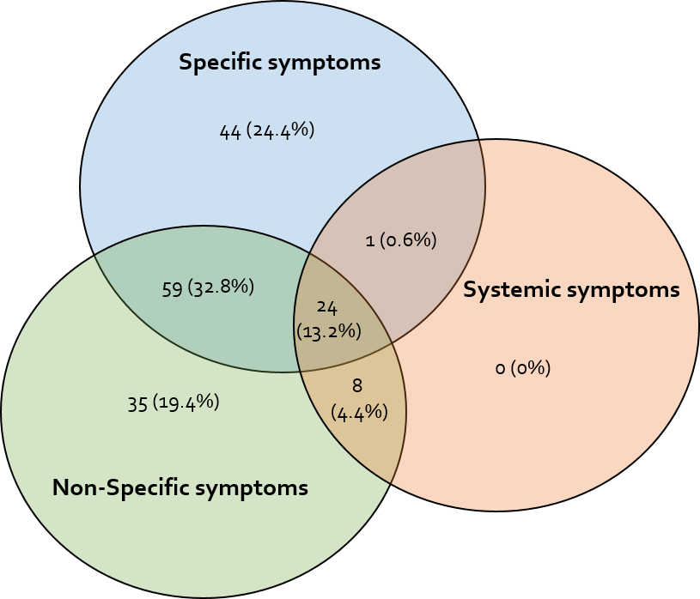
Supplementary table S4 2x2 table Model 1 Guideline-based
 |  |  | Model 1: Guideline-based
 |  |  | UTI absent (0) | UTI present (1) | Total
UTI outcome | UTI absent (0) | Counts | 76 | 61 | 137
 |  | Expected | 72.3 | 64.7
 |  | Residuals | 3.7 | -3.7
 | UTI present (1) | Counts | 19 | 24 | 43
 |  | Expected | 22.7 | 20.3
 |  | Residuals | -3.7 | 3.7
 | Total |  | 95 | 85 | 180
TP = 24, FP = 61

Supplementary table S5 2x2 table Model 2: Extended model

 |  |  | Model 2:Extended model
 |  |  | UTI absent (0) | UTI present (1) | Total
UTI outcome | UTI absent (0) | Counts | 40 | 96 | 137
 |  | Expected | 33.5 | 103.5
 |  | Residuals | 6.5 | -6.5
 | UTI present (1) | Counts | 4 | 39 | 43
 |  | Expected | 10.5 | 32.5
 |  | Residuals | -6.5 | 6.5
 | Total |  | 44 | 136 | 180
TP = 39, FP = 96
TP: True Positives; FP: False Positives. Model 1: guideline-based model inclusion of only specific urinary symptoms and positive leukocyte or nitrite dipstick results.Model 2: as per current guideline or ≥1 non-specific symptoms with positive leukocyte or nitrite dipstick results (extended model)

