Supplement Table 1. Provider-selected antibiotic indications during study period

Provider Selected Antibiotic Indications
Pneumonia/Lower respiratory infection
- Community-acquired (onset < 72 hours after admission, no recent healthcare exposure)
- Healthcare-associated (onset = 72 hours after admission or recent healthcare exposure)
Abdominal/pelvic
- Community-acquired (onset < 72 hours after admission, no recent healthcare exposure)
- Healthcare-associated (onset = 72 hours after admission or recent healthcare exposure)
Bloodstream infection
Bone/joint infection
Central nervous system
Endocarditis
ENT/OMFS/Ophtho
Genital infection
Gastrointestinal
Neutropenic fever
Other (specify below)
- Free text
Prophylaxis for immunosuppression
Severe sepsis/septic shock
Skin and soft tissue infection
Upper respiratory tract infection
Prophylaxis for surgery
Urinary tract infection
- Uncomplicated cystitis, community-acquired (onset <72 hours after admission, no recent healthcare exposure)
- Complicated cystitis, community-acquired (onset <72 hours after admission, no recent healthcare exposure)
- Pyelonephritis, community-acquired (onset <72 hours after admission, no recent healthcare exposure)
- Healthcare-associated cystitis or pyelonephritis

Unknown source

Supplement Table 2. List of systemic antibiotics that were not counted when defining the inclusion criteria. All other systemic (oral, enteral, intravenous, and intramuscular routes) were included in the list for the inclusion criteria.

Systemic Antibiotics Excluded from Inclusion Criteria
Daptomycin
Erythromycin
Ethambutol
Fidaxomicin
Fosfomycin
Isoniazid
Nitrofurantoin
Pyrazinamide
Rifabutin
Rifampin
Rifapentine
Rifaximin
Vancomycin oral/enteral (not IV)

Supplement Table 3. ICD-10 codes for pneumonia

ICD-10 Code for Pneumonia
J09.X1, J10.00, J10.01, J10.08, J11.00, J11.08, J12.0, J12.1, J12.2, J12.3, J12.8, J12.81, J12.82, J12.89, J12.9, J13, J14, J15, J15.1, J15.2, J15.21, J15.211, J15.212, J15.29, J15.3, J15.4, J15.5, J15.6, J15.7, J15.8, J15.9, J16.8, J16.0, J17, J18.0, J18.1, J18.8, J18.9, A37.01, A37.11, A37.81, A37.91, A48.1, J22

Supplement Figure 1. Proportion of patients with infiltrates on chest imaging by method of identification of community acquired pneumonia (CAP)
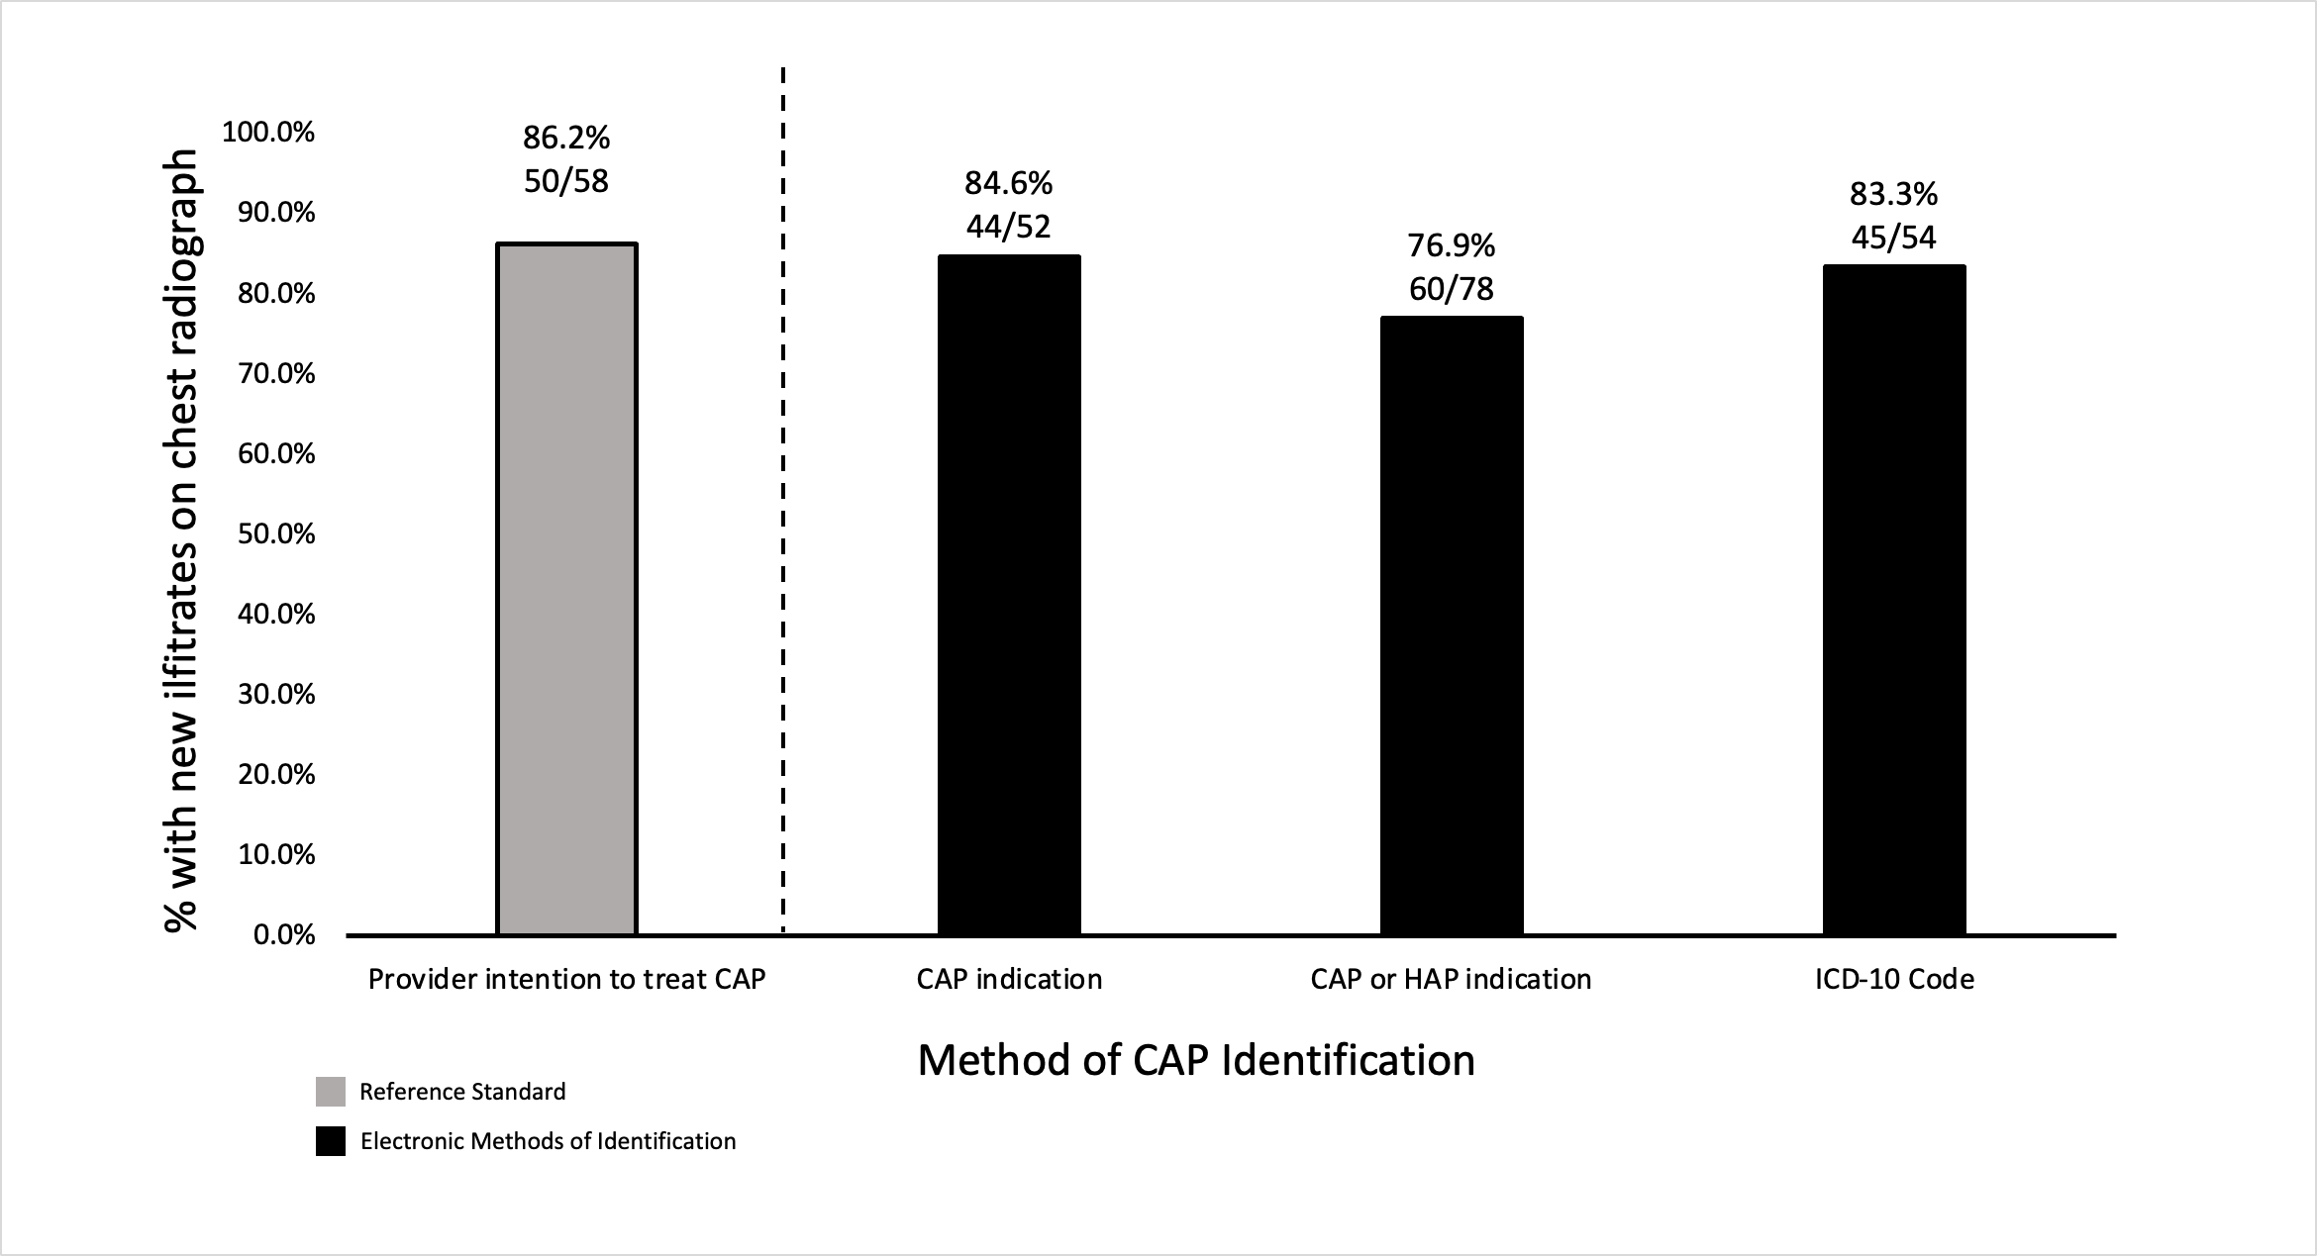
CAP, community-acquired pneumonia; HAP, healthcare-associated pneumonia

Supplement Figure 2. Distribution of pneumonia terminology among sixty-four patients with pneumonia by chart review
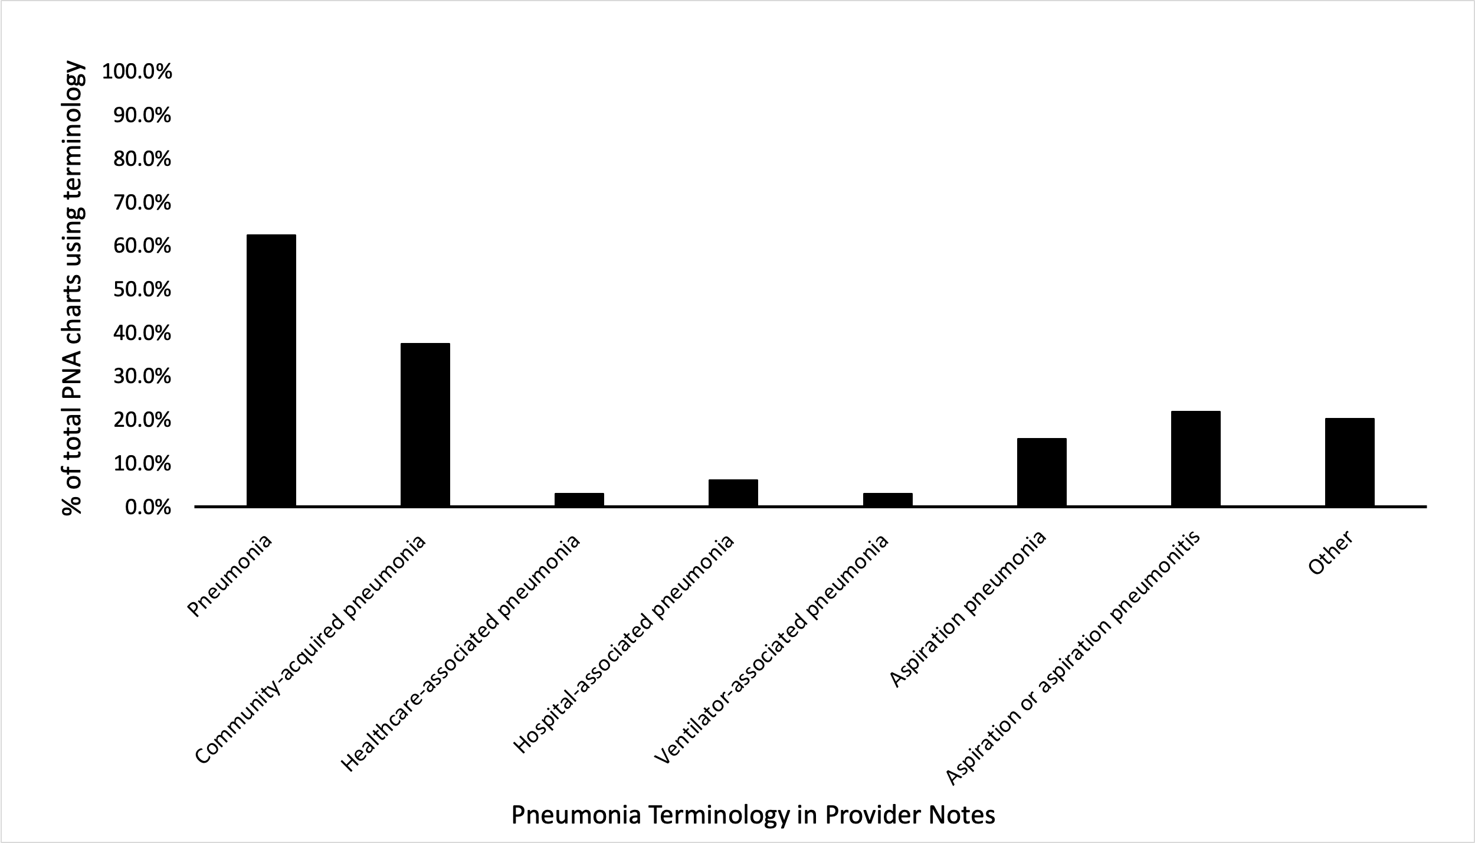
PNA, pneumonia
Note: the “other” category includes the following: COVID-19 pneumonia, 9 (64.3%); post-obstructive pneumonia, 2 (14.3%); Pneumocystis jiroveci pneumonia, 1 (7.1%); hemorrhagic pneumonia, 1 (7.1%); post-viral bacterial pneumonia, 1 (7.1%)

“

.

