SUPPLEMENTS

Supplement A. Sample syndrome-based guideline for physicians
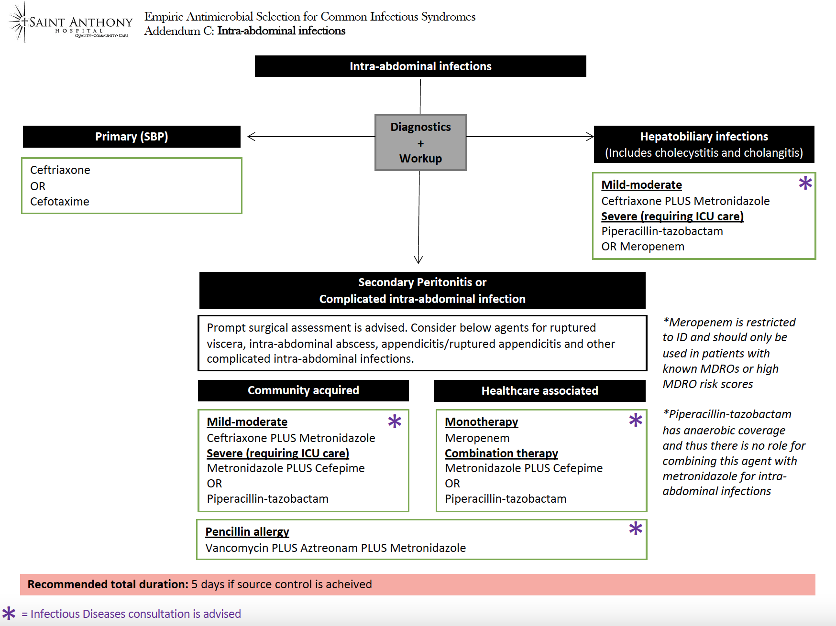

Supplement B. Sample syndrome-based order set for physicians

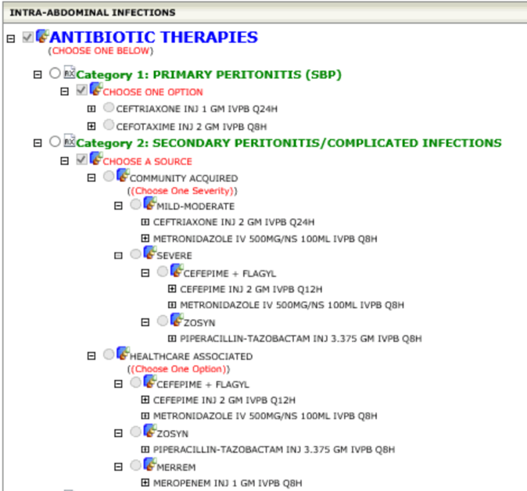
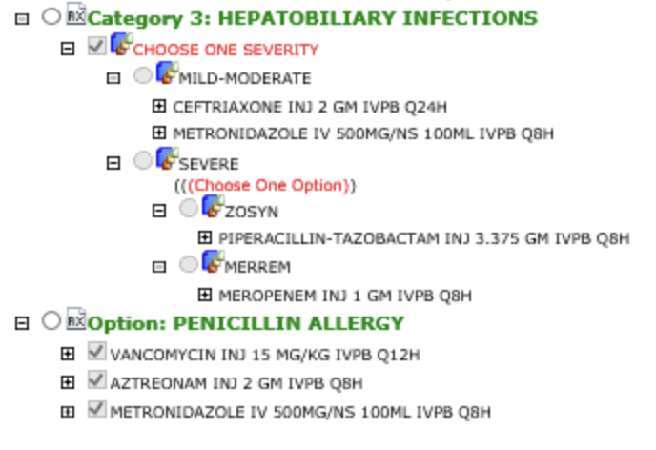
Supplement C. Sample syndrome-based order set for pharmacists
