SUPPLEMENT

Supplement A. Memorandum shared with physicians and nurses.
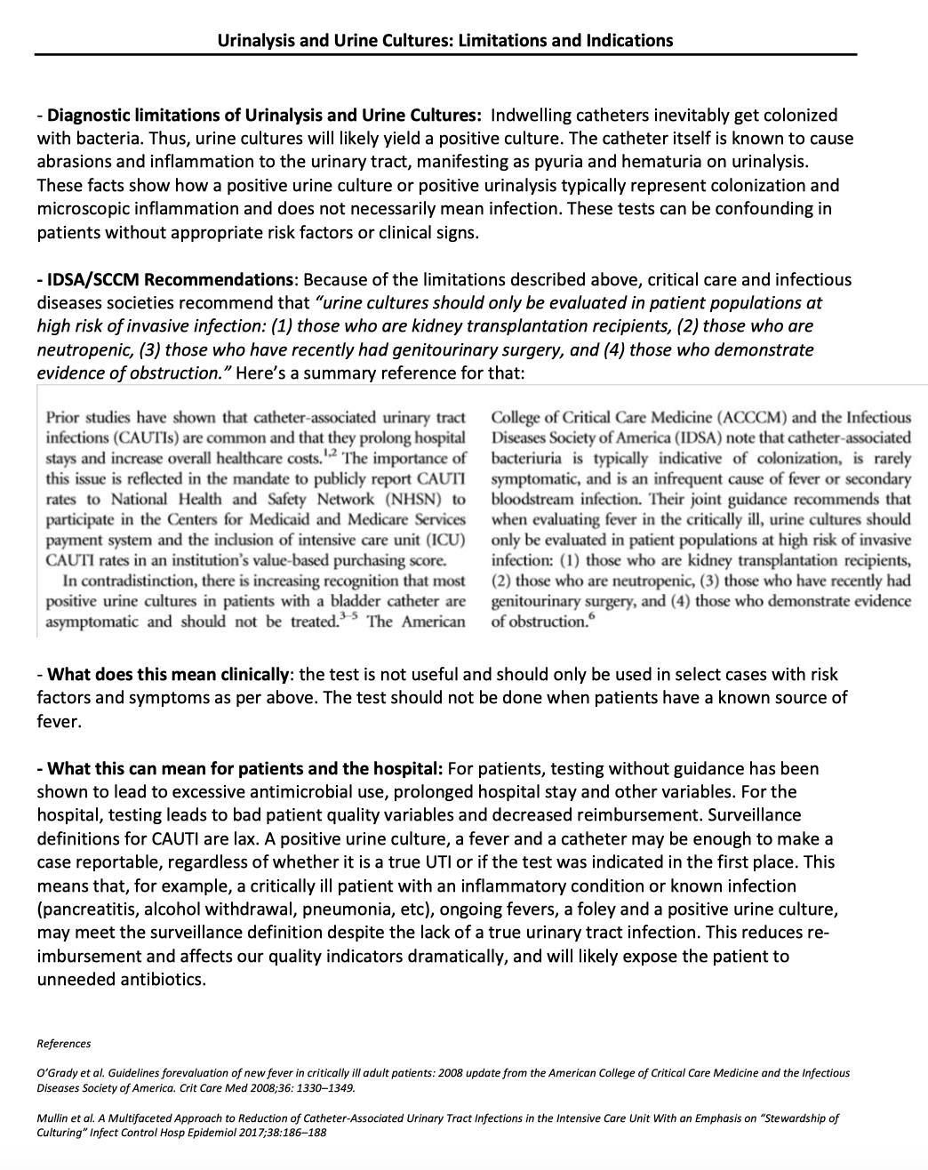
Supplement B. Signage posted in nursing units and areas where urine collection cups were stored.

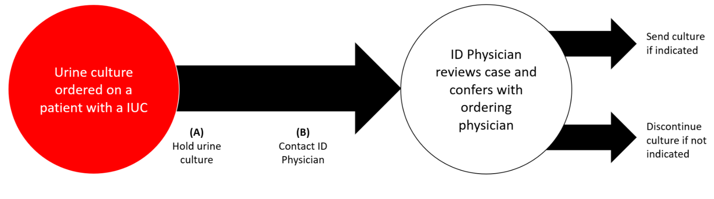
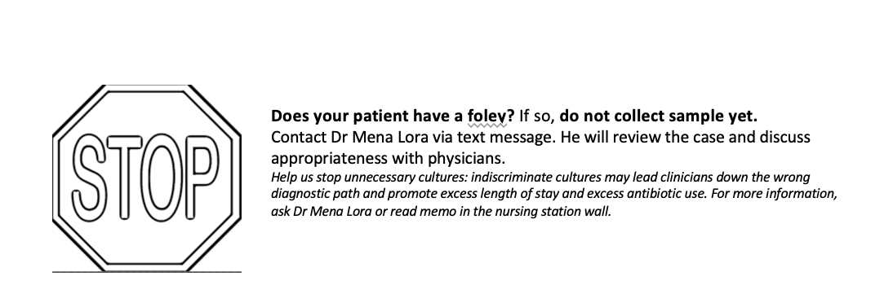

Supplement C. Table with patient days, urine cultures and urine cultures per 1000 patient days for each year before and after our intervention.
Year | Patient days | Total urine cultures | Urine cultures from urinary catheters | % TOTAL | Urine cultures from urinary catheters collected >72 hours | % urine cultures from urinary catheters | % of IUC form UC both >72h | Urine cultures/patient days x 1000
2016 | 2545 | 215 | 59 | 27% | 26 | 12% | 35% | 10.21611
2017 | 2431 | 316 | 37 | 12% | 12 | 4% | 32% | 4.93624023
2018 | 2339 | 222 | 38 | 17% | 10 | 4% | 32% | 4.27533134
2019 | 2352 | 203 | 28 | 13% | 8 | 4% | 19% | 3.40136054
2020 | 2791 | 175 | 36 | 20% | 12 | 7% | 40% | 4.29953422
2021 | 2724 | 158 | 18 | 11% | 5 | 3% | 25% | 1.83553598

