Supplemental Material: Appendix A
Integration of the QUAL (quant) mixed methods study*

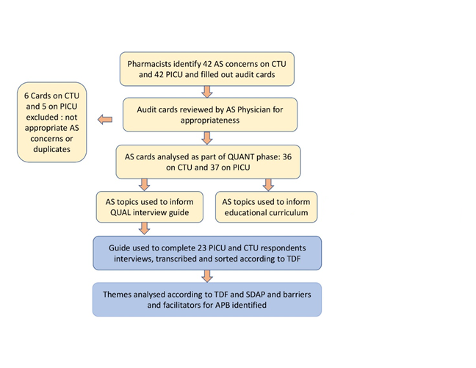

Supplemental Material: Appendix B
Audit cards for pharmacists for Antimicrobial Stewardship (AS) issues on CTU
On what team was this AS issue identified?
 Green  Red  Purple  Blue  Other____________
Please indicate the identified potential AS concern:
A viral etiology is confirmed for the clinical presentation, but antibacterial therapy is continued
 Bronchiolitis  Other___________________  Virus______________________
Stopping antibiotic treatment was an option but did not occur
Conversion to an oral antimicrobial was an option but did not occur
Narrowing antimicrobials was an option but did not occur
Patient on empiric antimicrobials without positive cultures supporting its use
Duration of antimicrobial treatment is longer than recommended per clinical practice guidelines
Patient has mild-moderate pneumonia, and patient not on ampicillin/amoxicillin low dose
Other (please specify) ____________________________________________________________

What antimicrobials is the patient currently receiving? ___________________________________________________
What is the patient’s infection? _______________________________________________________
Does this patient have an immunodeficiency or is on immunosuppression?
 Yes  No  Don’t know
If yes, please state what the immunodeficiency/immunosuppression is _________________________________________________________________
Was a 3-day review of antimicrobials done?  Yes  No  Don’t know
Is the Infectious Disease Service formally involved with this patient?
 Yes  No  Don’t know
Is the current antimicrobial plan recommended by the infectious disease service?
 Yes  No  Don’t know
Was this concern discussed with the team?  Yes  No  Don’t know
Please describe the clinical situation and the outcome: ________________________________________________________________________________________________________________________________________________________________________________________________________________________________________________________________________________________________________________________
Audit cards for pharmacists for Antimicrobial Stewardship (AS) issues in the PICU
Was this AS identified for a patient admitted in the PICU?
 Yes  No
Please indicate the identified potential AS concern:
A viral etiology is confirmed for the clinical presentation, but antibacterial therapy is continued
 Bronchiolitis Other___________________ Virus______________________
Stopping antibiotic treatment was an option but did not occur
Conversion to an oral antimicrobial was an option but did not occur
Patient on empiric antimicrobials without positive cultures supporting its use
Duration of antimicrobial treatment is longer than recommended per clinical practice guidelines
Patient has mild-moderate pneumonia, and patient not on ampicillin/amoxicillin low dose
Other (please specify) ____________________________________________________________

What antimicrobials is the patient on? ______________________________________________
What is the patient’s infection? ____________________________________________________
Is the patient immunosuppressed?  Yes  No  Don’t know
If yes, please state the immunosuppression? _______________________________________
Was a 3-day review of antimicrobials done?  Yes  No  Don’t know
Is the Infectious Disease Service involved with this patient?
 Yes  No  Don’t know
Is the current antimicrobial plan recommended by the infectious disease service?
 Yes  No  Don’t know
Was this concern discussed with the team?  Yes  No
Please describe the clinical situation and the final outcome: ________________________________________________________________________________________________________________________________________________________________________________________________________________________________________________________________________________________________________________________

Supplemental Material: Appendix C
Qualitative Interview Guide
Thank you very much for taking the time to participate in this interview on antimicrobial stewardship. This will take around 60 minutes.

Antimicrobial stewardship refers to “the optimal selection, dosage, and duration of antimicrobial treatment that results in the best clinical outcome for the treatment or prevention of infection, with minimal toxicity to the patient and minimal impact on subsequent resistance.
This project aims to complete a needs assessment for antimicrobial stewardship on Clinical Teaching Unit (CTU) and Pediatric Intensive Care Unit (PICU) and then use this needs assessment to develop an educational intervention for antimicrobial stewardship at the Alberta Children’s Hospital (ACH). We are conducting a set of interviews for this. In these interviews, we want to explore how clinicians make antimicrobial prescribing decisions. We will use the answers to build an educational strategy to assist and support them in their role as antimicrobial stewards.
Over the next hour, we hope to get your perspectives so as to contribute to a needs assessment for the development of an education curriculum for CTU/PICU.
You do not have to answer every question and can cease the interview at any time.
We will be audio recording this discussion with a digital audio recorder. Your answers will be used for research, but your name will remain anonymous. We will remove the names from the actual transcripts prior to analyzing the data.
Before we start, do you have any questions you would like to ask me?
Demographics:
What is your profession?
What is your gender?
Have you trained for residency or medical school in Calgary?
If not, where did you train?
How many years have you been practicing for?
If a resident: what level of training and training program
Theoretical Domain Framework questions
Knowledge
Which antimicrobials are more of a concern in terms of knowledge of spectrum, side effects, indication than others?
Is awareness about local antibiograms appropriate among team members?
How comfortable are you with using hospital guidelines and how would you describe your knowledge of them?
Skills
Do you know how to find antibiograms for Calgary?
How easy or difficult do you find accessing the hospital guidelines?
Do you know how to use certain point of care resources such as SPECTRUM app and Bugs and Drugs?
Do you use them?
Are there other published resources you use for such decisions?
Social/professional role and identity
Who do you think should make antimicrobial prescribing decisions on the team and how should these decisions be made?
Prompt: How do you see the role of the pharmacist, attending, residents on the team regarding antimicrobial prescribing?
How should antimicrobial prescribing be taught on the team?
Prompt: By whom?
Can you identify antimicrobial prescribing milestones you feel are important to achieve for your role on the team? (specific competencies for resident trainees vs staff pediatricians?
In educating trainees about antimicrobial prescribing and usage, what would you consider key areas for CTU/PICU?

Beliefs about capabilities
Can you identify some antimicrobial prescribing situations that are more difficult than others?
How easy or difficult do you find making antimicrobial choices around:
Starting antibiotics?
What factors play in this decision that led to starting antibiotics when they were not needed?
Deciding on duration of antibiotics?
What factors play in this decision for duration?
Deciding on dose of antibiotics?
What factors play in this decision for dosage choice?
Deciding on narrowing down or de-escalating therapy?
What factors play in this decision for de-escalation choices?
Deciding on moving down from IV to po as route of administration?
What factors play in this decision for moving to po?
How well trained or experienced from an AS perspective do you feel?
Do you feel you are a good antimicrobial steward?
What do you think would need so as to be even better at prescribing antimicrobials? (This answer is actually part of Behavioural regulation)
Optimism
How optimistic or pessimistic do you feel that you are or can become a good antimicrobial steward?
How optimistic or pessimistic do you feel that CTU or PICU teams can become good antimicrobial stewards?
Beliefs about consequences
What are the disadvantages to stopping antibiotics in unwell patients even when cultures are negative?
What are your thoughts about de-escalating therapy in patients who are very sick in PICU? (PICU teams only)?
How do you see AS in the context of patient safety?
Are there any legal consequences that come to mind around antimicrobial prescribing?
If yes, how do those play a role in your antimicrobial choices?
Reinforcement
What are the rewards of practicing antimicrobial stewardship to you?
Do you think there are or should be some incentives for appropriate prescribing?
How would you like to learn about AS as it applies to you?
How can we help to best equip you to educate trainees/colleagues on AS and also to be an AS health advocate for your patients?
Intention
How important is AS to you?
How committed do you feel you are to AS?
How important is AS to your patients?
How important is AS to PICU/CTU?
Goals
What should the goals of an AS program be at the ACH?
Who should be the target audience for an AS education intervention?
Memory, attention and decision processes?
Can you recall any specific AS measures that are already part of the ACH CTU or PICU rounds?
Who does those?
Can you recall any specific educational initiatives or opportunities you have had for antimicrobial prescribing on CTU or PICU rounds?
How did you find those?
Environmental context and resources
Tell me a bit about how you see antimicrobial prescribing decisions in the context of rounds on CTU/PICU (teams) and workflow?
To what extend do resources affect the antimicrobial prescribing decisions on teams?
Prompts:
Time you have to spend on each patient or team size?
Time of day?
Day of the week (start of the week vs the end of the week)
Social influences
How do you think you measure up for antimicrobial choices in relation to others? (more or less conservative)
How does the involvement of the Infectious Disease service impact antimicrobial choices?
How do the team dynamics impact these antimicrobial prescribing decisions?
How does presence of trainees affect this?
How does team hierarchy play a role in antimicrobial prescribing decisions (if at all)
How does the presence of a second attending affect this?
How does having to sign over the patient to another colleague play into this?
How do you think “personalities” or “egos” play into this, if at all?
How does signing over the patient to a colleague play into this?
Emotion
Can you identify what about antimicrobial prescribing behaviour makes you feel happy with your practice?
What do you find most disconcerting about antibiotics prescribing?
What fears or reservations about antimicrobial prescribing?
How do you feel when you change antibiotics that another colleague has started?
How does another colleague changing antibiotics you have started make you feel?
Behavioural regulation/Action Plan
What do you think needs to change for our CTU/PICU team to make better antimicrobial prescribing decisions?
How can we break certain habits such as: continuing broad spectrum therapy despite no microbiological evidence to support that continuation?
Would a monitoring system work? If so, what kind and how?
Education specific questions:
Have you had any formal training in antimicrobial prescribing?
What kind of antimicrobial prescribing education (as part of post graduate medical education or continuing medical education) have you had so far?
How do you stay current about antimicrobial prescribing presently? What resources do you use?
If we were to do AS education on rounds, how and when would you want this information to be delivered?
What do you think of a testing/evaluation format to an educational experience?
Are there any point of care tests you would like to see applied to help with antimicrobial choices?

