Supplementary Material
Supplementary Figure 1. Overview of the study cohort design and assessment windows
*End of follow-up is the earliest of date of discharge, date of death, or inpatient day 89.

Supplementary Table 1. Table of variable definitions used in the study
Variable type | Variable name | Data Source | Definition | Window
Time anchor | Date of hospital admission  (index date or day 0) | Hospitalization records and discharge status | Defined as the earliest (first) hospital admission date with date of COVID-19 confirmation during the eligibility window. | [21 January 2020, 30 September 2022]
Time anchor | Date of hospital discharge | Hospitalization records and discharge status  Date of death | Defined as the earliest date of death or discharge. | [21 January 2020, 30 October 2022]
Time anchor | End of follow-up | Hospitalization records and discharge status  Date of death | Defined as the earliest date of discharge, death or inpatient day 89. | NA
Time anchor | Date of COVID-19 confirmation | CHP case data | Date of COVID-19 confirmation by the CHP. | [-7, 3]
Time anchor | Epidemic wave | Hospitalization records | Date of hospital admission categorized into corresponding epidemic waves. | Wave 1-2: 1 January 2022 to 30 June 2020  Wave 3: 1 July 2022 to 31 October 2020  Wave 4: 1 November 2020 to 30 December 2021  Wave 5E (early):  31 December 2021 to 22 May 2022  Wave 5L (late): 23 May 2022 onward
Admission timing | Time interval between confirmation date and hospital admission | CHP case data and hospitalization records | COVID-19 confirmation date – index date. Interpretable on the study time scale relative to the index date, in days. | NA
Person time | Patient days | Hospitalization records and discharge status | Defined as date of hospital discharge – index date + 1 day.  Censored at the end of follow-up. | [0, end of follow-up]
COVID-19 case classification | Case classification | CHP case data | Cases classified by as either local or imported.  Local cases are defined as:  local, close contact of local, locally acquired case,  possibly local, close contact of possibly local and missing.  Imported cases are defined as:  Imported and close contact of imported. | NA
Demographics | Age | Demographics | As reported by CHP or HA, in years. | [0, 0]
Demographics | Sex | Demographics | Male or female. | [0, 0]
Demographics | Residence in a residential care home for the elderly  (Yes/No) | Inpatient | Admitted from a residential care home for the elderly. | [0, 0]
Clinical outcomes | ICU Admission  (Yes/No) | Inpatient transactions | Any admission record to intensive care unit/high-dependency unit. | [0, end of follow-up]
Clinical outcomes | In-hospital death  (Yes/No) | Inpatient transactions  Date of death | Discharge destination code is “D” – Death  OR  If date of death is available, date of death is on or before the discharge date. | [0, discharge date]
Baseline medical conditions | Cardiovascular disease  (Yes/No) | Inpatient diagnosis  General outpatient diagnosis | A diagnosis of any of the following cardiovascular diseases defined as the following diagnosis codes (including all subcodes and codes in any position).  Ischemic heart disease  ICD-9-CM code: 410-414, V45.81  OR  ICPC-2 code: K74, K75, K76  Cerebrovascular disease  ICD-9-CM code: 430-438  OR  ICPC-2 code: K89, K90, K91  Peripheral vascular disease  ICD-9-CM code: 440-443, 447.1, 557.1, 557.9, V43.4  OR  ICPC-2 code: K92  Heart failure  ICD-9-CM code: 398.91, 402.01, 402.11, 402.91, 404.01, 404.03, 404.11, 404.13, 404.91, 404.93, 428.x, 425.4, 425.5, 425.7, 425.8, 425.9, 428  OR  ICPC-2 code: K77 | [-1095, -1]
Baseline medical conditions | Chronic kidney disease  (Yes/No) | Inpatient diagnosis  General outpatient diagnosis | A diagnosis of chronic kidney disease defined as  ICD-9-CM code (including all subcodes and codes in any position): 403.01, 403.11,403.91, 404.02, 404.03, 404.12, 404.13, 404.92, 404.93, 582, 583.0-583.7, 585, 586, 588.0, V42.0, V45.1, V56 | [-1095, -1]
Baseline medical conditions | Hypertension  (Yes/No) | Inpatient diagnosis  General outpatient diagnosis  Prescriptions | A diagnosis of hypertension defined as  ICD-9-CM code (including all subcodes and codes in any position): 401-405  OR  ICPC-2 code: K86, K87  OR  A prescription dispensing date for any antihypertensive medication included in BNF Sections:  2.5.4 Alpha-adrenoreceptor blocking drugs  2.2.1 Thiazides and related diuretics  2.2.3 Potassium-sparing diuretics and aldosterone antagonists  2.2.4 Potassium-sparing diuretics with other diuretics  2.4 Beta-adrenoceptor blocking drugs  2.5.1 Vasodilator antihypertensive drugs  2.5.2 Centrally acting antihypertensive drugs  2.6.2 Calcium-channel blockers  2.5.5.1 Angiotensin-converting enzyme inhibitors  2.5.5.2 Angiotensin-II receptor antagonists  2.5.5.3 Renin inhibitors | [-1095, -1]  [-90, -1]
Baseline medical conditions | Diabetes mellitus  (Yes/No) | Inpatient diagnosis  General outpatient diagnosis  Prescriptions | A diagnosis of diabetes mellitus defined as  ICD-9-CM code (including all subcodes and codes in any position): 250, 790.2  OR  ICPC-2 code: T89, T90  OR  A prescription dispensing date for any antidiabetic medication included in BNF Sections:  6.1.1.1 Short-acting insulins  6.1.1.2 Intermediate- and long-acting insulins  6.1.2.1 Sulphonylureas  6.1.2.2 Biguanides  6.1.2.3 Other antidiabetic drugs | [-1095, -1]  [-90, -1]
Baseline medical conditions | Chronic obstructive pulmonary disease  (Yes/No) | Inpatient diagnosis  General outpatient diagnosis | A diagnosis of COPD defined as ICD-9-CM code (including all subcodes and codes in any position): 490-492, 494-6, 500-505, 506.4, 508.1, 508.8  OR  ICPC-2 code: R95 | [-1095, -1]
Baseline medical conditions | Asthma  (Yes/No) | Inpatient diagnosis  General outpatient diagnosis | A diagnosis of asthma defined as ICD-9-CM code (including all subcodes and codes in any position): 493  OR  ICPC-2 code: R96 | [-1095, -1]
Baseline medical conditions | Chronic liver disease  (Yes/No) | Inpatient diagnosis  General outpatient diagnosis | A diagnosis of liver disease defined as ICD-9-CM code (including all subcodes and codes in any position):  571, 572.3, 572.4, 572.8, 573.0, 573.1, 573.2, 573.4, 573.5, 573.8, 573.9  OR  ICPC-2 code: D97 | [-1095, -1]
Baseline medical conditions | Rheumatic disease and related conditions  (Yes/No) | Inpatient diagnosis  General outpatient diagnosis | A diagnosis of rheumatoid arthritis and related conditions defined as ICD-9-CM code (including all subcodes and codes in any position): 446.5, 710.0-710.9, 714.0-714.2, 714.8, 725  OR  ICPC-2 code: L88 | [-1095, -1]
Baseline medical conditions | Malignancy  (Yes/No) | Inpatient diagnosis  General outpatient diagnosis | Diagnosis of malignancy  defined as ICD-9-CM code (including all subcodes and codes in any position):  140-149, 150-159, 160-165, 170-176, 179-189, 190-199, 200-208  OR  ICPC-2 code: B72-B74, D74-D77, L71, N74, R84, R85, S77, T71, U75- U77, X75- X77, Y77, Y78 | [-1095, -1]
Baseline medical conditions | Organ transplant  (Yes/No) | Inpatient diagnosis | Diagnosis of solid organ transplant (kidney, heart, lung, or liver) defined as ICD-9-CM code (including all subcodes and codes in any position):  V42.0, V42.1, V42.6, V42.7 | [-1095, -1]
Baseline medical conditions | Neutropenia  (Yes/No) | Inpatient diagnosis | Diagnosis of neutropenia defined as ICD-9-CM code (including all subcodes and codes in any position):  288.0 | [-1095, -1]
Baseline drugs | Respiratory drugs  (Yes/No) | Prescriptions | A prescription dispensing date for any of the medications included in BNF Sections:  3.1.1.1 Adrenoceptor agonists  3.1.2 Antimuscarinic bronchodilators  3.1.3 Theophylline  3.1.4 Compound bronchodilator preparations  3.2 Corticosteroids (respiratory)  3.3.1 Cromoglycate and related therapy  3.3.2 Leukotriene receptor antagonists  3.3.3 Phosphodiesterase Type-4 inhibitors | [-90, -1]
Baseline drugs | Corticosteroids  (Yes/No) | Prescriptions | A prescription dispensing date for any of the medications included in BNF Sections:  1.5.2 Corticosteroids  6.3.1 Replacement therapy  6.3.2 Glucocorticoid therapy  10.1.2.2 Corticosteroids | [-90, -1]
Baseline drugs | Antibacterial drugs  (Yes/No) | Prescriptions | A prescription dispensing date for any of the medications included in BNF Section 5.1 Antibacterial drugs:  5.1.1.1 Benzylpenicillin and phenoxymethylpenicillin  5.1.1.2 Penicillinase-resistant penicillins  5.1.1.3 Broad-spectrum penicillins  5.1.1.4 Antipseudomonal penicillins  5.1.2.1 Cephalosporins  5.1.2.2 Carbapenems  5.1.2.3 Other beta-lactam antibiotics  5.1.3 Tetracyclines  5.1.4 Aminoglycosides  5.1.5 Macrolides  5.1.6 Clindamycin and lincomycin  5.1.7 Some other antibacterials  5.1.8 Sulfonamides and trimethoprim  5.1.9 Antituberculosis drugs  5.1.10 Antileprotic drugs  5.1.11 Metronidazole and tinidazole  5.1.12 Quinolones  5.1.13 Urinary-tract infections | [-90, -14]
Baseline drugs | SARS-CoV-2 antivirals  (Yes/No) | Prescriptions | A prescription dispensing date for any of the medications, defined as drug item codes:  remdesivir (REMD01, REMD02 and REMD03)  OR  paxlovid (PAXL01 and  PAXL02)  OR  molnupiravir (MOLN01) | [-90, -1]
COVID-19 vaccination | Number of COVID-19 vaccine doses  (0 to 4) | Vaccination records | Total number of COVID-19 vaccine doses administered during the window. | [start of data, -14]
Admission microbiological culture | Blood culture record  (Yes/No) | Laboratory | Documented record for a blood culture, defined as a test date during the window and a test description of any of the following:  "Blood Culture", "Blood culture:", "Bactec culture and ST",  "Blood culture :-", "Blood culture :", "Blood Culture :-" | [-7, 0]
Admission microbiological culture | Sputum culture record  (Yes/No) | Laboratory | Documented record for a sputum culture, defined as a test date during the window and a test description of any of the following:  "Sputum Culture :", "Sputum Culture", "Sputum Culture :-",  "Sputum culture :", "Respiratory Culture", "Microbiological test of respiratory specimens" | [-7, 0]
Admission microbiological culture | Urine culture record  (Yes/No) | Laboratory | Documented record for a urine culture, defined as a test date during the window and a test description of any of the following:  "Urine culture :", "Urine culture", "Urine Culture", "Urine Culture :-", "Microbiological test of urine specimens" | [-7, 0]
Abbreviations: CHP, Centre for Health Protection; COVID-19, coronavirus disease 2019; HA, Hospital Authority; ICD-9-CM. International Classification of Diseases, Ninth Revision, Clinical Modification; ICPC-2, International Classification of Primary Care, 2nd edition; ICU, intensive care unit; NA, not applicable; SARS-CoV-2, severe acute respiratory syndrome coronavirus 2.
Supplementary Table 2. COVID-19 severity definitions used in the study. Classification was hierarchal and mutually exclusive meaning that each patient, if meeting multiple criteria, was classified in the most severe category. Day zero is defined as the date of hospital admission
Severity | Definition | Window
Fatal | In-hospital death | [0, date of discharge]
Critical | Any inpatient condition recorded as ‘critical’*  OR  inpatient procedures for mechanical ventilation, intubation, or ECMO  OR  had any inpatient day present in ICU/HDU | [0, end of follow-up]
Severe | Prescription dispensing date for remdesivir, baricitinib, tocilizumab, or dexamethasone (in BNF Section 6.3.2 and oral or injectable route)  OR  any oxygen saturation test result ≤ 90%  OR  any inpatient condition recorded as ‘serious’* | [0, earliest of day 9 or end of follow-up]  [-7, end of follow-up]  [0, end of follow-up]
Mild to moderate | Not meeting the definition of either fatal, critical or severe disease | [0, end of follow-up]
Abbreviations: BNF, British National Formulary; ECMO, extracorporeal membrane oxygenation; HDU, high-dependency unit; ICU, intensive care unit.
* Inpatient condition as defined by the Hospital Authority:
- ‘Critical’: Patient in intensive care unit, OR intubated, OR requires extracorporeal membrane oxygenation (ECMO) OR in shock.
- ‘Serious’: Patient requires oxygen supplement of 3 liters per minute or more.

Supplementary Figure 2. Flow diagram of patient inclusion in the study cohort
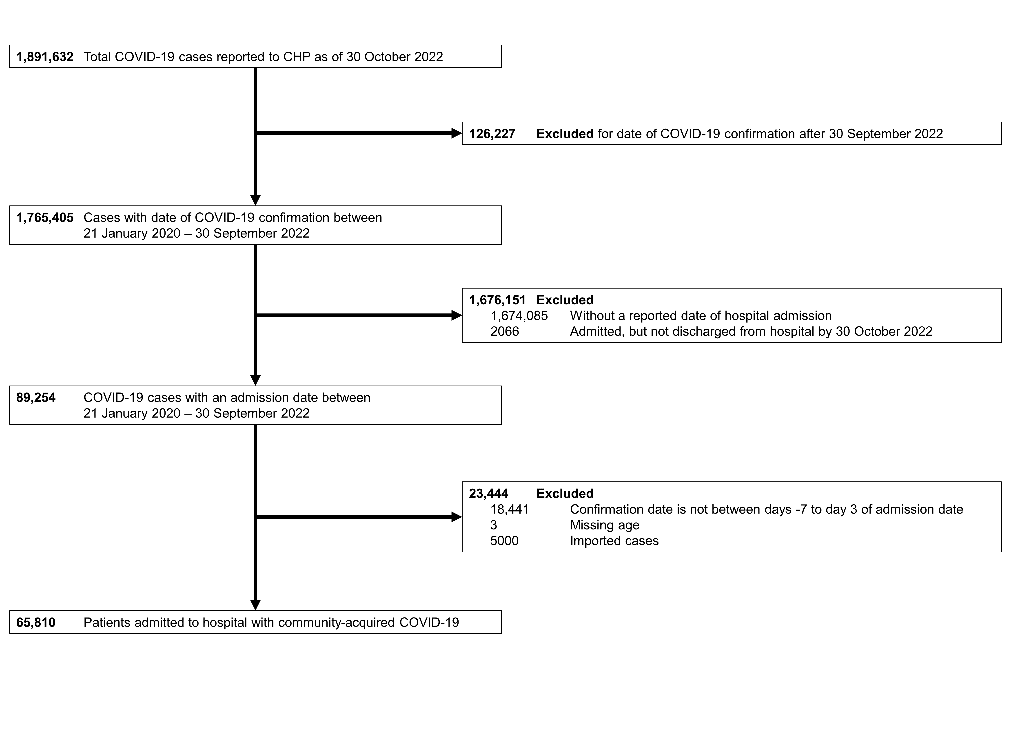

Supplementary Table 3. Prevalence (%) of antibacterial drug prescription by patient characteristic and stratified by epidemic wave. See Supplementary Table 1 for detailed definitions of each variable.
Wave | 1-2 |  |  | 3 |  |  | 4 |  |  | 5E |  |  | 5L |  |  | Overall
 | No. with Rx | No. Total | % | No. with Rx | No. Total | % | No. with Rx | No. Total | % | No. with Rx | No. Total | % | No. with Rx | No. Total | % | No. with Rx | No. Total | %
All patients | 189 | 405 | 46.7 | 1,248 | 3,402 | 36.7 | 1,523 | 5,448 | 28.0 | 24,531 | 37,991 | 64.6 | 8,016 | 18,564 | 43.2 | 35,507 | 65,810 | 54.0
Sex
F | 82 | 191 | 42.9 | 588 | 1,765 | 33.3 | 745 | 2,861 | 26.0 | 11,166 | 18,110 | 61.7 | 3,771 | 8,967 | 42.1 | 16,352 | 31,894 | 51.3
M | 107 | 214 | 50.0 | 660 | 1,637 | 40.3 | 778 | 2,587 | 30.1 | 13,365 | 19,881 | 67.2 | 4,245 | 9,597 | 44.2 | 19,155 | 33,916 | 56.5
Age group, years
< 20 | 3 | 12 | 25.0 | 12 | 281 | 4.3 | 23 | 508 | 4.5 | 459 | 3,228 | 14.2 | 250 | 3,730 | 6.7 | 747 | 7,759 | 9.6
20-59 | 134 | 324 | 41.4 | 587 | 2,042 | 28.7 | 712 | 3,407 | 20.9 | 2,730 | 7,124 | 38.3 | 1,381 | 3,243 | 42.6 | 5,544 | 16,140 | 34.3
60-79 | 47 | 62 | 75.8 | 500 | 892 | 56.1 | 643 | 1,328 | 48.4 | 7,899 | 11,762 | 67.2 | 3,009 | 6,435 | 46.8 | 12,098 | 20,479 | 59.1
≥ 80 | 5 | 7 | 71.4 | 149 | 187 | 79.7 | 145 | 205 | 70.7 | 13,443 | 15,877 | 84.7 | 3,376 | 5,156 | 65.5 | 17,118 | 21,432 | 79.9
RCHE resident
No | 189 | 405 | 46.7 | 1,248 | 3,402 | 36.7 | 1,523 | 5,448 | 28.0 | 13,948 | 26,005 | 53.6 | 7,072 | 17,290 | 40.9 | 23,980 | 52,550 | 45.6
Yes | 0 | 0 | 0.0 | 0 | 0 | 0.0 | 0 | 0 | 0.0 | 10,583 | 11,986 | 88.3 | 944 | 1,274 | 74.1 | 11,527 | 13,260 | 86.9
COVID-19 severityª
Fatal | 6 | 6 | 100.0 | 89 | 89 | 100.0 | 82 | 85 | 96.5 | 6,458 | 6,699 | 96.4 | 564 | 594 | 94.9 | 7,199 | 7,473 | 96.3
Critical | 21 | 27 | 77.8 | 127 | 129 | 98.4 | 176 | 190 | 92.6 | 879 | 973 | 90.3 | 188 | 235 | 80.0 | 1,391 | 1,554 | 89.5
Severe | 26 | 29 | 89.7 | 342 | 456 | 75.0 | 609 | 1,046 | 58.2 | 9,441 | 11,335 | 83.3 | 2,738 | 3,908 | 70.1 | 13,156 | 16,774 | 78.4
Mild to moderate | 136 | 343 | 39.7 | 690 | 2,728 | 25.3 | 656 | 4,127 | 15.9 | 7,753 | 18,984 | 40.8 | 4,526 | 13,827 | 32.7 | 13,761 | 40,009 | 34.4
ICU admissionª
No | 164 | 374 | 43.9 | 1,087 | 3,239 | 33.6 | 1,305 | 5,216 | 25.0 | 23,622 | 36,987 | 63.9 | 7,803 | 18,303 | 42.6 | 33,981 | 64,119 | 53.0
Yes | 25 | 31 | 80.6 | 161 | 163 | 98.8 | 218 | 232 | 94.0 | 909 | 1,004 | 90.5 | 213 | 261 | 81.6 | 1,526 | 1,691 | 90.2
Blood culture
No | 118 | 307 | 38.4 | 854 | 2,810 | 30.4 | 1,146 | 4,808 | 23.8 | 17,900 | 30,258 | 59.2 | 5,513 | 14,899 | 37.0 | 25,531 | 53,082 | 48.1
Yes | 71 | 98 | 72.4 | 394 | 592 | 66.6 | 377 | 640 | 58.9 | 6,631 | 7,733 | 85.7 | 2,503 | 3,665 | 68.3 | 9,976 | 12,728 | 78.4
Sputum culture
No | 164 | 374 | 43.9 | 1,103 | 3,203 | 34.4 | 1,340 | 5,197 | 25.8 | 22,447 | 35,745 | 62.8 | 7,052 | 17,352 | 40.6 | 32,106 | 61,871 | 51.9
Yes | 25 | 31 | 80.6 | 145 | 199 | 72.9 | 183 | 251 | 72.9 | 2,084 | 2,246 | 92.8 | 964 | 1,212 | 79.5 | 3,401 | 3,939 | 86.3
Urine culture
No | 161 | 374 | 43.0 | 1,051 | 3,164 | 33.2 | 1,319 | 5,194 | 25.4 | 19,131 | 31,942 | 59.9 | 5,694 | 15,536 | 36.7 | 27,356 | 56,210 | 48.7
Yes | 28 | 31 | 90.3 | 197 | 238 | 82.8 | 204 | 254 | 80.3 | 5,400 | 6,049 | 89.3 | 2,322 | 3,028 | 76.7 | 8,151 | 9,600 | 84.9
COVID-19 vaccine doses, number^{b}
0 | 189 | 405 | 46.7 | 1,248 | 3,402 | 36.7 | 1,523 | 5,448 | 28.0 | 14,274 | 20,418 | 69.9 | 1,233 | 4,031 | 30.6 | 18,467 | 33,704 | 54.8
1 | NA | NA | NA | NA | NA | NA | 0 | 0 | 0.0 | 4,864 | 6,710 | 72.5 | 228 | 568 | 40.1 | 5,092 | 7,278 | 70.0
2 | NA | NA | NA | NA | NA | NA | 0 | 0 | 0.0 | 4,681 | 9,236 | 50.7 | 2,498 | 5,100 | 49.0 | 7,179 | 14,336 | 50.1
3 | NA | NA | NA | NA | NA | NA | 0 | 0 | 0.0 | 710 | 1,623 | 43.7 | 3,714 | 8,000 | 46.4 | 4,424 | 9,623 | 46.0
4 | NA | NA | NA | NA | NA | NA | 0 | 0 | 0.0 | 2 | 4 | 50.0 | 343 | 865 | 39.7 | 345 | 869 | 39.7
Antibacterial drugs
No | 186 | 401 | 46.4 | 1,181 | 3,299 | 35.8 | 1,456 | 5,321 | 27.4 | 18,699 | 30,821 | 60.7 | 6,795 | 16,725 | 40.6 | 28,317 | 56,567 | 50.1
Yes | 3 | 4 | 75.0 | 67 | 103 | 65.0 | 67 | 127 | 52.8 | 5,832 | 7,170 | 81.3 | 1,221 | 1,839 | 66.4 | 7,190 | 9,243 | 77.8
Respiratory drugs
No | 189 | 404 | 46.8 | 1,217 | 3,358 | 36.2 | 1,501 | 5,395 | 27.8 | 21,040 | 33,968 | 61.9 | 7,312 | 17,526 | 41.7 | 31,259 | 60,651 | 51.5
Yes | 0 | 1 | 0.0 | 31 | 44 | 70.5 | 22 | 53 | 41.5 | 3,491 | 4,023 | 86.8 | 704 | 1,038 | 67.8 | 4,248 | 5,159 | 82.3
Corticosteroids
No | 189 | 405 | 46.7 | 1,225 | 3,368 | 36.4 | 1,504 | 5,422 | 27.7 | 20,992 | 33,858 | 62.0 | 7,408 | 17,641 | 42.0 | 31,318 | 60,694 | 51.6
Yes | 0 | 0 | 0.0 | 23 | 34 | 67.6 | 19 | 26 | 73.1 | 3,539 | 4,133 | 85.6 | 608 | 923 | 65.9 | 4,189 | 5,116 | 81.9
SARS-CoV-2 antivirals
No | 189 | 405 | 46.7 | 1,248 | 3,402 | 36.7 | 1,523 | 5,448 | 28.0 | 23,052 | 36,126 | 63.8 | 7,273 | 16,951 | 42.9 | 33,285 | 62,332 | 53.4
Yes | 0 | 0 | 0.0 | 0 | 0 | 0.0 | 0 | 0 | 0.0 | 1,479 | 1,865 | 79.3 | 743 | 1,613 | 46.1 | 2,222 | 3,478 | 63.9
Hypertension
No | 156 | 364 | 42.9 | 800 | 2,690 | 29.7 | 1,054 | 4,570 | 23.1 | 8,512 | 16,815 | 50.6 | 3,484 | 10,308 | 33.8 | 14,006 | 34,747 | 40.3
Yes | 33 | 41 | 80.5 | 448 | 712 | 62.9 | 469 | 878 | 53.4 | 16,019 | 21,176 | 75.6 | 4,532 | 8,256 | 54.9 | 21,501 | 31,063 | 69.2
Diabetes mellitus
No | 173 | 382 | 45.3 | 991 | 3,012 | 32.9 | 1,273 | 4,962 | 25.7 | 16,559 | 27,379 | 60.5 | 5,780 | 14,516 | 39.8 | 24,776 | 50,251 | 49.3
Yes | 16 | 23 | 69.6 | 257 | 390 | 65.9 | 250 | 486 | 51.4 | 7,972 | 10,612 | 75.1 | 2,236 | 4,048 | 55.2 | 10,731 | 15,559 | 69.0
Cardiovascular disease
No | 184 | 399 | 46.1 | 1,114 | 3,222 | 34.6 | 1,416 | 5,275 | 26.8 | 17,251 | 28,822 | 59.9 | 6,191 | 15,506 | 39.9 | 26,156 | 53,224 | 49.1
Yes | 5 | 6 | 83.3 | 134 | 180 | 74.4 | 107 | 173 | 61.8 | 7,280 | 9,169 | 79.4 | 1,825 | 3,058 | 59.7 | 9,351 | 12,586 | 74.3
Malignancy
No | 186 | 401 | 46.4 | 1,220 | 3,357 | 36.3 | 1,501 | 5,407 | 27.8 | 22,730 | 35,504 | 64.0 | 7,449 | 17,614 | 42.3 | 33,086 | 62,283 | 53.1
Yes | 3 | 4 | 75.0 | 28 | 45 | 62.2 | 22 | 41 | 53.7 | 1,801 | 2,487 | 72.4 | 567 | 950 | 59.7 | 2,421 | 3,527 | 68.6
Chronic kidney disease
No | 189 | 405 | 46.7 | 1,229 | 3,381 | 36.4 | 1,511 | 5,432 | 27.8 | 22,710 | 35,210 | 64.5 | 7,661 | 17,959 | 42.7 | 33,300 | 62,387 | 53.4
Yes | 0 | 0 | 0.0 | 19 | 21 | 90.5 | 12 | 16 | 75.0 | 1,821 | 2,781 | 65.5 | 355 | 605 | 58.7 | 2,207 | 3,423 | 64.5
Chronic obstructive pulmonary disease
No | 189 | 405 | 46.7 | 1,221 | 3,373 | 36.2 | 1,507 | 5,427 | 27.8 | 22,624 | 35,879 | 63.1 | 7,603 | 18,008 | 42.2 | 33,144 | 63,092 | 52.5
Yes | 0 | 0 | 0.0 | 27 | 29 | 93.1 | 16 | 21 | 76.2 | 1,907 | 2,112 | 90.3 | 413 | 556 | 74.3 | 2,363 | 2,718 | 86.9
Chronic liver disease
No | 188 | 403 | 46.7 | 1,233 | 3,367 | 36.6 | 1,500 | 5,398 | 27.8 | 23,624 | 36,806 | 64.2 | 7,788 | 18,175 | 42.9 | 34,333 | 64,149 | 53.5
Yes | 1 | 2 | 50.0 | 15 | 35 | 42.9 | 23 | 50 | 46.0 | 907 | 1,185 | 76.5 | 228 | 389 | 58.6 | 1,174 | 1,661 | 70.7
Asthma
No | 189 | 405 | 46.7 | 1,237 | 3,381 | 36.6 | 1,504 | 5,415 | 27.8 | 24,078 | 37,417 | 64.4 | 7,865 | 18,297 | 43.0 | 34,873 | 64,915 | 53.7
Yes | 0 | 0 | 0.0 | 11 | 21 | 52.4 | 19 | 33 | 57.6 | 453 | 574 | 78.9 | 151 | 267 | 56.6 | 634 | 895 | 70.8
Rheumatic disease
No | 189 | 405 | 46.7 | 1,247 | 3,400 | 36.7 | 1,520 | 5,441 | 27.9 | 24,355 | 37,739 | 64.5 | 7,950 | 18,448 | 43.1 | 35,261 | 65,433 | 53.9
Yes | 0 | 0 | 0.0 | 1 | 2 | 50.0 | 3 | 7 | 42.9 | 176 | 252 | 69.8 | 66 | 116 | 56.9 | 246 | 377 | 65.3
Neutropenia
No | 189 | 405 | 46.7 | 1,246 | 3,399 | 36.7 | 1,522 | 5,447 | 27.9 | 24,419 | 37,834 | 64.5 | 7,980 | 18,497 | 43.1 | 35,356 | 65,582 | 53.9
Yes | 0 | 0 | 0.0 | 2 | 3 | 66.7 | 1 | 1 | 100.0 | 112 | 157 | 71.3 | 36 | 67 | 53.7 | 151 | 228 | 66.2
Organ transplant
No | 189 | 405 | 46.7 | 1,247 | 3,399 | 36.7 | 1,522 | 5,447 | 27.9 | 24,436 | 37,834 | 64.6 | 7,978 | 18,506 | 43.1 | 35,372 | 65,591 | 53.9
Yes | 0 | 0 | 0.0 | 1 | 3 | 33.3 | 1 | 1 | 100.0 | 95 | 157 | 60.5 | 38 | 58 | 65.5 | 135 | 219 | 61.6
ªInpatient admission characteristic.
^{b}COVID-19 vaccines became available locally beginning in February 2021 (i.e., wave 4).
Abbreviations: NA, not applicable; Rx, inpatient antibacterial drug prescription; SARS-CoV-2, severe acute respiratory syndrome coronavirus 2.
Variables are shown as number of patients (%) unless otherwise indicated. Epidemic waves were defined as starting on the following dates: 1 January 2020 (waves 1-2), 1 July 2020 (wave 3), 1 November 2020 (wave 4), 31 December 2021 (wave 5E), and 23 May 2022 (wave 5L).

Supplementary Table 4. Antibacterial drug prescriptions according to British National Formulary (BNF) section for COVID-19 patients infected in the community in Hong Kong over five epidemic waves from 21 January 2020 through to 30 September 2022
BNF Section | Description | DOT (days) | DOT (%) | DOT/1000 patient days
5.1 | Antibacterial drugs | 416,031 | 100.0 | 550.5
5.1.1 | Penicillins | 234,893 | 56.5 | 310.8
5.1.1.1 | Benzylpenicillin and phenoxymethylpenicillin | 535 | 0.1 | 0.7
5.1.1.2 | Penicillinase-resistant penicillins | 1,390 | 0.3 | 1.8
5.1.1.3 | Broad-spectrum penicillins | 164,547 | 39.6 | 217.7
5.1.1.4 | Antipseudomonal penicillins | 68,421 | 16.4 | 90.5
5.1.2 | Cephalosporins, carbapenems, and other beta-lactams | 102,768 | 24.7 | 136.0
5.1.2.1 | Cephalosporins | 72,945 | 17.5 | 96.5
5.1.2.2 | Carbapenems | 29,802 | 7.2 | 39.4
5.1.2.3 | Other beta-lactam antibiotics | 21 | 0.0 | 0.0
5.1.3 | Tetracyclines | 13,606 | 3.3 | 18.0
5.1.4 | Aminoglycosides | 2,304 | 0.6 | 3.0
5.1.5 | Macrolides | 3,694 | 0.9 | 4.9
5.1.6 | Clindamycin and lincomycin | 545 | 0.1 | 0.7
5.1.7 | Some other antibacterials | 15,107 | 3.6 | 20.0
5.1.8 | Sulfonamides and trimethoprim | 5,453 | 1.3 | 7.2
5.1.9 | Antituberculosis drugs | 10,025 | 2.4 | 13.3
5.1.10 | Antileprotic drugs | 429 | 0.1 | 0.6
5.1.11 | Metronidazole and tinidazole | 4,747 | 1.1 | 6.3
5.1.12 | Quinolones | 21,275 | 5.1 | 28.2
5.1.13 | Urinary-tract infections | 1,185 | 0.3 | 1.6
Abbreviations: BNF, British National Formulary; DOT, days of therapy.

Supplementary Table 5. Days of therapy, initiation day of antibacterial therapy, and rates of use (days of therapy/1000 patient days) for each antibacterial drug in COVID-19 inpatients included in the analysis over 5 epidemic waves in Hong Kong
Rank | BNF | Antibacterial drug | DOT (days) | DOT (%) | DOT, median [IQR] | Initiation day, median [IQR] | Days of therapy/1000 patient days
1 | 5.1.1.3 | Amoxicillin/clavulanic acid | 161,694 | 38.9 | 6.0 [3.0, 8.0] | 0.0 [0.0, 1.0] | 213.95
2 | 5.1.1.4 | Piperacillin/tazobactam | 67,915 | 16.3 | 7.0 [4.0, 9.0] | 3.0 [0.0, 7.0] | 89.86
3 | 5.1.2.1 | Ceftriaxone | 52,936 | 12.7 | 5.0 [3.0, 8.0] | 0.0 [0.0, 1.0] | 70.04
4 | 5.1.2.2 | Meropenem | 26,962 | 6.5 | 8.0 [4.0, 11.0] | 8.0 [3.0, 14.0] | 35.68
5 | 5.1.12 | Levofloxacin | 19,042 | 4.6 | 6.0 [3.0, 8.0] | 3.0 [0.0, 11.0] | 25.20
6 | 5.1.7 | Vancomycin | 12,738 | 3.1 | 7.0 [3.0, 11.0] | 11.0 [4.0, 21.0] | 16.85
7 | 5.1.3 | Doxycycline | 11,871 | 2.9 | 6.0 [4.0, 8.0] | 1.0 [0.0, 3.0] | 15.71
8 | 5.1.2.1 | Cefoperazone/sulbactam | 7,350 | 1.8 | 7.0 [4.0, 9.0] | 8.0 [3.0, 16.0] | 9.73
9 | 5.1.8 | Trimethoprim/sulfamethoxazole | 5,371 | 1.3 | 7.0 [4.0, 13.0] | 1.0 [0.0, 13.0] | 7.11
10 | 5.1.11 | Metronidazole | 4,747 | 1.1 | 5.0 [3.0, 8.0] | 2.0 [0.0, 9.8] | 6.28
11 | 5.1.2.1 | Ceftazidime | 3,230 | 0.8 | 7.0 [4.0, 10.0] | 10.0 [3.0, 20.0] | 4.27
12 | 5.1.9 | Isoniazid | 3,090 | 0.7 | 10.0 [5.5, 19.0] | 1.0 [0.0, 5.0] | 4.09
13 | 5.1.9 | Rifampicin | 3,081 | 0.7 | 9.0 [5.0, 19.0] | 2.0 [0.0, 7.0] | 4.08
14 | 5.1.2.1 | Cefuroxime | 2,848 | 0.7 | 5.0 [3.0, 8.0] | 4.0 [1.0, 10.0] | 3.77
15 | 5.1.5 | Azithromycin | 2,728 | 0.7 | 3.0 [1.0, 4.0] | 0.0 [0.0, 1.0] | 3.61
16 | 5.1.2.1 | Cefepime | 2,591 | 0.6 | 7.0 [4.0, 10.0] | 10.0 [5.0, 19.0] | 3.43
17 | 5.1.2.2 | Ertapenem | 2,383 | 0.6 | 7.0 [4.0, 8.0] | 6.0 [4.0, 17.0] | 3.15
18 | 5.1.2.1 | Cefazolin | 2,088 | 0.5 | 2.0 [1.0, 3.0] | 0.0 [0.0, 3.0] | 2.76
19 | 5.1.9 | Ethambutol | 2,088 | 0.5 | 11.0 [6.0, 21.0] | 2.0 [1.0, 8.0] | 2.76
20 | 5.1.12 | Ciprofloxacin | 1,938 | 0.5 | 4.0 [3.0, 7.0] | 3.0 [0.0, 9.0] | 2.56
21 | 5.1.1.3 | Ampicillin | 1,844 | 0.4 | 4.0 [2.0, 5.0] | 0.0 [0.0, 1.0] | 2.44
22 | 5.1.9 | Pyrazinamide | 1,597 | 0.4 | 11.0 [6.0, 19.0] | 2.0 [1.0, 12.0] | 2.11
23 | 5.1.3 | Minocycline | 1,537 | 0.4 | 5.0 [3.0, 8.0] | 2.0 [0.0, 19.0] | 2.03
24 | 5.1.1.2 | Cloxacillin | 1,390 | 0.3 | 5.0 [3.0, 8.0] | 5.0 [1.0, 12.0] | 1.84
25 | 5.1.2.1 | Cefotaxime | 1,194 | 0.3 | 5.0 [3.0, 6.0] | 0.0 [0.0, 1.0] | 1.58
26 | 5.1.13 | Nitrofurantoin | 1,185 | 0.3 | 5.0 [3.0, 7.0] | 7.0 [4.0, 17.5] | 1.57
27 | 5.1.4 | Gentamicin | 1,137 | 0.3 | 3.0 [2.0, 6.0] | 2.0 [0.0, 14.0] | 1.50
28 | 5.1.4 | Amikacin | 1,117 | 0.3 | 2.0 [1.0, 6.0] | 6.5 [1.0, 18.0] | 1.48
29 | 5.1.7 | Linezolid | 825 | 0.2 | 7.0 [4.0, 9.0] | 13.0 [6.2, 22.0] | 1.09
30 | 5.1.5 | Clarithromycin | 738 | 0.2 | 4.0 [2.0, 7.0] | 1.0 [0.0, 6.0] | 0.98
31 | 5.1.7 | Rifaximin | 719 | 0.2 | 9.0 [5.0, 15.5] | 0.0 [0.0, 2.0] | 0.95
32 | 5.1.6 | Clindamycin | 545 | 0.1 | 6.0 [3.0, 9.0] | 5.0 [0.0, 9.8] | 0.72
33 | 5.1.7 | Colistin | 509 | 0.1 | 8.0 [5.0, 16.0] | 21.5 [12.2, 29.8] | 0.67
34 | 5.1.1.3 | Amoxicillin | 494 | 0.1 | 4.0 [2.0, 7.0] | 3.0 [0.0, 8.0] | 0.65
35 | 5.1.1.3 | Ampicillin/sulbactam | 459 | 0.1 | 7.0 [4.0, 13.0] | 13.0 [7.0, 32.0] | 0.61
36 | 5.1.2.2 | Imipenem | 457 | 0.1 | 6.0 [3.0, 9.0] | 3.0 [1.0, 6.0] | 0.60
37 | 5.1.1.4 | Ticarcillin/clavulanic acid | 383 | 0.1 | 7.0 [3.0, 11.0] | 17.0 [11.5, 34.5] | 0.51
38 | 5.1.10 | Clofazimine | 376 | 0.1 | 2.0 [1.0, 3.0] | 1.0 [0.0, 2.0] | 0.50
39 | 5.1.2.1 | Ceftazidime/avibactam | 364 | 0.1 | 8.0 [4.0, 11.5] | 13.0 [7.0, 20.0] | 0.48
40 | 5.1.1.1 | Benzylpenicillin | 353 | 0.1 | 2.0 [2.0, 6.0] | 0.0 [0.0, 2.0] | 0.47
41 | 5.1.12 | Moxifloxacin | 295 | 0.1 | 7.0 [3.8, 12.5] | 8.0 [1.0, 22.0] | 0.39
42 | 5.1.5 | Erythromycin | 228 | 0.1 | 7.0 [4.0, 12.0] | 1.0 [0.0, 5.0] | 0.30
43 | 5.1.7 | Daptomycin | 208 | 0.0 | 7.0 [2.5, 15.0] | 22.0 [13.5, 27.5] | 0.28
44 | 5.1.3 | Tigecycline | 179 | 0.0 | 10.0 [5.0, 12.0] | 17.0 [8.5, 29.5] | 0.24
45 | 5.1.1.1 | Phenoxymethylpenicillin | 161 | 0.0 | 4.5 [2.8, 7.0] | 0.5 [0.0, 2.0] | 0.21
46 | 5.1.2.1 | Ceftaroline | 139 | 0.0 | 9.0 [7.0, 10.2] | 18.5 [10.8, 25.0] | 0.18
47 | 5.1.9 | Rifabutin | 134 | 0.0 | 17.0 [12.0, 17.0] | 1.0 [1.0, 2.0] | 0.18
48 | 5.1.1.4 | Piperacillin | 123 | 0.0 | 8.0 [6.0, 9.5] | 11.0 [5.5, 22.0] | 0.16
49 | 5.1.7 | Fusidic acid | 85 | 0.0 | 9.0 [5.0, 19.0] | 24.0 [21.0, 37.0] | 0.11
50 | 5.1.8 | Trimethoprim | 82 | 0.0 | 3.0 [1.0, 4.0] | 1.0 [0.0, 4.0] | 0.11
51 | 5.1.2.1 | Cephalexin | 62 | 0.0 | 3.5 [1.8, 6.0] | 7.5 [1.0, 11.2] | 0.08
52 | 5.1.1.3 | Sultamicillin | 56 | 0.0 | 4.0 [2.2, 5.8] | 7.0 [2.5, 13.0] | 0.07
53 | 5.1.10 | Dapsone | 53 | 0.0 | 4.5 [4.0, 8.8] | 0.5 [0.0, 1.5] | 0.07
54 | 5.1.2.1 | Cefpodoxime | 51 | 0.0 | 1.5 [1.0, 3.0] | 4.0 [1.0, 6.0] | 0.07
55 | 5.1.2.1 | Cefoxitin | 38 | 0.0 | 17.0 [9.5, 18.0] | 1.0 [0.5, 20.0] | 0.05
56 | 5.1.2.1 | Ceftolozane/tazobactam | 38 | 0.0 | 13.0 [8.5, 17.0] | 36.0 [23.0, 39.0] | 0.05
57 | 5.1.4 | Tobramycin | 37 | 0.0 | 18.5 [13.8, 23.2] | 1.5 [0.8, 2.2] | 0.05
58 | 5.1.9 | Streptomycin | 35 | 0.0 | 4.0 [4.0, 8.0] | 4.0 [1.0, 10.0] | 0.05
59 | 5.1.7 | Fosfomycin | 23 | 0.0 | 1.0 [1.0, 2.8] | 9.0 [4.2, 14.8] | 0.03
60 | 5.1.2.3 | Aztreonam | 21 | 0.0 | 9.0 [5.0, 10.0] | 2.0 [1.0, 8.5] | 0.03
61 | 5.1.1.1 | Benzathine benzylpenicillin | 21 | 0.0 | 10.5 [9.2, 11.8] | 18.0 [9.0, 27.0] | 0.03
62 | 5.1.3 | Tetracycline | 19 | 0.0 | 4.0 [3.0, 4.0] | 6.0 [2.0, 26.0] | 0.03
63 | 5.1.4 | Neomycin | 13 | 0.0 | 1.0 [1.0, 1.0] | 0.0 [0.0, 0.0] | 0.02
64 | 5.1.2.1 | Cefaclor | 11 | 0.0 | 11.0 [11.0, 11.0] | 5.0 [5.0, 5.0] | 0.01
65 | 5.1.2.1 | Cefiderocol | 5 | 0.0 | 2.5 [2.2, 2.8] | 11.0 [9.0, 13.0] | 0.01

Supplementary Figure 3. Weekly rate of use for the 5 most prescribed antibacterial drugs (days of therapy/1000 patient days) by COVID-19 disease severity 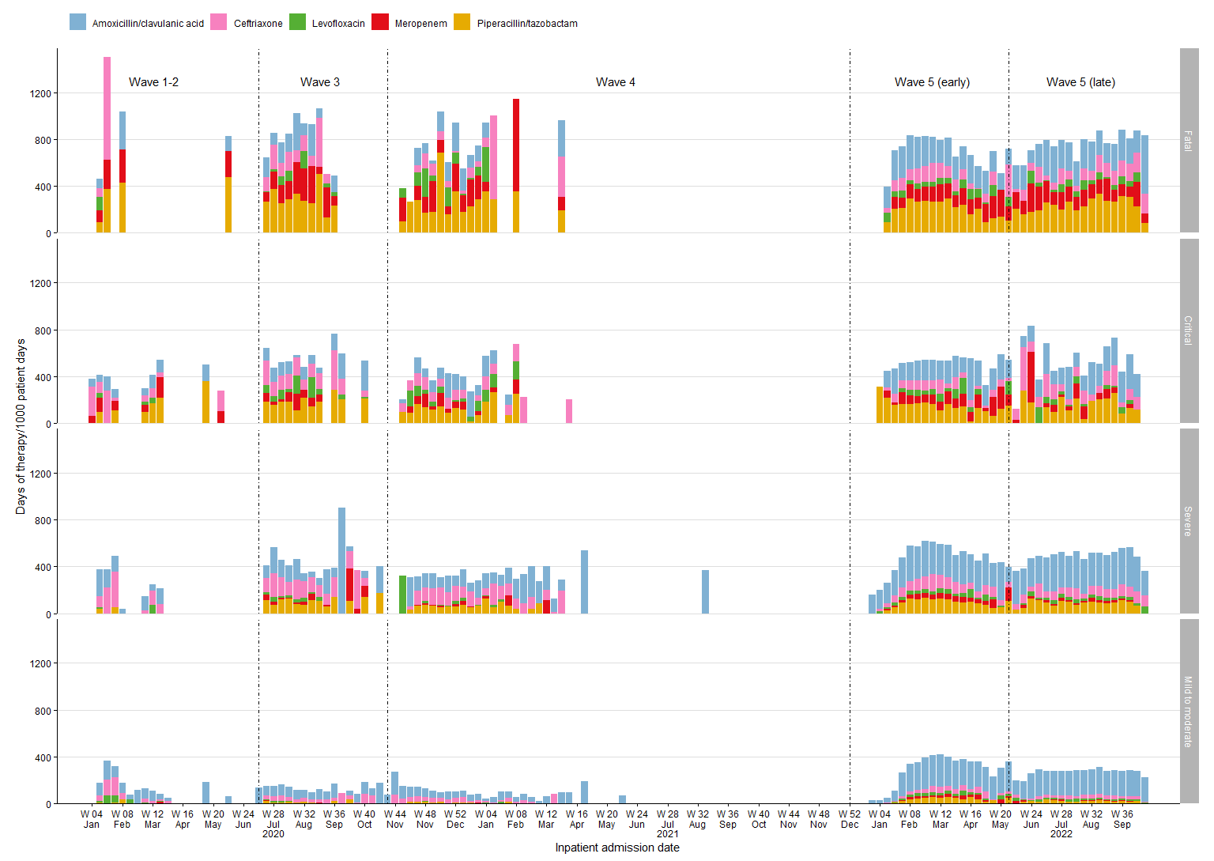

Supplementary Figure 4. Rate of antibacterial drug use according to the WHO AWaRe classification by epidemic wave
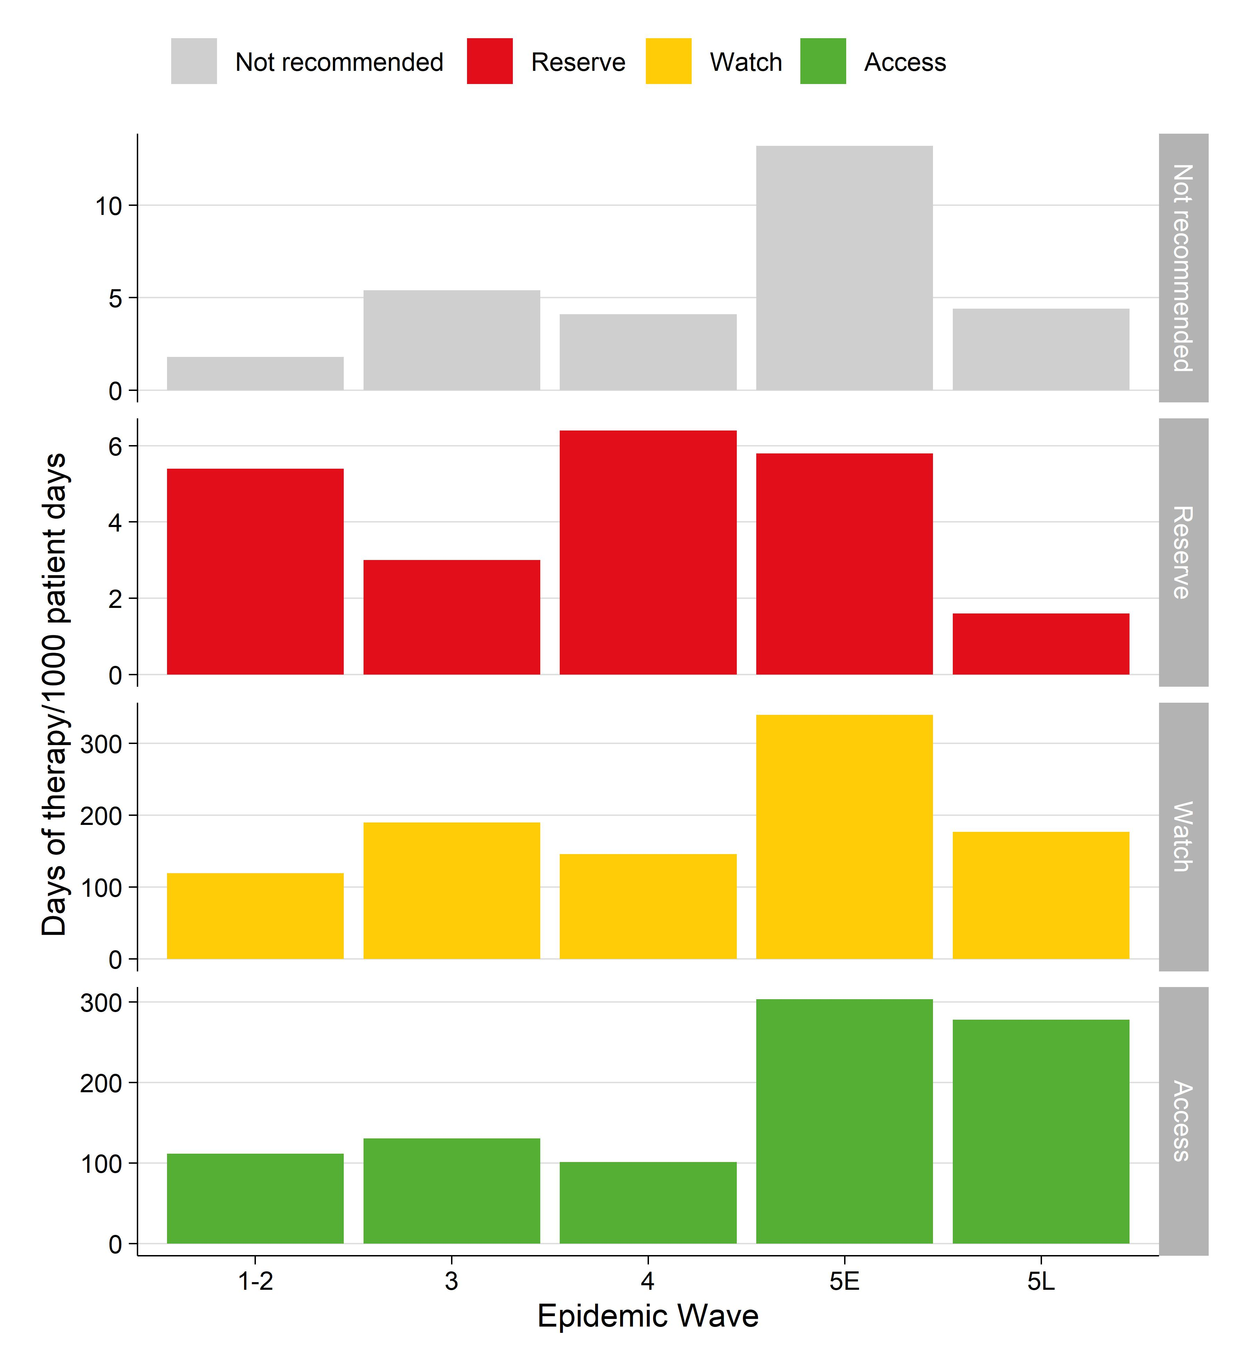

Supplementary Figure 5. Weekly proportion of days of therapy by WHO AWaRe group and COVID-19 disease severity 