Supplementary Material

Prevalence, Risk Factors, and Outcomes Associated with Delayed Second Doses of Antibiotics in Sepsis at a Large Academic Medical Center
Authors: Meghan E. Cook, PharmD¹; Brian R. Schuler, PharmD, BCCCP¹; Michael J. Schontz, PharmD, BCPS, BCCCP¹; Kevin C. McLaughlin, PharmD, BCPS, BCCCP¹; Kenneth E. Lupi, PharmD, BCPS, BCCCP¹; Jeremy R. DeGrado, PharmD, BCCCP¹; Chanu Rhee, MD, MPH^{2,3}
¹ Department of Pharmacy, Brigham and Women’s Hospital, Boston, MA
² Department of Population Medicine, Harvard Medical School / Harvard Pilgrim Health Care Institute, Boston, MA
³ Division of Infectious Diseases, Department of Medicine, Brigham and Women’s Hospital, Boston, MA

Table of Contents
Supplementary Table 1: Best Practice Alert (BPA) Criteria……………………………….....3
Supplementary Table 2. Antipseudomonal Beta-lactam Dosing……………………………...4
Supplementary Table 3. Vancomycin Dosing………………………………………………….6
Supplementary Table 4. Fluid Administration...........................................................................7
Supplementary Table 5. Subgroup Analysis: Patients Admitted to Non-Intensive Care Units................................................................................................................................................8
Supplementary Table 6. Regression Analysis Evaluating the Association Between Delayed Second Doses of Antibiotics and In-hospital Mortality in Patients Admitted to Non-Intensive Care Units......................................................................................................................9
Supplementary Figure 1. Vancomycin Dosing in Renal Insufficiency...................................10

Supplementary Table 1. Best Practice Alert (BPA) Criteria
BPA | Criteria
Sepsis | Possibleª or high suspicion^{b} of infection and ≥ 1 of the following:  - Systolic blood pressure < 90 mm Hg  - Lactate > 2.0 mmol/L  - Creatinine > 2.0 mg/dL (acute rise)  - Initiation of mechanical or non-invasive positive pressure ventilation
Septic shock | Possibleª or high suspicion^{b} of infection and ≥ 1 of the following:  - Systolic blood pressure < 90 mm Hg that persists for > 3 hours  - Lactate ≥ 4 mmol/L
ªPossible infection: Temperature > 100.4°F, white blood cell (WBC) count > 15 x 10⁹/L, urinalysis with > 20 WBC, culture ordered, emergency department (ED) screen positive for “possible infection”
^{b}High suspicion of infection: Intravenous antibiotics, bands ≥ 5%, ED screen positive for “looks sick”

Supplementary Table 2. Antipseudomonal Beta-Lactam Dosing
Antibiotic | Creatinine clearance (mL/min) | Recommended dosing interval
Aztreonam | >50 | Q8H
 | 10-50
 | <10
 | Hemodialysis
Cefepime | ≥60 | Q8H
 | 30-59 | Q12H
 | 10-29 | Q24H
 | <10
 | Hemodialysis | 1 g Q24H or 2 g post-HD
Ceftazidime | >50 | Q8H
 | 31-50 | Q12H
 | 16-30 | Q24H
 | 5-15
 | <5 | Q48H
 | Hemodialysis | 1 g Q24H or 2 g post-HD
Imipenem-cilastatin | ≥60 | Q6H
 | 30-59 | Q8H
 | 15-29 | Q12H
 | Hemodialysis
Meropenem | >50 | Q8H
 | 26-50 | Q12H
 | 10-25
 | <10 | Q24H
 | Hemodialysis
Piperacillin-tazobactam | >40 | Q6H
 | 20-40
 | <20
 | Hemodialysis | Q8H

Supplementary Table 3. Vancomycin Dosing
Age (years) | 18-49 |  |  | 50-79 |  | ≥80
Creatinine clearance (mL/min) | ≥90 | 50-89 | ≤49 | ≥50 | ≤49 | ≥60 | ≤59
Recommended interval | Q8H | Q12H | Q24H | Q12H | Q24H | Q12H | Q24H

Supplementary Table 4. Fluid Administration
Variable | Delayed group  (n=123) | Non-delayed group (n=326) | p
Received 30 mL/kg of fluid within 3 hours of BPAª | 39 (31.7) | 115 (35.3) | 0.48
Type of crystalloid administeredª
Normal saline | 100 (81.3) | 242 (74.2) | 0.12
Lactated Ringer’s | 56 (45.5) | 161 (49.4) | 0.47
Dextrose 5% in water | 2 (1.6) | 4 (1.2) | 0.74
Other^{b} | 11 (8.9) | 16 (4.9) | 0.11
BPA, best practice alert
ªData presented as n (%)
^{b}Other fluids include dextrose 10% in water, ½ normal saline, combination fluids with dextrose and sodium chloride, sodium bicarbonate, and electrolyte containing fluids (e.g., normal saline with potassium chloride)

Supplementary Table 5. Subgroup Analysis: Patients Admitted to Non-Intensive Care Units
Outcome | Delayed group  (n=49) | Non-delayed group (n=122) | p
In-hospital mortalityª | 9 (18.4) | 7 (5.7) | 0.01
Discharge to hospiceª | 4 (8.2) | 7 (5.7) | 0.56
Hospital length of stay (days)^{b} | 5.0 [4.0-9.0] | 7.0 [4.0-11.0] | 0.08
ªData presented as n (%)
^{b}Data presented as median [interquartile range]

Supplementary Table 6. Regression Analysis Evaluating the Association Between Delayed Second Doses of Antibiotics and In-hospital Mortality in Patients Admitted to Non-Intensive Care Units
Variable | OR (95% CI) | p
Delay in second dose | 4.10 (1.32-12.79) | 0.02
Weight (per 1 point BMI increase) | 0.98 (0.95-1.02) | 0.31
Malignancy | 1.92 (0.56-6.55) | 0.30
Respiratory infection | 2.04 (0.63-6.62) | 0.23
Non-ED location at time second dose due | 1.77 (0.16-20.01) | 0.65
Time in ED (per hour) | 0.97 (0.82-1.15) | 0.72
SOFA score (per 1 point increase) | 1.34 (1.08-1.66) | 0.01
Initiation of stress dose steroids within 24 h of inclusion BPA | 1.66 (0.30-9.06) | 0.56
BMI, body mass index; ED, emergency department; SOFA, sequential organ failure assessment; BPA, best practice alert

Supplementary Figure 1. Vancomycin Dosing in Renal Insufficiency

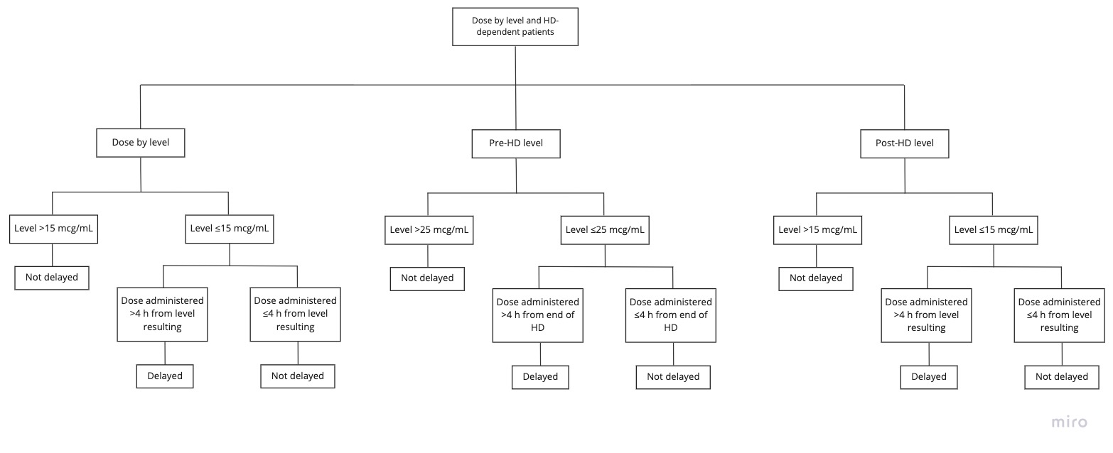
Abbreviations: HD, hemodialysis

