Supplementary Figure 1
VA North Texas Health Care System (VANTHCS) process for reviewing community hospital requests for outpatient parenteral antimicrobial therapy (OPAT)

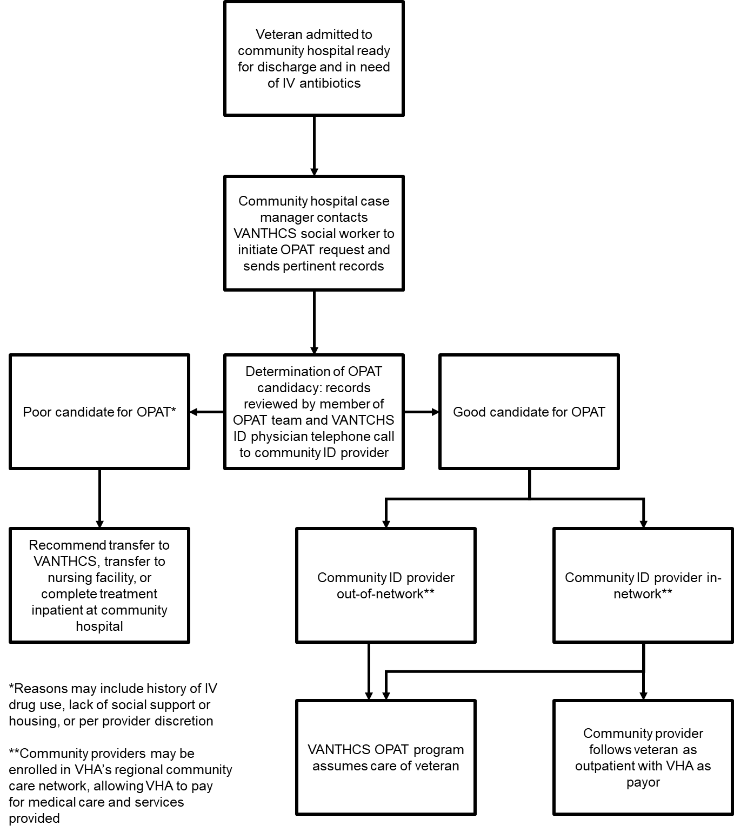

Supplementary Figure 2
Overview of patient charts reviewed for inclusion/exclusion

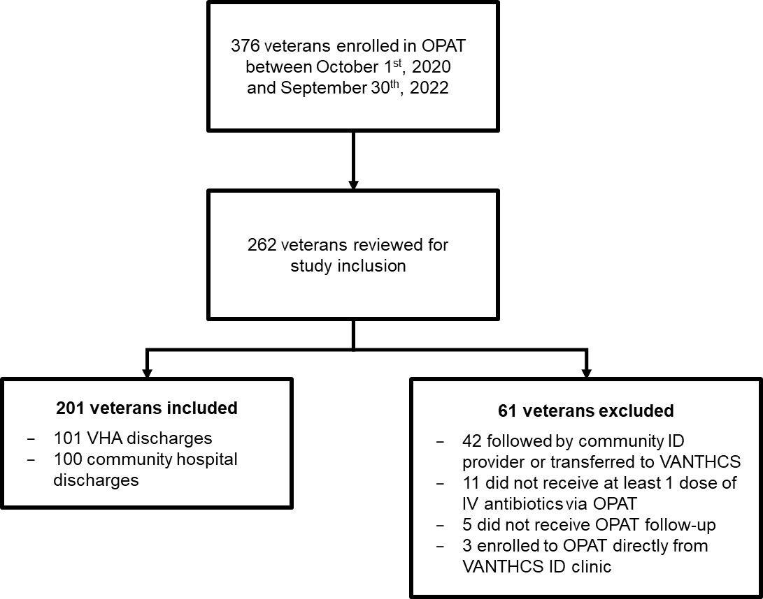

Supplementary Table 1
VANTHCS OPAT Program Changes Made to Antibiotic Regimens Planned by Community Hospitals
No change | 39
Spectrum | 36
Escalation | 15
De-escalation | 21
IV-to-PO | 3
Duration | 13
Convenience | 48
Note: 100 total changes recommended across 61 patients

