Appendix B: Comparison of the responses of different ChatGPT models with the ones based on the benchmark data
In Tables B1 to B6 letter “Y” indicates that the response aligns with the benchmark data in term of “Match” or “Ranking”, and letter “N” signifies a discrepancy. In Figs. B1 to B4, each parameter (or model) is assigned a specific color, and lines of the same color connect parameters (or models) to visually represent their consistency.
In Table B1, it should be noted that DNN (Deep Neural Network) is considered as specific type of ANN (Artificial Neural Network). Furthermore, MLP (Multilayer Perceptron) algorithms can be considered as Deep Neural Networks if they have multiple hidden layers. Additionally, Adaptive Boosting (AdaBoost), Extreme Gradient Boosting (XGBoost), GBM (Gradient Boosting Machine), and GBDT (Gradient Boosting Decision Tree) are all part of the Boost-Ens (Boosting Ensembles) category.
Table B1. The top ten ML models developed for FSM based on benchmark data and different ChatGPT models
Benchmark data | ChatGPT-4o |  |  | ChatGPT-4 |  |  | Chat-FSM
Benchmark data | Response | Match | Ranking | Response | Match | Ranking | Response | Match | Ranking
RF | RF | Y | Y | RF | Y | Y | RF | Y | Y
SVM | SVM | Y | Y | SVM | Y | Y | SVM | Y | Y
DNN | GBM | Y | N | LR | N | N | ANN | Y | Y
DT | ANN | Y | N | ANN | Y | N | XGBoost | Y | N
ANFIS | LR | N | N | DT | Y | N | CNN | Y | N
Boost-Ens | K-NN | N | N | GBM | Y | Y | MLP | Y | N
CNN | NB | N | N | K-NN | N | N | DT | Y | N
Bagg-Ens | DT | Y | N | NB | N | N | K-NN | N | N
LSTM | CNN | Y | N | DL | Y | N | ANFIS | Y | N
DBN | ELM | N | N | AdaBoost | Y | N | GBDT | Y | N
RF: Random Forest; SVM: Support Vector Machine; DT: Decision Tree; ANFIS: Adaptive Neuro-Fuzzy Inference System; CNN: Convolutional Neural Network; Bagg-Ens: Bagging Ensemble; LSTM: Long Short-Term Memory; DBN: Deep Belief Network; LR: Logistic Regression; K-NN: K-Nearest Neighbors; NB: Naïve Bayes; DL: Deep Learning; ELM: Extreme Learning Machines; DL: Deep Learning

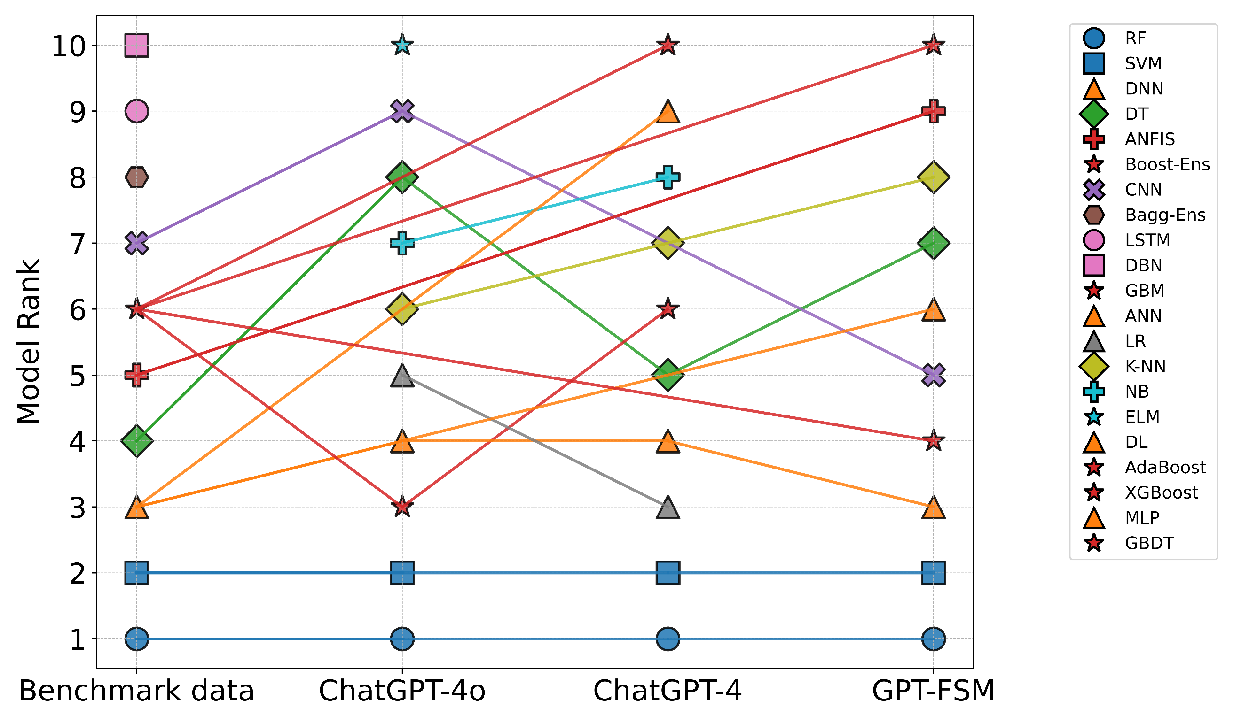 | Figure B1. Comparative model rankings across different configurations (lines connect models of similar type, highlighting changes in ranking between configurations)

Table B2. The top ten most important input parameters utilized in ML-based models developed for FSM based on benchmark data and different ChatGPT models
Benchmark data | ChatGPT-4o |  |  | ChatGPT-4 |  |  | Chat-FSM
Benchmark data | Response | Match | Ranking | Response | Match | Ranking | Response | Match | Ranking
Elevation | Rainfall | Y | N | Elevation | Y | Y | Elevation | Y | Y
Slope | Elevation | Y | N | Slope | Y | Y | Slope | Y | Y
Dis. River | Slope | Y | N | Rainfall | Y | N | Dis. River | Y | Y
TWI | Dis. River | Y | N | Dis. River | Y | N | Rainfall | Y | N
LULC | Soil type | Y | N | Soil type | Y | N | StrDen | Y | N
Rainfall | LULC | Y | N | LULC | Y | N | TWI | Y | N
Geology | Flow Acc | N | N | StrDen | Y | N | LULC | Y | N
StrDen | NDVI | N | N | Flow Acc | N | N | Curvature | Y | N
Curvature | TWI | Y | N | Lithology | Y | N | Soil type | Y | N
SPI | HFR | N | N | TWI | Y | N | Aspect | N | N
Dis River: Distance to River; TWI: Topographic Wetness Index; NDVI: Normalized Difference Vegetation Index; LULC: Land Use Land Cover; StrDen: Stream Density; SPI: Stream Power Index; Flow Acc: Flow Accumulation; Dis Road: Distance to Roads/Infrastructure; Flow Dir: Flow Direction; HFR: Historical Flood Records

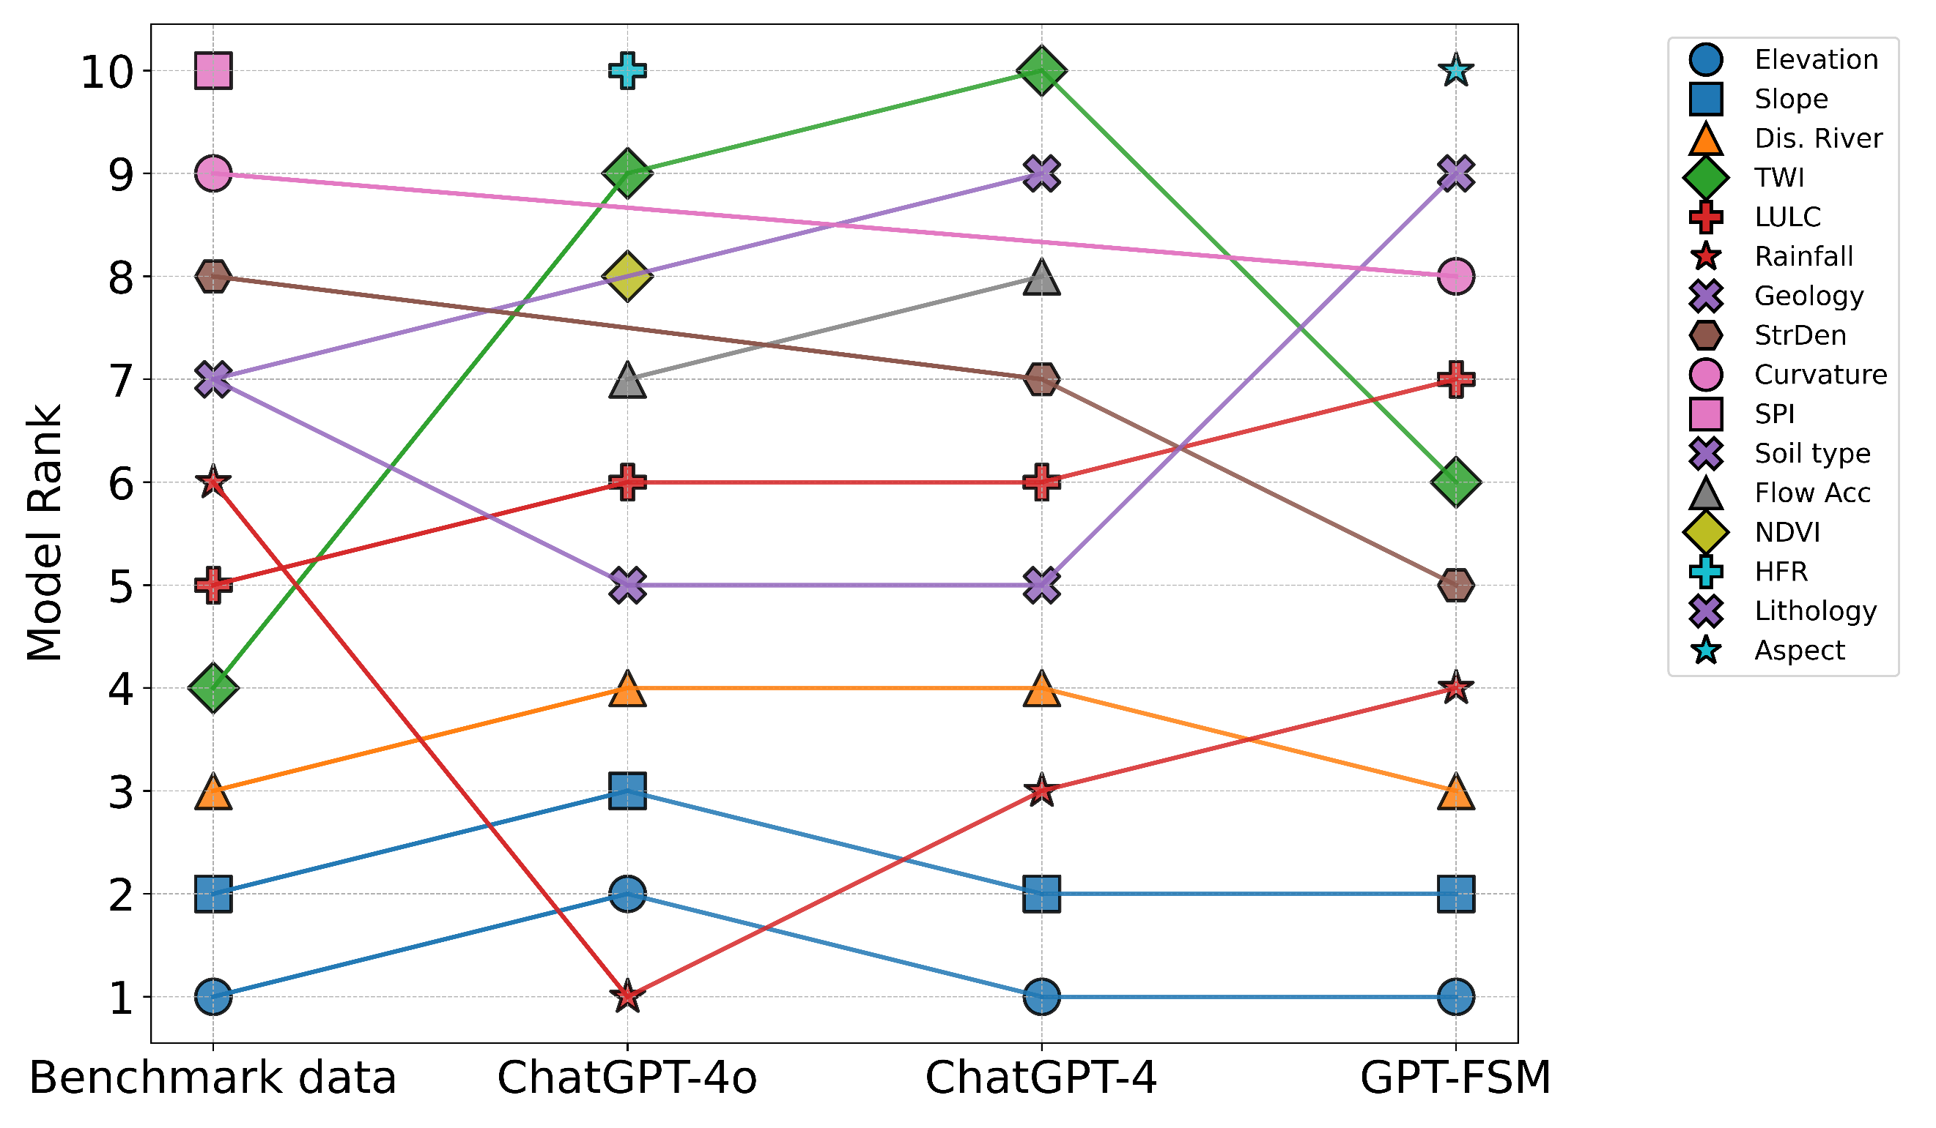 | Figure B2. Comparative analysis of different ChatGPT models’ responses against benchmark data, highlighting the top ten most important influential parameters in ML models developed for FSM (lines connect similar parameters).

Table B3. The top ten most frequently utilized parameters in ML-based models developed for FSM based on benchmark data and different ChatGPT models
Benchmark data | ChatGPT-4o |  |  | ChatGPT-4 |  |  | Chat-FSM
Benchmark data | Response | Match | Ranking | Response | Match | Ranking | Response | Match | Ranking
Slope | Elevation | Y | N | Elevation | Y | N | Slope | Y | Y
Elevation | Slope | Y | N | Slope | Y | N | Elevation | Y | Y
TWI | Rainfall | Y | N | Dis. River | Y | N | Rainfall | Y | N
LULC | Dis. River | Y | N | Rainfall | Y | N | Dis. River | Y | N
Rainfall | LULC | Y | N | LULC | Y | N | LULC | Y | N
Dis. River | Soil type | Y | N | Soil type | Y | N | StrDen | N | N
SPI | Flow Acc | N | N | SPI | Y | Y | TWI | Y | N
Curvature | TWI | Y | N | TWI | Y | N | Curvature | Y | Y
Lithology | Curvature | Y | N | Lithology | Y | Y | Aspect | N | N
Soil type | NDVI | N | N | Curvature | Y | N | Soil type | Y | Y

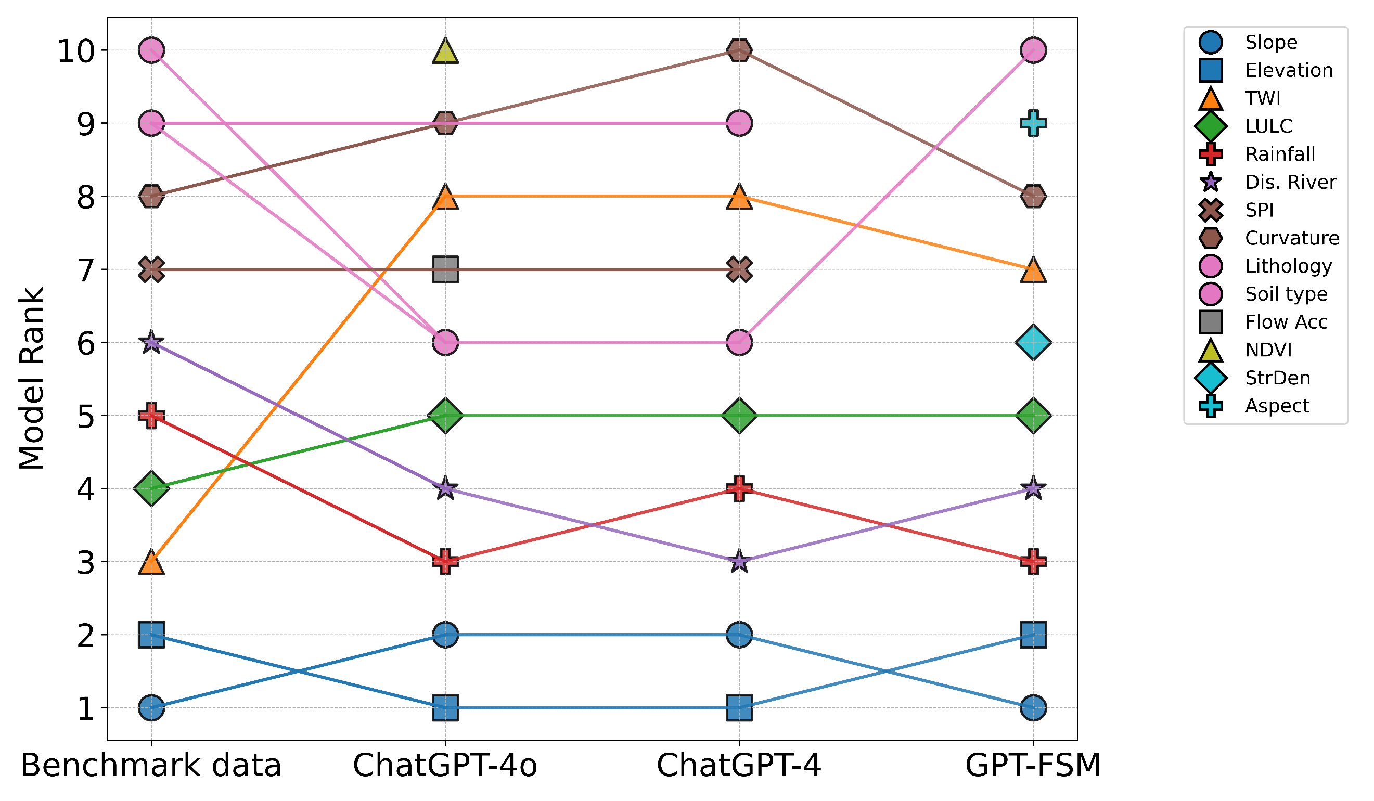 | Figure B3. Comparative analysis of different ChatGPT models’ responses against benchmark data, highlighting the top ten most frequently utilized parameters in ML models developed for FSM (lines connect similar parameters).

Table B4. The top ten most frequently utilized feature selection methods in ML-based models developed for FSM based on benchmark data and different ChatGPT models
Benchmark data | ChatGPT-4o |  |  | ChatGPT-4 |  |  | Chat-FSM
Benchmark data | Response | Match | Ranking | Response | Match | Ranking | Response | Match | Ranking
RF | RFE | N | N | RFE | N | N | ReliefF | Y | N
IGR | RF | Y | N | RF | Y | N | VIF | N | N
NB | CFS | N | N | CFS | N | N | FR | N | N
RoF | PCA | N | N | PCA | N | N | IGR | Y | N
Jackknife | IG | Y | N | MI | N | N | PCA | N | N
ReliefF | Chi-Square | N | N | Chi-square | N | N | Shannon | N | N
NN models | GR | N | N | IG | Y | N | RF | Y | N
XGB | ReliefF | Y | N | LASSO | N | N | Geodetector | N | N
SVM | MI | N | N | ReliefF | Y | N | Pearson | N | N
IG | Boruta | N | N | Stepwise | N | N | Stepwise | N | N
RF: Random Forest; IGR: Information Gain Ratio; NB: Naive Bayes; RoF: Rotation Forest; Jackknife: Jackknife Resampling Test; ReliefF: ReliefF Algorithm; NN models: Neural Network models; XGB: Extreme Gradient Boosting (XGBoost); SVM: Support Vector Machine; IG: Information Gain; RFE: Recursive Feature Elimination; CFS: Correlation-Based Feature Selection; PCA: Principal Component Analysis; GR: Gain Ratio; MI: Mutual Information; LASSO: LASSO Regression (L1 Regularization); Stepwise: Stepwise Selection (Forward/Backward); VIF: Variance Inflation Factor; FR: Frequency Ratio; Shannon: Shannon's Entropy; Pearson: Pearson’s Correlation Coefficient

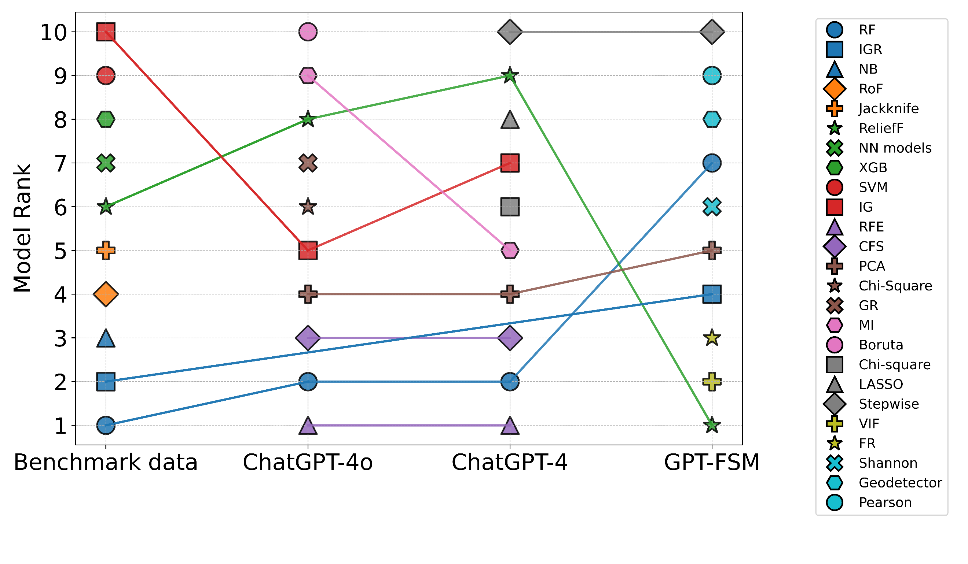 | Figure B4. Comparative analysis of different ChatGPT models’ responses against benchmark data, highlighting the top ten most frequently utilized feature selection methods in ML models developed for FSM (lines connect similar parameters).

Table B5. The top five most significant gaps and challenges in development of ML models for FSM
Benchmark models | ChatGPT-4o | ChatGPT-4 | Chat-FSM
Data augmentation and fusion | Data availability and quality | Data availability and quality | Data availability and quality
Incorporation of climate change indicators | Model generalizability across regions | Model generalizability and transferability | Overfitting
Use of social media data (e.g. in scare-data regions) | Integration with physical knowledge | Integration with hydrological knowledge | Model interpretability
Physical interpretation and soundness | Model interpretability and explainability | Interpretability and explainability | Feature selection and model generalization
Trade-off analysis and generalization | Temporal dynamics and real-time prediction | Computational resources and technical expertise | Integration with physical models

Table B6. Influence of typhoon frequency as a predictor on flash flood susceptibility modeling and its effect on model performance in cyclone-prone coastal regions
Reason for Incorporating ATF* | Benchmark | Chat-FSM | Match
Typhoons produce intense rainfall that can trigger flash floods | Typhoons are linked to heavy precipitation and form a typhoon → rainstorm → flash flood chain in coastal areas. | Tropical cyclones generate extreme short-duration rainfall, a key trigger of flash floods. | Y
Represents a regional hazard driver in coastal areas | ATF reflects that coastal regions are frequently affected by typhoons, influencing flood occurrence. | Typhoon frequency represents long-term climatic forcing/exposure to cyclone hazards. | Y
Captures repeated exposure to extreme rainfall events | Captures repeated exposure to extreme rainfall events: Implied through frequent typhoon impacts in coastal regions. | Explicitly states areas with higher typhoon frequency experience repeated extreme rainfall events. | Y
Helps represent regional flood-generation mechanisms | ATF captures the specific coastal flood-generation mechanism linked to typhoons. | Described as strengthening the causal linkage between climatic drivers and flash floods. | Y
Cyclone tracks/pathways influence spatial distribution of floods | Not explicitly discussed in the paper. | Explicitly mentioned as influencing flash-flood distribution. | N
Improves spatial differentiation of susceptibility classes | Not explicitly discussed in the paper. | Mentioned as a modeling advantage. | N
Improves model performance/accuracy | Experiments show accuracy decreases when ATF is removed, confirming its predictive value. | Expected to increase metrics such as AUC and accuracy. | Y
*ATF: Average Typhoon Frequency

