Rassul et al. Supplementary Figures

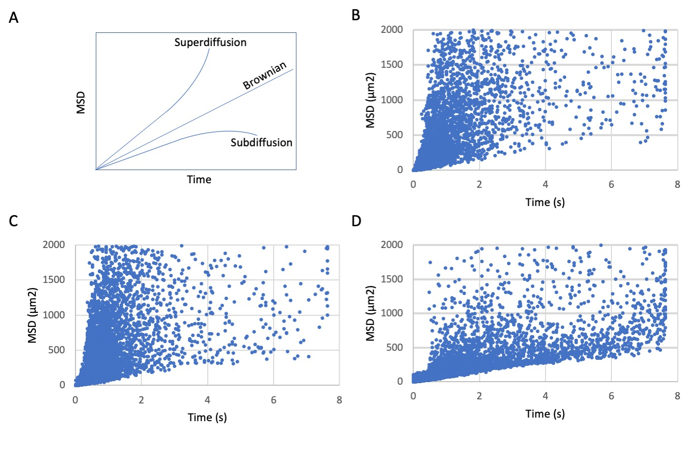

Supplementary Figure 1. MSD vs time plots reveal a shift in the diffusive behaviour of MBP particles during oligodendrocyte differentiation. A. Schematic showing possible modes of particle diffusion (adapted from ⁴⁹). Particle tracks in OPC processes (B) and eOL bubbles (C) exhibit a tendency towards higher diffusivity, particularly over a shorter time span. The distribution of more highly diffusive particles is reminiscent of superdiffusion. D. Particle tracks imaged from mOL sheets exhibit a restricted form of diffusion relative to OPC processes and eOL bubbles. Graphs in B-D were generated from imaging fields taken from 5 to 6 individual cells per cell type. Individual data points indicate unique particle tracks.

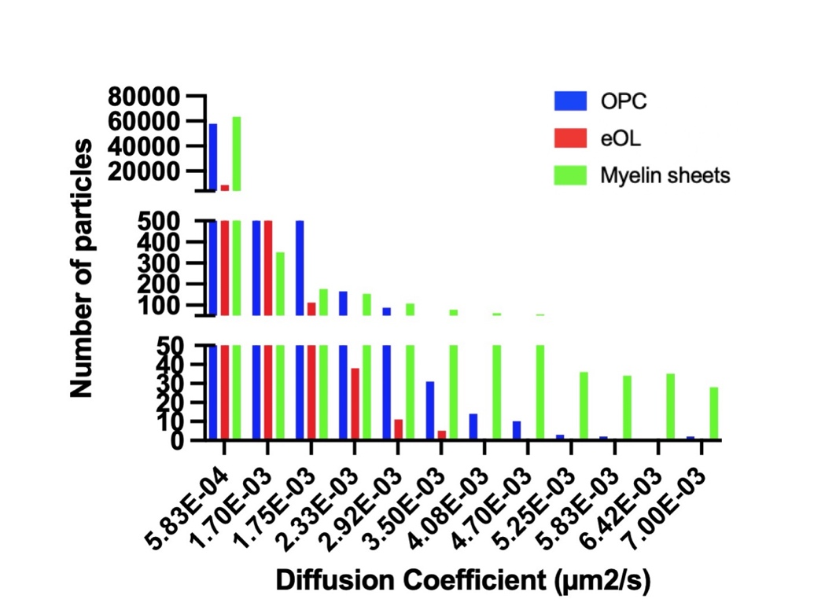

Supplementary Figure 2. Distributions of MBP particle diffusion coefficients expressed as raw particle numbers for OPC processes, eOL membrane bubbles and mOL myelin sheets. Y axis is split to accommodate the range of particle numbers allocated across the distribution bins. Note, the vast majority of particles for all cell types fall within the slowest bin.

